JAVA SERVER FACES
VIEW PARAM, GET METHOD, BOOKMARKING
LESSONS

SADRZAJ - 12

VIEW PARAM
GET METHOD
BOOKMARKING

JSF F VIEW PARAM

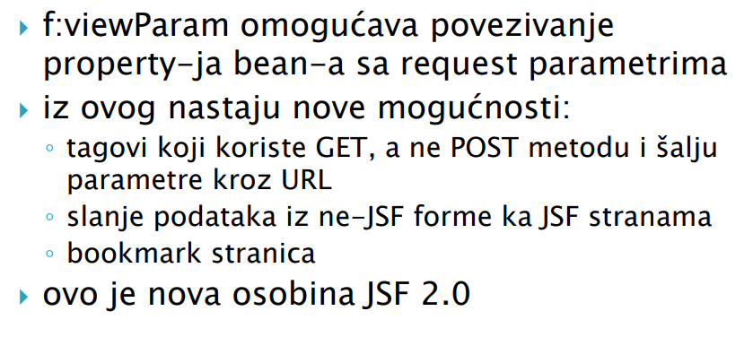

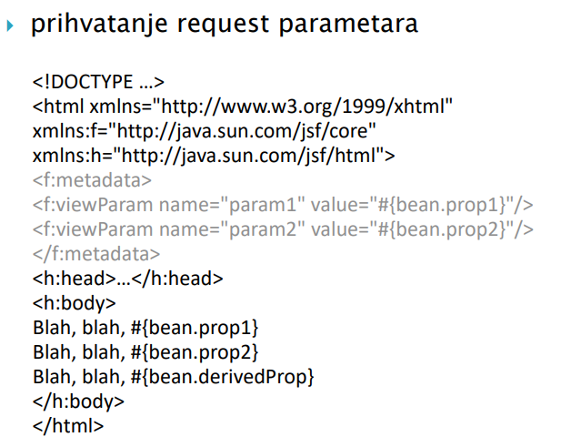

GET METHOD IN JSF

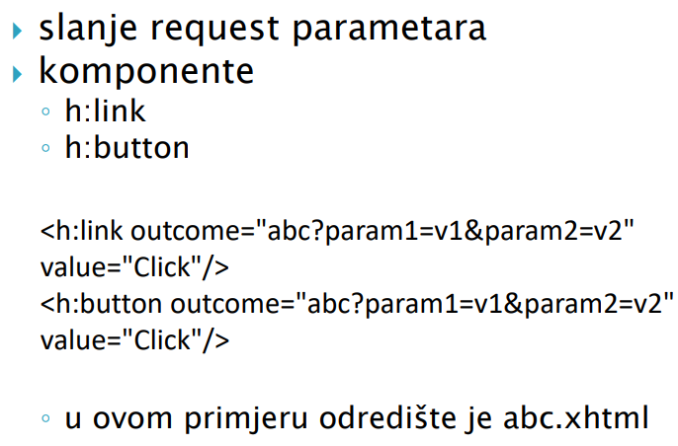
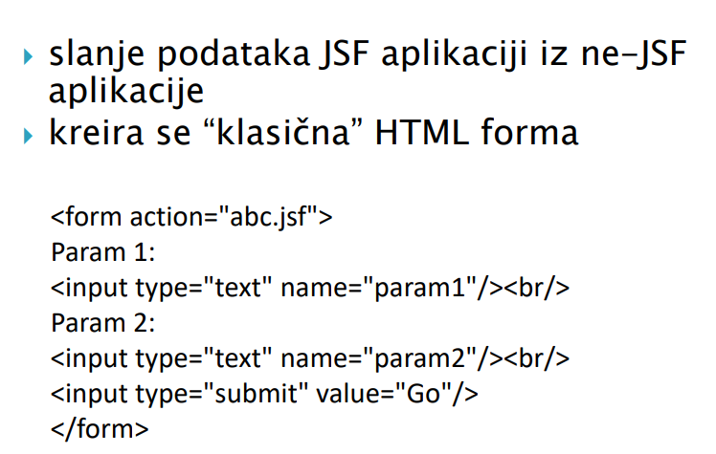

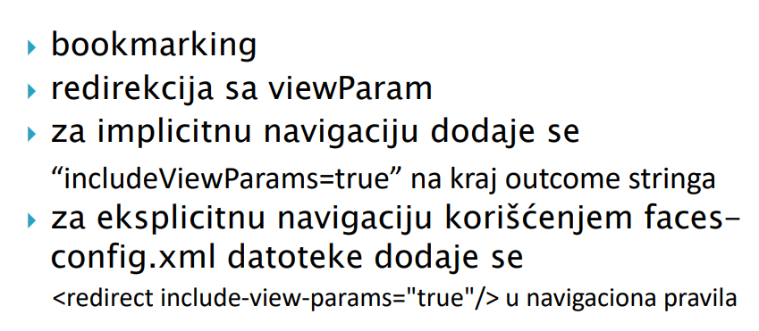
NAPOMENE

- POST (REDIRECT) BOOKMARKING FOR JSF
- GET (JSF) BOOKMARKING FOR JSF

