JAVA SERVER FACES
VIDEO MATERIALS
EXERCISES – 09 – 01

TEST JSF – 51 – EXAMPLE ACCEPT NAME

obaveze.xhtml
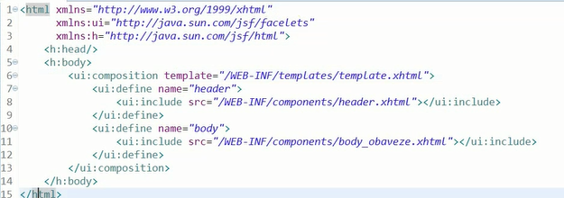

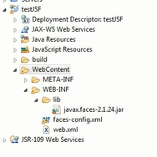

index.xhtml

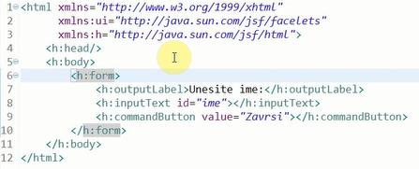

NameBean.java

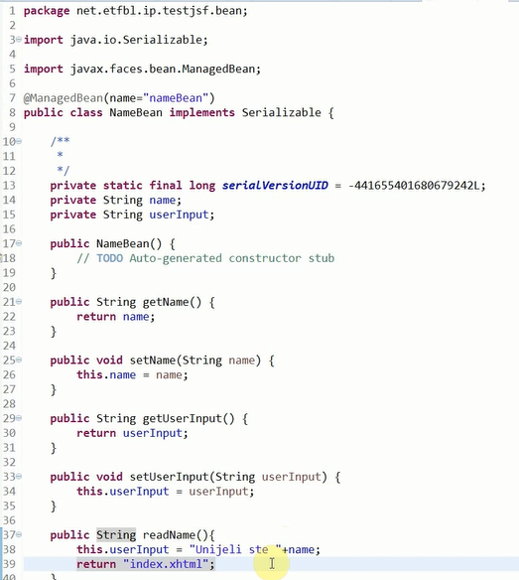
index.xhtml
