Iannelli Mirko 873039
Pettinato Christian 895270
Scampini Riccardo 891804
Flights delay predictions
This paper analyzes a dataset containing over thirty thousand records related to airline flights, with the goal of developing machine learning models capable of predicting whether a flight will experience a substantial delay, (we define delays when they last more than 15 minutes). The dataset includes approximately 25 variables covering various technical aspects, including the number of seats, the age and flight frequency of the aircraft, as well as information regarding airport traffic, the flight date, the distance traveled, and weather conditions. The approach focuses on building various predictive algorithms, which will be systematically compared to identify the most effective model for predicting delays in advance.

Data Insight:
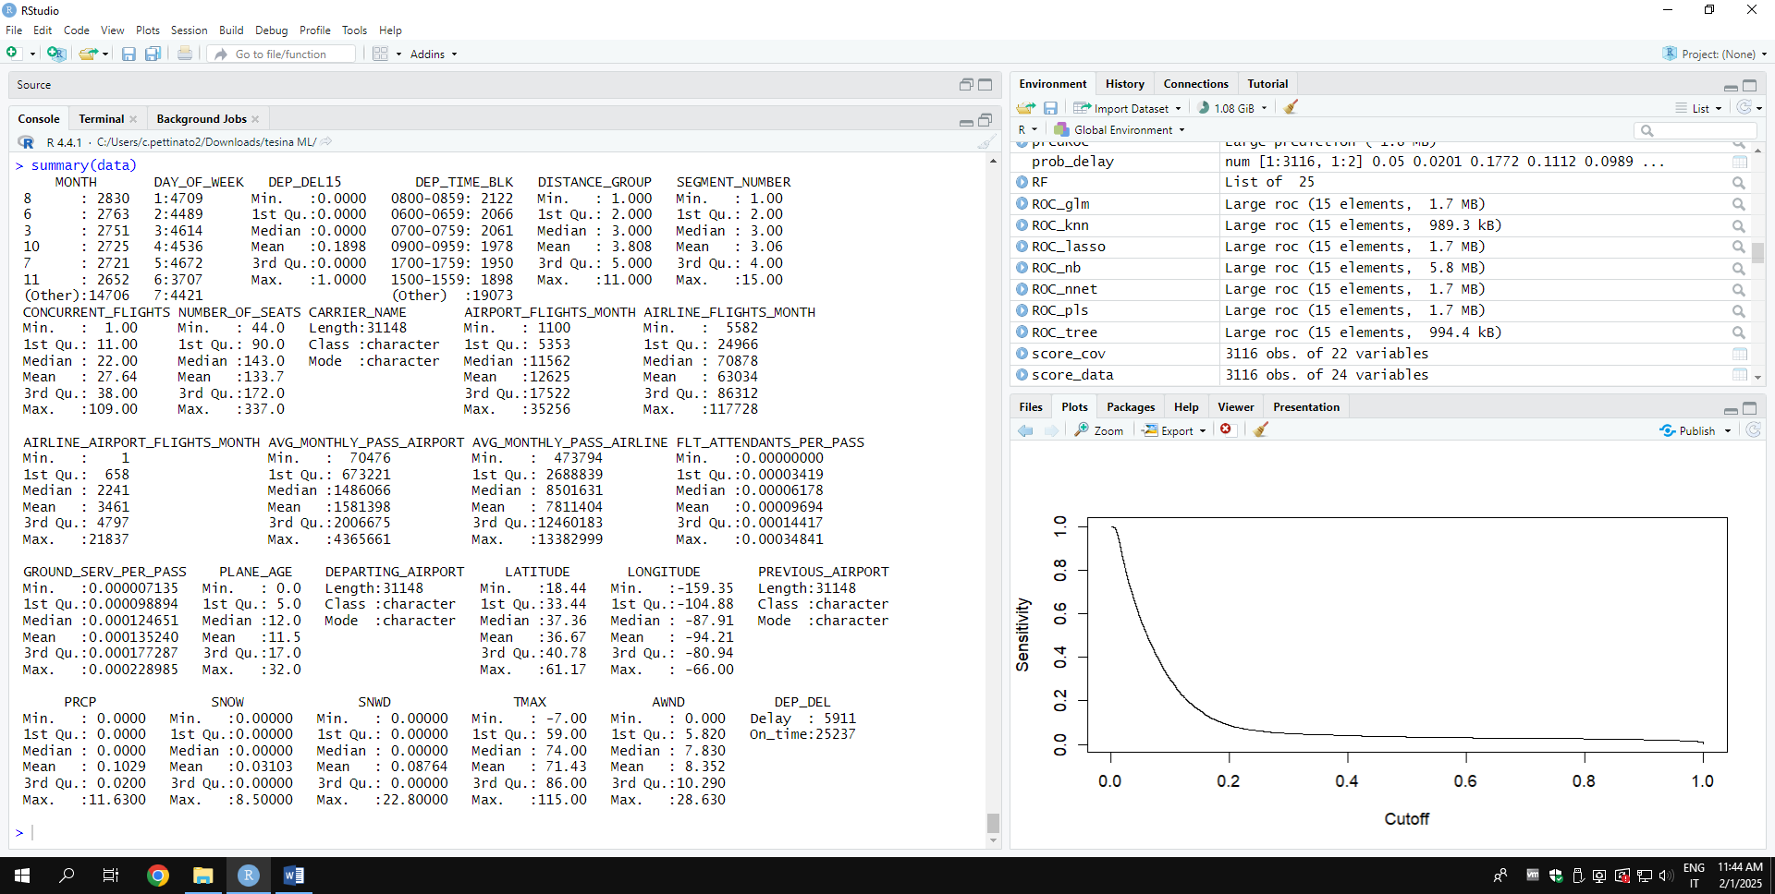

Target distribution:
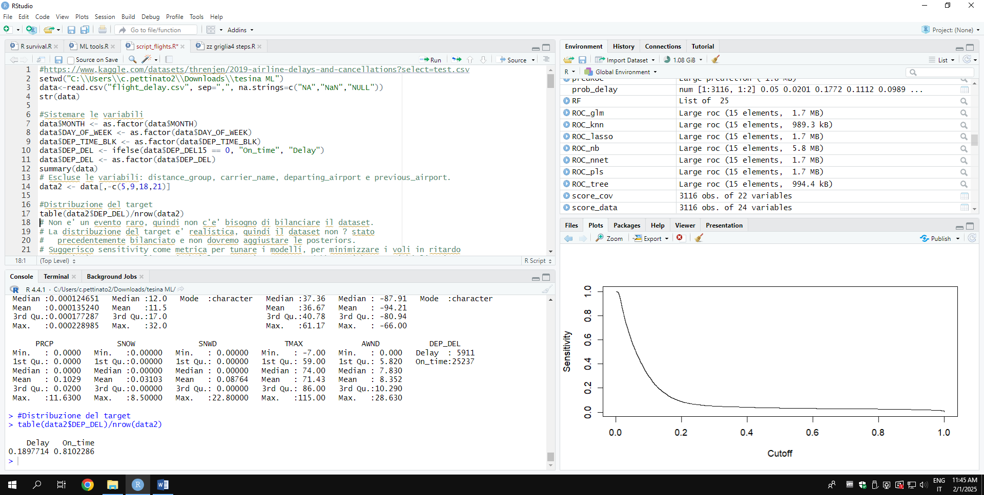
Positive class: Delay
The event of interest is not rare, and the distribution of the target is realistic; therefore, the dataset has not been balanced in advance.
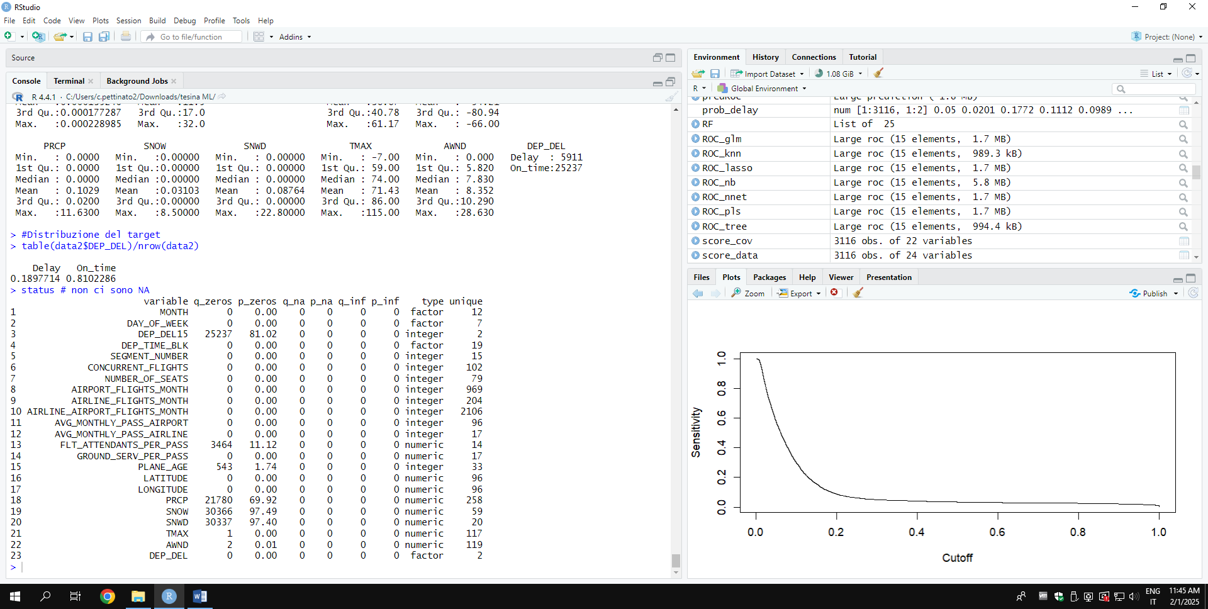
There are no NA values in the dataset

STEP 1: MODEL BUILDING

The following models were developed: decision tree, random forest, LASSO, GLM, PLS, Naive Bayes, nearest neighbor, and neural network.
For models that needed to be tuned based on a metric, the ROC curve was chosen because it was considered the most robust.

DECISION TREE
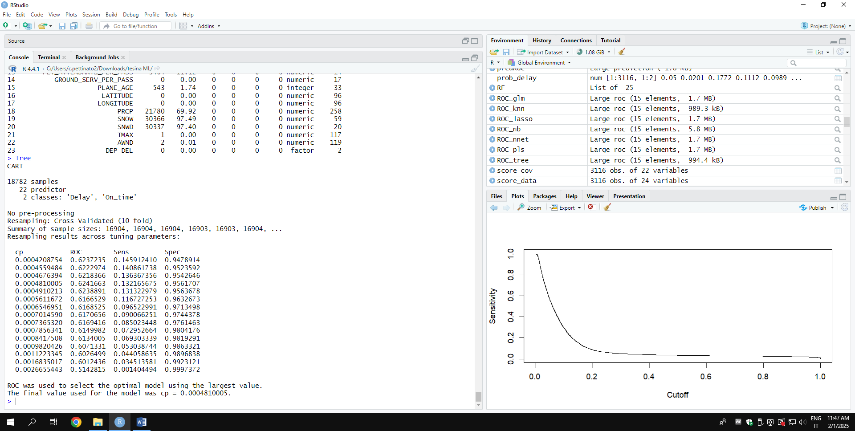
Overfitting albero: 0.03752713

Random forest
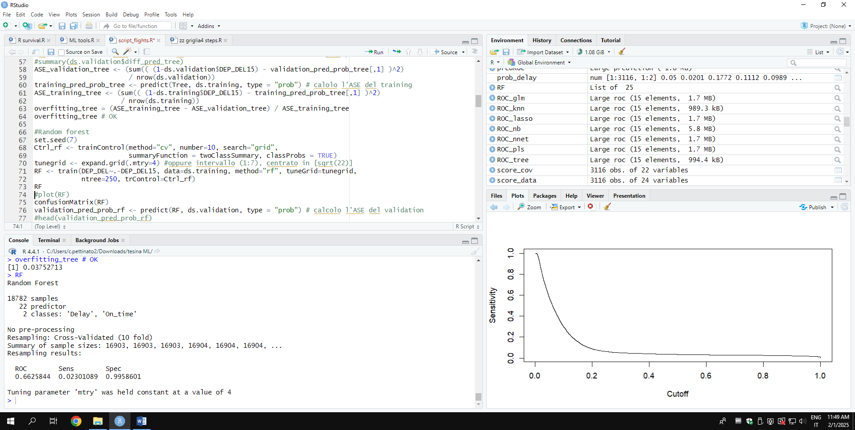
Overfiting random forest: 0.2408623
IT OVERFITTS!!!
Even though the random forest exhibits overfitting in its predictions, its feature importance remains very useful: because it is based on how much the variables contribute to reducing impurity or improving predictions within the trees, so it still provides a good criterion for selecting the most relevant variables, even if a different model is ultimately chosen.
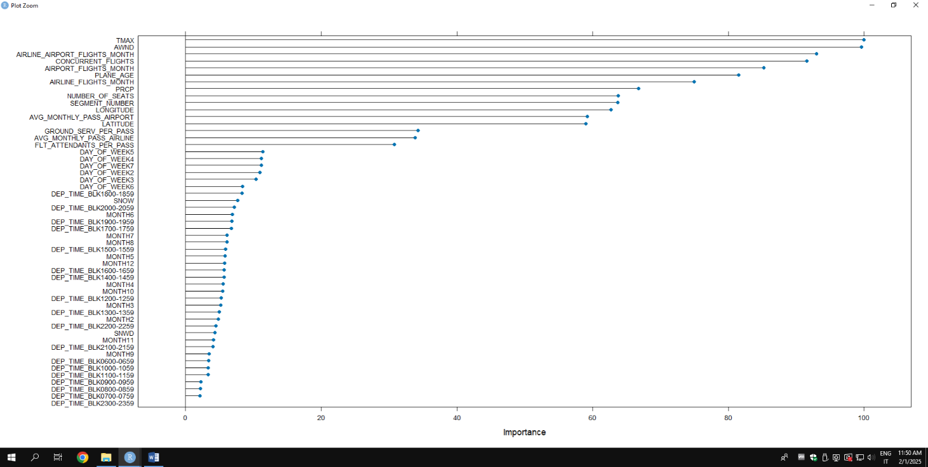
The random forest was also used to perform model selection, choosing those variables with varImp > 20.
Lasso
Tuning parameter 'alpha' was held constant at a value of 1
ROC was used to select the optimal model using the largest value.
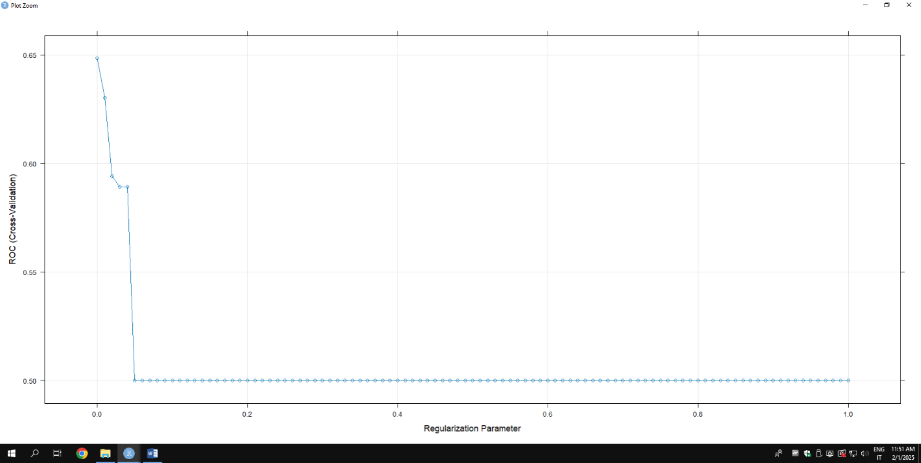
The final values used for the model were alpha = 1 and lambda = 0.

Overfittng Lasso: 0.0009250535
Glm

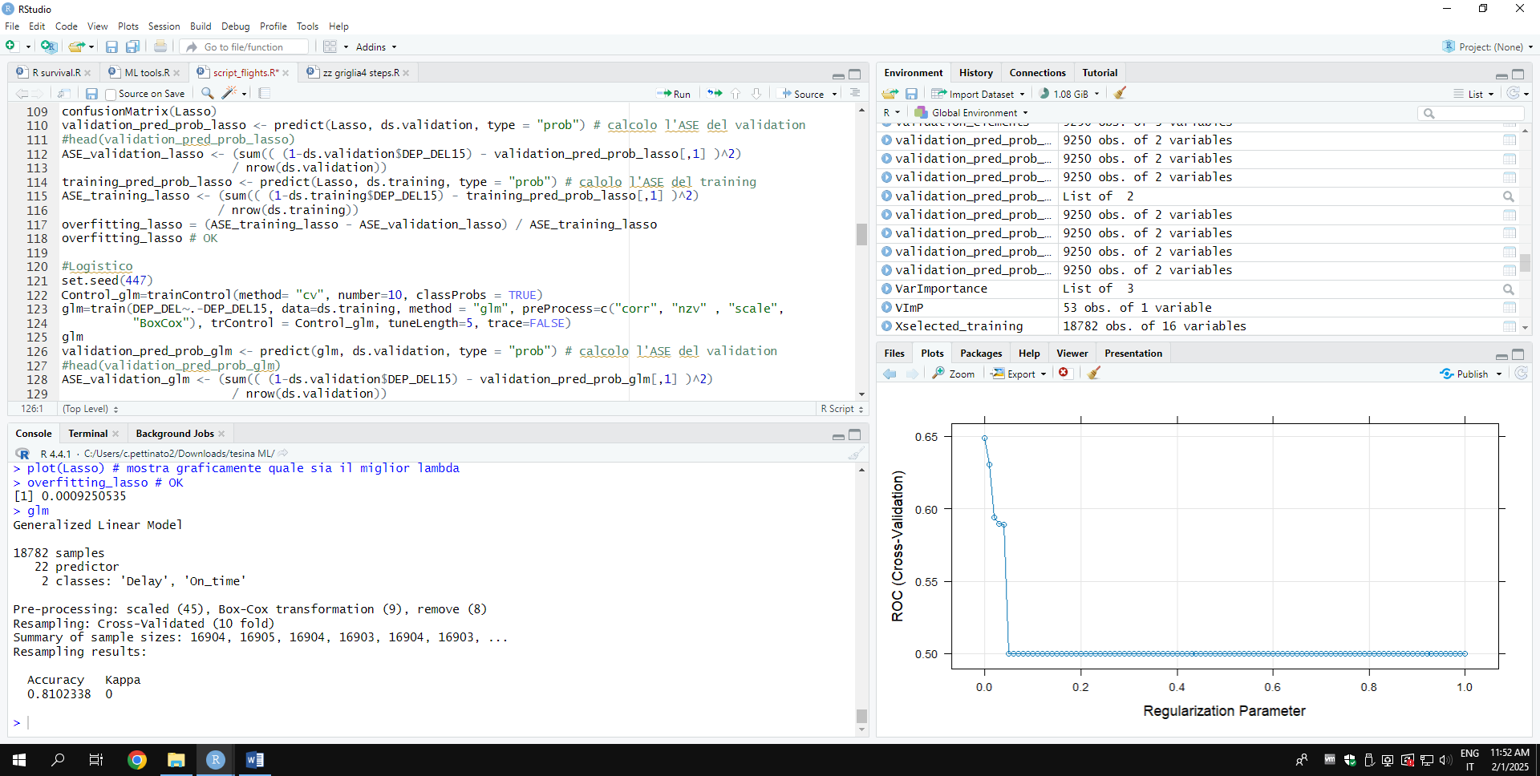
Overfitting glm: 0.0006411123

PLS

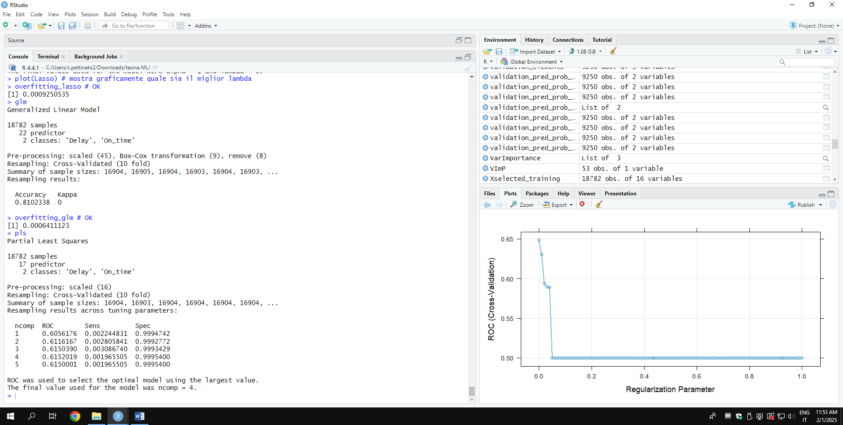
Overfitting PLS: -0.0009307492

Naive Bayes
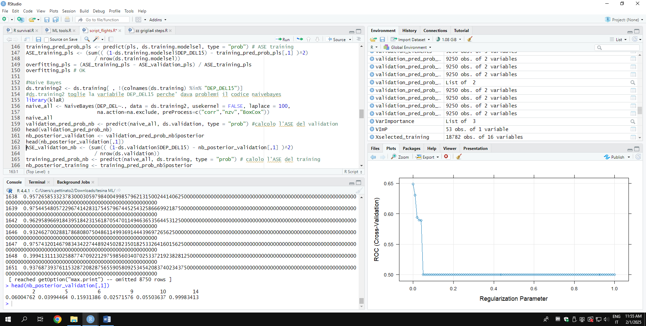
Overfitting Naïve Bayes: -0.003248625

Nearest neighbor
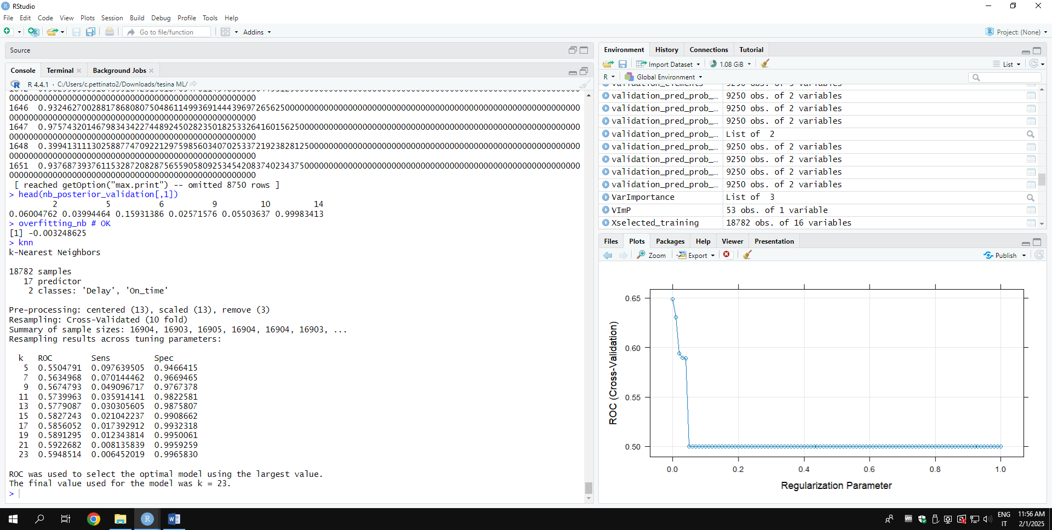
Overfitting knn: 0.01710012

Neural network
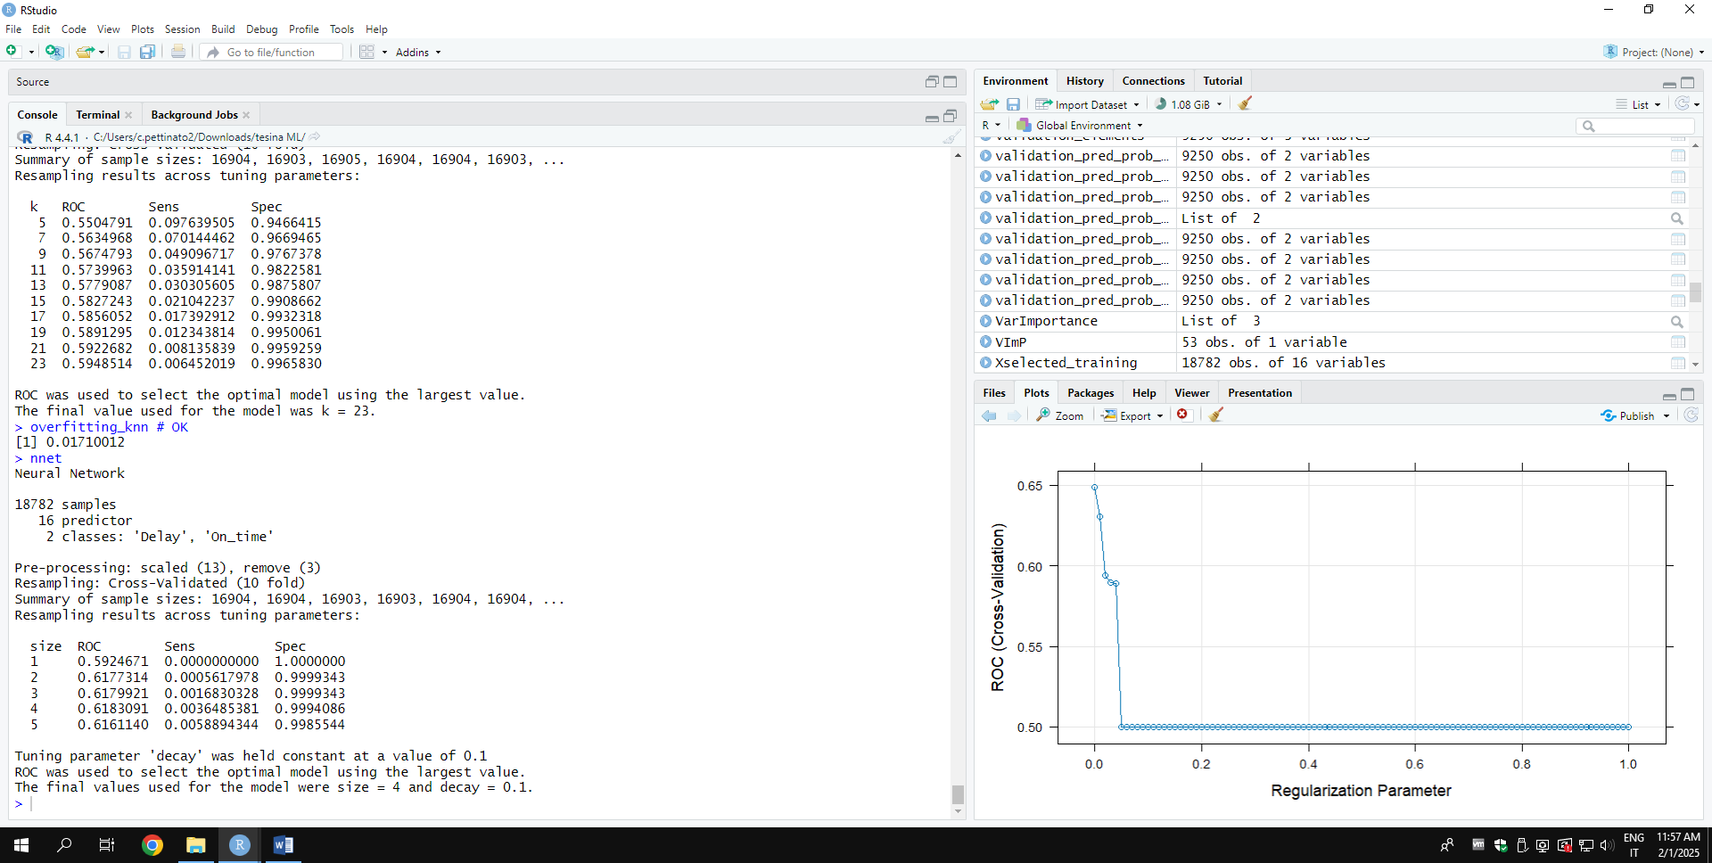
Neural Network converges
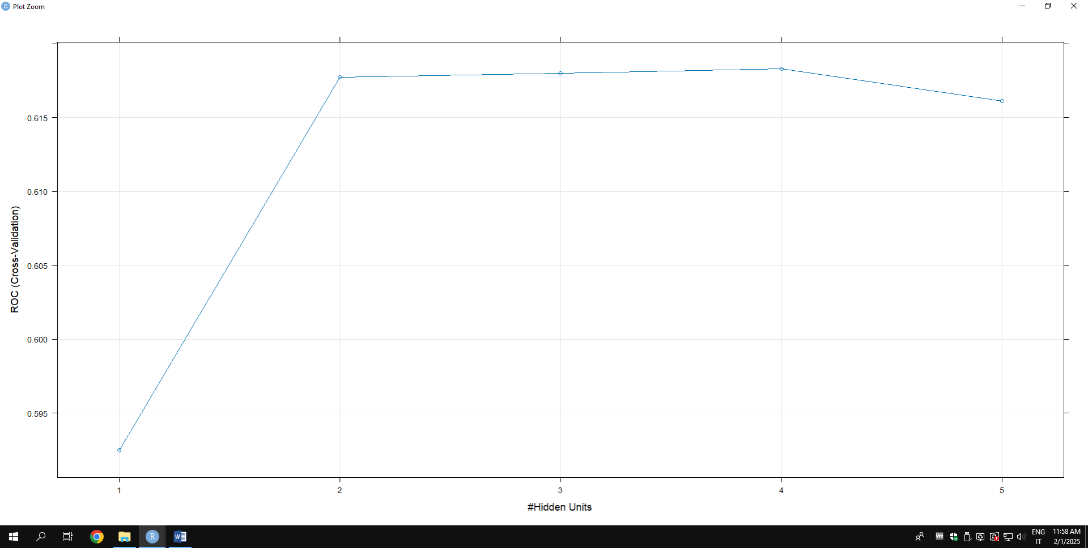
Neural Network Overfitting: 0.0008173618

STEP 2: ASSESSMENT

ROC Curves
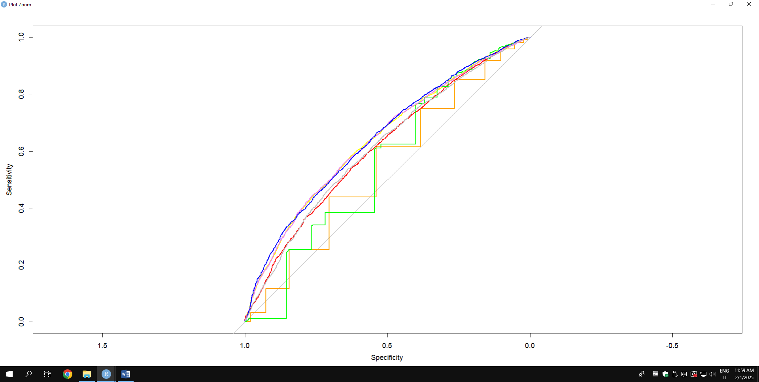
Key:
- Orange: Nearest Neighbor;
- Red: Pls;
- Yellow: Lasso;
- Green: Decision Tree;
- Pink: Glm;
- Blue: Naive Bayes;
- Grey: Neural Network.

AUC
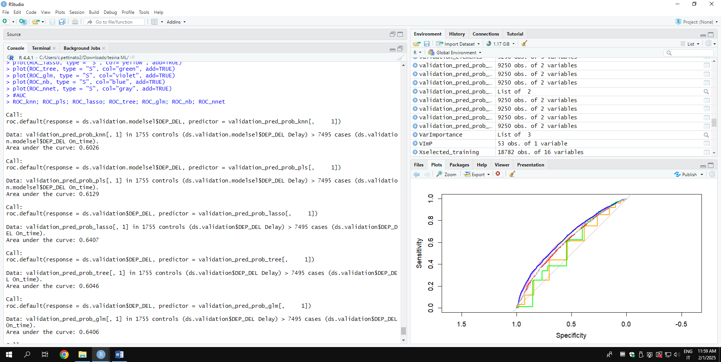
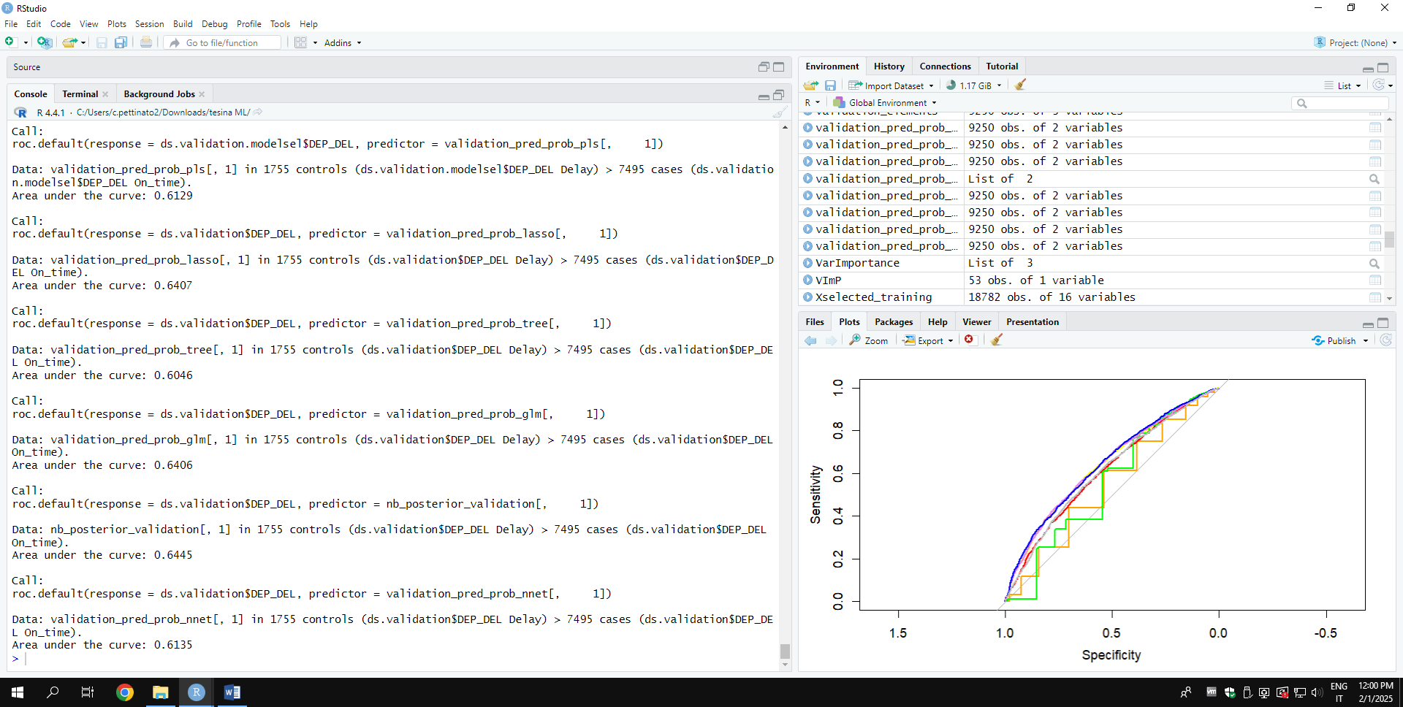
Based on the ROC curves and AUCs, the best models are Naive Bayes and glm. However, since their respective ROC curves intersect, lift curves were also constructed for these two models.

Lift Curves

Naive Bayes
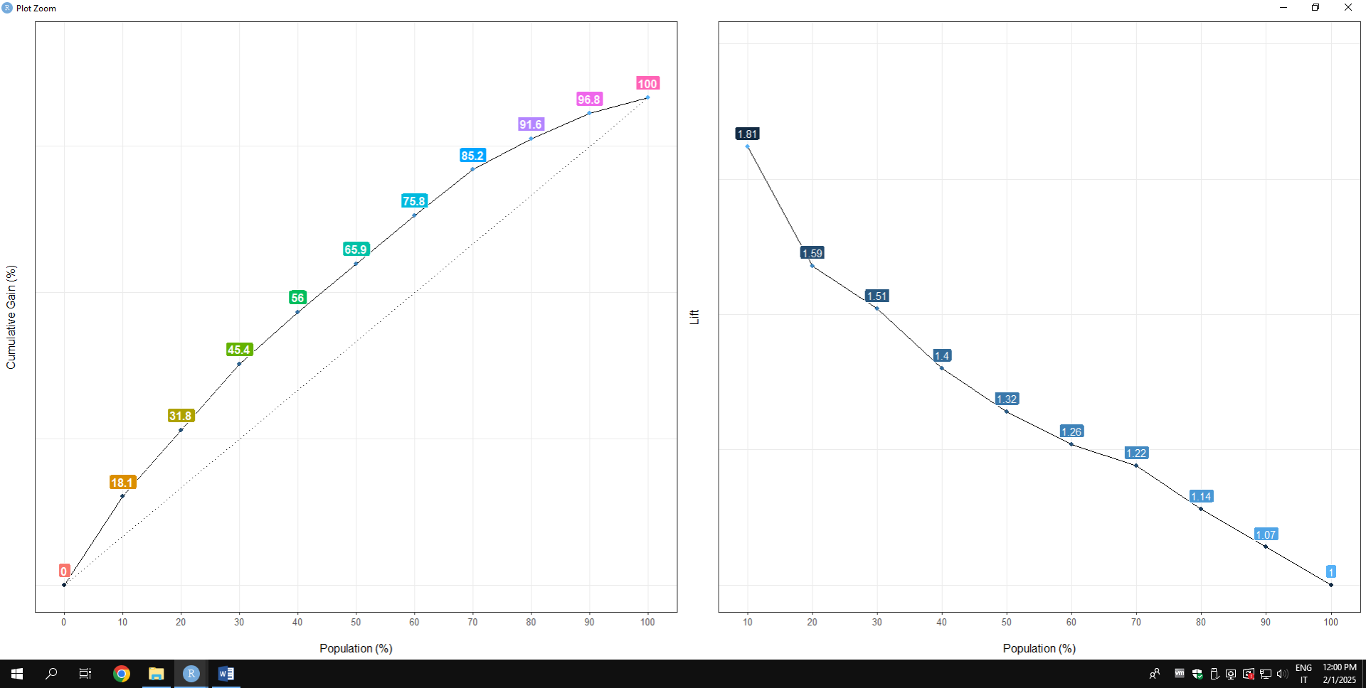

Glm
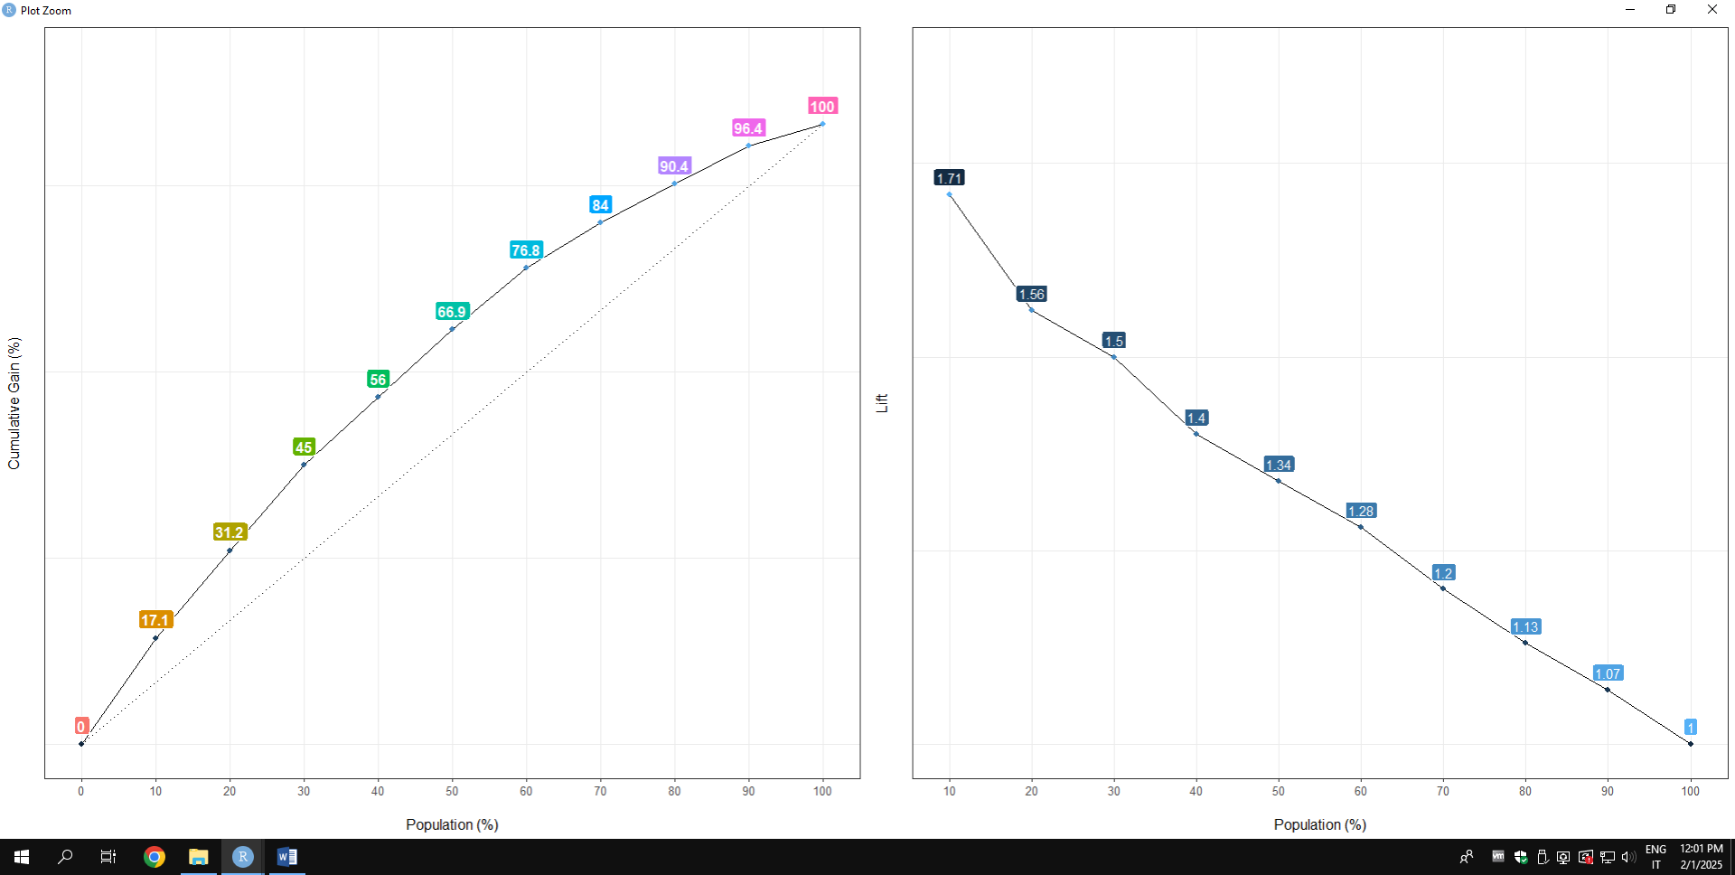
The winning model is Naive Bayes, because it correctly predicts a a higher percentage of delayed flights in the top deciles of the population.
STEP 3: threshold tuning
For threshold tuning, sensitivity was chosen as the metric, since the goal of the analysis is to correctly classify delayed flights, which represent the positive class of the target. Therefore, the event correct classification rate is the most appropriate metric for this purpose.

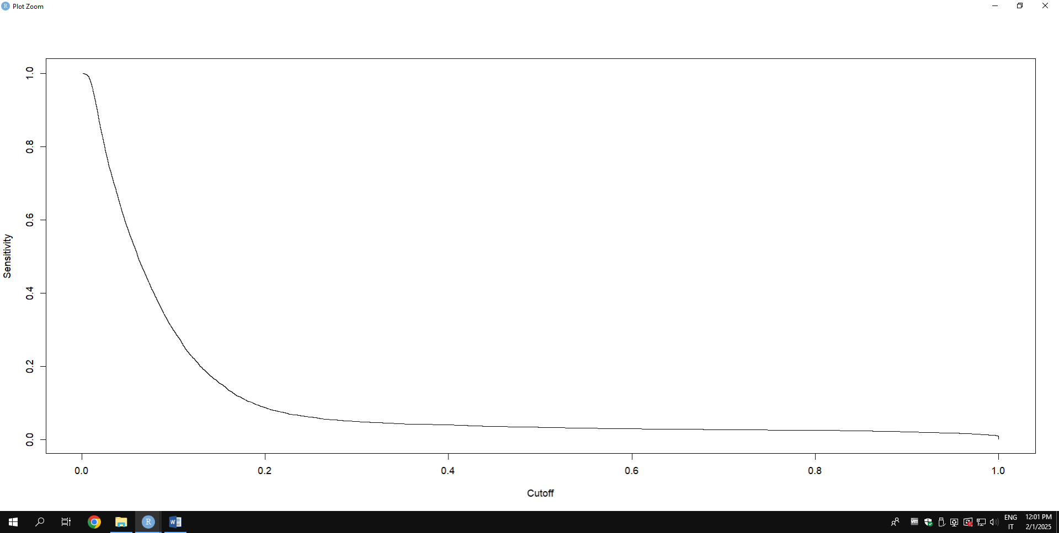

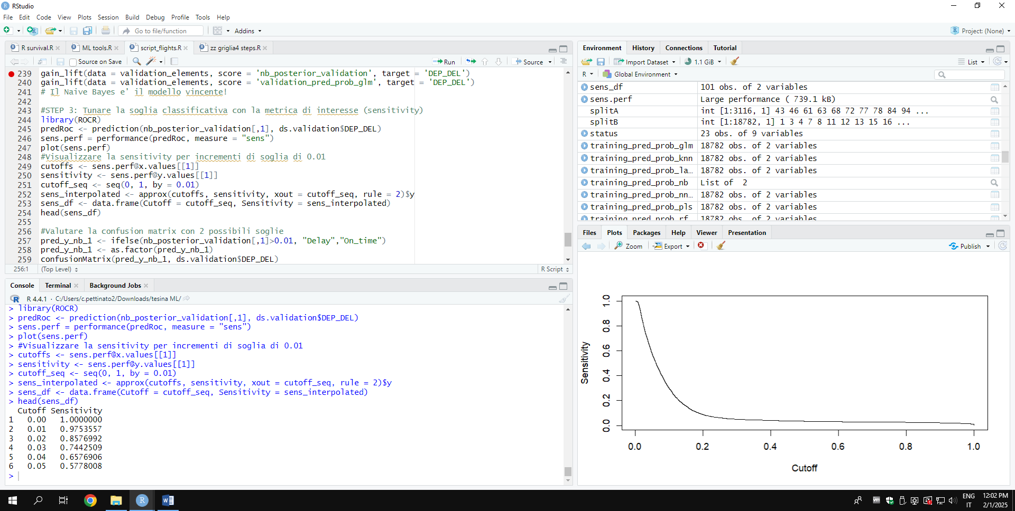

The threshold of 0.01 was chosen because, as can be seen from the graph and the performance results, a higher threshold would have caused the sensitivity to drop too sharply (from 0.97 to 0.86).

Final Model Confusion matrix (on validation set)
Once we use the threshold previously evaluated, as can be seen from the confusion matrix, the model has very high sensitivity; in fact, out of a total of 1755 delayed flights, only 18 cases were not correctly classified.

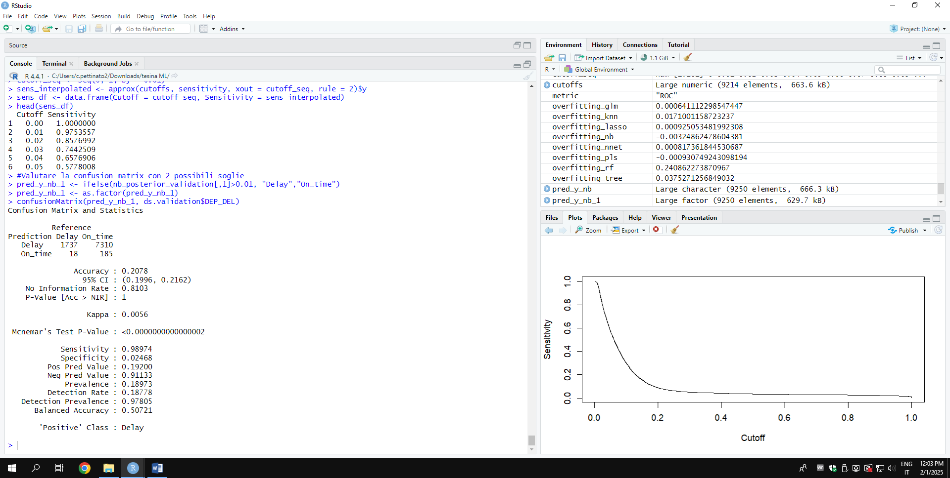

STEP 4: Predict the target based on new data
Here, the winning model (Naive Bayes) and the threshold determined in step 3 were applied to predict the target on the score dataset.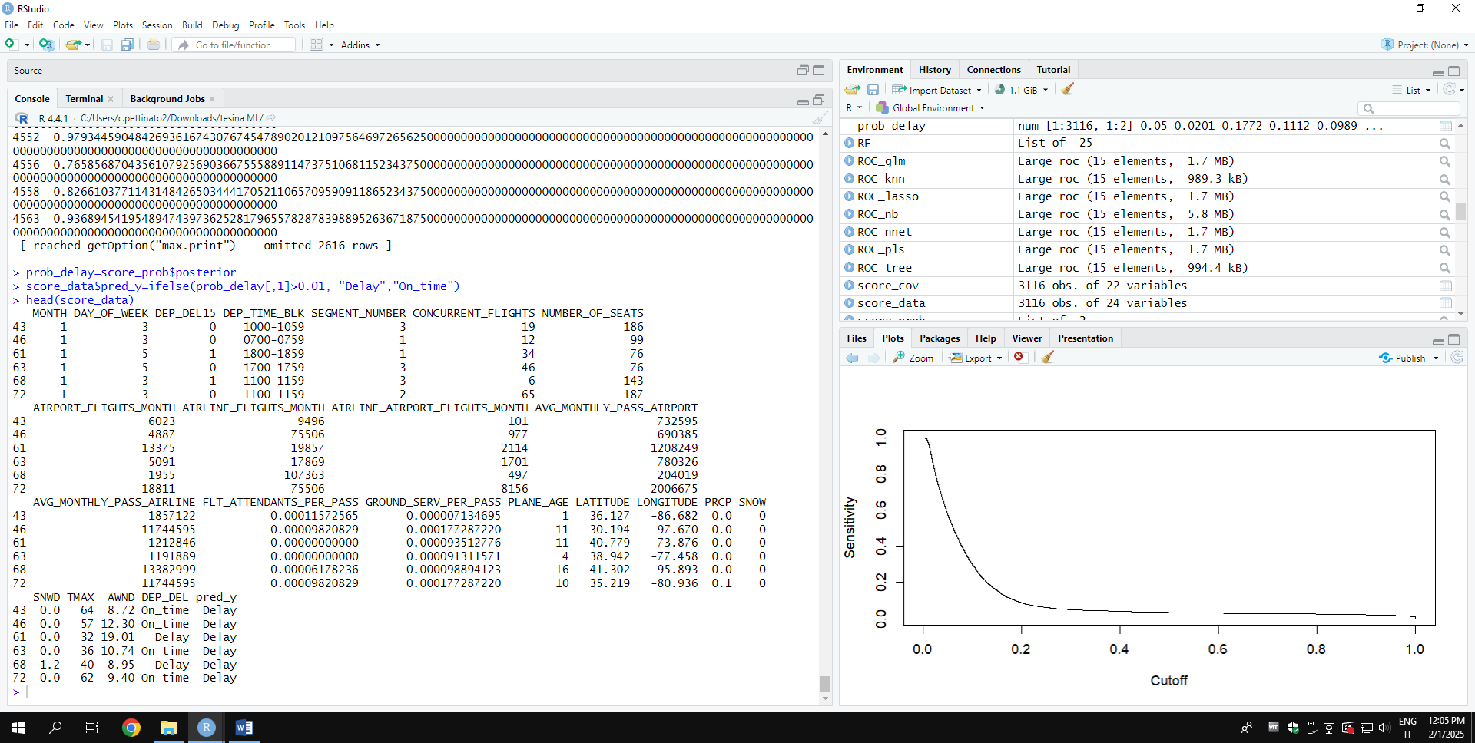

The confusion matrix for the score dataset shows that the model correctly classifies delayed flights, with a sensitivity of 0.9882 and only seven errors.
