Mogwai ERDesigner NG

User Documentation

About Mogwai ERDesigner NG 3
Support 4
Download and installation 4
Mogwai ERDesigner NG main screen 5
The Main menu 6
The model outline 7
The SQL preview 8
The 3D editor 9
Classpath configuration for JDBC drivers 10
Creating the first database model 11
Adding tables 12
Adding relations 13
Modifying existing model objects 15
Adding views to the model 16
Adding comments to the model 17
Working with domains 18
Working with subject areas 19
DDL script generation 20
Exporting the diagram 21
Reverse engineering existing databases 22
The complete compare functionality 24
Guide to the version control tracking system 25
Using the Model Repository 27
Setting up a Model Repository connection 27
Saving a model to the Model Repository 27
Loading a model from the Model Repository 28
Generating migration scripts 28
Converting a database model 30
Creating a database documentation 31
Generating an OpenXava Application 32

About Mogwai ERDesigner NG
The Mogwai ERDesigner NG is an database modelling tool such as ERWin and co. The only difference is that it is Open Source and does not cost anything. It was designed to make database modelling as easy as it can be and to support the developer in the whole development process, from database design to schema and code generation. This tool was also designed to support a flexible plug in architecture, to extend the system simply by installing a new plug in. This way, everybody can implement new features and tools to make Mogwai ERDesigner NG fit the requirements.

Mogwai ERDesigner NG has the following key features:

- is based on Java and therefore can run on Windows, Linux / Unix and MacOS
- has a powerful WYSIWYG editor for database schemas
- supports 2D and 3D editing modes
- handles Tables, Views, Indexes and Relations
- supports Subject Areas and Domains
- supports MySQL, MSSQL, Oracle, Postgres, H2 and DB2 using JDBC
- generates SQL DDL scripts for schema generation
- supports a central repository for all models ( Schema Repository )
- has an integrated version control system
- generates migration scripts for schema changes
- stores it’s model as XML files
- has an integrated reverse engineering module
- exports diagrams as GIF, PNG, JPEG and SVG files
- is based on GPL license
- has a good support by newsgroups and authors
- localisation is available in English and German

Mogwai ERDesigner NG is based on Mogwai ERDesigner. The core SQL API and the visual database editor were completely redesigned, bug fixed and enhanced to build the new Mogwai ERDesigner NG.

Support

Support is available using the project homepage and also using the provided task tracker from the SourceForge.net project site. Please submit help / feature requests or bugs to these trackers or to the project mailing lists also available using the website. Feel free to directly consult the project members for technical support and questions.

Since Mogwai ERDesigner NG is Open Source, the project lives from user feedback, so annotations, questions and remarks are very welcome!

Project homepage: http://mogwai.sourceforge.net
SF Project page: http://sourceforge.net/projects/mogwai
Mailing list: mogwai-users@lists.sourceforge.net
mogwai-developer@lists.sourceforge.net

Download and installation

Download and installation is quite easy. Please consult the Sourceforge.net project homepage and select downloads. There, you will find the distribution package of Mogwai ERDesigner NG. You will find one version for Linux/Unix operating systems in tar.gz format, and one version for Windows operating systems in .zip format.

After downloading the distribution for your operating system, you have to extract it to your hard disc. After extraction, you will find a new directory named mogwai-erdesignerng. The current version number is also added to the directory name. In this directory, you will find the following files:

run.bat Use this to start Mogwai ERDesigner NG on Windows systems
run.sh Use this to start Mogwai ERDesigner NG on Unix systems

Mogwai ERDesigner NG main screen

One you have started Mogwai ERDesigner NG, you will see a splash screen informing you that Mogwai ERDesigner NG is loading. After this short loading process, you will see the ERDesigner NG main screen:

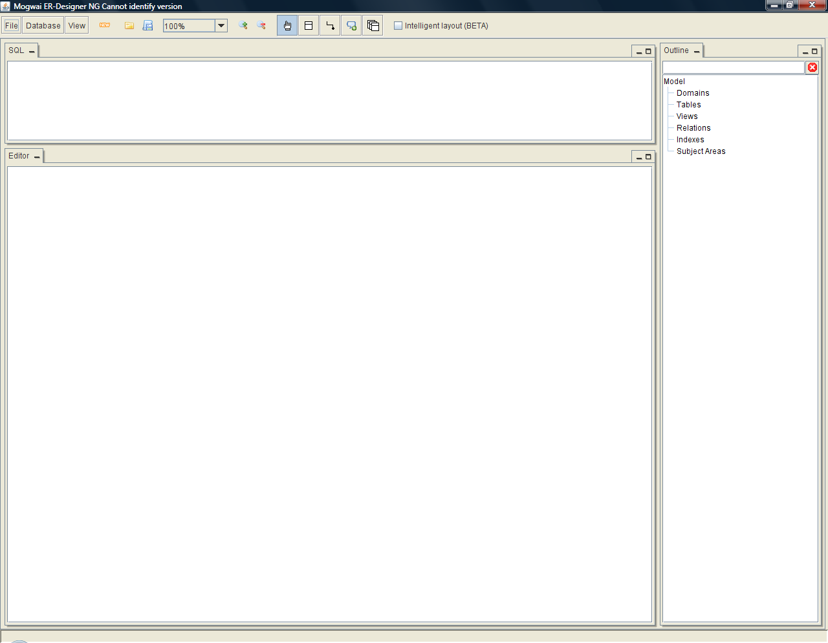
Main menu
Editing area
Model outline
SQL Preview

After the first start-up, the main screen will look like above. It is divided into tree working areas, the editing area, the model outline and the SQL preview area. The layout can be changed every time easily using drag and drop of areas to other docking positions. The layout is saved on exit, and will be restored when ERDesignerNG is restarted again.

The Main menu

Heart of ERDesigner NG is the main menu. It provides the core functionalities to the user. The layout is as follows:

The functionalities are from left to right:

File menu All functions related to saving, loading, creation and export of models
Database menu All functions related to database connection and SQL generation
View menu All functions related to zooming and graph layout
New button Short-cut for creating a new model
Load button Short-cut for loading a model
Save button Short-cut for saving a model
Zoom box Short-cut for setting the current zoom level
Zoom buttons Buttons for zooming in and zooming out
Hand button Selection tool
Table button Editing tool for tables
Relation button Editing tool for relations
Comment button Editing tool for comments
View button Editing tool for views

Intelligent Layout This enables an animated automatic layout algorithm for the current model. This feature is currently BETA!

The model outline

The model outline provides an overview about the current database model. It looks as follows:
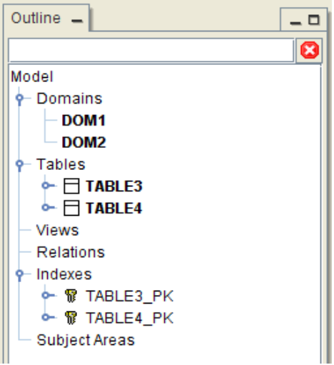
Filter expression
Model tree
The model outline shows all types of database models grouped in a model tree. You can navigate to model entries selecting them in the tree. The selected item will be focused in the editing area. If you select an entry in the editing area, it will also be selected in the model outline. There is also a quick filter available. You can filter the displayed model items by entering a filter expression here, for instance “name”. This will select all model entries, if their name or the name of one of its children matches “name*”, ignoring case. This is quite comfortable for navigation in large database models. The filter can be disabled by clicking the stop icon.

The model outline provides also a context menu for every model item. Using the context menu, model items can be edited or deleted, or the tree node just be collapsed or expanded. Give it a try!

The SQL preview

The SQL preview displays the SQL DDL code for the currently selected model item, either from the editing area or from the model outline. It looks as follows:

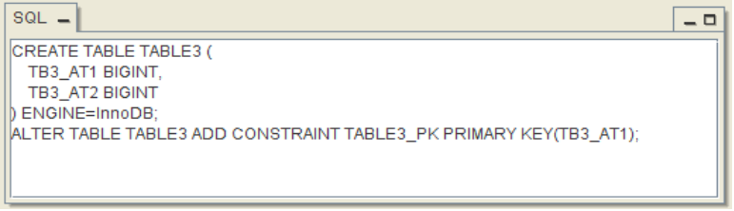
For tables, relations, indexes or views it will display the complete DDL code for the element. For attributes, it will display the DDL code to add the attribute to an existing table. For domains, it will display the code to create the domain in the database ( if the currently selected dialect supports domains, like Postgres ). If there is no DDL code available, if will display just nothing.

The 3D editor

The 3D editor allows you to navigate thru large models, show and analyze dependencies and trigger model changes. It looks as follows:

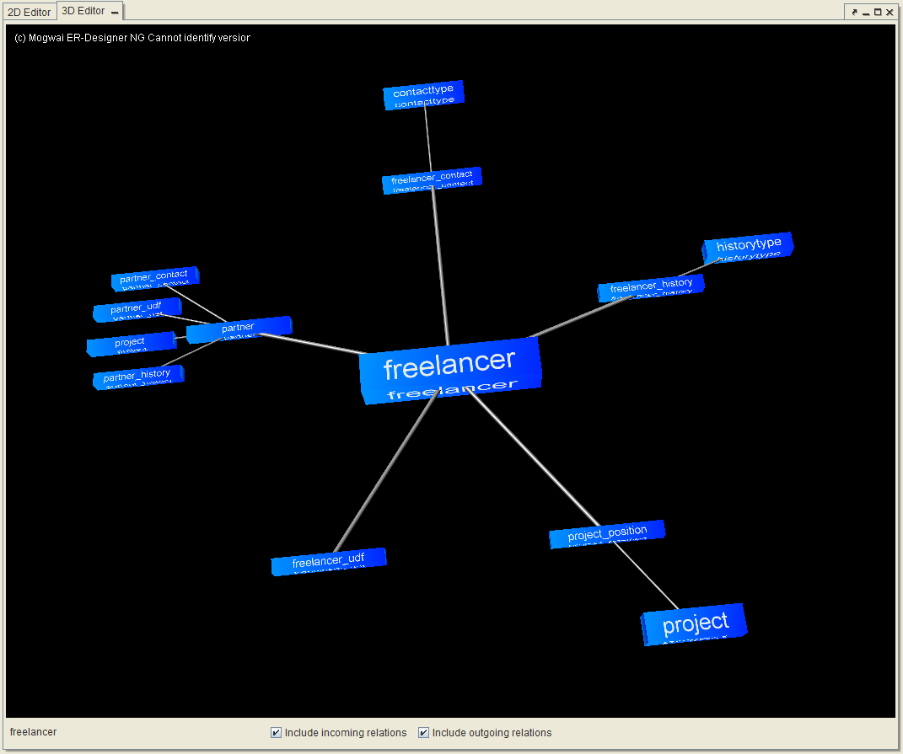
There is always one entity in the center of attention. All dependent entities are located around and are connected. The type of shown dependencies can be changed by clicking the “incoming relations” or “outgoing relations” checkboxes at the bottom. The name of the entitiy under the mouse cursor is shown at the left bottom of the screen. By clicking an entity, it is moved to the center, and the dependencies are updated. By holding the left mouse button down and moving the mouse, the whole scene can be rotated round the center. The entity editor can be triggered by double clicking on an entity.

Classpath configuration for JDBC drivers

Before you can use ERDesigner NG, you have to setup the JDBC driver Classpath. ERDesigner NG does not come with included JDBC drivers, due to license issues. You need to say ERDesigner where to find the JDBC drivers. You do so by selecting Database → Classpath from the main menu. The JDBC classpath editor dialog will be displayed:
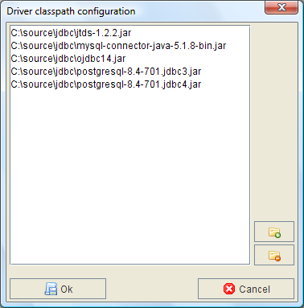
List of jar files
Add button
Remove button
Using this dialog, you can add. jar files to the classpath or remove them from the classpath. You add a file to the classpath by clicking the “Add” button. You can remove a file from the classpath by selecting the file and clicking the “Remove” button.

Creating the first database model

After you have setup the JDBC classpath configuration, you can start to create your first ERDesigner model. Please select File → New Model from the main menu. This will create an empty model.

Now, select Database → DB Connection. The database connection editor dialog will be displayed:
Dialect chooser
Connection properties
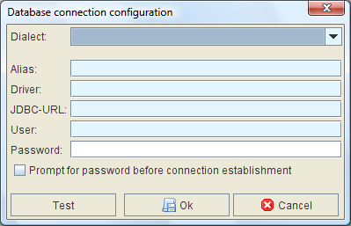
ERDesigner NG supports a rich set of different database types. These types are distinguished by their dialect. For every database, a special dialect exists. This dialect helps ERDesigner NG to create the right SQL statements for the right database, as every database vendor interprets the SQL standard differently.

Please enter the database connection properties. When you are ready, you can test the connection settings by clicking the “Test” button. ERDesigner NG will try to create a database connection. If something goes wrong, an error will be displayed. If the database connection is setup well, ERDesigner NG will display an information box informing you that everything is alright. Additionally, the current database version will be displayed to inform you about the type of database you’ve made a connection to.

Note: You do not need a working database connection to model a diagram. If you do not have the right connection properties yet, please enter dummy values.

Adding tables

After you have setup the JDBC classpath and you have created a new database model and configured the database connection, you can start to add tables to the model.

To add a table to the model, you have to select the table tool from the main menu.
Table tool

The table tool allows you to add tables to the model. Now, you have to click into the editing area. The table editor dialog will be displayed, allowing you to add attributes to the table, add indexes to the table, create a primary key, and finally to specify comments for documentation.
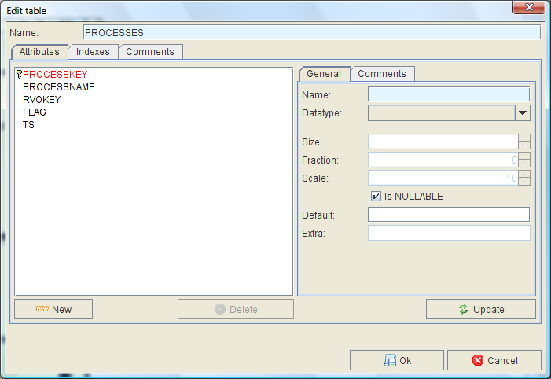
Attributes or indexes are added to the table by clicking the “New” button and specifying the necessary parameters. They can be removed from the table by selecting them from the list and clicking the “Delete” button. Attributes can be modified by selecting them from the list, modifying their parameters and clicking the “Update” button.

Adding relations

To add a relation to the model, you need to select the relation tool from the main menu:
Relation tool

Now, you need to click on the importing table, the table where the foreign key should be created. Then, keep the mouse button pressed, and drag to the exporting table, the table where the referenced data exists. Now, release the mouse button. The relation editor dialog will be displayed:
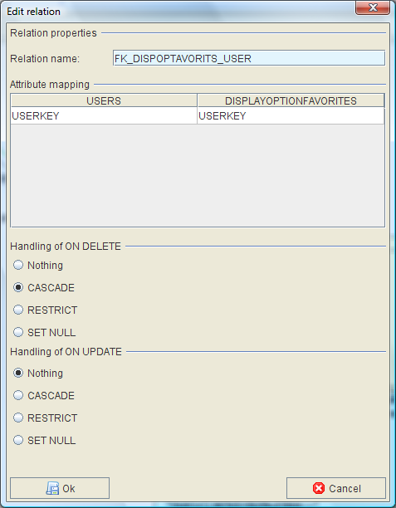
Delete and update rules
Attribute mapping
Relation name
In this dialog, you need to specify the unique relation name, and the attribute mapping fro the exporting table to the importing table. Finally, you need to specify the on delete and on update rules. After you have entered all parameters for the relation, click the “Ok” button, and the relation is added to the model.
Relations are displayed using an orthogonal layout. Sometimes, it might me necessary to add additional routing points to the relation. This can be done by holding down the ALT key and to a right mouse click to the place where you want to add the routing point. The added point can be moved to the place you want, and can also be deleted again by using the ALT key down and to a right mouse click on the existing routing point. Here is an example of an Relation with added routing points:
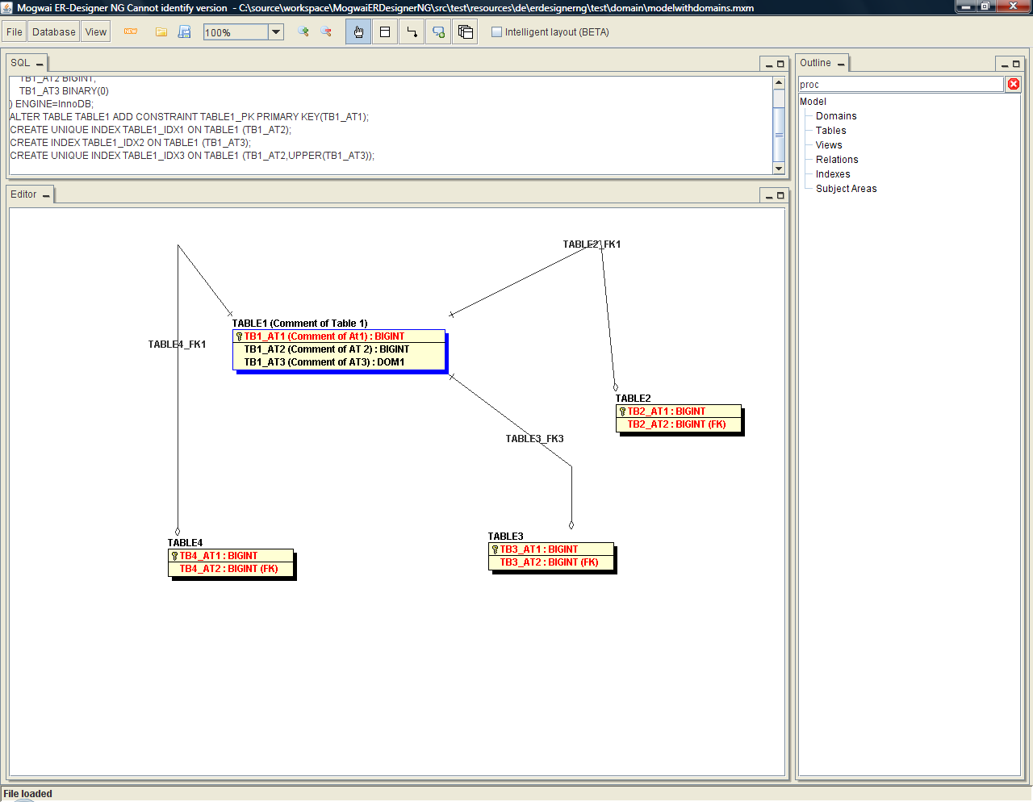
ERDesignerNG also has a build in quick table creation macro. If you drag a relation from an existing table to an empty place, ERDesignerNG will show you a context menu. Here you can select if you want to create a new child or a new parent table here and connect it with a relation to the existing table. If you chose a menu entry, the table editor will be displayed. Now you can design the new table. After you have finished with the ok button, the relation editor will be displayed. Here you can specify the attribute mapping for the new relation.

Modifying existing model objects

To modify an existent model object, you need to select it. To select an object, you have to select the hand tool from the toolbar.
Hand
tool

Now, click on the object you want to modify. It will get a blue border. Now, you can drag and drop if over the editing area to change its location. You can edit an existent object by double clicking it. The editing dialog will appear and you can change the object as you wish. You can also delete an object from the model. You do so by selecting the object, and to a right click on it. A context menu will appear. Here, you select “delete”. A confirmation dialog will be displayed, After you confirm the deletion with yes, the object will be permanently removed from the model.

Additionally, you can select multiple objects by selecting the hand tool clicking the left mouse button, select an area from the editing area, and release the left mouse button. All objects within this area will be selected. You can also add or remove objects to and from the current selection by keeping the left shift key pressed and click with the left mouse button, or keep the left CTRL key pressed and click with the left mouse button.

Adding views to the model

ERDesignerNG supports views. To add a view to the model, you have to select the view tool from the main menu, and click at the place where you want to add the new view:
View
tool

The view editor will appear. Now, you can enter the view definition.

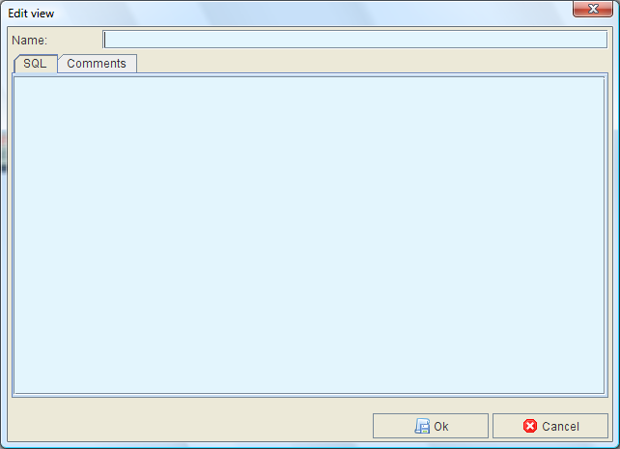
The view will be added to the model after you have clicked the “Ok” button. You can edit existing views by selecting the hand tool from the toolbar and clicking at the view.

Adding comments to the model

In some situations, you might want to add additional comments beside model elements. You can easily add comments to the model by selecting the comment tool from the toolbar, and click inside the model.
Comment
tool

The comment editor will appear. Now, you can enter your model comments.
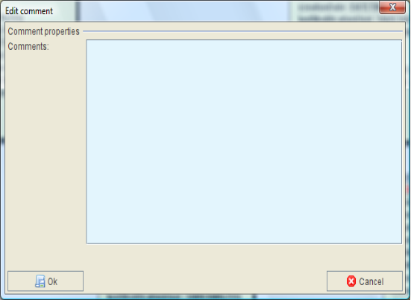
The comment will be added to the model after you have clicked the “Ok” button. You can edit existing comments by selecting the hand tool from the toolbar, and clicking at the comment.

Working with domains

Mogwai ERDesignerNG supports domains. A domain is a kind of logical datatype. For instance, if you want to model multiple tables with the same attribute like surname, and you want do make sure that every surname has the same datatype, you can define a domain called surname, and assign the datatype to this domain, varchar(20) for instance. Now, you can assign the domain to the attributes of the tables, and ERDesignerNG will take care of the correct datatype.

The domain editor can be started by selecting Database → Domain Editor from the main menu. The domain editor will appear.
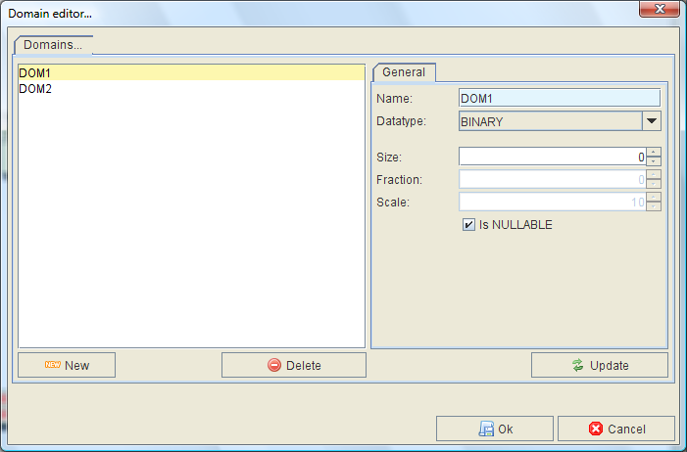
Defined Domains
Domain definition
After you have confirmed the Domain definition, you have to click the “Ok” button. Now, you can select the domain in the table attribute definition:
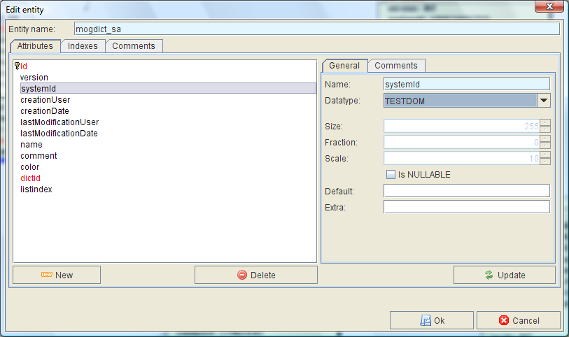
New Domain

Working with subject areas

Logically related tables or views can be grouped to units. These units are called subject areas. Building a subject area has no affect on SQL generation. They are only to form the logical part of the model and to make your model look fancier.

To add a subject area to the model, you have to select the tables you want to add. To do so, use the hand tool for table selection. After you have selected some tables, do a right click on the editing area. A context menu will be displayed. Here, you have to select the “add to subject area” function. After clicking this menu item, the selected tables will be added to a new subject area. Please note that a table can only be part of one subject area.
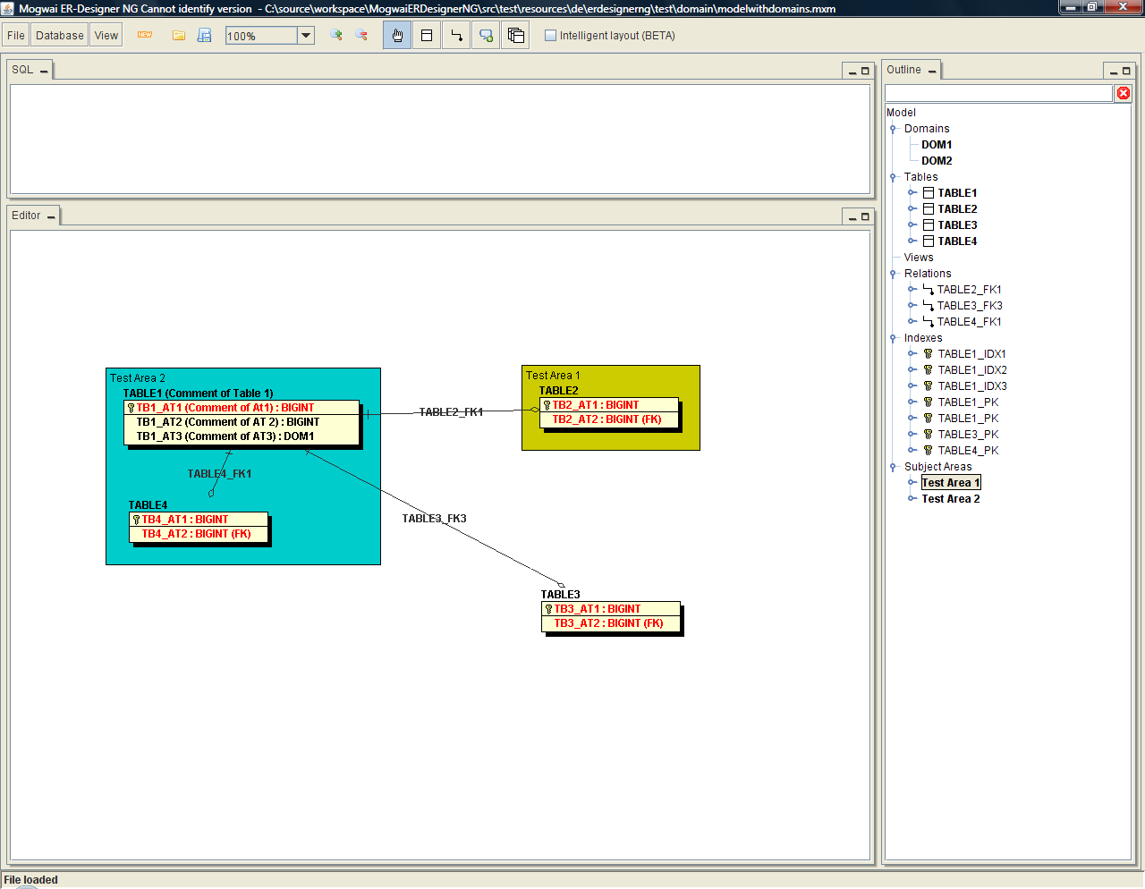
Tables can also be added to a subject area by dragging them into the area. They can be removed from a subject area by dragging them out of the area. If a subject area does not contain tables anymore, it will be deleted from the model. Subject areas can also be edited. You can edit a subject area by doing a double click on the subject area surface. The subject area editor will be displayed. Here, you can change the subject area properties and confirm your changes.
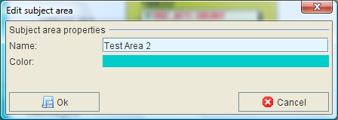

DDL script generation

Heart of Mogwai ERDesigner NG is the SQL DDL script generation module. Using this module, you can easily create the SQL statements for the current database model. The SQL statements will be optimized for the current database dialect (the dialect you have chosen when you have setup the database connection).

To create a DDL script for the current model, select Database → Create DDL for model from the main menu. The DDL SQL dialog will be displayed:
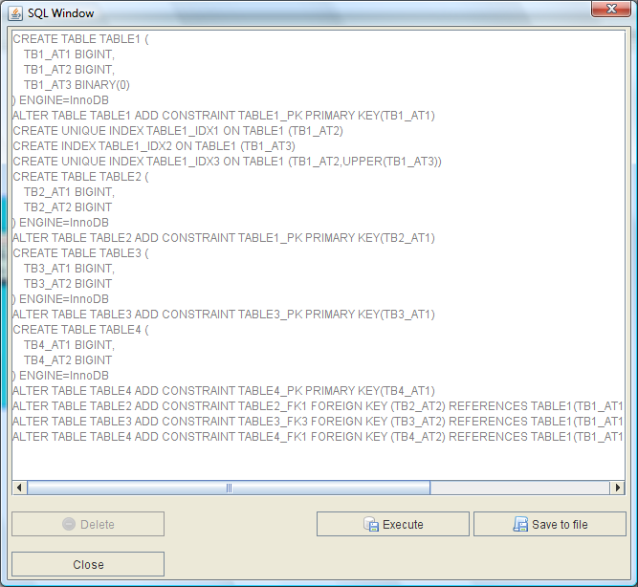
Now, you can save the generated statements to disc. Of course, you can also send them directly to the current database connection for execution. Statements you don’t want to be executed can be removed. Creating a full functional database creation SQL file is quite easy with this functionality!

Exporting the diagram

The current database diagram can be exported in various output formats. Currently, Mogwai ERDesigner NG supports the following formats:

- .MXM File : The core database model in XML notation (Mogwai format)
- .PNG file
- .BMP file
- .GIF file
- .SVG file

For every export, there are two operating modes. On mode is to export the whole model to the destination format, and one mode to export every table to a single file of the desired format.

You can start to export the current model to file by selecting File → Export as. Now, you have to select the item corresponding to the export format, and finally, select “All in one file”, or “One file per table”. After you have clicked the menu item of your choice, the “Save as” dialog will appear. Here, you have to select the target directory in one file per table mode, or the target file name in all on one file mode. If you export the model in one file per table mode, the files will be named by their tables, e.g. if the table is named “DATA” and you export it as a .PNG file, the file will be named “DATA.png”.

Reverse engineering existing databases

Mogwai ERDesigner NG can also reverse engineer existing databases. To reverse engineer a database, you need a working database connection. Now, you have to select Database → Reverse engineer from the main menu. The reverse engineering dialog will be displayed:
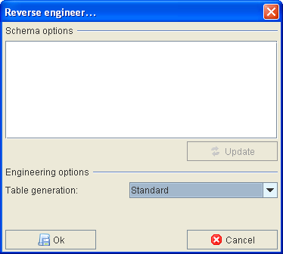
If the current database dialect supports schemas, you have to select a database schema you want to reverse engineer. Click the “Update” button, and select one ore more schemas. If the current dialect does not support schemas, just select the standard table generation engineering method and click the “Ok” button. Now, you have to select the tables and views you want to reverse engineer. The table selection dialog will be displayed:
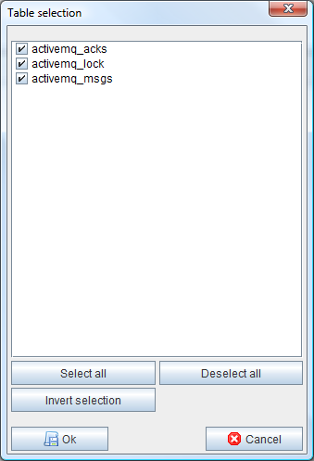
By default, all available tables are selected. If you don’t want to reverse engineer some tables, just deselect them. When you are ready, click the “Ok” button, and the reverse engineering process will start. The reverse engineering process will run in three steps. The first step is to add the tables to the model. The second step is to add indexes and primary keys to the tables. The third and last step is to add the relations and foreign keys to the reverse engineered tables.

The complete compare functionality

Mogwai ERDesigner NG has a build in complete compare functionality. Using this functionality, you can compare the current database model with an existing database. To compare the current database model, you need to specify the target connection using the database connection dialog. Of course, the target database dialect must match the database dialect used in the current model. Now, select Database → Compare with database from the main menu. ERDesigner NG will display the reverse engineering dialog. Use this dialog as described in the previous chapter of this documentation. After the reverse engineering process, ERDesigner NG will display the complete compare dialog with the comparison results:

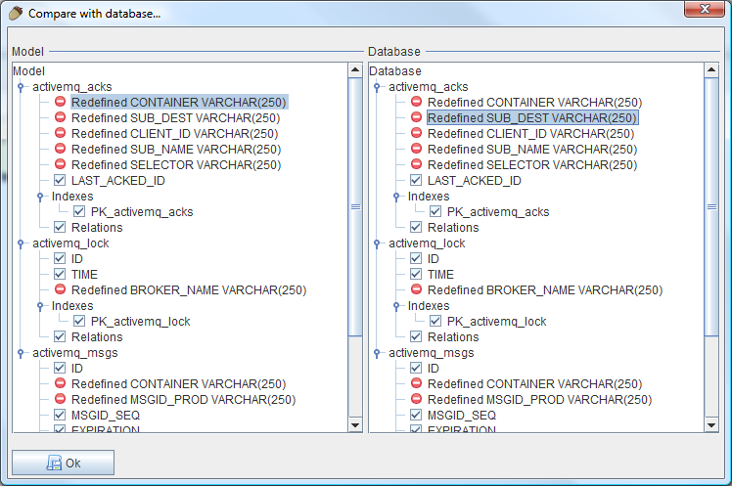
Now, you can see the differences between the model and the database. Missing or changed elements will be marked with a red icon. Using this functionality, you can easily see the difference between a model and a database!

Guide to the version control tracking system

ERDesigner NG has a build in version control tracking system. Every change you make to the database model is tracked, and corresponding SQL DDL statements are generated. These statements can be saved to disk or can be sent directly to the current database connection.

The version control tracking system has two operating modes. The first mode is the in time editing mode. Every change of the current model results in SQL statements. These statements can be seen by selecting Database → Current db changes from the main menu. The SQL editor dialog will be displayed, and the current model changes are shown as SQL files:
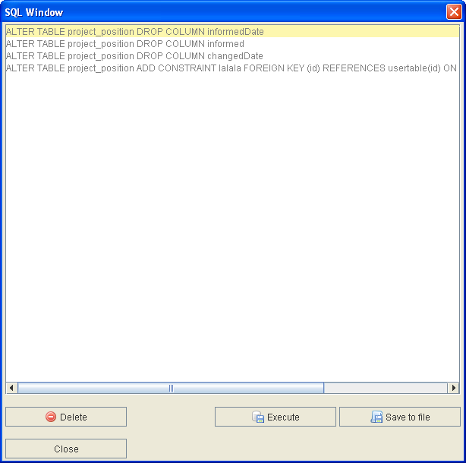
Now, you can save the current changes to disk, or you can send them directly to the current database connection.

Note: The database changes SQL dialog will always show every change you have made since you loaded the model, or the last time you saved the model to disk. When you save the model to disk, the latest db change statements are deleted.

Well, the statements are not completely deleted. The version control tracking system has a second operating mode. Every time you save the model to disk, a migration SQL DDL script is generated to migrate an existing database from the state when it was loaded to the state when it is saved. And you can guess: the content of this migration file is the content of the current db changes dialog. So, the statements are saved to disk (with a timestamp appended to the model file name, and with the .SQL extension), and then they are deleted.

Mogwai ERDesigner NG will also make a backup of an existing model before it is overwritten. Using these backup files, you can easily go back to a prior version of your model. And with the generated migration files, it is quite easy to migrate an existing database to another version!

Using the Model Repository

Mogwai ERDesigner NG as a build in Model Repository support. Using this feature, multiple models can be stored in the single repository. This repository is stored in a SQL database, and enables ERDesignerNG for future multi user support and better audit trails. Model information are stored in special tables with audit trails, so for every model item is tracked who created it and who changed it the last time. Model changes are also stored in this central repository, supporting you to create database schema migration scripts from one version of the schema to another!

Setting up a Model Repository connection

Before you can use the Model Repository, you have to specify the connection to the repository SQL server. You can specify a connection by selecting File → Repository Connection from the main menu. The well known database connection dialog will come up:
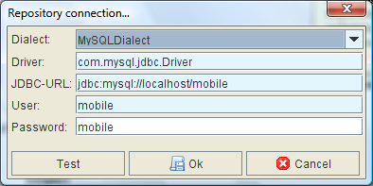
Here, you have to enter the connection parameters. When you are ready, you can test the settings by clicking the “Test” button. The connection parameters are saved after you have clicked the “Ok” button.

Saving a model to the Model Repository

A model can easily be saved to the Model Repository. After you have specified a connection to the repository, and then you have to select File → Save model to repository. The save model to repository dialog will appear:
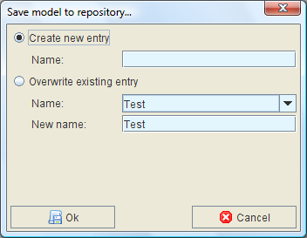
Here, you have the option to create a new entry in the Model Repository, or the option to overwrite an existing entry, and additionally give it a new name. After you have chosen the option of your choice, and entered the parameters like entry name, you have to click the “Ok” button. Then, the current model will be saved to the Model Repository.

Loading a model from the Model Repository

A model can be easily loaded from the Model Repository. You have to select File → Load model from repository. The load model dialog will be displayed:
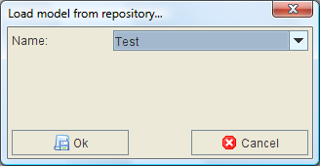
Here, you have to select an existing repository entry. After you have clicked the “Ok” button, the model is loaded from the repository and is displayed in the editor.

Generating migration scripts

Sometimes, you might want to create a script to migrate from one version of the model to another version. This can easily be done using the Model Repository. First of all, you have to load an existing model into the editor using the load model from repository functionality. Now, the menu item File → Repository utilities → Create migration script is enabled. Click this menu item. The migration script dialog will be displayed:
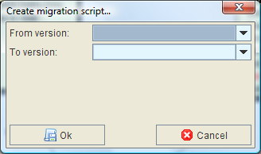
Here, you have to select the source version, and the target version. After you have clicked the “Ok” button, the SQL window is displayed. Here, you can send the SQL statements to the current database connection, or you can just save them to file.

Converting a database model

Mogwai ERDesignerNG help you to convert an existing database model to another Dialect. Using this functionality, you can reverse engineer an existing database, and convert it to another database type, like from Oracle to MySQL. To start the database conversion, you have to select Database → Convert Model from the main menu. The database conversion dialog will be displayed:
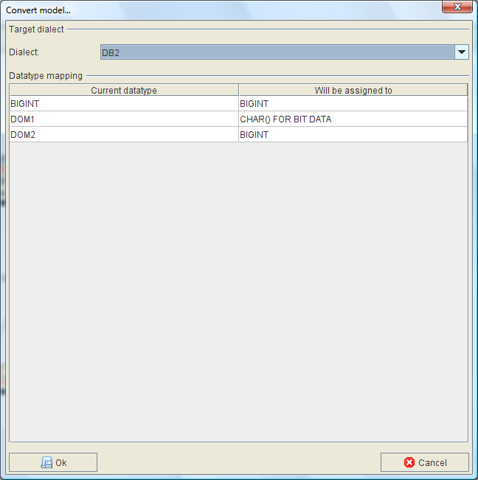
Here, you have to select the target dialect, and you have to specify the datatype mapping. By default, the model converter tries to find the corresponding datatype in the target dialect based on the JDBC datatype, but the default can of course be overridden. After the datatype mapping is done, click the “Ok” button, and the current database model including the schema and domain specification is converted to the new dialect.

Creating a database documentation

Mogwai ERDesignerNG has a built in model documentation functionality based on JasperReports. Using this functionality, reports can be generated in different formats, like HTML, PDF, RTF and others. ERDesignerNG comes with a set of sample reports, but can easily be extended with custom report templates. Templates can be added or modified using the JasperReports iReport editor. Templates are stored in the “reports” directory of the ERDesignerNG distribution. A model documentation can be generated by selecting Database → Create database Documentation → <The report you want to have> from the main menu. The report is generated and the report viewer is started. The following screen will be displayed:

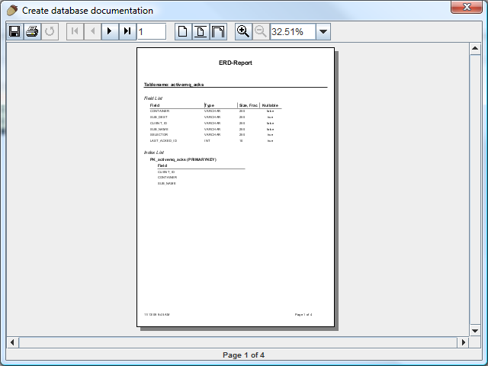
Now, the report can be read, and saved in the format you want to have. By default, the following formats are supported: PDF, RTF, ODT, HTML, XLS and CSV. Reports can also directly be printed using this screen. For more information about report design and JasperReports, please visit the following site:

http://jasperforge.org/plugins/project/project_home.php?group_id=83

Generating an OpenXava Application

Mogwai ERDesignerNG help to to create an OpenXava application for the loaded datamodel. OpenXava is a rapid application development framework based on Java and the concept of Nacked Objects. To start the OpenXava generator, Select File → Export → OpenXava export from the main menu. The OpenXava export dialog will be shown:
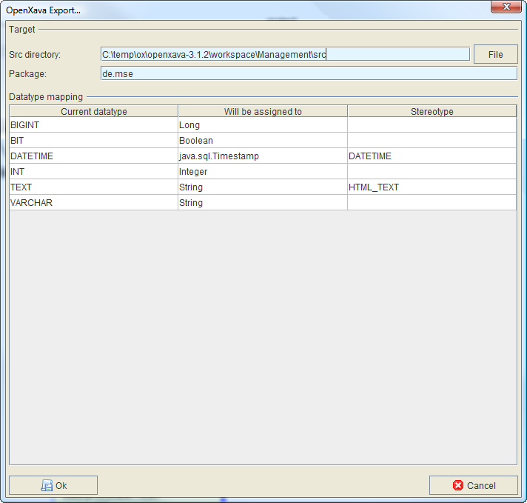
Here we can specify the SQL Datatype to Java Typemapping. Also, the OpenXava Stereotype can be specified, but it is optional. After entering the base directory for the Java source files and the package name, we can start the code generation process by clicking the “Ok” Button. Mogwai ERDesignerNG will generate the corresponding Java files. It is also possible to change the Java files after generation, and do a generation again. ERDesignerNG supports round trip engineering!

Now, the OpenXava files can be edited in your favorite IDE and the application can be deployed to Tomcat or a Portal server.
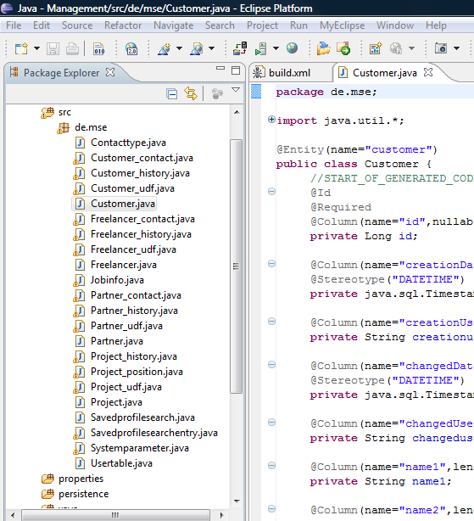
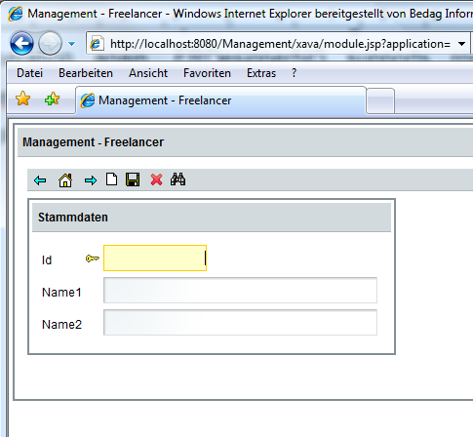
For more information about Nacked Objects and OpenXava, please visit the following site:
http://www.openxava.org

