# Lab Exercise: SQL Server Installation

This document is a walkthrough through the process of **installing and configuring MS SQL Server 2014 LocalDB and Microsoft SQL Server Management Studio** for **Windows 7 or XP**.

If you are using **Windows 8** or **later**, you should check the **other lab** for **SQL Server 2016**. After following all steps you will have fully installed and configured MSSQL and SSMS.

|  |
| --- |
| Install the older SQL Server 2014 **only on old Windows** that does not support the latest 2016 version!  If you use Windows 8 or later, use SQL Server 2016 (see the other lab). |

## Check If You Have LocalDB Already Installed

Open the command prompt (cmd.exe) and run the following command from the console:

|  |
| --- |
| **sqllocaldb versions** |

This command will show you the versions of **LocalDB** that you have already installed:

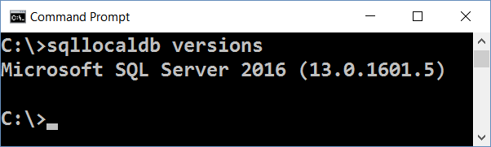

In most cases when you install Visual Studio, it silently installs SQL Server LocalDB as well. The LocalDB version depends on the Visual Studio version. You might have or not have SQL LocalDB.

If you **do not have LocalDB installed**, an **error** like this will be shown:

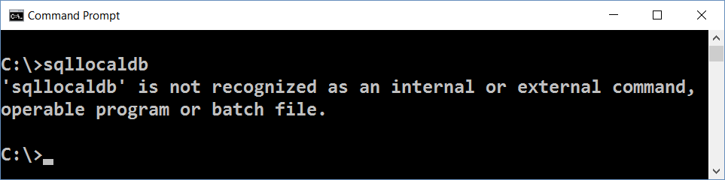

Now you can list the available **LocalDB instances** with this command:

|  |
| --- |
| **sqllocaldb info** |

The **result** should be like at the example below. The list of LocalDB instances could vary depending on your installed software and instances created during the time:

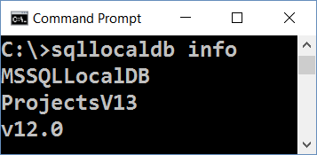

Finally, you can **check the version** and other info for certain instance:

|  |
| --- |
| **sqllocaldb info MSSQLLocalDB** |

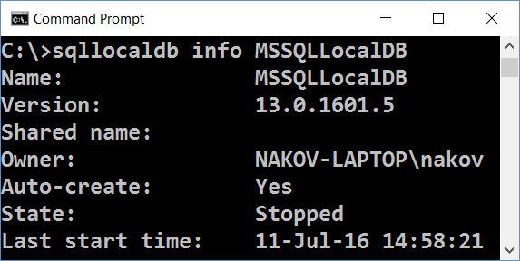

If you have LocalDB installed, skip to SQL Server installation steps. You **don’t need** to install MS SQL Server.

Note that you might have different **versions** of LocalDB in the same time:

* 13.0 means SQL Server 2016
* 12.0 means SQL Server 2014
* 11.0 means SQL Server 2012

Any of the above versions will work correctly for the SQL Server exercises.

### Important Note

|  |
| --- |
| If you **have already installed SQL Server LocalDB** (some version), **skip the download and install steps** for SQL Server LocalDB. Install only SQL Server Management Studio (SSMS). |

## Download MS SQL Server 2014 LocalDB

**Note**: install SQL Server 2014 only if you use old Windows (e.g. Windows 7 or XP) and the latest SQL Server does not support it. Otherwise install **SQL Server LocalDB 2016**.

From the **Microsoft SQL Server 2014 Express** download site download the SQLLocalDB 2014 and Management Studio 2014 installers from: <https://www.microsoft.com/en-us/download/details.aspx?id=42299>.

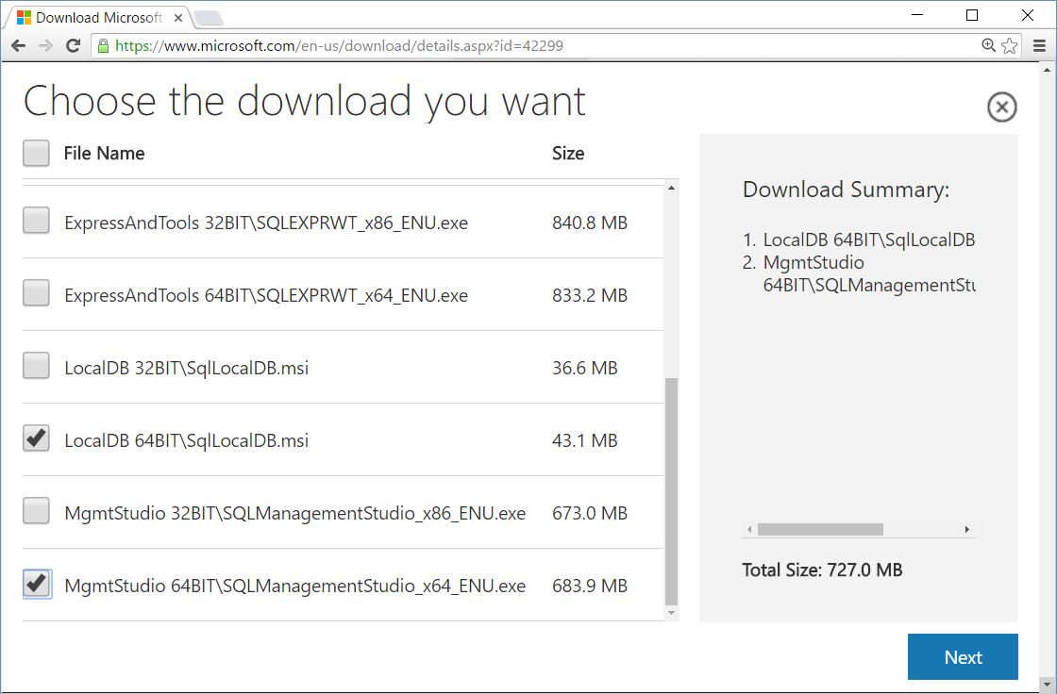

## Install MS SQL Server 2014 LocalDB

Use SQL LocalDB 2014 when you have **no LocalDB already installed** and when you use **old Windows**. [SQL Server 2014 Express LocalDB](https://www.microsoft.com/en-us/download/details.aspx?id=42299) is a lightweight **free** version of SQL Server. Install it through its installer SqlLocalDB.msi.

## Download and Install SQL Server Management Studio (SSMS)

Either install SSMS 2014 (for very old computer), or use a newer version (e.g. SSMS 2016 June 2016).

SSMS 2016 is compatible with the most Windows versions: 7, 8, 10 and later.

Download **Microsoft SQL Server Management Studio 2016** from: <https://msdn.microsoft.com/en-us/library/mt238488.aspx>. Don’t use “**SSMS July 2016**” version. It is **broken** and does not work!

The installation will start from this window:

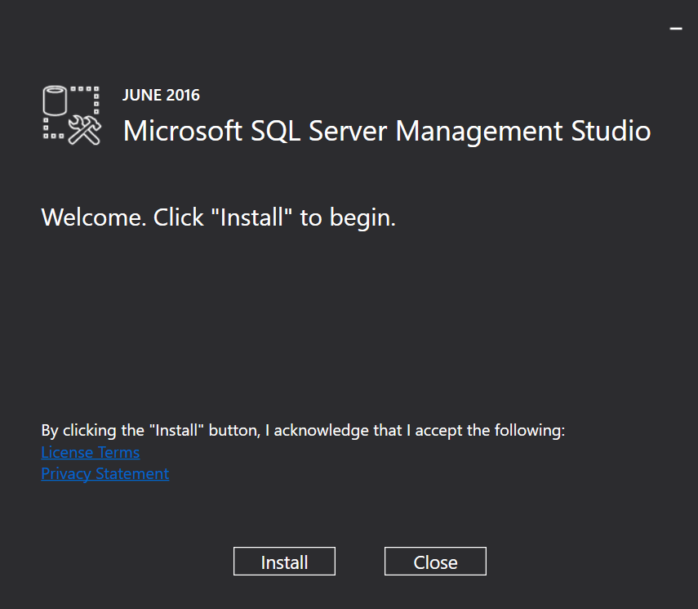

And the end result should be this:

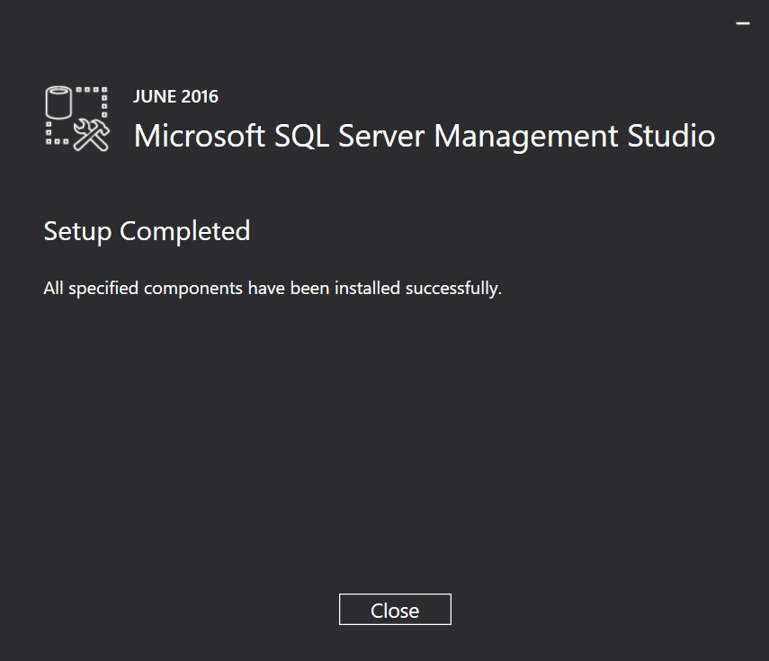

Now you should be ready to start SSMS for the first time.

## Start Management Studio (SSMS)

The first time you start Microsoft **SQL Server Management Studio**, you should see this screen:

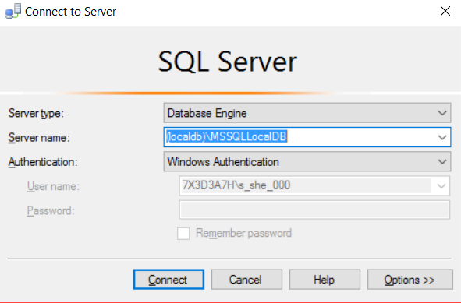

Use the following server name to connect to **MSSQLLocalDB** instance in the **LocalDB**:

|  |
| --- |
| **(localdb)\MSSQLLocalDB** |

After successful connection to the LocalDB, you should see this screen:

