PhD Tutorial: Gene Expression Analysis and Basic Bioinformatics Pipeline Using Python
Instructor: Mirna Mokhtar
Duration: 4 Days – 2 Hours per Day (8 Hours)
Level: Advanced (PhD Biotechnology)
Format: Research-Oriented Intensive Training
The complete tutorial documentation and full pipeline implementation are available at the following GitHub repository : https://github.com/mirna-git-2025/gene-expression-pipeline

Table of Contents
- Introduction and Study Objectives
- Project Architecture and Pipeline Design
- Computational Environment and Library Dependencies
- Simulation of Gene Expression Data
- Quantification of Differential Expression (Log₂ Fold Change Analysis)
- Threshold-Based Gene Filtering and Selection Criteria
- Synthetic DNA Sequence Generation
- Nucleotide Composition Analysis (GC Content)
- Pairwise Sequence Alignment and Similarity Assessment
- Phylogenetic Analysis and Tree Construction
- Master Script (Pipeline Controller)
- Data Export and Result Storage
- Integrated Results Interpretation and Biological Insights
- Limitations, Validation Strategies, and Future Extensions

1. Introduction and Study Objectives
This tutorial presents a structured and modular bioinformatics workflow designed to provide a comprehensive, PhD-level understanding of computational approaches in molecular biology. The pipeline integrates multiple analytical stages, including gene expression quantification, sequence generation, similarity assessment, and phylogenetic analysis.
The workflow includes:
- Differential gene expression analysis using log₂ fold change
- Threshold-based identification of biologically relevant genes
- Synthetic DNA sequence generation
- Nucleotide composition analysis (GC content)
- Pairwise sequence alignment
- Phylogenetic tree construction
A synthetic dataset is used to ensure a controlled computational environment, allowing clear demonstration of concepts without experimental noise.

2. Project Architecture and Pipeline Design
The pipeline is implemented using a modular architecture, reflecting best practices in computational biology and software engineering.

Project Structure
bio_pipeline/
│
├── main.py
├── data_generation.py
├── analysis.py
├── sequence_utils.py
├── alignment.py
├── phylo_tree.py
├── utils.py
└── output/

Design Principles
- Separation of concerns
- Reproducibility
- Maintainability
- Scalability for real datasets

3. Computational Environment and Library Dependencies

Tip : pip install numpy pandas matplotlib biopython
File: data_generation.py
import pandas as pd
import numpy as np
from Bio.Seq import Seq
from Bio.SeqRecord import SeqRecord
from Bio.Align import PairwiseAligner
from Bio import Phylo
from Bio.Align import MultipleSeqAlignment
from Bio.Phylo.TreeConstruction import DistanceCalculator, DistanceTreeConstructor
Explanation:
- pandas: data manipulation
- numpy: numerical computations and simulation
- BioPython: sequence handling, alignment, and phylogenetics

4. Simulation of Gene Expression Data
File: data_generation.py
import pandas as pd
import numpy as np
def generate_gene_data(n_genes=50, seed=42):
np.random.seed(seed)
return pd.DataFrame({
"Gene": [f"G{i}" for i in range(1, n_genes+1)],
"Control": np.random.poisson(lam=50, size=n_genes),
"Treatment": np.random.poisson(lam=60, size=n_genes)
})
Explanation:
- Poisson distribution simulates RNA-seq count data
- Control mean = 50, Treatment mean = 60
- Seed ensures reproducibility

5. Quantification of Differential Expression (Log₂ Fold Change Analysis)
File: analysis.py
import numpy as np
def compute_log2fc(df):
df["log2FC"] = np.log2((df["Treatment"] + 1) / (df["Control"] + 1))
return df
Explanation:
- Measures relative expression change
- +1 avoids division by zero
- Positive values indicate upregulation

6. Threshold-Based Gene Filtering and Selection Criteria
def select_genes(df, threshold=0.5):
return df[abs(df["log2FC"]) > threshold]
Explanation:
- Filters genes based on biological relevance
- Threshold commonly used in exploratory analysis
Output:
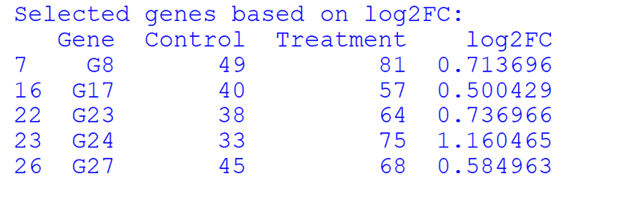

7. Synthetic DNA Sequence Generation
File: sequence_utils.py
import numpy as np
from Bio.Seq import Seq
from Bio.SeqRecord import SeqRecord
def generate_sequences(genes, length=50):
sequences = []
for gene in genes:
seq = ''.join(np.random.choice(list('ATGC'), length))
sequences.append(SeqRecord(Seq(seq), id=gene))
return sequences

Explanation:
- Generates random DNA sequences
- Each gene is assigned a synthetic sequence

8. Nucleotide Composition Analysis (GC Content)
def gc_content(record):
seq = record.seq
return (seq.count("G") + seq.count("C")) / len(seq) * 100
Explanation:
- GC% reflects nucleotide composition
- Important for stability and transcription
Output:
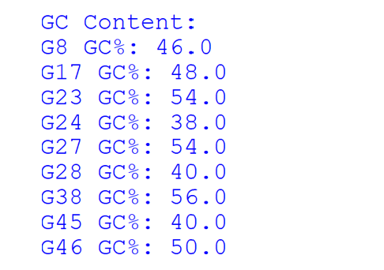

9. Pairwise Sequence Alignment and Similarity Assessment
File: alignment.py
from Bio.Align import PairwiseAligner
def pairwise_alignment(seq1, seq2):
aligner = PairwiseAligner()
return aligner.align(seq1, seq2)[0]

Explanation:
- Identifies similarity between sequences
- Detects matches, mismatches, and gaps
Output:
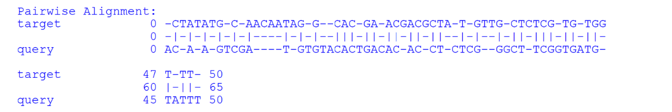

10. Phylogenetic Analysis and Tree Construction
File: phylo_tree.py
from Bio.Align import MultipleSeqAlignment
from Bio.Phylo.TreeConstruction import DistanceCalculator, DistanceTreeConstructor
def build_tree(sequences, n=5):
alignment = MultipleSeqAlignment(sequences[:n])
calculator = DistanceCalculator('identity')
dist_matrix = calculator.get_distance(alignment)
constructor = DistanceTreeConstructor()
return constructor.nj(dist_matrix)
Explanation:
- Constructs phylogenetic tree using Neighbor-Joining
- Based on sequence similarity

Output:
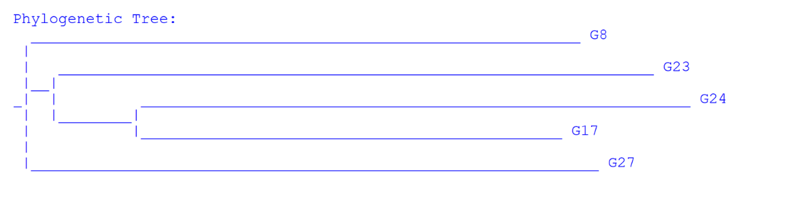

11. Master Script (Pipeline Controller)
File: main.py
from data_generation import generate_gene_data
from analysis import compute_log2fc, select_genes
from sequence_utils import generate_sequences, gc_content
from alignment import pairwise_alignment
from phylo_tree import build_tree
from Bio import Phylo
# Step 1: Generate data
gene_data = generate_gene_data()
# Step 2: Compute log2FC
gene_data = compute_log2fc(gene_data)
# Step 3: Filter genes
selected_genes = select_genes(gene_data, threshold=0.5)
print("Selected genes:")
print(selected_genes.head())
# Step 4: Generate sequences
sequences = generate_sequences(selected_genes["Gene"])
# Step 5: GC content
print("\nGC Content:")
for record in sequences:
print(record.id, round(gc_content(record), 2))
# Step 6: Pairwise alignment
if len(sequences) >= 2:
alignment = pairwise_alignment(sequences[0].seq, sequences[1].seq)
print("\nPairwise Alignment:")
print(alignment)
# Step 7: Phylogenetic tree
if len(sequences) >= 3:
tree = build_tree(sequences)
print("\nPhylogenetic Tree:")
Phylo.draw_ascii(tree)
# Step 8: Save results
gene_data.to_csv("output/gene_expression.csv", index=False)

12. Data Export and Result Storage
- Results are exported as CSV files
- Enables downstream analysis in R, Excel, or visualization tools
File : gene_expression.csv
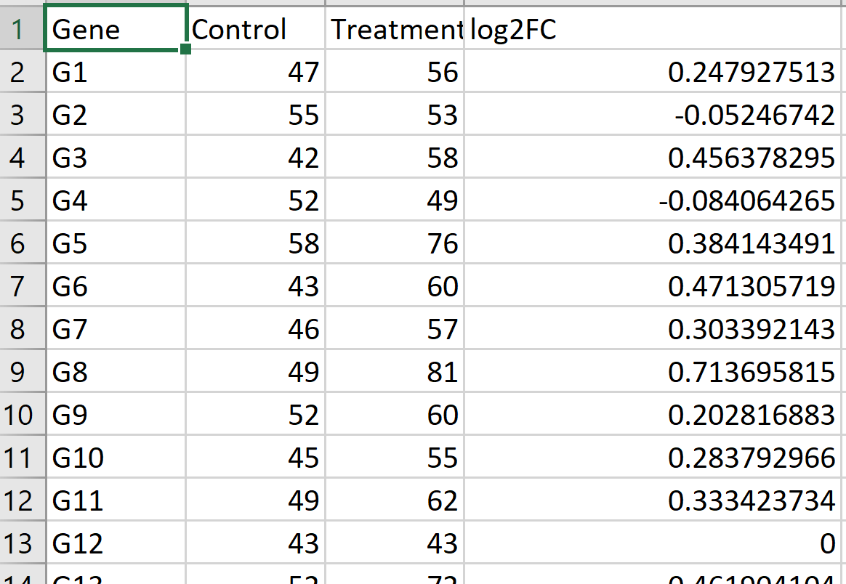

13. Integrated Results Interpretation and Biological Insights

13.1 Differential Gene Expression (log2FC Analysis)
Key Observation:
Genes were selected using a threshold of |log2FC| > 0.5, identifying those with biologically meaningful expression changes under the treatment condition.
Selected Genes (example):
- G8 (log2FC ≈ 0.71)
- G17 (log2FC ≈ 0.50)
- G23 (log2FC ≈ 0.74)
- G24 (log2FC ≈ 1.16)
- G27 (log2FC ≈ 0.58)
Interpretation:
- All selected genes are upregulated, indicating a consistent transcriptional response to the treatment.
- This suggests activation of specific biological pathways under the treatment condition.
- G24 exhibits the highest fold change and may represent a key responsive or regulatory gene.
- The relatively similar fold change values across genes may indicate coordinated regulation or shared pathway involvement.

13.2 GC Content Analysis
Observed GC Content:
- Range: 38% to 56%
- Examples:
  - G24: approximately 38% (AT-rich)
  - G23 and G27: approximately 54% (GC-rich)
Interpretation:
- Variability in GC content suggests differences in sequence composition that may influence gene behavior.
- GC-rich regions are generally more thermodynamically stable and may exhibit lower mutation rates.
- AT-rich sequences, such as G24, may facilitate easier strand separation, potentially enhancing transcription efficiency.
- These differences may reflect functional or structural diversity among the selected genes.

13.3 Pairwise Alignment Analysis
Observations:
- The alignment reveals matches, mismatches, and gaps.
- The presence of mismatches indicates sequence divergence.
- Gaps suggest insertion or deletion events (indels).
Interpretation:
- The compared sequences exhibit partial similarity, suggesting potential homology.
- This may indicate that the genes belong to the same family or share conserved domains.
- The presence of indels reflects evolutionary events that contribute to sequence variation.
- Overall, the alignment supports functional relatedness without implying complete identity.

13.4 Phylogenetic Tree Interpretation
Tree Structure Summary:
- Closest cluster: G23 and G24
- Next related: G17
- Separate branch: G27
- Most distant: G8
Evolutionary Insights:
G23 and G24
- Highly similar sequences
- Likely recently diverged from a common ancestor
- May share similar biological functions
G17
- Moderately related to G23 and G24
- Suggests divergence from a shared ancestor at an earlier stage
G27
- More distantly related
- May represent a distinct subgroup or functional category
G8
- Most divergent sequence
- May be functionally distinct or highly evolved relative to others

13.5 Integrated Biological Interpretation
Linking Expression, Sequence Composition, and Evolutionary Relationships:
- G23 and G24
  - High expression and strong sequence similarity
  - Likely represent a co-regulated gene cluster with shared biological function
- G17
  - Moderate expression and intermediate similarity
  - May be functionally related but less specialized
- G27
  - Differential expression with notable sequence divergence
  - May participate in a parallel or independent biological pathway
- G8
  - Upregulated but evolutionarily distant
  - Suggests involvement in a distinct functional mechanism

14. Limitations, Validation Strategies, and Future Extensions
Limitations:
- Synthetic data
- No statistical significance testing
- Random DNA sequences
Future Extensions:
- Integration with DESeq2 or edgeR
- Use of real RNA-seq datasets
- Multiple sequence alignment tools (MUSCLE, ClustalW)
- Maximum Likelihood phylogenetics
- Machine learning for gene classification

