**Project**: HTML  
**Editing by:** Mirna Ghayes,

Adel Gameil

**Sec:** (4)

**Doc:** Hesham Abo_ELfotoh

**Teaching Assistant:** Ahmed Fayez

**Project About**: Restaurant (retro diner)



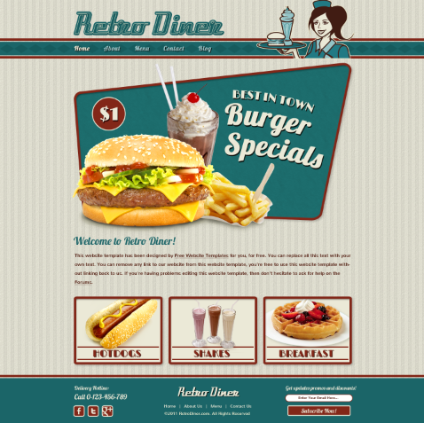  
***كود الصفحة***<!DOCTYPE html>  
<head>  
<title>Retro Diner</title>  
<meta charset="utf-8">

<link href="css/style.css" rel="stylesheet" type="text/css">

</head>

<body>

<div id="header">

<div>

<a href="index.html"><img class="logo" src="images/logo.png" width="513" height="84" alt="" title=""></a>

<a href="index.html"><img src="images/waitress.png" width="332" height="205" alt="" title=""></a>

<ul class="navigation">

<li>

<a class="active" href="index.html">Home</a>

</li>

<li>

<a href="burger.html">Menu</a>  
</li>

<li>  
<a href="Your Order.html">Your Order </a>

</li>

<li>

<a href="blog.html">Blog</a>

</li>

<li>

<a href="about.html">About</a>

</li>

</ul>

</div>

</div>

<div id="body">

<div class="featured"> <a href="burger.html"><img src="images/burger-specials.png" width="960" height="590" alt=""></a>

<h2>Welcome to Retro Diner!</h2>

<p>

Hello with you my Customer we work to make you happy ..we need you to enjoy by our services what we give you

we always make you be in good status ..we help you to eat healthy food ..and keep you fit ..we give you many and delicious favours.

</p>

<ul>

<li>

<a href="hotdog.html"><img src="images/hotdogs.jpg" width="284" height="214" alt=""></a>

</li>

<li>

<a href="shake.html"><img src="images/shakes.jpg" alt="" width="284" height="214"></a>

</li>

<li>

<a href="breakfast.html"><img src="images/breakfast.jpg" alt="" width="284" height="214"></a>

</li>  
</ul>  
</div>  
</div>  
<div id="footer">  
<div>  
<ul>  
<li class="first">  
<h2> Contact Us</h2>  
<h3>Call 0-123-456-789</h3>  
<ul>  
<li>  
<a href="https://www.facebook.com/Retro-Diner-123145751037872/" class="facebook"></a>  
</li>  
<li>

<a href="http://www.retrodiner.com/go/twitter" class="twitter"></a>

</li>

<li>

<a href="http://www.retrodiner.com/go/googleplus" class="googleplus"></a>

</li>

</ul>

</li>

<li>

<a href="index.html"><img class="logo" src="images/logo-footer.png" alt=""></a>

<ul class="navigation">

<li>

<a href="index.html">Home</a>

</li>  
<li>

<a href="menu.html">Menu</a>

</li>

<li>

<a href="Your Order.html">Your Order</a>

</li>

<li>

<a href="about.html">About Us</a>

</li>

</ul>

<span>&copy; 2023 RetroDiner.com. All Rights Reserved</span>

</li>

<li class="last">

<h2>Follow Us By Email</h2>

<form action="index.html">

<input type="text" name="subscribe" required="required"value="Enter Your Email Here...">

<input type="submit" value="">

</form>

</li>

</ul>

</div>

</div>

</body>

</html>  
<!miro>