Problem 1

1.i) Yes, binary matrix factorization can be used. Rows would be users, columns are movies, ratings can be binary where 1 means used likes the movie, 0 mean user dislikes the movie.

1.ii) Without considering the biology, binary matrix factorization can be used. Rows would be the drugs, columns are diseases. Something to consider is that the use of matrix factorization in this case makes a very strong assumption that all included diseases can be described with the same defined set of parameters, which may not be true from a biological standpoint.

2.i) Y would have dimensions n x m and the value of each entry would be represented by the r value associated with each m and n combination

ii. Intuitively, u and v represent characteristics of the users and the movies, respectively. For instance, u could numerically represent how much a user likes comedy, how much they like old movies, how much they like romantic movies .. etc. while v represents the same characteristics describing the movie: how comic a. movie is, how old it is, how romantic it is … etc. Such representations capture the parameters that help create a generalizable algorithm for capturing patterns in user preferences.

iii. This sub-problem is equivalent to linear regression. Where $θ$ in linear regression is equivalent to the u vector in matrix factorization problem.

iv.
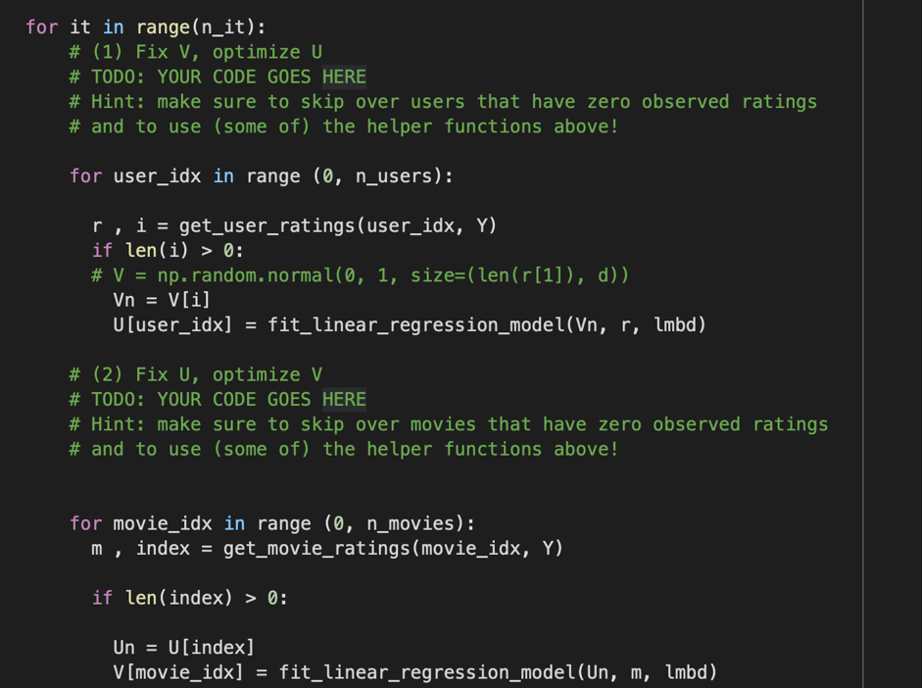

v.
train MSE for d=5 is: 0.34373457281665143
Validation MSE for d=5 is: 2.1199849137250917

train MSE for d=10 is: 0.19769303773365957
Validation MSE for d=10 is: 2.815151441660589

train MSE for d=50 is: 0.0010312698068674442
Validation MSE for d=50 is: 4.207703039604543

Increasing d leads to model overfitting due to increase in number of parameters. Model with more parameters and more likely to overfit to training data. d=5 seems to be a reasonable choice because it led to best performance of validation data. Although, a better way to ensure that d=5 is better than d=10 , since they are similar enough , is through cross-validation.

vi. i. Dimensions of W_{h} are k x number of all user-movie pairs. Dimensions of b_{h} are k x 1. Dimensions of W₀ are 1 x k. Dimensions of b₀ are 1 x 1.

$$f\left(x_{n},x_{m}\right)=W_{0}ReLU\left(W_{h}x+b_{h}\right)+b_{0}$$

ii. working with dataframes, not arrays
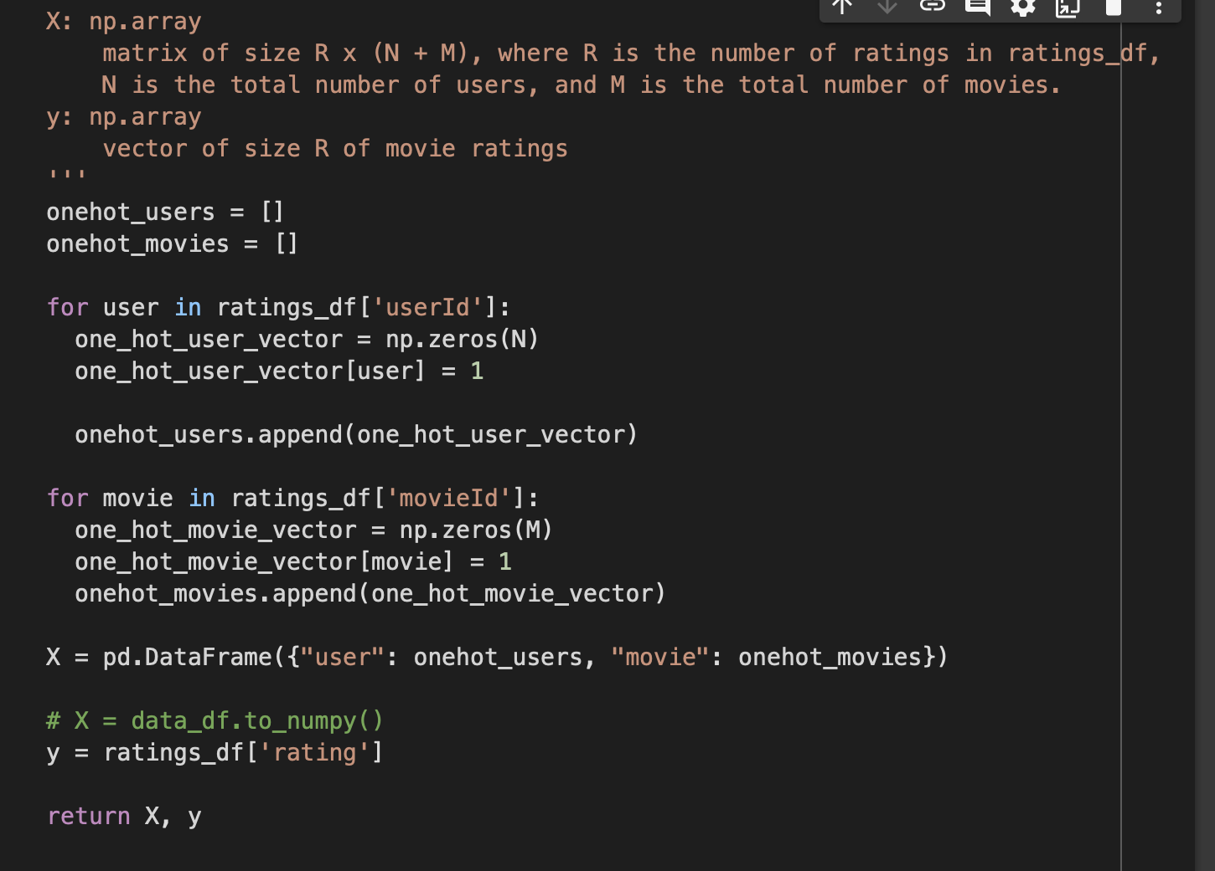
Train MSE for feature method one_hot, k=50 is: 0.7399419546127319
Validation MSE for feature method one_hot, k=50 is: 0.7948899865150452

The training and validation have very similar performances when using a NN as opposed to ALS where the MSE values were significantly different. But overall, the MSE values obtained from the NN are much smaller, indicating that a NN might be better at this task.

iii. genres can be represented using one-hot encoding , working with dataframes, not arrays
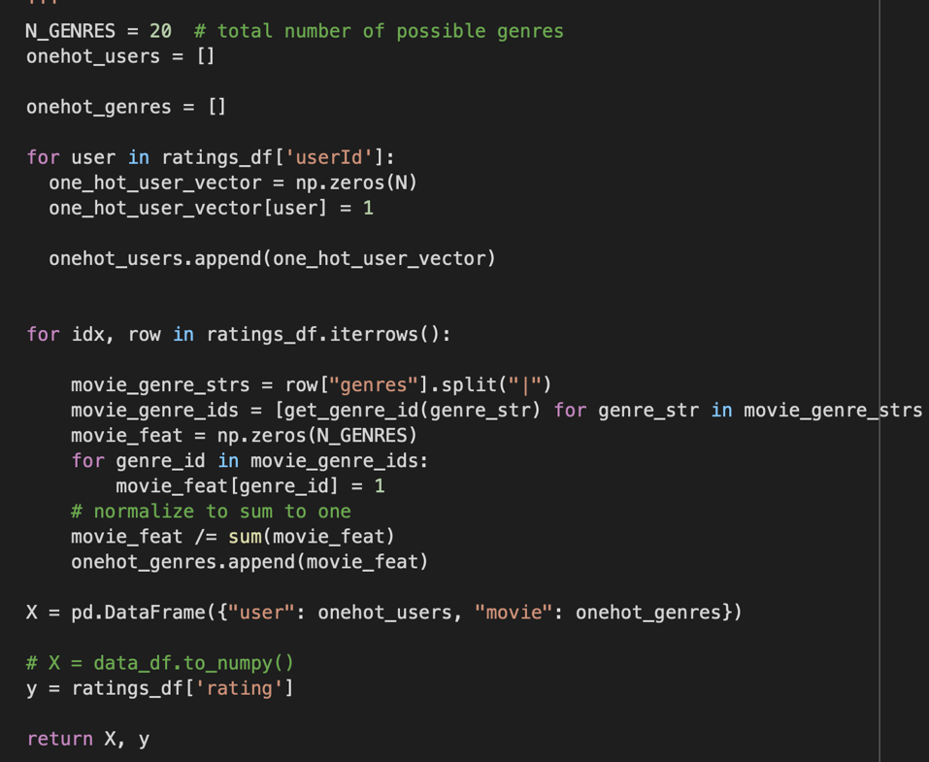
Train MSE when including genre info, k=50 is: 0.8478028774261475
Validation MSE when including genre info, k=50 is: 0.8697645664215088

Very similar results to part (ii), potentially indicating that the movie genres are not essential information to make predictions. A better way to compare the effect of inclusion vs exclusion of genre info is to take a closer look at the ratings that had a very large MSE and try to understand why the model is not performing well on those ratings.

Problem 2

- a) We can write a function for each class:

$$class 1:x_{2}=x_{1}^{2}+3$$

$$class 2:x_{2}=x_{1}^{2}+1$$
Therefore,
$$x_{2}-x_{1}^{2}$$

will bring class 1 close to a value of 3 and class 0 close to a value of 1 making the two classes linearly separable

b) $\left|x_{2}-x_{1}\right| or {\left(x_{2}-x_{1}\right)}^{2}$

- a) dimensions of W is 2x2 corresponding to the size of the input layer multiplied by the size of the hidden layer. Dimensions of V is 1x2, b⁽¹⁾ has dimension 2x1 , b⁽²⁾ is a 1-D array of length 1.

b) i)

ii)
$${{ z}_{1}=-x}_{1}-x_{2}+1.4= 0 , w_{11}= -1, w_{21}= -1$$

$${z_{2}=x}_{1}+x_{2}-0.6= 0, w_{12}= -1, w_{22}= -1$$

$W=\left[\begin{matrix}-1 & -1 \\ 1 & 1\end{matrix}\right], { b}^{(1)}=\left[\begin{matrix}1.4 \\ -0.6\end{matrix}\right]$

c) for point (0, 0)
$${{ z}_{1}=-x}_{1}-x_{2}+1.4= -0-0+1.4=1.4 (+)$$

$${{ z}_{2}=x}_{1}+x_{2}-0.6= 0+ 0 - 0.6 =-0.6 (-)$$

for point (0, 1)
$${{ z}_{1}=-x}_{1}-x_{2}+1.4= -0-1+1.4=0.4 (+)$$

$${{ z}_{2}=x}_{1}+x_{2}-0.6= 0+ 1 - 0.6 =0.4 (+)$$

for point (1, 0)
$${{ z}_{1}=-x}_{1}-x_{2}+1.4= -1-0+1.4=0.4 (+)$$

$${{ z}_{2}=x}_{1}+x_{2}-0.6= 1+ 0 - 0.6 =0.4 (+)$$

for point (1, 1)
$${{ z}_{1}=-x}_{1}-x_{2}+1.4= -1-1+1.4=-0.6 (-)$$

$${{ z}_{2}=x}_{1}+x_{2}-0.6=1+ 1 - 0.6 =1.4 (+)$$

The points are not linearly separable

d) for point (0, 0)
$$z_{1}= 1.4 , h_{1}=ReLU\left(z_{1}\right)=1.4$$

$$z_{2}=-0.6, h_{2}=ReLU\left(z_{2}\right)=0$$

for point (0, 1)
$$z_{1}= 0.4 , h_{1}=ReLU\left(z_{1}\right)=0.4$$

$$z_{2}=0.4, h_{2}=ReLU\left(z_{2}\right)=0 .4$$

for point (1, 0)
$$z_{1}= 0.4 , h_{1}=ReLU\left(z_{1}\right)=0.4$$

$$z_{2}=0.4, h_{2}=ReLU\left(z_{2}\right)=0 .4$$

for point (1, 1)
$$z_{1}= -0.6, h_{1}=ReLU\left(z_{1}\right)=0$$

$$z_{2}=1.4, h_{2}=ReLU\left(z_{2}\right)=1.4$$

The points are linearly separable

e) i)

ii)
$$z^{'}=-h_{1}-h_{2}+1$$
$$V=\left[-1-1\right], b^{(2)}=1$$

f)
$$\hat{y}=Binarize (z^{'})$$

for point (0, 0)

$$z^{'}= -1.4-0+1= -0.4 , \hat{y}=Binarize \left(z^{'}\right)=0$$

for point (0, 1)
$$z^{'}=-0.4-0.4+1=0.2 , \hat{y}=Binarize \left(z^{'}\right)=1$$

for point (1, 0)

$$z^{'}=-0.4-0.4+1=0.2 , \hat{y}=Binarize \left(z^{'}\right)=1$$

for point (1, 1)

$$z^{'}= -0-1.4+1= -0.4 , \hat{y}=Binarize \left(z^{'}\right)=0$$

g) i) No, the ReLU activation function introduces non-linearity to the model so that we can solve problems where Linear regression offers no solution. Removing the ReLU activation essentially means we are creating a linear regression model so no set of parameters can actually classify the data correctly.
ii) No, increasing the number of hidden layers does not solve the problem. without a ReLU activation, the full model can essentially be represented in a linear regression form regardless of NN depth.

Problem 3

- a) $\frac{∂L}{∂θ}=\frac{1}{N}\sum_{i=1}^{N}{(y^{\left(i\right)}-θ^{T}x^{(i)}})(-x^{\left(i\right)})$

b) $θ^{t+1}= θ^{t}-\frac{η}{N}\sum_{i=1}^{N}{(y^{\left(i\right)}-θ^{T}x^{(i)}})(-x^{\left(i\right)})$

c) $θ^{t+1}= θ^{t}-η\left(y^{\left(i\right)}-θ^{T}x^{\left(i\right)}\right)(-x^{\left(i\right)})$

d) SGD : Can be used for large training sets as only one training example is considered at a time , however, it might take longer to converge. GD can be more direct for finding the global minimum, especially if the training set size is small.

- Plot (a) corresponds to loss curve of a non-stochastic gradient descent. Plot (d) corresponds to a stochastic gradient decent with the smallest batch size because it has the noisiest trend, due to variations from batch to batch. the smaller the batches, the more likely there are variations between them because each batch can only capture a small number of training examples and so the error fluctuates more heavily from batch to batch.

- a) apply the chain rule,

$\frac{∂L}{∂w_{11}}= \frac{∂h_{1}}{∂w_{11}} \frac{∂\hat{y}}{∂h_{1}} \frac{∂L}{∂\hat{y}}=\frac{∂z_{1}}{∂w_{11}} \frac{∂h_{1}}{∂z_{1}} \frac{∂\hat{y}}{∂h_{1}} \frac{∂L}{∂\hat{y}} ={[x}_{1}]\left[\left[z_{1}>0\right]\right]\left[V_{1}\right]\left[\hat{y}-y\right]$

$$\left[\left[z_{1}>0\right]\right]=ReLU'(z_{1})$$

b) $z=Wx=\left[\begin{matrix}-0.5x1 + 2x1.5+ 1x-1 \\ 0.5x1+ -1x1.5+1x-1\end{matrix}\right]= \left[ \begin{matrix}1.5 \\ -2\end{matrix} \right]$

$$h=ReLU\left(z\right)= \left[ \begin{matrix}1.5 \\ 0\end{matrix} \right]$$

$$\hat{y}=Vh= 1.5x1+ 0 x-1=1.5$$

$$L\left(\hat{y}\right)=\frac{1}{2}{\left(\hat{y}-y\right)}^{2}=\frac{1}{2}{\left(1.5-2\right)}^{2}=0.125$$

c)
$$w_{11}-\frac{∂L}{∂w_{11}}={w_{11}-η[x}_{1}]\left[[z_{1}>0\right]]\left[V_{1}\right]\left[\hat{y}-y\right]=-0.5-(0.01)\left(1\right)\left(1\right)\left(1\right)\left(-0.5\right)=-0.495$$

