CPSC 462 - Software Design

Instructor: Christopher T. Ryu, Ph.D., Professor

Homework #3
Submission Date : 10.31.12

.

Team: NewGen

Name: Michael Robertson Email: mirob2005@gmail.com

Name: Xinchao Liu Email: lookfor@188.com

Name: Wee Siang Wong Email: willydk@gmail.com

Name: Bryan Tamada Email: btamada@gmail.com

Name: Wei Jen Lin Email: littlemike44@hotmail.com

1. CRC models for “Process Sale”
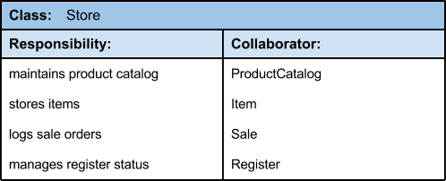

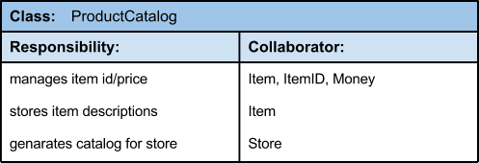

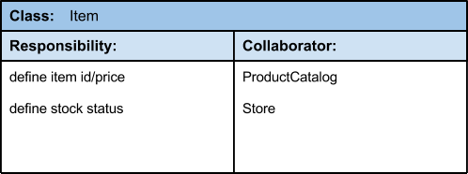

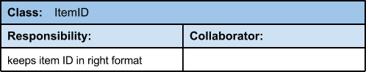

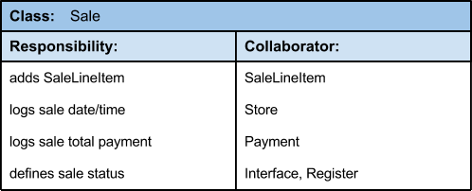

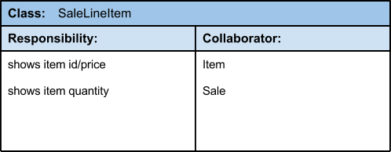

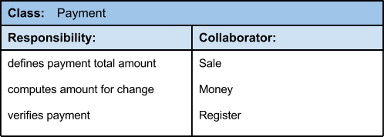

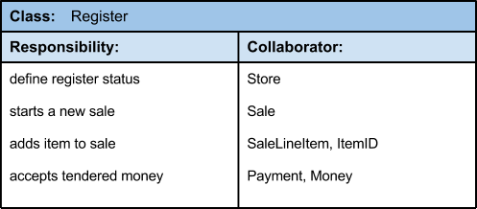

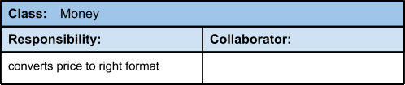

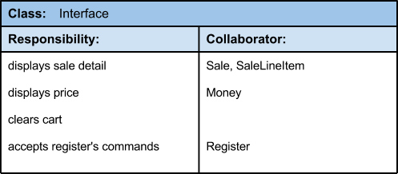

2. Architecture Diagram

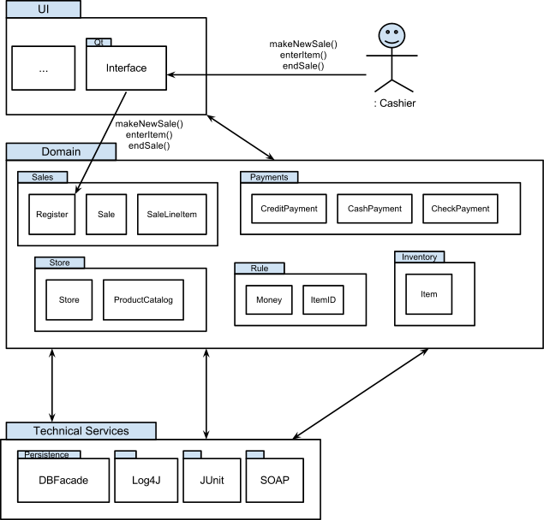

Usability - The POS System is an application that is made to be easier for the user to interact with as well as meet the requirements of the user and consumer. The usability quality attribute focuses in on the overall user experience by providing intuitive, easy to localize and globalize and easy access software.

Maintainability - Our POS system should be able to undergo changes with a certain amount of ease because these changes could impact several parts of the system such components, services, features and the interface. That is why when adding or changing the functionality, fixing errors, and meeting business requirements the system should be easy to accommodate these changes.

Reliability - A system should be able to remain operational over time without much trouble. A POS system running at a grocery store should have very little probability of failing to perform its intended functions over a specific time interval since it is possible that they are running 24 hours per day.

Scalability - In the future it is possible that the system would be required to handle more processes, be able to accommodate new resources (such as hardware), or an expansion of data. To protect against increases in load without sacrificing performance or having the ability to be readily enlarge our system scalability is an important quality attribute to handle these changes and safeguard against future goals while assuring that the system can be utilized.

Security - Due to our system dealing with third-party entities such as the authorization of checks or credit cards during the payment process we want our system to be secure. A secure system has the capability of preventing malicious or accidental actions outside of its usage and to prevent the leakage, retrieval and modification of personal information.

Availability - Similar to reliability, our system must be available for a period of time where it is functional and working. We can measure the system’s rate of availability as a percentage of the total system downtime over a predefined period. System availability will be affected by system errors, infrastructure problems, malicious attacks, and system load.

3. Coding for all classes
package newgenpos;
class Register {
private ProductCatalog catalog;
private Sale currentSale;
public Register(ProductCatalog pc){
this.catalog = pc;
}
public void endSale(){
//...
}
public void enterItem(ItemID ItemID, int qty){
//...
}
public void makeNewSale(){
//...
}
public void makePayment(Money cashTendered){
//...
}
}
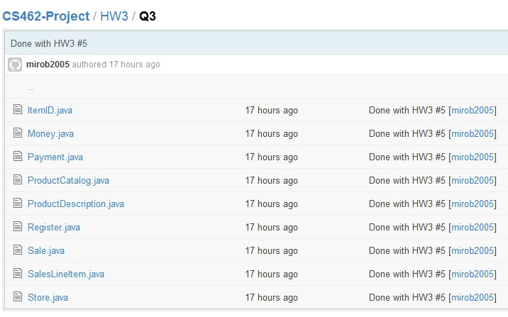

Full organized code for all the classes can be seen at: https://github.com/miro2005/CS462-Project/tree/master/HW3/Q3

4. Object Design Models

1. Sequence diagram for makePayment
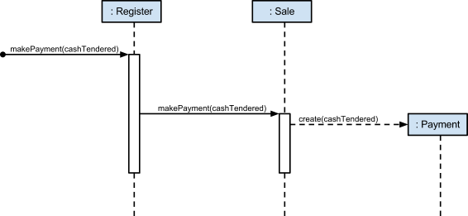

2. Sequence diagram for endSale
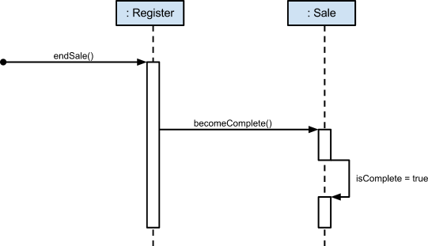

5. Codes for two operations in #4

package newgenpos;
import java.util.Date;

class Register {
private ProductCatalog catalog;
private Sale currentSale;
private ProductDescription description;

public Register(ProductCatalog pc){
this.catalog = pc;
}
public void endSale(){
currentSale.becomeComplete();
}
public void enterItem(ItemID ItemID, int qty){
description = catalog.getProductDescription(ItemID);
currentSale.makeLineItem(description, qty);
}
public void makeNewSale(){
currentSale = new Sale();
}
public void makePayment(Money cashTendered){
currentSale.makePayment(cashTendered);
}
}

class Sale {
private boolean isComplete;
private Date time;
private Payment payment;
private SalesLineItem cart;
private Money subTotal;
private Money total;
private double tax;

public Sale(){
isComplete = false;
time = new Date();
}

public boolean isComplete(){
return isComplete;
}

public void becomeComplete(){
isComplete = true;
}

public void makeLineItem(ProductDescription desc, int qty){
cart = new SalesLineItem(desc, qty);
}

public void makePayment(Money cashTendered){
payment = new Payment(cashTendered);
}

public Money getTotal(){
subTotal = cart.getSubtotal();
total = subTotal.calcTotal(tax);

return total;
}
}

class Payment {

private Money amount;

public Payment(Money Amount) {
this.amount = Amount;
}
}

