<Project Name>

Vision Document



[www.abc.sk](http://www.abc.sk)

*Contents*

Vision 2

Usage Scenario 2

Know your users 2

Users language 3

Most common tasks 4

Main Processes 5

Navigation 7

Mockups 7

Non functional requirements 9

# Vision

What is the benefit that the business expects to have with this application?

Make it short and be clear of the business goal – the business expects to increase revenue with the application? Expects to reduce costs? How they expects to get it?

Sales App Example:

The Sales App aims to increase sales. It will help the sales team to keep track of their opportunities, and get an accurate sales forecast. Doing so this application will help them to decide in which opportunities they should invest their time and when to do it.

# Usage Scenario

Define the context for your application usage. How would you describe the company and the group of people you are targeting? How do they work today?

Sales App Example:

ObservEverything is a small company that sells security systems. The company has a sales team of 6 Account Managers that report to a Sales Manager. They all focus on reaching their quarterly defined quotas. They've recently hired an Inside Sales person.

Up until now they have used their own individual Office Outlooks to keep track of their contacts, and some excel sheets for sales forecasting. The Sales Manager now wishes to consolidate all the chaotic contact and opportunity data into a single system so they can collaborate. The CEO is always pressing the Sales Manager to get accurate sales forecasts.

# Know your users

Define the major roles of the users that will interact with the application and classify them according to:

* users’ drivers
* number of users
* time spent in the application, ex: 1h/day, 1h/week
* frequency of use: ex: everyday, once a month
* business knowledge: expert in the subject, don’t know much about the business

Sales App Example:

**★** **Account Manager** (aka Sales Rep)

Sally Reps is always on the move to visit a large number of prospects and customers. She has a large contact database (that she does not wish to share with other account managers) and needs to be aware of all past interactions with her contacts. She is always worried about her quarterly quota – if she “has the numbers done” she gets her bonus. She uses Outlook a lot. Sometimes she also does cold calling and qualification, but this doesn’t help her to do the numbers, so she avoid it. As she travels a lot she doesn’t spend much time in front of her computer. She maybe using it for very short periods, almost every day and by the end of the quarter she needs to review her number. Sally works in Lisbon with 5 other account managers. Apart from Lisbon, there are 8 more Account Managers in 3 other locations: US West Cost, Benelux and Brazil. Every 2 weeks they have a status meeting with Sheila Manny.

**★** **Sales Manager**

Sheila Manny is focused on the team quarterly quota, funnel status, and individual status of account managers, so she can press them. For bigger accounts she works as an Account Manager. Sheila is the only Sales Manager. She will use the SalesApp for short periods of time, 2 to 3 times a week, except by the end of the quarter, when she is preparing the report to the CEO.

**★** **Inside Sales**

Stevie Wonder spends his days in the main office cold calling and qualifying leads. He tries to schedule meetings for account managers. Stevie Wonder is the only inside sales rep at ObservEverything. He has very deep knowledge of what he needs do to. He will have the SalesApp open all day so that he can record every call made. He works near Sheila Manny, the Sales Manager, and reports to her, so he has some political influence.

# Users language

Describe the application’s main concepts at a high level. User’s terms, how they relate with others, and their volume should also be defined.

Sales App Example:

**★** **Contact:** an individual from an external company.

The title and contact information are very important. A company usually has less than 10 contacts, but can have more.

**★** **Opportunity:** an opportunity within a company.

The opportunity has an amount associated to it, and expected close date and stage (% close to completion). Closed deals, either won or lost, are not as relevant for the day-to-day use. Each Account Manager usually has about 20 or more open opportunities, but approximately 5 are relevant to them based on stage and value.

**★** **Company:** an external organization.

After a deal opportunity is identified, an Account Manager is assigned to a company. An Account Manager can have dozens of companies associated to them, but usually stays focused on the ones that have open opportunities or have had higher closed deals.

# Most common tasks

Create a prioritized list of small user stories, using **★** for the highest priority stories. Try to use a common structure:

**As a [role], [a person] wants to [feature] so that [reason]**

A user story is NOT technical. A simple and fast intro on writing a good user story can be found[here](http://guide.agilealliance.org/guide/stories.html). Try to use the [INVEST](http://www.google.com/url?q=http%3A%2F%2Fxp123.com%2Fxplor%2Fxp0308%2Findex.shtml&sa=D&sntz=1&usg=AFQjCNEV1DLMfQKSfcthvJM9J4zOU) model, making them Independent, Negotiable, Valuable, Estimable, Small, Testable.

If some detail is needed in order to respect the INVEST model write it in a test perspective.

Sales App Example:

**As an account manager, Sally Reep wants to:**

**★** Constantly monitor her quarterly status, so that she knows if she will reach her quota.

**★** Register the estimated amount for a deal and expected close date, so that she can be aware how that will affect her quota.

**★** Update the stage of a deal (% close to completion), so that she and her manager can estimate its probability of success.

**★** Schedule follow up tasks for a contact, so that she can be notified later and this way she can be more efficient in her activities.

**★** Quickly register contact and/or company info after an initial phone call or email so that she can call them in a next iteration.

**★** Quickly log important details of an interaction with a contact, so that in the next interaction she can be aware of past interactions.

**As a sales manager, Sheila Manny wants to:**

**★** See the deals that are estimated to close this quarter, in order to reach the quarterly goals.

**★** See the quarterly quota status for each account managers so that she can follow up with them.

**★** See the pipeline status to make sure there are enough opportunities (and leads) in the early stages so that she can meet the quota for following quarters.

**★** Get the sales forecast for the next quarter so she can show it to the CEO.

**As an inside sales, Stevie Wonder wants to:**

**★** Quickly register contact and/or company info during an initial phone call.

**★** Schedule follow up tasks for a contact, so that he can be notified later.

**★** Assign an account manager to a company after a deal opportunity is identified and a meeting is scheduled.

**★** Log information after an interaction with a contact, so that in the next interaction he can be aware of past interactions.

# Main Processes

Most enterprise applications exist to support a business process. Most of the times this process is not well identified. Drafting this process helps you understand the actual flow of stories across the several roles (or systems) and may help you reach screen flows that better match the actual process, resulting in increased usability and a better demo.

Sales App Example:

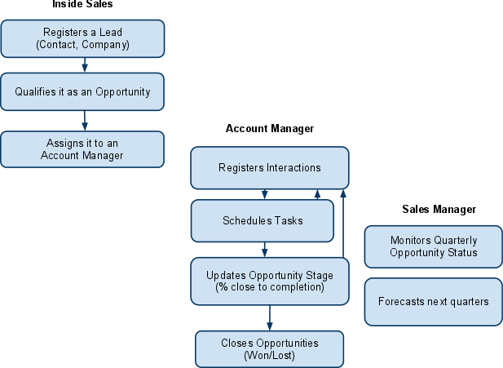

# Navigation

Represent graphically how different users will navigate through the application: What will they find in the homepage, main menu and following pages.

Sales App Example:

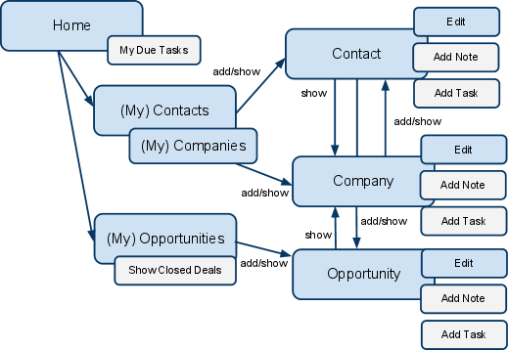

IMPORTANT NOTE: In the beginning of the process the Contact, Company, and Opportunity are seen by the users as a single entity that can be referred to as lead or opportunity (when qualified and assigned to an account manager). Navigation, creation, edition, and information sharing between these 3 should be seamless.

# Mockups

Define the content of your home page and top user story screens, for each role.

Each page should be created according to UX Principles. The homepage is especially important since it should present an easy way for the user to complete common tasks.

Sales App Example:

|  |  |
| --- | --- |
| **Account Manager** | |
|  | * Quarter Status ($12.000/$25.000, 10 days for quarter’s end) * My Pending Opportunities * Tasks to Complete |
| **Sales Manager** | |
|  | * Quarter Status ($45.000/$230.000, 10 days for quarter’s end) * Quarter Status by Account Manager * Pipeline Chart and Forecast * Recent Changes in Opportunities |
| **Inside Sales** | |
|  | * Quarter Status (25/60 new opportunities, 10 days for quarter’s end) * Register New Contact/Opportunity * My Due Tasks |

# Non functional requirements

Functional requirements aren’t the only important part of a project’s success. Non- functional requirements have high impact on the project success. For more information see the [OutSystems post](http://www.outsystems.com/blog/2013/03/the-truth-about-non-functional-requirements-nfrs.html) about it.

*Sales App Example:*

* **Browsers**Application must be optimized for IE8 and IE9. Must also work in IE7, but some degradation is acceptable.
* **Mobile**Since account managers do a lot of their work outside the desk it’s important that their top user’s stories can be done on an iPad or iPhone, or Android smartphone.