# Software Engineering and DevOps – Solution Template

Archive the document after providing the solution resources and upload in the form here:

Note: The system saves only the last uploaded archive!

Good luck! 🙂

# Solution Resources

Please provide the following resources for your solution.

## GitHub repository

* Link: https://github.com/miroslavgechev/miroslav.gechev-exam

## Render.com link

* Link: https://miroslav-gechev-exam.onrender.com/

## GitHub Actions Screenshot

Place the image here or in the archive (outside of the document):

**GitHub Actions:**

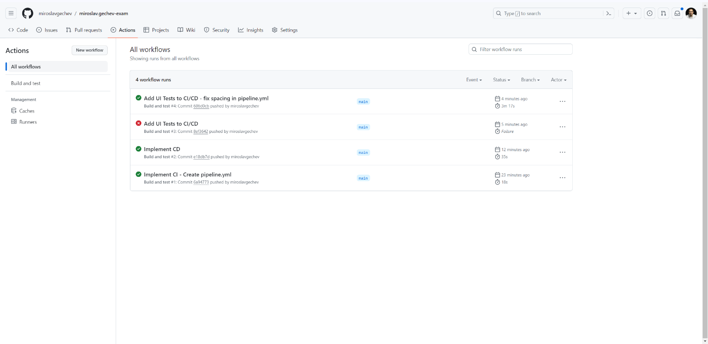

**Pipeline:**

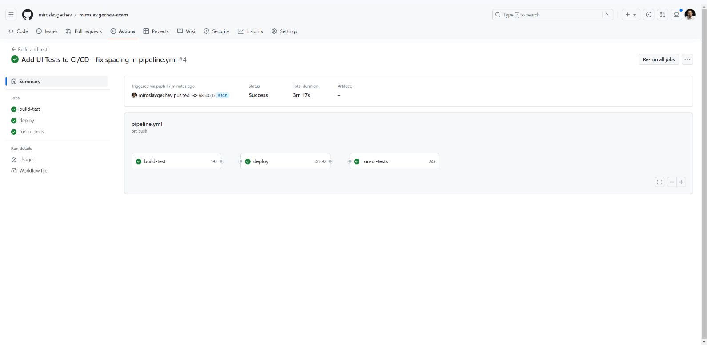

**Build-Test Job:**

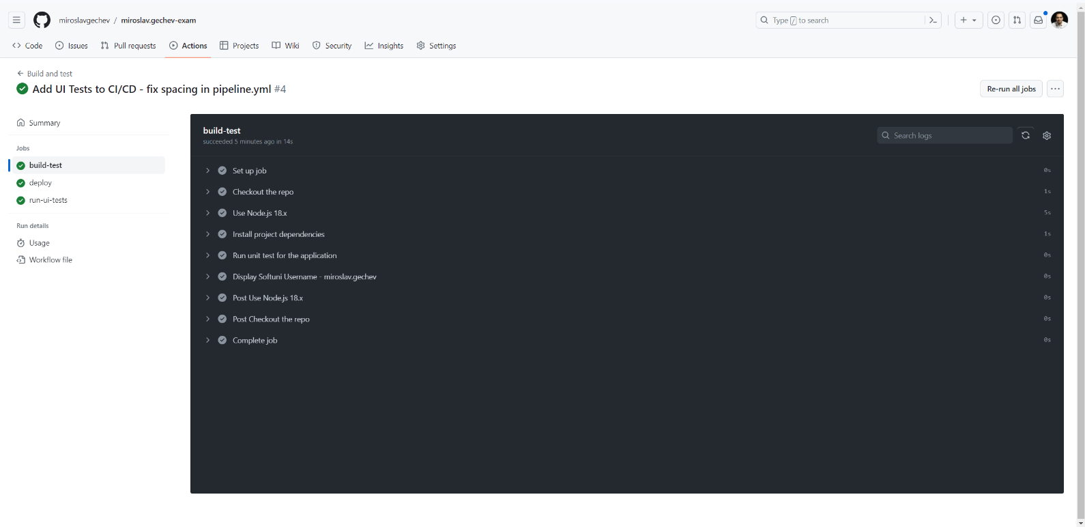

**Deploy Job:**

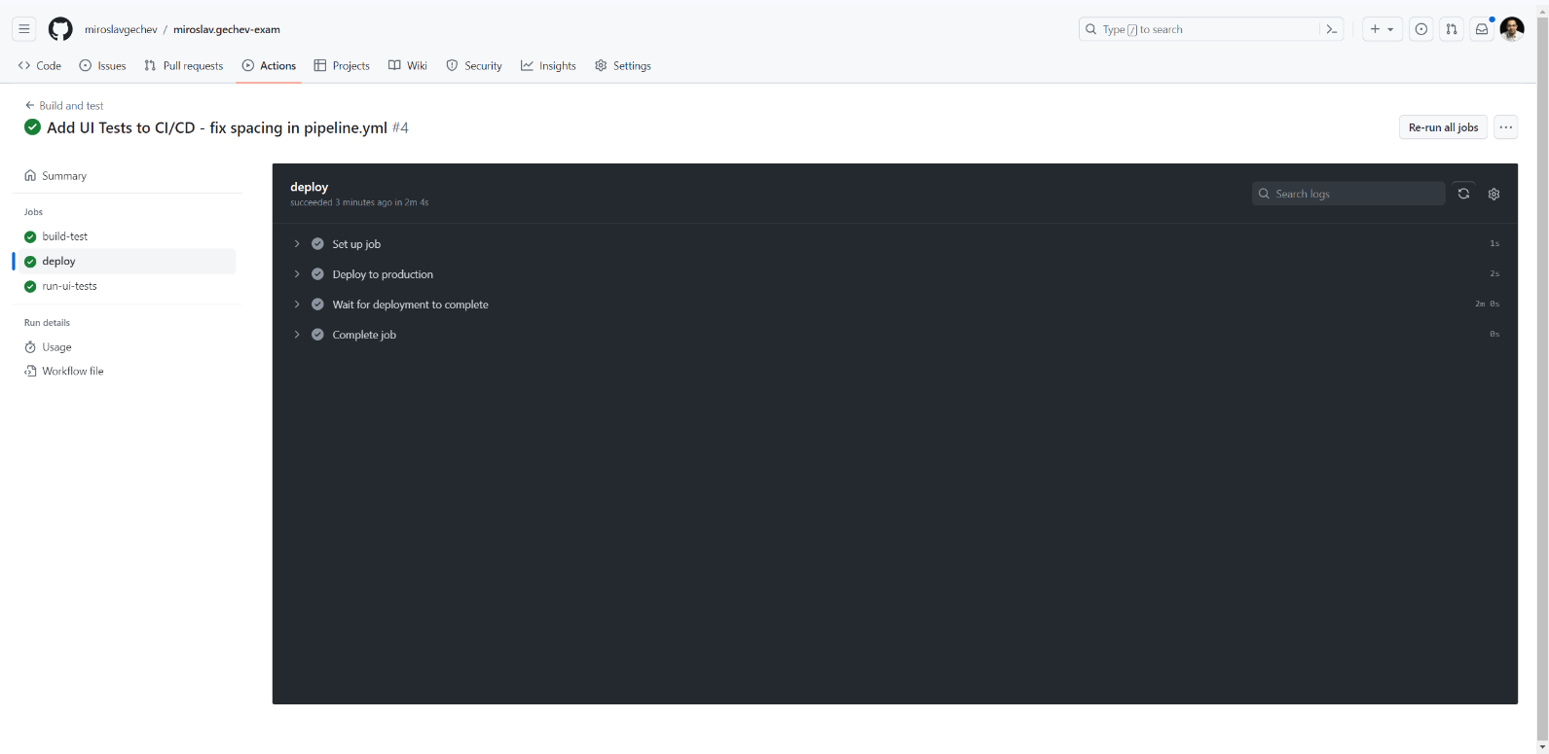

**Run UI Tests Job:**

