|  |  |
| --- | --- |
| 3GPP TS 26.449 V18.0.0 (2024-03) | |
| Technical Specification | |
| 3rd Generation Partnership Project;  Technical Specification Group Services and System Aspects;  Codec for Enhanced Voice Services (EVS);  Comfort Noise Generation (CNG) Aspects  (Release 18) | |
|  | |
|  |  |
|  | |
| The present document has been developed within the 3rd Generation Partnership Project (3GPP TM) and may be further elaborated for the purposes of 3GPP. The present document has not been subject to any approval process by the 3GPPOrganizational Partners and shall not be implemented. This Specification is provided for future development work within 3GPPonly. The Organizational Partners accept no liability for any use of this Specification. Specifications and Reports for implementation of the 3GPP TM system should be obtained via the 3GPP Organizational Partners' Publications Offices. | |

|  |
| --- |
|  |
| ***3GPP***  Postal address  3GPP support office address  650 Route des Lucioles - Sophia Antipolis  Valbonne - FRANCE  Tel.: +33 4 92 94 42 00 Fax: +33 4 93 65 47 16  Internet  http://www.3gpp.org |
| ***Copyright Notification***  No part may be reproduced except as authorized by written permission. The copyright and the foregoing restriction extend to reproduction in all media.  © 2024, 3GPP Organizational Partners (ARIB, ATIS, CCSA, ETSI, TSDSI, TTA, TTC).  All rights reserved.  UMTS™ is a Trade Mark of ETSI registered for the benefit of its members  3GPP™ is a Trade Mark of ETSI registered for the benefit of its Members and of the 3GPP Organizational Partners LTE™ is a Trade Mark of ETSI registered for the benefit of its Members and of the 3GPP Organizational Partners  GSM® and the GSM logo are registered and owned by the GSM Association |

Contents

Foreword 4

1 Scope 5

2 References 5

3 Abbreviations 5

4 General 5

5 Functions on the transmit (TX) side 6

5.1 EVS primary CNG operation 6

5.2 EVS AMR-WB IO CNG operation 7

6 Functions on the receive (RX) side 7

6.1 EVS primary CNG operation 7

6.2 EVS AMR-WB IO CNG operation 7

7 Computational details and bit allocation 7

Annex A (informative): Change history 8

# Foreword

This Technical Specification has been produced by the 3rd Generation Partnership Project (3GPP).

The contents of the present document are subject to continuing work within the TSG and may change following formal TSG approval. Should the TSG modify the contents of the present document, it will be re-released by the TSG with an identifying change of release date and an increase in version number as follows:

Version x.y.z

where:

x the first digit:

1 presented to TSG for information;

2 presented to TSG for approval;

3 or greater indicates TSG approved document under change control.

y the second digit is incremented for all changes of substance, i.e. technical enhancements, corrections, updates, etc.

z the third digit is incremented when editorial only changes have been incorporated in the document.

# 1 Scope

The present document gives an overview for the requirements of the background acoustic noise evaluation, noise parameter encoding/decoding and comfort noise generation for the Enhanced Voice Services (EVS) speech codec during Discontinuous Transmission (DTX) operation.

# 2 References

The following documents contain provisions which, through reference in this text, constitute provisions of the present document.

- References are either specific (identified by date of publication, edition number, version number, etc.) or non‑specific.

- For a specific reference, subsequent revisions do not apply.

- For a non-specific reference, the latest version applies. In the case of a reference to a 3GPP document (including a GSM document), a non-specific reference implicitly refers to the latest version of that document *in the same Release as the present document*.

[1] 3GPP TR 21.905: "Vocabulary for 3GPP Specifications".

[2] 3GPP TS 26.445: "Codec for Enhanced Voice Services (EVS); Codec Detailed Algorithmic Description".

[3] 3GPP TS 26.442: "Codec for Enhanced Voice Services (EVS); EVS Codec ANSI C code (fixed-point)".

[4] 3GPP TS 26.443: "Codec for Enhanced Voice Services (EVS); EVS Codec ANSI C code (floating-point)".

[5] 3GPP TS 26.452: "Codec for Enhanced Voice Services (EVS); ANSI C code; Alternative fixed-point using updated basic operators".

# 3 Abbreviations

For the purposes of the present document, the abbreviations given in TR 21.905 [1] and the following apply. An abbreviation defined in the present document takes precedence over the definition of the same abbreviation, if any, in TR 21.905 [1].

CNG Comfort Noise Generation

EVS Enhanced Voice Services

FD-CNG Frequency Domain based CNG

LP-CNG Linear Prediction based CNG

SID Silence Insertion Descriptor

# 4 General

The present document gives an overview for the requirements of the background acoustic noise evaluation, noise parameter encoding/decoding and comfort noise generation for the Enhanced Voice Services (EVS) speech codec during Discontinuous Transmission (DTX) operation.

The procedure of the present document is mandatory for implementation in all network entities and UEs supporting the EVS codec.

In the case of discrepancy between the EVS comfort noise aspects described in the present document and its ANSI-C code specification contained in [3], the procedure defined by [3] prevails. In the case of discrepancy between the procedure described in the present document and its ANSI-C code specification contained in [4], the procedure defined by [4] prevails. In the case of discrepancy between the procedure described in the present document and its ANSI-C code specification contained in [5], the procedure defined by [5] prevails.

A basic problem when using DTX is that the background acoustic noise, which is transmitted together with the speech, would disappear when the transmission is cut, resulting in discontinuities of the background noise. Since the DTX switching can take place rapidly, it has been found that this effect can be very annoying for the listener - especially in a car environment with high background noise levels. In bad cases, the speech may be hardly intelligible.

The present document specifies the way to overcome this problem by generating on the receive (RX) side synthetic noise similar to the transmit (TX) side background noise. The comfort noise parameters are estimated on the TX side and transmitted to the RX side at a regular rate when speech is not present. This allows the comfort noise to adapt to the changes of the noise on the TX side.

The Enhanced Voice Services (EVS) speech codec supports two Comfort Noise Generation (CNG) schemes, a linear prediction based CNG (LP-CNG) as well as a frequency domain based scheme (FD-CNG). The selection of the one of the two schemes is performed within the transmit side functions on an input signal bases. The parameters for generating the comfort noise are packed as a Silence Insertion Descriptor (SID) payload.

By default in the command line the transmission rate of CNG update is fixed to 8 frames. However, the update rate of the SID payload can be configured by a command line parameter to a fixed number or to a mode where the update rate is adaptively modified according to the background noise. The fixed rate mode is limited to updates between 1 and 100 frames while in the adaptive rate mode the updates are limited to 8 and 50 depending on the noise behaviour.

As the functions of the CNG processing are highly integrated into the speech codec and make use of other coding parameters, The present document only provides an overview of the functions. The relevant references to the algorithmic descriptions are provided in the following.

# 5 Functions on the transmit (TX) side

## 5.1 EVS primary CNG operation

The CNG operation on the transmit side is described in figure 1. In DTX operation, the SID updater decides if any SID update is required. If the SID payload should be updated, the CNG Selector enables either the LP or the FD CNG encoder depending on the signal characteristic of the background noise. The selected CNG encoder calculates the noise generation parameter and creates the related SID payload.

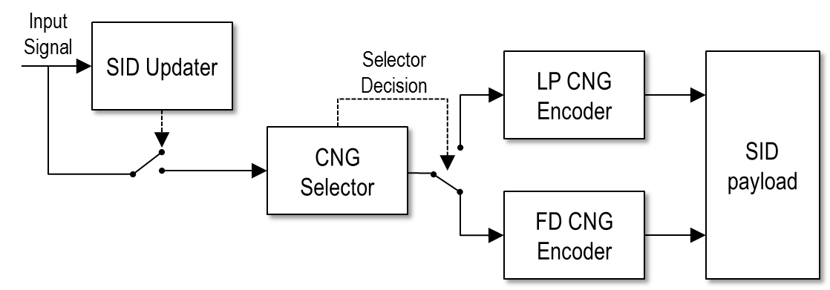

Figure 1: Transmit side Comfort Noise Generator functions

In [2], all TX functions are described in clause 5.6. The algorithmic description of the

- SID Update mechanism can be found in sub-clause 5.6.1.1 and 5.6.1.2

- CNG Selector can be found in sub-clause 5.6.1.3

- LP-CNG encoder in sub-clause 5.6.2

- FD-CNG encoder in sub-clause 5.6.3.

## 5.2 EVS AMR-WB IO CNG operation

The update rate is basically fixed to an update every 8th frame. However, when switching into DTX mode, the first and the third frame after active speech are coded by a SID frame.

The CNG in the EVS AMR-WB interoperable modes is based the LP-CNG coding scheme only. The complete CNG TX description of the EVS AMR-WB IO mode can be found in [2], clause 5.7.12.

# 6 Functions on the receive (RX) side

## 6.1 EVS primary CNG operation

The CNG operation on the receiver side is depicted in Figure 2. The first bit of the SID payload determines the CNG module. The remaining bits contain the information of the noise generator parameters to render the signal.

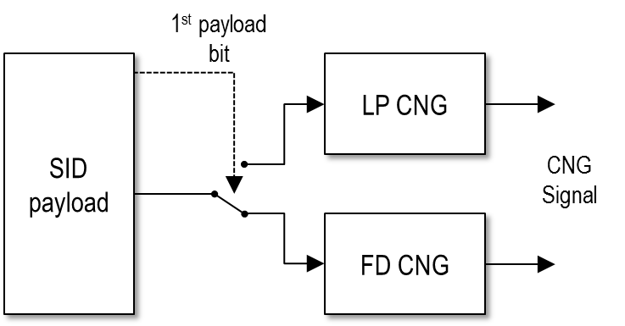

Figure 2: Receive side Comfort Noise Generator functions

The RX CNG operation is described in clause 6.7. The synthesis of the LP-CNG is described in sub-clause 6.7.2 and the synthesis of FD-CNG is described in clause 6.7.3 in [2].

## 6.2 EVS AMR-WB IO CNG operation

The CNG in the EVS AMR-WB interoperable modes use only the LP-CNG decoding scheme for rendering the AMR-WB compatible CN parameters. The complete CNG RX description of the EVS AMR-WB IO mode can be found in [2], clause 6.8.4.

# 7 Computational details and bit allocation

A computational description of comfort noise encoding and generation in form of an ANSI-C source code is given in [3] and [5] for the two fixed-point implementations, using different sets of basic operators, and in [4] for the floating-point implementation.

For the EVS primary modes, the SID payload consists of 48 bits. The first bit of the payload determines the CNG scheme, where 0 stands for the LP-CNG and 1 for the FD-CNG.

For the EVS AMR-WB IO modes, the SID payload consists of 35 bits.

Annex A (informative):  
Change history

|  |  |  |  |  |  |  |  |
| --- | --- | --- | --- | --- | --- | --- | --- |
| **Change history** | | | | | | | |
| **Date** | **TSG #** | **TSG Doc.** | **CR** | **Rev** | **Subject/Comment** | **Old** | **New** |
| 2014-09 | 65 | SP-140464 |  |  | Presented at TSG SA#65 for approval |  | 1.0.0 |
| 2014-09 | 65 |  |  |  | Approved at TSG SA#65 | 1.0.0 | 12.0.0 |
| 2015-12 | 70 |  |  |  | Version for Release 13 | 12.0.0 | 13.0.0 |
|  |  |  |  |  |  |  |  |

|  |  |  |  |  |  |  |  |
| --- | --- | --- | --- | --- | --- | --- | --- |
| **Change history** | | | | | | | |
| **Date** | **Meeting** | **TDoc** | **CR** | **Rev** | **Cat** | **Subject/Comment** | **New version** |
| 2017-03 | 75 |  |  |  |  | Version for Release 14 | 14.0.0 |
| 2018-06 | 80 |  |  |  |  | Version for Release 15 | 15.0.0 |
| 2019-03 | 83 | SP-190031 | 0006 | 1 | A | Correction of EVS SID update | 15.1.0 |
| 2019-03 | 83 | SP-190036 | 0001 | - | B | Correction and addition of reference to ALT_FX_EVS implementation | 16.0.0 |
| 2022-04 | - | - | - | - | - | Update to Rel-17 version (MCC) | **17.0.0** |
| 2024-03 | - | - | - | - | - | Update to Rel-18 version (MCC) | **18.0.0** |