|  |  |
| --- | --- |
| 3GPP TS 28.100 V18.0.0 (2024-04) | |
| Technical Specification | |
| 3rd Generation Partnership Project;  Technical Specification Group Services and System Aspects;  Management and orchestration;  Levels of autonomous network;  (Release 18) | |
|  | |
|  | 3GPP-logo_web |
|  | |
| The present document has been developed within the 3rd Generation Partnership Project (3GPP TM) and may be further elaborated for the purposes of 3GPP. The present document has not been subject to any approval process by the 3GPPOrganizational Partners and shall not be implemented. This Specification is provided for future development work within 3GPPonly. The Organizational Partners accept no liability for any use of this Specification. Specifications and Reports for implementation of the 3GPP TM system should be obtained via the 3GPP Organizational Partners' Publications Offices. | |

|  |
| --- |
|  |
| ***3GPP***  Postal address  3GPP support office address  650 Route des Lucioles - Sophia Antipolis  Valbonne - FRANCE  Tel.: +33 4 92 94 42 00 Fax: +33 4 93 65 47 16  Internet  http://www.3gpp.org |
| ***Copyright Notification***  No part may be reproduced except as authorized by written permission. The copyright and the foregoing restriction extend to reproduction in all media.  © 2024, 3GPP Organizational Partners (ARIB, ATIS, CCSA, ETSI, TSDSI, TTA, TTC).  All rights reserved.  UMTS™ is a Trade Mark of ETSI registered for the benefit of its members  3GPP™ is a Trade Mark of ETSI registered for the benefit of its Members and of the 3GPP Organizational Partners LTE™ is a Trade Mark of ETSI registered for the benefit of its Members and of the 3GPP Organizational Partners  GSM® and the GSM logo are registered and owned by the GSM Association |

Contents

Foreword 5

Introduction 6

1 Scope 7

2 References 7

3 Definitions of terms, symbols and abbreviations 7

3.1 Terms 7

3.2 Symbols 8

3.3 Abbreviations 8

4 Concepts and background 8

4.1 Autonomous network concept 8

4.2 Autonomous network level concept 8

4.3 Dimensions for evaluating autonomous network levels. 8

4.3.1 Introduction 8

4.3.2 Scenarios 8

4.3.3 Management scope 9

4.3.4 Workflow 9

5 Framework approach for evaluating autonomous network levels 10

6 Use cases and requirements 12

6.1 Network and service planning scenarios 12

6.2 Network and service deployment scenarios 12

6.2.1 Autonomous network level for RAN NE deployment 12

6.3 Network and service maintenance scenarios 12

6.3.1 Autonomous network level for fault management 12

6.4 Network and service optimization scenarios 12

6.4.1 Autonomous network level for radio network coverage optimization 12

6.4.2 Autonomous network level for RAN UE throughput optimization 12

7 Generic autonomous network level 13

7.1 Generic autonomous network level for network optimization 13

7.1.1 Generic workflow 13

7.1.2 Generic classification of autonomous network level 13

7.1.3 Generic autonomy capability description for management system 15

7.1.4 Generic MnS requirements 16

7.1.4.1 MnS requirements to support autonomous network level 1 16

7.1.4.2 Additional MnS requirements to support autonomous network level 2 16

7.1.4.3 Additional MnS requirements to support autonomous network level 3 16

7.1.4.4 Additional MnS requirements to support autonomous network level 4 16

7.1.5 Solutions for generic MnS requirements 16

7.2 Generic autonomous network level for RAN NE deployment 17

7.2.1 Generic workflow 17

7.2.2 Generic autonomous network level 18

7.2.3 Generic autonomy capability description for management system 19

7.2.4 Generic MnS requirements 19

7.2.4.1 MnS requirements to support autonomous network level 1 19

7.2.4.2 Additional MnS requirements to support autonomous network level 2 20

7.2.4.3 Additional MnS requirements to support autonomous network level 3 20

7.2.4.4 Additional MnS requirements to support autonomous network level 4 20

7.2.5 Solutions for generic MnS requirements 20

7.3 Generic autonomous network level for fault management 20

7.3.1 Generic workflow 20

7.3.2 Generic autonomous network level 21

7.3.3 Generic autonomy capability description for management system 23

7.3.4 Generic MnS requirements 23

7.3.4.1 MnS Requirements to support autonomous network level 1 23

7.3.4.2 Additional MnS requirements to support autonomous network level 2 23

7.3.4.3 Additional MnS requirements to support autonomous network level 3 24

7.3.4.4 Additional MnS requirements to support autonomous network level 4 24

7.3.5 Solutions for generic MnS requirements 25

Annex A (informative): Examples of Autonomous network level for network and service optimization 26

A.1 Autonomous network level for radio network coverage optimization 26

A.1.1 Workflow 26

A.1.2 Classification of autonomous network level 26

A.1.3 Example of mapping autonomous network level requirements for coverage optimization with functional/interface features. 29

A.2 Autonomous network level for RAN UE throughput optimization 29

A.2.1 Workflow 29

A.2.2 Classification of autonomous network level 30

Annex B (informative): Change history 32

# Foreword

This Technical Specification has been produced by the 3rd Generation Partnership Project (3GPP).

The contents of the present document are subject to continuing work within the TSG and may change following formal TSG approval. Should the TSG modify the contents of the present document, it will be re-released by the TSG with an identifying change of release date and an increase in version number as follows:

Version x.y.z

where:

x the first digit:

1 presented to TSG for information;

2 presented to TSG for approval;

3 or greater indicates TSG approved document under change control.

Y the second digit is incremented for all changes of substance, i.e. technical enhancements, corrections, updates, etc.

z the third digit is incremented when editorial only changes have been incorporated in the document.

In the present document, modal verbs have the following meanings:

**shall** indicates a mandatory requirement to do something

**shall not** indicates an interdiction (prohibition) to do something

The constructions "shall" and "shall not" are confined to the context of normative provisions, and do not appear in Technical Reports.

The constructions "must" and "must not" are not used as substitutes for "shall" and "shall not". Their use is avoided insofar as possible, and they are not used in a normative context except in a direct citation from an external, referenced, non-3GPP document, or so as to maintain continuity of style when extending or modifying the provisions of such a referenced document.

**Should** indicates a recommendation to do something

**should not** indicates a recommendation not to do something

**may** indicates permission to do something

**need not** indicates permission not to do something

The construction "may not" is ambiguous and is not used in normative elements. The unambiguous constructions "might not" or "shall not" are used instead, depending upon the meaning intended.

**Can** indicates that something is possible

**cannot** indicates that something is impossible

The constructions "can" and "cannot" are not substitutes for "may" and "need not".

**Will** indicates that something is certain or expected to happen as a result of action taken by an agency the behaviour of which is outside the scope of the present document

**will not** indicates that something is certain or expected not to happen as a result of action taken by an agency the behaviour of which is outside the scope of the present document

**might** indicates a likelihood that something will happen as a result of action taken by some agency the behaviour of which is outside the scope of the present document

**might not** indicates a likelihood that something will not happen as a result of action taken by some agency the behaviour of which is outside the scope of the present document

In addition:

**is** (or any other verb in the indicative mood) indicates a statement of fact

**is not** (or any other negative verb in the indicative mood) indicates a statement of fact

The constructions "is" and "is not" do not indicate requirements.

# Introduction

Autonomous network is one of the important topics in 5G network. Complexity of 5G network increases with large number of devices and diversity of services. Different autonomous mechanisms are introduced by the industry to reduce the complexity of mobile network and service management. Moving from a manual operating network to a fully autonomous network requires a stepwise progression. For each step there are different capability and performance level of autonomy. Thus the concept of autonomous network levels and corresponding requirements are introduced to describe and evaluate each level in details.

# 1 Scope

The present document specifies the concepts for autonomous networks, autonomous network level, and that use cases , requirements and solutions for the levels of autonomous functions in a 3GPP network.

# 2 References

The following documents contain provisions which, through reference in this text, constitute provisions of the present document.

- References are either specific (identified by date of publication, edition number, version number, etc.) or non‑specific.

- For a specific reference, subsequent revisions do not apply.

- For a non-specific reference, the latest version applies. In the case of a reference to a 3GPP document (including a GSM document), a non-specific reference implicitly refers to the latest version of that document *in the same Release as the present document*.

[1] 3GPP TR 21.905: "Vocabulary for 3GPP Specifications".

[2] 3GPP TS 28.312: "Management and orchestration; Intent driven management services for mobile networks".

[3] 3GPP TS 28.535: " Management and orchestration; Management Services for Communication Service Assurance; Requirements".

[4] 3GPP TS 28.532: "Management and orchestration; Generic management services".

[5] 3GPP TS 28.541: "Management and orchestration; 5G Network Resource Model (NRM); Stage 2 and stage 3".

[6] 3GPP TS 28.622: "Telecommunication management; Generic Network Resource Model (NRM) Integration Reference Point (IRP); Information Service (IS)".

[7] 3GPP TS 28.552: "Management and orchestration; 5G performance measurements".

[8] 3GPP TS 28.554: "Management and orchestration; 5G end to end Key Performance Indicators (KPI)".

[9] 3GPP TS 32.422: "Telecommunication management; Subscriber and equipment trace; Trace control and configuration management".

# 3 Definitions of terms, symbols and abbreviations

## 3.1 Terms

For the purposes of the present document, the terms given in TR 21.905 [1] and the following apply. A term defined in the present document takes precedence over the definition of the same term, if any, in TR 21.905 [1].

**Autonomous Network:** telecommunication system (including management system and network) with autonomy capabilities which is able to be governed by itself with minimal to no human intervention.

**Autonomous Network Level:** describes the level of autonomy capabilities in the autonomous network.

**Network and Service Deployment:** processes of allocation, installation, configuration, activation and verification of specific network and service.

**Network and Service Maintenance:** processes of monitoring, analysing and healing of the network and service issues.

**Network and Service Optimization:** processes of monitoring, analysing and optimizing the network and service performance.

## 3.2 Symbols

Void.

## 3.3 Abbreviations

For the purposes of the present document, the abbreviations given in TR 21.905 [1] and the following apply. An abbreviation defined in the present document takes precedence over the definition of the same abbreviation, if any, in TR 21.905 [1].

ANL Autonomous Network Level

AON Autonomous Network

# 4 Concepts and background

## 4.1 Autonomous network concept

The network become complex due to large number of devices and diversity of services. Different autonomy mechanisms are introduced in the industry to reduce the complexity of network management and control. The ultimate goal for autonomous network is to enable telecommunication system (including management system and network) to be governed by itself with minimal to no human intervention by utilizing the autonomy mechanisms (including intelligence mechanism, e.g. AI/ML, and automation mechanism, e.g. rule-based automatic control, and other mechanisms to enable the autonomous network). Autonomous network can reduce the operating expenditure (OPEX) associated with the autonomous management and control of the complexity network and improve the service experience to enable various vertical industries (e.g. autonomous vehicle, smart city). Following are concepts related to autonomous network:

- Autonomous network is telecommunication system (including management system and network) with autonomy capabilities which is able to be governed by itself with minimal to no human intervention.

- Autonomous network level is used to describe the level of autonomy capabilities in the autonomous network.

- Self-Organization Network, Management data analytics, Intent driven management, closed loop SLS assurance are examples of enablers for autonomous network.

## 4.2 Autonomous network level concept

Different autonomy mechanisms in the telecommunication system may lead to different capabilities of autonomy and different operation efficiency on network management and control workflow, and indicates the level of autonomy of the network. The term Autonomous network level is used to describe the levels of autonomy capabilities in the autonomous network to improve the efficiency for network management and control. Participation of the human and telecommunication system in the network management and control workflow are different for each level and are important factors to evaluate the autonomous network levels. For each autonomous network level, some tasks can be performed by telecommunication system, some performed by human, and some performed by cooperation of human and telecommunication system. For example, in the highest autonomous network level, all tasks are performed by telecommunication system.

## 4.3 Dimensions for evaluating autonomous network levels.

### 4.3.1 Introduction

This clause describes the dimensions i.e. scenarios, management scope and workflow, which can be used for evaluating autonomous network level.

### 4.3.2 Scenarios

The autonomous network can be implemented for different scenarios, the complexity of autonomous network depends on the detailed scenarios where it is applied. Also it will be more challenging for the telecommunication system to achieve the autonomous network for full scenarios than for certain scenarios. The autonomy capabilities of the scenarios will impact the autonomous network level for the whole autonomous network.

Following are scenario types categorized by network and service management process for autonomous network:

- Network and service planning

- Network and service deployment

- Network and service maintenance

- Network and service optimization

Note: The network and service planning is not addressed in the present document.

### 4.3.3 Management scope

The autonomy can be implemented in different scopes, the complexity of autonomous network depends on its applicable scope. For example, it will be more challenging for the telecommunication system to achieve the autonomous network on cross domain network layer than domain network layer, because more autonomy mechanism needs to be introduced for the coordination between different domains. The autonomy capabilities of the management scope will impact the autonomous network level for the whole autonomous network.

Following are applicable scopes for autonomous network:

- Autonomy in NE/NF layer, which means the autonomy mechanisms are executed in the NE/NF.

- Autonomy in domain network layer, which means the autonomy mechanisms are executed in the MnF(s) in domain.

- Autonomy in cross domain network layer, which means the autonomy mechanisms are executed in the MnF(s) in cross domain.

- Autonomy in communication service layer, how to execute the autonomy mechanisms are executed in MnF(s) for communication service.

Note: autonomy in communication service layer is not specified in the present document.

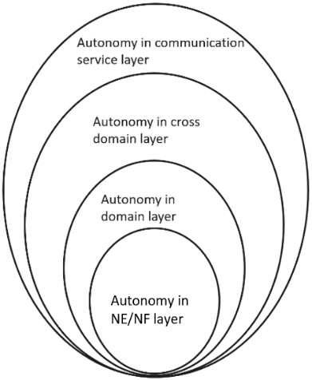

Figure 4.3.3-1: Autonomy for different management scope

### 4.3.4 Workflow

Workflow is used to describe the necessary steps to achieve certain management and control purposes. A workflow is composed of one or more management and control tasks. Each workflow task may be accomplished by human, or accomplished by telecommunication system with human assistance, or accomplished by telecommunication system without human intervention. The autonomy capabilities of the tasks in the workflow may impact the autonomous network level.

Following are the categorization of the tasks in a workflow:

- **Intent handling:** The group of tasks which translate network or service intent from operator or customer into detailed operations and/or control information which may affect one or more of the following groups of tasks (i.e. awareness, analysis, decision, execution), also evaluate and feedback intent fulfilment information (e.g. the intent is satisfied or not) based on the detailed network and service information. More information of intent handling see the Intent driven management defined in 28.312[2].

- **Awareness:** The group of tasks which include network and service data (e.g. configuration data, performance data, alarm data, etc.) collection and necessary data pre-processing (e.g. data cleaning, filtering, statistics, etc.) with the purpose of monitoring network and service information (including network and service performance, network and service anomaly, network and service event, etc.). More information of Awareness see corresponding Monitor of Management control loops defined in 28.535 [3].

- **Analysis:** The group of tasks which analyse the obtained network and service information (e.g. network and service status, network and service issues and so on) or based on the historical network and service information to further predict the future change trend of the above network and service status, and make recommendation for decision. More information of Analysis see corresponding Analytic of Management control loops defined in 28.535 [3].

- **Decision:** The group of tasks which evaluate and decide the necessary operation for execution, e.g. network configuration or adjustment. More information of Decision see corresponding Decision of Management control loops defined in 28.535 [3].

- **Execution:** The group of tasks which execute the operations. More information of Execution see corresponding Execution of Management control loops defined in 28.535 [3].

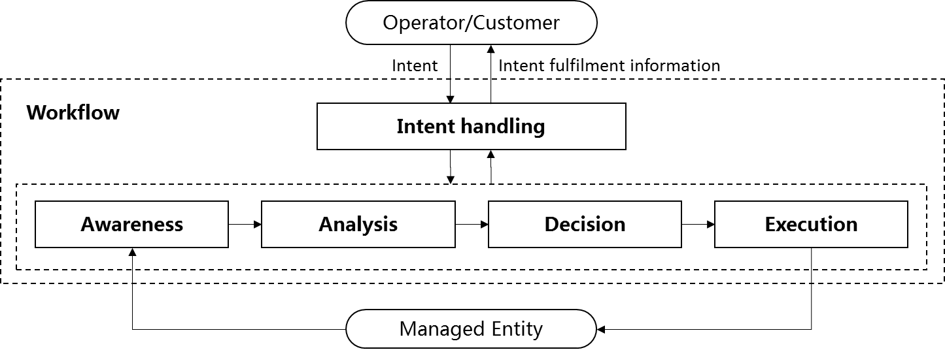

Figure 4.3.4-1: Categorization of the tasks in the workflow for evaluating autonomous network levels

# 5 Framework approach for evaluating autonomous network levels

A framework approach for evaluating autonomous network levels is as following, which is used for evaluating the autonomy capability of telecom system. In the following framework table:

- "Human" represents corresponding tasks are accomplished by human or human utilizing the tools for network and service management and orchestration.

- "Human & System" represents corresponding tasks are accomplished by collaboration of human and telecom system, the detailed collaboration pattern depends on the scenario, which is not addressed in the framework approach for evaluating autonomous network levels.

- "System" represents corresponding tasks are fully accomplished by telecom system.

Table 5-1: Framework approach for evaluating autonomous network levels

|  |  |  |  |  |  |  |
| --- | --- | --- | --- | --- | --- | --- |
| Autonomous network level | | Task categories | | | | |
| Execution | Awareness | Analysis | Decision | Intent handling |
| L0 | Manual operating network | Human | Human | Human | Human | Human |
| L1 | Assisted operating network | Human & Telecom system | Human & Telecom system | Human | Human | Human |
| L2 | Preliminary autonomous network | Telecom system | Human & Telecom system | Human & Telecom system | Human | Human |
| L3 | Intermediate autonomous network | Telecom system | Telecom system | Human & Telecom system | Human & Telecom system | Human |
| L4 | Advanced autonomous network | Telecom system | Telecom system | Telecom system | Telecom system | Human & Telecom system |
| L5 | Full autonomous network | Telecom system | Telecom system | Telecom system | Telecom system | Telecom system |
| Note 1: Human reviewed decision have the highest authority in each level if there is any confliction between human reviewed decision and telecom system generated decision.  Note 2: The order of above five task categories does not reflect the workflow sequence. | | | | | | |

**Level 0 manual operating network**: No categorization of the tasks is accomplished by telecom system itself.

**Level 1 assisted operating network**: A part of the execution and awareness tasks are accomplished automatically by telecom system itself based on human defined control information. At this level, telecom system can assist human to improve the execution and awareness efficiency.

**Level 2 preliminary autonomous network**: All the execution tasks are accomplished automatically by telecom system itself. A part of the awareness and analysis tasks are accomplished automatically by telecom system itself based on human defined control information. At this level, telecom system can assist human to achieve the closed loop based on human defined control information.

**Level 3 intermediate autonomous network**: All the execution and awareness tasks are accomplished automatically by telecom system itself. A part of the analysis and decision tasks are accomplished automatically by telecom system itself based on human defined control information. At this level, the telecom system can achieve the closed loop automation based on the human defined closed loop automation control information.

**Level 4 advanced autonomous network**: All the execution, awareness, analysis and decision tasks are accomplished automatically by telecom system itself. And intent handling tasks can be partly accomplished automatically by telecom system itself based on human defined intent handling control information. At this level, telecom system can achieve the intent driven closed loop automation based on human defined intent handling control information, which means the telecom system can translate the intent to the detailed closed loop automation control information and translate the detailed network and service information to intent fulfilment information (e.g. the intent is satisfied or not) based on human defined intent handling control information.

**Level 5 fully autonomous network**: The entire network autonomy workflow is accomplished automatically by telecom system without human intervention. At this level, telecom system can achieve the whole network autonomy.

Note 1: Above framework approach for evaluating autonomous network levels is applicable for evaluating the autonomous network level from both management scope and scenario perspective. The overall autonomous network level of the whole telecom system is a comprehensive reflection of autonomous network level of the individual management scope and scenarios, which means in fully autonomous network level, the telecom system can achieve the whole network autonomy for all management scopes and scenarios.

Note 2: The control information in the present document represents the information which can be formatted as rules or policies to assist/control the system to perform corresponding tasks in an autonomous manner.

# 6 Use cases and requirements

## 6.1 Network and service planning scenarios

Note: The Network and service planning scenarios is not addressed in the present document.

## 6.2 Network and service deployment scenarios

### 6.2.1 Autonomous network level for RAN NE deployment

RAN NE deployment use case refers to the entire workflow of deploying an RAN NE, full autonomy of RAN NE deployment can help the network operator to reduce OPEX by reducing manual involvement in such tasks. However, full autonomy of RAN NE deployment is a long term goal, it will be beneficial for operator to achieve this goal step by step and have clear view on which typical issues can be addressed by utilizing network autonomy mechanisms in corresponding steps. The requirements for each autonomous level for RAN NE deployment are different.

## 6.3 Network and service maintenance scenarios

### 6.3.1 Autonomous network level for fault management

Fault management use case refers to the entire workflow of network fault management, autonomy of fault management can help the network operator to reduce OPEX by reducing manual involvement in such tasks and to enhance user experience and reduce network and service failure time by reducing the time for network fault supervision and recovery. However, full autonomy of fault management is a long term goal, it will be beneficial for operator to achieve this goal step by step and have clear view on which typical issues can be addressed by utilizing network autonomy mechanism in corresponding steps. The requirements for each autonomous level for fault management autonomy are different.

## 6.4 Network and service optimization scenarios

### 6.4.1 Autonomous network level for radio network coverage optimization

Radio networks are geographically distributed, and mobile user activity varies significantly in different places and at different times of day. To achieve the optimal coverage, a set of initial coverage configuration parameters (e.g. coverageShape, digitalTilt and digitalAzimuth) may not always meet the requirements. Therefore, the coverage configuration parameters need to be adjusted in a differentiated manner with the change of the radio network environment. It is complex for the adjustment due to multiple factors needs to be considered, e.g. interference control, huge data and frequent traffic changes. So introducing the autonomous network level for radio network coverage optimization will benefit for operator to achieve the full autonomy goal step by step and have clear view on which typical issues can be addressed by utilizing autonomy mechanism in corresponding steps. The requirements for each autonomous level for radio network coverage optimization are different.

### 6.4.2 Autonomous network level for RAN UE throughput optimization

RAN UE throughput is a key performance for radio network, and, numerous radio feature parameters with broad value ranges affect the RAN UE throughput. There are many radio feature parameters of RAN NE level or cell level, for examples, MLB related parameters, resource schedule related parameters, cell reselection related parameters, handover related parameters, different radio feature parameters affect each other and the combination number of various parameter values is large. Therefore, it is complex to adjust radio feature configuration parameters to achieve the optimized RAN UE throughput. So introducing the autonomous network level for RAN UE throughput optimization will be benefit for operator to achieve the full autonomy goal step by step and have clear view on which typical issues can be addressed by utilizing autonomy mechanism in corresponding steps. The requirements for each autonomous level for RAN UE throughput optimization are different.

# 7 Generic autonomous network level

## 7.1 Generic autonomous network level for network optimization

### 7.1.1 Generic workflow

Following is the generic entire workflow for the network optimization:

**Intent handling:**

- **Task A**: Network optimization control information generation and determination. The tasks of generating and determining the network optimization related control information (e.g., control information for network issue identification, network issue analysis and network parameters adjustment) based on received network optimization intent (e.g. network targets for the specified areas).

- **Task B**: Network optimization intent fulfilment evaluation. The tasks of evaluating network optimization intent fulfilment information (e.g. corresponding network targets are satisfied or not).

**Awareness:**

- **Task C**: Network related information collection. The tasks of collecting network related data, including network performance data (i.e. performance measurement, MDT data), network configuration data and environment data (e.g. electronic map)).

**Analysis:**

- **Task D**: Network issues identification. The tasks of analysing the network performance (e.g. geographical grid based network performance) and identifying whether there are network issues (e.g. coverage related issues, RAN UE throughput related issues).

- **Task E**: Network deterioration prediction. The tasks of analysing current network performance and historical network performance, predicting the network performance trend in the future and identifying potential network performance deterioration in advance.

- **Task F**: Network issue demarcation. The tasks of analyse the network issue and determine the network issue categories (e.g. weak coverage, high load, low throughput).

- **Task G**: Network issue root cause analysis. The tasks of analysing the root cause (i.e. the location for the issue occurs and the cause for the issue) of the identified or predicted network issues.

- **Task H**: Network adjustment solutions analysis. The tasks of generating the recommended network adjustment solution which can address the identified or predicted network issues.

**Decision:**

- **Task I**: Network adjustment solutions evaluation and determination. The tasks of evaluating the recommended network adjustment solutions, and deciding the network adjustment solutions to be executed.

**Execution:**

- **Task J**: Network adjustment solutions execution. The tasks of adjusting and configuring the network configuration parameters.

### 7.1.2 Generic classification of autonomous network level

**Level 0:**

- All the tasks in the network optimization workflow (Task A, Task B, Task C, Task D, Task E, Task F, Task G, Task H, Task I, Task J) are accomplished by human.

**Level 1:**

- Telecom system executes the tasks of network adjustment solutions execution based on the specified network related parameters (Task J). Telecom system also can execute the tasks of collecting part of network related information (including performance metrics, configuration data, MDT data) based on the specified collection control information (Task C). At this level, telecom system can assist human to improve the execution and awareness efficiency for network optimization.

- All the other tasks in the network optimization workflow (Task A, Task B, Task D, Task E, Task F, Task G, Task H, Task I) are accomplished by human.

**Level 2:**

- Compared to Level 1, telecom system additionally executes the tasks of network issues identification, network issue demarcation and network issue root cause analysis based on the specified network issue identification and analysis control information (Task D, Task F，Task G). In this level, telecom system also can execute the task of collecting all network related information (including network performance data, network configuration data and environment data) based on the specified collection control information(Task C),The tasks of network adjustment solutions execution (Task I) are fully accomplished by telecom system. At this level, telecom system can assist human to achieve the closed loop for network optimization based on human defined control information.

- All the other tasks in the network optimization workflow (Task A, Task B, Task E, Task H, Task I) are accomplished by human.

**Level 3:**

- Compared to Level 2, telecom system additionally executes the tasks of network adjustment solutions analysis (Task H) and network adjustment solutions evaluation and determination (Task I) based on the specified network adjustment control information and evaluation control information. In this level, telecom system also can execute the tasks of network deterioration prediction (Task E) based on the specified network deterioration prediction control information. The tasks of network related information collection (Task C), network issues identification (Task D) and network issue demarcation (Task F) are fully accomplished by telecom system. At this level, the telecom system can achieve the closed loop automation for network optimization based on the human defined optimization control information.

- All the other tasks in the network optimization workflow (Task A, Task B) are accomplished by human.

**Level 4:**

- Compared to Level 3, the telecom system additionally executes the tasks of network optimization control information determination (Task A), and network optimization intent evaluation (Task B) based on received network optimization intent and intent translation/evaluation control information. The tasks of network issue root cause analysis (Task G), network adjustment solutions analysis (Task H), network adjustment solutions evaluation and determination (Task I), and network deterioration prediction (Task E) are fully accomplished by telecom system. At this level, telecom system can achieve the intent driven closed loop automation for network optimization based on human defined intent translation and evaluation control information.

- The intent translation and evaluation control information maybe pre-defined and specified by human to assist the telecom system.

**Level 5:**

- Telecom system can autonomously execute the entire workflow of radio network optimization for all scenarios, which means the telecom system can achieve the full autonomy for network optimization for full scenarios.

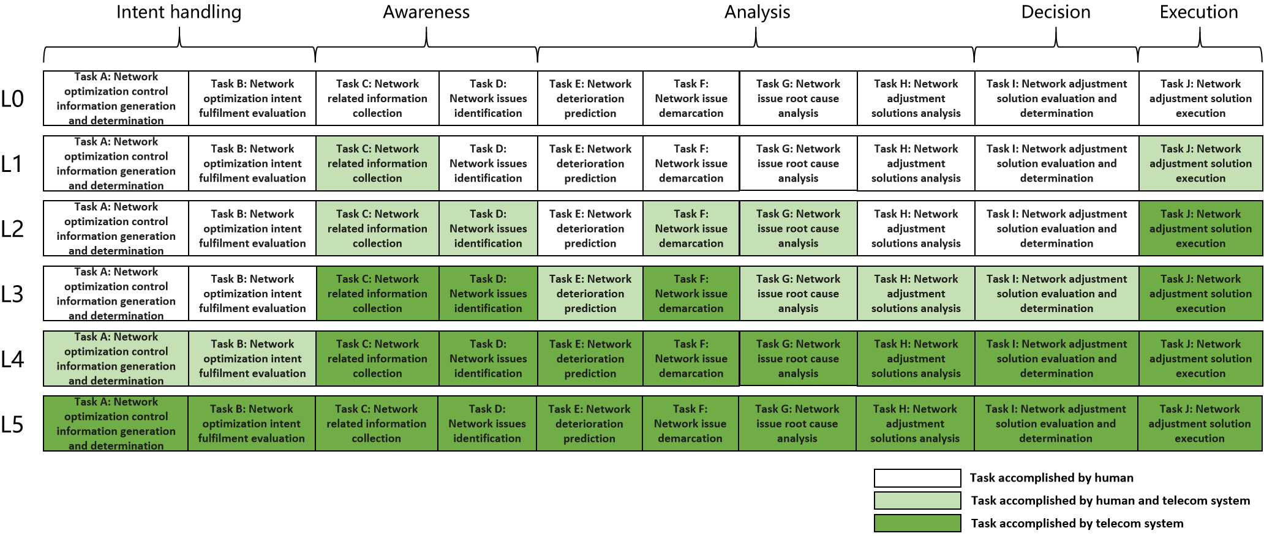

Figure 7.1.2-1 Classification of generic autonomous network level for network optimization

### 7.1.3 Generic autonomy capability description for management system

**Level 1 for Network Optimization:** The 3GPP management system has the following autonomy capabilities:

- Adjust network based on the specified network adjustment solution.

- Collect network related information (including network performance data, network configuration data and environment data) based on specified collection control information.

**Level 2 for Network Optimization:** The 3GPP management system has following autonomy capabilities:

- Identify the network issue based on the specified network issue identification control information.

- Demarcate the network issue (including network issue categories based on the specified network issue demarcation control information.

- Analyse the root cause of network issue based on the specified network issue analysis control information.

**Level 3 for Network Optimization:** The 3GPP management system has the following autonomy capabilities:

- Analyse and generate the recommended network adjustment solutions based on specified network adjustment control information.

- Evaluate the recommended network adjustment solutions and determine the network adjustment solutions to be executed based on specified network adjustment decision control information.

- Predict network performance deterioration.

**Level 4 for Network Optimization:** The 3GPP management system has the following autonomy capabilities:

- Determine or update network optimization policies according to network optimization intent based on specified intent translation control information.

- Evaluate network optimization intent fulfilment result based on specified intent evaluation control information.

**Level 5 for Network Optimization:** The 3GPP management system has the following autonomy capabilities:

- Generate the network optimization intent translation and evaluation control information.

### 7.1.4 Generic MnS requirements

##### 7.1.4.1 MnS requirements to support autonomous network level 1

**REQ-ANL-NetOpt-Level\_1-MnS-1** The 3GPP management system shall have the capability allowing its authorized consumer to specify the network adjustment solution.

**REQ-ANL-NetOpt-Level\_1-MnS-2** The 3GPP management system shall have the capability allowing its authorized consumer to specify the network related information collection control information.

**REQ-ANL-NetOpt-Level\_1-MnS-3** The 3GPP management system shall have the capability allowing its authorized consumer to obtain the network related information (including network performance data, network configuration data and environment data).

##### 7.1.4.2 Additional MnS requirements to support autonomous network level 2

**REQ-ANL-NetOpt-Level\_2-MnS-1** The 3GPP management system shall have the capability allowing its authorized consumer to specify the network issue identification control information.

**REQ-ANL-NetOpt-Level\_2-MnS-2** The 3GPP management system shall have the capability allowing its authorized consumer to obtain the network issue.

**REQ-ANL-NetOpt-Level\_2-MnS-3** The 3GPP management system shall have the capability allowing its authorized consumer to specify the network issue demarcation control information.

**REQ-ANL-NetOpt-Level\_2-MnS-4** The 3GPP management system shall have the capability allowing its authorized consumer to obtain the network issue demarcation result.

**REQ-ANL-NetOpt-Level\_2-MnS-5** The 3GPP management system shall have the capability allowing its authorized consumer to specify the network issue root cause analysis control information.

##### 7.1.4.3 Additional MnS requirements to support autonomous network level 3

**REQ-ANL-NetOpt-Level\_3-MnS-1** The 3GPP management system shall have the capability allowing its authorized consumer to specify the network adjustment analytic control information.

**REQ-ANL-NetOpt-Level\_3-MnS-2** The 3GPP management system shall have the capability allowing its authorized consumer to specify the network adjustment decision control information.

##### 7.1.4.4 Additional MnS requirements to support autonomous network level 4

The additional MnS requirements for level 4 are not specified in the present document.

### 7.1.5 Solutions for generic MnS requirements

**Table 7.1.5-1: Solutions for generic MnS requirements of autonomous network level for network optimization**

|  |  |  |
| --- | --- | --- |
| **Autonomous Network Level** | **Requirements**  **(Defined in Clause 7.1.4)** | **Corresponding solutions** |
| **Level 1** | **REQ-ANL-NetOpt-Level\_1-MnS-1** | This is implemented by provisioning MnS defined in TS 28.532 [4] with 5G Network Resource model defined in TS 28.541[5]. |
| **REQ-ANL-NetOpt-Level\_1-MnS-2** | This is implemented by provisioning MnS defined in TS 28.532 [4] with PM control NRM fragment and Trace control NRM fragment defined in TS 28.622 [6]. |
| **REQ-ANL-NetOpt-Level\_1-MnS-3** | This is implemented by file data reporting MnS and streaming data report MnS defined in TS 28.532 [4] with measurements defined in TS 28.552 [7], KPI defined in TS 28.554[8], MDT data defined in TS 32.422 [9]. |
| **Level2** | **REQ-ANL-NetOpt-Level\_2-MnS-1** | For the network issues which can be detected based on threshold, this can be implemented by generic provisioning MnS defined in TS 28.532 [4] with Threshold monitoring control NRM fragment defined in TS 28.622 [6]. |
| **REQ-ANL-NetOpt-Level\_2-MnS-2** | For the network issues which can be detected based on threshold, this can be implemented by notifyThresholdCrossing of performance assurance MnS defined in TS 28.532 [4]. |
| **REQ-ANL-NetOpt-Level\_2-MnS-3** | For the network issues which can be detected based on threshold,this can be implemented by generic provisioning MnS (e.g, createMOI) defined in TS 28.532 [4] with Threshold monitoring control NRM fragment defined in TS 28.622 [6]. |
| **REQ-ANL-NetOpt-Level\_2-MnS-4** | For the network issues which can be detected based on threshold, this can be implemented by notifyThresholdCrossing of performance assurance MnS defined in TS 28.532 [4]. |
| **REQ-ANL-NetOpt-Level\_2-MnS-5** | This can be implemented by using generic proivisioning MnS (e.g, createMOI) defined in TS 28.532 [4] to specify the network issue root cause analysis control information. |
| **Level3** | **REQ-ANL-NetOpt-Level\_3-MnS-1** | This can be implemented by using generic proivisioning MnS (e.g, createMOI) defined in TS 28.532 [4] to specify the network adjustment analytic control information. |
| **REQ-ANL-NetOpt-Level\_3-MnS-2** | This can be implemented by using generic provisioning MnS (e.g, createMOI) defined in TS 28.532 [4] to specify the network adjustment decision control information. |

## 7.2 Generic autonomous network level for RAN NE deployment

### 7.2.1 Generic workflow

Following are the entire workflow for RAN NE deployment:

**Intent handling:**

- **Task A**: RAN NE deployment control information generation based on received RAN NE deployment intent. The tasks of generating and determining the RAN NE deployment related control information (e.g. control information for RAN NE configuration data generation, RAN NE commissioning, RAN NE dialing test).

- **Task B**: RAN NE deployment intent evaluation, the tasks of evaluating RAN NE deployment fulfilment information (e.g. satisfied or not).

**Awareness:**

- **Task C**: RAN NE information collection, the tasks of collecting the RAN NE information (e.g., IP address, hardware information).

**Analysis:**

- **Task D**: RAN NE configuration data analysis, the tasks of analysing and generating the recommended network configuration data for the RAN NE based on the network planning data for the RAN NE and hardware information collected.

- **Task E**: RAN NE commissioning test, the tasks of performing the RAN NE commissioning test to put RAN NE into service (e.g. ensure the software and configuration (including radio configuration and transport configuration) is correct, and alarms are cleared).

- **Task F**: RAN NE dialing test, the tasks of performing the RAN NE dialing test to check whether RAN NE services are normal by testing whether the communication can be established between two subscribers.

**Decision:**

**- Task G:** RAN NE configuration data determination, the tasks of evaluating and determining the RAN NE configuration data to be download and activated.

**Execution:**

- **Task H**: RAN NE configuration data and software download and activation, the tasks of downloading and activating network configuration data and software in RAN NE.

### 7.2.2 Generic autonomous network level

**Level 0:**

- All the tasks in the RAN NE deployment workflow (Task A, Task B, Task C, Task D, Task E, Task F, Task G, Task H) are accomplished by human.

**Level 1:**

- Telecom system executes tasks of downloading and activating the available RAN NE network configuration data and software prepared by human (Task H) and tasks of collecting part of RAN NE information (including IP address) based on specified collection control information(Task C).

- All the other tasks in the RAN NE deployment workflow (Task A, Task B, Task C, Task D, Task E, Task F, Task G) are accomplished by human.

**Level 2:**

- Compared to Level 1, telecom system additionally executes the tasks of collecting RAN NE information (including hardware information) (Task C). Telecom system also can execute the tasks of analysing the network configuration data for the RAN NE based on the network configuration data generation control information (e.g. configuration template) specified by human(Task D). The tasks of RAN NE configuration data and software download and activation (Task H) are fully accomplished by telecom system.

- All the other tasks in the RAN NE deployment workflow (Task A, Task B, Task E, Task F, Task G) are accomplished by human.

**Level 3**:

- Compared to Level 2, the telecom system additionally executes tasks of analysing and determining the network configuration data for the RAN NE based on the network configuration data generation control information specified by human (Task D, Task G). Telecom system also can executes tasks of performing the RAN NE commissioning test based on commissioning control information specified by human (Task E), and tasks of performing the RAN NE dialing test based on dialing test control information specified by human(Task F). The tasks of RAN NE information collection (Task C) are fully accomplished by telecom system.

- All the other tasks in the RAN NE deployment workflow (Task A, Task B) are accomplished by human.

**Level 4:**

- Compared to Level 3, the telecom system can additionally execute the tasks of RAN NE deployment control information generation (Task A) and RAN NE deployment intent evaluation (Task B) based on intent handling control information specified by human. The tasks of RAN NE configuration data analysis (Task D), RAN NE configuration data determination (G), RAN NE commissioning test (Task E) and RAN NE dialing test (Task F) are fully accomplished by telecom system.

- The intent handling control information maybe pre-defined and specified by human.

**Level 5:**

- Telecom system can autonomously execute the entire workflow of RAN NE deployment for all scenarios,

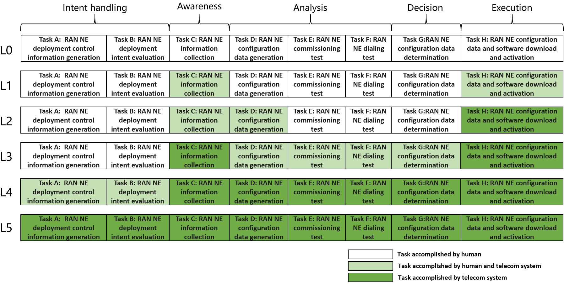

Figure 7.2.2-1 Classification of autonomous network level for RAN NE deployment

### 7.2.3 Generic autonomy capability description for management system

**Level 1 for RAN NE deployment:** The 3GPP management system has the following autonomy capabilities:

- Download and activate the specified RAN NE network configuration data and software.

- Collect RAN NE information based on the specified RAN NE information collection control information.

**Level 2 for RAN NE deployment:** The 3GPP management system has the following autonomy capabilities:

- Analyse the network configuration data for the RAN NE based on the specified network configuration data generation control information.

**Level 3 for** **RAN NE deployment**: The 3GPP management system has the following autonomy capabilities:

- Analyse and determine the network configuration data for the RAN NE based on the specified network configuration data generation control information.

- Perform the RAN NE commissioning test based on specified commissioning test control information.

**-** Perform the RAN NE dialing test based on specified dialing test control information.

**Level 4 for RAN NE deployment:** The 3GPP management system has the following autonomy capabilities:

- Determine or update RAN NE deployment control information according to RAN NE deployment intent based on specified intent translation control information.

**-** Evaluate RAN NE deployment intent fulfilment result based on specified intent evaluation control information.

**Level 5 for RAN NE deployment:** The 3GPP management system has the following autonomy capabilities:

- Generate the RAN NE deployment intent translation and evaluation control information.

### 7.2.4 Generic MnS requirements

##### 7.2.4.1 MnS requirements to support autonomous network level 1

**REQ-ANL-RanNeDeploy-Level\_1-MnS-1** The 3GPP management system shall have the capability allowing its authorized consumer to specify the RAN NE network configuration data and software.

**REQ-ANL-RanNeDeploy-Level\_1-MnS-2** The 3GPP management system shall have the capability allowing its authorized consumer to specify the RAN NE information collection control information.

##### 7.2.4.2 Additional MnS requirements to support autonomous network level 2

**REQ-ANL-RanNeDeploy-Level\_2-MnS-1** The 3GPP management system shall have the capability allowing its authorized consumer to specify the network configuration data generation control information.

##### 7.2.4.3 Additional MnS requirements to support autonomous network level 3

**REQ-ANL-RanNeDeploy-Level\_3-MnS-1** The 3GPP management system shall have the capability allowing its authorized consumer to specify the network configuration data generation control information.

**REQ-ANL-RanNeDeploy-Level\_3-MnS-2** The 3GPP management system shall have the capability allowing its authorized consumer to specify the commissioning test control information.

**REQ-ANL-RanNeDeploy-Level\_3-MnS-3** The 3GPP management system shall have the capability allowing its authorized consumer to specify the dialing test control information.

##### 7.2.4.4 Additional MnS requirements to support autonomous network level 4

The additional MnS requirements for level 4 are not specified in the present document.

### 7.2.5 Solutions for generic MnS requirements

Table 7.2.5-1: Solutions for generic MnS requirements of autonomous network level for RAN NE deployment

|  |  |  |
| --- | --- | --- |
| Autonomous Network Level | Requirements  (Defined in Clause 7.1.4) | Corresponding solutions |
| **Level 1** | **REQ-ANL-RanNeDeploy-Level\_1-MnS-1** | This is implemented by provisioning MnS defined in TS 28.532 [4] with 5G Network Resource model defined in TS 28.541 [5]. |
| **REQ-ANL-RanNeDeploy-Level\_1-MnS-2** | This is implemented by provisioning MnS defined in TS 28.532 [4] with 5G Network Resource model defined in TS 28.541 [5]. |
| **Level2** | **REQ-ANL-RanNeDeploy-Level\_2-MnS-1** | This can be implemented by provisioning MnS (e.g. createMOI) defined in TS 28.532 [4] to specify the network configuration data generation control information. |
| **Level3** | **REQ-ANL-RanNeDeploy-Level\_3-MnS-1** | This can be implemented by using generic provisioning MnS defined in TS 28.532 [4] to specify the network configuration data generation control information. |
| **REQ-ANL-RanNeDeploy-Level\_3-MnS-2** | This can be implemented by using generic provisioning MnS defined in TS 28.532 [4] to specify the commissioning test control information. |
| **REQ-ANL-RanNeDeploy-Level\_3-MnS-3** | This can be implemented by using generic provisioning MnS defined in TS 28.5326 [4] to specify the dialing test control information. |

## 7.3 Generic autonomous network level for fault management

### 7.3.1 Generic workflow

Following is the generic workflow for fault management:

**Intent handling:**

- **Task A:** Fault management control information generation. The group of tasks of generating the fault management related control information (e.g., control information for alarm filtering, fault recognition, root cause analysis, fault recovery) based on fault management intent (e.g. reduce fault recovery response time to a certain value, reduce network and service failure times to a certain value within a specific duration).

- **Task B:** Fault management intent fulfilment evaluation. The group of tasks of evaluating fault management intent fulfilment information (e.g. corresponding fault recovery response time is satisfied or not).

**Awareness:**

- **Task C:** Fault related information collection. The group of tasks which collect the alarm information and other fault related information (e.g. performance information and configuration information etc.).

- **Task D:** Alarm filtering. The group of tasks which filter the alarms collected in Task C based on the specified alarm filtering control information. A single network fault may generate a large number of correlative alarms over space and time, therefore it is considered advantageous to have methods filtering the redundant alarms. Reporting only effective alarms without redundant alarms would improve the efficiency of alarm management.

**Analysis:**

- **Task E:** Fault recognition. The group of tasks which recognize the fault based on the alarm information and other fault related information.

- **Task F:** Fault prediction. The group of tasks which predict the potential fault and its category based on the performance information and other fault related information.

- **Task G**: Fault demarcation. The group of tasks which analysis and determines the fault type and corresponding affected managed object (e.g. NE) based on the alarm information and other fault related information.

- **Task H:** Fault root cause analysis (RCA). The group of tasks which analyse the detailed root cause of the network and service failure.

- **Task I:** Fault recovery mechanism analysis. The group of tasks which analyse the possible fault recovery mechanisms based on the fault root cause, thereby generate the feasible options (e.g. recommended recovery solutions).

**Decision:**

- **Task J:** Fault management action evaluation and determination. The group of tasks which evaluate the feasible options and determine the fault recovery solutions and other corresponding actions (e.g. clear of alarms, storage and retrieval of alarms).

**Execution:**

- **Task K:** Fault management action execution. The group of tasks which execute the fault recovery actions and other corresponding actions.

Note: If the faulty resource has no redundancy (e.g. backup equipment/board/battery/transport link) and all the fall back recovery actions are not available nor effective, then the subsequent fault recovery actions (e.g. replace physical equipment/board/battery, repair the physical connector/fibre/cable, repair the power supply, etc.) are considered as beyond the capabilities of the telecom system. And those actions execution is excluded from the consideration of autonomous network level classification.

### 7.3.2 Generic autonomous network level

Level 0:

- All the tasks in the fault management workflow (Task A, Task B, Task C, Task D, Task E, Task F, Task G, Task H, Task I, Task J, Task K) are accomplished by human.

Level 1:

- Telecom system executes the tasks of fault related information collection to collect part of fault related information (including alarm information, performance metric, configuration data) (Task C) automatically based on predefined data collection control information, and the tasks of fault management action execution (Task K) based on specified fault recovery control information. Telecom system can also execute the tasks of alarm filtering (Task D) based on specified alarm filtering control information.

- All the other tasks in the fault management workflow (Task A, Task B, Task E, Task F, Task G, Task H, Task I, Task J) are accomplished by human.

Level 2:

- Compared to Level 1, telecom system can additionally executes the tasks of fault recognition (Task E) and fault demarcation (Task G) based on specified fault recognition and demarcation control information. In this level, telecom system can collect all fault related information (including environment data) based on specified data collection control information (Task C).The tasks of fault management action execution (Task J) is fully accomplished by telecom system.

- All the other tasks (Task A, Task B, Task F, Task H, Task I, Task J) are accomplished by human.

Level 3:

- Compared to Level 2, telecom system can additionally execute the tasks of fault root cause analysis based on specified fault root cause analysis control information (Task H). For certain network faults, telecom system can also additionally execute the tasks of fault prediction (Task F), fault recovery mechanism analysis (Task H) and action evaluation and determination(Task I) based on specified fault management control information (i.e. control information for fault prediction, fault recovery mechanism analysis, fault recovery mechanism decision). The tasks of fault related information collection (Task C),alarm filtering (Task D), fault recognition (Task E) and fault demarcation (Task G) are fully accomplished by telecom system.

- All the other tasks (Task A, Task B) are accomplished by human.

Level 4:

- Compared to Level 3, for certain scenario, telecom system additionally execute the tasks of fault management control information generation (Task A) and fault management intent fulfilment information evaluation (Task B) based on specified intent handling control information. The tasks of fault prediction (Task F), fault root cause analysis (Task H), fault recovery mechanism analysis (Task I) and action generation (Task J) are accomplished automatically by telecom system without human intervention.

- Intent handling control information can be pre-defined and specified by human.

Level 5:

- The entire fault management workflows is accomplished by telecom system without human intervention and human predefined control information.

- Human can optionally supervise the fault management action generated by telecom system.

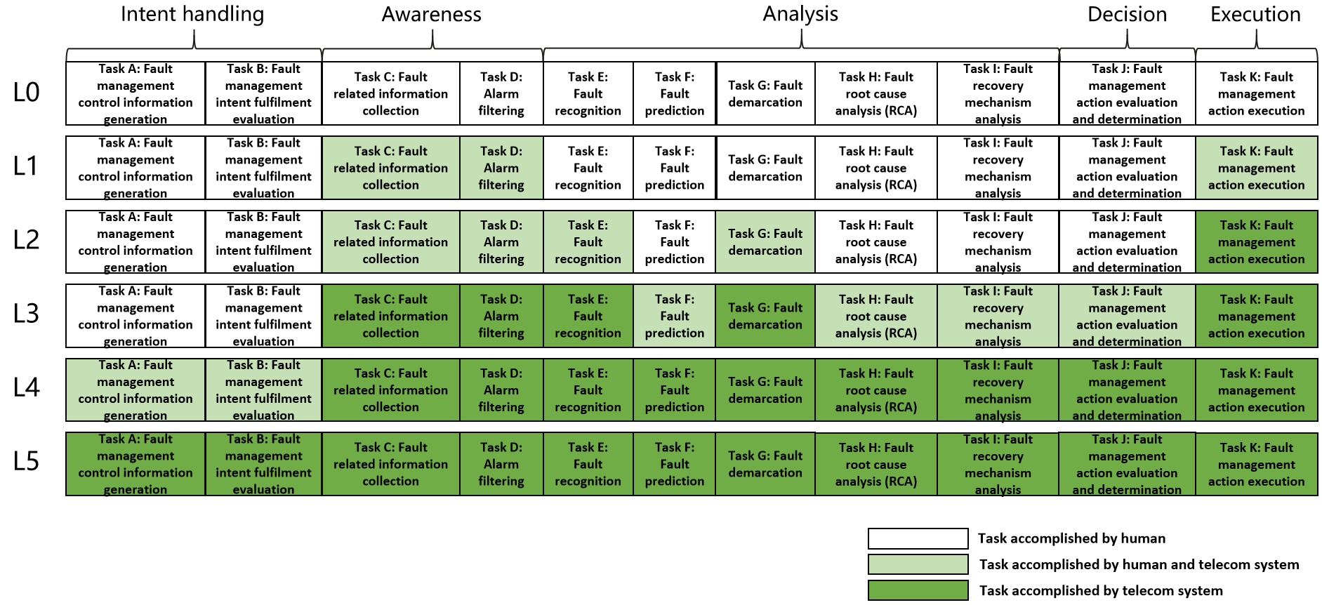

**Figure 7.3.2-1: Generic classification of autonomous network level for fault management**

### 7.3.3 Generic autonomy capability description for management system

**Level 1 for Fault Management:** The 3GPP management system has the following autonomy capabilities:

- Execute the network recovery actions (including reset the hardware/software, switch to the backup hardware, rollback to the backup software/firmware) with corresponding network elements based on the specified fault recovery control information.

- Obtain fault related data (including alarms, events, signaling data, performance data, configuration data and environment data) based on specified collection control information.

- Filter the alarms based on the specified filtering control information.

**Level 2 for Fault Management:** The 3GPP management system has the following autonomy capabilities:

- Identify the fault based on specified fault recognition control information.

- Demarcate the fault type and corresponding affected managed object (e.g. NE) based on specified fault demarcation control information.

**Level 3 for Fault Management:** The 3GPP management system has the following autonomy capabilities:

- Analyse the root cause of the network fault based on specified fault root cause analysis control information.

- Analyse and generate the recommended fault recovery mechanism and determine the fault recover actions to be executed based on specified fault recovery mechanism analysis and decision control information.

- Predict the potential fault.

**Level 4 for Fault Management:** The 3GPP management system has the following autonomy capabilities:

- Generate or update fault management control information according to fault management intent based on specified intent translation control information.

- Evaluate fault management intent fulfilment based on specified intent evaluation control information.

**Level 5 for Fault Management:** The 3GPP management system has the following autonomy capabilities:

- Generate the fault management intent translation and evaluation control information.

### 7.3.4 Generic MnS requirements

##### 7.3.4.1 MnS Requirements to support autonomous network level 1

**REQ-ANL-FM-Level\_1-MnS-1** The 3GPP management system shall have the capability allowing its authorized consumer to specify the fault recovery control information.

**REQ-ANL-FM-Level\_1-MnS-2** The 3GPP management system shall have the capability allowing its authorized consumer to specify the fault related data collection control information.

**REQ-ANL-FM-Level\_1-MnS-3** The 3GPP management system shall have the capability allowing its authorized consumer to specify the alarm filtering control information.

**REQ-ANL-FM-Level\_1-MnS-4** The 3GPP management system shall have the capability allowing its authorized consumer to obtain fault related data (including alarms, events, signaling data, performance data, configuration data and environment data).

**REQ-ANL-FM-Level\_1-MnS-5** The 3GPP management system shall have the capability allowing its authorized consumer to obtain the filtered alarm data.

##### 7.3.4.2 Additional MnS requirements to support autonomous network level 2

**REQ-ANL-FM-Level\_2-MnS-1**. The 3GPP management system shall have the capability allowing its authorized consumer to specify the fault recognition control information.

**REQ-ANL-FM-Level\_2-MnS-2** The 3GPP management system shall have the capability allowing its authorized consumer to obtain the recognized fault information.

**REQ-ANL-FM-Level\_2-MnS-3**. The 3GPP management system shall have the capability allowing its authorized consumer to specify the fault demarcation control information.

**REQ-ANL-FM-Level\_2-MnS-4** The 3GPP management system shall have the capability allowing its authorized consumer to obtain the fault demarcation information (including fault type and corresponding affected managed object e.g. NE).

##### 7.3.4.3 Additional MnS requirements to support autonomous network level 3

**REQ-ANL-FM-Level\_3-MnS-1** The 3GPP management system shall have the capability allowing its authorized consumer to specify the fault root cause analysis control information.

**REQ-ANL-FM-Level\_3-MnS-2** The 3GPP management system shall have the capability allowing its authorized consumer to specify the fault recovery mechanism analysis control information.

**REQ-ANL-FM-Level\_3-MnS-3** The 3GPP management system shall have the capability allowing its authorized consumer to specify the fault recovery mechanism decision control information.

**REQ-ANL-FM-Level\_3-MnS-4** The 3GPP management system shall have the capability allowing its authorized consumer to obtain the root cause of the network fault.

**REQ-ANL-FM-Level\_3-MnS-5** The 3GPP management system shall have the capability allowing its authorized consumer to obtain the recommended fault recovery mechanism.

**REQ-ANL-FM-Level\_3-MnS-6** The 3GPP management system shall have the capability allowing its authorized consumer to obtain the potential fault prediction information.

##### 7.3.4.4 Additional MnS requirements to support autonomous network level 4

The additional MnS requirements for level 4 are not specified in the present document.

### 7.3.5 Solutions for generic MnS requirements

Table 7.3.5-1: Solutions for generic MnS requirements of autonomous network level for fault management

|  |  |  |
| --- | --- | --- |
| Autonomous Network Level | Requirements  (Defined in Clause 7.1.4) | Corresponding solutions |
| **Level 1** | **REQ-ANL-FM-Level\_1-MnS-1** | This is implemented by fault supervision MnS defined in TS 28.532 [4], and provisioning MnS defined in TS 28.532 [4] with 5G Network Resource model defined in TS 28.541 [5]. |
| **REQ-ANL-FM-Level\_1-MnS-2** | This is implemented by fault supervision MnS defined in TS 28.532 [4], provisioning MnS defined in TS 28.532 [4] with 5G Network Resource model defined in TS 28.541 [5], PM control NRM fragment and Trace control NRM fragment define in TS 28.622 [6]. |
| **REQ-ANL-FM-Level\_1-MnS-3** | This can be implemented by utilizing fault supervision MnS (e.g. getAlarmList) defined in TS 28.532 [4] to specify the alarm filtering control information. |
| **REQ-ANL-FM-Level\_1-MnS-4** | This is implemented by fault supervision MnS defined in TS 28.532 [4], provisioning MnS defined in TS 28.532 [4] with 5G Network Resource model defined in TS 28.541 [5], streaming data reporting MnS and File data reporting MnS defined in TS 28.532 [4]. |
| **REQ-ANL-FM-Level\_1-MnS-5** | This can be implemented by utilizing fault supervision MnS (e.g. getAlarmList, notifyNewAlarm) defined in TS 28.532 [4] to obtain the filtered alarm data. |
| **Level2** | **REQ-ANL-FM-Level\_2-MnS-1** | This can be implemented by utilizing generic provisioning MnS defined in TS 28.532 [4] to specify the fault recognition control information. |
| **REQ-ANL-FM-Level\_2-MnS-2** | This can be implemented by utilizing fault supervision MnS (e.g. getAlarmList, notifyNewAlarm) defined in TS 28.532 [4] to obtain the recognized fault information. |
| **REQ-ANL-FM-Level\_2-MnS-3** | This can be implemented by utilizing generic provisioning MnS defined in TS 28.532 [4] to specify the fault demarcation control information. |
| **REQ-ANL-FM-Level\_2-MnS-4** | This can be implemented by Fault supervision MnS defined in TS 28.532 [4] to obtain the fault demarcation information (including fault type and corresponding affected managed object). |
| **Level3** | **REQ-ANL-FM-Level\_3-MnS-1** | This can be implemented by utilizing generic provisioning MnS defined in TS 28.532 [4] to specify the fault root cause analysis control information. |
| **REQ-ANL-FM-Level\_3-MnS-2** | This can be implemented by utilizing generic provisioning MnS defined in 28.532 [4] to specify the fault recovery mechanism analysis control information. |
| **REQ-ANL-FM-Level\_3-MnS-3** | This can be implemented by utilizing generic provisioning MnS defined in 28.532 [4] to specify the fault recovery mechanism decision control information. |
| **REQ-ANL-FM-Level\_3-MnS-4** | This can be implemented by Fault supervision MnS (e.g. getAlarmList, notifyNewAlarm) defined in TS 28.532 [4] to obtain the root cause of the network fault. |
| **REQ-ANL-FM-Level\_3-MnS-5** | This can be implemented by Fault supervision MnS (e.g. getAlarmList, notifyNewAlarm) defined in TS 28.532 [4] to obtain the recommended fault recovery mechanism. |
| **REQ-ANL-FM-Level\_3-MnS-6** | This can be implemented by MDA MnS (i.e. MDAAssistedFaultManagement.FailurePrediction) defined in TS 28.104 [6] to obtain the potential fault prediction information. |

Annex A (informative):  
Examples of Autonomous network level for network and service optimization

## A.1 Autonomous network level for radio network coverage optimization

### A.1.1 Workflow

Following are the entire workflow for the radio network coverage optimization:

**Intent handling:**

- **Task A**: Coverage optimization policies generation and determination. The tasks of generating and determining the coverage optimization related policies (e.g. weak coverage issue identification policies, weak coverage analysis policies and coverage parameters adjustment policies) based on received coverage optimization intent (e.g. coverage targets (e.g. weak coverage ratio) for the specified areas).

- **Task B**: Coverage optimization intent evaluation. The tasks of evaluating coverage optimization intent fulfilment information (e.g. corresponding coverage targets are satisfied or not).

**Awareness:**

- **Task C**: Coverage related information collection. The tasks of collecting coverage related data, including coverage performance data (i.e. performance measurement, MDT data), coverage configuration data (e.g. coverageShape, digitalTilt and digitalAzimuth) and environment data (e.g. electronic map)).

**Analysis:**

- **Task D**: Coverage issues identification. The tasks of analysing the coverage performance (e.g. geographical grid based coverage performance) and identifying the coverage issues.

- **Task E**: Coverage deterioration prediction. The tasks of analysing current coverage performance and historical coverage performance, predicting the coverage performance trend in the future and identifying potential coverage performance deterioration in advance.

**- Task F**: Coverage issues demarcation. The tasks of analysing the coverage issues and determining the coverage categories (e.g. weak coverage, coverage hole, overshoot coverage).

- **Task G**: Coverage issue root cause analysis. The tasks of analysing the root cause (e.g. Inappropriate NRSectorCarrier parameters) of the identified or predicted coverage issues.

- **Task H**: Coverage adjustment solutions analysis. The tasks of generating the recommended coverage adjustment solution which can address the identified or predicted coverage issues.

**Decision:**

- **Task I**: Coverage adjustment solutions evaluation and determination. The tasks of evaluating the recommended coverage adjustment solutions, and deciding the coverage adjustment solutions to be executed.

**Execution:**

- **Task J**: Coverage adjustment solutions execution. The tasks of adjusting and configuring the coverage related parameters (e.g. selection of coverageShape, digitalTilt and digitalAzimuth).

### A.1.2 Classification of autonomous network level

**Level 0:**

- All the tasks in the radio network coverage optimization workflow (Task A, Task B, Task C, Task D, Task E, Task F, Task G, Task H, Task I, Task J) are accomplished by human.

**Level 1:**

- Telecom system executes the tasks of coverage adjustment solutions execution based on the specified coverage related parameters (Task J). Telecom system also can execute the tasks of coverage related information collection based on the specified collection rule (Task C). At this level, telecom system can assist human to improve the execution and awareness efficiency for radio network coverage optimization.

- All the other tasks in the radio network coverage optimization workflow (Task A, Task B, Task D, Task E, Task F, Task G, Task H, Task I) are accomplished by human.

**Level 2:**

- Compared to Level 1, telecom system additionally executes the tasks of coverage issues identification, coverage issues demarcation and coverage issue root cause analysis based on the specified coverage issue identification and analysis rule (Task D, Task F, Task G). The tasks of coverage adjustment solutions execution (Task J) is fully accomplished by telecom system. At this level, telecom system can assist human to achieve the closed loop for radio network coverage optimization based on human defined rules.

- All the other tasks in the radio network coverage optimization workflow (Task A, Task B, Task E, Task H, Task I) are accomplished by human.

**Level 3:**

- Compared to Level 2, telecom system additionally executes the tasks of coverage adjustment solutions analysis (Task H) and coverage adjustment solutions evaluation and determination (Task I) based on the specified coverage adjustment policies and evaluation policies. In this level, telecom system also can execute the tasks of coverage deterioration prediction (Task E) based on the specified deterioration prediction policies. The tasks of coverage related information collection (Task C), coverage issues identification (Task D) and coverage issues demarcation (Task F) are fully accomplished by telecom system. At this level, the telecom system can achieve the closed loop automation for coverage optimization based on the human defined optimization policies.

- All the other tasks in the radio network coverage optimization workflow (Task A, Task B) are accomplished by human.

**Level 4:**

- Compared to Level 3, the telecom system additionally executes the tasks of coverage optimization policies determination (Task A), and coverage optimization intent evaluation (Task B) based on received coverage optimization intent and intent translation/evaluation policies. The tasks of coverage issue root cause analysis (Task G), coverage adjustment solutions analysis (Task H), coverage adjustment solutions evaluation and determination (Task I) and coverage deterioration prediction (Task E) are fully accomplished by telecom system. At this level, telecom system can achieve the intent driven closed loop automation for radio network coverage optimization based on human defined intent translation and evaluation policies

- The intent translation and evaluation policies maybe pre-defined and specified by human to assist the telecom system.

**Level 5:**

- Telecom system can autonomously execute the entire workflow of radio network coverage optimization for all scenarios, which means the telecom system can achieve the full autonomy for radio network coverage optimization for full scenarios.

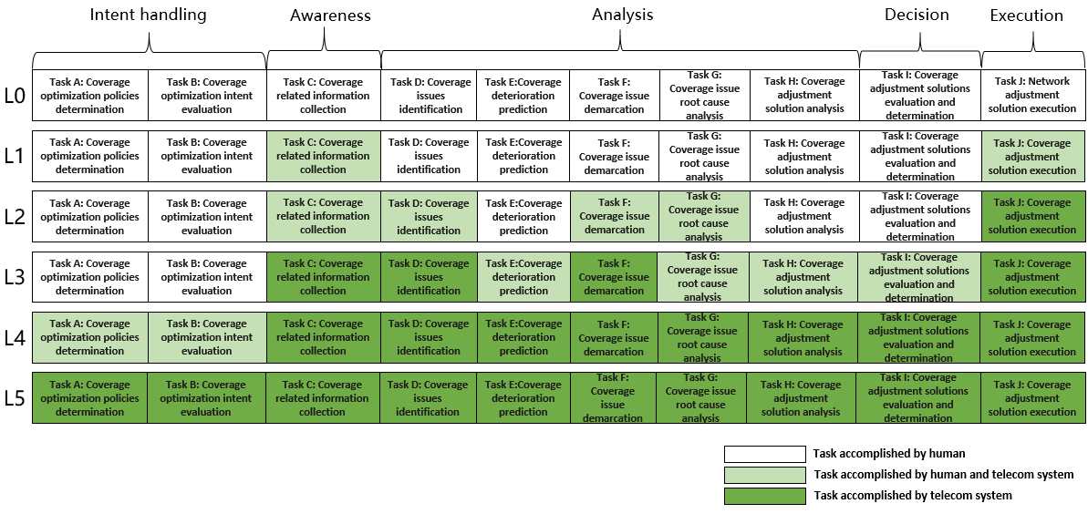

Figure A.1.2-1: Classification of autonomous network level for coverage optimization

### A.1.3 Example of mapping autonomous network level requirements for coverage optimization with functional/interface features.

|  |  |  |
| --- | --- | --- |
| Autonomous Network Level (ANL) | Requirements  (Defined in Clause 7.1.4) | Potential implementation |
| **Level 1** | **REQ-ANL-NetOpt-Level\_1-MnS-1** | This can be implemented by generic provisioning MnS defined in TS 28.532 [4] with CommonBeamformingFunction IOC defined in TS 28.541[5]. |
| **REQ-ANL-NetOpt-Level\_1-MnS-2** | This can be implemented by generic performance assurance MnS (defined in TS 28.532[4]) with PerfMetricJob IOC defined in TS 28.622[6] and TraceJob IOC defined in TS 28.622[6]. |
| **REQ-ANL-NetOpt-Level\_1-MnS-3** | This can be implemented by streaming data reporting MnS and file data reporting MnS defined in TS 28.532[4] with coverage related data (including SS-RSRP, SS-RSRQ, SS-SINR, RRC connection setup success (or failure) rate, handover failures) defined in TS 28.552 [7]. |
| **Level 2** | **REQ-ANL-NetOpt-Level\_2-MnS-1** | This can be implemented by generic provisioning MnS defined in TS 28.532 [4] with ThresholdMonitor IOC defined in TS 28.622 [6] to specify the SS-RSRP, SS-RSRQ, SS-SINR and handover failures threshold for coverage issues. |
| **REQ-ANL-NetOpt-Level\_2-MnS-2** | This can be implemented by notifyThresholdCrossing of performance assurance MnS defined in TS 28.532 [4] to notify SS-RSRP, SS-RSRQ, SS-SINR and handover failures threshold crossing for coverage issues. |
| **REQ-ANL-NetOpt-Level\_2-MnS-3** | This can be implemented by generic provisioning MnS defined in TS 28.532 [4] with ThresholdMonitor IOC defined in TS 28.622 [6] to specify the SS-RSRP, SS-RSRQ, SS-SINR and handover failures threshold for coverage hole issue and weak coverage issue. |
| **REQ-ANL-NetOpt-Level\_2-MnS-4** | This can be implemented by notifyThresholdCrossing of performance assurance MnS defined in TS 28.532 [4] to notify SS-RSRP, SS-RSRQ, SS-SINR and handover failures threshold crossing for coverage hole issue and weak coverage issue. |
| **REQ-ANL-NetOpt-Level\_2-MnS-5** | This can be implemented by using generic proivisioning MnS (e.g, createMOI) defined in TS 28.532 [4] to specify the coverage issue root cause analysis policies. The detailed coverage adjustment analytic policies is not specified in the present document. |
| **Level 3** | **REQ-ANL-NetOpt-Level\_3-MnS-1** | This can be implemented by using generic proivisioning MnS (e.g, createMOI) defined in TS 28.532 [4] to specify the coverage adjustment analytic policies. The detailed coverage adjustment analytic policies is not specified in the present document. |
| **REQ-ANL-NetOpt-Level\_3-MnS-3** | This can be implemented by using generic provisioning MnS (e.g, createMOI) defined in TS 28.532 [4] to specify the coverage adjustment decision policies. The detailed coverage adjustment decision policies is not specified in the present document. |

## A.2 Autonomous network level for RAN UE throughput optimization

### A.2.1 Workflow

Following are the entire workflow for the RAN UE throughput optimization:

**Intent handling:**

- **Task A:** RAN UE throughput optimization policies generation and determination. The tasks of generating and determining the RAN UE throughput optimization related policies (e.g. RAN UE throughput issue identification policies, RAN UE throughput analysis policies and RAN UE throughput parameters adjustment policies) based on received RAN UE throughput optimization intent (e.g. RAN UE throughput targets (e.g. low RAN UE throughput ratio, target average RAN UE throughput) for the specified areas).

- **Task B:** RAN UE throughput optimization intent fulfilment evaluation. The tasks of evaluating RAN UE throughput optimization intent fulfilment information (e.g. corresponding RAN UE throughput targets are satisfied or not).

**Awareness:**

- **Task C:** RAN UE throughput related information collection. The tasks of collecting RAN UE throughput related data, including RAN UE throughput performance data (e.g. Average UL/ DL UE throughput in gNB, Distribution of UL/DL UE throughput in gNB), RAN UE throughput configuration data (e.g. cellIndividualOffset, isHOAllowed and isMLBAllowed of corresponding NRCellRelation(s) and environment data (e.g. electronic map)).

**Analysis:**

- **Task D:** RAN UE throughput issues identification. The tasks of analysing the RAN UE throughput performance (e.g. geographical grid based RAN UE throughput performance) and identifying the RAN UE throughput issues.

- **Task E:** RAN UE throughput deterioration prediction. The tasks of analysing current RAN UE performance and historical RAN UE throughput performance, predicting the RAN UE throughput performance trend in the future and identifying potential RAN UE throughput performance deterioration in advance.

**- Task F:** RAN UE throughput issues demarcation. The tasks of analysing the RAN UE throughput issues (e.g. low average RAN UE throughput, large number of UEs with low RAN UE throughput).

- **Task G:** RAN UE throughput issues root cause analysis. The tasks of analysing the root cause (e.g. unbalanced load between different cells, frequently handover among several cells) of the identified or predicted RAN UE throughput issues.

- **Task H:** RAN UE throughput adjustment solutions analysis. The tasks of generating the recommended RAN UE throughput adjustment solution (e.g. reconfigure the NRCellRelation IOC and DMROFunction IOC of corresponding RAN NEs) which can address the identified or predicted RAN UE throughput issues.

**Decision:**

- **Task I:** RAN UE throughput adjustment solutions evaluation and determination. The tasks of evaluating the recommended RAN UE throughput adjustment solutions, and deciding the RAN UE throughput adjustment solutions to be executed.

**Execution:**

- **Task J:** RAN UE throughput adjustment solutions execution. The tasks of adjusting and configuring the RAN UE throughput related parameters (e.g. cellIndividualOffset, isHOAllowed and isMLBAllowed of corresponding NRCellRelation(s), maximumDeviationHoTrigger of corresponding DMROFunction).

### A.2.2 Classification of autonomous network level

**Level 0:**

- All the tasks in the RAN UE throughput optimization workflow (Task A, Task B, Task C, Task D, Task E, Task F, Task G, Task H, Task I, Task J) are accomplished by human.

**Level 1:**

- Telecom system executes the tasks of RAN UE throughput adjustment solutions execution based on the specified RAN UE throughput related parameters (Task J). Telecom system also can execute the tasks of RAN UE throughput related information collection based on the specified collection rule (Task C). At this level, telecom system can assist human to improve the execution and awareness efficiency for RAN UE throughput optimization.

- All the other tasks in the RAN UE throughput optimization workflow (Task A, Task B, Task D, Task E, Task F, Task G, Task H, Task I) are accomplished by human.

**Level 2:**

- Compared to Level 1, telecom system additionally executes the tasks of RAN UE throughput issues identification, RAN UE throughput issues demarcation and RAN UE throughput issues root cause analysis based on the specified RAN UE throughput issues identification rule, RAN UE throughput issues demarcation rule and RAN UE throughput issues root cause analysis rule (Task D, Task F, Task G). The tasks of RAN UE throughput adjustment solutions execution (Task J) is fully accomplished by telecom system. At this level, telecom system can assist human to achieve the closed loop for RAN UE throughput optimization based on human defined rules.

- All the other tasks in the RAN UE throughput optimization workflow (Task A, Task B, Task E, Task H, Task I) are accomplished by human.

**Level 3:**

- Compared to Level 2, telecom system additionally executes the tasks of RAN UE throughput adjustment solutions analysis (Task H) and RAN UE throughput adjustment solutions evaluation and determination (Task I) based on the specified RAN UE throughput adjustment policies and evaluation policies. In this level, telecom system also can execute the tasks of RAN UE throughput deterioration prediction (Task E) based on the specified deterioration prediction policies. The tasks of RAN UE throughput related information collection (Task C), RAN UE throughput issues identification (Task D) and RAN UE throughput issues demarcation (Task F) are fully accomplished by telecom system. At this level, the telecom system can achieve the closed loop automation for RAN UE throughput optimization based on the human defined optimization policies.

- All the other tasks in the RAN UE throughput optimization workflow (Task A, Task B) are accomplished by human.

**Level 4:**

- Compared to Level 3, the telecom system additionally executes the tasks of RAN UE throughput optimization policies determination (Task A), and RAN UE throughput optimization intent evaluation (Task B) based on received RAN UE throughput optimization intent and intent translation/evaluation policies. The tasks of RAN UE throughput adjustment solutions analysis (Task H), RAN UE throughput adjustment solutions evaluation and determination (Task I), RAN UE throughput deterioration prediction (Task E) and RAN UE throughput issues root cause analysis (Task G) are fully accomplished by telecom system. At this level, telecom system can achieve the intent driven closed loop automation for RAN UE throughput optimization based on human defined intent translation and evaluation policies

- The intent translation and evaluation policies maybe pre-defined and specified by human to assist the telecom system.

**Level 5:**

- Telecom system can autonomously execute the entire workflow of RAN UE throughput optimization for all scenarios, which means the telecom system can achieve the full autonomy for RAN UE throughput optimization for full scenarios.

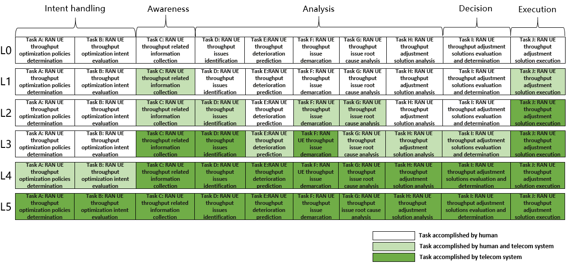Figure A.2.2-1: Classification of autonomous network level for RAN UE throughput optimization

Annex B (informative):  
Change history

|  |  |  |  |  |  |  |  |
| --- | --- | --- | --- | --- | --- | --- | --- |
| **Change history** | | | | | | | |
| **Date** | **Meeting** | **Tdoc** | **CR** | **Rev** | **Cat** | **Subject/Comment** | **New version** |
| 2021-12 | SA#94e |  |  |  |  | Upgrade to change control version | 17.0.0 |
| 2022-09 | SA#97e | SP-220848 | 0001 | - | F | Correct solution for fault management | 17.1.0 |
| 2024-04 | - | - | - | - | - | Update to Rel-18 version (MCC) | **18.0.0** |