|  |  |
| --- | --- |
| 3GPP TS 28.315 V18.0.0 (2024-04) | |
| Technical Specification | |
| 3rd Generation Partnership Project;  Technical Specification Group Services and System Aspects;  Management and orchestration;  Plug and connect;  Procedure flows  (Release 18) | |
|  | |
|  |  |
|  | |
| The present document has been developed within the 3rd Generation Partnership Project (3GPP TM) and may be further elaborated for the purposes of 3GPP. The present document has not been subject to any approval process by the 3GPPOrganizational Partners and shall not be implemented. This Specification is provided for future development work within 3GPPonly. The Organizational Partners accept no liability for any use of this Specification. Specifications and Reports for implementation of the 3GPP TM system should be obtained via the 3GPP Organizational Partners' Publications Offices. | |

|  |
| --- |
|  |
| ***3GPP***  Postal address  3GPP support office address  650 Route des Lucioles - Sophia Antipolis  Valbonne - FRANCE  Tel.: +33 4 92 94 42 00 Fax: +33 4 93 65 47 16  Internet  http://www.3gpp.org |
| ***Copyright Notification***  No part may be reproduced except as authorized by written permission. The copyright and the foregoing restriction extend to reproduction in all media.  © 2024, 3GPP Organizational Partners (ARIB, ATIS, CCSA, ETSI, TSDSI, TTA, TTC).  All rights reserved.  UMTS™ is a Trade Mark of ETSI registered for the benefit of its members  3GPP™ is a Trade Mark of ETSI registered for the benefit of its Members and of the 3GPP Organizational Partners LTE™ is a Trade Mark of ETSI registered for the benefit of its Members and of the 3GPP Organizational Partners  GSM® and the GSM logo are registered and owned by the GSM Association |

Contents

Foreword 4

Introduction 5

1 Scope 6

2 References 6

3 Definitions of terms, symbols and abbreviations 6

3.1 Terms 6

3.2 Symbols 6

3.3 Abbreviations 6

4 Architecture for Plug and Connect 6

4.1 Functional architecture 6

4.2 Functional elements 7

4.2.1 IP Autoconfiguration services 7

4.2.2 DNS server 7

4.2.3 Certification Authority server 7

4.2.4 Software and Configuration Server (SCS) 7

4.2.5 Security Gateway (SeGW) 7

5 Procedure flows 8

5.1 High-level plug-and-connect 8

5.2 Initial IP Autoconfiguration 9

5.3 Certificate enrolment 11

5.4 Establishing secure connection 12

5.5 Establishing connection to Software and Configuration Server (SCS) 13

Annex A (informative): PlantUML source code 16

Annex B (informative): Change history 20

# Foreword

This Technical Specification has been produced by the 3rd Generation Partnership Project (3GPP).

The contents of the present document are subject to continuing work within the TSG and may change following formal TSG approval. Should the TSG modify the contents of the present document, it will be re-released by the TSG with an identifying change of release date and an increase in version number as follows:

Version x.y.z

where:

x the first digit:

1 presented to TSG for information;

2 presented to TSG for approval;

3 or greater indicates TSG approved document under change control.

y the second digit is incremented for all changes of substance, i.e. technical enhancements, corrections, updates, etc.

z the third digit is incremented when editorial only changes have been incorporated in the document.

In the present document, modal verbs have the following meanings:

**shall** indicates a mandatory requirement to do something

**shall not** indicates an interdiction (prohibition) to do something

The constructions "shall" and "shall not" are confined to the context of normative provisions, and do not appear in Technical Reports.

The constructions "must" and "must not" are not used as substitutes for "shall" and "shall not". Their use is avoided insofar as possible, and they are not used in a normative context except in a direct citation from an external, referenced, non-3GPP document, or so as to maintain continuity of style when extending or modifying the provisions of such a referenced document.

**should** indicates a recommendation to do something

**should not** indicates a recommendation not to do something

**may** indicates permission to do something

**need not** indicates permission not to do something

The construction "may not" is ambiguous and is not used in normative elements. The unambiguous constructions "might not" or "shall not" are used instead, depending upon the meaning intended.

**can** indicates that something is possible

**cannot** indicates that something is impossible

The constructions "can" and "cannot" are not substitutes for "may" and "need not".

**will** indicates that something is certain or expected to happen as a result of action taken by an agency the behaviour of which is outside the scope of the present document

**will not** indicates that something is certain or expected not to happen as a result of action taken by an agency the behaviour of which is outside the scope of the present document

**might** indicates a likelihood that something will happen as a result of action taken by some agency the behaviour of which is outside the scope of the present document

**might not** indicates a likelihood that something will not happen as a result of action taken by some agency the behaviour of which is outside the scope of the present document

In addition:

**is** (or any other verb in the indicative mood) indicates a statement of fact

**is not** (or any other negative verb in the indicative mood) indicates a statement of fact

The constructions "is" and "is not" do not indicate requirements.

# Introduction

The present document is part of a TS family covering the 3rd Generation Partnership Project Technical Specification Group Services and System Aspects, Management and orchestration; as identified below:

TS 28.314: "Plug and Connect; Concepts and requirements".

**TS 28.315: "Plug and Connect; Procedure flows".**

TS 28.316: "Plug and Connect; Data formats".

# 1 Scope

The present document specifies procedure flows for *Plug and Connect* NE in 3GPP systems.

# 2 References

The following documents contain provisions which, through reference in this text, constitute provisions of the present document.

- References are either specific (identified by date of publication, edition number, version number, etc.) or non‑specific.

- For a specific reference, subsequent revisions do not apply.

- For a non-specific reference, the latest version applies. In the case of a reference to a 3GPP document (including a GSM document), a non-specific reference implicitly refers to the latest version of that document *in the same Release as the present document*.

[1] 3GPP TR 21.905: "Vocabulary for 3GPP Specifications".

[2] 3GPP TS 28.314: "Management and orchestration; Plug and Connect; Concepts and requirements".

[3] 3GPP TS 28.316: "Management and orchestration; Plug and Connect; Data formats".

# 3 Definitions of terms, symbols and abbreviations

## 3.1 Terms

For the purposes of the present document, the terms given in 3GPP TR 21.905 [1], TS 28.314 [2] and the following apply. A term defined in the present document takes precedence over the definition of the same term, if any, in 3GPP TR 21.905 [1] and TS 28.314 [2].

## 3.2 Symbols

Void.

## 3.3 Abbreviations

For the purposes of the present document, the abbreviations given in 3GPP TR 21.905 [1], TS 28.314 [2] and the following apply. An abbreviation defined in the present document takes precedence over the definition of the same abbreviation, if any, in 3GPP TR 21.905 [1] and in TS 28.314 [2].

# 4 Architecture for Plug and Connect

## 4.1 Functional architecture

The functional architecture for plug-and-connect connection of NE to the network is described in 3GPP TS 28.314 [2] clause 4.1.2. It covers the scenarios where NE is connected to the Secure Operator Network either via an External Network or via a Non-Secure Operator Network.   
The entities (functional elements) involved in the PnC are listed and described in detail in clause 4.2.

## 4.2 Functional elements

### 4.2.1 IP Autoconfiguration services

The IP Autoconfiguration services such as DHCP servers and Router Advertisements are used primarily to provide the NE with basic IP configuration information (e.g. IP address, netmask, default gateway, domain name, IP address(es) of DNS servers, time servers). IP Autoconfiguration services may recognize the NE as a client (using, for example, the vendor class identifier DHCP option) and provide with information such as IP address or FQDN of CA/RA server, IP address or FQDN of SeGW, IP address or FQDN of SCS, etc.  
The specific data formats used by IP Autoconfiguration services for **plug-and-connect** procedures are described in 3GPP TS 28.316 [3].

From the **plug-and-connect** feature perspective, the IP Autoconfiguration services may be categorized into secure (those located within a Secure Operator Network) and public (those located either within a Non-Secure Operator Network or within an External Network).

### 4.2.2 DNS server

DNS servers are used to resolve FQDNs into IP addresses. The FQDNs used for **plug-and-connect** may be factory programmed, provided by IP Autoconfiguration services, configured by SCS, or derived/generated within the NE using the vendor information, operator network domain name and name of the functional element.   
The specific FQDN formats used in **plug-and-connect** procedures are described in 3GPP TS 28.316 [3].

From the **plug-and-connect** feature perspective, the DNS servers may be categorized into secure (those located within a Secure Operator Network) and public (those located either within a   
Non-Secure Operator Network or within an External Network).

The DNS server is an optional functional element and is only required if particular Operator deployment scenario relies on resolution of FQDNs (e.g. FQDNs are configured at the IP Autoconfiguration services, NE and/or SCS, while IP addresses are configured at DNS servers).

### 4.2.3 Certification Authority server

The Certification Authority server (CA/RA) is used in the in the **plug-and-connect** procedures for security certificate enrolment (e.g. to provision operator certificates at the NE using the factory-installed vendor certificates).

There could be one or more CA/RA depending on a particular operator deployment scenario (e.g. one CA/RA per vendor).

### 4.2.4 Software and Configuration Server (SCS)

The SCS is a vendor-specific functional element that is used in **plug-and-connect** procedures to provide the NE with correct software and configuration information.

There could be one or more SCS depending on a particular Operator deployment scenario (e.g. initial SCS, serving SCS).

The configuration may contain an IP address or FQDN of (another) SCS that this specific NE shall use as SCS.

The configuration may contain an IP address or FQDN of (another) SeGW that should be used before connecting to the SCS.

SCS can be implemented in EM in IRP based architecture or MnF in SBMA.

### 4.2.5 Security Gateway (SeGW)

The SeGW is used to establish a secure connection between the NE and the Secure Operator Network.

Depending on a particular operator deployment scenario, there could be separate SeGW for connection to the OAM network and to the CN. The OAM SeGW and CN SeGW may or may not be in practice separate physical entities.

Depending on a particular operator deployment scenario, there could be more than one OAM SeGW (e.g. one per vendor).

# 5 Procedure flows

## 5.1 High-level plug-and-connect

The high level procedure for "plug-and-connect" is described next and illustrated in figure 5.1.1.

Operators may deploy their management infrastructure in different ways. The following options are possible:

- One or multiple SCS for each vendor (e.g. an Initial SCS and zero or more Serving SCS);

- One or more SeGW (e.g. one SeGW for OAM and one or more for each CN, and/or one SeGW per vendor);

- Zero or more IP Autoconfiguration services in the Secure Operator Network;

- Zero or more DNS servers in the Secure Operator Network;

- One or more IP Autoconfiguration services in the External Network / non-Secure Operator Network;

- Zero or more DNS servers in the External Network / non-Secure Operator Network;

- One or more CA/RA (e.g. one per vendor).

The procedure described in this clause applies to all deployment options listed above. In this procedure NE is the RAN NE. Other types of NE might also be compliant and use this procedure. Examples of NEs are:

- gNB

- eNB

The NE within virtualization is not addressed.

The procedure begins when the NE is powered up and ends when all mandatory steps in this procedure are completed or when an exception occurs.

**The pre-conditions for this procedure are:**

- The NE is physically installed;

- IP connectivity exists between involved telecom resources (functional elements listed in clause 4.2);

- The involved telecom resources (functional elements listed in clause 4.2) are functional;

- The relevant information is stored and available.

**The post-conditions for this procedure are:**

- One or more secure connection exists between NE and SCS and the Core Network(s);

- Via the connection to the SCS the NE can receive further instructions to become operational and carry user traffic (e.g. the administrativeState is set to "unlocked").

**The exceptions:**

- One of the steps outlined in the procedure fails.

**Procedure steps:**

1) If a VLAN ID is available the NE uses it. Otherwise the NE uses the native VLAN where PnC traffic is sent and received untagged.

2) In this step NE invokes the "Initial IP Autoconfiguration" procedure (described in clause 5.2) and acquires its IP address through stateful or stateless IP Autoconfiguration. There may be additional information provided to the NE.

3) In this step NE invokes the "Certificate Enrolment" procedure (described in clause 5.3).

4) In this step NE invokes the "Establishing Secure Connection" procedure (described in clause 5.4) and connects to the OAM SeGW.

5) In this step NE invokes the "Establishing Connection to SCS" procedure (described in clause 5.5). In this step SCS may provide the NE with new configuration. The configuration may contain an address to another SCS that this specific node shall use as SCS. The configuration may contain an address to another SeGW that should be used before connecting to the SCS.

6) If the configuration obtained in step 5 contains the address or FQDN of the SeGW and/or SCS different from the one that NE is currently connected to, the NE may execute steps 6.1 and 6.2 until the configured SeGW and SCS will match the connected SeGW and SCS. The configuration may also contain OAM VLAN Id to be used from this step onwards.

6.1) In this step, if the NE is connected to the OAM SeGW different from the SeGW that is configured, it releases the connection to the current SeGW and invokes the "Establish Secure Connection" procedure (described in clause 5.4) and connects to the configured SeGW.

6.2) In this step, if the NE is connected to the SCS different from the SCS that is configured, it releases the connection to the current SCS and invokes the "Establish Connection to SCS" procedure (described in clause 5.5) and connects to the configured SCS.

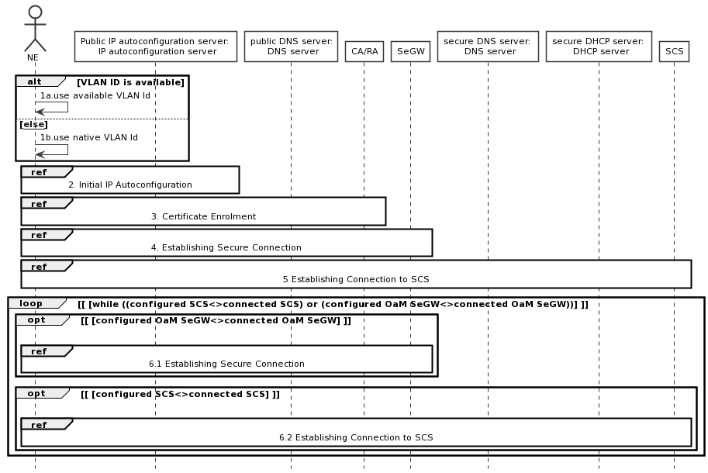

Figure 5.1.1: High-level plug-and-connect flow

## 5.2 Initial IP Autoconfiguration

The procedure for initial IP Autoconfiguration is described next and illustrated in figure 5.2.1.

Operators may deploy their management infrastructure in different ways. Specifically, the following options are possible:

- IP Autoconfiguration service is configured with basic IP configuration only (e.g. IP address, netmask, gateway, domain name, DNS server address);

- IP Autoconfiguration service is configured with basic IP configuration and the IP address of CA/RA, and other CA/RA attributes defined in TS 28.316 [3] clause 4.2.3;

- IP Autoconfiguration service is configured with basic IP configuration and the FQDN of CA/RA, and other CA/RA attributes defined in TS 28.316 [3] clause 4.2.3;

- IP Autoconfiguration service is configured with basic IP configuration and the IP addresses of CA/RA and SeGW, and other CA/RA attributes defined in TS 28.316 [3] clause 4.2.3;

- IP Autoconfiguration service is configured with basic IP configuration and the FQDNs of CA/RA and SeGW, and other CA/RA attributes defined in TS 28.316 [3] clause 4.2.3;

- IP Autoconfiguration service is configured with basic IP configuration and the IP addresses of CA/RA, SeGW and SCS, and other CA/RA attributes defined in TS 28.316 [3] clause 4.2.3;

- IP Autoconfiguration service is configured with basic IP configuration and the FQDNs of CA/RA, SeGW and SCS, and other CA/RA attributes defined in TS 28.316 [3] clause 4.2.3;

- IP Autoconfiguration service is unable to recognize that the client is an NE performing   
the **plug-and-connect** procedure;

- IP Autoconfiguration service is able to recognize that the client is an NE performing   
the **plug-and-connect** procedure;

- IP Autoconfiguration service is unable to recognize that the client is an NE performing   
the **plug-and-connect** procedure and the specific NE vendor.

The procedure described in this clause applies to all deployment options listed above.

**The exceptions:**

- One of the steps outlined in the procedure fails.

**Procedure steps:**

1.1) In this step NE sends a request for IP address configuration to the IP Autoconfiguration service (e.g. DHCP server). The NE may include the vendor specific identifier. The data format used by the NE in this step is specified in 3GPP TS 28.316 [3].

1.2) Depending on the particular operator deployment scenario, the information configured in the IP Autoconfiguration service may be different and the IP Autoconfiguration service may or may not be able to recognize the specific details about the client (whether it is an NE performing **plug-and-connect** procedure and the specific NE vendor). Therefore, in this step the following replies by the IP Autoconfiguration service are possible:

1.2.a) Client IP configuration only (e.g. IP address, netmask, gateway, domain name, DNS server address);

1.2.b) Client IP configuration and the IP address of CA/RA, and other CA/RA attributes defined in TS 28.316 [3] clause 4.2.3;

1.2.c) Client IP configuration and the FQDN of CA/RA, and other CA/RA attributes defined in TS 28.316 [3] clause 4.2.3;

1.2.d) Client IP configuration and the IP addresses of CA/RA and SeGW, and other CA/RA attributes defined in TS 28.316 [3] clause 4.2.3;

1.2.e) Client IP configuration and the FQDNs of CA/RA and SeGW, and other CA/RA attributes defined in TS 28.316 [3] clause 4.2.3;

1.2.f) Client IP configuration and the IP addresses of CA/RA, SeGW and SCS, and other CA/RA attributes defined in TS 28.316 [3] clause 4.2.3;

1.2.g) Client IP configuration and the FQDNs of CA/RA, SeGW and SCS, and other CA/RA attributes defined in TS 28.316 [3] clause 4.2.3.

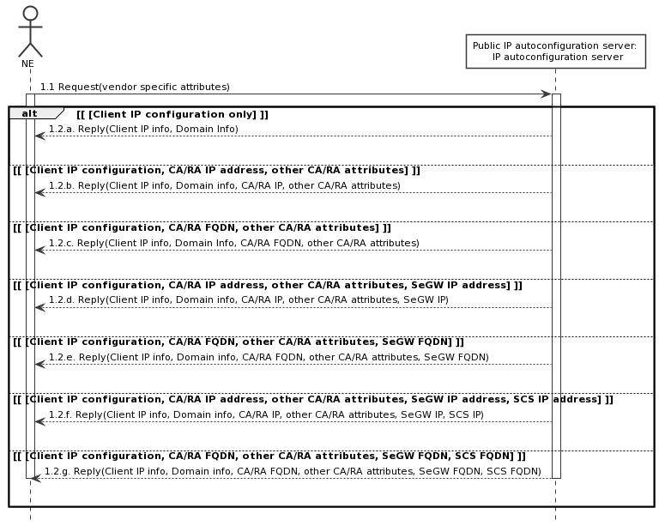

Figure 5.2.1: Initial IP Autoconfiguration flow

## 5.3 Certificate enrolment

The procedure for certificate enrolment is described next and illustrated in figure 5.3.1.

Operators may deploy their management infrastructure in different ways. The following options are possible:

- The IP address of the CA/RA is known to the NE (e.g. provided by the IP Autoconfiguration service);

- The IP address of the CA/RA is unknown to the NE, but the FQDN of the CA/RA is known to the NE (e.g. provided by the IP Autoconfiguration service, pre-configured at the factory);

The procedure described in this clause applies to all deployment options listed above.

**The exceptions:**

- One of the steps outlined in the procedure fails.

**Procedure steps:**

1) This step is executed only if the IP address of CA/RA is unknown to the NE, but the FQDN of the CA/RA is known (e.g. provided by the IP Autoconfiguration service, pre-configured at the factory). The format of the FQDN is specified in 3GPP TS 28.316 [3]:

1.1) NE sends a request containing the FQDN of the CA/RA to the DNS server.

1.2) DNS server resolves the FQDN of the CA/RA into the IP address and provides it to the NE.

2) In this step NE performs actual security certificate enrolment (e.g. using CMPv2 protocol). The sub-steps are included for the illustration purposes only:

2.1) In this sub-step the NE enrols using the vendor certificate (e.g. pre-programmed at the factory) and other CA/RA attributes defined in TS 28.316 [3] clause 4.2.3 provided by IP Autoconfiguration service.

2.2) In this sub-step the NE receives the Operator certificates from the CA/RA.

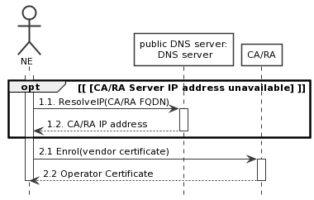

Figure 5.3.1: Certificate enrolment flow

## 5.4 Establishing secure connection

The procedure for establishing the secure connection is described next and illustrated in figure 5.4.1.

Operators may deploy their management infrastructure in different ways. Specifically, the following options are possible:

- The IP address of the SeGW is known to the NE (e.g. provided by the IP Autoconfiguration service, configured by SCS);

- The IP address of the SeGW is unknown to the NE, but the FQDN of the SeGW is known to the NE   
(e.g. provided by the IP Autoconfiguration service, configured by SCS, pre-configured at the factory);

- The SeGW provides NE only with internal IP configuration;

- The SeGW provides NE with internal IP configuration and the IP address of the secure (internal) DHCP server;

- The SeGW provides NE with internal IP configuration and the IP address(es) of the secure (internal) DNS server(s);

- The SeGW provides NE with internal IP configuration and the IP addresses of the secure (internal) DHCP and DNS servers.

The procedure described in this clause applies to all deployment options listed above.

**The exceptions:**

- One of the steps outlined in the procedure fails.

**Procedure steps:**

1) This step is executed only if the IP address of SeGW is unknown to the NE, but the FQDN of the SeGW is known (e.g. provided by the IP Autoconfiguration service, configured by SCS, pre-configured at the factory).   
The format of the FQDN is specified in 3GPP TS 28.316 [3].

1.1) NE sends a request containing the FQDN of the SeGW to the DNS server.

1.2) DNS server resolves the FQDN of the SeGW into the IP address and provides it to the NE.

2) In this step NE establishes secure tunnel to the SeGW using IKEv2 protocol. The sub-steps are included for the illustration purposes only.

2.1) In this sub-step the NE establishes secure connection using the operator certificate (e.g. provided in the Certificate Enrolment procedure described in clause 5.3).

2.2) In this sub-step the NE receives its inner IP configuration from the SeGW in the Configuration Parameters of IKEv2. The "inner" IP address may be the same as the "outer" IP address (e.g. obtained in the Initial IP Autoconfiguration procedure described in clause 5.2).

2.3) In this optional sub-step the NE receives the IP addresses of one or more secure (internal) DNS servers from the SeGW in the Configuration Parameters of IKEv2.

2.4) In this optional sub-step the NE receives the IP address of secure (internal) DHCP server from the SeGW in the Configuration Parameters of IKEv2.

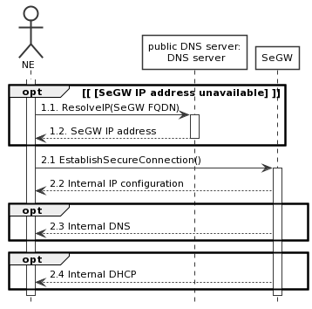

Figure 5.4.1: Establishing secure connection flow

## 5.5 Establishing connection to Software and Configuration Server (SCS)

The procedure for establishing connection to Software and Configuration Server (SCS) is described next and illustrated in figure 5.5.1.

Operators may deploy their management infrastructure in different ways. Specifically, the following options are possible:

- The IP address of the SCS is known to the NE (e.g. provided by the IP Autoconfiguration service, configured by SCS);

- The IP address of the SCS is unknown to the NE, but the FQDN of the SCS is known to the NE (e.g. provided by the IP Autoconfiguration service, configured by SCS, pre-configured at the factory);

- The IP address of secure (internal) DHCP server is known to the NE (e.g. provided in the Configuration Parameters of IKEv2);

- The IP address of secure (internal) DNS server is known to the NE (e.g. provided in the Configuration Parameters of IKEv2);

- The IP address of the SCS configured in the secure (internal) DHCP server;

- The FQDN of the SCS configured in the secure (internal) DHCP server.

The procedure described in this clause applies to all deployment options listed above.

**The exceptions:**

- One of the steps outlined in the procedure fails.

**Procedure steps:**

1) This step is executed only if the IP address of SCS is unknown to the NE, but the IP address of the secure (internal) DHCP server is known (e.g. provided by the SeGW in the Configuration Parameters of IKEv2):

1.1) NE sends a request to the secure DHCP server. The NE may include the vendor specific identifier. The data format used by the NE in this step is specified in 3GPP TS 28.316 [3].

1.2) DHCP server provides the IP address of the SCS to the NE. The data format used by the DHCP server in this step is specified in 3GPP TS 28.316 [3].

2) This step is executed only if the IP address of SCS is unknown to the NE, but the FQDN of the SCS is known (e.g. provided by the IP Autoconfiguration service, configured by SCS, pre-configured at the factory) and the IP address of the secure (internal) DNS server is known (e.g. provided by the SeGW in the Configuration Parameters of IKEv2). The format of the FQDN is specified in 3GPP TS 28.316 [3]:

2.1) NE sends a request containing the FQDN of the SCS to the secure (internal) DNS server.

2.2) DNS server resolves the FQDN of the SCS into the IP address and provides it to the NE.

3) and 4) These steps are executed only if the IP address and FQDN of the SCS are unknown to the NE, but the IP addresses of the secure (internal) DHCP and DNS servers are known (e.g. provided by the SeGW in the Configuration Parameters of IKEv2):

3.1) NE sends a request to the secure DHCP server. The NE may include the vendor specific identifier. The data format used by the NE in this step is specified in 3GPP TS 28.316 [3].

3.2) DHCP server provides the FQDN of the SCS to the NE. The data format used by the DHCP server in this step is specified in 3GPP TS 28.316 [3].

4.1) NE sends a request containing the FQDN of the SCS to the secure (internal) DNS server.

4.2) DNS server resolves the FQDN of the SCS into the IP address and provides it to the NE.

5) In this step NE establishes communication with SCS. The protocol used for communication between NE and SCS is vendor specific and is out of scope of the present document. The sub-steps listed below are for illustration purposes only:

5.1) In this step NE connects to the SCS and identifies itself. The NE may provide SCS with its current software version and configuration.

5.2) In this step SCS may provide the NE with new configuration.

5.3) In this step SCS may provide the NE with new software.

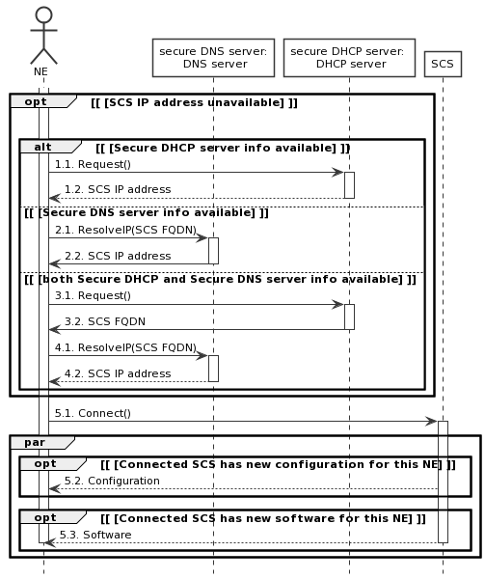

Figure 5.5.1: Establishing connection to Software and Configuration Server (SCS) flow

Annex A (informative):  
PlantUML source code

A.1 High-level plug-and-connect

The following PlantUML source code is used to describe the procedure for High-level plug-and-connect, as depicted by Figure 5.1.1:

@startuml

actor NE

participant "Public IP autoconfiguration server: \n IP autoconfiguration server" as IP_Server

participant "public DNS server:\n DNS server" as P_DNS_Server

participant "CA/RA" as CA_RA

participant SeGW

participant "secure DNS server: \n DNS server" as S_DNS_Server

participant "secure DHCP server: \n DHCP server" as S_DHCP_Server

participant SCS

alt VLAN ID is available

NE->NE: 1a.use available VLAN Id

Else [[else]]

NE->NE: 1b.use native VLAN Id

End

Ref over NE, IP_Server: 2. Initial IP Autoconfiguration

Ref over NE, IP_Server,CA_RA: 3. Certificate Enrolment

Ref over NE, IP_Server,CA_RA,SeGW: 4. Establishing Secure Connection

Ref over NE, IP_Server,CA_RA,SeGW,SCS: 5 Establishing Connection to SCS

loop [ [while ((configured SCS<>connected SCS) or (configured OaM SeGW<>connected OaM SeGW))] ]

opt [ [configured OaM SeGW<>connected OaM SeGW] ]

|||

Ref over NE,IP_Server,P_DNS_Server,CA_RA, SeGW:6.1 Establishing Secure Connection

End

opt [ [configured SCS<>connected SCS] ]

|||

Ref over NE,IP_Server,P_DNS_Server,CA_RA, SeGW,S_DNS_Server,S_DHCP_Server,SCS:6.2 Establishing Connection to SCS

End

End

hide footbox

skinparam DefaultFontSize 11

skinparam sequenceActorBackgroundColor #FFFFFF

skinparam sequenceParticipantBackgroundColor #FFFFFF

skinparam noteBackgroundColor #FFFFFF

autonumber "#'.'"

skinparam monochrome true

skinparam shadowing false

@enduml

A.2 Initial IP Autoconfiguration

The following PlantUML source code is used to describe the procedure for Initial IP Autoconfiguration, as depicted by Figure 5.2.1:

@startuml

actor NE

participant "Public IP autoconfiguration server: \n IP autoconfiguration server" as IP_Server

NE -> IP_Server: 1.1 Request(vendor specific attributes)

activate NE

activate IP_Server

Alt [ [Client IP configuration only] ]

IP_Server --> NE: 1.2.a. Reply(Client IP info, Domain Info)

|||

Else [ [Client IP configuration, CA/RA IP address, other CA/RA attributes] ]

IP_Server --> NE: 1.2.b. Reply(Client IP info, Domain info, CA/RA IP, other CA/RA attributes)

|||

Else [ [Client IP configuration, CA/RA FQDN, other CA/RA attributes] ]

IP_Server -->NE: 1.2.c. Reply(Client IP info, Domain Info, CA/RA FQDN, other CA/RA attributes)

|||

Else [ [Client IP configuration, CA/RA IP address, other CA/RA attributes, SeGW IP address] ]

IP_Server -->NE: 1.2.d. Reply(Client IP info, Domain info, CA/RA IP, other CA/RA attributes, SeGW IP)

|||

Else [ [Client IP configuration, CA/RA FQDN, other CA/RA attributes, SeGW FQDN] ]

IP_Server -->NE: 1.2.e. Reply(Client IP info, Domain info, CA/RA FQDN, other CA/RA attributes, SeGW FQDN)

|||

Else [ [Client IP configuration, CA/RA IP address, other CA/RA attributes, SeGW IP address, SCS IP address] ]

IP_Server --> NE: 1.2.f. Reply(Client IP info, Domain info, CA/RA IP, other CA/RA attributes, SeGW IP, SCS IP)

|||

Else [ [Client IP configuration, CA/RA FQDN, other CA/RA attributes, SeGW FQDN, SCS FQDN] ]

IP_Server -->NE: 1.2.g. Reply(Client IP info, Domain info, CA/RA FQDN, other CA/RA attributes, SeGW FQDN, SCS FQDN)

|||

deactivate IP_Server

deactivate NE

End

hide footbox

skinparam defaultFontSize 11

skinparam sequenceActorBackgroundColor #FFFFFF

skinparam sequenceParticipantBackgroundColor #FFFFFF

skinparam noteBackgroundColor #FFFFFF

autonumber "#'.'"

skinparam monochrome true

skinparam shadowing false

@enduml

A.3 Certificate enrolment

The following PlantUML source code is used to describe the procedure for Certificate enrolment, as depicted by Figure 5.3.1:

@startuml

actor NE

activate NE

participant "public DNS server:\n DNS server" as P_DNS_Server

participant "CA/RA" as CA_RA

opt [ [CA/RA Server IP address unavailable] ]

NE->P_DNS_Server: 1.1. ResolveIP(CA/RA FQDN)

activate P_DNS_Server

P_DNS_Server -->NE: 1.2. CA/RA IP address

deactivate P_DNS_Server

End

NE->CA_RA: 2.1 Enrol(vendor certificate)

activate CA_RA

CA_RA-->NE: 2.2 Operator Certificate

deactivate CA_RA

deactivate NE

hide footbox

skinparam defaultFontSize 11

skinparam sequenceActorBackgroundColor #FFFFFF

skinparam sequenceParticipantBackgroundColor #FFFFFF

skinparam noteBackgroundColor #FFFFFF

autonumber "#'.'"

skinparam monochrome true

skinparam shadowing false

@enduml

A.4 Establishing secure connection

The following PlantUML source code is used to describe the procedure for Establishing secure connection, as depicted by Figure 5.4.1:

@startuml

actor NE

participant "public DNS server:\n DNS server" as P_DNS_Server

participant SeGW

activate NE

opt [ [SeGW IP address unavailable] ]

NE -> P_DNS_Server: 1.1. ResolveIP(SeGW FQDN)

activate P_DNS_Server

P_DNS_Server -->NE: 1.2. SeGW IP address

deactivate P_DNS_Server

End

NE->SeGW: 2.1 EstablishSecureConnection()

activate SeGW

SeGW -->NE: 2.2 Internal IP configuration

opt

SeGW -->NE: 2.3 Internal DNS

End

opt

SeGW -->NE: 2.4 Internal DHCP

End

deactivate SeGW

deactivate NE

hide footbox

skinparam defaultFontSize 11

skinparam sequenceActorBackgroundColor #FFFFFF

skinparam sequenceParticipantBackgroundColor #FFFFFF

skinparam noteBackgroundColor #FFFFFF

autonumber "#'.'"

skinparam monochrome true

skinparam shadowing false

@enduml

A.5 Establishing connection to Software and Configuration Server (SCS)

The following PlantUML source code is used to describe the procedure for Establishing connection to SCS, as depicted by Figure 5.5.1:

@startuml

actor NE

participant "secure DNS server:\n DNS server" as S_DNS_Server

participant "secure DHCP server: \n DHCP server" as S_DHCP_Server

activate NE

opt [ [SCS IP address unavailable] ]

|||

alt [ [Secure DHCP server info available] ]

NE -> S_DHCP_Server: 1.1. Request()

activate S_DHCP_Server

S_DHCP_Server --> NE: 1.2. SCS IP address

deactivate S_DHCP_Server

Else [ [Secure DNS server info available] ]

NE->S_DNS_Server: 2.1. ResolveIP(SCS FQDN)

activate S_DNS_Server

S_DNS_Server->NE: 2.2. SCS IP address

deactivate S_DNS_Server

Else [ [both Secure DHCP and Secure DNS server info available] ]

NE->S_DHCP_Server: 3.1. Request()

activate S_DHCP_Server

S_DHCP_Server->NE: 3.2. SCS FQDN

deactivate S_DHCP_Server

NE->S_DNS_Server: 4.1. ResolveIP(SCS FQDN)

activate S_DNS_Server

S_DNS_Server-->NE: 4.2. SCS IP address

deactivate S_DNS_Server

End

End

NE->SCS: 5.1. Connect()

activate SCS

par

opt [ [Connected SCS has new configuration for this NE] ]

SCS --> NE: 5.2. Configuration

End

opt [ [Connected SCS has new software for this NE] ]

SCS-->NE: 5.3. Software

deactivate SCS

deactivate NE

End

End

hide footbox

skinparam DefaultFontSize 11

skinparam sequenceActorBackgroundColor #FFFFFF

skinparam sequenceParticipantBackgroundColor #FFFFFF

skinparam noteBackgroundColor #FFFFFF

autonumber "#'.'"

skinparam monochrome true

skinparam shadowing false

@enduml

Annex B (informative):  
Change history

|  |  |  |  |  |  |  |  |
| --- | --- | --- | --- | --- | --- | --- | --- |
| **Change history** | | | | | | | |
| **Date** | **Meeting** | **TDoc** | **CR** | **Rev** | **Cat** | **Subject/Comment** | **New version** |
| **2021-06** | **SA5#137-e** | **S5-213663** |  |  |  |  | **0.1.0** |
| **2021-10** | **SA5#139-e** | **S5-215629** |  |  |  |  | **0.2.0** |
| **2021-12** | **SA5#140-e** | **S5-216603** |  |  |  |  | **0.3.0** |
| **2022-01** | **SA5#141-e** | **S5-221709** |  |  |  |  | **0.4.0** |
| **2022-03** | **SA#95e** | **SP-220123** |  |  |  | **Presented for information and approval** | **1.0.0** |
| **2022-03** | **SA#95e** |  |  |  |  | **Upgrade to change control version** | **17.0.0** |
| **2024-04** | **-** | **-** | **-** | **-** | **-** | **Update to Rel-18 version (MCC)** | **18.0.0** |