|  |  |
| --- | --- |
| 3GPP TS 28.317 V18.0.0 (2024-03) | |
| Technical Specification | |
| 3rd Generation Partnership Project;  Technical Specification Group Services and System Aspects;  Management and orchestration;  Self-configuration of Radio Access Network entities  (Release 18) | |
|  | |
|  | 3GPP-logo_web |
|  | |
| The present document has been developed within the 3rd Generation Partnership Project (3GPP TM) and may be further elaborated for the purposes of 3GPP. The present document has not been subject to any approval process by the 3GPPOrganizational Partners and shall not be implemented. This Specification is provided for future development work within 3GPPonly. The Organizational Partners accept no liability for any use of this Specification. Specifications and Reports for implementation of the 3GPP TM system should be obtained via the 3GPP Organizational Partners' Publications Offices. | |

|  |
| --- |
|  |
| ***3GPP***  Postal address  3GPP support office address  650 Route des Lucioles - Sophia Antipolis  Valbonne - FRANCE  Tel.: +33 4 92 94 42 00 Fax: +33 4 93 65 47 16  Internet  http://www.3gpp.org |
| ***Copyright Notification***  No part may be reproduced except as authorized by written permission. The copyright and the foregoing restriction extend to reproduction in all media.  © 2024, 3GPP Organizational Partners (ARIB, ATIS, CCSA, ETSI, TSDSI, TTA, TTC).  All rights reserved.  UMTS™ is a Trade Mark of ETSI registered for the benefit of its members  3GPP™ is a Trade Mark of ETSI registered for the benefit of its Members and of the 3GPP Organizational Partners LTE™ is a Trade Mark of ETSI registered for the benefit of its Members and of the 3GPP Organizational Partners  GSM® and the GSM logo are registered and owned by the GSM Association |

Contents

Foreword 5

1 Scope 7

2 References 7

3 Definitions of terms, symbols and abbreviations 7

3.1 Terms 7

3.2 Symbols 8

3.3 Abbreviations 8

4 Concept and Background 8

4.1 Background 8

4.2 Network configuration data handling 8

4.3 Self-configuration 8

4.4 Self-configuration management 9

5 Management capabilities 9

5.1 Network configuration data handling 9

5.1.1 Use cases 9

5.1.2 Requirements 9

5.2 Self-configuration management 10

5.2.1 Use cases 10

5.2.2 Requirements 11

6 Stage 2 definition 11

6.1 Management operation for Self-configuration management (MnS component typeA) 11

6.2 Information model definition for Self-configuration management (MnS component typeB) 12

6.2.1 Imported information entities and local labels 12

6.2.2 Class diagram 12

6.2.2.1 Relationship 12

6.2.2.2 Inheritance 12

6.2.3 Class definition 13

6.2.3.1 ScMgmtProfile 13

6.2.3.1.1 Definition 13

6.2.3.1.2 Attributes 13

6.2.3.1.3 Attributes constraints 13

6.2.3.1.4 Notifications 13

6.2.3.2 Sc\_Process 13

6.2.3.2.1 Definition 13

6.2.3.2.2 Attributes 14

6.2.3.2.3 Attributes constraints 15

6.2.3.2.4 Notifications 15

6.2.4 Attribute definition 15

6.2.5 Common notifications 16

6.2.5.1 Configuration notifications 16

7 Stage 3 definition 17

7.1 RESTful HTTP-based solution set 17

7.2 OpenAPI specification 17

7.2.1 OpenAPI document "TS28532\_ProvMnS.yaml" 17

7.2.2 OpenAPI document for RANSC NRM 17

8 Procedure for Self-establishment 17

8.1 Self-configuration management 17

Annex A (informative): PlantUML source code 20

A.1 Procedure for Self-establishment 20

A.1.1 Procedure for start self-configuration management 20

A.2 Information model definition for RANSC management 21

A.2.1 Relationship UML diagram 21

A.2.2 Inheritance UML diagram 21

Annex B (informative): Change history 22

# Foreword

This Technical Specification has been produced by the 3rd Generation Partnership Project (3GPP).

The contents of the present document are subject to continuing work within the TSG and may change following formal TSG approval. Should the TSG modify the contents of the present document, it will be re-released by the TSG with an identifying change of release date and an increase in version number as follows:

Version x.y.z

where:

x the first digit:

1 presented to TSG for information;

2 presented to TSG for approval;

3 or greater indicates TSG approved document under change control.

y the second digit is incremented for all changes of substance, i.e. technical enhancements, corrections, updates, etc.

z the third digit is incremented when editorial only changes have been incorporated in the document.

In the present document, modal verbs have the following meanings:

**shall** indicates a mandatory requirement to do something

**shall not** indicates an interdiction (prohibition) to do something

The constructions "shall" and "shall not" are confined to the context of normative provisions, and do not appear in Technical Reports.

The constructions "must" and "must not" are not used as substitutes for "shall" and "shall not". Their use is avoided insofar as possible, and they are not used in a normative context except in a direct citation from an external, referenced, non-3GPP document, or so as to maintain continuity of style when extending or modifying the provisions of such a referenced document.

**should** indicates a recommendation to do something

**should not** indicates a recommendation not to do something

**may** indicates permission to do something

**need not** indicates permission not to do something

The construction "may not" is ambiguous and is not used in normative elements. The unambiguous constructions "might not" or "shall not" are used instead, depending upon the meaning intended.

**can** indicates that something is possible

**cannot** indicates that something is impossible

The constructions "can" and "cannot" are not substitutes for "may" and "need not".

**will** indicates that something is certain or expected to happen as a result of action taken by an agency the behaviour of which is outside the scope of the present document

**will not** indicates that something is certain or expected not to happen as a result of action taken by an agency the behaviour of which is outside the scope of the present document

**might** indicates a likelihood that something will happen as a result of action taken by some agency the behaviour of which is outside the scope of the present document

**might not** indicates a likelihood that something will not happen as a result of action taken by some agency the behaviour of which is outside the scope of the present document

In addition:

**is** (or any other verb in the indicative mood) indicates a statement of fact

**is not** (or any other negative verb in the indicative mood) indicates a statement of fact

The constructions "is" and "is not" do not indicate requirements.

# 1 Scope

The present document describes the functionality for RAN NE self-configuration and ARCF data handling to enable RAN NE self-establishment, as well as requirements need to be met to support this functionality. The concepts, use cases, requirements, procedure and management service definition for RAN NE self-configuration management and ARCF data handling of RAN NEs are specified in the present document.

The NE within virtualization is not in the scope of the present document.

# 2 References

The following documents contain provisions which, through reference in this text, constitute provisions of the present document.

- References are either specific (identified by date of publication, edition number, version number, etc.) or non‑specific.

- For a specific reference, subsequent revisions do not apply.

- For a non-specific reference, the latest version applies. In the case of a reference to a 3GPP document (including a GSM document), a non-specific reference implicitly refers to the latest version of that document *in the same Release as the present document*.

[1] 3GPP TR 21.905: "Vocabulary for 3GPP Specifications".

[2] 3GPP TS 28.314: "Management and orchestration; Plug and Connect; Concepts and requirements".

[3] 3GPP TS 28.532: "Management and orchestration; Generic management services".

[4] 3GPP TS 28.622: "Telecommunication management; Generic Network Resource Model (NRM); Integration Reference Point (IRP); Information Service (IS)".

[5] Management and Orchestration APIs Stage3 repository, "https://forge.3gpp.org/rep/sa5/MnS/-/tree/Tag\_Rel18\_SA103/".

# 3 Definitions of terms, symbols and abbreviations

## 3.1 Terms

For the purposes of the present document, the terms given in 3GPP TR 21.905 [1] and the following apply. A term defined in the present document takes precedence over the definition of the same term, if any, in 3GPP TR 21.905 [1].

**RAN NE Self-Configuration:** The process which brings a RAN network element into service requiring minimal human operator intervention or none at all.

## 3.2 Symbols

Void.

## 3.3 Abbreviations

For the purposes of the present document, the abbreviations given in 3GPP TR 21.905 [1] and the following apply. An abbreviation defined in the present document takes precedence over the definition of the same abbreviation, if any, in 3GPP TR 21.905 [1].

RANSC RAN NE self-configuration

# 4 Concept and Background

## 4.1 Background

Establishment of a new RAN NE in network by an autonomous way can greatly improve the efficiency of RAN deployment. It refers to the procedure of a new RAN NE automatically establishing when it is powered up and connects to the IP network, which includes:

- Network configuration data handling

- Plug and connect to management system

- Self-Configuration

Plug and connect to management system has been specified in TS 28.314 [2]. This document mainly focuses on Network configuration data handling and Self-Configuration.

## 4.2 Network configuration data handling

Network configuration data handling refers to the procedures to make the network configuration data (i.e. additional data used to generate the complete RAN NE configuration data) available to the RANSC MnS producer, which may include network configuration data preparation, network configuration data transfer and network configuration data validation. This happens except all of the network configuration data for RAN NE can be generated by the RANSC MnS producer.

**Network configuration data preparation:** This makes the network configuration data ready in operator's network management system who provides the network configuration data. How to prepare the network configuration data in operator's network management system is out of scope of the present document.

**Network configuration data transfer:** This transfers the network configuration data from operator's network management system to the RANSC MnS producer.

**Network configuration data validation:** This validates the syntax and semantics of network configuration data. It takes place in the RANSC MnS producer.

Note: The process of network configuration data preparation and network configuration data validation is not in the scope of the present document.

## 4.3 Self-configuration

RAN NE can be taken to a state ready to carry traffic using self-configuration in an automated manner. Self-configuration may include following processes: generate the RAN NE configuration data, download and activate software, download and active configuration data, self-test and update network resource model, etc.

## 4.4 Self-configuration management

Self-configuration management capability is needed to monitor the self-configuration process and provide the operator with this information (e.g. progress information). In addition, it allows the operator to control the execution of the self-configuration process.

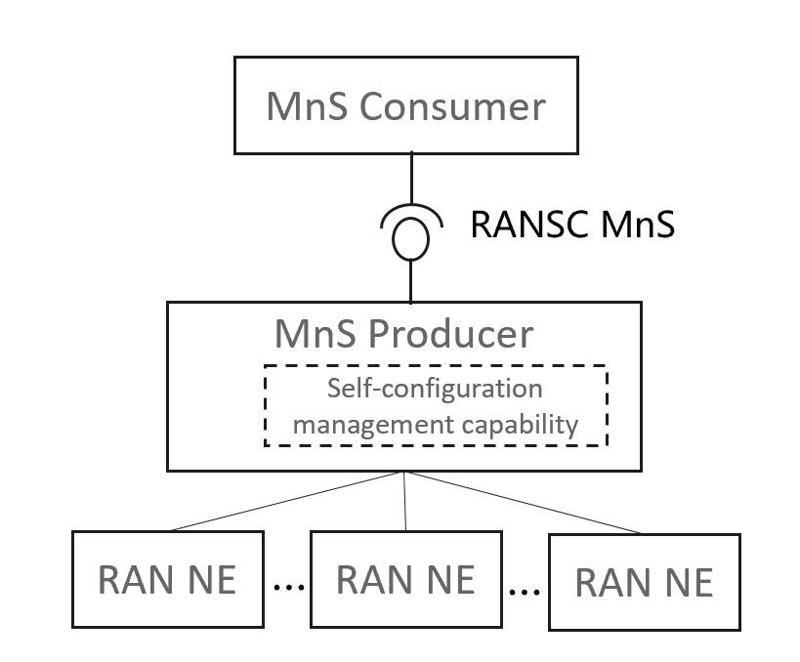

Figure 4.4-1: Example of deployment scenario for Self-configuration management

# 5 Management capabilities

## 5.1 Network configuration data handling

### 5.1.1 Use cases

The goal of this use case is to ensure the RAN NE configuration data available for self-configuration process.

The RANSC MnS producer may need to obtain the additional network configuration data (e.g. nRTAC, gNBId, PCIList) from RANSC MnS consumer and generate the completed RAN NE configuration data to RAN NE. The RANSC MnS consumer will provide this additional network configuration data to RANSC MnS producer directly or indicate it where the configuration data is available and it can retrieve the network configuration data from there.

When RANSC MnS producer receive the additional network configuration data, it may perform network configuration data validation to validate the syntax and semantics of network configuration data.

### 5.1.2 Requirements

Table 5.1.2-1

|  |  |  |
| --- | --- | --- |
| Requirement label | Description | Related use case(s)/Motivation |
| **REQ-RANSC\_DataHandling-1** | The RANSC MnS producer should have the capability to obtain the information which indicate the location where the network configuration data is available for downloading. | Network configuration data handling |

## 5.2 Self-configuration management

### 5.2.1 Use cases

Self-configuration management capability is performed by RANSC MnS producer. RANSC MnS producer monitors the self-configuration process and provides the RANSC MnS consumer with this information (e.g. progress information). In addition, RANSC MnS producer also allows the RANSC MnS consumer to control the execution of the self-configuration process.

The RANSC MnS consumer can request RANSC MnS producer to create and activate a self-configuration process for certain RAN NE in the case of the RANSC MnS consumer trigger the self-configuration process. Besides, RANSC MnS producer also can create and activate a self-configuration process triggered by itself based on the self-configuration management profile (representing the decision of RANSC MnS consumer) configured by RANSC MnS consumer.

As the self-configuration process is complex and time-consuming, the RANSC MnS consumer needs to obtain the progress of the self-configuration process. Self-configuration process includes several steps (each step can represent one or several of activities) according to the self-configuration capabilities. The authorized RANSC MnS consumer may want to be informed the important events for step transition (e.g. start to execute a new step) and abnormal events during the self-configuration process. The RANSC MnS consumer also wants to be informed the reasons when abnormal event (e.g. failure) occurred.

During the self-configuration, the RANSC MnS consumers can send request to RANSC MnS producer to query the list of ongoing self-configuration process or the progress for certain self-configuration process.

When the last step of the self-configuration process is completed, RANSC MnS producer needs to send the result of this process to the RANSC MnS consumers. The authorized RANSC MnS consumers can terminate an ongoing self-configuration process for failure analysis and solving. When the last step of the self-configuration process is completed successfully, the RANSC MnS producer can delete the self-configuration process automatically.

### 5.2.2 Requirements

Table 5.2.2-1

|  |  |  |
| --- | --- | --- |
| Requirement label | Description | Related use case(s)/Motivation |
| REQ-RANSC\_Mgmt-1 | The RANSC MnS producer shall have the capability to allow the authorized MnS consumers to request to create and activate a self-configuration process. | Self-configuration management |
| REQ-RANSC\_Mgmt-2 | The RANSC MnS producer shall have the capability to allow the authorized MnS consumers to request to query the list of ongoing Self-configuration processes. | Self-configuration management |
| REQ-RANSC\_Mgmt-3 | The RANSC MnS producer shall have the capability to report the step information of a self-configuration process to the authorized MnS consumers. | Self-configuration management |
| REQ-RANSC\_Mgmt-4 | The RANSC MnS producer should have the capability to report abnormal information to the authorized MnS consumers when detected. | Self-configuration management |
| REQ-RANSC\_Mgmt-5 | The RANSC MnS producer shall have the capability to inform the authorized MnS consumers the result (success or failure) of the self-configuration process when the process is finished. | Self-configuration management |
| REQ-RANSC\_Mgmt-6 | The RANSC MnS producer shall have the capability to allow the authorized MnS consumers to request to query the progress (e.g. step information) of the self-configuration process when needed. | Self-configuration management |
| REQ-RANSC\_Mgmt-7 | The RANSC MnS producer shall have the capability to allow the authorized MnS consumers to request to terminate an ongoing self-configuration process. | Self-configuration management |
| REQ-RANSC\_Mgmt-8 | The RANSC MnS producer should have the capability to inform the authorized MnS consumers the information that it has deleted the self-configuration process automatically. | Self-configuration management |

# 6 Stage 2 definition

## 6.1 Management operation for Self-configuration management (MnS component typeA)

The operations (e.g. createMOI operations) and notifications (e.g. notifyMOIcreation) of generic provisioning MnS defined in 3GPP TS 28.532 [3] can be used for Self-configuration management. The ScMgmtProfile and Sc\_Process can be treated as object instance. Following is the IS to support intent lifecycle management.

Table 6.1-1

|  |  |
| --- | --- |
| Self-configuration management | IS operation |
| Create an ScMgmtProfile | createMOI operation |
| Delete an ScMgmtProfile | deleteMOI operation |
| Modify an ScMgmtProfile | modifyMOIAttributes operation |
| Query an ScMgmtProfile | getMOIAttributes operation |
| Query an Sc\_Process | getMOIAttributes operation |
| Cancel an Sc\_Process | modifyMOIAttributes operation |

## 6.2 Information model definition for Self-configuration management (MnS component typeB)

### 6.2.1 Imported information entities and local labels

Table 6.2.1-1

|  |  |
| --- | --- |
| Label reference | Local label |
| TS 28.622 [4], IOC, Top | Top |

### 6.2.2 Class diagram

#### 6.2.2.1 Relationship

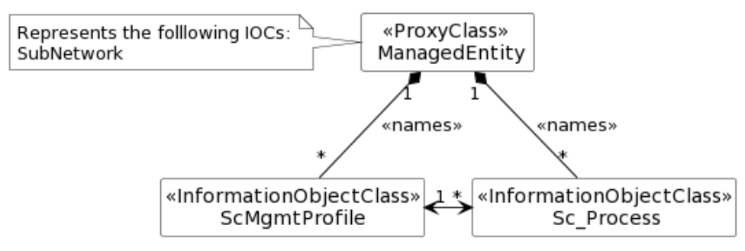

Figure 6.2.2.1-1: Relationship UML diagram

#### 6.2.2.2 Inheritance

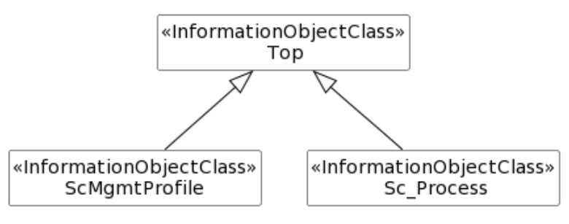

Figure 6.2.2.2-1: Inheritance UML diagram

### 6.2.3 Class definition

#### 6.2.3.1 ScMgmtProfile

##### 6.2.3.1.1 Definition

The ScMgmtProfile represents MnS Consumer's requirements for self-configuration management for a set of RAN NEs or RAN NE types. It can be name-contained by IOC SubNetwork.

A ScMgmtProfile is created by a MnS consumer to request MnS producer to manage the self-configuration processes for a set of RAN NEs or RAN NE types. The creation request contains the information required by the MnS consumer to start self-configuration processes for a set of RAN NEs or RAN NE types (specified by nEInformation). For ultimate deactivation of requirements for self-configuration management for a set of RAN NEs or NE types, the MnS consumer should request MnS producer to delete the ScMgmttProfile to free up resources.

Attribute nEInformation specifies the RAN NEs or RAN NE types for which this ScMgmtProfile instance is valid. For a RAN NE starting its Self-configuration process, there shall be no ambiguity which ScMgmtProfile is valid for the RAN NE. Therefore, the attribute nEInformation of different ScMgmtProfile instances shall not intersect.

Attribute configDataFileLocation specifies the address where the files of network configuration data can be retrieved for the specified RAN NEs.

The ScMgmtProfile IOC includes the attribute objectClass and objectInstance from the TOP IOC. The value of attribute objectClass is ScMgmtProfile and the value of attribute objectInstance is the DN of the instance of ScMgmtProfile IOC.

##### 6.2.3.1.2 Attributes

The ScMgmtProfile IOC includes attributes inherited from Top IOC (defined in TS 28.622 [4]) and the following attributes:

Table 6.2.3.1.2-1

|  |  |  |  |  |  |
| --- | --- | --- | --- | --- | --- |
| Attribute Name | Support Qualifier | isReadable | isWritable | isInvariant | isNotifyable |
| nEInformation | M | T | T | F | T |
| configDataFileLocation | O | T | T | F | T |

##### 6.2.3.1.3 Attributes constraints

None.

##### 6.2.3.1.4 Notifications

The common notifications defined in clause 6.2.5.1 are valid for this IOC, without exceptions or additions.

#### 6.2.3.2 Sc\_Process

##### 6.2.3.2.1 Definition

This IOC represents the self-configuration process for a RAN NE, which allows the MnS Consumer to be informed about the current situation of the Self Configuration process.

When the automated management process for an RAN NE starts, an instance of the Sc\_Process is created automatically by the MnS Producer and informed to MnS consumer.

The ScProcessMonitor attribute represents the status of self configuration process and includes information the MnS consumer can use to monitor the progress and result of the self configuration process. The data type of this attribute is ProcessMonitor in TS 28.622 [4]. The following specializations are provided for this data type for the self configuration process:

- The value of attribute status are "NOT\_STARTED", "RUNNING", "CANCELLING","FINISHED, "FAILED" and "CANCELLED". The values "SUSPENDED" and "PARTIALLY\_FAILED" are not used.

- The timer attribute is not used.

- The attribute progessPercentage indicates progress of the process as percentage. The percent can be measured by number of finished steps from total steps in the self configuration process.

- When the attribute status is equal to "RUNNING" the attribute progressStateInfo attribute shall indicate one of the following states: "NE\_HEALTH\_CHECK", "SW\_DOWNLOAD", "SW\_INSTALLATION","SW\_ACTIVATION"," PREPARE\_BASIC\_CONFIGURATION\_AND\_OAMLINK", "RETRIEVE\_CONFIGURATION\_DATA", "SETUP\_PRECONFIGURED\_SIGNALLING\_LINKS", "SET\_FINAL\_STATE\_OF\_NE ". Vendor specific information may be provided though.

- For the case that the attribute status is equal to "FAILED" the attribute resultStateInfo shall indicate one of the following failure reasons: "UNKNOWN", "INCORRECT\_CONFIGURATION", "NE\_HARDWARE\_ERROR\_DETECTED", "DISCONNECTION\_BETWEEN\_NE\_AND\_OAM", "OTHER". Vendor specific information may be provided though.

- For the case that the attribute status is equal to "FINISHED" or "CANCELLED", no specializations are provided for the attribute resultStateInfo. Vendor specific information may be provided though.

- No specializations are provided for the attribute startTime and endTime.

MnS consumer can terminate a self-configuration process which is currently ongoing (the value of the attribute status is "RUNING") by configuring attribute cancelScProcess to "True". Then the attribute status will change from "RUNGING" to "CANCELLED" when MnS producer have terminated the self-configuration process as MnS consumer requested.

The MnS producer can delete the Sc\_Process instance whose attribute status equals to "FINISHED" or "FAILED"or "CANCELLED" automatically.

MnS consumer can query different attributes of the Sc\_Process instance or subscribe attribute value change notifications for Sc\_Process instance to obtain corresponding progress and result information for a self-configuration process when the Sc\_Process instance is created by the MnS Producer and informed to MnS consumer.

The Sc\_Process IOC includes the attribute objectClass and objectInstance from the TOP IOC. The value of attribute objectClass is "Sc\_Process" and the value of attribute objectInstance is the DN of the instance of Sc\_Process IOC.

##### 6.2.3.2.2 Attributes

The Sc\_Process IOC includes attributes inherited from Top IOC (defined in TS 28.622 [4]) and the following attributes:

Table 6.2.3.2.2-1

|  |  |  |  |  |  |
| --- | --- | --- | --- | --- | --- |
| Attribute name | Support Qualifier | isReadable | isWritable | isInvariant | isNotifyable |
| nEIdentification | M | T | F | F | T |
| scProcessMonitor | M | T | F | F | T |
| cancelScProcess | M | T | T | F | T |
| **Attributes related to roles** | | | | | |
| ScMgmtProfileRef | M | T | F | F | T |

##### 6.2.3.2.3 Attributes constraints

##### 6.2.3.2.4 Notifications

The common notifications defined in clause 6.2.5.1 are valid for this IOC, without exceptions or additions.

### 6.2.4 Attribute definition

The following table defines the properties of attributes specified in the present document.

Table 6.2.4-1 Attribute definition

| Attribute Name | Documentation and Allowed Values | Properties |
| --- | --- | --- |
| nEInformation | This attribute defines the NE Type(s) or the NE instance(s) for which this ScMgmtProfile instance is valid. | type: String  multiplicity: \*  isOrdered: False  isUnique: True  defaultValue: None  allowedValues: N/A  isNullable: False |
| configDataFileLocation | This attribute specifies the address where the files of network configuration data can be retrieved.  allowedValues: File URI | type: String  multiplicity: 1  isOrdered: N/A  isUnique: N/A  defaultValue: None  allowedValues: N/A  isNullable: False |
| cancelScProcess | Setting this attribute to "TRUE" cancels the self configuration process. Cancellation is possible in the "NOT\_STARTED" and "RUNNING" state. Setting the attribute to "FALSE" has no observable result.  allowedValues: TRUE, FALSE | Type: ENUM  multiplicity: 0..1  isOrdered: N/A  isUnique: N/A  defaultValue: None  isNullable: False |
| nEIdentification | This attribute identifies the NE for which the Sc\_Process instance is done.  Note: nEIdentification should be identity of RAN NEs. | type: String  multiplicity: 1  isOrdered: N/A  isUnique: N/A  defaultValue: None  allowedValues: N/A  isNullable: False |
| ScProcessMonitor | This attribute provides monitoring for the self configuration process. The data type of this attribute is the "ProcessMonitor" as defined in clause 4.3.43 in TS 28.622 [4] with the specialisations defined in clause 6.2.3.2.1.  allowedValues: N/A | Type: ProcessMonitor  multiplicity: 1  isOrdered: N/A  isUnique: N/A  defaultValue: None  isNullable: False |
| ScProcessMonitor. status | This attribute represents the status of the associated self-configuration process, whether it fails (represented by FAILED), succeeds (represented by FINISHED) etc.  allowedValues:  - NOT\_STARTED  - RUNNING  - CANCELLING  - FINISHED  - FAILED  - CANCELLED | Type: ENUM  multiplicity: 1  isOrdered: N/A  isUnique: N/A  defaultValue: None  isNullable: False |
| ScProcessMonitor. progressStateInfo | This attributes following specialization for the "progressStateInfo" attribute of the "ProcessMonitor" data type for the Sc\_Process"  When the " Sc\_Process.ScProcessMonitor.status " is equal to "RUNNING", it provides the more detailed progress information.  allowedValues  - NE\_HEALTH\_CHECK  - SW\_DOWNLOAD  - SW\_INSTALLATION  - SW\_ACTIVATION  - PREPARE\_BASIC\_CONFIGURATION\_AND\_OAMLINK  - RETRIEVE\_CONFIGURATION\_DATA  - SETUP\_PRECONFIGURED\_SIGNALLING\_LINKS  - SET\_FINAL\_STATE\_OF\_NE | Type: ENUM  multiplicity: 1  isOrdered: N/A  isUnique: N/A  defaultValue: None  isNullable: False |
| ScProcessMonitor. resultStateInfo | This attribute provides the following specialisation for the "resultStateInfo" attribute of the "ProcessMonitor" data type for the Sc\_Process.  In the attribute status is equal to "FAILED", it provides the reason for the failure.  allowedValues for attribute status = "FAILED":  - UNKNOWN  - INCORRECT\_CONFIGURATION,  - NE\_HARDWARE\_ERROR\_DELECTED"  - DISCONNECTION\_BETWEEN\_NE\_AND\_OAM  - OTHER | Type: ENUM  multiplicity: 1  isOrdered: N/A  isUnique: N/A  defaultValue: None  isNullable: False |
| ScProcessMonitor. startTime | This attribute provides start time of the associated SCprocess, i.e. the time when the status changed from "NOT\_STARTED" to "RUNNING".  allowedValues: N/A | Type: DateTime  multiplicity: 0..1  isOrdered: N/A  isUnique: N/A  defaultValue: None  isNullable: False |
| ScProcessMonitor. endTime | This attribute provides the end time when status changed to FINISHED, CANCELLED or FAILED.  allowedValues: N/A | Type: DateTime  multiplicity: 0..1  isOrdered: N/A  isUnique: N/A  defaultValue: None  isNullable: False |
| ScProcessMonitor. progessPercentage | This attribute indicates progress of the process as percentage. The percent can be measured by number of finished steps from total steps in the self configuration process.  allowedValues: [0, 100] | Type: Integer  multiplicity: 1  isOrdered: N/A  isUnique: N/A  defaultValue: None  isNullable: False |
| ScMgmtProfileRef | This attributes specifies the DN of the associated ScMgmtProfile | Type: DN  multiplicity: 1  isOrdered: N/A  isUnique: N/A  defaultValue: None  isNullable: False |

### 6.2.5 Common notifications

#### 6.2.5.1 Configuration notifications

This clause presents a list of notifications, defined in TS 28.532 [3], that an MnS consumer may receive. The notification header attribute objectClass/objectInstance shall capture the DN of an instance of a class defined in the present document.

Table 6.2.5.1-1

| Name | Qualifier | Notes |
| --- | --- | --- |
| notifyMOICreation | O | -- |
| notifyMOIDeletion | O | -- |
| notifyMOIAttributeValueChanges | O | -- |

# 7 Stage 3 definition

## 7.1 RESTful HTTP-based solution set

The RESTful HTTP-based solution set for generic is defined in clause 12.1.1 in 3GPP TS 28.532 [3]. Corresponding className is ScMgmtProfile and Sc\_Process.

## 7.2 OpenAPI specification

### 7.2.1 OpenAPI document "TS28532\_ProvMnS.yaml"

OpenAPI definition of the provisioning MnS which includes the provisioning MnS operations see clause A.1.1 in 3GPP TS 28.532 [3].

### 7.2.2 OpenAPI document for RANSC NRM

The OpenAPI/YAML definitions for RANSC NRM are specified in 3GPP Forge [5].

Directory: OpenAPI

File: TS28317\_RanScNrm.yaml

# 8 Procedure for Self-establishment

## 8.1 Self-configuration management

The Figure 8.1-1 illustrates the procedure for start self-configuration management.

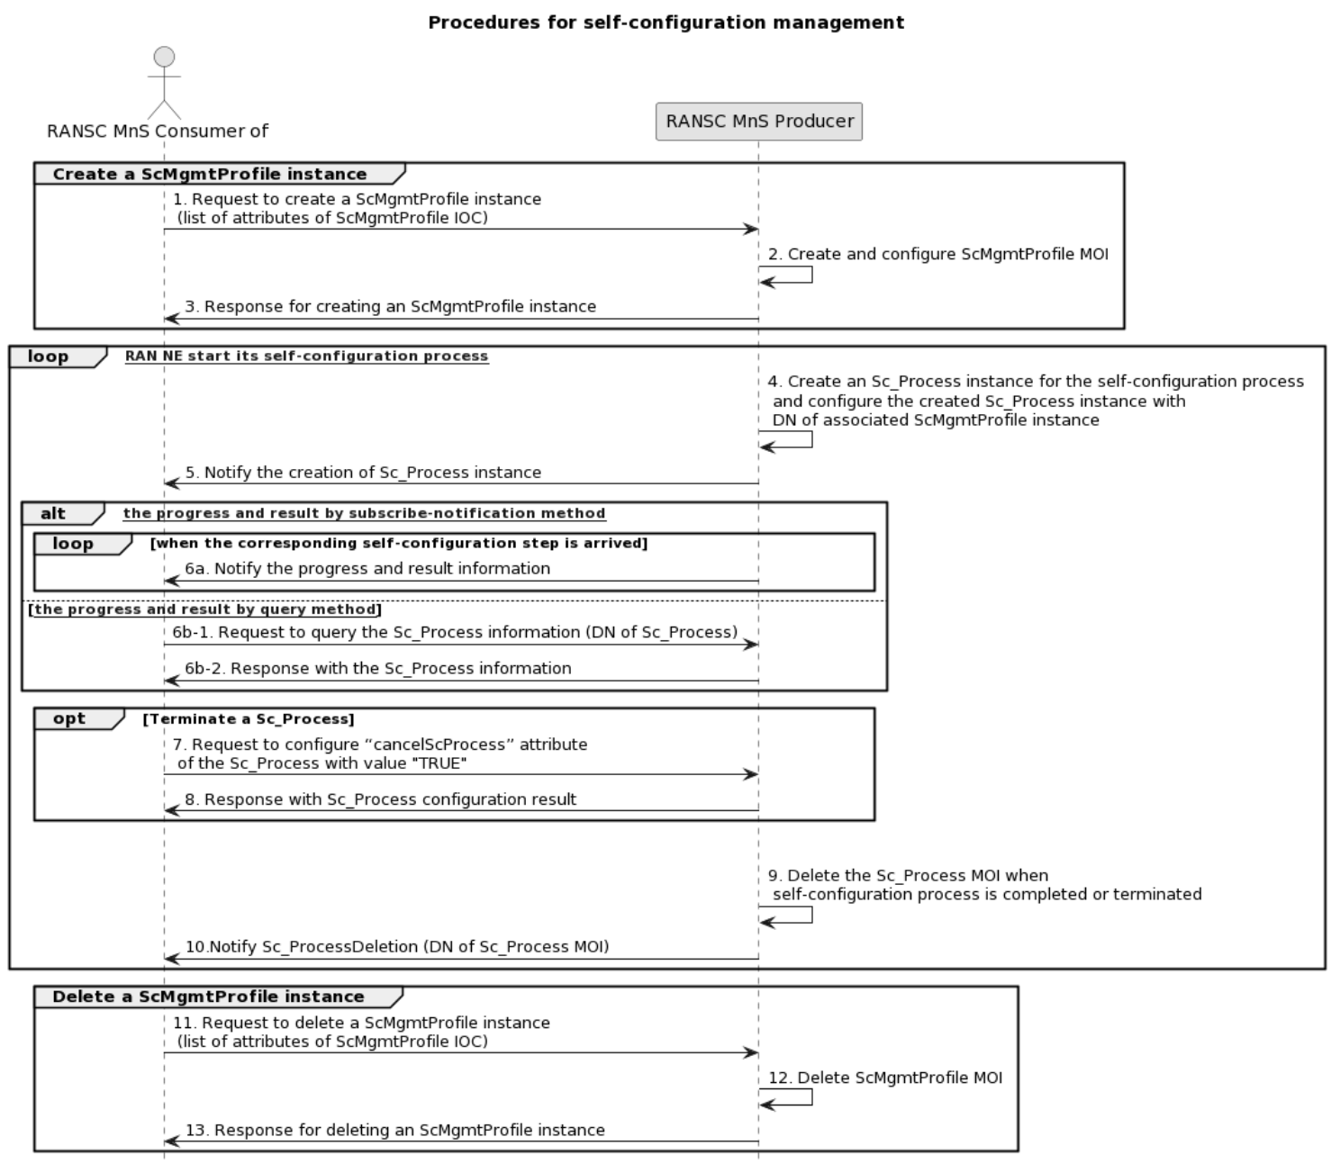

Figure 8.1-1: Procedures for self-configuration management

1. MnS consumer sends a request to create a ScMgmtProfile instance (see createMOI operation defined in TS 28.532 [3]) to MnS producer with self-configuration profile information. The detailed self-configuration profile information see attribute in ScMgmtProfile IOC in clause 6.2.3.1.2.

2. Based on the received request, the MnS producer creates the concrete ScMgmtProfile instance (i.e. instance of ScMgmtProfile) for NE(s) or NE type(s) specified by attribute "neInformation".

3. MnS Producer sends a response (see createMOI operation defined in TS 28.532 [3]) to the MnS Consumer with attribute "objectInstance" of the created ScMgmtProfile instance.

4. For each NE (specified in the created ScMgmtProfile) starting its self-configuration process, MnS producer creates an Sc\_Process instance for the started self-configuration process and configure the created Sc\_Process instance with DN of the associated ScMgmtProfile.

5. MnS producer notifies (see notifyMOICreation notification defined in TS 28.532 [3]) the MnS consumer about the creation of a new Sc\_Process instance, including DN of Sc\_Process instance.

The following step 6 describes the procedures for MnS consumer to monitor self-configuration progress and result. These steps can happen anytime after the Sc\_Process instance is created until the Sc\_Process instance is deleted.

6a) The MnS producer sends notification (see notifyMOIAttributeValueChanges defined in TS 28.532 [3]) to MnS consumer to notify the progress and result for self-configuration process (see attributes in Sc\_Process IOC).

6b) The MnS consumer sends query request to MnS producer to query the attribute values of Sc\_Process instance (see getMOIAttributes operation defined in TS 28.532 [3]) to obtain the progress and result (including DN of the Sc\_Process instance and other attributes of Sc\_Process instance) for self-configuration process.

Following Steps 7 and 8 are the steps for MnS consumer request to terminate an ongoing self-configuration process.

7. The MnS consumer sends a request (see modifyMOIAttributes operation defined in TS 28.532 [3]) to MnS producer to configure cancelScProcess attribute of the Sc\_Process instance with value "TRUE" to terminate an ongoing self-configuration process.

8. The MnS producer sends a response (see modifyMOIAttributes operation defined in TS 28.532 [3]) for terminating an ongoing self-configuration process to MnS consumer.

9. MnS producer deletes the Sc\_Process instance when self-configuration process is completed or terminated.

10. MnS producer notifies the MnS consumer about the deletion of a Sc\_Process instance.

The following steps describes the procedures for MnS consumer request to delete a ScMgmtProfile instance to ultimate deactivation of requirements for self-configuration management for a set of RAN NEs.

11. MnS consumer sends a request to delete a ScMgmtProfile instance (see deleteMOI operation defined in TS 28.532 [3]) to MnS producer with the DN of the ScMgmtProfile instance.

12. Based on the received request, the MnS producer delete the concrete ScMgmtProfile instance

13. MnS Producer sends a response (see deleteMOI operation defined in TS 28.532 [3]) to the MnS Consumer.

Annex A (informative):   
PlantUML source code

## A.1 Procedure for Self-establishment

### A.1.1 Procedure for start self-configuration management

@startuml

title " Procedures for self-configuration management "

actor "RANSC MnS Consumer of " as SC

participant "RANSC MnS Producer" as SP

group Create a ScMgmtProfile instance

SC -> SP: 1. Request to create a ScMgmtProfile instance \n (list of attributes of ScMgmtProfile IOC)

SP -> SP: 2. Create and configure ScMgmtProfile MOI

SP -> SC: 3. Response for creating an ScMgmtProfile instance

end

loop [Corresponding RAN NE start its self-configuration process]

SP -> SP: 4. Create an Sc\_Process instance for the self-configuration process \n and configure the created Sc\_Process instance with \n DN of associated ScMgmtProfile instance

SP -> SC: 5. Notify the creation of Sc\_Process instance

alt [obtain the progress and result by subscribe-notification method]

loop when the corresponding self-configuration step is arrived

SP -> SC: 6a. Notify the progress and result information

end

else [[obtain the progress and result by query method]]

SC -> SP: 6b-1. Request to query the Sc\_Process information (DN of Sc\_Process)

SP -> SC: 6b-2. Response with the Sc\_Process information

end

opt Terminate a Sc\_Process

SC -> SP: 7. Request to configure "cancelScProcess" attribute \n of the Sc\_Process with value "TRUE"

SP -> SC: 8. Response with Sc\_Process configuration result

end

|||

SP -> SP: 9. Delete the Sc\_Process MOI when \n self-configuration process is completed or terminated

SP->SC: 10.Notify Sc\_ProcessDeletion (DN of Sc\_Process MOI)

end

group Delete a ScMgmtProfile instance

SC -> SP: 11. Request to delete a ScMgmtProfile instance \n (list of attributes of ScMgmtProfile IOC)

SP -> SP: 12. Delete ScMgmtProfile MOI

SP -> SC: 13. Response for deleting an ScMgmtProfile instance

end

skinparam sequenceActorBackgroundColor #FFFFFF

skinparam sequenceParticipantBackgroundColor #FFFFFF

skinparam noteBackgroundColor #FFFFFF

autonumber "#'.'"

skinparam monochrome true

skinparam shadowing false

hide footbox

## A.2 Information model definition for RANSC management

### A.2.1 Relationship UML diagram

@startuml

hide circle

hide methods

hide members

skinparam class {

AttributeIconSize 0

BackgroundColor white

BorderColor black

ArrowColor black

}

skinparam Shadowing false

skinparam Monochrome true

skinparam ClassBackgroundColor White

skinparam NoteBackgroundColor White

class "<<ProxyClass>> \n ManagedEntity " as ManagedEntity{}

class "<<InformationObjectClass>>\n ScMgmtProfile " as ScMgmtProfile {}

class "<<InformationObjectClass>>\n Sc\_Process" as Sc\_Process{}

ManagedEntity "1" \*-- "\*" ScMgmtProfile : <<names>>

ManagedEntity "1" \*-- "\*" Sc\_Process : <<names>>

ScMgmtProfile "1" <-right-> "\*"Sc\_Process

note left of ManagedEntity

Represents the folllowing IOCs:

SubNetwork

end note

@enduml

### A.2.2 Inheritance UML diagram

@startuml

hide circle

hide methods

hide members

skinparam class {

AttributeIconSize 0

BackgroundColor white

BorderColor black

ArrowColor black

}

skinparam Shadowing false

skinparam Monochrome true

skinparam ClassBackgroundColor White

skinparam NoteBackgroundColor White

class "<<InformationObjectClass>>\n Top" as Top{}

class "<<InformationObjectClass>>\n ScMgmtProfile " as ScMgmtProfile {}

class "<<InformationObjectClass>>\n Sc\_Process" as Sc\_Process{}

Top <|--ScMgmtProfile

Top <|--Sc\_Process

@enduml

Annex B (informative):  
Change history

|  |  |  |  |  |  |  |  |
| --- | --- | --- | --- | --- | --- | --- | --- |
| **Change history** | | | | | | | |
| **Date** | **Meeting** | **TDoc** | **CR** | **Rev** | **Cat** | **Subject/Comment** | **New version** |
| 2022-04 | SA5#142e | S5-222393 | - | - | - | Initial skeleton | 0.0.0 |
| 2022-04 | SA5#142e | S5-222634  S5-222605 |  |  |  | 1. Add structure  2. Add scope | 0.1.0 |
| 2022-11 | SA5#146 | S5-226807  S5-226811 |  |  |  | 1.pCR 28.317 Add Concept for RANSC  2. PCR 28.317 Usecase and requirement for Self-configuration control and monitor | 0.2.0 |
| 2023-03 | SA5#147 | S5-232145 |  |  |  | pCR TS 28.317 Update the requirement format to follow the stage1 templated in TS 32.160 | 0.3.0 |
| 2023-05 | SA5#149 | S5-234581 |  |  |  | pCR TR 28.317 Correction of the requirements from mandatory to optional | 0.4.0 |
| 2023-06 | SA5#149 |  |  |  |  | Re-upload due to the previous version being corrupted | 0.4.1 |
| 2023-08 | SA5#150 | S5-235818 |  |  |  | pCR TS 28.317 Add procedure for Self-configuration management | 0.5.0 |
| 2023-10 | SA5#151 | S5-236277  S5-236278 |  |  |  | pCR TS 28.317 Add MnS component type A and type B for self-configuration management | 0.6.0 |
| 2023-11 | SA5#152 | S5-237445  S5-237465  S5-237466 |  |  |  | pCR TS 28.317 Add stage3 definition for MnS component type B  pCR TS 28.317 Update use case for self-configuration management  pCR TS 28.317 Update attribute definition of self-configuration management (type B) | 0.7.0 |
| 2023-12 | SA#102 | SP-231524 |  |  |  | EditHelp review and presented for information | 1.0.0 |
| 2024-02 | SA5#153 | S5-240940  S5-240941  S5-240942  S5-240943  [S5-240030](file:///D:\Zou%20Lan\2024工作\标准工作\3GPP\SA5%23153\docs\S5-240030.zip) |  |  |  | pCR TS 28.317 Add concept, use case and requirements for network configuration data handling  pCR TS 28.317 Rapporteur clean up  pCR TS 28.317 Add reference of stage3 definition for MnS component type A  pCR TS 28.317 normative yaml code in 3gpp forge  TS28.317 Rel18 correction to Schema definition Issues for SubNetwork of OpenAPI SS | 1.1.0 |
| 2024-03 | SA#103 | SP-240253 |  |  |  | EditHelp review and presented for approval | 2.0.0 |
| 2024-03 | SA#103 |  |  |  |  | Upgrade to change control version | 18.0.0 |