|  |  |
| --- | --- |
| 3GPP TS 28.556 V18.0.0 (2024-04) | |
| Technical Specification | |
| 3rd Generation Partnership Project;  Technical Specification Group Services and System Aspects;  Management and orchestration;  Network policy management for 5G mobile networks;  Stage 2 and stage 3  (Release 18) | |
|  | |
|  | 3GPP-logo_web |
|  | |
| The present document has been developed within the 3rd Generation Partnership Project (3GPP TM) and may be further elaborated for the purposes of 3GPP. The present document has not been subject to any approval process by the 3GPPOrganizational Partners and shall not be implemented. This Specification is provided for future development work within 3GPPonly. The Organizational Partners accept no liability for any use of this Specification. Specifications and Reports for implementation of the 3GPP TM system should be obtained via the 3GPP Organizational Partners' Publications Offices. | |

|  |
| --- |
|  |
| ***3GPP***  Postal address  3GPP support office address  650 Route des Lucioles - Sophia Antipolis  Valbonne - FRANCE  Tel.: +33 4 92 94 42 00 Fax: +33 4 93 65 47 16  Internet  http://www.3gpp.org |
| ***Copyright Notification***  No part may be reproduced except as authorized by written permission. The copyright and the foregoing restriction extend to reproduction in all media.  © 2024, 3GPP Organizational Partners (ARIB, ATIS, CCSA, ETSI, TSDSI, TTA, TTC).  All rights reserved.  UMTS™ is a Trade Mark of ETSI registered for the benefit of its members  3GPP™ is a Trade Mark of ETSI registered for the benefit of its Members and of the 3GPP Organizational Partners LTE™ is a Trade Mark of ETSI registered for the benefit of its Members and of the 3GPP Organizational Partners  GSM® and the GSM logo are registered and owned by the GSM Association |

Contents

Foreword 5

Introduction 6

1 Scope 7

2 References 7

3 Definitions of terms, symbols and abbreviations 7

3.1 Terms 7

3.2 Symbols 7

3.3 Abbreviations 7

4 Policy management procedures 8

4.1 Policy Creation 8

4.2 Policy Deletion 8

4.3 Policy Update 8

4.4 Policy Query 9

4.5 Policy Conflicts Notification 9

4.6 Policy Activation 9

4.7 Policy Deactivation 10

5 Policy MnS – Stage 2 10

5.1 Management operation for Policy (MnS component type A) 10

5.2 Information model definition entities for Policy 10

5.2.1 Imported information entities and local labels 10

5.2.2 Class diagram 11

5.2.2.1 Relationships 11

5.2.2.2 Inheritance 11

5.2.3 Class definitions 11

5.2.3.1 Policy 11

5.2.3.1.1 Definition 11

5.2.3.1.2 Attributes 11

5.2.3.2 Notifications 12

5.2.3.2.0 General 12

5.2.3.2.1 Notification notifyPolicyConflict (CM) 12

5.2.3.2.1.2 Notification information 12

5.2.3.3 PolicyContent <<dataType>> 12

5.2.3.3.1 Definition 12

5.2.3.3.2 Attributes 13

5.2.4 Information attribute definitions 13

5.2.4.1 Introduction 13

5.2.4.2 Definitions and legal values 13

6 Policy MnS – Stage 3 14

6.1 RESTful HTTP-based solution set 14

6.1.1 Mapping of operations 14

6.1.1.1 Introduction 14

6.1.1.2 Operation 14

6.1.2 Mapping of notifications 14

6.1.2.1 Introduction 14

6.1.2.2 Notification 14

6.1.2.2.0 General 14

6.1.2.2.1 Notification "notifyPolicyConflict" 14

6.1.3 Resources 15

6.1.4 Data type definitions 15

6.1.4.1 Query, message body and resource data types 15

6.1.4.1.0 General 15

6.1.4.1.1 Notification "notifyPolicyConflict" 15

6.1.4.2 Referenced structured data types 15

6.1.4.3 Simple data types and enumerations 15

6.1.4.3.0 General 15

6.1.4.3.1 Simple data types 16

6.1.4.3.2 Enumeration notificationType-Type 16

6.2 YANG/Netconf-based solution set 16

Annex A (informative): Change history 17

# Foreword

This Technical Specification has been produced by the 3rd Generation Partnership Project (3GPP).

The contents of the present document are subject to continuing work within the TSG and may change following formal TSG approval. Should the TSG modify the contents of the present document, it will be re-released by the TSG with an identifying change of release date and an increase in version number as follows:

Version x.y.z

where:

x the first digit:

1 presented to TSG for information;

2 presented to TSG for approval;

3 or greater indicates TSG approved document under change control.

y the second digit is incremented for all changes of substance, i.e. technical enhancements, corrections, updates, etc.

z the third digit is incremented when editorial only changes have been incorporated in the document.

In drafting the TS/TR, pay particular attention to the use of modal auxiliary verbs! TRs shall not contain any normative provisions.

In the present document, modal verbs have the following meanings:

**shall** indicates a mandatory requirement to do something

**shall not** indicates an interdiction (prohibition) to do something

The constructions "shall" and "shall not" are confined to the context of normative provisions, and do not appear in Technical Reports.

The constructions "must" and "must not" are not used as substitutes for "shall" and "shall not". Their use is avoided insofar as possible, and they are not used in a normative context except in a direct citation from an external, referenced, non-3GPP document, or so as to maintain continuity of style when extending or modifying the provisions of such a referenced document.

**should** indicates a recommendation to do something

**should not** indicates a recommendation not to do something

**may** indicates permission to do something

**need not** indicates permission not to do something

The construction "may not" is ambiguous and is not used in normative elements. The unambiguous constructions "might not" or "shall not" are used instead, depending upon the meaning intended.

**can** indicates that something is possible

**cannot** indicates that something is impossible

The constructions "can" and "cannot" are not substitutes for "may" and "need not".

**will** indicates that something is certain or expected to happen as a result of action taken by an agency the behaviour of which is outside the scope of the present document

**will not** indicates that something is certain or expected not to happen as a result of action taken by an agency the behaviour of which is outside the scope of the present document

**might** indicates a likelihood that something will happen as a result of action taken by some agency the behaviour of which is outside the scope of the present document

**might not** indicates a likelihood that something will not happen as a result of action taken by some agency the behaviour of which is outside the scope of the present document

In addition:

**is** (or any other verb in the indicative mood) indicates a statement of fact

**is not** (or any other negative verb in the indicative mood) indicates a statement of fact

The constructions "is" and "is not" do not indicate requirements.

# Introduction

The present document is part of a TS-family covering the 3rd Generation Partnership Project Technical Specification Group Services and System Aspects Management and orchestration of networks, as identified below:

TS 28.555: Management and orchestration; Network policy management for 5G mobile networks; Stage 1 [2].

**TS 28.556: Management and orchestration; Network policy management for 5G mobile networks; Stage 2 and stage 3 [3].**

# 1 Scope

The present document specifies policy management procedures, stage 2 and stage 3 for policy MnS.

# 2 References

The following documents contain provisions which, through reference in this text, constitute provisions of the present document.

- References are either specific (identified by date of publication, edition number, version number, etc.) or non‑specific.

- For a specific reference, subsequent revisions do not apply.

- For a non-specific reference, the latest version applies. In the case of a reference to a 3GPP document (including a GSM document), a non-specific reference implicitly refers to the latest version of that document *in the same Release as the present document*.

[1] 3GPP TR 21.905: "Vocabulary for 3GPP Specifications".

[2] 3GPP TS 28.555: "Management and orchestration; Network policy management for 5G mobile networks; Stage 1".

[3] 3GPP TS 28.556: "Management and orchestration; Network policy management for 5G mobile networks; Stage 2 and stage 3".

[4] 3GPP TS 28.532: "Management and orchestration; Generic management services".

[5] 3GPP TS 28.622: "Telecommunication management; Generic Network Resource Model (NRM) Integration Reference Point (IRP); Information Service (IS)".

[6] ITU-T Recommendation X.733 (02/92): "Information technology - Open Systems Interconnection - Systems Management: Alarm reporting function".

# 3 Definitions of terms, symbols and abbreviations

## 3.1 Terms

For the purposes of the present document, the terms given in TR 21.905 [1] and the following apply. A term defined in the present document takes precedence over the definition of the same term, if any, in TR 21.905 [1].

## 3.2 Symbols

Void.

## 3.3 Abbreviations

For the purposes of the present document, the abbreviations given in TR 21.905 [1] and the following apply. An abbreviation defined in the present document takes precedence over the definition of the same abbreviation, if any, in TR 21.905 [1].

# 4 Policy management procedures

## 4.1 Policy Creation

The Figure 4.1-1 illustrates the procedure for creating a new policy.

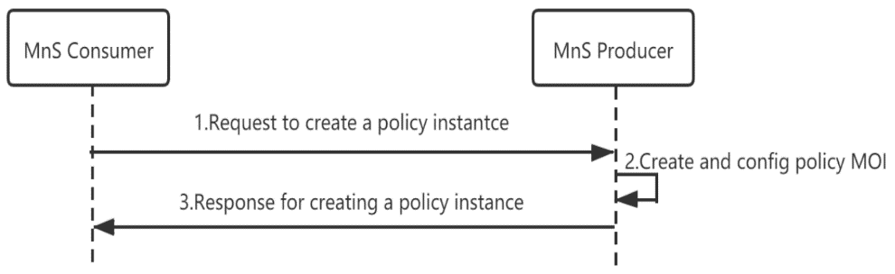

Figure 4.1-1: Procedure for creating a policy

1) MnS Consumer sends a request to create a policy instance to MnS Producer for the new policy to be created(see createMOI operation defined in TS 28.532 [4]). Based on the request, the MnS Producer creates the concrete policy MOI].

2) MnS Producer sends a response to the MnS consumer(see createMOI operation defined in TS 28.532 [4]).

## 4.2 Policy Deletion

The Figure 4.2-1 illustrates the procedure for deleting a policy.

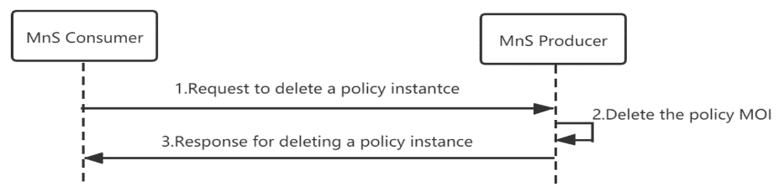

Figure 4.2-1: Procedure for deleting a policy

1) MnS Consumer sends a request to delete a policy instance(see deleteMOI operation defined in TS 28.532 [4]) to MnS Producer.

2) Based on the request, the MnS Producer deletes the concrete policy MOI (i.e. instance of policy IOC).

3) MnS Producer sends a response to the MnS consumer(see deleteMOI operation defined in TS 28.532 [4]).

## 4.3 Policy Update

The Figure 4.3-1 illustrates the procedure for updating a policy.

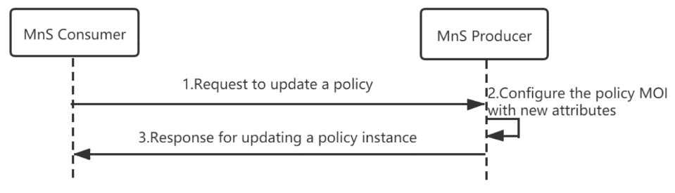

Figure 4.3-1: Procedure for updating a policy

1) MnS Consumer sends a request to update a policy instance to MnS Producer(see modifyMOIAttributes operation defined in TS 28.532 [4]).

2) Based on the request, the MnS Producer updates the concrete policy MOI (i.e. instance of policy IOC).

3) MnS Producer sends a response to the MnS consumer(see modifyMOIAttributes operation defined in TS 28.532 [4]).

## 4.4 Policy Query

The Figure 4.4-1 illustrates the procedure for querying a new policy.

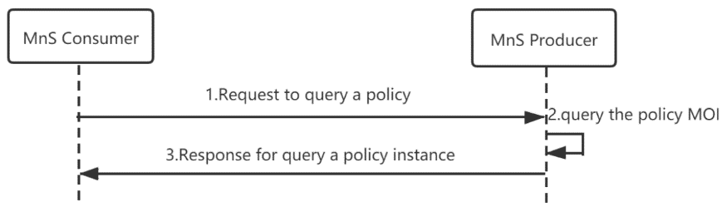

Figure 4.4-1: Procedure for querying a policy

1) MnS Consumer sends a request to query a policy instance to MnS Producer(see getMOIAttributes operation defined in TS 28.532 [4]).

2) Based on the request, the MnS Producer queries the concrete policy MOI (i.e. instance of policy IOC).

3) MnS Producer sends a response to the MnS consumer(see getMOIAttributes operation defined in TS 28.532 [4]).

## 4.5 Policy Conflicts Notification

The Figure 4.5-1 illustrates the procedure for notifying policy conflicts.

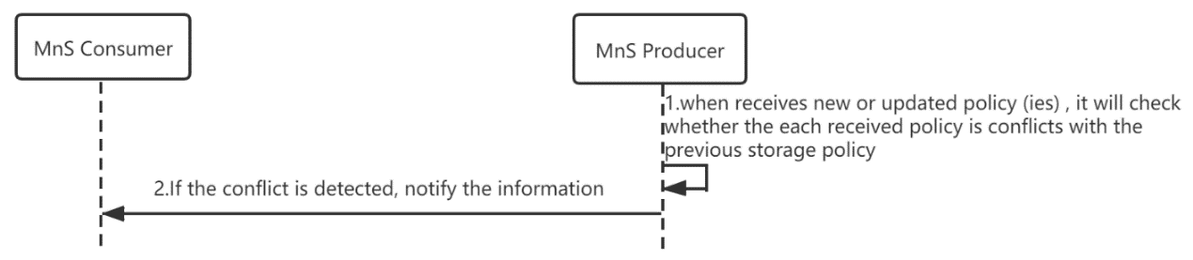

Figure 4.5-1: Procedure for policy conflicts notification

1) 1. When MnS Producer receives new or updated policy (ies) from MnS Consumer, it will check whether the each received policy is conflicts with the previous storage policy.

2) 2. If the conflict is detected, MnS Producer will notify the information to MnS Consumer(see notifyEvent operation defined in TS 28.532 [4]).

## 4.6 Policy Activation

The Figure 4.6-1 illustrates the procedure for activating a new policy.

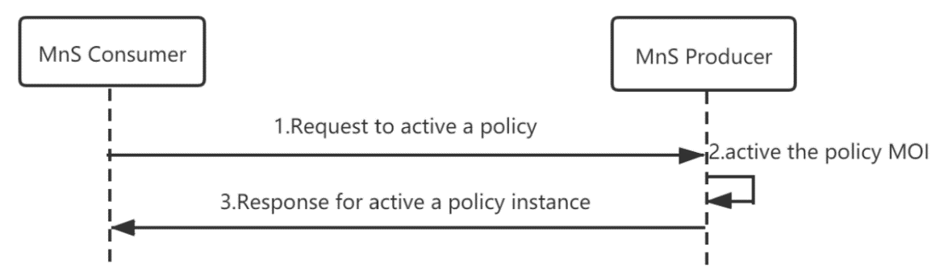

Figure 4.6-1: Procedure for activating a policy

1) MnS Consumer sends a request to activate a policy instance to MnS Producer.

2) Based on the request, the MnS Producer activate the concrete policy MOI (i.e. instance of policy IOC).

3) MnS Producer sends a response to the MnS Consumer.

## 4.7 Policy Deactivation

The Figure 4.7-1 illustrates the procedure for deactivating a policy.

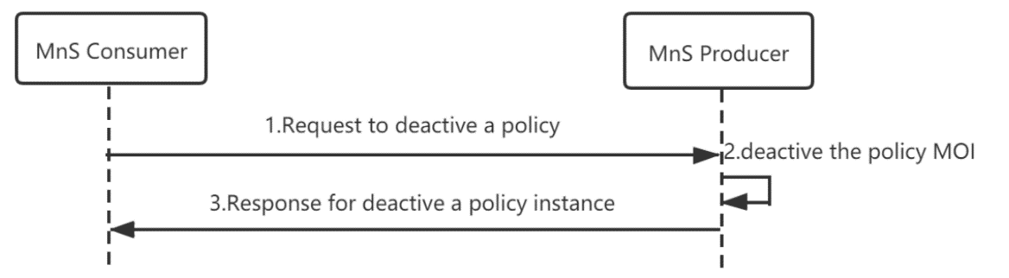

Figure 4.7-1: Procedure for deactivating a policy

1) MnS Consumer sends a request to deactivate a policy instance to MnS Producer.

2) Based on the request, the MnS Producer deactivate the concrete policy MOI (i.e. instance of policy IOC).

3) MnS Producer sends a response to the MnS Consumer.

# 5 Policy MnS – Stage 2

## 5.1 Management operation for Policy (MnS component type A)

The operations (e.g. createMOI operations) and notifications (e.g. notifyMOIcreation) of generic provisioning MnS defined in TS 28.532 [4] can be used for policy lifecycle management. The policy can be treated as object instance.

## 5.2 Information model definition entities for Policy

### 5.2.1 Imported information entities and local labels

|  |  |
| --- | --- |
| Label reference | Local label |
| TS 28.622 [5], IOC, Top | Top |
| TS 28.622 [5], IOC, SubNetwork | SubNetwork |

### 5.2.2 Class diagram

#### 5.2.2.1 Relationships

This clause introduces the set of information object classes (IOCs).

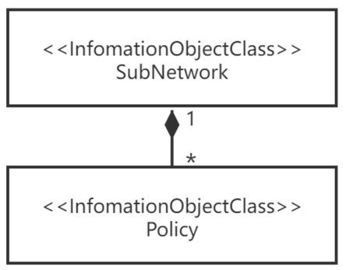

Figure 5.2.2.1: Information Object Class UML Diagram

NOTE: The diagram maybe updated depending on the scenarios.

#### 5.2.2.2 Inheritance

This clause depicts the inheritance relationships.

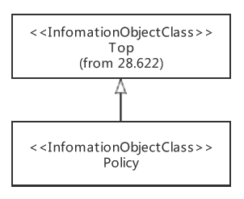

Figure 5.2.2.2: Information Object Class UML Diagram

### 5.2.3 Class definitions

#### 5.2.3.1 Policy

##### 5.2.3.1.1 Definition

This IOC represents a network policy.

##### 5.2.3.1.2 Attributes

The Policy IOC includes attributes inherited from Top IOC (defined in TS 28.622) and the following attributes:

|  |  |  |  |  |  |
| --- | --- | --- | --- | --- | --- |
| Attribute name | Support Qualifier | isReadble | isWriteble | isInvariant | isNotifyable |
| policyPriority | M | T | T | F | T |
| policyStatus | M | T | T | F | T |
| policyType | M | T | T | F | T |
| policyContent | M | T | T | F | T |

#### 5.2.3.2 Notifications

##### 5.2.3.2.0 General

The Notifications include notifications (e.g. notifyMOIcreation) of generic provisioning MnS defined in TS 28.532[4] and Notification notifyPolicyConflict(5.2.3.2.1)

##### 5.2.3.2.1 Notification notifyPolicyConflict (CM)

5.2.3.2.1.1 Definition

This notification supports the policy conflict notification to be notified when a new policy conflicts with the previous storage policy.

###### 5.2.3.2.1.2 Notification information

| **Parameter Name** | **Qualifier** | **Information Type** | **Comment** |
| --- | --- | --- | --- |
| objectClass | M, Y | It shall carry the ManagedEntity class name. | It indicates the class, whose instance emitted this notification. |
| objectInstance | M, Y | DN of the instance of the "ManagedElement" | It identifies the instance of the sender of this notification. |
| notificationId | M, N | This is an identifier of the notification, which may be used to correlate notifications. | The unique identifier of the notification across all notifications sent by a particular management service producer throughout the time that correlation is significant.  How identifiers of notifications are re-used to correlate notifications is outside of the scope of the present document. |
| eventTime | M, Y | It indicates the event occurrence time. | The semantics of Generalised Time specified by ITU-T shall be used here. |
| systemDN | C | It shall carry the DN of management service producers. | - |
| notificationType | M, Y | "notifyPolicyConflict" | The type of notification, and it shall be assigned to "notifyThresholdCrossing" for this notification. |
| conflictDescription | M, Y | It specifies the policy conflict details. | conflictDetails shall convey more information about the conflict.  Description of the detected policy conflicts, e.g. conflicting events, conditions or actions among the policies. Typically, this is due to the fact that a policy is executing, or that Some attributes that require policy execution are missing. |

#### 5.2.3.3 PolicyContent <<dataType>>

##### 5.2.3.3.1 Definition

This data type represents the content of a network policy.

##### 5.2.3.3.2 Attributes

|  |  |  |  |  |  |
| --- | --- | --- | --- | --- | --- |
| **Attribute name** | **Support Qualifier** | **isReadble** | **isWriteble** | **isInvariant** | **isNotifyable** |
| condition | M | T | T | F | T |
| action | M | T | T | F | T |

### 5.2.4 Information attribute definitions

#### 5.2.4.1 Introduction

This clause defines the semantics of the attributes used in IOCs.

#### 5.2.4.2 Definitions and legal values

| Attribute Name | Definition | Legal Values |
| --- | --- | --- |
| policyPriority | It specifies the priority of Policy.  allowedValues:LOW,Medium,High | type: ENUM  multiplicity: 1  isOrdered: N/A  isUnique: N/A  defaultValue: Null  isNullable: False |
| policyStatus | It specifies the status of Policy. If a policy is activated, and then its status is activated. If it is deactivated ,then its status is deactivated  allowedValues:ACTIVATED,DEACTIVATED | type: ENUM  multiplicity: 1  isOrdered: N/A  isUnique: N/A  defaultValue: DEACTIVATED  isNullable: False |
| policyType | It specifies the type of Policy.  allowedValues: N/A  NOTE: Its value is not defined in the present document. | type: string  multiplicity: 0..N  isOrdered: N/A  isUnique: N/A  defaultValue: Null  isNullable: False |
| policyContent | It identifies the content of a network policy  A policyContent <<dataType>> condition and action.  allowedValues: N/A | type: PolicyContent  multiplicity: 1  isOrdered: N/A  isUnique: N/A  defaultValue: Null  isNullable: False |
| condition | It identifies the condition of the policy.  The type of condition depends on the concrete policy.  allowedValues: N/A | type: None  multiplicity: 1  isOrdered: N/A  isUnique: N/A  defaultValue: Null  isNullable: False |
| action | It identifies the action of policy.  The type of action depends on the concrete policy.  allowedValues: N/A | type: None  multiplicity: 1  isOrdered: N/A  isUnique: N/A  defaultValue: Null  isNullable: False |

# 6 Policy MnS – Stage 3

## 6.1 RESTful HTTP-based solution set

### 6.1.1 Mapping of operations

#### 6.1.1.1 Introduction

The IS operations are mapped to SS equivalents according to table 6.1.1.1-1.

Table 6.1.1.1-1: Mapping of IS operations to SS equivalents

|  |  |  |  |
| --- | --- | --- | --- |
| **IS operation** | **HTTP Method** | **Resource URI** | **SQ** |
| createMOI | PUT | http://{URI-DN-prefix}/{root}/PoliMnS/{MnSVersion}/ {LDN-first-part}/{className}={id} | M |
| getMOIAttributes | GET | http://{URI-DN-PREFIX}/{root}/PoliMnS/{MnSVersion}/{LDN-first-part}/{className}={id} | M |
| modifyMOIAttributes | PUT  PATCH | http://{URI-DN-prefix}/{root}/PoliMnS/{MnSVersion}/{LDN-first-part}/{className}={id} | M |
| deleteMOI | DELETE | http://{URI-DN-prefix}/{root}/PoliMnS/{MnSVersion}/{LDN-first-part}/{className}={id} | M |

#### 6.1.1.2 Operation

The mapping of operations (e.g. createMOI operations) of generic provisioning MnS defined in TS 28.532[4] can be used for policy lifecycle management.

### 6.1.2 Mapping of notifications

#### 6.1.2.1 Introduction

The IS notifications are mapped to SS equivalents according to table 6.1.2.1-1.

Table 6.1.2.1-1: Mapping of IS notifications to SS equivalents

|  |  |  |  |
| --- | --- | --- | --- |
| **IS notifications** | **HTTP Method** | **Resource URI** | **SQ** |
| notifyMOICreation | POST | /notificationSink | M |
| notifyMOIDeletion | POST | /notificationSink | M |
| notifyMOIAttributeValueChange | POST | /notificationSink | M |
| notifyMOIChanges | POST | /notificationSink | M |
| notifyPolicyConflict | POST | /notificationSink | M |

#### 6.1.2.2 Notification

##### 6.1.2.2.0 General

The mapping of notifications (e.g. notifyMOICreation) of generic provisioning MnS defined in TS 28.532[4] and notifyPolicyConflict(6.1.1.2.1) can be used for policy lifecycle management.

##### 6.1.2.2.1 Notification "notifyPolicyConflict"

The IS notification parameters are mapped to SS equivalents according to table 6.1.1.2.1-1.

Table 6.1.1.2.1-1: Mapping of IS notification input parameters to SS equivalents (HTTP POST)

|  |  |  |  |  |
| --- | --- | --- | --- | --- |
| **IS operation parameter name** | **SS parameter location** | **SS parameter name** | **SS parameter type** | **SQ** |
| objectClass  objectInstance | request body | href | uri-Type | M |
| notificationId | request body | notificationId | notificationId-Type | M |
| notificationType | request body | notificationType | notificationTyp-Type | M |
| eventTime | request body | eventTime | dateTime-Type | M |
| systemDN | request body | systemDN | systemDN-Type | M |
| conflictDescription | request body | conflictDescription | conflictDescription-Type | M |

### 6.1.3 Resources

The resources of generic provisioning MnS defined in TS 28.532 [4] can be used for policy lifecycle management.

### 6.1.4 Data type definitions

#### 6.1.4.1 Query, message body and resource data types

##### 6.1.4.1.0 General

Query, message body and resource data types of generic provisioning MnS defined in TS 28.532 [4] and the following definitions can be used for policy lifecycle management.

##### 6.1.4.1.1 Notification "notifyPolicyConflict"

Table 6.1.4.1.1-1: Definition of type notifyPolicyConflict-NotifType

|  |  |  |  |
| --- | --- | --- | --- |
| **Attribute name** | **Data type** | **Description** | **SQ** |
| href | uri-Type | URI of the resource where the event (alarm) occurred | M |
| notificationId | notificationId-Type | Notification identifier as defined in ITU-T Rec. X. 733 [6] | M |
| notificationType | notificationType-Type | Notification type (notifyPolicyConflict) | M |
| eventTime | dateTime-Type | Event (PolicyConflict) occurrence time | M |
| systemDN | systemDN-Type | System DN | M |
| correlatedNotifications | array(correlatedNotification-Type) | Set of all notifications to which this notification is considered to be correlated as defined in ITU-T Rec. X. 733 [6] | O |
| additionalText | additionalText-Type | Allows a free form text description to be reported as defined in ITU-T Rec. X. 733 [6] | O |
| sourceIndicator | sourceIndicator-Type | Indicates the source of the operation that led to the generation of this notification. | O |
| attributeList | map(anyValue) | The attributes (name/value pairs) of the conflicting MOI. | O |

#### 6.1.4.2 Referenced structured data types

The referenced structured data types of generic provisioning MnS defined in TS 28.532 [4] can be used for policy lifecycle management.

#### 6.1.4.3 Simple data types and enumerations

##### 6.1.4.3.0 General

The simple data types and enumerations of generic provisioning MnS defined in TS 28.532 [4], and the following simple data types and enumerations can be used for policy lifecycle management.

##### 6.1.4.3.1 Simple data types

Table 6.1.4.3.1-1: Simple data types

|  |  |  |
| --- | --- | --- |
| Type name | Type definition | Description |
| conflictDescription-Type | string | Description of the policy conflict details. |

##### 6.1.4.3.2 Enumeration notificationType-Type

Table 6.1.4.3.2-1: Enumeration notificationType-Type

|  |  |
| --- | --- |
| Enumeration value | Description |
| notifyPolicyConflict | Notification type is notifyPolicyConflict |

### 6.2 YANG/Netconf-based solution set

The YANG/Netconf based solution set of generic provisioning MnS defined in TS 28.532 [4] can be used for policy lifecycle management.

Annex A (informative):  
Change history

|  |  |  |  |  |  |  |  |
| --- | --- | --- | --- | --- | --- | --- | --- |
| **Change history** | | | | | | | |
| **Date** | **Meeting** | **TDoc** | **CR** | **Rev** | **Cat** | **Subject/Comment** | **New version** |
| 2020-08 | SA5#132e | S5-204442 |  |  |  | Skeleton | 0.0.0 |
| 2020-11 | SA5#134e | S5-206030  S5-206365 |  |  |  | pCR 28.556 add scope  pCR 28.556 add skeleton | 0.1.0 |
| 2021-05 | SA#137e | S5-213015  S5-213017  S5-213018 |  |  |  | pCR 28.556 add introduction  pCR 28.556 add policy management procedures  pCR 28.556 add management operation for Policy | 0.2.0 |
| 2021-09 | SA#138e | S5-214089  S5-214094 |  |  |  | pCR 28.556 add policy activation management procedure  pCR 28.556 add policy deactivation management procedure | 0.3.0 |
| 2021-10 | SA#139e | S5-215543  S5-215544  S5-215545  S5-215546 |  |  |  | pCR 28.556 Add information model definition entities for Policy  pCR 28.556 Add class diagram  pCR 28.556 Add class definition  pCR 28.556 Add Information attribute definitions | 0.4.0 |
| 2021-11 | SA#140 | S5-216455  S5-216456  S5-216457  S5-216458  S5-216459 |  |  |  | pCR 28.556 Add notification definition  pCR 28.556 Change stage 2 information attribute definition  pCR 28.556 update Policy activation and deactivation procedure  pCR 28.556 Add stage 3 definition  pCR 28.556 update PolicyContent definition  EditHelp review | 0.5.0 |
| 2021-12 | SA#94e | SP-211419 |  |  |  | Presented for information and approval | 1.0.0 |
| 2021-12 | SA#94e |  |  |  |  | Upgrade to change control version | 17.0.0 |
| 2023-12 | SA#102 | SP-231493 | 0002 | 1 | F | Rel-17 CR 28.556 Correction of attribute properties | 17.1.0 |
| 2024-04 | - | - | - | - | - | Update to Rel-18 version (MCC) | **18.0.0** |