|  |  |
| --- | --- |
| 3GPP TS 38.161 V18.0.0 (2023-12) | |
| Technical Specification | |
| 3rd Generation Partnership Project;  Technical Specification Group Radio Access Network;  NR;  User Equipment (UE) TRP (Total Radiated Power) and TRS (Total Radiated Sensitivity) requirements;  Range 1 Standalone and Range 1 Interworking operation with other radios  (Release 18) | |
|  | |
|  | 3GPP-logo_web |
|  | |
| The present document has been developed within the 3rd Generation Partnership Project (3GPP TM) and may be further elaborated for the purposes of 3GPP. The present document has not been subject to any approval process by the 3GPPOrganizational Partners and shall not be implemented. This Specification is provided for future development work within 3GPPonly. The Organizational Partners accept no liability for any use of this Specification. Specifications and Reports for implementation of the 3GPP TM system should be obtained via the 3GPP Organizational Partners' Publications Offices. | |

|  |
| --- |
|  |
| ***3GPP***  Postal address  3GPP support office address  650 Route des Lucioles - Sophia Antipolis  Valbonne - FRANCE  Tel.: +33 4 92 94 42 00 Fax: +33 4 93 65 47 16  Internet  http://www.3gpp.org |
| ***Copyright Notification***  No part may be reproduced except as authorized by written permission. The copyright and the foregoing restriction extend to reproduction in all media.  © 2023, 3GPP Organizational Partners (ARIB, ATIS, CCSA, ETSI, TSDSI, TTA, TTC).  All rights reserved.  UMTS™ is a Trade Mark of ETSI registered for the benefit of its members  3GPP™ is a Trade Mark of ETSI registered for the benefit of its Members and of the 3GPP Organizational Partners LTE™ is a Trade Mark of ETSI registered for the benefit of its Members and of the 3GPP Organizational Partners  GSM® and the GSM logo are registered and owned by the GSM Association |

Contents

Foreword 7

1 Scope 9

2 References 9

3 Definitions of terms, symbols and abbreviations 10

3.1 Terms 10

3.2 Symbols 10

3.3 Abbreviations 10

4 General 11

4.1 Relationship between minimum requirements and test requirements 11

4.2 Applicability of minimum requirements 11

4.2.1 General 11

4.2.1 UE mechanical modes 11

4.3 Applicability rules for testing of FR1 SA and NSA UEs 11

4.4 Applicability rules for testing of power class capability of UEs 11

5 Frequency bands 12

5.1 General 12

5.2 Operating bands 12

5.2.1 FR1 Standalone Operating bands 12

5.2.2 FR1 EN-DC band combinations 13

5.3 Test parameters for each band 15

6 FR1 TRP requirements 21

6.1 General 21

6.2 Minimum requirement 21

6.2.1 Minimum requirement for handheld UE 21

6.2.1.1 Hand phantom browsing mode 22

6.2.1.1.1 NR FR1 22

6.2.1.1.2 NR FR1 in EN-DC mode 22

6.2.1.2 Beside the head and hand phantom talk mode 23

6.2.1.2.1 NR FR1 23

6.2.1.2.2 NR FR1 in EN-DC mode 23

7 FR1 TRS requirements 24

7.1 General 24

7.2 Minimum requirement 24

7.2.1 Minimum requirement for handheld UE 24

7.2.1.1 Hand phantom browsing mode 24

7.2.1.1.1 NR FR1 24

7.2.1.1.2 NR FR1 in EN-DC mode 25

7.2.1.2 Beside the head and hand phantom position 25

7.2.1.2.1 NR FR1 25

7.2.1.2.2 NR FR1 in EN-DC mode 25

Annex A (normative): Test methodology 27

A.1 General 27

A.2 UE configuration 27

A.2.1 General 27

A.2.2 UE configuration for TRP test 27

A.2.3 UE configuration for TRS test 27

A.3 Test system of Anechoic Chamber method 28

A.3.1 System setup 28

A.3.2 Calibration procedure 28

A.3.3 Test procedure 29

A.3.3.1 General 29

A.3.3.2 TRP Test procedure 29

A.3.3.3 TRS Test procedure 30

A.3.4 Minimum Range Length 30

A.3.5 Definition of TRP and TRS for AC 32

A.3.5.1 Total Radiated Power (TRP) 32

A.3.5.2 Total Radiated Sensitivity (TRS) 32

A.4 Preliminary example MU budget 34

Annex B (normative): Phantoms definition and Positioning 45

B.1 General 45

B.2 Phantom Definition 45

B.2.1 Head Phantom 45

B.2.2 PDA Grip Hand Phantom 45

B.2.3 Wide Grip Hand Phantom 45

B.2.4 Forearm Phantom 46

B.3 UE positioning guidelines 46

B.3.1 Hand phantom only (Browsing mode) 46

B.3.1.1 Wide Grip Hand 47

B.3.1.2 PDA Grip Hand 47

B.3.2 Head and Hand phantom (Talk Mode) 49

B.3.2.1 General 49

B.3.2.2 Wide Grip Hand and Head 50

B.3.2.1 PDA Grip Hand and Head 50

B.3.3 Forearm phantom (Wrist-worn Mode) 50

B.3.2.1 General 50

B.3.2.2 Forearm phantom positioning in the chamber 50

B.3.2.3 Wrist-Worn RedCap Device mounted on the Forearm Phantom 51

Annex C (normative): Environmental requirements 53

C.1 General 53

C.2 Environmental 53

C.2.1 Temperature 53

C.2.2 Voltage 53

Annex D (informative): Change history 54

# Foreword

This Technical Specification has been produced by the 3rd Generation Partnership Project (3GPP).

The contents of the present document are subject to continuing work within the TSG and may change following formal TSG approval. Should the TSG modify the contents of the present document, it will be re-released by the TSG with an identifying change of release date and an increase in version number as follows:

Version x.y.z

where:

x the first digit:

1 presented to TSG for information;

2 presented to TSG for approval;

3 or greater indicates TSG approved document under change control.

y the second digit is incremented for all changes of substance, i.e. technical enhancements, corrections, updates, etc.

z the third digit is incremented when editorial only changes have been incorporated in the document.

In the present document, modal verbs have the following meanings:

**shall** indicates a mandatory requirement to do something

**shall not** indicates an interdiction (prohibition) to do something

The constructions "shall" and "shall not" are confined to the context of normative provisions, and do not appear in Technical Reports.

The constructions "must" and "must not" are not used as substitutes for "shall" and "shall not". Their use is avoided insofar as possible, and they are not used in a normative context except in a direct citation from an external, referenced, non-3GPP document, or so as to maintain continuity of style when extending or modifying the provisions of such a referenced document.

**should** indicates a recommendation to do something

**should not** indicates a recommendation not to do something

**may** indicates permission to do something

**need not** indicates permission not to do something

The construction "may not" is ambiguous and is not used in normative elements. The unambiguous constructions "might not" or "shall not" are used instead, depending upon the meaning intended.

**can** indicates that something is possible

**cannot** indicates that something is impossible

The constructions "can" and "cannot" are not substitutes for "may" and "need not".

**will** indicates that something is certain or expected to happen as a result of action taken by an agency the behaviour of which is outside the scope of the present document

**will not** indicates that something is certain or expected not to happen as a result of action taken by an agency the behaviour of which is outside the scope of the present document

**might** indicates a likelihood that something will happen as a result of action taken by some agency the behaviour of which is outside the scope of the present document

**might not** indicates a likelihood that something will not happen as a result of action taken by some agency the behaviour of which is outside the scope of the present document

In addition:

**is** (or any other verb in the indicative mood) indicates a statement of fact

**is not** (or any other negative verb in the indicative mood) indicates a statement of fact

The constructions "is" and "is not" do not indicate requirements.

# 1 Scope

The present document establishes the TRP (Total Radiated Power) and TRS (Total Radiated Sensitivity) requirements for NR UEs operating on Range 1 Standalone and Range 1 Interworking operation with other radios.

# 2 References

The following documents contain provisions which, through reference in this text, constitute provisions of the present document.

- References are either specific (identified by date of publication, edition number, version number, etc.) or non‑specific.

- For a specific reference, subsequent revisions do not apply.

- For a non-specific reference, the latest version applies. In the case of a reference to a 3GPP document (including a GSM document), a non-specific reference implicitly refers to the latest version of that document *in the same Release as the present document*.

[1] 3GPP TR 21.905: "Vocabulary for 3GPP Specifications".

[2] 3GPP TR 38.834: “Measurements of User Equipment (UE) Over-the-Air (OTA) performance for NR FR1; Total Radiated Power (TRP) and Total Radiated Sensitivity (TRS) test methodology”.

[3] 3GPP TS 38.101-1: "NR; User Equipment (UE) radio transmission and reception; Part 1: Range 1 Standalone".

[4] 3GPP TS 38.101-3: "NR; User Equipment (UE) radio transmission and reception; Part 3: Range 1 and Range 2 Interworking operation with other radios".

[5] 3GPP TS 38.521-1: "NR; User Equipment (UE) conformance specification; Radio transmission and reception; Part 1: Range 1 Standalone".

[6] 3GPP TS 38.521-3: "NR; User Equipment (UE) conformance specification; Radio transmission and reception; Part 3: Range 1 and Range 2 Interworking operation with other radios".

[7] 3GPP TS 38.508-1: "5GS; User Equipment (UE) conformance specification; Part 1: Common test environment ".

[8] 3GPP TS 37.544: “Universal Terrestrial Radio Access (UTRA) and Evolved Universal Terrestrial Radio Access (E-UTRA); User Equipment (UE) Over The Air (OTA) performance; Conformance testing “.

[9] CTIA Certification™: “CTIA Certification Test Plan for Wireless Device Over-the-Air Performance, CTIA 01.71 Device Setup and Positioning Guidelines”, latest active version available at: <https://ctiacertification.org/test-plans/>

[10] CTIA Certification™: “CTIA Certification Test Plan for Wireless Device Over-the-Air Performance, CTIA 01.72: Near-Field Phantoms”, latest active version available at: <https://ctiacertification.org/test-plans/>

# 3 Definitions of terms, symbols and abbreviations

## 3.1 Terms

For the purposes of the present document, the terms given in 3GPP TR 21.905 [1] and the following apply. A term defined in the present document takes precedence over the definition of the same term, if any, in 3GPP TR 21.905 [1].

**Browsing mode usage:** This mode corresponds to “data” mode, the device is tested via hand-only phantoms.

**Primary mechanical mode:** The mode that is most often used for a specific user scenario. Every terminal has at least one primary mechanical mode, if multiple modes are supported, different primary mechanical modes may be applicable for different user scenarios, e.g., different primary mechanical modes for Browsing mode usage and Talk mode usage for the same UE.

**Talk mode usage:** This mode corresponds to “talk” mode, the device is tested via head&hand phantoms.

**Wrist-worn mode usage:** This mode corresponds to wearable device for wrist-worn mode, the device is tested via forearm phantoms.

## 3.2 Symbols

For the purposes of the present document, the following symbols apply:

*TRPaverage* The average measured total radiated power of low, mid and high channel. When hand phantom is involved, the average is performed with low, mid and high channel from both hand left and hand right.

*TRSaverage* The average measured total radiated sensitivity of low, mid and high channel. When hand phantom is involved, the average is performed with low, mid and high channel from both hand left and hand right.

## 3.3 Abbreviations

For the purposes of the present document, the abbreviations given in 3GPP TR 21.905 [1] and the following apply. An abbreviation defined in the present document takes precedence over the definition of the same abbreviation, if any, in 3GPP TR 21.905 [1].

AC Anechoic Chamber

BHHL Beside Head and Hand Left Side (Head and Hand Phantom)

BHHR Beside Head and Hand Right Side (Head and Hand Phantom)

CA Carrier Aggregation

DUT Device Under Test

E-UTRA Evolved UTRA

EIRP Effective Isotropic Radiated Power

EUT Equipment Under Test

FR1 Frequency Range 1

FS Free Space

HL Hand Left (Hand Phantom Only)

HR Hand Right (Hand Phantom Only)

MPR Allowed maximum power reduction

NR New Radio

NSA Non-Standalone, a mode of operation where operation of an other radio is assisted with an other radio

OTA Over The Air

QZ Quiet Zone

RedCap Reduced Capability

SA Standalone

SS System Simulator

TAA Time-Averaging Algorithm

TAS Tx Antenna Switching

TRP Total Radiated Power

TRS Total Radiated Sensitivity

TxD Tx Diversity

UE User Equipment

UL MIMO Uplink Multiple Antenna transmission

# 4 General

## 4.1 Relationship between minimum requirements and test requirements

The Minimum Requirements given in this specification make no allowance for measurement uncertainty. The test specification in RAN5 will define final test tolerances for FR1 TRP TRS. The test tolerances are used to relax the minimum requirements in this specification to create test requirements.

## 4.2 Applicability of minimum requirements

### 4.2.1 General

The minimum requirements apply only to the corresponding primary mechanical mode of UE in the environmental conditions specified in Annex C.4.2.2.

### 4.2.1 UE mechanical modes

The mechanical modes of a device under test (DUT) are declared by the manufacturer. A DUT shall have at least one mechanical mode. If only one mode is supported, then this is defined as the primary. If multiple modes are supported, the manufacturer can declare different primary mechanical modes applicable for different user scenarios, e.g., different primary mechanical mode for Browsing mode usage and Talk mode usage for the same UE.

## 4.3 Applicability rules for testing of FR1 SA and NSA UEs

The applicability and test coverage rules for Non-Standalone (NSA) only capable devices shall include the following:

- For each NR band supported by the device, test the UE in EN-DC mode using any one example configuration containing that NR band or configuration declaration decision tree as per recommended TRP/TRS test procedures in this specification.

The applicability and test coverage rules for Standalone (SA) and NSA (EN-DC) capable devices shall include the following:

- For each NR band in a device, test the UE in Standalone Mode as per the TRP/TRS test procedures in this specification.

- This shall also fulfil coverage for all EN-DC FR1 minimum performance requirements for that NR band and need not be retested in EN-DC mode.

## 4.4 Applicability rules for testing of power class capability of UEs

The applicability and test coverage rules for PC2 and PC3 UEs shall include the following:

- For UEs that support PC2 in a given band: verify the requirement only with PC2 configuration

- For UEs that only support PC3 in a given band: verify the requirement with PC3 configuration

NOTE 1: The test procedure and requirements in this version of the specification apply only for handheld UEs based on 1 Tx configuration and are not applicable to UEs under TxD and UL MIMO configurations.

# 5 Frequency bands

## 5.1 General

The requirements defined in this specification for NR apply to the frequency bands defined in Clause 5.2.

## 5.2 Operating bands

### 5.2.1 FR1 Standalone Operating bands

The requirements defined in this specification for FR1 standalone apply to the operating bands defined in Table 5.2.1-1.

Table 5.2.1-1 NR operating bands in FR1 standalone

|  |  |  |  |
| --- | --- | --- | --- |
| NR operating band | Uplink (UL) *operating band* BS receive / UE transmit  FUL\_low  – FUL\_high | Downlink (DL) *operating band* BS transmit / UE receive  FDL\_low – FDL\_high | Duplex Mode |
| n1 | 1920 MHz – 1980 MHz | 2110 MHz – 2170 MHz | FDD |
| n2 | 1850 MHz – 1910 MHz | 1930 MHz – 1990 MHz | FDD |
| n3 | 1710 MHz – 1785 MHz | 1805 MHz – 1880 MHz | FDD |
| n5 | 824 MHz – 849 MHz | 869 MHz – 894 MHz | FDD |
| n7 | 2500 MHz – 2570 MHz | 2620 MHz – 2690 MHz | FDD |
| n8 | 880 MHz – 915 MHz | 925 MHz – 960 MHz | FDD |
| n12 | 699 MHz – 716 MHz | 729 MHz – 746 MHz | FDD |
| n14 | 788 MHz – 798 MHz | 758 MHz – 768 MHz | FDD |
| n20 | 832 MHz – 862 MHz | 791 MHz – 821 MHz | FDD |
| n25 | 1850 MHz – 1915 MHz | 1930 MHz – 1995 MHz | FDD |
| n26 | 814 MHz – 849 MHz | 859 MHz – 894 MHz | FDD |
| n28 | 703 MHz – 748 MHz | 758 MHz – 803 MHz | FDD |
| n30 | 2305 MHz – 2315 MHz | 2350 MHz – 2360 MHz | FDD |
| n34 | 2010 MHz – 2025 MHz | 2010 MHz – 2025 MHz | TDD |
| n38 | 2570 MHz – 2620 MHz | 2570 MHz – 2620 MHz | TDD |
| n39 | 1880 MHz – 1920 MHz | 1880 MHz – 1920 MHz | TDD |
| n40 | 2300 MHz – 2400 MHz | 2300 MHz – 2400 MHz | TDD |
| n41 | 2496 MHz – 2690 MHz | 2496 MHz – 2690 MHz | TDD |
| n48 | 3550 MHz – 3700 MHz | 3550 MHz – 3700 MHz | TDD |
| n50 | 1432 MHz – 1517 MHz | 1432 MHz – 1517 MHz | TDD1 |
| n51 | 1427 MHz – 1432 MHz | 1427 MHz – 1432 MHz | TDD |
| n53 | 2483.5 MHz – 2495 MHz | 2483.5 MHz – 2495 MHz | TDD |
| n65 | 1920 MHz – 2010 MHz | 2110 MHz – 2200 MHz | FDD4 |
| n66 | 1710 MHz – 1780 MHz | 2110 MHz – 2200 MHz | FDD |
| n70 | 1695 MHz – 1710 MHz | 1995 MHz – 2020 MHz | FDD |
| n71 | 663 MHz – 698 MHz | 617 MHz – 652 MHz | FDD |
| n74 | 1427 MHz – 1470 MHz | 1475 MHz – 1518 MHz | FDD |
| n75 | N/A | 1432 MHz – 1517 MHz | SDL |
| n76 | N/A | 1427 MHz – 1432 MHz | SDL |
| n7712 | 3300 MHz – 4200 MHz | 3300 MHz – 4200 MHz | TDD |
| n78 | 3300 MHz – 3800 MHz | 3300 MHz – 3800 MHz | TDD |
| n79 | 4400 MHz – 5000 MHz | 4400 MHz – 5000 MHz | TDD |
| n80 | 1710 MHz – 1785 MHz | N/A | SUL |
| n81 | 880 MHz – 915 MHz | N/A | SUL |
| n82 | 832 MHz – 862 MHz | N/A | SUL |
| n83 | 703 MHz – 748 MHz | N/A | SUL |
| n84 | 1920 MHz – 1980 MHz | N/A | SUL |
| n86 | 1710 MHz – 1780 MHz | N/A | SUL |
| n95 | 2010 MHz – 2025 MHz | N/A | SUL |

Other operating bands may be considered in future releases.

### 5.2.2 FR1 EN-DC band combinations

*<Editor’s note: Example EN-DC combinations can be further added. >*

Principle of EN-DC band combinations selection for FR1 TRP TRS OTA testing:

1) Focus on the performance of the NR carrier and do not consider multiple permutations between different LTE bands and NR band under test, i.e., for each NR band, only select one EN-DC band combination.

2) For UE supporting multiple EN-DC band combinations for the same NR band, consider only those EN-DC configurations which have no MSD impact on either LTE or NR, i.e., the selected EN-DC combination should be no MSD issue identified in TS 38.101-3 Section 7.3B.2.3 (Inter-band EN-DC within FR1).

Table 5.2.2-1: Measurement parameters for example inter-band EN-DC band combinations (two bands)

| EN-DC  configuration | E-UTRA configurations | NR configurations |
| --- | --- | --- |
| DC\_3A\_n28A | Note1 | Note2 |
| DC\_2A\_n41A | Note1 | Note2 |
| DC\_1A\_n78A | Note1 | Note2 |
| DC\_1A\_n79A | Note1 | Note2 |
| Note 1: As per TS 37.544 [8], Clause 5.3 and 5.4 (Measurement frequencies for E-UTRA FDD and TDD).  Note 2: As per Table 5.3-1 and Table 5.3-2 in this specification. The measurement parameters for NR Low Mid High ranges correspond to E-UTRA Low Mid High ranges respectively. | | |

With the above basic principle and EN-DC example band combination, the selection logic for testing is defined by the decision tree below.

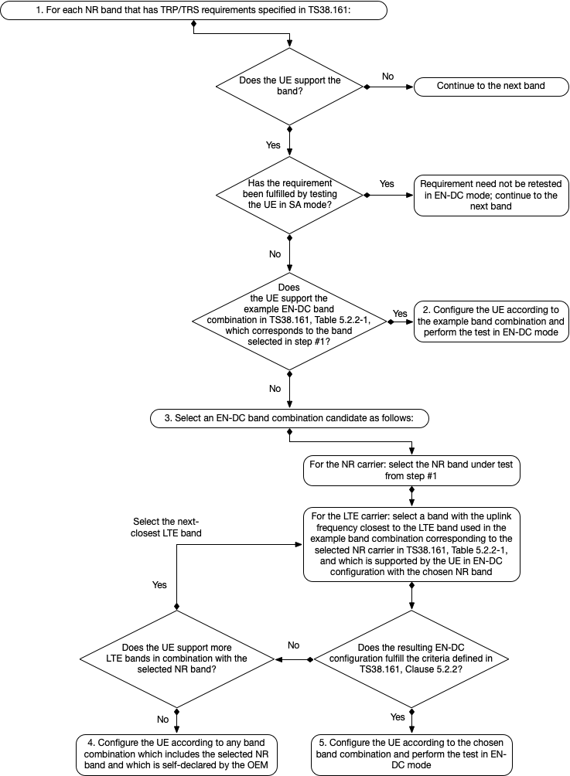

Figure 5.2.2-1: Decision tree to select the EN-DC band combination for TRP/TRS testing

## 5.3 Test parameters for each band

The detailed testing parameters for each band is defined in Table 5.3-1 and Table 5.3-2.

Table 5.3-1: NR FR1 TRP measurement parameters

|  |  |  |  |  |  |  |  |  |  |  |
| --- | --- | --- | --- | --- | --- | --- | --- | --- | --- | --- |
| NR Band | CBW [MHz] | SCS (kHz) | UL modulation | Range | UL Carrier centre  [ARFCN] | UL Carrier Center (MHz) | DL Carrier centre  [ARFCN] | DL Carrier Center (MHz) | UL RB Allocation  (LCRB @ RBstart) | DL configuration |
| n1 | 15 | 15 | DFT-s-OFDM  QPSK | Low | 385500 | 1927.5 | 423500 | 2117.5 | 36@18 | N/A |
| Mid | 390000 | 1950 | 428000 | 2140 |
| High | 394500 | 1972.5 | 432500 | 2162.5 |
| n2 | 15 | 15 | DFT-s-OFDM  QPSK | Low | 371500 | 1857.5 | 387500 | 1937.5 | 36@18 | N/A |
| Mid | 376000 | 1880 | 392000 | 1960 |
| High | 380500 | 1902.5 | 396500 | 1982.5 |
| n3 | 20 | 15 | DFT-s-OFDM  QPSK | Low | 344000 | 1720 | 363000 | 1815 | 50@25 | N/A |
| Mid | 349500 | 1747.5 | 368500 | 1842.5 |
| High | 355000 | 1775 | 374000 | 1870 |
| n5 | 15 | 15 | DFT-s-OFDM  QPSK | Low | 166300 | 831.5 | 175300 | 876.5 | 36@18 | N/A |
| Mid | 167300 | 836.5 | 176300 | 881.5 |
| High | 168300 | 841.5 | 177300 | 886.5 |
| n7 | 15 | 15 | DFT-s-OFDM  QPSK | Low | 501500 | 2507.5 | 525500 | 2627.5 | 36@18 | N/A |
| Mid | 507000 | 2535 | 531000 | 2655 |
| High | 512500 | 2562.5 | 536500 | 2682.5 |
| n8 | 15 | 15 | DFT-s-OFDM  QPSK | Low | 177500 | 887.5 | 186500 | 932.5 | 36@18 | N/A |
| Mid | 179500 | 897.5 | 188500 | 942.5 |
| High | 181500 | 907.5 | 190500 | 952.5 |
| n12 | 10 | 15 | DFT-s-OFDM  QPSK | Low | 140800 | 704 | 146800 | 734 | 25@12 | N/A |
| Mid | 141500 | 707.5 | 147500 | 737.5 |
| High | 142200 | 711 | 148200 | 741 |
| n14 | 10 | 15 | DFT-s-OFDM  QPSK | Low | 158600 | 793 | 152600 | 763 | 25@12 | N/A |
| Mid |
| High |
| n20 | 15 | 15 | DFT-s-OFDM  QPSK | Low | 167900 | 839.5 | 159700 | 798.5 | 36@18 | N/A |
| Mid | 169400 | 847 | 161200 | 806 |
| High | 170900 | 854.5 | 162700 | 813.5 |
| n25 | 15 | 15 | DFT-s-OFDM  QPSK | Low | 371500 | 1857.5 | 387500 | 1937.5 | 36@18 | N/A |
| Mid | 376500 | 1882.5 | 392500 | 1962.5 |
| High | 381500 | 1907.5 | 397500 | 1987.5 |
| n26 | 10 | 15 | DFT-s-OFDM  QPSK | Low | 163800 | 819 | 172800 | 864 | 25@12 | N/A |
| Mid | 166300 | 831.5 | 175300 | 876.5 |
| High | 168800 | 844 | 177800 | 889 |
| n28 | 20 | 15 | DFT-s-OFDM  QPSK | Low | 142600 | 713 | 153600 | 768 | 50@25 | N/A |
| Mid | 145600 | 728 | 156600 | 783 |
| High | 147600 | 738 | 158600 | 793 |
| n30 | 10 | 15 | DFT-s-OFDM  QPSK | Low | 462000 | 2310 | 471000 | 2355 | 25@12 | N/A |
| Mid |
| High |
| n34 | 10 | 15 | DFT-s-OFDM  QPSK | Low | 403000 | 2015 | 403000 | 2015 | 25@12 | N/A |
| Mid | 403500 | 2017.5 | 403500 | 2017.5 |
| High | 404000 | 2020 | 404000 | 2020 |
| n38 | 15 | 15 | DFT-s-OFDM  QPSK | Low | 515500 | 2577.5 | 515500 | 2577.5 | 36@18 | N/A |
| Mid | 519000 | 2595 | 519000 | 2595 |
| High | 522500 | 2612.5 | 522500 | 2612.5 |
| n39 | 20 | 15 | DFT-s-OFDM  QPSK | Low | 378000 | 1890 | 378000 | 1890 | 50@25 | N/A |
| Mid | 380000 | 1900 | 380000 | 1900 |
| High | 382000 | 1910 | 382000 | 1910 |
| n40 | 30 | 15 | DFT-s-OFDM  QPSK | Low | 463000 | 2315 | 463000 | 2315 | TBD | N/A |
| Mid | 470000 | 2350 | 470000 | 2350 |
| High | 477000 | 2385 | 477000 | 2385 |
| n41 | 100 | 30 | DFT-s-OFDM  QPSK | Low | 509202 | 2546.01 | 509202 | 2546.01 | 135@67 | N/A |
| Mid | 518598 | 2592.99 | 518598 | 2592.99 |
| High | 528000 | 2640 | 528000 | 2640 |
| n48 | 20 | 15 | DFT-s-OFDM  QPSK | Low | 637334 | 3560.01 | 637334 | 3560.01 | 50@25 | N/A |
| Mid | 641666 | 3624.99 | 641666 | 3624.99 |
| High | 646000 | 3690 | 646000 | 3690 |
| n50 | 20 | 15 | DFT-s-OFDM  QPSK | Low | 288400 | 1442 | 288400 | 1442 | 50@25 | N/A |
| Mid | 294900 | 1474.5 | 294900 | 1474.5 |
| High | 301400 | 1507 | 301400 | 1507 |
| n51 | 5 | 15 | DFT-s-OFDM  QPSK | Low | 285900 | 1429.5 | 285900 | 1429.5 | 12@6 | N/A |
| Mid |
| High |
| n53 | 10 | 15 | DFT-s-OFDM  QPSK | Low | 497700 | 2488.5 | 497700 | 2488.5 | 25@12 | N/A |
| Mid | 497860 | 2489.3 | 497860 | 2489.3 |
| High | 498000 | 2490 | 498000 | 2490 |
| n65 | 15 | 15 | DFT-s-OFDM  QPSK | Low | 423500 | 2117.5 | 423500 | 2117.5 | 36@18 | N/A |
| Mid | 431000 | 2155 | 431000 | 2155 |
| High | 438500 | 2192.5 | 438500 | 2192.5 |
| n66 | 20 (20+20) | 15 | DFT-s-OFDM  QPSK | Low | 344000 | 1720 | 424000 | 2120 | 50@25 | N/A |
| Mid | 349000 | 1745 | 429000 | 2145 |
| High | 354000 | 1770 | 434000 | 2170 |
| n70 | 15 (15+15) | 15 | DFT-s-OFDM  QPSK | Low | 340500 | 1702.5 | 400500 | 2002.5 | 36@18 | N/A |
| Mid |
| High |
| n71 | 10 | 15 | DFT-s-OFDM  QPSK | Low | 133600 | 668 | 124400 | 622 | 25@12 | N/A |
| Mid | 136100 | 680.5 | 126900 | 634.5 |
| High | 138600 | 693 | 129400 | 647 |
| n74 | 15 | 15 | DFT-s-OFDM  QPSK | Low | 286900 | 1434.5 | 296500 | 1482.5 | 36@18 | N/A |
| Mid | 289700 | 1448.5 | 299300 | 1496.5 |
| High | 292500 | 1462.5 | 302100 | 1510.5 |
| n77 | 100 | 30 | DFT-s-OFDM  QPSK | Low | 623334 | 3350.01 | 623334 | 3350.01 | 135@67 | N/A |
| Mid | 650000 | 3750 | 650000 | 3750 |
| High | 676666 | 4149.99 | 676666 | 4149.99 |
| n78 | 100 | 30 | DFT-s-OFDM  QPSK | Low | 623334 | 3350.01 | 623334 | 3350.01 | 135@67 | N/A |
| Mid | 636666 | 3549.99 | 636666 | 3549.99 |
| High | 650000 | 3750 | 650000 | 3750 |
| n79 | 100 | 30 | DFT-s-OFDM  QPSK | Low | 696668 | 4450.02 | 696668 | 4450.02 | 135@67 | N/A |
| Mid | 713334 | 4700.01 | 713334 | 4700.01 |
| High | 730000 | 4950 | 730000 | 4950 |
| n80 | 20 | 15 | DFT-s-OFDM  QPSK | Low | 344000 | 1720 | N/A | N/A | 50@25 | N/A |
| Mid | 349500 | 1747.5 | N/A | N/A |
| High | 355000 | 1775 | N/A | N/A |
| n81 | 15 | 15 | DFT-s-OFDM  QPSK | Low | 177500 | 887.5 | N/A | N/A | 36@18 | N/A |
| Mid | 179500 | 897.5 | N/A | N/A |
| High | 181500 | 907.5 | N/A | N/A |
| n82 | 15 | 15 | DFT-s-OFDM  QPSK | Low | 167900 | 839.5 | N/A | N/A | 36@18 | N/A |
| Mid | 169400 | 847 | N/A | N/A |
| High | 170900 | 854.5 | N/A | N/A |
| n83 | 15 | 15 | DFT-s-OFDM  QPSK | Low | 142100 | 710.5 | N/A | N/A | 36@18 | N/A |
| Mid | 145100 | 725.5 | N/A | N/A |
| High | 148100 | 740.5 | N/A | N/A |
| n84 | 15 | 15 | DFT-s-OFDM  QPSK | Low | 385500 | 1927.5 | N/A | N/A | 36@18 | N/A |
| Mid | 390000 | 1950 | N/A | N/A |
| High | 394500 | 1972.5 | N/A | N/A |
| n86 | 20 | 15 | DFT-s-OFDM  QPSK | Low | 344000 | 1720 | N/A | N/A | 50@25 | N/A |
| Mid | 349000 | 1745 | N/A | N/A |
| High | 354000 | 1770 | N/A | N/A |
| N95 | 10 | 15 | DFT-s-OFDM  QPSK | Low | 403000 | 2015 | N/A | N/A | 50@25 | N/A |
| Mid | 403500 | 2017.5 | N/A | N/A |
| High | 404000 | 2020 | N/A | N/A |

Table 5.3-2: NR FR1 TRS measurement parameters

|  |  |  |  |  |  |  |  |  |  |  |  |
| --- | --- | --- | --- | --- | --- | --- | --- | --- | --- | --- | --- |
| NR Band | CBW (MHz) | SCS (kHz) | DL modulation | UL modulation | Range | UL Carrier centre  [ARFCN] | UL Carrier Center (MHz) | DL Carrier centre  [ARFCN] | DL Carrier Center (MHz) | UL RB Allocation  (LCRB @ RBstart) | DL Configuration (FULL RB, LCRB @ RBstart) |
| n1 | 15 | 15 | CP-OFDM QPSK | DFT-s-OFDM  QPSK | Low | 385500 | 1927.5 | 423500 | 2117.5 | 75@4 | 79@0 |
| Mid | 390000 | 1950 | 428000 | 2140 |
| High | 394500 | 1972.5 | 432500 | 2162.5 |
| n2 | 15 | 15 | CP-OFDM QPSK | DFT-s-OFDM  QPSK | Low | 371500 | 1857.5 | 387500 | 1937.5 | 50@29 | 79@0 |
| Mid | 376000 | 1880 | 392000 | 1960 |
| High | 380500 | 1902.5 | 396500 | 1982.5 |
| n3 | 20 | 15 | CP-OFDM QPSK | DFT-s-OFDM  QPSK | Low | 344000 | 1720 | 363000 | 1815 | 50@56 | 106@0 |
| Mid | 349500 | 1747.5 | 368500 | 1842.5 |
| High | 355000 | 1775 | 374000 | 1870 |
| n5 | 15 | 15 | CP-OFDM QPSK | DFT-s-OFDM  QPSK | Low | 166300 | 831.5 | 175300 | 876.5 | 25@54 | 79@0 |
| Mid | 167300 | 836.5 | 176300 | 881.5 |
| High | 168300 | 841.5 | 177300 | 886.5 |
| n7 | 15 | 15 | CP-OFDM QPSK | DFT-s-OFDM  QPSK | Low | 501500 | 2507.5 | 525500 | 2627.5 | 75@4 | 79@0 |
| Mid | 507000 | 2535 | 531000 | 2655 |
| High | 512500 | 2562.5 | 536500 | 2682.5 |
| n8 | 15 | 15 | CP-OFDM QPSK | DFT-s-OFDM  QPSK | Low | 177500 | 887.5 | 186500 | 932.5 | 25@54 | 79@0 |
| Mid | 179500 | 897.5 | 188500 | 942.5 |
| High | 181500 | 907.5 | 190500 | 952.5 |
| n12 | 10 | 15 | CP-OFDM QPSK | DFT-s-OFDM  QPSK | Low | 140800 | 704 | 146800 | 734 | 20@32 | 52@0 |
| Mid | 141500 | 707.5 | 147500 | 737.5 |
| High | 142200 | 711 | 148200 | 741 |
| n14 | 10 | 15 | CP-OFDM QPSK | DFT-s-OFDM  QPSK | Low | 158600 | 793 | 152600 | 763 | 20@32 | 52@0 |
| Mid |
| High |
| n20 | 15 | 15 | CP-OFDM QPSK | DFT-s-OFDM  QPSK | Low | 167900 | 839.5 | 159700 | 798.5 | 20@11 | 79@0 |
| Mid | 169400 | 847 | 161200 | 806 |
| High | 170900 | 854.5 | 162700 | 813.5 |
| n25 | 15 | 15 | CP-OFDM QPSK | DFT-s-OFDM  QPSK | Low | 371500 | 1857.5 | 387500 | 1937.5 | 50@29 | 79@0 |
| Mid | 376500 | 1882.5 | 392500 | 1962.5 |
| High | 381500 | 1907.5 | 397500 | 1987.5 |
| n26 | 10 | 15 | CP-OFDM QPSK | DFT-s-OFDM  QPSK | Low | 163800 | 819 | 172800 | 864 | 25@27 | 52@0 |
| Mid | 166300 | 831.5 | 175300 | 876.5 |
| High | 168800 | 844 | 177800 | 889 |
| n28 | 20 | 15 | CP-OFDM QPSK | DFT-s-OFDM  QPSK | Low | 142600 | 713 | 153600 | 768 | 25@81 | 106@0 |
| Mid | 145600 | 728 | 156600 | 783 |
| High | 147600 | 738 | 158600 | 793 |
| n30 | 10 | 15 | CP-OFDM QPSK | DFT-s-OFDM  QPSK | Low | 462000 | 2310 | 471000 | 2355 | 20@32 | 52@0 |
| Mid |
| High |
| n34 | 10 | 15 | CP-OFDM QPSK | DFT-s-OFDM  QPSK | Low | 403000 | 2015 | 403000 | 2015 | 50@0 | 52@0 |
| Mid | 403500 | 2017.5 | 403500 | 2017.5 |
| High | 404000 | 2020 | 404000 | 2020 |
| n38 | 15 | 15 | CP-OFDM QPSK | DFT-s-OFDM  QPSK | Low | 515500 | 2577.5 | 515500 | 2577.5 | 75@0 | 79@0 |
| Mid | 519000 | 2595 | 519000 | 2595 |
| High | 522500 | 2612.5 | 522500 | 2612.5 |
| n39 | 20 | 15 | CP-OFDM QPSK | DFT-s-OFDM  QPSK | Low | 378000 | 1890 | 378000 | 1890 | 100@0 | 106@0 |
| Mid | 380000 | 1900 | 380000 | 1900 |
| High | 382000 | 1910 | 382000 | 1910 |
| n40 | 30 | 15 | CP-OFDM QPSK | DFT-s-OFDM  QPSK | Low | 463000 | 2315 | 463000 | 2315 | 160@0 | 160@0 |
| Mid | 470000 | 2350 | 470000 | 2350 |
| High | 477000 | 2385 | 477000 | 2385 |
| n41 | 100 | 30 | CP-OFDM QPSK | DFT-s-OFDM  QPSK | Low | 509202 | 2546.01 | 509202 | 2546.01 | 270@0 | 273@0 |
| Mid | 518598 | 2592.99 | 518598 | 2592.99 |
| High | 528000 | 2640 | 528000 | 2640 |
| n48 | 20 | 15 | CP-OFDM QPSK | DFT-s-OFDM  QPSK | Low | 637334 | 3560.01 | 637334 | 3560.01 | 100@0 | 106@0 |
| Mid | 641666 | 3624.99 | 641666 | 3624.99 |
| High | 646000 | 3690 | 646000 | 3690 |
| n50 | 20 | 15 | CP-OFDM QPSK | DFT-s-OFDM  QPSK | Low | 288400 | 1442 | 288400 | 1442 | 100@0 | 106@0 |
| Mid | 294900 | 1474.5 | 294900 | 1474.5 |
| High | 301400 | 1507 | 301400 | 1507 |
| n51 | 5 | 15 | CP-OFDM QPSK | DFT-s-OFDM  QPSK | Low | 285900 | 1429.5 | 285900 | 1429.5 | 25@0 | 25@0 |
| Mid |
| High |
| n53 | 10 | 15 | CP-OFDM QPSK | DFT-s-OFDM  QPSK | Low | 497700 | 2488.5 | 497700 | 2488.5 | 50@0 | 52@0 |
| Mid | 497860 | 2489.3 | 497860 | 2489.3 |
| High | 498000 | 2490 | 498000 | 2490 |
| n65 | 15 | 15 | CP-OFDM QPSK | DFT-s-OFDM  QPSK | Low | 423500 | 2117.5 | 423500 | 2117.5 | 75@4 | 79@0 |
| Mid | 431000 | 2155 | 431000 | 2155 |
| High | 438500 | 2192.5 | 438500 | 2192.5 |
| n66 | 20 (20+20) | 15 | CP-OFDM QPSK | DFT-s-OFDM  QPSK | Low | 344000 | 1720 | 424000 | 2120 | 100@6 | 106@0 |
| Mid | 349000 | 1745 | 429000 | 2145 |
| High | 354000 | 1770 | 434000 | 2170 |
| n70 | 15 | 15 | CP-OFDM QPSK | DFT-s-OFDM  QPSK | Low | 340500 | 1702.5 | 400500 | 2002.5 | 75@4 | 79@0 |
| Mid |
| High |
| n71 | 10 | 15 | CP-OFDM QPSK | DFT-s-OFDM  QPSK | Low | 133600 | 668 | 124400 | 622 | 25@0 | 52@0 |
| Mid | 136100 | 680.5 | 126900 | 634.5 |
| High | 138600 | 693 | 129400 | 647 |
| n74 | 15 | 15 | CP-OFDM QPSK | DFT-s-OFDM  QPSK | Low | 286900 | 1434.5 | 296500 | 1482.5 | 25@54 | 79@0 |
| Mid | 289700 | 1448.5 | 299300 | 1496.5 |
| High | 292500 | 1462.5 | 302100 | 1510.5 |
| n75 SDL | 15 | 15 | CP-OFDM QPSK | DFT-s-OFDM  QPSK | Low | N/A | N/A | 287900 | 1439.5 | NA | 79@0 |
| Mid | N/A | N/A | 294900 | 1474.5 |
| High | N/A | N/A | 301900 | 1509.5 |
| n76 SDL | 5 | 15 | CP-OFDM QPSK | DFT-s-OFDM  QPSK | Low | N/A | N/A | 285900 | 1429.5 | NA | 25@0 |
| Mid |
| High |
| n77 | 100 | 30 | CP-OFDM QPSK | DFT-s-OFDM  QPSK | Low | 623334 | 3350.01 | 623334 | 3350.01 | 270@0 | 273@0 |
| Mid | 650000 | 3750 | 650000 | 3750 |
| High | 676666 | 4149.99 | 676666 | 4149.99 |
| n78 | 100 | 30 | CP-OFDM QPSK | DFT-s-OFDM  QPSK | Low | 623334 | 3350.01 | 623334 | 3350.01 | 270@0 | 273@0 |
| Mid | 636666 | 3549.99 | 636666 | 3549.99 |
| High | 650000 | 3750 | 650000 | 3750 |
| n79 | 100 | 30 | CP-OFDM QPSK | DFT-s-OFDM  QPSK | Low | 696668 | 4450.02 | 696668 | 4450.02 | 270@0 | 273@0 |
| Mid | 713334 | 4700.01 | 713334 | 4700.01 |
| High | 730000 | 4950 | 730000 | 4950 |

The detailed testing parameters for each band for RedCap UE is defined in Table 5.3-3 and Table 5.3-4.

Table 5.3-3: NR FR1 TRP measurement parameters for RedCap UE

|  |  |  |  |  |  |  |  |  |  |  |
| --- | --- | --- | --- | --- | --- | --- | --- | --- | --- | --- |
| NR Band | CBW [MHz] | SCS (kHz) | UL modulation | Range | UL Carrier centre  [ARFCN] | UL Carrier Center (MHz) | DL Carrier centre  [ARFCN] | DL Carrier Center (MHz) | UL RB Allocation  (LCRB @ RBstart) | DL configuration |
| n1 | 15 | 15 | DFT-s-OFDM  QPSK | Low | 385500 | 1927.5 | 423500 | 2117.5 | 36@18 | N/A |
| Mid | 390000 | 1950 | 428000 | 2140 |
| High | 394500 | 1972.5 | 432500 | 2162.5 |
| n2 | 15 | 15 | DFT-s-OFDM  QPSK | Low | 371500 | 1857.5 | 387500 | 1937.5 | 36@18 | N/A |
| Mid | 376000 | 1880 | 392000 | 1960 |
| High | 380500 | 1902.5 | 396500 | 1982.5 |
| n3 | 15 | 15 | DFT-s-OFDM  QPSK | Low | 343500 | 1717.5 | 362500 | 1812.5 | 36@18 | N/A |
| Mid | 349500 | 1747.5 | 368500 | 1842.5 |
| High | 355500 | 1777.5 | 374500 | 1872.5 |
| n5 | 15 | 15 | DFT-s-OFDM  QPSK | Low | 166300 | 831.5 | 175300 | 876.5 | 36@18 | N/A |
| Mid | 167300 | 836.5 | 176300 | 881.5 |
| High | 168300 | 841.5 | 177300 | 886.5 |
| n7 | 15 | 15 | DFT-s-OFDM  QPSK | Low | 501500 | 2507.5 | 525500 | 2627.5 | 36@18 | N/A |
| Mid | 507000 | 2535 | 531000 | 2655 |
| High | 512500 | 2562.5 | 536500 | 2682.5 |
| n8 | 15 | 15 | DFT-s-OFDM  QPSK | Low | 177500 | 887.5 | 186500 | 932.5 | 36@18 | N/A |
| Mid | 179500 | 897.5 | 188500 | 942.5 |
| High | 181500 | 907.5 | 190500 | 952.5 |
| n12 | 10 | 15 | DFT-s-OFDM  QPSK | Low | 140800 | 704 | 146800 | 734 | 25@12 | N/A |
| Mid | 141500 | 707.5 | 147500 | 737.5 |
| High | 142200 | 711 | 148200 | 741 |
| n14 | 10 | 15 | DFT-s-OFDM  QPSK | Low | 158600 | 793 | 152600 | 763 | 25@12 | N/A |
| Mid |
| High |
| n20 | 15 | 15 | DFT-s-OFDM  QPSK | Low | 167900 | 839.5 | 159700 | 798.5 | 36@18 | N/A |
| Mid | 169400 | 847 | 161200 | 806 |
| High | 170900 | 854.5 | 162700 | 813.5 |
| n25 | 15 | 15 | DFT-s-OFDM  QPSK | Low | 371500 | 1857.5 | 387500 | 1937.5 | 36@18 | N/A |
| Mid | 376500 | 1882.5 | 392500 | 1962.5 |
| High | 381500 | 1907.5 | 397500 | 1987.5 |
| n26 | 15 | 15 | DFT-s-OFDM  QPSK | Low | 164300 | 821.5 | 173300 | 866.5 | 36@18 | N/A |
| Mid | 166300 | 831.5 | 175300 | 876.5 |
| High | 168300 | 841.5 | 177300 | 886.5 |
| n28 | 15 | 15 | DFT-s-OFDM  QPSK | Low | 142100 | 710.5 | 153100 | 765.5 | 36@18 | N/A |
| Mid | 145100 | 725.5 | 156100 | 780.5 |
| High | 148100 | 740.5 | 159100 | 795.5 |
| n30 | 10 | 15 | DFT-s-OFDM  QPSK | Low | 462000 | 2310 | 471000 | 2355 | 25@12 | N/A |
| Mid |
| High |
| n34 | 10 | 15 | DFT-s-OFDM  QPSK | Low | 403000 | 2015 | 403000 | 2015 | 25@12 | N/A |
| Mid | 403500 | 2017.5 | 403500 | 2017.5 |
| High | 404000 | 2020 | 404000 | 2020 |
| n38 | 15 | 15 | DFT-s-OFDM  QPSK | Low | 515500 | 2577.5 | 515500 | 2577.5 | 36@18 | N/A |
| Mid | 519000 | 2595 | 519000 | 2595 |
| High | 522500 | 2612.5 | 522500 | 2612.5 |
| n39 | 15 | 15 | DFT-s-OFDM  QPSK | Low | 377500 | 1887.5 | 377500 | 1887.5 | 36@18 | N/A |
| Mid | 380000 | 1900 | 380000 | 1900 |
| High | 382500 | 1912.5 | 382500 | 1912.5 |
| n40 | 15 | 15 | DFT-s-OFDM  QPSK | Low | 461500 | 2307.5 | 461500 | 2307.5 | 36@18 | N/A |
| Mid | 470000 | 2350 | 470000 | 2350 |
| High | 478500 | 2392.5 | 478500 | 2392.5 |
| n41 | 15 | 15 | DFT-s-OFDM  QPSK | Low | 500700 | 2503.5 | 500700 | 2503.5 | 36@18 | N/A |
| Mid | 518601 | 2593.005 | 518601 | 2593.005 |
| High | 536499 | 2682.495 | 536499 | 2682.495 |
| n48 | 15 | 15 | DFT-s-OFDM  QPSK | Low | 637168 | 3557.52 | 637168 | 3557.52 | 36@18 | N/A |
| Mid | 641666 | 3624.99 | 641666 | 3624.99 |
| High | 646166 | 3692.49 | 646166 | 3692.49 |
| n50 | 15 | 15 | DFT-s-OFDM  QPSK | Low | 287900 | 1439.5 | 287900 | 1439.5 | 36@18 | N/A |
| Mid | 294900 | 1474.5 | 294900 | 1474.5 |
| High | 301900 | 1509.5 | 301900 | 1509.5 |
| n51 | 5 | 15 | DFT-s-OFDM  QPSK | Low | 285900 | 1429.5 | 285900 | 1429.5 | 12@6 | N/A |
| Mid |
| High |
| n53 | 10 | 15 | DFT-s-OFDM  QPSK | Low | 497700 | 2488.5 | 497700 | 2488.5 | 25@12 | N/A |
| Mid | 497860 | 2489.3 | 497860 | 2489.3 |
| High | 498000 | 2490 | 498000 | 2490 |
| n65 | 15 | 15 | DFT-s-OFDM  QPSK | Low | 423500 | 2117.5 | 423500 | 2117.5 | 36@18 | N/A |
| Mid | 431000 | 2155 | 431000 | 2155 |
| High | 438500 | 2192.5 | 438500 | 2192.5 |
| n71 | 10 | 15 | DFT-s-OFDM  QPSK | Low | 133600 | 668 | 124400 | 622 | 25@12 | N/A |
| Mid | 136100 | 680.5 | 126900 | 634.5 |
| High | 138600 | 693 | 129400 | 647 |
| n74 | 15 | 15 | DFT-s-OFDM  QPSK | Low | 286900 | 1434.5 | 296500 | 1482.5 | 36@18 | N/A |
| Mid | 289700 | 1448.5 | 299300 | 1496.5 |
| High | 292500 | 1462.5 | 302100 | 1510.5 |
| n77 | 15 | 15 | DFT-s-OFDM  QPSK | Low | 620500 | 3307.5 | 620500 | 3307.5 | 36@18 | N/A |
| Mid | 650000 | 3750 | 650000 | 3750 |
| High | 679500 | 4192.5 | 679500 | 4192.5 |
| n78 | 15 | 15 | DFT-s-OFDM  QPSK | Low | 620500 | 3307.5 | 620500 | 3307.5 | 36@18 | N/A |
| Mid | 636666 | 3549.99 | 636666 | 3549.99 |
| High | 652832 | 3792.48 | 652832 | 3792.48 |
| n79 | 20 | 15 | DFT-s-OFDM  QPSK | Low | 694000 | 4410 | 694000 | 4410 | 50@25 | N/A |
| Mid | 713333 | 4699.995 | 713333 | 4699.995 |
| High | 732667 | 4990.005 | 732667 | 4990.005 |

Table 5.3-4: NR FR1 TRS measurement parameters for RedCap UE

|  |  |  |  |  |  |  |  |  |  |  |  |
| --- | --- | --- | --- | --- | --- | --- | --- | --- | --- | --- | --- |
| NR Band | CBW (MHz) | SCS (kHz) | DL modulation | UL modulation | Range | UL Carrier centre  [ARFCN] | UL Carrier Center (MHz) | DL Carrier centre  [ARFCN] | DL Carrier Center (MHz) | UL RB Allocation  (LCRB @ RBstart) | DL Configuration (FULL RB, LCRB @ RBstart) |
| n1 | 15 | 15 | CP-OFDM QPSK | DFT-s-OFDM  QPSK | Low | 385500 | 1927.5 | 423500 | 2117.5 | 75@4 | 79@0 |
| Mid | 390000 | 1950 | 428000 | 2140 |
| High | 394500 | 1972.5 | 432500 | 2162.5 |
| n2 | 15 | 15 | CP-OFDM QPSK | DFT-s-OFDM  QPSK | Low | 371500 | 1857.5 | 387500 | 1937.5 | 50@29 | 79@0 |
| Mid | 376000 | 1880 | 392000 | 1960 |
| High | 380500 | 1902.5 | 396500 | 1982.5 |
| n3 | 15 | 15 | CP-OFDM QPSK | DFT-s-OFDM  QPSK | Low | 343500 | 1717.5 | 362500 | 1812.5 | 50@29 | 79@0 |
| Mid | 349500 | 1747.5 | 368500 | 1842.5 |
| High | 355500 | 1777.5 | 374500 | 1872.5 |
| n5 | 15 | 15 | CP-OFDM QPSK | DFT-s-OFDM  QPSK | Low | 166300 | 831.5 | 175300 | 876.5 | 25@54 | 79@0 |
| Mid | 167300 | 836.5 | 176300 | 881.5 |
| High | 168300 | 841.5 | 177300 | 886.5 |
| n7 | 15 | 15 | CP-OFDM QPSK | DFT-s-OFDM  QPSK | Low | 501500 | 2507.5 | 525500 | 2627.5 | 75@4 | 79@0 |
| Mid | 507000 | 2535 | 531000 | 2655 |
| High | 512500 | 2562.5 | 536500 | 2682.5 |
| n8 | 15 | 15 | CP-OFDM QPSK | DFT-s-OFDM  QPSK | Low | 177500 | 887.5 | 186500 | 932.5 | 25@54 | 79@0 |
| Mid | 179500 | 897.5 | 188500 | 942.5 |
| High | 181500 | 907.5 | 190500 | 952.5 |
| n12 | 10 | 15 | CP-OFDM QPSK | DFT-s-OFDM  QPSK | Low | 140800 | 704 | 146800 | 734 | 20@32 | 52@0 |
| Mid | 141500 | 707.5 | 147500 | 737.5 |
| High | 142200 | 711 | 148200 | 741 |
| n14 | 10 | 15 | CP-OFDM QPSK | DFT-s-OFDM  QPSK | Low | 158600 | 793 | 152600 | 763 | 20@32 | 52@0 |
| Mid |
| High |
| n20 | 15 | 15 | CP-OFDM QPSK | DFT-s-OFDM  QPSK | Low | 167900 | 839.5 | 159700 | 798.5 | 20@11 | 79@0 |
| Mid | 169400 | 847 | 161200 | 806 |
| High | 170900 | 854.5 | 162700 | 813.5 |
| n25 | 15 | 15 | CP-OFDM QPSK | DFT-s-OFDM  QPSK | Low | 371500 | 1857.5 | 387500 | 1937.5 | 50@29 | 79@0 |
| Mid | 376500 | 1882.5 | 392500 | 1962.5 |
| High | 381500 | 1907.5 | 397500 | 1987.5 |
| n26 | 15 | 15 | CP-OFDM QPSK | DFT-s-OFDM  QPSK | Low | 164300 | 821.5 | 173300 | 866.5 | 25@54 | 79@0 |
| Mid | 166300 | 831.5 | 175300 | 876.5 |
| High | 168300 | 841.5 | 177300 | 886.5 |
| n28 | 15 | 15 | CP-OFDM QPSK | DFT-s-OFDM  QPSK | Low | 142100 | 710.5 | 153100 | 765.5 | 25@54 | 79@0 |
| Mid | 145100 | 725.5 | 156100 | 780.5 |
| High | 148100 | 740.5 | 159100 | 795.5 |
| n30 | 10 | 15 | CP-OFDM QPSK | DFT-s-OFDM  QPSK | Low | 462000 | 2310 | 471000 | 2355 | 20@32 | 52@0 |
| Mid |
| High |
| n34 | 10 | 15 | CP-OFDM QPSK | DFT-s-OFDM  QPSK | Low | 403000 | 2015 | 403000 | 2015 | 50@0 | 52@0 |
| Mid | 403500 | 2017.5 | 403500 | 2017.5 |
| High | 404000 | 2020 | 404000 | 2020 |
| n38 | 15 | 15 | CP-OFDM QPSK | DFT-s-OFDM  QPSK | Low | 515500 | 2577.5 | 515500 | 2577.5 | 75@0 | 79@0 |
| Mid | 519000 | 2595 | 519000 | 2595 |
| High | 522500 | 2612.5 | 522500 | 2612.5 |
| n39 | 15 | 15 | CP-OFDM QPSK | DFT-s-OFDM  QPSK | Low | 377500 | 1887.5 | 377500 | 1887.5 | 75@0 | 79@0 |
| Mid | 380000 | 1900 | 380000 | 1900 |
| High | 382500 | 1912.5 | 382500 | 1912.5 |
| n40 | 15 | 15 | CP-OFDM QPSK | DFT-s-OFDM  QPSK | Low | 461500 | 2307.5 | 461500 | 2307.5 | 75@0 | 79@0 |
| Mid | 470000 | 2350 | 470000 | 2350 |
| High | 478500 | 2392.5 | 478500 | 2392.5 |
| n41 | 15 | 15 | CP-OFDM QPSK | DFT-s-OFDM  QPSK | Low | 500700 | 2503.5 | 500700 | 2503.5 | 75@0 | 79@0 |
| Mid | 518601 | 2593.005 | 518601 | 2593.005 |
| High | 536499 | 2682.495 | 536499 | 2682.495 |
| n48 | 15 | 15 | CP-OFDM QPSK | DFT-s-OFDM  QPSK | Low | 637168 | 3557.52 | 637168 | 3557.52 | 75@0 | 79@0 |
| Mid | 641666 | 3624.99 | 641666 | 3624.99 |
| High | 646166 | 3692.49 | 646166 | 3692.49 |
| n50 | 15 | 15 | CP-OFDM QPSK | DFT-s-OFDM  QPSK | Low | 287900 | 1439.5 | 287900 | 1439.5 | 75@0 | 79@0 |
| Mid | 294900 | 1474.5 | 294900 | 1474.5 |
| High | 301900 | 1509.5 | 301900 | 1509.5 |
| n51 | 5 | 15 | CP-OFDM QPSK | DFT-s-OFDM  QPSK | Low | 285900 | 1429.5 | 285900 | 1429.5 | 25@0 | 25@0 |
| Mid |
| High |
| n53 | 10 | 15 | CP-OFDM QPSK | DFT-s-OFDM  QPSK | Low | 497700 | 2488.5 | 497700 | 2488.5 | 50@0 | 52@0 |
| Mid | 497860 | 2489.3 | 497860 | 2489.3 |
| High | 498000 | 2490 | 498000 | 2490 |
| n65 | 15 | 15 | CP-OFDM QPSK | DFT-s-OFDM  QPSK | Low | 423500 | 2117.5 | 423500 | 2117.5 | 75@4 | 79@0 |
| Mid | 431000 | 2155 | 431000 | 2155 |
| High | 438500 | 2192.5 | 438500 | 2192.5 |
| n70 | 15 | 15 | CP-OFDM QPSK | DFT-s-OFDM  QPSK | Low | 340500 | 1702.5 | 400500 | 2002.5 | 75@4 | 79@0 |
| Mid |
| High |
| n71 | 10 | 15 | CP-OFDM QPSK | DFT-s-OFDM  QPSK | Low | 133600 | 668 | 124400 | 622 | 25@0 | 52@0 |
| Mid | 136100 | 680.5 | 126900 | 634.5 |
| High | 138600 | 693 | 129400 | 647 |
| n74 | 15 | 15 | CP-OFDM QPSK | DFT-s-OFDM  QPSK | Low | 286900 | 1434.5 | 296500 | 1482.5 | 25@54 | 79@0 |
| Mid | 289700 | 1448.5 | 299300 | 1496.5 |
| High | 292500 | 1462.5 | 302100 | 1510.5 |
| n77 | 15 | 15 | CP-OFDM QPSK | DFT-s-OFDM  QPSK | Low | 620500 | 3307.5 | 620500 | 3307.5 | 75@0 | 79@0 |
| Mid | 650000 | 3750 | 650000 | 3750 |
| High | 679500 | 4192.5 | 679500 | 4192.5 |
| n78 | 15 | 15 | CP-OFDM QPSK | DFT-s-OFDM  QPSK | Low | 620500 | 3307.5 | 620500 | 3307.5 | 75@0 | 79@0 |
| Mid | 636666 | 3549.99 | 636666 | 3549.99 |
| High | 652832 | 3792.48 | 652832 | 3792.48 |
| n79 | 20 | 15 | CP-OFDM QPSK | DFT-s-OFDM  QPSK | Low | 694000 | 4410 | 694000 | 4410 | 100@0 | 106@0 |
| Mid | 713333 | 4699.995 | 713333 | 4699.995 |
| High | 732667 | 4990.005 | 732667 | 4990.005 |

# 6 FR1 TRP requirements

## 6.1 General

The TRP requirements specified in Clause 6 apply to handheld UE with TAS off and power back-off functions disabled.

The TRP requirements defined in Clause 6.2 should be verified based on the detailed test parameters in Table 5.3-1.

## 6.2 Minimum requirement

### 6.2.1 Minimum requirement for handheld UE

The average measured total radiated power (TRP) of low, mid and high channel for handheld UE shall be higher than the average TRP requirement specified in subclauses 6.2.1.1 and 6.2.1.2. The averaging shall be done in linear scale for the TRP results of both right and left side of the phantom head in case of beside the head and hand phantom positions. For the hand phantom browsing mode position the averaging shall be done in linear scale for the TRP results of both right and left hand phantom measurements.

For UEs which do not support NR FR1 in stand-alone mode, EN-DC mode requirements apply. SA and EN-DC test case applicability is defined in Clause 4.3, and test case applicability based on power class capability is defined in Clause 4.4. The relevant test methodology is defined in Annexes A and B of this specification.

#### 6.2.1.1 Hand phantom browsing mode

Hand phantom browsing mode positions are defined in Clause B.3.1.

##### 6.2.1.1.1 NR FR1

Handheld UE TRP minimum performance requirement for NR FR1 bands in the hand phantom browsing position and the primary mechanical mode are defined in Tables 6.2.1.1.1-1 and 6.2.1.1.1-2.

Table 6.2.1.1.1-1: Handheld PC3 UE TRP minimum performance requirement for NR FR1 bands in the hand phantom browsing position and the primary mechanical mode

|  |  |  |  |  |
| --- | --- | --- | --- | --- |
| NR Band | Bandwidth (MHz) | Usage Scenario | Power Class 3 | |
| Average TRP (dBm) | |
| UE width ≤ 72mm | UE width > 72mm |
| n28 | 20 | HL and HR |  |  |
| n41 | 100 | HL and HR |  |  |
| n78 | 100 | HL and HR |  |  |
| n79 | 100 | HL and HR |  |  |

Table 6.2.1.1-2: Handheld PC2 UE TRP minimum performance requirement for NR FR1 bands in the hand phantom browsing position and the primary mechanical mode

|  |  |  |  |  |
| --- | --- | --- | --- | --- |
| NR Band | Bandwidth (MHz) | Usage Scenario | Power Class 2 | |
| Average TRP (dBm) | |
| UE width ≤ 72mm | UE width > 72mm |
| n28 | 20 | HL and HR |  |  |
| n41 | 100 | HL and HR |  | 12.5 |
| n78 | 100 | HL and HR |  | 13 |
| n79 | 100 | HL and HR |  |  |

##### 6.2.1.1.2 NR FR1 in EN-DC mode

Handheld UE TRP minimum performance requirement for NR FR1 bands (in EN-DC mode) in the hand phantom browsing position and the primary mechanical mode are defined in Tables 6.2.1.1.2-1 and 6.2.1.1.2-2.

Table 6.2.1.1.2-1: Handheld PC3 UE TRP minimum performance requirement for NR FR1 bands (in EN-DC mode) in the hand phantom browsing position and the primary mechanical mode

|  |  |  |  |  |
| --- | --- | --- | --- | --- |
| NR Band | Bandwidth (MHz) | Usage Scenario | Power Class 3 | |
| Average TRP (dBm) | |
| UE width ≤ 72mm | UE width > 72mm |
| n28 | 20 | HL and HR |  |  |
| n41 | 100 | HL and HR |  |  |
| n78 | 100 | HL and HR |  |  |
| n79 | 100 | HL and HR |  |  |

Table 6.2.1.1.2-2: Handheld PC2 UE TRP minimum performance requirement for NR FR1 bands (in EN-DC mode) in the hand phantom browsing position and the primary mechanical mode

|  |  |  |  |  |
| --- | --- | --- | --- | --- |
| NR Band | Bandwidth (MHz) | Usage Scenario | Power Class 2 | |
| Average TRP (dBm) | |
| UE width ≤ 72mm | UE width > 72mm |
| n28 | 20 | HL and HR |  |  |
| n41 | 100 | HL and HR |  |  |
| n78 | 100 | HL and HR |  |  |
| n79 | 100 | HL and HR |  |  |

#### 6.2.1.2 Beside the head and hand phantom talk mode

Beside the head and hand phantom mode positions are defined in Clause B.3.2 of this specification.

##### 6.2.1.2.1 NR FR1

Handheld UE TRP minimum performance requirement for NR FR1 bands in the beside head and hand phantom talk position and the primary mechanical mode are defined in Tables 6.2.1.2.1-1 and 6.2.1.2.1-2.

Table 6.2.1.2.1-1: Handheld PC3 UE TRP minimum performance requirement for NR FR1 bands in the beside head and hand phantom talk position and the primary mechanical mode

|  |  |  |  |  |
| --- | --- | --- | --- | --- |
| NR Band | Bandwidth (MHz) | Usage Scenario | Power Class 3 | |
| Average TRP (dBm) | |
| UE width ≤ 72mm | UE width > 72mm |
| n28 | 20 | BHHL and BHHR |  |  |
| n41 | 100 | BHHL and BHHR |  |  |
| n78 | 100 | BHHL and BHHR |  |  |
| n79 | 100 | BHHL and BHHR |  |  |

Table 6.2.1.2.1-2: Handheld PC2 UE TRP minimum performance requirement for NR FR1 bands in the beside head and hand phantom talk position and the primary mechanical mode

|  |  |  |  |  |
| --- | --- | --- | --- | --- |
| NR Band | Bandwidth (MHz) | Usage Scenario | Power Class 2 | |
| Average TRP (dBm) | |
| UE width ≤ 72mm | UE width > 72mm |
| n28 | 20 | BHHL and BHHR |  |  |
| n41 | 100 | BHHL and BHHR |  |  |
| n78 | 100 | BHHL and BHHR |  |  |
| n79 | 100 | BHHL and BHHR |  |  |

##### 6.2.1.2.2 NR FR1 in EN-DC mode

Handheld UE TRP minimum performance requirement for NR FR1 bands (in EN-DC mode) in the beside head and hand phantom talk position and the primary mechanical mode are defined in Tables 6.2.1.2.2-1 and 6.2.1.2.2-2.

Table 6.2.1.2.2-1: Handheld PC3 UE TRP minimum performance requirement for NR FR1 bands (in EN-DC mode) in the beside head and hand phantom talk position and the primary mechanical mode

|  |  |  |  |  |
| --- | --- | --- | --- | --- |
| NR Band | Bandwidth (MHz) | Usage Scenario | Power Class 3 | |
| Average TRP (dBm) | |
| UE width ≤ 72mm | UE width > 72mm |
| n28 | 20 | BHHL and BHHR |  |  |
| n41 | 100 | BHHL and BHHR |  |  |
| n78 | 100 | BHHL and BHHR |  |  |
| n79 | 100 | BHHL and BHHR |  |  |

Table 6.2.1.2.2-2: Handheld PC2 UE TRP minimum performance requirement for NR FR1 bands (in EN-DC mode) in the beside head and hand phantom talk position and the primary mechanical mode

|  |  |  |  |  |
| --- | --- | --- | --- | --- |
| NR Band | Bandwidth (MHz) | Usage Scenario | Power Class 2 | |
| Average TRP (dBm) | |
| UE width ≤ 72mm | UE width > 72mm |
| n28 | 20 | BHHL and BHHR |  |  |
| n41 | 100 | BHHL and BHHR |  |  |
| n78 | 100 | BHHL and BHHR |  |  |
| n79 | 100 | BHHL and BHHR |  |  |

# 7 FR1 TRS requirements

## 7.1 General

The TRS requirements specified in Clause 7 apply to handheld UE configured with maximum number of Rx antennas supported for each band, which is specified in TS 38.101-1 Clause 7.3 [3].

The TRS requirements defined in Clause 7.2 should be verified based on the detailed test parameters in Table 5.3-2.

## 7.2 Minimum requirement

### 7.2.1 Minimum requirement for handheld UE

The average measured total radiated sensitivity (TRS) of low, mid and high channel for handheld UE shall be lower than the average TRS requirement specified in subclauses 7.2.1.1 and 7.2.1.2. The averaging shall be done in linear scale for the TRS results of both right and left side of the phantom head in case of beside the head and hand phantom positions. For the hand phantom browsing mode position the averaging shall be done in linear scale for the TRP results of both right and left hand phantom measurements.

For UEs which do not support NR FR1 in stand-alone mode, EN-DC mode requirements apply. SA and EN-DC test case applicability is defined in Clause 4.3, and test case applicability based on power class capability is defined in Clause 4.4. The relevant test methodology is defined in Annexes A and B of this specification.

#### 7.2.1.1 Hand phantom browsing mode

Hand phantom browsing mode positions are defined in Clause B.3.1.

##### 7.2.1.1.1 NR FR1

Handheld UE TRS minimum performance requirement for NR FR1 bands in the hand phantom browsing position and the primary mechanical mode are defined in Tables 7.2.1.1.1-1 and 7.2.1.1.1-2.

Table 7.2.1.1.1-1: Handheld PC3 and PC2 UE TRS minimum performance requirement for NR FR1 bands in the hand phantom browsing position and the primary mechanical mode

|  |  |  |  |  |
| --- | --- | --- | --- | --- |
| NR Band | Bandwidth (MHz) | Usage Scenario | Power Class 3 and Power Class 2 | |
| Average TRS (dBm) | |
| UE width ≤ 72mm | UE width > 72mm |
| n28 | 20 | HL and HR |  |  |
| n41 | 100 | HL and HR |  | -80 |
| n78 | 100 | HL and HR |  | -81.2 |
| n79 | 100 | HL and HR |  |  |

##### 7.2.1.1.2 NR FR1 in EN-DC mode

Handheld UE TRS minimum performance requirement for NR FR1 bands (in EN-DC mode) in the hand phantom browsing position and the primary mechanical mode are defined in Tables 6.2.1.1.2-1 and 6.2.1.1.2-2.

Table 7.2.1.1.2-1: Handheld PC3 and PC2 UE TRS minimum performance requirement for NR FR1 bands (in EN-DC mode) in the hand phantom browsing position and the primary mechanical mode

|  |  |  |  |  |
| --- | --- | --- | --- | --- |
| NR Band | Bandwidth (MHz) | Usage Scenario | Power Class 3 and Power Class 2 | |
| Average TRS (dBm) | |
| UE width ≤ 72mm | UE width > 72mm |
| n28 | 20 | HL and HR |  |  |
| n41 | 100 | HL and HR |  |  |
| n78 | 100 | HL and HR |  |  |
| n79 | 100 | HL and HR |  |  |

#### 7.2.1.2 Beside the head and hand phantom position

Beside the head and hand phantom mode positions are defined in Clause B.3.2.

##### 7.2.1.2.1 NR FR1

Handheld UE TRP minimum performance requirement for NR FR1 bands in the beside head and hand phantom position and the primary mechanical mode are defined in Tables 7.2.1.2.1-1 and 7.2.1.2.1-2.

Table 7.2.1.2.1-1: Handheld PC3 and PC2 UE TRS minimum performance requirement for NR FR1 bands in the beside head and hand phantom position and the primary mechanical mode

|  |  |  |  |  |
| --- | --- | --- | --- | --- |
| NR Band | Bandwidth (MHz) | Usage Scenario | Power Class 3 and Power Class 2 | |
| Average TRS (dBm) | |
| UE width ≤ 72mm | UE width > 72mm |
| n28 | 20 | BHHL and BHHR |  |  |
| n41 | 100 | BHHL and BHHR |  |  |
| n78 | 100 | BHHL and BHHR |  |  |
| n79 | 100 | BHHL and BHHR |  |  |

##### 7.2.1.2.2 NR FR1 in EN-DC mode

Handheld UE TRS minimum performance requirement for NR FR1 bands (in EN-DC mode) in the beside head and hand phantom position and the primary mechanical mode are defined in Tables 6.2.1.2.2-1 and 6.2.1.2.2-2.

Table 7.2.1.2.2-1: Handheld PC3 and PC2 UE TRS minimum performance requirement for NR FR1 bands (in EN-DC mode) in the beside head and hand phantom position and the primary mechanical mode

|  |  |  |  |  |
| --- | --- | --- | --- | --- |
| NR Band | Bandwidth (MHz) | Usage Scenario | Power Class 3 and Power Class 2 | |
| Average TRS (dBm) | |
| UE width ≤ 72mm | UE width > 72mm |
| n28 | 20 | BHHL and BHHR |  |  |
| n41 | 100 | BHHL and BHHR |  |  |
| n78 | 100 | BHHL and BHHR |  |  |
| n79 | 100 | BHHL and BHHR |  |  |

Annex A (normative):  
Test methodology

# A.1 General

TRP TRS minimum requirement specified in Clause 6 and Clause 7 should be measured with Anechoic Chamber method.

# A.2 UE configuration

## A.2.1 General

For FR1 TRP and TRS radiated conformance testing, P-MPRc shall be 0 dB.

FR1 TRP and TRS radiated conformance testing shall be performed with the UE consistently operating at maximum power level, e.g., Time-Averaged Algorithm (TAA) and other power back-off functions should be disabled. The above functions OFF should be based on manufacturer declaration, if declared, then the manufacturer is required to provide a mechanism for the test lab to enable/disable the function.

The NR SS should send continuous uplink power control “up” commands to the DUT to ensure the DUT’s transmitter is at maximum output power during the TRP and TRS test.

## A.2.2 UE configuration for TRP test

For devices containing multiple Tx antennas, the Tx Antenna Switching (TAS) function should be OFF, and the TRP should be measured for each Tx antenna individually. The antenna with better TRP is identified as the primary antenna, and the corresponding TRP result will be used to determine the pass/fail compliance. Otherwise, the primary antenna should be selected based on manufacturer declaration. To ensure the TAS OFF testing, the manufacture should provide either software/guidance to lab to control which Tx antenna is used, or the pre-configured DUT locked at primary antenna.

For Standalone, the NR System Simulator (SS) and DUT shall be configured per TS 38.521-1 [5], section 6.2.1 (UE maximum output power) using the default settings specified in TS 38.521-1 [5] and TS 38.508-1 [7] as applicable. The measurement should be carried out based on the detailed test parameters for each band, as defined in Clause 5 Table 5.3-1.

For EN-DC, the SS and DUT shall be configured per TS 38.521-3 [6], Section 6.2B.1 (UE Maximum Output Power for EN-DC) using the default settings specified in TS 38.521-3 [6] and TS 38.508 [7] as applicable. The measurement should be carried out based on the detailed test parameters for each band, as defined in Clause 5 Table 5.3-1. The UL output power of LTE carrier should be set as a constant power of 10dBm, while measuring NR at maximum output power, i.e., with fixed p-MaxEUTRA-r15=10 dBm, and p-NR-FR1 not configured.

## A.2.3 UE configuration for TRS test

For TRS measurement, no specific setting is needed for Rx antennas. By default, the maximum number of Rx antennas supported at each band should be enabled during the TRS test.

For Standalone, the NR System Simulator (SS) and DUT shall be configured per section 7.3.2 (Reference sensitivity power level) of TS 38.521-1 [5] using the defaults specified in TS 38.521-1 [5] and TS 38.508-1 [7] as applicable. The measurement should be carried out based on the detailed test parameters for each band, as defined in Clause 5 Table 5.3-2.

For EN-DC, the EN-DC SS and DUT shall be configured per section 7.3B.2 (Reference Sensitivity for EN-DC) of TS 38.521-3 [6], using the defaults specified in TS 38.521-3 [6] and TS 38.508 [7], as applicable. The measurement should be carried out based on the detailed test parameters for each band, as defined in Clause 5 Table 5.3-2. The UL power configuration for LTE and NR is 50%-50% power splitting, i.e.,

- For PC3, p-MaxEUTRA-r15=20 dBm, and p-NR-FR1= 20dBm;

- For PC2, p-MaxEUTRA-r15=23 dBm, and p-NR-FR1= 23dBm.

# A.3 Test system of Anechoic Chamber method

## A.3.1 System setup

For FR1 TRP TRS testing, both Single-antenna and multiple-antennas anechoic chambers can be applied. In Figure A.3.1-1, an example TRP TRS test system with combined axes system is presented.

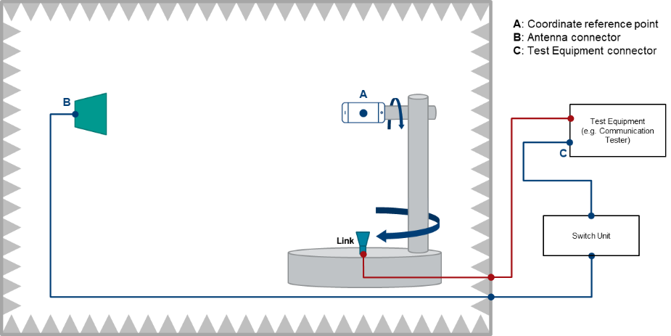

Figure A.3.1-1: Example of a FR1 TRP TRS OTA test system with combined axis

In Figure A.3.1-2, an example TRP TRS test system with distributed axes system is presented.

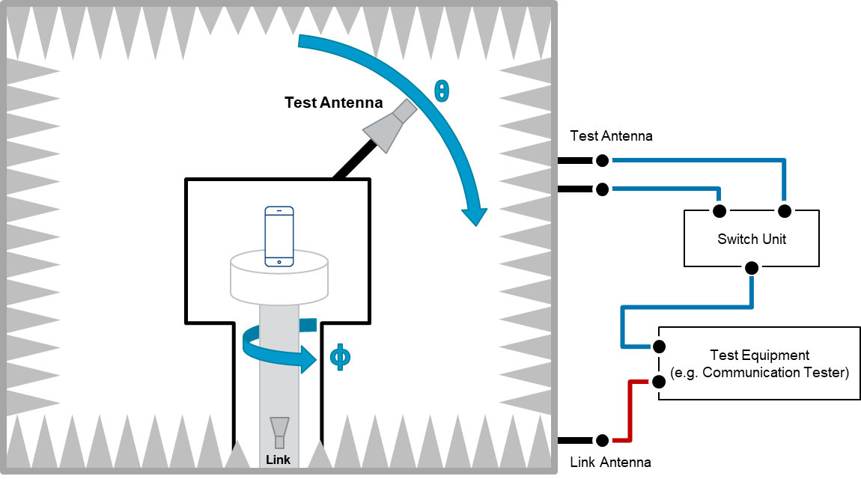

Figure A.3.1-2: Example of a FR1 TRP TRS OTA test system with distributed axis

## A.3.2 Calibration procedure

The relative power values of the measurement points will be transformed to absolute radiated power values (in dBm) by performing a range path loss calibration measurement. The system needs to be calibrated by using a reference calibration antenna with known gain values. In the range path loss calibration measurement, the reference antenna is measured in the same place as the DUT, i.e. the center of the QZ, and the attenuation of the complete transmission path () from the DUT to the measurement receiver/BS simulator is calibrated out.

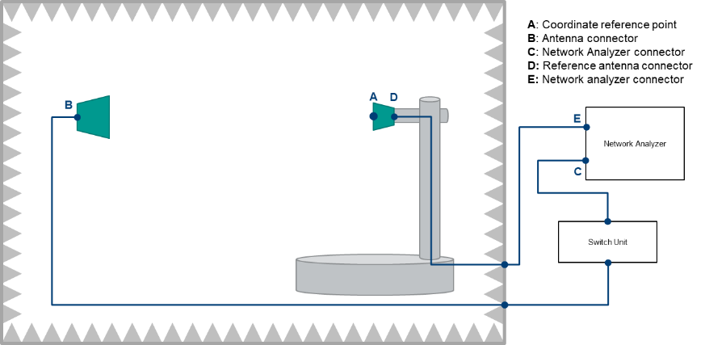

Figure A.3.2-1: Example FR1 TRP TRS calibration setup

The calibration measurement is repeated for each measurement path (two orthogonal polarizations and each signal path). The range path loss calibration measurement is performed in a two-step process including total path loss measurement and cable calibration.

Step 1: Cable calibration: the measurement of path loss *LDE* , by connecting the cable from D to E to the two ports of VNA, and measure the cable path loss.

Step 2: Total path loss measurement: the measurement of total path loss *LBC*;

1. Place the reference calibration antenna (e.g. reference dipole) in the center of the test zone aligned with θ polarization of the measurement antenna, connected to a VNA port E, with the other VNA port C connected to the input of the Switch box – in Figure A.2.2-1.

2. Configure the proper output power of VNA.

3. Measure the response *LCE* of each path from each θ polarization of the measurement antenna to the reference antenna in the center of QZ.

4. Repeat the steps 1 to 3 with the reference antenna aligned with the ϕ polarization of the measurement antenna.

Then, the , Where *LDE* is cable loss from D to E. is the gain or efficiency of the calibration antenna at the frequency of interest. In TRP and TRS measurements point C is connected to the calibrated input/output port of measurement receiver.

This range path loss calibration procedure is common to both SA and EN-DC measurements.

## A.3.3 Test procedure

### A.3.3.1 General

For TRP and TRS testing in SA or EN-DC mode, measurements should be only performed at NR carrier. The LTE link antenna in EN-DC mode is used to provide a stable LTE link to the DUT without precise path loss or polarization control.

### A.3.3.2 TRP Test procedure

The TRP of the DUT is measured by sampling the radiated transmit power of the DUT with three-dimensional scan at various locations surrounding the device. The measurement is performed with a constant sampling step, e.g., 15 degrees or 30 degrees, in both theta () and phi () axes for TRP measurement. For some test system can not measure 180º EIRP, then the extrapolation approach can be adopted when generating the 3D antenna pattern. All of the measured power values will be integrated to TRP, as defined in Clause A.3.5.1.

For TRP measurement, the evaluations shall be performed at maximum transmit power.

The measurement procedure includes the following steps:

1) Place the DUT inside the QZ following the positioning guideline defined in Clause 6.

2) Connect the SS with the DUT through the link antenna following steps 1 and 2 in section 6.2.1.4.2 of TS 38.521-1 [5] and ensure the DUT transmits with its maximum power.

3) Measure the power at each measurement point, and calculate by adding the composite loss of the entire transmission path.

The TRP value is calculated using the TRP integration approaches outlined in Clause A.3.5.1.

This TRP test procedure is common to both SA and EN-DC measurements. The detailed UE configurations for TRP test in SA and EN-DC mode are specified in Clause A.2.

### A.3.3.3 TRS Test procedure

The TRS of the DUT is measured by sampling effective isotropic sensitivity (EIS) of the DUT with three-dimensional scan at various locations surrounding the device. The measurement is performed with a constant sampling step, e.g., 30 degrees or 45 degree in both theta () and phi () axes for TRS measurement.

EIS, or receiver sensitivity measurements, is defined as the minimum downlink signal power received at the UE antenna input required to provide a data throughput rate greater than or equal to 95% of the maximum throughput of the reference measurement channel (RMC) (the maximum throughput is per Appendix A of TS 38.521-1 [5]).

For TRS measurement, the evaluations shall be performed at maximum transmit power.

The measurement procedure includes the following steps:

1) Place the DUT inside the QZ following the positioning guideline defined in Clause 6.

2) Connect the SS with the DUT through the measurement antenna.

3) Follow steps 1 through 4 in section 7.3.2.4.2 of TS 38.521-1 [5], with the following exception: determine each EIS, i.e., by adjusting the downlink signal level until the minimum power level at which the throughput exceeds or equal to 95% of the maximum throughput of the specified RMC, at each sampling point. The downlink power step size shall be no more than 0.5 dB when the RF power level is near the NR sensitivity level.

The TRS value is calculated using the equation and integration approaches outlined in Clause A.3.5.2.

This TRS test procedure is common to both SA and EN-DC measurements. The detailed UE configurations for TRS test in SA and EN-DC mode are specified in Clause A.2.

## A.3.4 Minimum Range Length

This sub-section specifies the minimum range lengths for Anechoic-Chamber-based FR1 TRP-TRS OTA systems. The range length is defined as the distance from the centre of the quiet zone to the aperture of the measurement probes/antennas, as illustrated in Figure A.3.4-1.

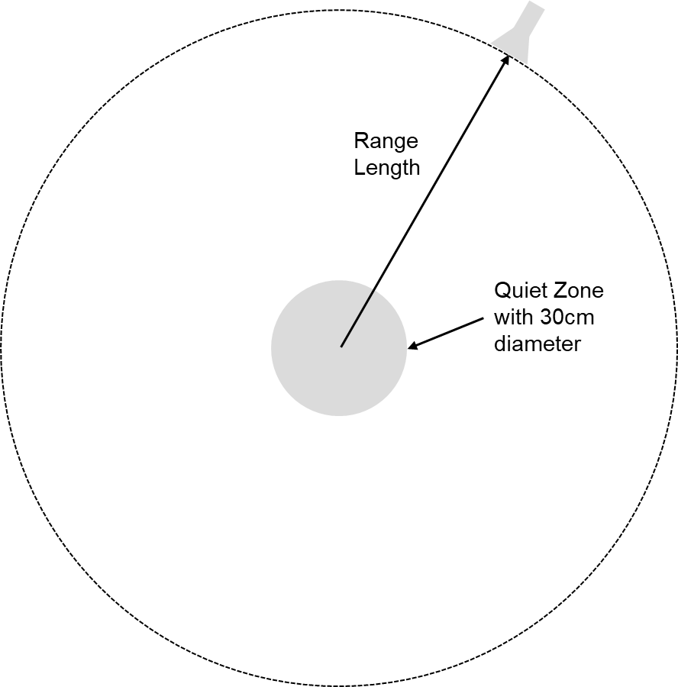

Figure A.3.4-1: Illustration of range length definition

The minimum range length shall be the maximum of the following three limits

- The phase uncertainty limit: *R*QZ+2*D*rad2/

- The amplitude uncertainty limit: 3*D*

- The reactive Near-Field limit: *R*QZ+2

where *R*QZ is defined as the radius of the quiet zone, i.e., *R*QZ=*D*/2, and *D*rad is the diameter of the effective radiating aperture. The minimum range length calculations for *D*=30cm quiet zone size TRP-TRS OTA test systems shall assume that *D*rad is 30cm below 1GHz and decrease linearly from 30cm to 5cm from 1GHz to 7.125GHz, respectively. The last column of Table A.3.4-1 shall be considered the minimum range length for NR FR1 TRP-TRS OTA systems with 30cm quiet zone size.

Table A.3.4-1: Minimum Range Length for NR FR1 TRP-TRS OTA systems with 30cm quiet zone size.

|  |  |  |  |  |  |
| --- | --- | --- | --- | --- | --- |
| *F* [GHz] | Drad [m] | RQZ+2*Drad*²/λ | 3*D* = 6*R*QZ | RQZ+2λ | max(RQZ+2λ,3*D*,RQZ+2*D*²/λ) |
| 0.41 | 0.30 | 0.40 | 0.9 | 1.61 | 1.61 |
| 0.6 | 0.30 | 0.51 | 0.9 | 1.15 | 1.15 |
| 0.7 | 0.30 | 0.57 | 0.9 | 1.01 | 1.01 |
| 0.8 | 0.30 | 0.63 | 0.9 | 0.90 | 0.90 |
| 1 | 0.30 | 0.75 | 0.9 | 0.75 | 0.90 |
| 1.2 | 0.29 | 0.83 | 0.9 | 0.65 | 0.90 |
| 1.4 | 0.28 | 0.90 | 0.9 | 0.58 | 0.90 |
| 1.6 | 0.28 | 0.96 | 0.9 | 0.52 | 0.96 |
| 1.8 | 0.27 | 1.01 | 0.9 | 0.48 | 1.01 |
| 2 | 0.26 | 1.05 | 0.9 | 0.45 | 1.05 |
| 2.2 | 0.25 | 1.07 | 0.9 | 0.42 | 1.07 |
| 2.4 | 0.24 | 1.09 | 0.9 | 0.40 | 1.09 |
| 2.6 | 0.23 | 1.11 | 0.9 | 0.38 | 1.11 |
| 2.8 | 0.23 | 1.11 | 0.9 | 0.36 | 1.11 |
| 3 | 0.22 | 1.10 | 0.9 | 0.35 | 1.10 |
| 4 | 0.18 | 0.99 | 0.9 | 0.30 | 0.99 |
| 5 | 0.14 | 0.77 | 0.9 | 0.27 | 0.90 |
| 6 | 0.10 | 0.52 | 0.9 | 0.25 | 0.90 |
| 7 | 0.06 | 0.29 | 0.9 | 0.24 | 0.90 |
| 7.125 | 0.05 | 0.27 | 0.9 | 0.23 | 0.90 |

## A.3.5 Definition of TRP and TRS for AC

### A.3.5.1 Total Radiated Power (TRP)

This definition is used to calculate the Total Radiated Power (TRP) value. For Anechoic Chamber method, TRP is defined as:

Where the effective isotropic radiated power (EIRP) is defined as

Where is the product of the power delivered to the antenna and the antenna’s power gain, and EIRPθ and EIRPϕ are the EIRP in the corresponding θ and ϕ polarizations.

The summation form based on the sin⋅ weights of TRP with Anechoic Chamber method is defined as:

Where N and M are the number of sampling intervals for θ and ϕ. θn and ϕm are the measurement angles.

The summation form based on the Clenshaw-Curtis quadrature integral approximation of TRP with Anechoic Chamber method is defined as:

Where the value of can be calculated as follows:

with

and

The applicability of TRP quadratures, frequency ranges, and measurement grids is tabulated in Table A.3.5.1-1.

Table A.3.5.1-1: Applicability for TRP measurement grids

|  |  |  |  |  |  |
| --- | --- | --- | --- | --- | --- |
| Frequency Range | Quadrature |  [°] | *N* | *M* | Min. Number of Grid Points |
| FR1 | sin() | 15 | 12 | 24 | 266 |
| 30 | 6 | 12 | 62 |
| Clenshaw-Curtis | 15 | 12 | 24 | 266 |
| 30 | 6 | 12 | 62 |

### A.3.5.2 Total Radiated Sensitivity (TRS)

This definition is used to calculate the Total Radiated Sensitivity (TRS) value. For Anechoic Chamber method, the TRS with is defined as:

Where the effective isotropic sensitivity (EIS) is defined as the minimum power level at which the throughput exceeds or equal to 95% of the maximum throughput of the specified RMC, at each sampling point, and EISθ and EISϕ are the EIS in the corresponding θ and ϕ polarizations.

The summation form based on the sin⋅ weights of TRS with Anechoic Chamber method defined as:

Where N and M are the number of sampling intervals for θ and ϕ. θn and ϕm are the measurement angles.

The summation form based on the Clenshaw-Curtis quadrature integral approximation of TRS with Anechoic Chamber method is defined as:

Where the value of can be calculated as follows (same equation as TRP):

with

and

The applicability of TRS quadratures, frequency ranges, and measurement grids is tabulated in Table A.3.5.2-1.

Table A.3.5.2-1: Applicability for TRS measurement grids

|  |  |  |  |  |  |
| --- | --- | --- | --- | --- | --- |
| Frequency Range | Quadrature |  [°] | *N* | *M* | Min. Number of Grid Points |
| < 3GHz | sin() | 30 | 6 | 12 | 62 |
| Clenshaw-Curtis | 30 | 6 | 12 | 62 |
| 45 | 4 | 8 | 26 |
| > 3GHz | sin() | 30 | 6 | 12 | 62 |
| Clenshaw-Curtis | 30 | 6 | 12 | 62 |
| 45 | 4 | 8 | 26 (Note 1) |
| Note 1: When the back pole at  = 180° cannot be measured due to obstruction and/or blocking, extrapolation is used to estimate EIS at  = 180° for measurement grids with =45° by either a) using at least two points within 15° of the pole or b) averaging the last cut (i.e.  = 135°) | | | | | |

# A.4 Preliminary example MU budget

A.4.1 General

A.4.2 Test system of Anechoic Chamber method

The uncertainty contributions related to TRP are described in Annex B in [2]. The preliminary example uncertainty budget for TRP test case using Anechoic Chamber test system is presented in Table A.4.2-1 for Browsing mode and Table A.4.2-2 for Talk mode, respectively.

Table A.4.2-1 Preliminary example of uncertainty budget for TRP hand only (browsing mode) measurement for anechoic chamber method for NR FR1 bands

|  |  |  |  |  |  |  |  |  |  |
| --- | --- | --- | --- | --- | --- | --- | --- | --- | --- |
| UID | Uncertainty Source | Comment | Uncertainty Value [dB] | | Prob Distr | Div | ci | Standard Uncertainty [dB] | |
| Below 3GHz | Above 3GHz | Below 3GHz | Above 3GHz |
| Stage 2: DUT measurement | | | | | | | | | |
| 1 | Mismatch of receiver chain | Гreceiver < 0.33 Гmeasurement antenna < 0.5 Cable attenuation > 3dB | 0.26 | 0.26 | U-shaped | 1.4 | 1 | 0.18 | 0.18 |
| 2 | Insertion loss of receiver chain | Systematic with Stage 1 (=> cancels) | 0 | 0 | Rectangular | 1.7 | 1 | 0.00 | 0.00 |
| 3 | Influence of the measurement antenna cable | Systematic with Stage 1 (=> cancels) | 0 | 0 | Rectangular | 1.7 | 1 | 0.00 | 0.00 |
| 4 | Measurement Receiver: uncertainty of the absolute level | Spectrum Analyzer | 0.42 | 0.54 | Normal | 2 | 1 | 0.21 | 0.27 |
| 5 | Measurement distance | DUT is not offset for hand-only phantom testing | 0 | 0 | Rectangular | 1.7 | 1 | 0.00 | 0.00 |
| 6 | Quality of quiet zone | Surface standard deviation of power measurements in ripple test | 0.5 | 0.5 | Actual | 1 | 1 | 0.50 | 0.50 |
| 7 | DUT Tx-power drift | Drift | 0.2 | 0.2 | Rectangular | 1.7 | 1 | 0.12 | 0.12 |
| 8 | Uncertainty related to the use of phantoms | Material Dielectric Constant, Material Conductivity, Geometry/Shape (incl. spacer), Data Mode Fixture | 0.64 | 0.64 | Rectangular | 1.7 | 1 | 0.37 | 0.37 |
| 9 | Coarse sampling grid | Sampling grids per Table Table B.2.12-1 | 0 | 0.11 | Actual | 1 | 1 | 0.00 | 0.11 |
| 10 | Random Uncertainty | Fixed MU to account for all the unknown, unquantifiable, etc. uncertainties | 0.25 | 0.25 | Normal | 2 | 1 | 0.13 | 0.13 |
| 11 | Frequency Response | Average path loss corrected | 0 | 0 | Rectangular | 1.7 | 1 | 0.00 | 0.00 |
| **Stage 1: Calibration measurement, network analyzer method** | | | | | | | | | |
| 12 | Uncertainty of network analyzer | From datasheet of VNA with assessed transmission coefficients | [0.2] | [0.5] | Normal | 2 | 1 | [0.10] | [0.25] |
| 13 | Mismatch of receiver chain | Taken into account in VNA uncertainty term | 0 | 0 | U-shaped | 1.4 | 1 | 0.00 | 0.00 |
| 14 | Insertion loss of receiver chain | Systematic with Stage 2 (=> cancels) | 0 | 0 | Rectangular | 1.7 | 1 | 0.00 | 0.00 |
| 15 | Mismatch in the connection of calibration antenna | Taken in to account in VNA setup uncertainty | 0 | 0 | U-shaped | 1.4 | 1 | 0.00 | 0.00 |
| 16 | Influence of the calibration antenna feed cable | Gain calibration with a dipole | 0.3 | 0.3 | Rectangular | 1.7 | 1 | 0.17 | 0.17 |
| 17 | Influence of the measurement antenna cable | Systematic with Stage 2 (=> cancels) | 0 | 0 | Rectangular | 1.7 | 1 | 0.00 | 0.00 |
| 18 | Uncertainty of the absolute gain/ radiation efficiency of the calibration antenna | Calibration report with traceability to a National Metrology Institute | [0.58] | [0.58] | Normal | 2 | 1 | [0.29] | [0.29] |
| 19 | Measurement distance | Dipole: aligned with phase center | 0 | 0 | Rectangular | 1.7 | 1 | 0.00 | 0.00 |
| 20 | Quality of the Quiet Zone | Peak-to-null ripple | 0.5 | 0.5 | Rectangular | 1.7 | 1 | 0.29 | 0.29 |
| Combined standard uncertainty [dB] | | | | | | | | [0.84] | [0.89] |
| Expanded uncertainty [dB] (Confidence interval of 95 %) | | | | | | | | [1.64] | [1.75] |
| 21 | Systematic Error related to TRP grids | mean error | 0 | 0 | Actual | 1 | 1 | 0.00 | 0.00 |
| Total Expanded uncertainty [dB] (Confidence interval of 95 %) | | | | | | | | [1.64] | [1.75] |

Table A.4.2-2 Preliminary example of uncertainty budget for TRP Beside Head and Hand (Talk mode) measurement for anechoic chamber method for NR FR1 bands

|  |  |  |  |  |  |  |  |  |  |
| --- | --- | --- | --- | --- | --- | --- | --- | --- | --- |
| UID | Uncertainty Source | Comment | Uncertainty Value [dB] | | Prob Distr | Div | ci | Standard Uncertainty [dB] | |
| Below 3GHz | Above 3GHz | Below 3GHz | Above 3GHz |
| Stage 2: DUT measurement | | | | | | | | | |
| 1 | Mismatch of receiver chain | Гreceiver < 0.33 Гmeasurement antenna < 0.5 Cable attenuation > 3dB | 0.26 | 0.26 | U-shaped | 1.4 | 1 | 0.18 | 0.18 |
| 2 | Insertion loss of receiver chain | Systematic with Stage 1 (=> cancels) | 0 | 0 | Rectangular | 1.7 | 1 | 0.00 | 0.00 |
| 3 | Influence of the measurement antenna cable | Systematic with Stage 1 (=> cancels) | 0 | 0 | Rectangular | 1.7 | 1 | 0.00 | 0.00 |
| 4 | Measurement Receiver: uncertainty of the absolute level | Spectrum Analyzer | 0.42 | 0.54 | Normal | 2 | 1 | 0.21 | 0.27 |
| 5 | Measurement distance | d=1.6m, Δd=0.05m | 0.27 | 0.27 | Rectangular | 1.7 | 1 | 0.16 | 0.16 |
| 6 | Quality of quiet zone | Surface standard deviation of power measurements in ripple test | 0.5 | 0.5 | Actual | 1 | 1 | 0.50 | 0.50 |
| 7 | DUT Tx-power drift | Drift | 0.2 | 0.2 | Rectangular | 1.7 | 1 | 0.12 | 0.12 |
| 8 | Uncertainty related to the use of phantoms | Material Dielectric Constant, Material Conductivity, Geometry/Shape (incl. spacer), Beside Head and Hand | 0.99 | 0.99 | Rectangular | 1.7 | 1 | 0.57 | 0.57 |
| 9 | Coarse sampling grid | Sampling grids per Table Table B.2.12-1 | 0 | 0.11 | Actual | 1 | 1 | 0.00 | 0.11 |
| 10 | Random Uncertainty | Fixed MU to account for all the unknown, unquantifiable, etc. uncertainties | 0.25 | 0.25 | Normal | 2 | 1 | 0.13 | 0.13 |
| 11 | Frequency Response | Average path loss corrected | 0 | 0 | Rectangular | 1.7 | 1 | 0.00 | 0.00 |
| Stage 1: Calibration measurement, network analyzer method | | | | | | | | | |
| 12 | Uncertainty of network analyzer | From datasheet of VNA with assessed transmission coefficients | [0.2] | [0.5] | Normal | 2 | 1 | [0.10] | [0.25] |
| 13 | Mismatch of receiver chain | Taken into account in VNA uncertainty term | 0 | 0 | U-shaped | 1.4 | 1 | 0.00 | 0.00 |
| 14 | Insertion loss of receiver chain | Systematic with Stage 2 (=> cancels) | 0 | 0 | Rectangular | 1.7 | 1 | 0.00 | 0.00 |
| 15 | Mismatch in the connection of calibration antenna | Taken in to account in VNA setup uncertainty | 0 | 0 | U-shaped | 1.4 | 1 | 0.00 | 0.00 |
| 16 | Influence of the calibration antenna feed cable | Gain calibration with a dipole | 0.3 | 0.3 | Rectangular | 1.7 | 1 | 0.17 | 0.17 |
| 17 | Influence of the measurement antenna cable | Systematic with Stage 2 (=> cancels) | 0 | 0 | Rectangular | 1.7 | 1 | 0.00 | 0.00 |
| 18 | Uncertainty of the absolute gain/ radiation efficiency of the calibration antenna | Calibration report with traceability to a National Metrology Institute | [0.58] | [0.58] | Normal | 2 | 1 | [0.29] | [0.29] |
| 19 | Measurement distance | Dipole: aligned with phase center | 0 | 0 | Rectangular | 1.7 | 1 | 0.00 | 0.00 |
| 20 | Quality of the Quiet Zone | Peak-to-null ripple | 0.5 | 0.5 | Rectangular | 1.7 | 1 | 0.29 | 0.29 |
| Combined standard uncertainty [dB] | | | | | | | | [0.96] | [1.00] |
| Expanded uncertainty [dB] (Confidence interval of 95 %) | | | | | | | | [1.87] | [1.97] |
| 21 | Systematic Error related to TRP grids | mean error | 0 | 0 | Actual | 1 | 1 | 0.00 | 0.00 |
| Total Expanded uncertainty [dB] (Confidence interval of 95 %) | | | | | | | | [1.87] | [1.97] |

The uncertainty contributions related to TRS are described in Annex B in [2]. T preliminary example uncertainty budget TRS test cases using Anechoic Chamber test system is presented in Table A.4.2-3 for Browsing mode and Table A.4.2-4 for Talk mode, respectively.

Table A.4.2-3: Preliminary example of uncertainty budget for TRS hand only (browsing mode) measurement for anechoic chamber method for NR FR1 bands

|  |  |  |  |  |  |  |  |  |  |  |  |  |
| --- | --- | --- | --- | --- | --- | --- | --- | --- | --- | --- | --- | --- |
| UID | Uncertainty Source | Comment | Uncertainty Value [dB] | | Prob Distr | | Div | | ci | | Standard Uncertainty [dB] | |
| Below 3GHz | Above 3GHz | Below 3GHz | Above 3GHz |
| Stage 2: DUT measurement | | | | | | | | | | | | |
| 1 | Mismatch of receiver chain | Гcomm tester < 0.29 Гmeasurement antenna < 0.5 Cable attenuation > 3dB | 0.22 | 0.22 | U-shaped | | 1.4 | | 1 | | 0.16 | 0.16 |
| 2 | Insertion loss of receiver chain | Systematic with Stage 1 (=> cancels) | 0 | 0 | Rectangular | | 1.7 | | 1 | | 0.00 | 0.00 |
| 3 | Influence of the measurement antenna cable | Systematic with Stage 1 (=> cancels) | 0 | 0 | Rectangular | | 1.7 | | 1 | | 0.00 | 0.00 |
| 4 | Communication Tester: uncertainty of the absolute output level | Manufacturer’s data sheet | [1.16] | [1.16] | Normal | | 2 | | 1 | | [0.58] | [0.58] |
| 5 | Sensitivity measurement: output level step resolution | Systematic error that can be corrected | 0 | 0 | Rectangular | | 1.73 | | 1 | | 0.00 | 0.00 |
| 6 | Measurement distance | DUT is not offset for hand-only phantom testing | 0 | 0 | Rectangular | | 1.7 | | 1 | | 0.00 | 0.00 |
| 7 | Quality of quiet zone | Surface standard deviation of power measurements in ripple test | 0.5 | 0.5 | Actual | | 1 | | 1 | | 0.50 | 0.50 |
| 8 | DUT sensitivity drift | Drift | 0.2 | 0.2 | Rectangular | | 1.7 | | 1 | | 0.12 | 0.12 |
| 9 | Uncertainty related to the use of phantoms | Material Dielectric Constant, Material Conductivity, Geometry/Shape (incl. spacer), Data Mode Fixture | 0.64 | 0.64 | Rectangular | | 1.7 | | 1 | | 0.37 | 0.37 |
| 10 | Coarse sampling grid | Sampling grids per Table Table B.2.12-1 | 0.04 | 0.25 | Actual | | 1 | | 1 | | 0.04 | 0.25 |
| 11 | Random Uncertainty | Fixed MU to account for all the unknown, unquantifiable, etc. uncertainties including digital error rate | 0.4 | 0.4 | Normal | | 2 | | 1 | | 0.20 | 0.20 |
| 12 | Frequency Response | Included in the output level step resolution | 0 | 0 | Rectangular | | 1.7 | | 1 | | 0.00 | 0.00 |
| Stage 1: Calibration measurement, network analyzer method | | | | | | | | | | | | |
| 13 | Uncertainty of network analyzer | From datasheet of VNA with assessed transmission coefficients | [0.2] | [0.5] | Normal | | 2 | | 1 | | [0.10] | [0.25] |
| 14 | Mismatch of receiver chain | Taken into account in VNA uncertainty term | 0 | 0 | U-shaped | | 1.4 | | 1 | | 0.00 | 0.00 |
| 15 | Insertion loss of receiver chain | Systematic with Stage 2 (=> cancels) | 0 | 0 | Rectangular | | 1.7 | | 1 | | 0.00 | 0.00 |
| 16 | Mismatch in the connection of calibration antenna | Taken in to account in VNA setup uncertainty | 0 | 0 | U-shaped | | 1.4 | | 1 | | 0.00 | 0.00 |
| 17 | Influence of the calibration antenna feed cable | Gain calibration with a dipole | 0.3 | 0.3 | Rectangular | | 1.7 | | 1 | | 0.17 | 0.17 |
| 18 | Influence of the measurement antenna cable | Systematic with Stage 2 (=> cancels) | 0 | 0 | Rectangular | | 1.7 | | 1 | | 0.00 | 0.00 |
| 19 | Uncertainty of the absolute gain/ radiation efficiency of the calibration antenna | Calibration report with traceability to a National Metrology Institute | [0.58] | [0.58] | Normal | | 2 | | 1 | | [0.29] | [0.29] |
| 20 | Measurement distance | Dipole: aligned with phase center | 0 | 0 | Rectangular | | 1.7 | | 1 | | 0.00 | 0.00 |
| 21 | Quality of the Quiet Zone | Peak-to-null ripple | 0.5 | 0.5 | Rectangular | | 1.7 | | 1 | | 0.29 | 0.29 |
| Combined standard uncertainty [dB] | | | | | | | | | | | [1.00] | [1.06] |
| Expanded uncertainty [dB] (Confidence interval of 95 %) | | | | | | | | | | | [1.97] | [2.08] |
| 22 | Systematic Error related to TRP grids | mean error | 0 | 0 | | Actual | | 1 | | 1 | 0.00 | 0.08 |
| Total Expanded uncertainty [dB] (Confidence interval of 95 %) | | | | | | | | | | | [1.97] | [2.16] |

Table A.4.2-4: Preliminary example of uncertainty budget for TRS Beside Head and Hand (Talk mode) measurement for anechoic chamber method for NR FR1 bands

|  |  |  |  |  |  |  |  |  |  |  |  |  |
| --- | --- | --- | --- | --- | --- | --- | --- | --- | --- | --- | --- | --- |
| UID | Uncertainty Source | Comment | Uncertainty Value [dB] | | Prob Distr | | Div | | ci | | Standard Uncertainty [dB] | |
| Below 3GHz | Above 3GHz | Below 3GHz | Above 3GHz |
| Stage 2: DUT measurement | | | | | | | | | | | | |
| 1 | Mismatch of receiver chain | Гcomm tester < 0.29 Гmeasurement antenna < 0.5 Cable attenuation > 3dB | 0.22 | 0.22 | U-shaped | | 1.4 | | 1 | | 0.16 | 0.16 |
| 2 | Insertion loss of receiver chain | Systematic with Stage 1 (=> cancels) | 0 | 0 | Rectangular | | 1.7 | | 1 | | 0.00 | 0.00 |
| 3 | Influence of the measurement antenna cable | Systematic with Stage 1 (=> cancels) | 0 | 0 | Rectangular | | 1.7 | | 1 | | 0.00 | 0.00 |
| 4 | Communication Tester: uncertainty of the absolute output level | Manufacturer’s data sheet | [1.16] | [1.16] | Normal | | 2 | | 1 | | [0.58] | [0.58] |
| 5 | Sensitivity measurement: output level step resolution | Systematic error that can be corrected | 0 | 0 | Rectangular | | 1.73 | | 1 | | 0.00 | 0.00 |
| 6 | Measurement distance | d=1.6m, Δd=0.05m | 0.27 | 0.27 | Rectangular | | 1.7 | | 1 | | 0.16 | 0.16 |
| 7 | Quality of quiet zone | Surface standard deviation of power measurements in ripple test | 0.5 | 0.5 | Actual | | 1 | | 1 | | 0.50 | 0.50 |
| 8 | DUT sensitivity drift | Drift | 0.2 | 0.2 | Rectangular | | 1.7 | | 1 | | 0.12 | 0.12 |
| 9 | Uncertainty related to the use of phantoms | Material Dielectric Constant, Material Conductivity, Geometry/Shape (incl. spacer), Data Mode Fixture | 0.99 | 0.99 | Rectangular | | 1.7 | | 1 | | 0.57 | 0.57 |
| 10 | Coarse sampling grid | Sampling grids per Table Table B.2.12-1 | 0.04 | 0.25 | Actual | | 1 | | 1 | | 0.04 | 0.25 |
| 11 | Random Uncertainty | Fixed MU to account for all the unknown, unquantifiable, etc. uncertainties including digital error rate | 0.4 | 0.4 | Normal | | 2 | | 1 | | 0.20 | 0.20 |
| 12 | Frequency Response | Included in the output level step resolution | 0 | 0 | Rectangular | | 1.7 | | 1 | | 0.00 | 0.00 |
| Stage 1: Calibration measurement, network analyzer method | | | | | | | | | | | | |
| 13 | Uncertainty of network analyzer | From datasheet of VNA with assessed transmission coefficients | [0.2] | [0.5] | Normal | | 2 | | 1 | | [0.10] | [0.25] |
| 14 | Mismatch of receiver chain | Taken into account in VNA uncertainty term | 0 | 0 | U-shaped | | 1.4 | | 1 | | 0.00 | 0.00 |
| 15 | Insertion loss of receiver chain | Systematic with Stage 2 (=> cancels) | 0 | 0 | Rectangular | | 1.7 | | 1 | | 0.00 | 0.00 |
| 16 | Mismatch in the connection of calibration antenna | Taken in to account in VNA setup uncertainty | 0 | 0 | U-shaped | | 1.4 | | 1 | | 0.00 | 0.00 |
| 17 | Influence of the calibration antenna feed cable | Gain calibration with a dipole | 0.3 | 0.3 | Rectangular | | 1.7 | | 1 | | 0.17 | 0.17 |
| 18 | Influence of the measurement antenna cable | Systematic with Stage 2 (=> cancels) | 0 | 0 | Rectangular | | 1.7 | | 1 | | 0.00 | 0.00 |
| 19 | Uncertainty of the absolute gain/ radiation efficiency of the calibration antenna | Calibration report with traceability to a National Metrology Institute | [0.58] | [0.58] | Normal | | 2 | | 1 | | [0.29] | [0.29] |
| 20 | Measurement distance | Dipole: aligned with phase center | 0 | 0 | Rectangular | | 1.7 | | 1 | | 0.00 | 0.00 |
| 21 | Quality of the Quiet Zone | Peak-to-null ripple | 0.5 | 0.5 | Rectangular | | 1.7 | | 1 | | 0.29 | 0.29 |
| Combined standard uncertainty [dB] | | | | | | | | | | | [1.11] | [1.16] |
| Expanded uncertainty [dB] (Confidence interval of 95 %) | | | | | | | | | | | [2.17] | [2.27] |
| 22 | Systematic Error related to TRP grids | mean error | 0 | 0 | | Actual | | 1 | | 1 | 0.00 | 0.08 |
| Total Expanded uncertainty [dB] (Confidence interval of 95 %) | | | | | | | | | | | [2.17] | [2.35] |

Annex B (normative):  
Phantoms definition and Positioning

# B.1 General

This Clause defines the phantom definition and positioning guidance for TPR TRS requirement measurement.

# B.2 Phantom Definition

## B.2.1 Head Phantom

The basic head phantom is based on the “SAM” head phantom in IEEE Std 1528-2003, which is also described in TS 37.544 Annex A.2 [8]. For TRP TRS test, the IEEE SAM head model has been extended to the neck region, which is specified in CTIA Certification OTA Test Plan 01.72 [10].

The Head phantom defined in CTIA Certification OTA Test Plan 01.72, section 2.1 [10], is used for FR1 TRP TRS requirement testing.

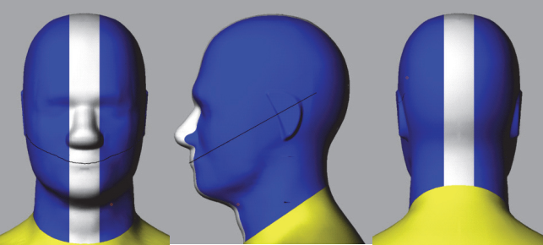

Figure B.2.1-1 Head Phantom (© 2001 – 2022 CTIA Certification. Reproduced with permission.), defined in the CTIA Certification OTA Test Plan

## B.2.2 PDA Grip Hand Phantom

The PDA Grip Hand described in TS 37.544 Annex A.2.2 [8], which is identical to that defined in CTIA Certification OTA Test Plan 01.72, section 2.2.12 [10], is adopted for TRP TRS testing for the UE with width ≥56mm and ≤72mm.

## B.2.3 Wide Grip Hand Phantom

The Wide Grip hand defined in CTIA Certification OTA Test Plan 01.72, section 2.2.13 [10], is used for FR1 TRP TRS testing for UE with width >72mm and ≤92mm.

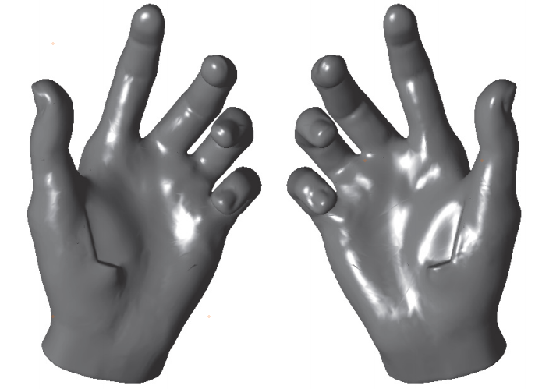

Figure B.2.3-1 Wide Grip hand (© 2001 – 2022 CTIA Certification. Reproduced with permission.), defined in the CTIA Certification OTA Test Plan

## B.2.4 Forearm Phantom

The Forearm phantom defined in CTIA Certification OTA Test Plan 01.72 section 2.3 [10], is used for FR1 TRP TRS testing for wrist-worn RedCap UE in this technical report.

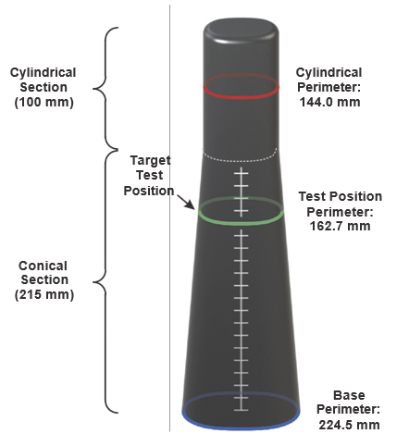

Figure B.2.4-1: Forearm Phantom with Target Test Position (© 2001 – 2022 CTIA Certification. Reproduced with permission.), defined in the CTIA Certification OTA Test Plan

# B.3 UE positioning guidelines

## B.3.1 Hand phantom only (Browsing mode)

The positioning specified in this clause is used for the test cases for Browsing Mode with Hand Phantom. The characteristics of the Hand Phantom are specified in Clause B.3.1. Browsing mode is used to simulate user cases where the DUT is held in hand, but not pressed against ear e.g. web browsing and navigation. The DUT should be set as primary mechanical mode for browsing mode scenario, which is declared by manufacturer if the UE support multiple mechanical modes. Then, the DUT shall be mounted in a suitable hand phantom and oriented such that the DUT’s main display is tilted 45 degrees from vertical:

- Wide Grip Hand for UE with Width >72mm and ≤92mm

- PDA Grip Hand for UE with Width ≥56mm and ≤72mm

Note: the width is the UE width under primary mechanical mode for Browsing mode scenario.

### B.3.1.1 Wide Grip Hand

This positioning guideline is suitable for DUTs with width >72mm and ≤92mm.

The positioning guideline for mounting a DUT in the Wide Grip Hand Phantom defined in CTIA Certification OTA Test Plan 01.71 section 2.2.7 [9], is used for FR1 TRP TRS testing for UE with width >72mm and ≤92mm.

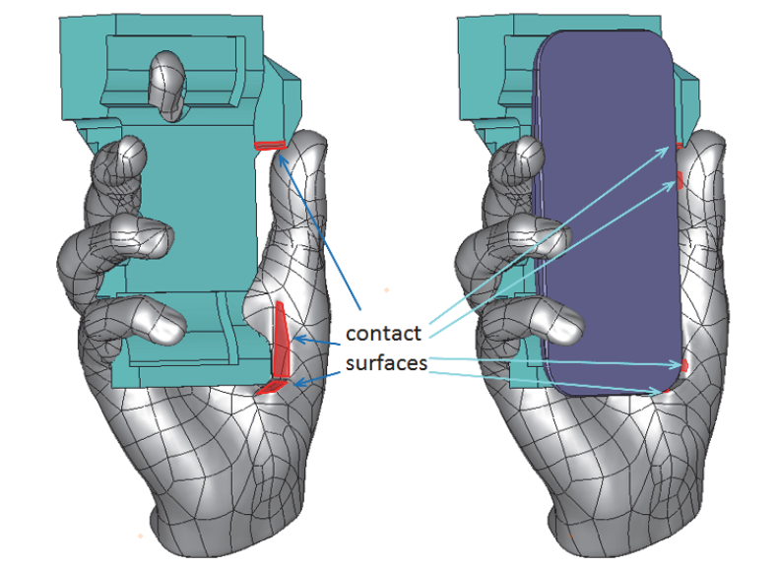

Figure B.3.1.1-1: Positioning guidance for Wide Grip Hand (© 2001 – 2022 CTIA Certification. Reproduced with permission.), defined in the CTIA Certification OTA Test Plan

### B.3.1.2 PDA Grip Hand

This clause defines the positioning guideline for mounting a DUT in the PDA Grip Hand Phantom. This positioning guideline is suitable for DUTs with width ≥56mm and ≤72mm.

To help achieve a consistent positioning, the DUT is aligned to a PDA palm spacer. No alignment tool is required. The PDA spacer features side and bottom walls to ensure consistent alignment of DUTs of various sizes.

1. Place the DUT on the PDA spacer between the fingers and align the DUT to the side wall of the PDA.

2. If the DUT is shorter than 135 mm, then align the top of the DUT with the top of the PDA spacer. Otherwise, align the bottom of the DUT with the bottom wall of the PDA spacer.

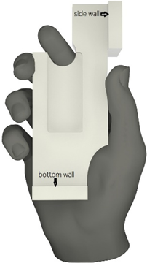

Figure 6.2.2-1: Right-handed PDA Grip hand phantom with a spacer

NOTE: Use left-handed (mirror-imaged) spacers with left-handed phantoms.

## B.3.2 Head and Hand phantom (Talk Mode)

### B.3.2.1 General

The positioning specified in this clause is used for the test cases for Talk Mode using Head & Hand Phantom. The characteristics of the Hand Phantom and Head Phantom are specified in Clause B.2.

Talk mode is used to simulate user cases where the DUT is placed into a hand phantom, which is holding the DUT against the SAM head phantom, presenting a realistic voice call operation of the DUT. The DUT should be set as primary mechanical mode for talk mode scenario, which is declared by manufacturer if the UE support multiple mechanical modes. Same as Browsing mode, the DUT for talk mode shall also be mounted in a suitable hand phantom:

- Wide Grip Hand for UE with Width >72mm and ≤92mm

- PDA Grip Hand for UE with Width ≥56mm and ≤72mm

Note: the width is the UE width under primary mechanical mode for talk mode scenario.

In this section, the procedure provides the guideline on how to place the DUT+hand against the head phantom. The detailed DUT positioning into hand phantom for talk mode is defined in Clause B.3.1.

For talk mode, the DUT is attached to the head phantom in “cheek” position. The DUT performance is measured on both left and right side of the head. Three points as shown in Figure B.3.2.1-1 define the reference plane: centre of the right ear piece (RE), centre of the left ear piece (LE) and centre of mouth (M).

Definition of the ‘Cheek’ position:

1. Align the ear piece of the phone (see Figure B.3.2.1-1) at the line RE-LE. Then, position the DUT beside the phantom so that the vertical line (see Figure B.3.2.1-3) is parallel to the reference plane in Figure B.3.2.1-2 and is aligned with the line M-RE on the reference plane (see Figure B.3.2.1-3).

2. Position the DUT so that the ear piece of the DUT touches the ear piece of the phantom head on the line RE-LE. Tilt the DUT chassis towards the cheek of the phantom having the vertical line aligned with the reference plane until any point on the front side of the DUT is in contact with the cheek or until the contact with the ear is lost.

NOTE: A holder fixture made of e.g. plastic may be used to position the handset against the phantom.



Figure B.3.2.1-1: Reference plane on head phantom, front view



Figure B.3.2.1-2: Reference plane on head phantom, side view



Figure B.3.2.1-3: Reference lines at a mobile handset.

In addition, 6°tilt angle from the cheek is being used instead of having direct contact between the cheek and DUT. A mask may be used to help configuration of cheek + 6° tilt angle. The mask is a 32 mm wide conformal strip, created by sweeping the surface of the head phantom through a 6º rotation about the ear. Direct DUT contact against the mask thus establishes the required 6º spacing away from the cheek, regardless of DUT form factor. The material for the head phantom mask spacer shall have dielectric constant of less than 1.3 and a loss tangent of less than 0.003. Material additions can be used to help fixing of the mask spacer onto the head phantom.

In summary, for head + hand phantom, keeping the DUT in the hand phantom in the position defined in clause B.3.1, while place the DUT and the hand phantom against the head phantom in such way that the DUT is in 6°tilt angle as described above.

### B.3.2.2 Wide Grip Hand and Head

This procedure is suitable for talk mode use with DUTs of width >72mm and ≤92mm. The positioning of the DUT in the Wide Grip hand for talk mode is identical to that for browsing mode described in Clause B.3.1.1.

### B.3.2.1 PDA Grip Hand and Head

This procedure is suitable for talk mode use with DUTs of width ≥56mm and ≤72mm. The positioning of the DUT in the PDA Grip hand for talk mode is identical to that for browsing mode described in Clause B.3.1.2.

## B.3.3 Forearm phantom (Wrist-worn Mode)

### B.3.2.1 General

The positioning specified in this clause is used for the test cases for Wrist-worn Mode using Forearm Phantom. The characteristics of the Forearm phantom is specified in Clause B.2.4.

Talk mode is used to simulate user cases where the DUT is placed in Forearm phantom. The DUT should be set as primary mechanical mode for browsing mode scenario, which is declared by manufacturer if the UE support multiple mechanical modes.

### B.3.2.2 Forearm phantom positioning in the chamber

The Forearm Phantom shall be mounted in the chamber coordinate system as shown in Figure B.3.2.2-1.

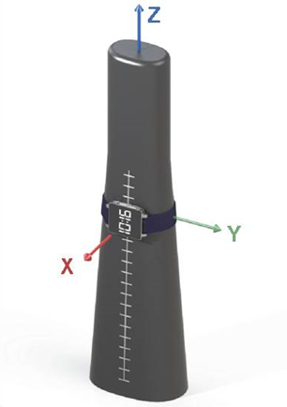

Figure B.3.2.2-1: Positioning guidance for Forearm Phantom in the chamber (© 2001 – 2022 CTIA Certification. Reproduced with permission.), defined in the CTIA Certification OTA Test Plan

### B.3.2.3 Wrist-Worn RedCap Device mounted on the Forearm Phantom

This clause defines the positioning guideline for wrist-worn RedCap devices.

The positioning guideline defined in CTIA Certification OTA Test Plan 01.71, section 2.3 [9], is used for FR1 TRP TRS testing for wrist-worn RedCap devices in this technical specification.

The Wrist-worn Device should be fully aligned under some specific virtual Plane to make sure the Wrist-worn Device is properly mounted on the Forearm Phantom, as shown in B.3.2.3-1. Plane *J* cuts through the surface of the forearm phantom and passes through the target test position and is perpendicular to the Y-axis. Plane *J* is the X-Z plane. Plane *K* cuts through the forearm phantom at the target test position and is perpendicular to the Z‑axis. Plane *K* is the X-Y plane. Plane A and Plane B are virtual planes on wrist-worn device. Plane A cuts through the center of wrist band and Plane B cuts through the center of the display.

Plane *B* shall be fully aligned with Plane *J* when the device is mounted on the forearm phantom.

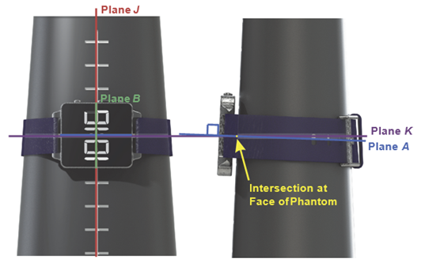

Figure B.3.2.3-1: Positioning guidance for Wrist-Worn Device mounted on the Forearm Phantom (© 2001 – 2022 CTIA Certification. Reproduced with permission.), defined in the CTIA Certification OTA Test Plan

DUTs shall be mounted with sufficiently snug band tightness so as to prevent the DUT from slipping off under the force of gravity when the phantom is inverted.

Similar to handheld UEs, there are also two Orientations for Wrist-worn RedCap Devices representing the Left and Right Wrist, as shown in Figure B.3.2.3-2.

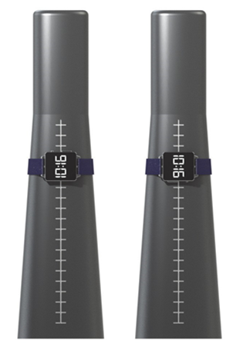

Figure B.3.2.3-2: Left and Right positioning for Wrist-Worn Device on Forearm Phantom (© 2001 – 2022 CTIA Certification. Reproduced with permission.), defined in the CTIA Certification OTA Test Plan

Annex C (normative):  
Environmental requirements

# C.1 General

This normative annex specifies the environmental requirements of the UE. Within these limits the requirements of the present documents shall be fulfilled.

# C.2 Environmental

The requirements in this clause apply to all types of UE(s).

## C.2.1 Temperature

All the test cases defined in this technical specification should be measured in room temperature e.g. 25°C.

## C.2.2 Voltage

All test cases shall be performed with the DUT operated in stand-alone battery powered mode. It is preferable if the UE is fully charged in the beginning of the test.

Annex D (informative):  
Change history

|  |  |  |  |  |  |  |  |
| --- | --- | --- | --- | --- | --- | --- | --- |
| **Change history** | | | | | | | |
| **Date** | **Meeting** | **TDoc** | **CR** | **Rev** | **Cat** | **Subject/Comment** | **New version** |
| 2021-11 | RAN4#101-e | R4-2120687 |  |  |  | Initial Skeleton | 0.0.1 |
| 2022-01 | RAN4#101-bis-e | R4-2200971 |  |  |  | R4-2200974 TP to TS 38.161 on requirement applicability | 0.1.0 |
| 2022-03 | RAN4#102-e | R4-2204952 |  |  |  | R4-2205174 TP to 38.161 on general aspects  R4-2207315 Text proposal on environmental requirements for 38.161  R4-2207323 TP to 38.161 on TRP aspects  R4-2207316 TP to TS 38.161 on frequency bands  R4-2207322 TP to TS 38.161 on Annex A: Test methodology | 0.2.0 |
| 2022-05 | RAN4#103-e | R4-2208626 |  |  |  | R4-2208481 TP to TS 38.161 on primary mechanical mode  R4-2210939 TP to 38.161 on EN-DC and PC2 test case applicability rules  R4-2210940 TP to 38.161 on TRP aspects  R4-2210942 TP to TS 38.161 on test method  R4-2210944 TP to TS 38.161 on Phantoms | 0.3.0 |
| 2022-08 | RAN4#104-e | R4-2212810 |  |  |  | R4-2214795 TP to TS 38.161 on general aspects  R4-2214796 TP to TS 38.161 on TRP TRS requirements | 0.4.0 |
| 2022-09 | RAN#97-e | RP-222321 |  |  |  | For one-step approval in RAN Plenary | 1.0.0 |
| 2022-09 | RAN#97-e | RP-222608 |  |  |  | Editorial update from Rapporteur | 1.1.0 |
| 2022-09 | RAN#97-e |  |  |  |  | Under change control | 17.0.0 |
| 2022-12 | RAN#98-e | RP-223310 | 0001 |  | F | CR to TS 38.161 on test parameters | 17.1.0 |
| 2023-03 | RAN#99 | RP-230514 | 0002 |  | F | CR to TS 38.161 on clarification of test parameters | 17.2.0 |
| 2023-06 | RAN#100 | RP-231343 | 0003 | 1 | F | CR to TS 38.161 on EN-DC decision tree | 17.3.0 |
| 2023-06 | RAN#100 | RP-231343 | 0004 | 1 | F | CR to TS 38.161 on measurement grids and editorial correction | 17.3.0 |
| 2023-12 | RAN#102 | RP-233365 | 0007 |  | B | CR to TS 38.161 on New test configurations for Rel-18 TRP TRS | 18.0.0 |