3GPP TS 28.550 V18.1.0 (2023-03)
Technical Specification
3rd Generation Partnership Project;
Technical Specification Group Services and System Aspects;
Management and orchestration;
Performance assurance
(Release 18)
 | 

The present document has been developed within the 3rd Generation Partnership Project (3GPP TM) and may be further elaborated for the purposes of 3GPP..
The present document has not been subject to any approval process by the 3GPP Organizational Partners and shall not be implemented.
This Specification is provided for future development work within 3GPP only. The Organizational Partners accept no liability for any use of this Specification.
Specifications and Reports for implementation of the 3GPP TM system should be obtained via the 3GPP Organizational Partners' Publications Offices.

Keywords
performance, assurance, management, orchestration
3GPP
Postal address

3GPP support office address
650 Route des Lucioles - Sophia Antipolis
Valbonne - FRANCE
Tel.: +33 4 92 94 42 00 Fax: +33 4 93 65 47 16
Internet
http://www.3gpp.org
Copyright Notification
No part may be reproduced except as authorized by written permission.
The copyright and the foregoing restriction extend to reproduction in all media.

© 2023, 3GPP Organizational Partners (ARIB, ATIS, CCSA, ETSI, TSDSI, TTA, TTC).
All rights reserved.

UMTS™ is a Trade Mark of ETSI registered for the benefit of its members
3GPP™ is a Trade Mark of ETSI registered for the benefit of its Members and of the 3GPP Organizational Partners
LTE™ is a Trade Mark of ETSI registered for the benefit of its Members and of the 3GPP Organizational Partners
GSM® and the GSM logo are registered and owned by the GSM Association
Contents
Foreword 7
1 Scope 8
2 References 8
3 Definitions and abbreviations 9
3.1 Definitions 9
3.2 Abbreviations 9
4 Concepts and overview 9
4.1 Overview 9
4.2 Management data analytics 9
4.3 PM services 10
4.4 PM services for multiple tenant support 10
5 Specification level requirements 11
5.1 Use cases 11
5.1.0 Introduction 11
5.1.1 NF PM services 11
5.1.1.1 NF measurement job control service 11
5.1.1.1.1 Creation of measurement job for NF(s) 11
5.1.1.1.2 Termination of measurement job for NF(s) 12
5.1.1.1.3 Query of measurement jobs for NF(s) 12
5.1.1.2 NF performance data file reporting service 13
5.1.1.2.1 3GPP NF performance data file reporting 13
5.1.1.3 NF performance data streaming service 13
5.1.1.3.1 3GPP NF performance data streaming 13
5.1.1.4 NF performance threshold monitoring 14
5.1.1.4.1 Creation of threshold monitoring for NF performance measurements 14
5.1.1.4.2 Termination of threshold monitoring for NF performance measurements 15
5.1.2 NSSI PM services 16
5.1.2.1 NSSI measurement job control service 16
5.1.2.1.1 Creation of measurement job for NSSI(s) 16
5.1.2.1.2 Termination of measurement job for NSSI(s) 17
5.1.2.1.3 Query of measurement jobs for NSSI(s) 17
5.1.2.2 NSSI performance data file reporting service 18
5.1.2.2.1 NSSI performance data file reporting 18
5.1.2.3 NSSI performance data streaming service 18
5.1.2.3.1 NSSI performance data streaming 18
5.1.2.4 NSSI performance threshold monitoring 19
5.1.2.4.1 Creation of threshold monitoring for NSSI performance measurements 19
5.1.2.4.2 Termination of threshold monitoring for NSSI performance measurements 20
5.1.3 NSI PM services 21
5.1.3.1 NSI measurement job control service 21
5.1.3.1.1 Creation of measurement job for NSI(s) 21
5.1.3.1.2 Termination of measurement job for NSI(s) 22
5.1.3.1.3 Query of measurement jobs for NSI(s) 23
5.1.3.2 NSI performance data file reporting service 23
5.1.3.2.1 NSI performance data file reporting 23
5.1.3.3 NSI performance data streaming service 24
5.1.3.3.1 NSI performance data streaming 24
5.1.3.4 NSI performance threshold monitoring 25
5.1.3.4.1 Creation of threshold monitoring for NSI performance measurements 25
5.1.3.4.2 Termination of threshold monitoring for NSI performance measurements 26
5.1.4 Network/Sub-network PM services 27
5.1.4.1 Network/Sub-network measurement job control service 27
5.1.4.1.1 Creation of measurement job for network(s)/sub-network(s) 27
5.1.4.1.2 Termination of measurement job for network(s)/sub-network(s) 28
5.1.4.1.3 Query of measurement jobs for network(s) 28
5.1.4.2 Network/Sub-network performance data file reporting service 29
5.1.4.2.1 Network/Sub-network performance data file reporting 29
5.1.4.3 Network/Sub-network performance data streaming service 29
5.1.4.3.1 Network/Sub-network performance data streaming 29
5.1.5 Management data analytics 30
5.1.5.1 Management data analytics for NSIs/NSSIs 30
5.1.5.2 Management data analytics for network 31
5.1.6 MnS responsible for KPI job control 32
5.1.6.1 Creation of KPI job 32
5.1.6.2 Termination of KPI job 32
5.1.6.3 Query of KPI jobs 33
5.1.7 Performance management supporting multiple tenants in the NSaaS scenario 33
5.2 Requirements 34
5.2.1 Requirements for NF measurement job control service 34
5.2.2 Requirements for NF performance data file reporting service 34
5.2.3 Requirements for NF performance data streaming service 34
5.2.4 Requirements for NSSI measurement job control service 34
5.2.5 Requirements for NSSI performance data file reporting service 35
5.2.6 Requirements for NSSI performance data streaming service 35
5.2.7 Requirements for NSI measurement job control service 35
5.2.8 Requirements for NSI performance data file reporting service 35
5.2.9 Requirements for NSI performance data streaming service 35
5.2.10 Requirements for network/sub-network measurement job control service 36
5.2.11 Requirements for network/sub-network performance data file reporting service 36
5.2.12 Requirements for network/sub-network performance data streaming service 36
5.2.13 Management data analytics service 36
5.2.14 Management service for NF performance threshold monitoring 37
5.2.15 Requirements for MnS responsible for KPI production 37
5.2.16 Requirements for performance management supporting multiple tenants 37
6. Performance assurance specific operations and notifications 37
6.1 Measurement job control related operations 37
6.1.1 Operation createMeasurementJob (M) 37
6.1.1.1 Definition 37
6.1.1.2 Input parameters 39
6.1.1.3 Output parameters 41
6.1.1.4 Exceptions 41
6.1.2 Operation stopMeasurementJob (M) 41
6.1.2.1 Definition 41
6.1.2.2 Input parameters 42
6.1.2.3 Output parameters 42
6.1.2.4 Exceptions 42
6.1.3 Operation listMeasurementJobs (M) 42
6.1.3.1 Definition 42
6.1.3.2 Input parameters 42
6.1.3.3 Output parameters 43
6.1.3.4 Exceptions 43
6.2 Performance data streaming related operations 43
6.3 Performance threshold monitoring related operations and notifications 43
7. Performance assurance services components 43
7.1 Measurement job control services 43
7.2 Performance data file reporting services 44
7.3 Performance data streaming services 45
7.4 Management service for performance threshold monitoring 46
7.5 MnS responsible for KPI job control 47
7.6 Management service components used for configurable performance measurement control 47
8 RESTful HTTP-based solution set of performance measurement job control service specific operations and notifications 49
8.1 Mapping of operations 49
8.1.1 Introduction 49
8.1.2 Operation createMeasurementJob 49
8.1.3 Operation listMeasurementJobs 49
8.1.4 Operation stopMeasurementJob 50
8.2 Resources 50
8.2.0 Resource structure 50
8.2.1 Resource definitions 51
8.2.1.1 Void 51
8.2.1.2 Resource “/measJobs” 51
8.2.1.2.1 Description 51
8.2.1.2.2 URI 51
8.2.1.2.3 HTTP methods 51
8.2.1.3 Resource “/measJobs/{jobId}” 52
8.2.1.3.1 Description 52
8.2.1.3.2 URI 52
8.2.1.3.3 HTTP methods 52
8.3 Data type definitions 54
8.3.1 General 54
8.3.2 Void 54
8.3.3 Void 54
8.3.4 Structured general data types 54
8.3.5 Structured path data types 54
8.3.6 Query, message body and resource data types 55
8.3.6.1 Type measJobCreation-RequestType 55
8.3.6.2 Type measJobCreation-ResponseType 55
8.3.6.3 Type measJobsRetrieval-ResponseType 55
8.3.6.4 Type error-ResponseType 55
8.3.6.5 Type measJobInfo-ResourceType 56
8.3.7 Referenced structured data types 56
8.3.7.1 Type schedule-Type 56
8.3.7.2 Type timeInterval-Type 56
8.3.7.3 Type scheduleOfDay-Type 56
8.3.7.4 Void 57
8.3.7.5 Type unsupportedMeas-Type 57
8.3.8 Simple data types and enumerations 57
8.3.8.1 General 57
8.3.8.2 Simple data types 57
8.3.8.3 Enumeration reportingMethod-Type 57
8.3.8.4 Enumeration priority-Type 57
8.3.8.5 Enumeration scheduleOption-Type 57
8.3.8.6 Enumeration dayOfWeek-Type 58
9 Void 58
Annex A (informative): Void 59
Annex B (informative): Procedures for performance assurance services 60
B.1 NF measurement job creation 60
B.2 NSSI measurement job creation 61
B.3 NSI measurement job creation 62
B.4 Network measurement job creation 64
B.5 NF measurement job termination 65
B.6 NSSI measurement job termination 66
B.7 NSI measurement job termination 67
B.8 Network measurement job termination 68
Annex C (normative): Performance Data Stream Unit content description 69
Annex D (informative): Performance data streaming holistic sequence 70
D.1 Performance data streaming for starting measurement collection 70
D.1.1 Sequence flow 70
D.1.2 PlantUML codes 71
D.2 Performance data streaming for stopping measurement collection 72
D.2.1 Sequence flow 72
D.2.2 PlantUML codes 73
Annex E (normative): OpenAPI specification 74
E.1 Introduction 74
E.2 OpenAPI document " TS28550_PerMeasJobCtlMnS.yaml" 74
E.3 Void 78
Annex F (normative): Threshold crossing notifications triggering 79
F.1 Threshold crossing notifications triggering for cumulative counters 79
F.2 Threshold crossing notifications triggering for measurements that are not cumulative counters 80
Annex G (normative): ASN.1 definition for performance data stream units 81
G.1 ASN.1 definition rule 81
G.2 ASN.1 definition 81
Annex H (normative): NSI and NSSI performance assurance 83
H.1 General 83
H.2 Procedure of NSI and NSSI performance assurance 83
Annex I (normative): GPB schema for performance data stream units 85
I.1 Performance Data Stream Units (GPB) schema 85
Annex J (Informative): Example of ASN.1 Streaming of PMs 86
Annex K (informative): Change history 87

Foreword
This Technical Specification has been produced by the 3rd Generation Partnership Project (3GPP).
The contents of the present document are subject to continuing work within the TSG and may change following formal TSG approval. Should the TSG modify the contents of the present document, it will be re-released by the TSG with an identifying change of release date and an increase in version number as follows:
Version x.y.z
where:
x the first digit:
1 presented to TSG for information;
2 presented to TSG for approval;
3 or greater indicates TSG approved document under change control.
y the second digit is incremented for all changes of substance, i.e. technical enhancements, corrections, updates, etc.
z the third digit is incremented when editorial only changes have been incorporated in the document.

1 Scope
The present document specifies the stage 1, 2 and 3 of performance assurance related management services for 5G networks including network slicing.
The present document does not specify the performance data, i.e. performance measurements, Key Performance Indicators (KPIs).

2 References
The following documents contain provisions which, through reference in this text, constitute provisions of the present document.
- References are either specific (identified by date of publication, edition number, version number, etc.) or non-specific.
- For a specific reference, subsequent revisions do not apply.
- For a non-specific reference, the latest version applies. In the case of a reference to a 3GPP document (including a GSM document), a non-specific reference implicitly refers to the latest version of that document in the same Release as the present document.
[1] 3GPP TR 21.905: "Vocabulary for 3GPP Specifications".
[2] 3GPP TS 28.552: "Management and orchestration; 5G performance measurements".
[3] 3GPP TS 28.541: "Management and orchestration; 5G Network Resource Model (NRM); Stage 2 and stage 3".
[4] ITU-T Recommendation X.721 (1992): "Information technology - Open Systems Interconnection - Structure of management information: Definition of management information".
[5] 3GPP TS 28.622: "Telecommunication management; Generic Network Resource Model (NRM) Integration Reference Point (IRP); Information Service (IS)".
[6] ISO 8601:2000(E) Data elements and interchange formats – Information interchange – Representation of dates and times".
[7] 3GPP TS 28.532: "Management and orchestration; Generic management services".
[8] Void
[9] Void
[10] Void
[11] Void
[12] Void
[13] 3GPP TS 28.628: "Telecommunication management; Self-Organizing Networks (SON) Policy Network Resource Model (NRM) Integration Reference Point (IRP); Information Service (IS)".
[14] 3GPP TS 32.158: "Management and orchestration; Design rules for Representational State Transfer (REST) Solution Sets (SS)".
[15] ITU-T Recommendation X.680 (08/2015) "Information Technology - Abstract Syntax Notation One (ASN.1): Specification of basic notation" (Same as the ISO/IEC International Standard 8824-1).
[16] ITU-T Recommendation X.681 (08/2015) "Information Technology - Abstract Syntax Notation One (ASN.1): Information object specification" (Same as the ISO/IEC International Standard 8824-2).
[17] ITU-T Recommendation X.691 (08/2015) "Information technology - ASN.1 encoding rules: Specification of Packed Encoding Rules (PER)" (Same as the ISO/IEC International Standard 8825-2).
[18] IETF RFC 6455: "The WebSocket Protocol".
[19] IETF RFC 793: "TRANSMISSION CONTROL PROTOCOL".
[20] Void.
[21] 3GPP TS 28.554: "Management and orchestration; 5G end to end Key Performance Indicators (KPI)".
[22] 3GPP TS 23.288: " Technical Specification Group Services and System Aspects; Architecture enhancements for 5G System (5GS) to support network data analytics services".
[23] 3GPP TS 28.530: "Technical Specification Group Services and System Aspects; Management and orchestration; Concepts, use cases and requirements".
[24] 3GPP TS 28.531: " Management and orchestration; Provisioning".

3 Definitions and abbreviations

3.1 Definitions
For the purposes of the present document, the terms and definitions given in 3GPP TR 21.905 [1] and the following apply. A term defined in the present document takes precedence over the definition of the same term, if any, in 3GPP TR 21.905 [1].

3.2 Abbreviations
For the purposes of the present document, the abbreviations given in 3GPP TR 21.905 [1] and the following apply. An abbreviation defined in the present document takes precedence over the definition of the same abbreviation, if any, in 3GPP TR 21.905 [1].

4 Concepts and overview

4.1 Overview
The 5G networks and network slicing are designed to support eMBB, URLLC and mIoT services. Some services have ultra-low latency, high data capacity, and strict reliability requirements, as any faults or performance issues in the networks can cause service failure which may result in property damage and body injury. Therefore, it is necessary to collect real-time performance data that can be used by analytic applications (e.g., network optimization, SON, etc.) to detect the potential issues in advance, and take appropriate actions to prevent or mitigate the issues. Also, the performance data shall be able to be consumed by multiple analytic applications with specific purposes.

4.2 Management data analytics
The raw performance data of NFs of the mobile network can be analysed, together with other management data (e.g., alarm information, configuration data),and formed into one or more management analytical data for NFs, sub-networks, NSSIs or NSIs. The management analytical data can be used to diagnose ongoing issues impacting the performance of the mobile network and predict any potential issues (e.g., potential failure and/or performance degradation). For example, the analysis of NSI/NSSI resource usage can form a management analytical data indicating whether a certain resource is deteriorating. The analysis and correlation of the overall performance data of mobile network may indicate overload situation and potential failure(s).
SON Capacity and Coverage Optimization (CCO) is one typical case that may consume the management analytical data. CCO provides optimal coverage and capacity for the E-UTRAN, see clause 4.5 of TS 28.628 [13], which may also be applicable for 5G radio networks. The management analytical data related to coverage and capacity help the SON CCO to realise the situation of coverage and capacity or interference, and to trigger corresponding optimization if needed.
Note: Details of the management analytical data including e.g. format, categorisation and method/algorithm of calculations are to be defined.

4.3 PM services
The PM for 5G networks and network slicing is comprised of the management services listed in the table 4.3-1 below:
Table 4.3-1: PM services for 5G networks and network slicing
Management service | Description
Measurement job control service for NF | The management service for creating, terminating and querying the measurement job(s) for the NF(s).
Performance data file reporting service for NF | The management service for reporting the NF performance data file.
Performance data streaming service for NF | The management service for reporting the NF performance data steam.
Measurement job control service for NSSI | The management service for creating, terminating and querying the measurement job(s) for the NSSI(s).
Performance data file reporting service for NSSI | The management service for reporting the NSSI performance data file.
Performance data streaming service for NSSI | The management service for reporting the NSSI performance data stream.
Measurement job control service for NSI | The management service for creating, terminating and querying the measurement job(s) for the NSI(s).
Performance data file reporting service for NSI | The management service for reporting the NSI performance data file.
Performance data streaming service for NSI | The management service for reporting the NSI performance data stream.
Measurement job control service for network/sub-network | The management service for creating, terminating and querying the measurement job(s) for the network(s)/subnetwork(s). The measurement job for the network(s)/subnetwork(s) is to collect the network/subnetwork performance data that are not specific to network slicing.
Performance data file reporting service for network/sub-network | The management service for reporting the file of the network/subnetwork performance data that is not specific to network slicing.
Performance data streaming service for network/sub-network | The management service for reporting the stream of the network/subnetwork performance data that is not specific to network slicing.
MnS responsible for KPI job control | The management service for creating, terminating and querying the KPI job(s)

4.4 PM services for multiple tenant support
The MnS consumer, acting on behalf of a tenant, may get the performance measurements of a network slice.. Performance measurements specified in TS 28.552 [1] can be split into sub-counters per S-NSSAI. 3GPP management system can use these sub-counters to distinguish performance measurements for different tenants, which might be required when performance measurements are exposed as part of Network Slice as a Service (NSaaS) specified in TS 28.530 [23].

5 Specification level requirements

5.1 Use cases

5.1.0 Introduction
The steps of the use cases are logical illustration on how the management service request can be fulfilled. Depending on the deployment scenario, other steps can be used to fulfil the management service request.

5.1.1 NF PM services

5.1.1.1 NF measurement job control service

5.1.1.1.1 Creation of measurement job for NF(s)
Use case stage | Evolution/Specification | <<Uses>>  Related use
Goal | To enable the authorized consumer to create a measurement job for collecting the performance data of NF(s).
Actors and Roles | An authorized consumer of NF measurement job control service.
Telecom resources | NF(s);  Producer of the NF measurement job control service.
Assumptions | N/A
Pre-conditions | - The NF(s) have been deployed.  - The NF measurement job control service producer is in operation.
Begins when | The authorized consumer needs to create measurement job for collecting the performance data of NF(s).
Step 1 (M) | The authorized consumer requests the NF measurement job control service producer to create measurement job to collect the performance data of NF(s).  The request needs to indicate that the performance data needs to be reported by performance data file or by performance data streaming.
Step 2 (M) | The NF measurement job control service producer requests the NF(s) to collect the performance data, per the received measurement job creation request.
Ends when | All the steps identified above are successfully completed.
Exceptions | One of the steps identified above fails.
Post-conditions | The measurement job for NF(s) has been created, and the NF measurement job control service producer generates the performance data for the NF measurement job.
Traceability | REQ-MJCS_NF-FUN-1, REQ-MJCS_NF-FUN-2, REQ-MJCS_NF-FUN-3, REQ-MJCS_NF-FUN-4 and REQ-MJCS_NF-FUN-7

5.1.1.1.2 Termination of measurement job for NF(s)
Use case stage | Evolution/Specification | <<Uses>>  Related use
Goal | To enable the authorized consumer to request the NF measurement job control service producer to terminate a NF measurement job.
Actors and Roles | An authorized consumer of NF measurement job control service.
Telecom resources | NF(s)  NF measurement job control service producer.
Assumptions | N/A
Pre-conditions | The NF measurement job has been created.
Begins when | The authorized consumer does not need the NF measurement job that is collecting the performance data of NF(s).
Step 1 (M) | The authorized consumer requests the NF measurement job control service producer to terminate a measurement job that is collecting the performance data of NF(s).
Step 2 (M) | The NF measurement job control service producer terminates the measurement job and may request the NF(s) to stop collecting the measurements requested by the measurement job.
Ends when | All the steps identified above are successfully completed.
Exceptions | One of the steps identified above fails.
Post-conditions | The NF measurement job is terminated, or still retained but not does not serve the subject consumer anymore.
Traceability | REQ-MJCS_NF-FUN-5

5.1.1.1.3 Query of measurement jobs for NF(s)
Use case stage | Evolution/Specification | <<Uses>>  Related use
Goal | To enable the authorized consumer to query the ongoing NF measurement jobs (i.e. the NF measurement jobs that have been created by the subject consumer and not terminated).
Actors and Roles | An authorized consumer of NF measurement job control service.
Telecom resources | NF(s)  NF measurement job control service producer.
Assumptions | N/A
Pre-conditions | The NF measurement job control service producer is in operation.
Begins when | The authorized consumer needs to query the ongoing NF measurement jobs.
Step 1 (M) | The authorized consumer queries the information about the ongoing NF measurement jobs from the NF measurement job control service producer.
Step 2 (M) | The NF measurement job control service producer provides the information about the ongoing NF measurement jobs to the consumer.
Ends when | All the steps identified above are successfully completed.
Exceptions | One of the steps identified above fails.
Post-conditions | The information about the ongoing NF measurements jobs are available to the consumer.
Traceability | REQ-MJCS_NF-FUN-6

5.1.1.2 NF performance data file reporting service

5.1.1.2.1 3GPP NF performance data file reporting
Use case stage | Evolution/Specification | <<Uses>>  Related use
Goal | To enable the authorized consumer to get the performance data file of 3GPP NF(s).
Actors and Roles | An authorized consumer of NF performance data file reporting service.
Telecom resources | Producer of the NF performance data file reporting service.
Assumptions | N/A
Pre-conditions | - The 3GPP NF has been deployed.  - The NF performance data file reporting service producer is in operation.  - The NF performance data file reporting service consumer has subscribed the notification about NF performance data file ready.
Begins when | The performance data file of 3GPP NF is ready at the NF performance data file reporting service producer.
Step 1 (M) | The NF performance data file reporting service producer sends the notification about performance data file ready to the authorized consumer.
Step 2 (M) | The authorized consumer fetches the performance data file from the NF performance data file reporting service producer.
Ends when | All the steps identified above are successfully completed.
Exceptions | One of the steps identified above fails.
Post-conditions | The performance data file of 3GPP NF have been reported.
Traceability | REQ-PDFR_NF-FUN-1, REQ-PDFR_NF-FUN-2

5.1.1.3 NF performance data streaming service

5.1.1.3.1 3GPP NF performance data streaming
Use case stage | Evolution/Specification | <<Uses>>  Related use
Goal | To enable the authorized consumer to receive the performance data stream of 3GPP NF(s).
Actors and Roles | An authorized consumer of NF performance data streaming service.
Telecom resources | Producer of the NF performance data streaming service.
Assumptions | N/A
Pre-conditions | - The 3GPP NF has been deployed.  - The NF performance data streaming service producer is in operation.  - The NF performance data streaming service consumer has subscribed for receiving the performance data stream from the NF performance data streaming service producer.
Begins when | The performance data of 3GPP NF is ready at the NF performance data streaming service producer.
Step 1 (M) | The NF performance data streaming service producer sends the NF performance data stream to the consumer.
Ends when | The NF performance data streaming service consumer receives the performance data stream.
Exceptions | One of the steps identified above fails.
Post-conditions
Traceability | REQ-PDS_NF-FUN-1

5.1.1.4 NF performance threshold monitoring

5.1.1.4.1 Creation of threshold monitoring for NF performance measurements
Use case stage | Evolution/Specification | <<Uses>>  Related use
Goal | To enable the authorized consumer to request creation of threshold monitoring for NF performance measurements.
Actors and Roles | An authorized consumer monitoring service for NF performance threshold monitoring.
Telecom resources | Producer of management service for NF performance threshold monitoring.
Assumptions | N/A
Pre-conditions | - The 3GPP NF has been deployed.  - The management service for NF performance threshold monitoring is in operation.  - The authorized consumer of management service for NF performance threshold monitoring has subscribed to the threshold crossing notifications.
Begins when | The authorized consumer needs to create performance threshold monitoring for NF performance measurements.
Step 1 (M) | The authorized consumer requests the management service producer to create performance threshold monitoring for NF performance measurements. The request contains the threshold information with the conditions for triggering the threshold crossing notifications, and the information about the threshold monitoring notification target to receive the notifications.
Step 2 (O) | The service producer may reject the request, if  - the NF performance measurements included in the threshold monitor are not being collected (e.g., by a measurement job or by NRM configurations); or  - the NF performance measurements included in the threshold monitor are being collected but with a GP different from the monitoring GP of this request.
Step 3 (M) | The management service producer for NF performance threshold monitoring requests the NF(s) to monitor the performance measurements.
Ends when | All the steps identified above are successfully completed.
Exceptions | One of the steps identified above fails.
Post-conditions | The NF performance threshold monitoring has been created, and the target will receive the threshold crossing notifcations when performance threshold is crossed or reached.
Traceability | REQ-THMS_NF-FUN-1, REQ-THMS_NF-FUN-3

5.1.1.4.2 Termination of threshold monitoring for NF performance measurements
Use case stage | Evolution/Specification | <<Uses>>  Related use
Goal | To enable the authorized consumer to request termination of threshold monitoring for NF performance measurements.
Actors and Roles | An authorized consumer of management service for NF performance threshold monitoring.
Telecom resources | Producer of management service for NF performance threshold monitoring.
Assumptions | N/A
Pre-conditions | - The 3GPP NF has been deployed.  - The producer of management service for NF performance threshold monitoring is in operation.  - The threshold monitoring for NF performance measurements has been created for the authorized consumer.
Begins when | The authorized consumer needs to terminate the performance threshold monitoring for NF performance measurements.
Step 1 (M) | The authorized consumer requests the management service producer to terminate the performance threshold monitoring for NF performance measurements.
Step 2 (M) | The management service producer stops the subject threshold monitoring, and requests the NF(s) to stop monitoring the performance measurements.
Ends when | All the steps identified above are successfully completed.
Exceptions | One of the steps identified above fails.
Post-conditions | The threshold monitoring for NF performance measurements is stopped.
Traceability | REQ-THMS_NF-FUN-2

5.1.2 NSSI PM services

5.1.2.1 NSSI measurement job control service

5.1.2.1.1 Creation of measurement job for NSSI(s)
Use case stage | Evolution/Specification | <<Uses>>  Related use
Goal | To enable the authorized consumer to create a measurement job for collecting the performance data of NSSI(s).
Actors and Roles | An authorized consumer of NSSI measurement job control service.
Telecom resources | NSSI(s);  NSSI measurement job control service producer;  NF measurement job control service producer;  NF performance data file reporting service producer and/or NF performance data streaming service producer;  NSSI performance data file reporting service producer and/or NSSI performance data streaming service producer.
Assumptions | N/A
Pre-conditions | - The NSSI(s) have been deployed.  - The NSSI measurement job control service producer is in operation.
Begins when | The authorized consumer needs to create measurement job for collecting the performance data of NSSI(s).
Step 1 (M) | The authorized consumer requests the NSSI measurement job control service producer to create a NSSI measurement job to collect the performance data of NSSI(s).  The request needs to indicate that the performance data needs to be reported by performance data file or by performance data streaming.
Step 2 (M) | The NSSI measurement job control service producer decomposes the performance data type(s) of NSSI into performance data type(s) of the constituent NSSI(s) and/or NF(s).The NSSI measurement job control service producer checks whether the decomposed performance data types of the constituent NSSI(s) and NF(s) can be collected by the existing measurement job(s) for NSSI(s) and/or NF(s). If new measurement job(s) for the constituent NSSI(s) and/or NF(s) are required, the NSSI measurement job control service producer consumes the NSSI measurement job control service and/or the NF measurement job control service to create the new measurement job(s) for the constituent NSSI(s) and/or NF(s) respectively (according to the use case "Creation of measurement job for NF" as described in clause 5.1.1.1.1). | Creation of measurement job for NF
Ends when | All the steps identified above are successfully completed.
Exceptions | One of the steps identified above fails.
Post-conditions | The measurement job for NSSI has been created, and the NSSI measurement job control service producer consumes the NSSI performance data file reporting service and/or NSSI performance data streaming service to get the performance data of the constituent NSSI(s), and/or consumes the NF performance data file reporting service and/or NF performance data streaming service to get the performance data of the constituent NF(s), and generates the performance data for the NSSI measurement job. | NSSI performance data file reporting;  NSSI performance data streaming;  NF performance data file reporting;  NF performance data streaming
Traceability | REQ-MJCS_NSSI-FUN-1, REQ-MJCS_NSSI-FUN-2, REQ-MJCS_NSSI-FUN-3, REQ-MJCS_NSSI-FUN-4 and REQ-MJCS_NSSI-FUN-7

5.1.2.1.2 Termination of measurement job for NSSI(s)
Use case stage | Evolution/Specification | <<Uses>>  Related use
Goal | To enable the authorized consumer to request the NSSI measurement job control service producer to terminate a NSSI measurement job.
Actors and Roles | An authorized consumer of NSSI measurement job control service.
Telecom resources | NSSI(s)  NSSI measurement job control service producer.  NF measurement job control service producer
Assumptions | N/A
Pre-conditions | The NSSI measurement job has been created.
Begins when | The authorized consumer does not need the NSSI measurement job.
Step 1 (M) | The authorized consumer requests the NSSI measurement job control service producer to terminate a measurement job that is collecting the performance data of NSSI(s).
Step 2 (M) | The NSSI measurement job control service producer terminates the NSSI measurement job, and may  - request the corresponding NSSI measurement job control service producer(s) to terminate the supporting measurement job(s) of the constituent NSSI(s), and/or  - consume the NF measurement job control service to request termination of the supporting measurement job(s) of the constituent NF(s) (according to the use case "Termination of measurement job for NF(s)" as described in clause 5.1.1.1.2). | Termination of measurement job for NF(s)
Ends when | All the steps identified above are successfully completed.
Exceptions | One of the steps identified above fails.
Post-conditions | The NSSI measurement job is terminated.
Traceability | REQ-MJCS_NSSI-FUN-5

5.1.2.1.3 Query of measurement jobs for NSSI(s)
Use case stage | Evolution/Specification | <<Uses>>  Related use
Goal | To enable the authorized consumer to query the ongoing NSSI measurement jobs (i.e. the NSSI measurement jobs that have been created by the subject consumer and not terminated).
Actors and Roles | An authorized consumer of NSSI measurement job control service.
Telecom resources | NSSI measurement job control service producer.
Assumptions | N/A
Pre-conditions | The NSSI measurement job control service producer is in operation.
Begins when | The authorized consumer needs to query the ongoing NSSI measurement jobs.
Step 1 (M) | The authorized consumer queries the information about the ongoing NSSI measurement jobs from the NSSI measurement job control service producer.
Step 2 (M) | The NSSI measurement job control service producer provides the information about the ongoing NSSI measurement jobs to the consumer.
Ends when | All the steps identified above are successfully completed.
Exceptions | One of the steps identified above fails.
Post-conditions | The information about the ongoing NSSI measurements jobs are available to the consumer.
Traceability | REQ-MJCS_NSSI-FUN-6

5.1.2.2 NSSI performance data file reporting service

5.1.2.2.1 NSSI performance data file reporting
Use case stage | Evolution/Specification | <<Uses>>  Related use
Goal | To enable the authorized consumer to get the performance data file of 3GPP NSSI(s).
Actors and Roles | An authorized consumer of NSSI performance data file reporting service.
Telecom resources | Producer of the NSSI performance data file reporting service.
Assumptions | N/A
Pre-conditions | - The 3GPP NSSI has been deployed.  - The NSSI performance data file reporting service producer is in operation.  - The NSSI performance data file reporting service consumer has subscribed the notification about performance data file ready.
Begins when | The performance data file of 3GPP NSSI(s) is ready at the NSSI performance data file reporting service producer.
Step 1 (M) | The NSSI performance data file reporting service producer sends the notification about performance data file ready to the authorized consumer.
Step 2 (M) | The authorized consumer fetches the performance data file from the NSSI performance data file reporting service producer.
Ends when | All the steps identified above are successfully completed.
Exceptions | One of the steps identified above fails.
Post-conditions | The performance data file of 3GPP NSSI have been reported.
Traceability | REQ-PDFR_NSSI-FUN-1, REQ-PDFR_NSSI-FUN-2

5.1.2.3 NSSI performance data streaming service

5.1.2.3.1 NSSI performance data streaming
Use case stage | Evolution/Specification | <<Uses>>  Related use
Goal | To enable the authorized consumer to receive the performance data stream of NSSI(s).
Actors and Roles | An authorized consumer of NSSI performance data streaming service.
Telecom resources | Producer of the NSSI performance data streaming service.
Assumptions | N/A
Pre-conditions | - The 3GPP NSSI has been deployed.  - The NSSI performance data streaming service producer is in operation.  - The NSSI performance data streaming service consumer has subscribed for receiving the performance data stream from the NSSI performance data streaming service producer.
Begins when | The performance data of 3GPP NSSI is ready at the NSSI performance data streaming service producer.
Step 1 (M) | The NSSI performance data streaming service producer sends the NSSI performance data stream to the consumer.
Ends when | The NSSI performance data streaming service consumer receives the performance data stream.
Exceptions | One of the steps identified above fails.
Post-conditions
Traceability | REQ-PDS_NSSI-FUN-1

5.1.2.4 NSSI performance threshold monitoring

5.1.2.4.1 Creation of threshold monitoring for NSSI performance measurements
Use case stage | Evolution/Specification | <<Uses>>  Related use
Goal | To enable the authorized consumer to request creation of threshold monitoring for NSSI performance measurements.
Actors and Roles | An authorized consumer monitoring service for NSSI performance threshold monitoring.
Telecom resources | Producer of management service for NSSI performance threshold monitoring.
Assumptions | N/A
Pre-conditions | - The 3GPP NSSI has been deployed.  - The management service for NSSI performance threshold monitoring is in operation.  - The authorized consumer of management service for NSSI performance threshold monitoring has subscribed to the threshold crossing notifications.
Begins when | The authorized consumer needs to create performance threshold monitoring for NSSI performance measurements.
Step 1 (M) | The authorized consumer requests the management service producer to create performance threshold monitoring for NSSI performance measurements. The request contains the threshold information with the conditions for triggering the threshold crossing notifications.
Step 2 (M) | The management service producer for NSSI performance threshold monitoring requests the NSSI(s) to monitor the performance measurements.
Ends when | All the steps identified above are successfully completed.
Exceptions | One of the steps identified above fails.
Post-conditions | The NSSI performance threshold monitoring has been created.  The NSSI monitors the performance measurements, and when the condition is met (e.g., a specific threshold is crossed or reached), the NSSI  - sends the threshold crossing notification to the consumer; or  - reports the threshold crossing event to NSSI performance threshold monitoring service producer, who then sends the threshold crossing notification to the consumer.
Traceability

5.1.2.4.2 Termination of threshold monitoring for NSSI performance measurements
Use case stage | Evolution/Specification | <<Uses>>  Related use
Goal | To enable the authorized consumer to request termination of threshold monitoring for NSSI performance measurements.
Actors and Roles | An authorized consumer of management service for NSSI performance threshold monitoring.
Telecom resources | Producer of management service for NSSI performance threshold monitoring.
Assumptions | N/A
Pre-conditions | - The 3GPP NSSI has been deployed.  - The roducer of management service for NSSI performance threshold monitoring is in operation.  - The threshold monitoring for NSSI performance measurements has been created for the authorized consumer.
Begins when | The authorized consumer needs to terminate the performance threshold monitoring for NSSI performance measurements.
Step 1 (M) | The authorized consumer requests the management service producer to terminate the performance threshold monitoring for NSSI performance measurements.
Step 2 (M) | The management service producer stops the subject threshold monitoring, and requests the NSSI(s) to stop monitoring the performance measurements.
Ends when | All the steps identified above are successfully completed.
Exceptions | One of the steps identified above fails.
Post-conditions | The threshold monitoring for NSSI performance measurements is stopped.
Traceability

5.1.3 NSI PM services

5.1.3.1 NSI measurement job control service

5.1.3.1.1 Creation of measurement job for NSI(s)
Use case stage | Evolution/Specification | <<Uses>>  Related use
Goal | To enable the authorized consumer to create a measurement job for collecting the performance data of NSI(s).
Actors and Roles | An authorized consumer of NSI measurement job control service.
Telecom resources | NSI(s);  NSI measurement job control service producer;  The set of  NSSI measurement job control service producer,  NSSI performance data file reporting service producer and/or NSSI performance data streaming service producer; and/or  The set of  NF measurement job control service producer,  NF performance data file reporting service producer and/or NF performance data streaming service producer.
Assumptions | N/A
Pre-conditions | - The NSI(s) have been deployed.  - The NSI measurement job control service producer is in operation.
Begins when | The authorized consumer needs to create measurement job for collecting the performance data of NSI(s).
Step 1 (M) | The authorized consumer requests the NSI measurement job control service producer to create a NSI measurement job to collect the performance data of NSI(s).  The request needs to indicate that the performance data needs to be reported by performance data file or by performance data streaming.
Step 2 (M) | The NSI measurement job control service producer decomposes the performance data type of NSI(s) into performance data type(s) of the constituent NSSI(s) and/or of constituent NF(s).  - The NSI measurement job control service producer checks whether the decomposed performance data of the constituent NSSI(s) can be collected by the existing measurement job(s) for NSSI(s). If new measurement job(s) for the constituent NSSI(s) are required, the NSI measurement job control service producer consumes the NSSI measurement job control service to create the new measurement job(s) for the constituent NSSI(s) (according to the use case "Creation of measurement job for NSSI(s)" as described in clause 5.1.2.1.1); or  - The NSI measurement job control service producer checks whether the decomposed performance data of the constituent NF(s) can be collected by the existing measurement job(s) for NF(s). If new measurement job(s) for the constituent NF(s) are required, NSI measurement job control service producer requests the NF PM measurement job control service producer to create the new measurement job(s) for the constituent NF(s) (according to the use case "Creation of measurement job for NF" as described in clause 5.1.1.1.1). | Creation of measurement job for NSSI; and/or Creation of measurement job for NF
Ends when | All the steps identified above are successfully completed.
Exceptions | One of the steps identified above fails.
Post-conditions | The measurement job for NSI has been created, and the NSI measurement job control service producer consumes the NSSI performance data file reporting service, NSSI performance data streaming service, the NF performance data file reporting service and/or NF performance data streaming service to get the performance data of the constituent NSSI(s) and/or NF(s), and generates the performance data for the NSI measurement job. | NSSI performance data file reporting;  NSSI performance data streaming  NF performance data file reporting;  and/or  NF performance data streaming
Traceability | REQ-MJCS_NSI-FUN-1, REQ-MJCS_NSI-FUN-2, REQ-MJCS_NSI-FUN-3, REQ-MJCS_NSI-FUN-4 and REQ-MJCS_NSI-FUN-7.

5.1.3.1.2 Termination of measurement job for NSI(s)
Use case stage | Evolution/Specification | <<Uses>>  Related use
Goal | To enable the authorized consumer to request the NSI measurement job control service producer to terminate a NSI measurement job.
Actors and Roles | An authorized consumer of NSI measurement job control service.
Telecom resources | NSI(s);  NSI measurement job control service producer;  NSSI measurement job control service producer;  NF measurement job control service producer.
Assumptions | N/A
Pre-conditions | The NSI measurement job has been created.
Begins when | The authorized consumer does not need the NSI measurement job.
Step 1 (M) | The authorized consumer requests the NSI measurement job control service producer to terminate a NSI measurement job that is collecting the performance data of NSI(s).
Step 2 (M) | The NSI measurement job control service producer terminates the NSI measurement job, and may  - consume the NSSI measurement job control service to request termination of the supporting measurement job(s) of the constituent NSSI(s) if any (according to the use case "Termination of measurement job for NSSI(s)" as described in clause 5.1.2.1.2), and  - consume the NF measurement job control service to request termination of the supporting measurement job(s) of the constituent NF(s) if any (according to the use case "Termination of measurement job for NF(s)" as described in clause 5.1.1.1.2). | Termination of measurement job for NSSI(s);  Termination of measurement job for NF(s)
Ends when | All the steps identified above are successfully completed.
Exceptions | One of the steps identified above fails.
Post-conditions | The NSI measurement job is terminated, or still retained to serve other consumers according to step 2.
Traceability | REQ-MJCS_NSI-FUN-5

5.1.3.1.3 Query of measurement jobs for NSI(s)
Use case stage | Evolution/Specification | <<Uses>>  Related use
Goal | To enable the authorized consumer to query the ongoing NSI measurement jobs (i.e. the NSI measurement jobs that have been created by the subject consumer and not terminated).
Actors and Roles | An authorized consumer of NSI measurement job control service.
Telecom resources | NSI(s)  NSI measurement job control service producer.
Assumptions | N/A
Pre-conditions | The NSI measurement job control service producer is in operation.
Begins when | The authorized consumer needs to query the ongoing NSI measurement jobs.
Step 1 (M) | The authorized consumer queries the information about the ongoing NSI measurement jobs from the NSI measurement job control service producer.
Step 2 (M) | The NSI measurement job control service producer provides the information about the ongoing NSI measurement jobs to the consumer.
Ends when | All the steps identified above are successfully completed.
Exceptions | One of the steps identified above fails.
Post-conditions | The information about the ongoing NSI measurements jobs are available to the consumer.
Traceability | REQ-MJCS_NSI-FUN-6

5.1.3.2 NSI performance data file reporting service

5.1.3.2.1 NSI performance data file reporting
Use case stage | Evolution/Specification | <<Uses>>  Related use
Goal | To enable the authorized consumer to get the performance data file of 3GPP NSI(s).
Actors and Roles | An authorized consumer of NSI performance data file reporting service.
Telecom resources | Producer of the NSI performance data file reporting service.
Assumptions | N/A
Pre-conditions | - The 3GPP NSI has been deployed.  - The NSI performance data file reporting service producer is in operation.  - The NSI performance data file reporting service consumer has subscribed the notification about performance data file ready.
Begins when | The performance data file of 3GPP NSI(s) is ready at the NSI performance data file reporting service producer.
Step 1 (M) | The NSI performance data file reporting service producer sends the notification about performance data file ready to the authorized consumer.
Step 2 (M) | The authorized consumer fetches the performance data file from the NSI performance data file reporting service producer.
Ends when | All the steps identified above are successfully completed.
Exceptions | One of the steps identified above fails.
Post-conditions | The performance data file of 3GPP NSSI have been reported.
Traceability | REQ-PDFR_NSI-FUN-1, REQ-PDFR_NSI-FUN-2

5.1.3.3 NSI performance data streaming service

5.1.3.3.1 NSI performance data streaming
Use case stage | Evolution/Specification | <<Uses>>  Related use
Goal | To enable the authorized consumer to receive the performance data stream of NSI(s).
Actors and Roles | An authorized consumer of NSI performance data streaming service.
Telecom resources | Producer of the NSI performance data streaming service.
Assumptions | N/A
Pre-conditions | - The 3GPP NSI has been deployed.  - The NSI performance data streaming service producer is in operation.  - The NSI performance data streaming service consumer has subscribed for receiving the performance data stream from the NSI performance data streaming service producer.
Begins when | The performance data of 3GPP NSI is ready at the NSI performance data streaming service producer.
Step 1 (M) | The NSI performance data streaming service producer sends the NSI performance data stream to the consumer.
Ends when | The NSI performance data streaming service consumer receives the performance data stream.
Exceptions | One of the steps identified above fails.
Post-conditions
Traceability | REQ-PDS_NSI-FUN-1

5.1.3.4 NSI performance threshold monitoring

5.1.3.4.1 Creation of threshold monitoring for NSI performance measurements
Use case stage | Evolution/Specification | <<Uses>>  Related use
Goal | To enable the authorized consumer to request creation of threshold monitoring for NSI performance measurements.
Actors and Roles | An authorized consumer monitoring service for NSI performance threshold monitoring.
Telecom resources | Producer of management service for NSI performance threshold monitoring.
Assumptions | N/A
Pre-conditions | - The 3GPP NSI has been deployed.  - The management service for NSI performance threshold monitoring is in operation.  - The authorized consumer of management service for NSI performance threshold monitoring has subscribed to the threshold crossing notifications.
Begins when | The authorized consumer needs to create performance threshold monitoring for NSI performance measurements.
Step 1 (M) | The authorized consumer requests the management service producer to create performance threshold monitoring for NSI performance measurements. The request contains the threshold information with the conditions for triggering the threshold crossing notifications.
Step 2 (M) | The management service producer for NSI performance threshold monitoring requests the NSI(s) to monitor the performance measurements.
Ends when | All the steps identified above are successfully completed.
Exceptions | One of the steps identified above fails.
Post-conditions | The NSI performance threshold monitoring has been created.  The NSI monitors the performance measurements, and when the condition is met (e.g., a specific threshold is crossed or reached), the NSI  - sends the threshold crossing notification to the consumer; or  - reports the threshold crossing event to NSI performance threshold monitoring service producer, who then sends the threshold crossing notification to the consumer.
Traceability

5.1.3.4.2 Termination of threshold monitoring for NSI performance measurements
Use case stage | Evolution/Specification | <<Uses>>  Related use
Goal | To enable the authorized consumer to request termination of threshold monitoring for NSI performance measurements.
Actors and Roles | An authorized consumer of management service for NSI performance threshold monitoring.
Telecom resources | Producer of management service for NSI performance threshold monitoring.
Assumptions | N/A
Pre-conditions | - The 3GPP NSI has been deployed.  - The roducer of management service for NSI performance threshold monitoring is in operation.  - The threshold monitoring for NSI performance measurements has been created for the authorized consumer.
Begins when | The authorized consumer needs to terminate the performance threshold monitoring for NSI performance measurements.
Step 1 (M) | The authorized consumer requests the management service producer to terminate the performance threshold monitoring for NSI performance measurements.
Step 2 (M) | The management service producer stops the subject threshold monitoring, and requests the NSI(s) to stop monitoring the performance measurements.
Ends when | All the steps identified above are successfully completed.
Exceptions | One of the steps identified above fails.
Post-conditions | The threshold monitoring for NSI performance measurements is stopped.
Traceability

5.1.4 Network/Sub-network PM services

5.1.4.1 Network/Sub-network measurement job control service

5.1.4.1.1 Creation of measurement job for network(s)/sub-network(s)
Use case stage | Evolution/Specification | <<Uses>>  Related use
Goal | To enable the authorized consumer to create a measurement job for collecting the network/sub-network performance data that are not specific to network slicing.
Actors and Roles | An authorized consumer of network measurement job control service.
Telecom resources | Network(s)/sub-network(s);  Network measurement job control service producer;  NF measurement job control service producer;  NF performance data file reporting service producer and/or NF performance data streaming service producer.
Assumptions | N/A
Pre-conditions | - The network(s)/sub-network(s) have been deployed;  - The network measurement job control service producer is in operation.
Begins when | The authorized consumer needs to create a network measurement job for collecting the network performance data that are not specific to network slicing.
Step 1 (M) | The authorized consumer requests the network measurement job control service producer to create measurement job to collect the network performance data that are not specific to network slicing.  The request needs to indicate that the performance data needs to be reported by performance data file or by performance data streaming.
Step 2 (M) | The network measurement job control service producer decomposes the performance data type of network/sub-network into performance data type(s) of the constituent 3GPP NF(s).  The network measurement job control service producer whether the decomposed performance data type(s) of the constituent NF(s) can be collected by the existing measurement job(s) for NF(s). If new measurement job(s) for the constituent NF(s) are required, the network measurement job control service producer requests the NF measurement job control service producer to create the new measurement job(s) for the constituent NF(s) (according to the use case "Creation of measurement job for NF" as described in clause 5.1.1.1.1). | Creation of measurement job for NF
Ends when | All the steps identified above are successfully completed.
Exceptions | One of the steps identified above fails.
Post-conditions | The measurement job for network(s)/sub-network(s) has been created, and the network measurement job control service producer consumes the NF performance data file reporting service and/or NF performance data streaming service to get the performance data of the constituent NF(s), and generates the performance data for the network measurement job. | NF performance data file reporting;  NF performance data streaming
Traceability | REQ-MJCS_NW-FUN-1, REQ-MJCS_NW-FUN-2, REQ-MJCS_NW-FUN-3, REQ-MJCS_NW-FUN-4 and REQ-MJCS_NW-FUN-7

5.1.4.1.2 Termination of measurement job for network(s)/sub-network(s)
Use case stage | Evolution/Specification | <<Uses>>  Related use
Goal | To enable the authorized consumer to request the network measurement job control service producer to terminate a network measurement job.
Actors and Roles | An authorized consumer of network measurement job control service.
Telecom resources | NSSI(s);  Network measurement job control service producer;  NF measurement job control service producer.
Assumptions | N/A
Pre-conditions | The network measurement job has been created.
Begins when | The authorized consumer does not need the network measurement job.
Step 1 (M) | The authorized consumer requests the network measurement job control service producer to terminate a network measurement job that is collecting the performance data of network(s)/sub-network(s).
Step 2 (M) | The network measurement job control service producer terminates the network measurement job, and may consume the NF measurement job control service to request termination of the supporting measurement job(s) of the constituent NF(s) (according to the use case "Termination of measurement job for NF(s)" as described in clause 5.1.1.1.2). | Termination of measurement job for NF(s)
Ends when | All the steps identified above are successfully completed.
Exceptions | One of the steps identified above fails.
Post-conditions | The network measurement job is terminated, or still retained to serve other consumers according to step 2.
Traceability | REQ-MJCS_NW-FUN-5

5.1.4.1.3 Query of measurement jobs for network(s)
Use case stage | Evolution/Specification | <<Uses>>  Related use
Goal | To enable the authorized consumer to query the ongoing network measurement jobs (i.e. the network measurement jobs that have been created by the subject consumer and not terminated).
Actors and Roles | An authorized consumer of network measurement job control service.
Telecom resources | Network(s)/sub-network(s)  Network measurement job control service producer.
Assumptions | N/A
Pre-conditions | The network measurement job control service producer is in operation.
Begins when | The authorized consumer needs to query the ongoing network measurement jobs.
Step 1 (M) | The authorized consumer queries the information about the ongoing network measurement jobs from the network measurement job control service producer.
Step 2 (M) | The network measurement job control service producer provides the information about the ongoing network measurement jobs to the consumer.
Ends when | All the steps identified above are successfully completed.
Exceptions | One of the steps identified above fails.
Post-conditions | The information about the ongoing network measurements jobs are available to the consumer.
Traceability | REQ-MJCS_NW-FUN-6

5.1.4.2 Network/Sub-network performance data file reporting service

5.1.4.2.1 Network/Sub-network performance data file reporting
Use case stage | Evolution/Specification | <<Uses>>  Related use
Goal | To enable the authorized consumer to get the network/sub-network performance data that are not specific to network slicing.
Actors and Roles | An authorized consumer of network/sub-network performance data file reporting service.
Telecom resources | Network/sub-network performance data file reporting service producer.
Assumptions | N/A
Pre-conditions | - The network/sub-network has been deployed.  - The network/sub-network performance data file reporting service producer is in operation.  - The network/sub-network performance data file reporting service consumer has subscribed the notification about performance data file ready.
Begins when | The performance data file of network/sub-network is ready at the network/sub-network performance data file reporting service producer.
Step 1 (M) | The network/sub-network performance data file reporting service producer sends the notification about performance data file ready to the authorized consumer.
Step 2 (M) | The authorized consumer fetches the network /sub-network performance data file from the network/sub-network performance data file reporting service producer.
Ends when | All the steps identified above are successfully completed.
Exceptions | One of the steps identified above fails.
Post-conditions | The network/sub-network performance data file have been reported.
Traceability | REQ-PDFR_NW-FUN-1, REQ-PDFR_NW-FUN-2

5.1.4.3 Network/Sub-network performance data streaming service

5.1.4.3.1 Network/Sub-network performance data streaming
Use case stage | Evolution/Specification | <<Uses>>  Related use
Goal | To enable the authorized consumer to receive the stream of the network/sub-network performance data that are not specific to network slicing.
Actors and Roles | An authorized consumer of network/sub-network performance data streaming service.
Telecom resources | Network/Sub-network performance data streaming service producer.
Assumptions | N/A
Pre-conditions | - The network/sub-network has been deployed.  - The network/sub-network performance data streaming service producer is in operation.  - The network/sub-network performance data streaming service consumer has subscribed for receiving the performance data stream from the network/sub-network performance data streaming service producer.
Begins when | The performance data of network is ready at the network/sub-network performance data streaming service producer.
Step 1 (M) | The network/sub-network performance data streaming service producer sends the network/sub-network performance data stream to the consumer.
Ends when | The Network/sub-network performance data streaming service consumer receives the network performance data stream.
Exceptions | One of the steps identified above fails.
Post-conditions
Traceability | REQ-PDS_NW-FUN-1

5.1.5 Management data analytics

5.1.5.1 Management data analytics for NSIs/NSSIs
Use case stage | Evolution/Specification | <<Uses>>  Related use
Goal | To enable the authorized consumer to collect management analytical data for NSIs/NSSIs.
Actors and Roles | An authorized consumer of management data analytics service.
Telecom resources | NSI(s), NSSI(s), NF(s);  Producer of management data analytics service;  Producer of measurement job control service for NSI(s);  Producer of measurement job control service for NSSI(s);  Producer of measurement job control service for NF(s);  Producer of performance data file reporting service for NSI(s);  Producer of performance data file reporting service for NSSI(s);  Producer of performance data file reporting service for NF(s);
Assumptions | N/A
Pre-conditions | - The NSI(s) have been deployed.  - The management data analytics service producer is in operation.
Begins when | The authorized consumer subscribes to the management analytical data for NSI(s)/NSSI(s).
Step 1 (M) | The management data analytics service producer determines what performance measurements of NSI(s), NSSI(s) and NF(s) are needed to generate the subject management analytical data.
Step 2 (M) | The management data analytics service producer checks whether the required  NSI performance measurements can be collected by the existing measurement job(s) for NSI(s), NSSI(s) and NF(s).  - If new measurement job(s) for the NSI(s) are required, the management data analytics service producer consumes the NSI measurement job control service to create the new measurement job(s) for the NSI(s) (according to the use case "Creation of measurement job for NSI(s)" as described in clause 5.1.3.1.1);  - If new measurement job(s) for the NSSI(s) are required, the management data analytics service producer consumes the NSSI measurement job control service to create the new measurement job(s) for the NSSI(s) (according to the use case "Creation of measurement job for NSSI(s)" as described in clause 5.1.2.1.1);  - If new measurement job(s) for the NF(s) are required, the management data analytics service producer consumes the NF measurement job control service to create the new measurement job(s) for the NF(s) (according to the use case "Creation of measurement job for NF(s)" as described in clause 5.1.1.1.1). | Creation of measurement job for NSI(s);  Creation of measurement job for NSSI(s);  Creation of measurement job for NF(s)
Ends when | The consumer unsubscribes to the management analytical data for NSI(s)/NSSI(s).
Exceptions | One of the steps identified above fails.
Post-conditions | The management data analytics service producer consumes the performance data reporting related services to get the required performance measurements for NSI(s), NSSI(s) and NF(s), generate the management analytical data based on the collected performance measurements, and makes the management analytical data available to the management service responsible for reporting the data.
Traceability | REQ-MDAS-FUN-1

5.1.5.2 Management data analytics for network
Use case stage | Evolution/Specification | <<Uses>>  Related use
Goal | To enable the authorized consumer to collect management analytical data for the network.
Actors and Roles | An authorized consumer of network management data analytics service.
Telecom resources | 3GPP network(s);  Producer of network management data analytics service;  Producer of measurement job control service for NF(s);  Producer of performance data file reporting service for NF(s);
Assumptions | N/A
Pre-conditions | - The 3GPP network(s) have been deployed.  - The network management data analytics service producer is in operation.
Begins when | The authorized consumer subscribes to the service of management analytical data for network(s).
Step 1 (M) | The network management data analytics service producer determines what performance measurements of NF(s) are needed to generate the subject network management analytical data.
Step 2 (M) | The management data analytics service producer checks whether the required network performance measurements can be collected by the existing measurement job(s) for NF(s.  - If new measurement job(s) for the constituent NF(s) are required, the management data analytics service producer consumes the NF measurement job control service to create the new measurement job(s) for the NF(s) (according to the use case "Creation of measurement job for NF(s)" as described in clause 5.1.1.1.1). | Creation of measurement job for NF(s)
Step 3 (M) | The management data analytics service producer consumes the performance data reporting related services to get the required performance measurements for NF(s) and generates the management analytical KPI(s) based on the collected performance measurements.
Ends when | The consumer unsubscribes to the management analytical data for network(s).
Exceptions | One of the steps identified above fails.
Post-conditions | The management analytical data is available to the management service responsible for reporting the data to the consumer.
Traceability | REQ-MDAS-FUN-2

5.1.6 MnS responsible for KPI job control

5.1.6.1 Creation of KPI job
Use case stage | Evolution/Specification | <<Uses>>  Related use
Goal | To enable the authorized consumer to create a KPI job for collecting the KPIs of one or more object instance(s).
Actors and Roles | An authorized consumer of the MnS responsible for KPI job control.
Telecom resources | NSSI(s), Network slice(s), Network(s)/sub-network(s);  Producer of the MnS responsible for KPI job control.  Producers of measurement job control services
Assumptions | N/A
Pre-conditions | - The NF(s), NSSI(s), Network slice(s) and Network(s)/sub-network(s) have been deployed.  - The producer of the MnS responsible for KPI job control is in operation.
Begins when | The authorized consumer needs to create KPI job for collecting the KPIs of one or more object instance(s).
Step 1 (M) | The authorized consumer requests the producer of the MnS responsible for KPI job control to create KPI job to calculate and collect the KPIs of the subject object instance(s).  The request needs to indicate that the KPIs needs to be reported by performance data file or by performance data streaming.
Step 2 (M) | The producer of the MnS responsible for KPI job control identifies the performance measurement type(s) used for the KPI(s) and checks whether the corresponding performance measurement type(s) can be collected by the existing measurement job(s).
Step 3 (M) | If measurement(s) are missing for the calculation of KPI(s), the management function hosting the producer of the MnS responsible for KPI job control would consume the necessary measurement MnS, for the missing measurement(s).
Ends when | All the steps identified above are successfully completed.
Exceptions | One of the steps identified above fails.
Post-conditions | The KPI job for the subject object instance(s) has been created, and the producer of the MnS responsible for KPI job control generates the KPIs for the KPI job.
Traceability | REQ- KJCS_FUN-1, REQ- KJCS_FUN-2, REQ- KJCS_FUN-3

5.1.6.2 Termination of KPI job
Use case stage | Evolution/Specification | <<Uses>>  Related use
Goal | To enable the authorized consumer to request the producer of the MnS responsible for KPI job control to terminate a KPI job.
Actors and Roles | An authorized consumer of the MnS responsible for KPI job control.
Telecom resources | NSSI(s), Network slice(s), Network(s)/sub-network(s);  The producer of the MnS responsible for KPI job control.
Assumptions | N/A
Pre-conditions | The KPI job has been created.
Begins when | The authorized consumer does not need the KPI job that is calculating or collecting the KPIs.
Step 1 (M) | The authorized consumer requests the producer of the MnS responsible for KPI job control to terminate a KPI job that is calculating or collecting the KPIs.
Step 2 (M) | The producer of the MnS responsible for KPI job control terminates the KPI job.
Ends when | All the steps identified above are successfully completed.
Exceptions | One of the steps identified above fails.
Post-conditions | The KPI job is terminated
Traceability | REQ- KJCS_FUN-4

5.1.6.3 Query of KPI jobs
Use case stage | Evolution/Specification | <<Uses>>  Related use
Goal | To enable the authorized consumer to query which KPI jobs are ongoing (i.e. the KPI jobs that have been created by the subject consumer and not terminated).
Actors and Roles | An authorized consumer of the MnS responsible for KPI job control.
Telecom resources | NSSI(s), Network slice(s), Network(s)/sub-network(s);  The producer of the MnS responsible for KPI job control.
Assumptions | N/A
Pre-conditions | The producer of the MnS responsible for KPI job control is in operation.
Begins when | The authorized consumer needs to query the ongoing KPI jobs.
Step 1 (M) | The authorized consumer queries the information which KPI jobs are ongoing from the producer of the MnS responsible for KPI job control.
Step 2 (M) | The producer of the MnS responsible for KPI job control provides the information which KPI jobs are ongoing to the consumer.
Ends when | All the steps identified above are successfully completed.
Exceptions | One of the steps identified above fails.
Post-conditions | The information about the ongoing KPI jobs are available to the consumer.
Traceability | REQ- KJCS_FUN-5

5.1.7 Performance management supporting multiple tenants in the NSaaS scenario
Use case stage | Evolution/Specification | <<Uses>>  Related use
Goal | To enable the tenant obtain their own network slice performance data in the Network Slice as a Service (NSaaS) scenario.
Actors and Roles | Tenant plays the role of network slice performance data consumer
Telecom resources | Network slice performance data provider as the network slice performance data file/streaming report MnS producer  Network slice subnet data provider as the network slice subnet performance data file/streaming report MnS producer
Assumptions | N/A
Pre-conditions | The tenant related S-NSSAI(s) is configured for network slice
Begins when | The authorized network slice performance data consumer(s) (i.e. tenant) request the network slice performance data provider to report his own performance data.
Step 1 (M) | Network slice performance data provider request the network slice subnet performance data provider report the network slice subnet and/or network function performance data with information indicating the performance data needs to be collected in S-NSSAI granularity.
Step 2 (M) | Network slice subnet performance data provider report the network slice subnet performance data, and the network slice subnet performance data in S-NSSAI granularity should be included (i.e. which means the corresponding S-NSSAI(s) is included in the network slice subnet performance data)
Step 3 (M) | Based on the network slice subnet performance data in S-NSSAI granularity, the network slice performance data provider derive the network slice performance data for the tenant (e.g. calculate the network slice performance data based on all the network slice subnet performance data related to corresponding S-NSSAI(s)).
Ends when | Network slice performance data provider report the tenant’s own network slice performance data to the tenant, the S-NSSAI information may be included.
Exceptions | One of the steps identified above fails.
Post-conditions | Tenant obtain their own network slice performance data individually in the Network Slice as a Service (NSaaS) scenario.
Traceability | REQ-PM_NSI-FUN-1

5.2 Requirements

5.2.1 Requirements for NF measurement job control service
REQ-MJCS_NF-FUN-1 The management service producer responsible for NF measurement job control shall have the capability allowing its authorized consumer to request creation of a measurement job to collect the performance data of NF(s).
REQ-MJCS_NF-FUN-2 The management service producer responsible for NF measurement job control shall have the capability allowing its authorized consumer to indicate the reporting method (i.e. by performance data file or by performance data streaming) for the performance data when requesting to create a measurement job for NF(s).
REQ-MJCS_NF-FUN-3 The management service producer responsible for NF measurement job control shall have the capability to fulfill the consumer's request to create a measurement job for NF(s).
REQ-MJCS_NF-FUN-4 The management service producer responsible for NF measurement job control shall have the capability to generate the performance data of NF(s) according to the measurement job.
REQ-MJCS_NF-FUN-5 The management service producer responsible for NF measurement job control shall have the capability to fulfill the request from its authorized consumer to terminate a NF measurement job.
REQ-MJCS_NF-FUN-6 The management service producer responsible for NF measurement job control shall have the capability allowing its authorized consumer to query the information about the ongoing NF measurement jobs.
REQ-MJCS_NF-FUN-7 The management service producer responsible for NF measurement job control may reject a NF measurement job creation request.

5.2.2 Requirements for NF performance data file reporting service
REQ-PDFR_NF-FUN-1 The management service producer responsible for NF performance data file reporting shall have the capability to send the notification about NF performance data file ready to its authorized consumer.
REQ-PDFR_NF-FUN-2 The management service producer responsible for NF performance data file reporting shall have the capability to allow its authorized consumer to fetch the performance data file of NF(s).

5.2.3 Requirements for NF performance data streaming service
REQ-PDS_NF-FUN-1 The management service producer responsible for NF performance data streaming shall have the capability to send the NF performance data stream to its authorized consumer.

5.2.4 Requirements for NSSI measurement job control service
REQ-MJCS_NSSI-FUN-1 The management service producer responsible for NSSI measurement job control shall have the capability allowing its authorized consumer to request creation of a measurement job to collect the performance data of NSSI(s).
REQ-MJCS_NSSI-FUN-2 The management service producer responsible for NSSI measurement job control shall have the capability allowing its authorized consumer to indicate the reporting method (i.e. by performance data file or by performance data streaming) for the performance data when requesting to create a measurement job for NSSI(s).
REQ-MJCS_NSSI-FUN-3 The management service producer responsible for NSSI measurement job control shall have the capability to generate the performance data of NSSI(s).
REQ-MJCS_NSSI-FUN-4 The management service producer responsible for NSSI measurement job control shall have the capability to fulfill the consumer's request to create a measurement job for NSSI(s).
REQ-MJCS_NSSI-FUN-5 The management service producer responsible for NSSI measurement job control shall have the capability to fulfill the request from its authorized consumer to terminate a NSSI measurement job.
REQ-MJCS_NSSI-FUN-6 The management service producer responsible for NSSI measurement job control shall have the capability to fulfil the request from its authorized consumer to query the information about the ongoing NSSI measurement jobs.
REQ-MJCS_NSSI-FUN-7 The management service producer responsible for NSSI measurement job control may reject a NSSI measurement job creation request.

5.2.5 Requirements for NSSI performance data file reporting service
REQ-PDFR_NSSI-FUN-1 The management service producer responsible for NSSI performance data file reporting shall have the capability to send the notification about NSSI performance data file ready to its authorized consumer.
REQ-PDFR_NSSI-FUN-2 The management service producer responsible for NSSI performance data file reporting shall have the capability to allow its authorized consumer to fetch the performance data file of NSSI(s).

5.2.6 Requirements for NSSI performance data streaming service
REQ-PDS_NSSI-FUN-1 The management service producer responsible for NSSI performance data streaming shall have the capability to send the NSSI performance data stream to its authorized consumer.

5.2.7 Requirements for NSI measurement job control service
REQ-MJCS_NSI-FUN-1 The management service producer responsible for NSI measurement job control shall have the capability allowing its authorized consumer to request creation of a measurement job to collect the performance data of NSI(s).
REQ-MJCS_NSI-FUN-2 The management service producer responsible for NSI measurement job control shall have the capability allowing its authorized consumer to indicate the reporting method (i.e. by performance data file or by performance data streaming) for the performance data when requesting to create a measurement job for NSI(s).
REQ-MJCS_NSI-FUN-3 The management service producer responsible for NSI measurement job control shall have the capability to generate the performance data of NSI(s).
REQ-MJCS_NSI-FUN-4 The management service producer responsible for NSI measurement job control shall have the capability to fulfill the consumer's request to create a measurement job for NSI(s).
REQ-MJCS_NSI-FUN-5 The management service producer responsible for management service producer responsible for NSI measurement job control shall have the capability to fulfill the request from its authorized consumer to terminate a NSI measurement job.
REQ-MJCS_NSI-FUN-6 The management service producer responsible for NSI measurement job control shall have the capability to fulfill the request from its authorized consumer to query the information about the ongoing NSI measurement jobs.
REQ-MJCS_NSI-FUN-7 The management service producer responsible for NSI measurement job control may reject a NSI measurement job creation request.

5.2.8 Requirements for NSI performance data file reporting service
REQ-PDFR_NSI-FUN-1 The management service producer responsible for NSI performance data file reporting shall have the capability to send the notification about NSI performance data file ready to its authorized consumer.
REQ-PDFR_NSI-FUN-2 The management service producer responsible for NSI performance data file reporting shall have the capability to allow its authorized consumer to fetch the performance data file of NSI(s).

5.2.9 Requirements for NSI performance data streaming service
REQ-PDS_NSI-FUN-1 The management service producer responsible for NSI performance data streaming shall have the capability to send the NSI performance data stream to its authorized consumer.

5.2.10 Requirements for network/sub-network measurement job control service
REQ-MJCS_NW-FUN-1 The management service producer responsible for network/sub-network measurement job control shall have the capability allowing its authorized consumer to request creation of a measurement job to collect the network/sub-network performance data that are not specific to network slicing.
REQ-MJCS_NW-FUN-2 The management service producer responsible for network/sub-network measurement job control shall have the capability allowing its authorized consumer to indicate the reporting method (i.e. by performance data file or by performance data streaming) for the performance data that are not specific to network slicing when requesting to create a measurement job for network(s)/sub-network(s).
REQ-MJCS_NW-FUN-3 The management service producer responsible for network/sub-network measurement job control shall have the capability to generate the network/sub-network performance data that are not specific to network slicing.
REQ-MJCS_NW-FUN-4 The management service producer responsible for network/sub-network measurement job control shall have the capability to fulfill the consumer's request to create a measurement job for network(s)/sub-network(s).
REQ-MJCS_NW-FUN-5 The management service producer responsible for network/sub-network measurement job control shall have the capability to fulfill the request from its authorized consumer to terminate a network/sub-network measurement job.
REQ-MJCS_NW-FUN-6 The management service producer responsible for network/sub-network measurement job control shall have the capability to fulfill the request from its authorized consumer to query the information about the ongoing network measurement jobs.
REQ-MJCS_NW-FUN-7 The management service producer responsible for network/sub-network measurement job control may reject a network/sub-network measurement job creation request.

5.2.11 Requirements for network/sub-network performance data file reporting service
REQ-PDFR_NW-FUN-1 The management service producer responsible for network/sub-network performance data file reporting shall have the capability to send the notification about network/sub-network performance data file ready to its authorized consumer.
REQ-PDFR_NW-FUN-2 The management service producer responsible for network/sub-network performance data file reporting shall have the capability to allow its authorized consumer to fetch the performance data file of network(s)/sub-network(s).

5.2.12 Requirements for network/sub-network performance data streaming service
REQ-PDS_NW-FUN-1 The management service producer responsible for network/sub-network performance data streaming shall have the capability to send the network/sub-network performance data stream to its authorized consumer.

5.2.13 Management data analytics service
REQ-MDAS-FUN-1 The management data analytics service producer shall have the capability allowing its authorized consumer to request collection of management analytical data for NSIs/NSSIs.
REQ-MDAS-FUN-2 The management data analytics service producer shall have the capability allowing its authorized consumer to request collection of management analytical data for network(s).

5.2.14 Management service for NF performance threshold monitoring
REQ-THMS_NF-FUN-1 The management service producer responsible for NF performance threshold monitoring shall have the capability to fulfill the consumer's request to create a performance threshold monitoring for the performance measurements of NF(s).
REQ-THMS_NF-FUN-2 The management service producer responsible for NF performance threshold monitoring shall have the capability to fulfill the request from its authorized consumer to terminate a performance threshold monitoring.
REQ-THMS_NF-FUN-3 The management service producer responsible for NF performance threshold monitoring shall have the capability to allow the threshold monitoring notification target to receive the threshold crossing notifications.

5.2.15 Requirements for MnS responsible for KPI production
REQ-KJCS_FUN-1 The management service producer responsible for KPI production shall have the capability allowing its authorized consumer to request production of KPI(s) of one or more object instance(s).
REQ-KJCS_FUN-2 The management service producer responsible for KPI production shall have the capability allowing its authorized consumer to indicate the reporting method (i.e. by performance data file or by performance data streaming) for the KPI(s).
REQ-KJCS_FUN-3 The management service producer responsible for KPI production shall have the capability to produce KPI(s) of one or more object instance(s) according to request of its authorized consumer.
REQ-KJCS_FUN-4 The management service producer responsible for KPI production shall have the capability allowing its authorized consumer to request termination of the production of KPI(s).
REQ-KJCS_FUN-5 The management service producer responsible for KPI production shall have the capability allowing its authorized consumer to query the information which KPI jobs are ongoing.

5.2.16 Requirements for performance management supporting multiple tenants
REQ-PM_NSI-FUN-1 The network slice performance data provider shall have the capability to allow its authorized consumer(s) acting the role of tenant to obtain its own network slice performance data in the Network Slice as a Service scenario.

6. Performance assurance specific operations and notifications

6.1 Measurement job control related operations

6.1.1 Operation createMeasurementJob (M)

6.1.1.1 Definition
This operation supports the authorized consumer to request the procedure of measurement job control related MnS or KPI job control related MnS to create a measurement job.
One measurement job can collect the value of one or multiple measurement types which are the performance measurements and assurance data defined in TS 28.552 [2], or collect the value of one or multiple KPIs defined in TS 28.554 [21].
When a measurement type or KPI is collected by one measurement job for a given instance (e.g., an NF instance or a subnetwork instance), another measurement job creation request which wants to collect the same measurement type or KPI for the same instance with different granularity period may be rejected. This behaviour shall be consistent for a given implementation by a specific management service producer.
There are two different methods for the performance data to be reported:
- Performance data file method: In this method the performance data is accumulated for certain time before it is reported; the data will be delivered as a file.
- Performance data streaming method: In this method, the performance data streaming producer, when the performance data are ready, sends the performance data to the consumer (i.e., stream target). The volume of the performance data reported by streaming is expected to be small, and the Granularity period of the performance data stream needs to be configurable and is expected to be short.

6.1.1.2 Input parameters
Parameter Name | Qualifier | Information type | Comment
iOCName | M | The IOC name defined of the NRMs (e.g., as defined in TS 28.541 [3]), or the class name defined locally in the performance data related specifications (e.g., TS 28.552 [2], TS 28.554 [21]). | It specifies one object class name. The consumer requests to collect one or more measurement type(s) of the instances of this class.
iOCInstanceList | M | List of DN | It specifies the list of DNs of object instances whose measurements or KPIs of the corresponding type(s) are to be collected.  An empty list means that for all instances (including the object instances existing at the time of measurement job creation, and the instances added later) known by the management service producer the measurements or KPIs will be collected.  If the MnS consumer represents a tenant, the object instances to be collected measurements should satisfy the conditions listed in Clause 4.4.
measurementCategoryList | M | List of measurement type names (see TS 28.552 [2]) or KPI names (see TS 28.554 [21]). | It specifies the measurement type(s) or KPI(s) to be measured.  If the measurement job is for the collection of performance measurement(s), the elements of the measurementCategoryList shall be one of the following forms:  - The form "family.measurementName.subcounter" can be used in order to retrieve a specified subcounter of a measurement type.  - The form "family.measurementName" can be used in order to retrieve a specific measurement type. In case the measurement type includes subcounters, all subcounters will be retrieved.  - The form "family" can be used in order to retrieve all measurement types in this family.  If the measurement job is for the collection of KPI(s), the elements of the measurementCategoryList shall be the KPI name defined in TS 28.554 [21].
reportingMethod | M | The reporting method of the collected performance data. | It specifies the method for the collected performance data to be reported. One of the following methods can be selected:  - by performance data file  - by performance data streaming (optional).
granularityPeriod | M | The period between generation of two successive measurements. | The management service producer will produce the value of the measurements or KPIs at the end of each granularityPeriod.  For performance measurements collection:  If the reportingMethod is performance data file reporting:  - The value of granularityPeriod can be 5 minutes, 15 minutes, 30 minutes, 1 hour, 12 hours or 24 hours or other values (see Note 1 below).  If the reportingMethod is performance data streaming:  - The value of granularityPeriod is an integer value in seconds (see Note 1 below).  For KPIs collection:  - The value of granularityPeriod can be 5 minutes, 15 minutes, 30 minutes, 1 hour, 12 hours or 24 hours or other values (see Note 1 below).
reportingPeriod | M | The period between two successive performance data reporting. | Applicable when the reportingMethod is performance data file reporting.  The performance data report(s) are produced when the reporting period arrives.  The reportingPeriod shall be one or multiple of granularityPeriod. The measurement or KPI value of each granularityPeriod will be made available to the performance data reporting related service producer, who will prepare the performance data file(s) for each reportingPeriod.  If the consumer has subscribed to the notifyFileReady and notifyFilePreparationError notifications from the performance data reporting related service producer, the consumer will receive the notifications about the result of the performance data file preparation from that producer with the interval as defined by reportPeriod;
startTime | O | It specifies the begin time from which the measurement job will be active. | All values that indicate valid timestamp.  Default value is "start now". If startTime is in the past, the current time will be used and the job will start immediately.  When a measurement job becomes active, it does not mean that the measurement job immediately starts generation of the measurements or KPIs. The consumer can set the detailed time frame (e.g. dailySchedule or weeklySchedule) by schedule parameter for a measurement job to generate the measurements or KPIs. If there is no time frame scheduled, the measurement job immediately starts generation of the measurements or KPIs when it becomes active.
stopTime | O | It specifies the end time after which the measurement job will be stopped. | The value indicates valid timestamp and shall be later than startTime and current time.  This attribute may carry the value "indefinitely".  Default value is to run indefinitely.
schedule | O | It specifies the detailed time frames (within the startTime and stopTime) during which the measurement job is active and monitors the measurement type(s) or KPI(s). | Its value is only one of the following, dailyScheduling or weeklyScheduling. The legal values for them refer to ITU-T Recommendation X.721 [4].  The legal values for them are as follows.  dailyScheduling:  {{ intervalStart {hour 0, minute 0},  intervalEnd {hour 23, minute 59}}}  weeklyScheduling:  {{ daysOfWeek '1111111'B,  intervalsOfDay dailyScheduling}}  Default value is "daily".
streamTarget | M | It specifies the target of performance data streams carrying the performance data stream unit(s). | Applicable when the reportingMethod is performance data streaming.
priority | O | It specifies the priority of measurement job | Its value should be one of the following:  Low,  Medium,  High  Default value is “Medium”
reliability | O | It specifies the reliability of measurement job | Its value is vendor specific.  See NOTE 2.
Note 1: The granularityPeriod defines the measurement or KPI data production rate. The supported rates are dependent on the capacity of the producer involved (e.g. the processing power of the producer, number of measurements or KPIs being collected by the producer at the time, the complexity of the measurement type or KPI involved etc) and therefore, it cannot be standardized for all producers involved. The supported rates can only reflect the negotiated agreement between producer and the consumer involved.
NOTE 2: meaning of “reliability” is not defined in the present document.

6.1.1.3 Output parameters
Parameter Name | Qualifier | Matching Information | Comment
jobId | M | It identifies the measurement job instance (and distinguishes it from all other ongoing and stopped measurement job instances that have been created for the subject consumer). | Unique identifier of the measurement job from all the ongoing and stopped Measurement jobs that have been created for the subject consumer.
unsupportedList | M | List of <  iOC instance,  measurement type or KPI name,  reason  > | To create a measurement job, best-effort is required. The parameter of 'unsupportedList' has to be returned if status = PartialSuccess.  The reason can be any of:  - Measurement type or KPI name is unknown.  - Measurement type or KPI name is invalid.  - Measurement type or KPI name is not supported in the specific implementation.  - Measurement type or KPI name is already monitored for the IOC instance with a different granularityPeriod.  - The related IOC instance is unknown (e.g. it does not exist at the time of this operation invocation).  - Insufficient capacity to monitor the related IOC instance(s).  - (For KPI only) At least one related measurement job is not activated.  - The object instance listed in iOCInstanceList does not satisfy the condition in clause 4.4 in multiple tenant environment.
status | M | ENUM (Success, Failure, PartialSuccess) | An operation may fail because of a specified or unspecified reason.

6.1.1.4 Exceptions
Exception Name | Definition
invalidStartTime | Condition: startTime is invalid.  Returned Information: Name of the exception; status is set to 'Failure'.
invalidStopTime | Condition: stopTime is invalid.  Returned Information: Name of the exception; status is set to 'Failure'.
invalidSchedule | Condition: schedule is invalid.  Returned Information: Name of the exception; status is set to 'Failure'.
invalidReportingMethod | Condition: reportingMethod is invalid.  Returned Information: Name of the exception; status is set to 'Failure'.
invalidGranularityPeriod | Condition: granularityPeriod is invalid.  Returned Information: Name of the exception; status is set to 'Failure'.
invalidReportingPeriod | Condition: reportingPeriod is invalid.  Returned Information: Name of the exception; status is set to 'Failure'.
highWorkLoad | Condition: no sufficient capacity  Returned Information: Name of the exception and the detailed reason which is one of: CpuBusy; DiskShortage, LowMemory, maxJobReached, otherReason; status is set to 'Failure'.
noValidMeasurementType | Condition: all measurement type or KPI names are invalid (i.e. none of the measurement type or KPI names are valid).  Returned information: output parameter status is set to 'Failure'.
invalidPriority | Condition: priority is invalid.  Returned Information: Name of the exception; status is set to ‘Failure'.
invalidReliability | Condition: reliability is invalid.  Returned Information: Name of the exception; status is set to ‘Failure'.
lackofMeasurementJobs | Condition: At least one related measurement job is not activated.  Returned Information: Name of the exception and the name(s) of the measurement(s) whose job is not activated; status is set to ‘Failure'.

6.1.2 Operation stopMeasurementJob (M)

6.1.2.1 Definition
This operation supports the authorized consumer to request the measurement job control related service producer to terminate a measurement job.
Whether the measurement job is removed from the management service producer is vendor specific and out of scope of the present document.
The measurement job shall be stopped at the end of the granularityPeriod.
After the job has been stopped, the performance data reporting related notification (i.e. notifyFileReady or notifyFilePreparationError) and the performance data stream unit(s) for the last granularityPeriod shall be emitted, by the performance data reporting related service producer immediately.

6.1.2.2 Input parameters
Parameter Name | Qualifier | Information type | Comment
jobId | M | See subclause 6.1.1.3 | It specifies the measurement job to be stopped.

6.1.2.3 Output parameters
Parameter Name | Qualifier | Matching Information | Comment
Status | M | ENUM (Success, Failure) | An operation may fail because of a specified or unspecified reason.

6.1.2.4 Exceptions
Exception Name | Definition
unknownJob | Condition: the jobId does not exist.  Returned information: output parameter status is set to 'Failure'.
jobCannotBeStopped | Condition: the measurement job cannot be stopped.  Returned information: output parameter status is set to 'Failure'.

6.1.3 Operation listMeasurementJobs (M)

6.1.3.1 Definition
This operation supports the authorized consumer to request the measurement job control related service producer to list the information of all or a set of specified ongoing measurement jobs.

6.1.3.2 Input parameters
Parameter Name | Qualifier | Information type | Comment
jobIdList | M | List of jobId of the measurement jobs | This parameter specifies the criteria to list the measurement jobs.  If the parameter specifies the list of jobId to be retrieved, then the corresponding information of measurement jobs will be returned.  If the parameter contains no information, all the measurement jobs are retrieved.

6.1.3.3 Output parameters
Parameter Name | Qualifier | Matching Information | Comment
jobInfoList | M | List of <attributes (refer to input and output parameter of operation createMeasurementJob in clause 6.1.1.2 and clause 6.1.1.3) of measurement job:  - jobId  - iOCName  - iOCInstanceList  - measurementCategoryList  - granularityPeriod  - reportingMethod  - reportingPeriod  - startTime  - stopTime  - streamTarget  - schedule  - priority  - reliability> | Returned information of corresponding Measurement Jobs matching the input criteria. If no match, then the length of the jobInfolist will be 0 (with status == Success).  If the measurement job is created using non-empty iOCInstanceList in createMeasurementJob, then iOCInstanceList here shall contain the DNs of the supported IOC instances.  If the measurement job is created using empty iOCInstanceList, then iOCInstanceList here shall be empty as well.
status | M | ENUM (Success, Failure) | An operation may fail because of a specified or unspecified reason.

6.1.3.4 Exceptions
Exception Name | Definition
invalidJobIdList | Condition: jobIdList specified in the input parameter is valid.  Returned information: output parameter status is set to 'Failure'.

6.2 Performance data streaming related operations
See 3GPP TS 28.532 [7].

6.3 Performance threshold monitoring related operations and notifications
See 3GPP TS 28.532 [7].

7. Performance assurance services components

7.1 Measurement job control services
The components of measurement job control services for NFs, NSSIs, NSIs and networks/sub-networks are listed in table 7.1-1.
Table 7.1-1: Components of measurement job control services
Management service | Management service component type A | Management service component type B | Management service component type C
Measurement job control services for NFs | createMeasurementJob | IOCs for 5G NFs, as defined in TS 28.541 [3] | Performance measurements and assurance data for 5G NFs, as defined in TS 28.552 [2].
Measurement job control services for NFs | stopMeasurementJob | IOCs for 5G NFs, as defined in TS 28.541 [3]
Measurement job control services for NFs | listMeasurementJobs | IOCs for 5G NFs, as defined in TS 28.541 [3]
Measurement job control services for NSSIs | createMeasurementJob | IOC(s) for NSSI, as defined in TS 28.541 [3]. | Performance measurements and assurance data for NSSI, as defined in TS 28.552 [2].
Measurement job control services for NSSIs | stopMeasurementJob | IOC(s) for NSSI, as defined in TS 28.541 [3].
Measurement job control services for NSSIs | listMeasurementJobs | IOC(s) for NSSI, as defined in TS 28.541 [3].
Measurement job control services for NSIs | createMeasurementJob | IOC(s) for NSI, as defined in TS 28.541 [3] | Performance measurements and assurance data for NSI, as defined in TS 28.552 [2].
Measurement job control services for NSIs | stopMeasurementJob | IOC(s) for NSI, as defined in TS 28.541 [3]
Measurement job control services for NSIs | listMeasurementJobs | IOC(s) for NSI, as defined in TS 28.541 [3]
Measurement job control services for sub-networks | createMeasurementJob | IOC(s) for sub-network, as defined in TS 28.541 [3] | Performance measurements and assurance data for sub-network, as defined in TS 28.552 [2].
Measurement job control services for sub-networks | stopMeasurementJob | IOC(s) for sub-network, as defined in TS 28.541 [3]
Measurement job control services for sub-networks | listMeasurementJobs | IOC(s) for sub-network, as defined in TS 28.541 [3]

7.2 Performance data file reporting services
The components of performance data file reporting services for NFs, NSSIs, NSIs and networks/sub-networks are listed in table 7.2-1.
Table 7.2-1: Components of performance data file reporting services
Management service | Management service component type A | Management service component type B | Management service component type C
Performance data file reporting services for NFs | notifyFileReady (see TS 28.532 [7] | IOCs for 5G NFs, as defined in TS 28.541 [3] | Performance measurements for 5G NFs, as defined in TS 28.552 [2].
Performance data file reporting services for NFs | notifyFilePreparationError (see TS 28.532 [7] | IOCs for 5G NFs, as defined in TS 28.541 [3]
Performance data file reporting services for NFs | listAvailableFiles (see TS 28.532 [7] | IOCs for 5G NFs, as defined in TS 28.541 [3]
Performance data file reporting services for NFs | subscribe (see TS 28.532 [7]) | IOCs for 5G NFs, as defined in TS 28.541 [3]
Performance data file reporting services for NFs | unsubscribe (see TS 28.532 [7]) | IOCs for 5G NFs, as defined in TS 28.541 [3]
Performance data file reporting services for NSSIs | notifyFileReady (see TS 28.532 [7] | IOC(s) for NSSI, as defined in TS 28.541 [3]. | Performance measurements for NSSI, as defined in TS 28.552 [2].
Performance data file reporting services for NSSIs | notifyFilePreparationError (see TS 28.532 [7] | IOC(s) for NSSI, as defined in TS 28.541 [3].
Performance data file reporting services for NSSIs | listAvailableFiles (see TS 28.532 [7] | IOC(s) for NSSI, as defined in TS 28.541 [3].
Performance data file reporting services for NSSIs | subscribe (see TS 28.532 [7]) | IOC(s) for NSSI, as defined in TS 28.541 [3].
Performance data file reporting services for NSSIs | unsubscribe (see TS 28.532 [7]) | IOC(s) for NSSI, as defined in TS 28.541 [3].
Performance data file reporting services for NSIs | notifyFileReady (see TS 28.532 [7] | IOC(s) for NSI, as defined in TS 28.541 [3]. | Performance measurements for NSI, as defined in TS 28.552 [2].
Performance data file reporting services for NSIs | notifyFilePreparationError (see TS 28.532 [7] | IOC(s) for NSI, as defined in TS 28.541 [3].
Performance data file reporting services for NSIs | listAvailableFiles (see TS 28.532 [7] | IOC(s) for NSI, as defined in TS 28.541 [3].
Performance data file reporting services for NSIs | subscribe (see TS 28.532 [7]) | IOC(s) for NSI, as defined in TS 28.541 [3].
Performance data file reporting services for NSIs | unsubscribe (see TS 28.532 [7]) | IOC(s) for NSI, as defined in TS 28.541 [3].
Performance data file reporting services for sub-networks | notifyFileReady (see TS 28.532 [7] | IOC(s) for sub-network, as defined in TS 28.622 [5]. | Performance measurements for sub-network, as defined in TS 28.552 [2].
Performance data file reporting services for sub-networks | notifyFilePreparationError (see TS 28.532 [7] | IOC(s) for sub-network, as defined in TS 28.622 [5].
Performance data file reporting services for sub-networks | listAvailableFiles (see TS 28.532 [7] | IOC(s) for sub-network, as defined in TS 28.622 [5].
Performance data file reporting services for sub-networks | subscribe (see TS 28.532 [7]) | IOC(s) for sub-network, as defined in TS 28.622 [5].
Performance data file reporting services for sub-networks | unsubscribe (see TS 28.532 [7]) | IOC(s) for sub-network, as defined in TS 28.622 [5].

7.3 Performance data streaming services
The components of performance data streaming services for NFs, NSSIs, NSIs and networks/sub-networks are listed in table 7.3-1.
Table 7.3-1: Components of performance data streaming services
Management service | Management service component type A | Management service component type B | Management service component type C
Performance data streaming service for NFs | The following operations defined in TS 28.532 [7]:  establishStreamingConnectioncreateMeasurementJob;  terminateStreamingConnection; stopMeasurementJob;  reportStreamData;listMeasurementJobs  getConnectionInfo;  getStreamInfo;  addStreamInfo;  updateStreamInfo;  deleteStreamInfo. | IOCs for 5G NFs, as defined in TS 28.541 [3] | Performance measurements and KPIs for 5G NFs, as defined in TS 28.552 [2] and TS 28.554 [21].
Performance data streaming service for NSSIs | The following operations defined in TS 28.532 [7]:  establishStreamingConnection;  terminateStreamingConnection;  reportStreamData;  getConnectionInfo;  getStreamInfo;  addStreamInfo;  updateStreamInfo;  deleteStreamInfo.createMeasurementJob;  stopMeasurementJob;  listMeasurementJobs | IOC(s) for NSSI, as defined in TS 28.541 [3]. | Performance measurements and KPIs for NSSI, as defined in TS 28.552 [2] and TS 28.554 [21].
Performance data streaming service for NSIs | The following operations defined in TS 28.532 [7]:  establishStreamingConnection;  terminateStreamingConnection;  reportStreamData;  getConnectionInfo;  getStreamInfo;  addStreamInfo;  updateStreamInfo;  deleteStreamInfo.createMeasurementJob;  stopMeasurementJob;  listMeasurementJobs | IOC(s) for NSI, as defined in TS 28.541 [3]. | Performance measurements and KPIs for NSI, as defined in TS 28.552 [2] and TS 28.554 [21].
Performance data streaming service for sub-networks | The following operations defined in TS 28.532 [7]:  establishStreamingConnection;  terminateStreamingConnection;  reportStreamData;  getConnectionInfo;  getStreamInfo;  addStreamInfo;  updateStreamInfo;  deleteStreamInfo.createMeasurementJob;  stopMeasurementJob;  listMeasurementJobs | IOC(s) for sub-network, as defined in TS 28.622 [5]. | Performance measurements and KPIs for sub-network, as defined in TS 28.552 [2] and TS 28.554 [21].

7.4 Management service for performance threshold monitoring
The components of management service for performance threshold monitoring for NFs, are listed in table 7.4-1.
Table 7.4-1: Components of management service for performance threshold monitoring
Management service | Management service component type A | Management service component type B | Management service component type C
Performance threshold monitoring for NFs | createMOI operation (see TS 28.532 [7]) | <<IOC>>ThresholdMonitoringCapability, and <<IOC>>ThresholdMonitoring, as defined in TS 28.622 [5] | Performance measurements for 5G NFs, as defined in TS 28.552 [2].
Performance threshold monitoring for NFs | getMOIAttributes operation (see TS 28.532 [7])
Performance threshold monitoring for NFs | modifyMOIAttributes operation (see TS 28.532 [7])
Performance threshold monitoring for NFs | deleteMOI operation (see TS 28.532 [7])
Performance threshold monitoring for NFs | notifyThresholdCrossing notification (see TS 28.532 [7])

7.5 MnS responsible for KPI job control
The components of MnS responsible for KPI job control are listed in table 7.5-1.
Table 7.5-1: Components of MnS responsible for KPI job control
Management service | Management service component type A | Management service component type B | Management service component type C
MnS responsible for KPI job control | createMeasurementJob | IOCs for 5G network resources, as defined in TS 28.541 [3] | Key Performance Indicators (KPIs), as defined in TS 28.554 [21].
MnS responsible for KPI job control | stopMeasurementJob | IOCs for 5G network resources, as defined in TS 28.541 [3]
MnS responsible for KPI job control | listMeasurementJobs | IOCs for 5G network resources, as defined in TS 28.541 [3]

7.6 Management service components used for configurable performance measurement control
The MnS components used for configurable performance measurement control are listed in table 7.6-1. The configurable performance measurement control approach and measurement job control service described in clause 7.1 are two alternative solutions used for controlling performance measurement.
Table 7.6-1: MnS components used for configurable performance measurement control
Management purpose | Management service component type A | Management service component type B
Configurable performance measurement control for NE/NF | Following operations/notifications defined in Clause 11.1.1 in TS 28.532[7]:  Operations:  - createMOI  - getMOIAttributes  - modifyMOIAttributes  - deleteMOI  Notifications:  - notifyMOICreation  - notifyMOIAttributeValueChanges  - notifyMOIDeletion  - notifyMOIChanges | Following IOCs defined in performance measurement control NRM fragment in TS 28.622 [5] /TS 28.541[3]:  -PerfMetricJob  -ManagedElement or concrete ManagedFunction
Configurable performance measurement control for NetworkSlice | Following operations/notifications defined in Clause 11.1.1 in TS 28.532[7]:  Operations:  - createMOI  - getMOIAttributes  - modifyMOIAttributes  - deleteMOI  Notifications:  - notifyMOICreation  - notifyMOIAttributeValueChanges  - notifyMOIDeletion  - notifyMOIChanges | Following IOCs defined in performance measurement control NRM fragment in TS 28.622 [5] /TS 28.541[3]:  PerfMetricJob  -NetworkSlice
Configurable performance measurement control for NetworkSliceSubnet | Following operations/notifications defined in Clause 11.1.1 in TS 28.532[7]:  Operations:  - createMOI  - getMOIAttributes  - modifyMOIAttributes  - deleteMOI  Notifications:  - notifyMOICreation  - notifyMOIAttributeValueChanges  - notifyMOIDeletion  - notifyMOIChanges | Following IOCs defined in performance measurement control NRM fragment in TS 28.622 [5] / TS 28.541[3]:  PerfMetricJob  -NetworkSliceSubnet
Configurable performance measurement control for SubNetwork | Following operations/notifications defined in Clause 11.1.1 in TS 28.532[7]:  Operations:  - createMOI  - getMOIAttributes  - modifyMOIAttributes  - deleteMOI  Notifications:  - notifyMOICreation  - notifyMOIAttributeValueChanges  - notifyMOIDeletion  - notifyMOIChanges | Following IOCs defined in performance measurement control NRM fragment in TS 28.622 [5]:  PerfMetricJob  -SubNetwork

8 RESTful HTTP-based solution set of performance measurement job control service specific operations and notifications

8.1 Mapping of operations

8.1.1 Introduction
The IS operations are mapped to SS equivalents according to table 8.1.1-1.
Table 8.1.1-1: Mapping of IS operations to SS equivalents
IS operation | HTTP Method | Resource URI | Qualifier
createMeasurementJob | POST | /measJobs | M
listMeasurementJobs | GET | /measJobs | M
listMeasurementJobs | GET | /measJobs/{jobId} | M
stopMeasurementJob | DELETE | /measJobs/{jobId} | M

8.1.2 Operation createMeasurementJob
The IS operation parameters are mapped to SS equivalents according to table 8.1.2-1 and table 8.1.2-2.
Table 8.1.2-1: Mapping of IS operation input parameters to SS equivalents (HTTP POST)
IS operation parameter name | SS parameter location | SS parameter name | SS parameter type | Qualifier
iOCName | request body | iOCName | string | M
iOCInstanceList | request body | iOCInstanceList | array(uri-Type) | M
measurementCategoryList | request body | measurementCategoryList | array(string) | M
reportingMethod | request body | reportingMethod | reportingMethodType | M
granularityPeriod | request body | granularityPeriod | Integer | M
reportingPeriod | request body | reportingPeriod | Integer | M
startTime | request body | startTime | dateTime-Type | O
stopTime | request body | stopTime | dateTime-Type | O
schedule | request body | schedule | ScheduleType | O
streamTarget | request body | streamTarget | string | M
priority | request body | priority | PriorityType | O
reliability | request body | reliability | string | O

Table 8.1.2-2: Mapping of IS operation output parameters to SS equivalents (HTTP POST)
IS operation parameter name | SS parameter location | SS parameter name | SS parameter type | Qualifier
jobId | Location header | href | uri-Type | M
unsupportedList | response body | unsupportedList | array(unsupportedMeas-Type) | M
status | response status codes  response body | n/a  error | n/a  error-ResponseType | M

8.1.3 Operation listMeasurementJobs
The IS operation parameters are mapped to SS equivalents according to table 8.1.3-1 and table 8.1.3-2.
Table 8.1.3-1: Mapping of IS operation input parameters to SS equivalents (HTTP GET)
IS operation parameter name | SS parameter location | SS parameter name | SS parameter type | Qualifier
jobIdList | Path  Query | MeasJobs/{jobId}  jobIdList | jobId: string  array(string) | O

Table 8.1.3-2: Mapping of IS operation output parameters to SS equivalents (HTTP POST)
IS operation parameter name | SS parameter location | SS parameter name | SS parameter type | Qualifier
jobInfoList | response body | data | measJobsRetrieval-ResponseType | O
status | response status codes  response body | n/a  error | n/a  error-ResponseType | M

8.1.4 Operation stopMeasurementJob
The IS operation parameters are mapped to SS equivalents according to table 8.1.4-1 and table 8.1.4-2.
Table 8.1.4-1: Mapping of IS operation input parameters to SS equivalents (HTTP DELETE)
IS operation parameter name | SS parameter location | SS parameter name | SS parameter type | Qualifier
jobId | path | /MeasJobs/{jobId} | jobId:string | M

Table 8.1.4-2: Mapping of IS operation output parameters to SS equivalents (HTTP DELETE)
IS operation parameter name | SS parameter location | SS parameter name | SS parameter type | Qualifier
status | response status codes  response body | n/a  error | n/a  error-ResponseType | M

8.2 Resources

8.2.0 Resource structure
Figure 8.2.0-1 shows the resource structure of the performance measurement job control service.
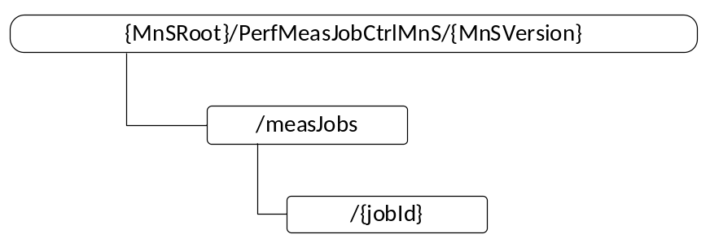
Figure 8.2.0-1: Resource URI structure of the performance measurement job control service
Table 8.2.0-1 provides an overview of the resources and applicable HTTP methods.
Table 8.2.0-1: Resources and methods overview
Resource name | Resource URI | HTTP method | Description
measJobs | /measJobs | GET | Retrieve all or a list of measurement jobs
measJobs | /measJobs | POST | Create a measurement job
measJob | /measJobs /{jobId} | GET | Retrieve a measurement job
measJob | /measJobs /{jobId} | DELETE | Stop a measurement job

8.2.1 Resource definitions

8.2.1.1 Void

8.2.1.2 Resource “/measJobs”

8.2.1.2.1 Description
This resource represents a collection of measurement jobs.

8.2.1.2.2 URI
Resource URI = {MnSRoot}/PerfMeasJobCtrlMnS/{MnSVersion}/measJobs
The resource URI variables a defined in the following table.
Table 8.2.1.2.2-1: URI variables
Name | Definition
MnSRoot | See subclause 4.4.3 of TS 32.158 [14]
MnSVersion | See subclause 4.4.3 of TS 32.158 [14]

8.2.1.2.3 HTTP methods
8.2.1.2.3.1 HTTP POST
This method shall support the URI query parameters specified in the following table.
Table 8.2.1.2.3.1-1: URI query parameters supported by the POST method on this resource
Name | Data type | Description | SQ

This method shall support the request data structures, the response data structures and response codes specified in the following table.
Table 8.2.1.2.3.1-2: Data structures supported by the POST request body on this resource
Data type | Description | SQ
measJobCreation-RequestType | The resource representation of the measurement job to be created | M

Table 8.2.1.2.3.1-3: Data structures supported by the POST Response Body on this resource
Data type | Response  codes | Description | SQ
measJobCreation-ResponseType | 201 Created | In case of success the representation of the created measurement job is returned. | M
measJobCreation-ResponseType | 202 Partially created | In case of partial success the representation of the created measurement job with unsupported list is returned.
error-Type | 4xx/5xx | Returned in case of an error | M

8.2.1.2.3.2 HTTP GET
This method shall support the URI query parameters specified in the following table.
Table 8.2.1.2.3.2-1: URI query parameters supported by the GET method on this resource
Name | Data type | Description | SQ
jobIdList | Array (string) | This parameter extends the set of targeted resources beyond the base resource identified with the path component of the URI. No scoping mechanism is specified in the present release. | O

This method shall support the request data structures, the response data structures and response codes specified in the following tables.
Table 8.2.1.2.3.2-2: Data structures supported by the GET request body on this resource
Data type | Description | SQ

Table 8.2.1.2.3.2-3: Data structures supported by the GET response body on this resource
Data type | Response  codes | Description | SQ
measJobsRetrieval-ResponseType | 200 OK | The resource representations of the measurement job list retrieved. | M
error-ResponseType | 4xx/5xx | Returned in case of an error | M

8.2.1.3 Resource “/measJobs/{jobId}”

8.2.1.3.1 Description
This resource represents a measurement job.

8.2.1.3.2 URI
Resource URI = {MnSRoot}/PerfMeasJobCtrlMnS/{MnSVersion}/measJobs/{jobId}
The resource URI variables a defined in the following table.
Table 8.2.1.3.2-1: URI variables
Name | Definition
MnSRoot | See subclause 4.4.3 of TS 32.158 [14]
MnSVersion | See subclause 4.4.3 of TS 32.158 [14]
jobId | The id of the measurement job

8.2.1.3.3 HTTP methods
8.2.1.3.3.1 HTTP GET
This method shall support the URI query parameters specified in the following table.
Table 8.2.1.3.3.1-1: URI query parameters supported by the GET method on this resource
Name | Data type | Description | SQ

This method shall support the request data structures, the response data structures and response codes specified in the following tables.
Table 8.2.1.3.3.1-2: Data structures supported by the GET request body on this resource
Data type | Description | SQ
n/a | n/a | n/a

Table 8.2.1.3.3.1-3: Data structures supported by the GET response body on this resource
Data type | Response  codes | Description | SQ
measJobsRetrieval-ResponseType | 200 OK | The resource representations of the measurement job retrieved. | M
error-ResponseType | 4xx/5xx | Returned in case of an error | M

8.2.1.3.3.2 HTTP DELETE
This method shall support the URI query parameters specified in the following table.
Table 8.2.1.3.3.2-1: URI query parameters supported by the DELETE method on this resource
Name | Data type | Description | SQ

This method shall support the request data structures, the response data structures and response codes specified in the following tables.
Table 8.2.1.3.3.2-2: Data structures supported by the DELETE request body on this resource
Data type | Description | SQ
n/a | n/a | n/a

Table 8.2.1.3.3.2-3: Data structures supported by the DELETE response body on this resource
Data type | Response  codes | Description | SQ
n/a | 204 No Content | In case of success no message body is returned | M
error-ResponseType | 4xx/5xx | Returned in case of an error | M

8.3 Data type definitions

8.3.1 General
Table 8.3.1-1: Data types defined in this specification
Data type | Reference | Description
General types
dataTime-Type | 8.3.8.2 | Data type of date and time.
uri-Type | 8.3.8.2 | The data type of a URI
Types used in paths
Types used in query parts
Types used in request bodies
measJobCreation-RequestType | 8.3.6.1 | Used in the request body of HTTP POST describing the measurement job to be created
Types used in response bodies
measJobCreation-ResponseType | 8.3.6.2 | Used in the response body of HTTP POST describing the measurement job created
measJobsRetrieval-ResponseType | 8.3.6.3 | Used in the response body of HTTP GET describing the measurement job(s) retrieved
error-ResponseType | 8.3.6.4 | Used in the response body describing the error.
Types used for resources
measJobInfo-ResourceType | 8.3.6.5 | Used for representation of the measurement job information.
Types referenced by the definitions above
reportingMethod-Type | 8.3.8.3 | This defines the data type for reporting method.
schedule-Type | 8.3.7.1 | This defines the data type for schedule.
priority-Type | 8.3.8.4 | This defines the data type for priority of the measurement job.
unsupportedMeas-Type | 8.3.7.5 | This defines the data type for the unsupported measurement types for an IOC instance.

Table 8.3.1-2: Data types imported
Data type | Reference | Description

8.3.2 Void

8.3.3 Void

8.3.4 Structured general data types
None.

8.3.5 Structured path data types
None.

8.3.6 Query, message body and resource data types

8.3.6.1 Type measJobCreation-RequestType
Table 8.3.6.1-1: Definition of type measJobCreation-RequestType
Attribute name | Data type | Description | SQ
iOCName | string | The IOC name of the IOC instances for which the measurement job is to be created. | M
iOCInstanceList | array(uri-Type) | The URI(s) of the IOC instances for which the measurement job is to be created. | M
measurementCategoryList | array(string) | The list of measurement type(s) to be measured. | M
reportingMethod | reportingMethod-Type | The reporting method of the measurements to be collected, i.e., by performance data file or by performance data streaming. | M
granularityPeriod | Integer | The granularity period of the measurement job. | M
reportingPeriod | Integer | The reporting period of the measurement job. | M
startTime | dateTime-Type | The begin time from which the measurement job will be active. | O
stopTime | dateTime-Type | The end time after which the measurement job will be stopped. | O
schedule | schedule-Type | The detailed time frames (within the startTime and stopTime) during which the measurement job is active and monitors the measurement type(s). | O
streamTarget | string | The target of performance data streams carrying the performance data stream unit(s). | M
priority | priority-Type | The priority of the measurement job. | O
reliability | string | The reliability of the measurement job. | O

8.3.6.2 Type measJobCreation-ResponseType
Table 8.3.6.2-1: Definition of type measJobCreation-ResponseType
Attribute name | Data type | Description | SQ
unsupportedList | array(unsupportedMeas-Type) | The list of unsupported IOC instances, unsupported measurement types and reason. | M

8.3.6.3 Type measJobsRetrieval-ResponseType
Table 8.3.6.3-1: Definition of type measJobsRetrieval-ResponseType
Attribute name | Data type | Description | SQ
jobInfoList | array(measJobInfo-ResourceType) | The list of measurement job information. | M

8.3.6.4 Type error-ResponseType
Table 8.3.6.4-1: Definition of type error-ResponseType
Attribute name | Data type | Description | SQ
error | object | Key indicating the response body containing an error | M
> errorInfo | string | Attribute allowing to convey error information in string format | M

8.3.6.5 Type measJobInfo-ResourceType
Table 8.3.6.3-1: Definition of type measJobsRetrieval-ResponseType
Attribute name | Data type | Description | SQ
href | uri-Type | The URI of the measurement job. | M
iOCName | string | The IOC name of the IOC instances for which the measurement job created. | M
iOCInstanceList | array(uri-Type) | The URI(s) of the IOC instances for which the measurement job is created. | M
measurementCategoryList | array(string) | The list of measurement type(s) measured. | M
reportingMethod | reportingMethod-Type | The reporting method of the measurements, i.e., by performance data file or by performance data streaming. | M
granularityPeriod | Integer | The granularity period of the measurement job. | M
reportingPeriod | Integer | The reporting period of the measurement job. | M
startTime | dateTime-Type | The begin time from which the measurement job is active. | O
stopTime | dateTime-Type | The end time after which the measurement job will be stopped. | O
schedule | schedule-Type | The detailed time frames (within the startTime and stopTime) during which the measurement job is active and monitors the measurement type(s). | O
streamTarget | string | The target of performance data streams carrying the performance data stream unit(s). | M
priority | priority-Type | The priority of the measurement job. | O
reliability | string | The reliability of the measurement job. | O

8.3.7 Referenced structured data types

8.3.7.1 Type schedule-Type
Table 8.3.7.1-1: Definition of schedule-Type
Attribute name | Data type | Description | SQ
scheduleOption | scheduleOption-Type | It indicates the schedule is daily or weekly | M
dailySchedule | array(timeInterval-Type) | It defines the daily schedule. | M
weeklySchedule | array(scheduleOfDay-Type) | It defines the weekly schedule. | M

8.3.7.2 Type timeInterval-Type
Table 8.3.7.2-1: Definition of timeInterval-Type
Attribute name | Data type | Description | SQ
intervalStart | string | It defines the start time of the schedule, by a string in Time format. | M
intervalEnd | string | It defines the end time of the schedule, by a string in Time format.s | M

8.3.7.3 Type scheduleOfDay-Type
Table 8.3.7.3-1: Definition of scheduleOfDay-Type
Attribute name | Data type | Description | SQ
dayOfWeek | dayOfWeek-Type | It defines the day of a week. | M
intervalsOfDay | array(timeInterval-Type) | It defines the schedule of the day. | M

8.3.7.4 Void

8.3.7.5 Type unsupportedMeas-Type
Table 8.3.7.5-1: Definition of unsupportedMeas-Type
Attribute name | Data type | Description | SQ
iOCInstance | uri-Type | The URI of the IOC instance. | M
measurementTypeName | string | It defines the measurement type name that the IOC Instance as indicated above does not support | M
reason | string | It specifies the reason that measurement type name is not supported by the IOC instance | M

8.3.8 Simple data types and enumerations

8.3.8.1 General
This subclause defines simple data types and enumerations that are used by the data structures defined in the previous subclauses.

8.3.8.2 Simple data types
Table 8.3.8.2-1: Simple data types
Type name | Type definition | Description
dataTime-Type | string | The data type for date and time in “date-time” format.
uri-Type | string | The type of a URI

8.3.8.3 Enumeration reportingMethod-Type
Table 8.3.8.3-1: Enumeration reportingMethod-Type
Enumeration value | Description
file | It indicates that the performance data are to be reported by performance data file.
streaming | It indicates that the performance data are to be reported by performance data streaming.

8.3.8.4 Enumeration priority-Type
Table 8.3.8.4-1: Enumeration priority-Type
Enumeration value | Description
Low | It indicates that the priority of the measurement job is low
medium | It indicates that the priority of the measurement job is medium
high | It indicates that the priority of the measurement job is high

8.3.8.5 Enumeration scheduleOption-Type
Table 8.3.8.5-1: Enumeration scheduleOption-Type
Enumeration value | Description
daily | It indicates the schedule of the measurement job is daily.
weekly | It indicates the schedule of the measurement job is weekly.

8.3.8.6 Enumeration dayOfWeek-Type
Table 8.3.8.6-1: Enumeration dayOfWeek-Type
Enumeration value | Description
Monday | It indicates Monday of a week.
Tuesday | It indicates Tuesday of a week.
Wednesday | It indicates Wednesday of a week.
Thursday | It indicates Thursday of a week.
Friday | It indicates Friday of a week.
Saturday | It indicates Saturday of a week.
Sunday | It indicates Sunday of a week.

9 Void

Annex A (informative):
Void

Annex B (informative):
Procedures for performance assurance services

B.1 NF measurement job creation
The Figure B.1-1 illustrates an example of procedure for creating a measurement job for NF(s).
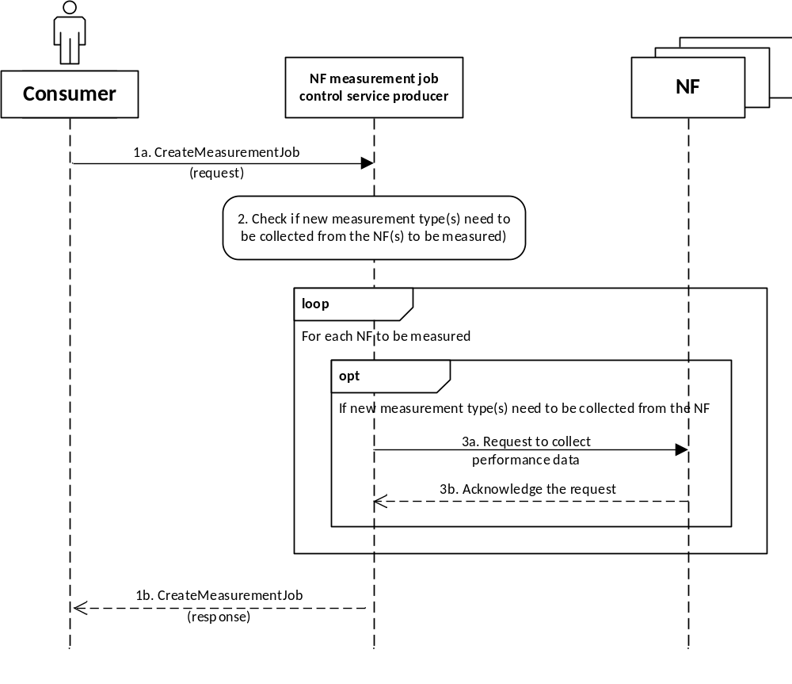
Figure B.1-1: Example of procedure for NF measurement job creation
1a. The authorized consumer invokes the CreateMeasurementJob operation (see clause 6.1.1) to NF measurement job control service producer to request creation of a measurement job for NF(s).
2. The NF measurement job control service producer checks if new measurement type(s) need to be collected from the NF(s) to be measured.
3. For each NF to be measured, if new measurements type(s) need to be collected:
3a. the NF measurement job control service producer requests NF to collect the performance data;
3b. the NF measurement job control service producer receives the acknowledgement of the request from NF.
1b. The NF measurement job control service producer returns the result of CreateMeasurementJob operation (see clause 6.1.1) to the consumer.
If the NF measurement job is successfully created, the NF measurement job control service producer will collect the performance data from the NF(s) accordingly, and make the measurement results available to the NF performance data reporting service producer for each reporting period.

B.2 NSSI measurement job creation
The Figure B.2-1 illustrates an example of procedure for creating a measurement job for NSSI(s).
This procedure is only applicable for the scenario where the NSSI measurement type(s) can be decomposed into the measurement data type(s) of the constituent NSSI(s) and NF(s).
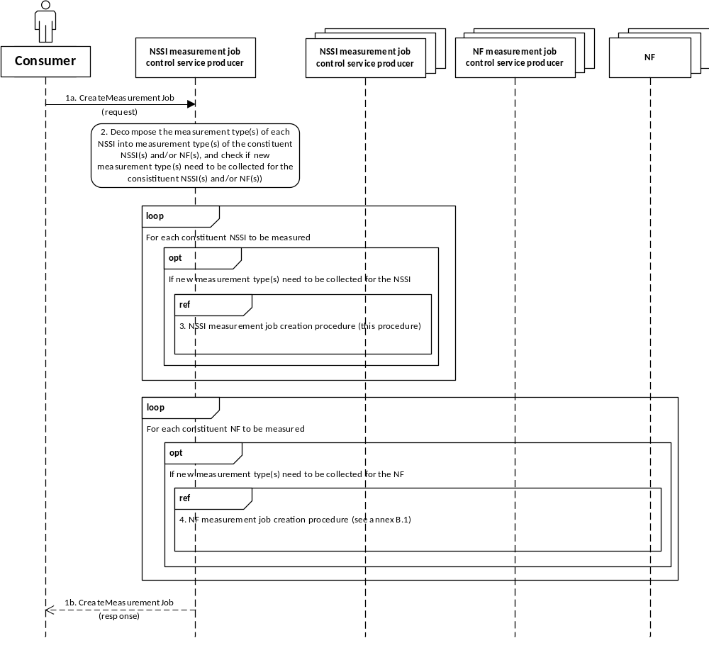
Figure B.2-1: Example of procedure for NSSI measurement job creation
1a. The authorized consumer invokes the CreateMeasurementJob operation (see clause 6.1.1) to NSSI measurement job control service producer to request creation of a measurement job for NSSI(s).
2. The NSSI measurement job control service producer decomposes the measurement type(s) of each NSSI to the measurement type(s) of the constituent NSSI(s) and/or NF(s), and checks if new measurement type(s) need to be collected for the constituent NSSI(s) and/or NF(s).
3. For each constituent NSSI to be measured, if new measurements type(s) need to be collected, the NSSI measurement job control service producer acts as consumer of another NSSI measurement job control service instance, and requests the corresponding NSSI measurement job control service producer to request creation of measurement job for the NSSI (following the same procedure as illustrated in this figure).
It is also possible to create one measurement job to collect the performance data for multiple NSSI(s).
4. For each constituent NF to be measured, if new measurements type(s) need to be collected, the NSSI measurement job control service producer acts as consumer of NF measurement job control service, and requests the corresponding NF measurement job control service producer to request creation of measurement job for the NF (according to the NF measurement job creation procedure as illustrated in clause B.1).
It is also possible to create one measurement job to collect the performance data for multiple NF(s).
1b. The NSSI measurement job control service producer returns the result of CreateMeasurementJob operation (see clause 6.1.1) to the consumer.
If the NSSI measurement job is successfully created, the NSSI measurement job control service producer will collect the performance data for the constituent NSSI(s) and/or NF(s) accordingly, generate the measurement results for the measured NSSI(s) and make the measurement results available to the NSSI performance data reporting service producer for each reporting period.

B.3 NSI measurement job creation
This Figure B.3-1 illustrates an example of procedure for creating a measurement job for NSI(s).
This procedure is only applicable for the scenario where the NSI measurement type(s) can be decomposed into the measurement data type(s) of the constituent NSSI(s) or NF(s).
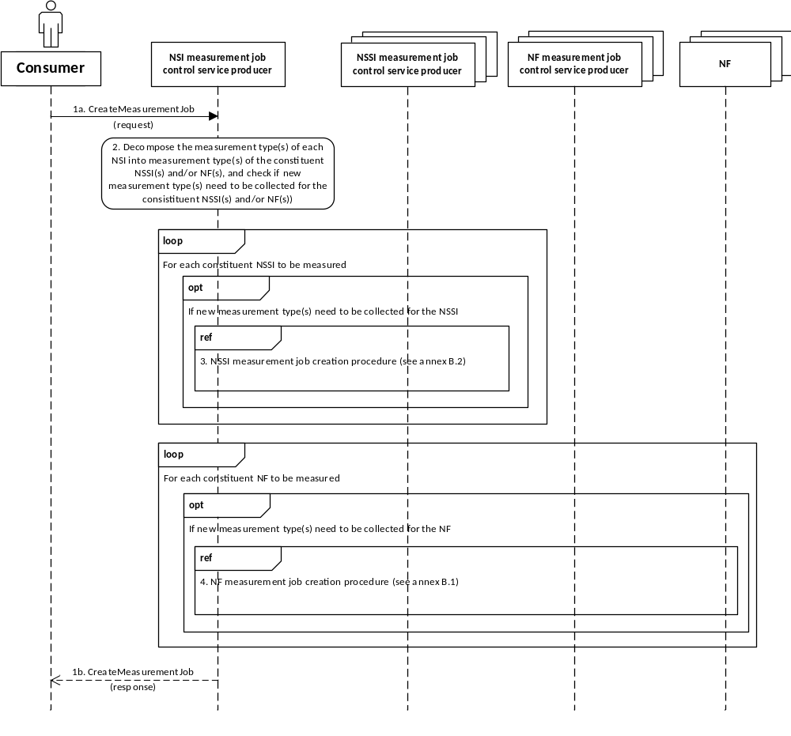
Figure B.3-1: Example of procedure for NSI measurement job creation
1a. The authorized consumer invokes the CreateMeasurementJob operation (see clause 6.1.1) to NSI measurement job control service producer to request creation of a measurement job for NSI(s).
2. The NSI measurement job control service producer decomposes the measurement type(s) of each NSI to the measurement type(s) of the constituent NSSI(s) and/or NF(s), and checks if new measurement type(s) need to be collected for the constituent NSSI(s) and/or NF(s).
3. For each constituent NSSI to be measured, if new measurements type(s) need to be collected, the NSI measurement job control service producer acts as consumer of the NSSI measurement job control service, and requests the corresponding NSSI measurement job control service producer to request creation of measurement job for the NSSI (according to the procedure as illustrated in clause B.2).
It is also possible to create one measurement job to collect the performance data for multiple NSSI(s).
4. For each constituent NF to be measured, if new measurements type(s) need to be collected, the NSI measurement job control service producer acts as consumer of NF measurement job control service, and requests the corresponding NF measurement job control service producer to request creation of measurement job for the NF (according to the NF measurement job creation procedure as illustrated in clause B.1).
It is also possible to create one measurement job to collect the performance data for multiple NF(s).
1b. The NSI measurement job control service producer returns the result of CreateMeasurementJob operation (see clause 6.1.1) to the consumer.
If the NSI measurement job is successfully created, the NSI measurement job control service producer will collect the performance data for the constituent NSSI(s) and/or NF(s) accordingly, generate the measurement results for the measured NSI(s) and make the measurement results available to the NSI performance data reporting service producer for each reporting period.

B.4 Network measurement job creation
This Figure B.4-1 illustrates an example of procedure for creating a measurement job for network/subnetwork(s).
This procedure is only applicable for the scenario where the network/subnetwork measurement type(s) can be decomposed into the measurement data type(s) of the constituent NF(s).
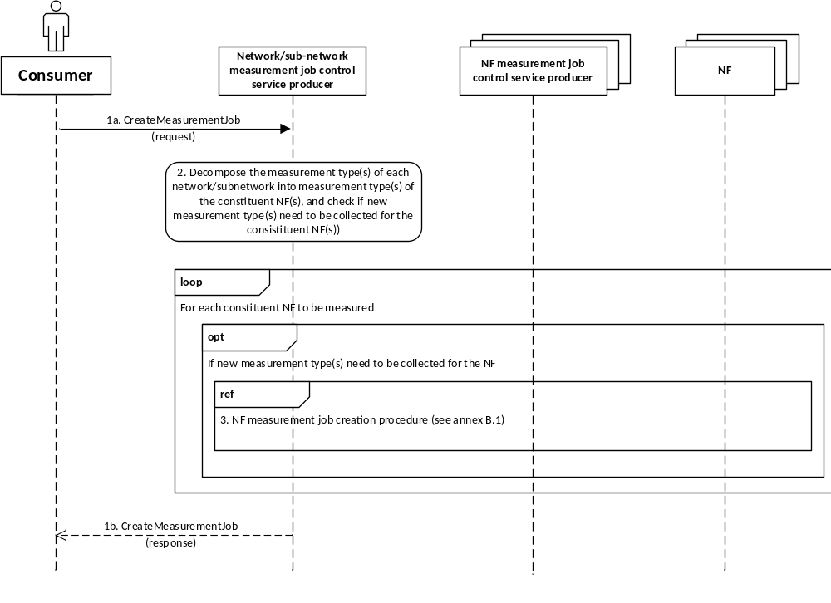
Figure B.4-1: Example of procedure for network measurement job creation
1a. The authorized consumer invokes the CreateMeasurementJob operation (see clause 6.1.1) to network measurement job control service producer to request creation of a measurement job for network/subnetwork(s).
1b. The network measurement job control service producer returns the result of CreateMeasurementJob operation (see clause 6.1.1) to the consumer.
2. The network measurement job control service producer decomposes the measurement type(s) of each network/subnetwork to the measurement type(s) of the constituent NF(s), and checks if new measurement type(s) need to be collected for the constituent NF(s).
3. For each constituent NF to be measured, if new measurements type(s) need to be collected, the network/sub-network measurement job control service producer acts as consumer of NF measurement job control service, and requests the corresponding NF measurement job control service producer to request creation of measurement job for the NF (according to the NF measurement job creation procedure as illustrated in annex B.1).
It is also possible to create one measurement job to collect the performance data for multiple NF(s).
If the network measurement job is successfully created, the network measurement job control service producer will collect the performance data for the constituent NF(s) accordingly, generate the measurement results for the measured network/subnetwork(s) and make the measurement results available to the network performance data reporting service producer for each reporting period.

B.5 NF measurement job termination
This Figure B.5-1 illustrates an example of procedure for stopping a measurement job for NF(s).
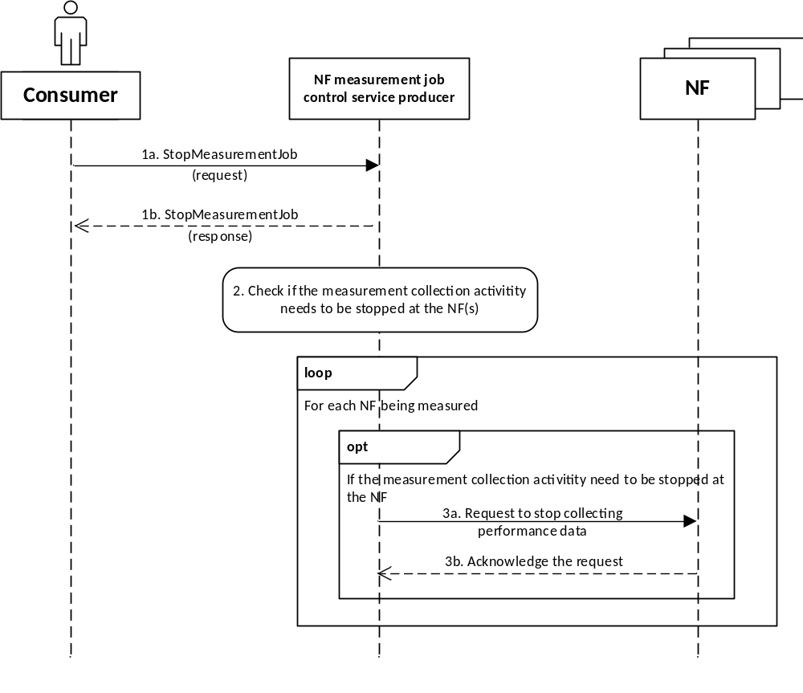
Figure B.5-1: Example of procedure for NF measurement job termination
1a. The authorized consumer invokes the StopMeasurementJob operation (see clause 6.1.2) to NF measurement job control service producer to request termination of a measurement job for NF(s).
1b. The NF measurement job control service producer returns the result of StopMeasurementJob operation (see clause 6.1.2) to the consumer.
2. The NF measurement job control service producer checks if the measurement collection activity needs to be stopped at the NF(s).
3. For each NF being measured, if the measurement collection activity needs to be stopped at the NF(s),
3a. the NF measurement job control service producer requests NF to stop collecting the performance data;
3b. the NF measurement job control service producer receives the acknowledgement of the request from NF.

B.6 NSSI measurement job termination
This Figure B.6-1 illustrates an example of procedure for stopping a measurement job for NSSI(s).
This procedure is only applicable for the scenario where the NSSI measurement type(s) can be decomposed into the measurement data type(s) of the constituent NSSI(s) and NF(s).
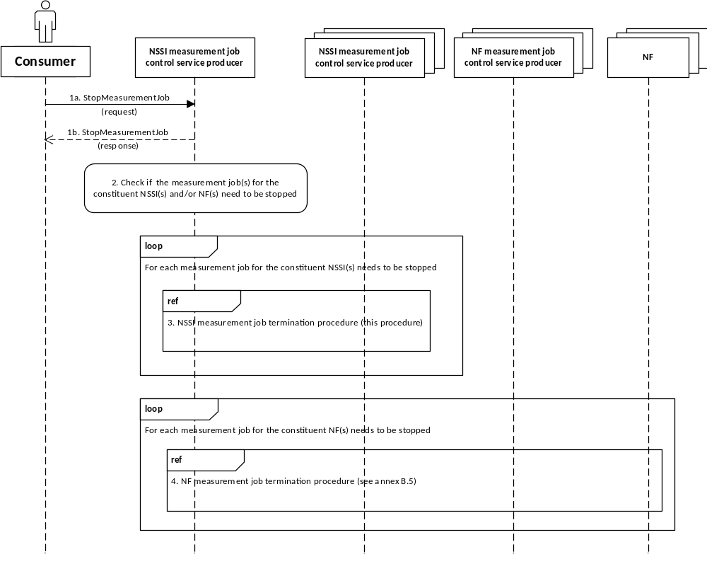
Figure B.6-1: Example of procedure for NSSI measurement job termination
1a. The authorized consumer invokes the StopMeasurementJob operation (see clause 6.1.2) to NSSI measurement job control service producer to request termination of a measurement job for NSSI(s).
1b. The NSSI measurement job control service producer returns the result of StopMeasurementJob operation (see clause 6.1.2) to the consumer.
2. The NSSI measurement job control service producer checks if the measurement job(s) for the constituent NSSI(s) and/or NF(s) need to be stopped.
3. For each measurement job for the constituent NSSI(s) needs to be stopped, the NSSI measurement job control service producer acts as consumer of another NSSI measurement job control service instance, and requests the corresponding NSSI measurement job control service producer to terminate the measurement job for the constituent NSSI(s) (following the same procedure as illustrated in this figure).
4. For each measurement job for the constituent NF(s) needs to be stopped, the NSSI measurement job control service producer acts as consumer of NF measurement job control service, and requests the corresponding NF measurement job control service producer to terminate the measurement job for the NF(s) (according to the NF measurement job termination procedure as illustrated in clause B.5).

B.7 NSI measurement job termination
This Figure B.7-1 illustrates an example of procedure for stopping a measurement job for NSI(s).
This procedure is only applicable for the scenario where the NSI measurement type(s) can be decomposed into the measurement data type(s) of the constituent NSSI(s) and NF(s).
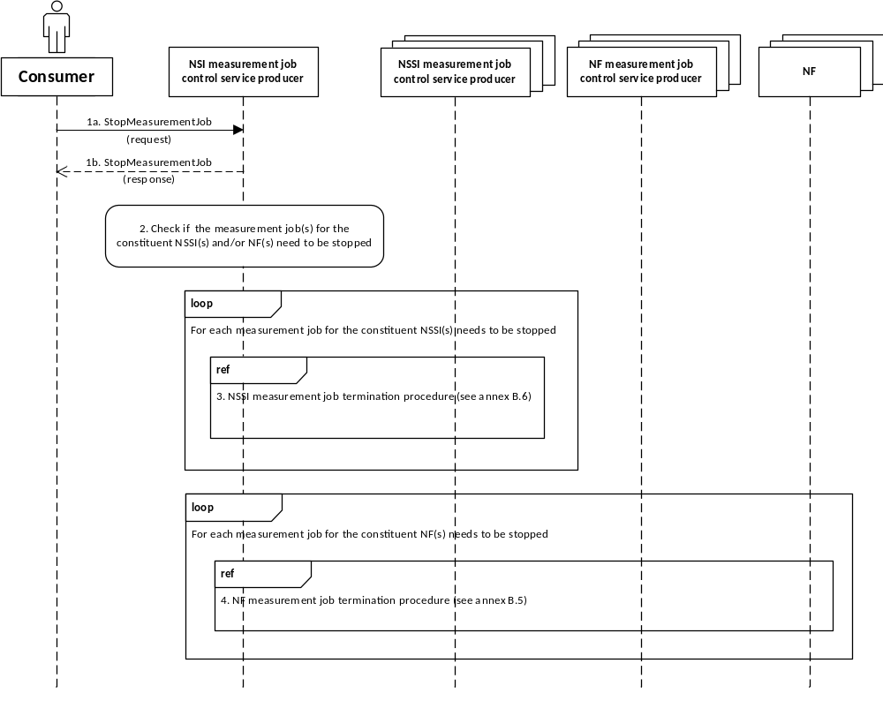
Figure B.7-1: Example of procedure for NSI measurement job termination
1a. The authorized consumer invokes the StopMeasurementJob operation (see clause 6.1.2) to NSI measurement job control service producer to request creation of a measurement job for NSI(s).
1b. The NSI measurement job control service producer returns the result of StopMeasurementJob operation (see clause 6.1.2) to the consumer.
2. The NSI measurement job control service producer checks if the measurement job(s) for the constituent NSSI(s) and/or NF(s) need to be stopped.
3. For each measurement job for the constituent NSSI(s) needs to be stopped, the NSI measurement job control service producer acts as consumer of the NSSI measurement job control service, and requests the corresponding NSSI measurement job control service producer to terminate the measurement job for the constituent NSSI(s) (according to the NSSI measurement job termination procedure as illustrated in clause B.6).
4. For each measurement job for the constituent NF(s) needs to be stopped, the NSI measurement job control service producer acts as consumer of NF measurement job control service, and requests the corresponding NF measurement job control service producer to terminate the measurement job for the NF(s) (according to the NF measurement job termination procedure as illustrated in clause B.5).

B.8 Network measurement job termination
This Figure B.8-1 illustrates an example of procedure for stopping a measurement job for network/subnetwork(s).
This procedure is only applicable for the scenario where the network/subnetwork measurement type(s) can be decomposed into the measurement data type(s) of the constituent NF(s).
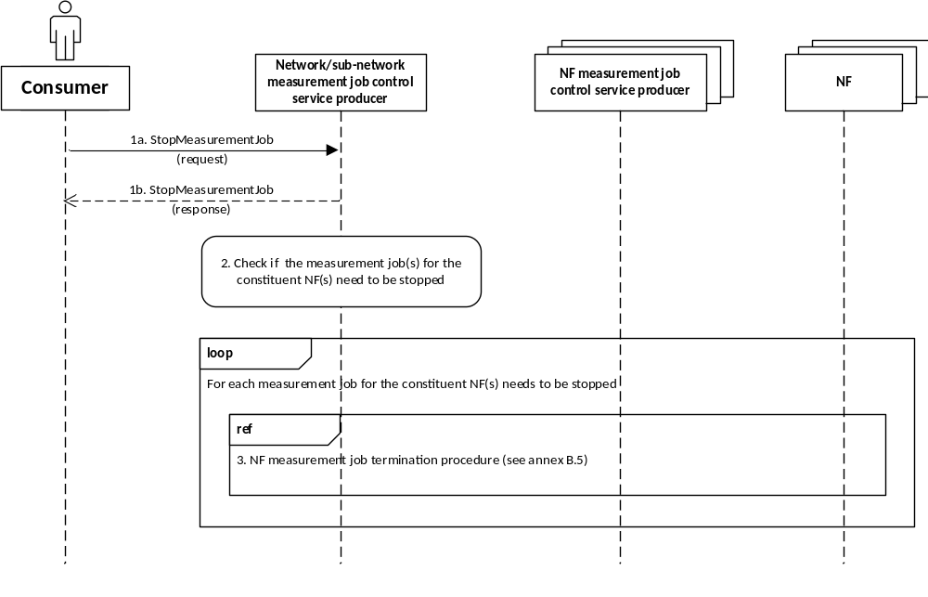
Figure B.8-1: Example of procedure for network measurement job creation
1a. The authorized consumer invokes the StopMeasurementJob operation (see clause 6.1.2) to network measurement job control service producer to request termination of a measurement job for network/subnetwork(s).
1b. The network measurement job control service producer returns the result of StopMeasurementJob operation (see clause 6.1.2) to the consumer.
2. The network measurement job control service producer checks if the measurement job(s) for the constituent NF(s) need to be stopped.
3. For each measurement job for the constituent NF(s) needs to be stopped, the network measurement job control service producer acts as consumer of NF measurement job control service, and requests the corresponding NF measurement job control service producer to terminate the measurement job for the NF(s) (according to the NF measurement job termination procedure as illustrated in clause B.5).

Annex C (normative):
Performance Data Stream Unit content description
Table C-1 lists all the Performance Data Stream Unit content items. It also provides an explanation of the individual items.
Table C-1: Performance Data Stream Unit content description
Performance Data Stream Unit Content | Description
streamId | The streamId of the performance data stream.
granularityPeriodEndTime | Time stamp referring to the end of the granularity period.
measResults | This parameter contains the sequence of result values for the observed measurement types or KPIs.  The "measResults" sequence shall have the same number of elements, which follow the same order as the measurement types or KPIs presented in “performanceMetrics” for the subject stream in the input parameter streamInfoList of the establishStreamingConnection operation (see clause 6.2.1.2).

Annex D (informative):
Performance data streaming holistic sequence

D.1 Performance data streaming for starting measurement collection

D.1.1 Sequence flow
This annex shows the holistic sequence for performance data streaming, starting from starting the measurement collection (by job or configuration) to sending the performance data to the performance data streaming consumer (stream target).
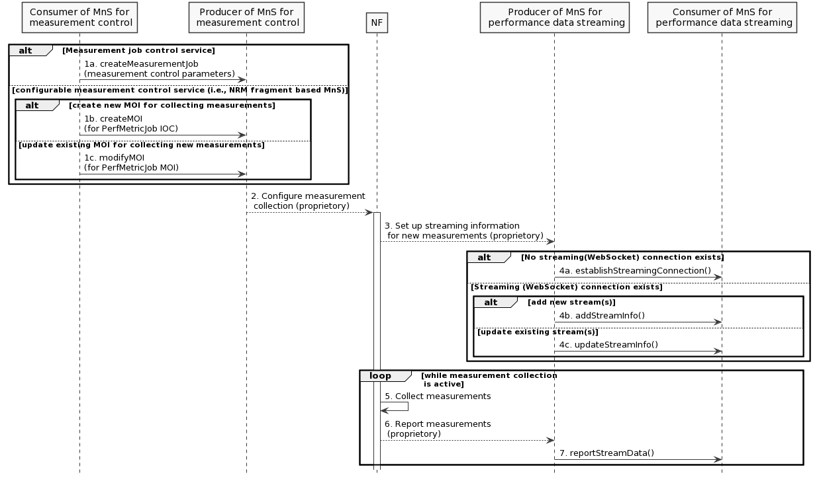
Figure D.1.1-1
1. The consumer of MnS for measurement control requests the MnS producer to start the measurement collection by the following two alternatives:
1) by the measurement job control service
1a. The MnS consumer invokes the createMeasurementJob operation towards the MnS producer;
2) by the configurable measurement control service (a.k.a, NRM fragment-based measurement control service).
1b. The MnS consumer creates a new PerfMetricJob MOI, by invoking the createMOI operation towards the MnS producer; or
1c. The MnS consumer modifies an existing PerfMetricJob MOI to add new measurements to be collected, by invoking the modifyMOIAttributes operation towards the MnS producer.
2. The producer of MnS for measurement control configures the NF to collect the measurements. The mechanism of this step is vendor specific. If producer of MnS for measurement control is in the NF, this step can be skipped.
3. The NF triggers the producer of MnS for performance data streaming to set up the streaming information for the new measurements to be collected. The mechanism of this step is vendor specific. If producer of MnS for performance data streaming is in the NF, this step can be skipped.
4. The producer of MnS for performance data streaming communicates with the consumer to:
4a. establish the streaming (WebSocket) connection containing the stream information if it does not exist yet, by invoking the establishStreamingConnection operation;
4b. add the stream information for the new measurements if they will be reported by new streams, by invoking the addStreamInfo operation;
4c. update the stream information for the new measurements if they will be reported by existing streams, by invoking the updateStreamInfo operation.
5. The NF collects the measurements. This step is the internal behaviour of the NF.
6. The NF report the collected measurements to the producer of MnS for performance data streaming. The mechanism of this step is vendor specific. If producer of MnS for performance data streaming is in the NF, this step can be skipped.
7. The producer of MnS for performance data streaming sends the collected measurements to the consumer via performance data streams, by invoking the reportStreamData operation.

D.1.2 PlantUML codes
@startuml
skinparam shadowing false
skinparam monochrome true
hide footbox

participant "Consumer of MnS for\n measurement control" as MC
participant "Producer of MnS for\n measurement control" as MP
participant "NF" as NF
participant "Producer of MnS for\n performance data streaming" as SP
participant "Consumer of MnS for\n performance data streaming" as SC

alt Measurement job control service
else configurable measurement control service (i.e., NRM fragment based MnS)
alt create new MOI for collecting measurements
MC -> MP : 1b. createMOI\n(for PerfMetricJob IOC)
Else update existing MOI for collecting new measurements
MC -> MP : 1c. modifyMOIAttributes\n(for PerfMetricJob MOI) end
end

MP --> NF: 2. Configure measurement\n collection (proprietory)

activate NF
NF --> SP: 3. Set up streaming information\n for new measurements (proprietory)
alt No streaming(WebSocket) connection exists
SP->SC: 4a. establishStreamingConnection()

else Streaming (WebSocket) connection exists
alt add new stream(s)
SP->SC: 4b. addStreamInfo()
else update existing stream(s)
SP->SC: 4c. updateStreamInfo()
end
end

Loop while measurement collection\n is active
NF->NF: 5. Collect measurements
NF --> SP: 6. Report measurements\n (proprietory)
SP -> SC: 7. reportStreamData()
end

@enduml

D.2 Performance data streaming for stopping measurement collection

D.2.1 Sequence flow
This annex shows the holistic sequence for performance data streaming in connection with the measurement collection termination.

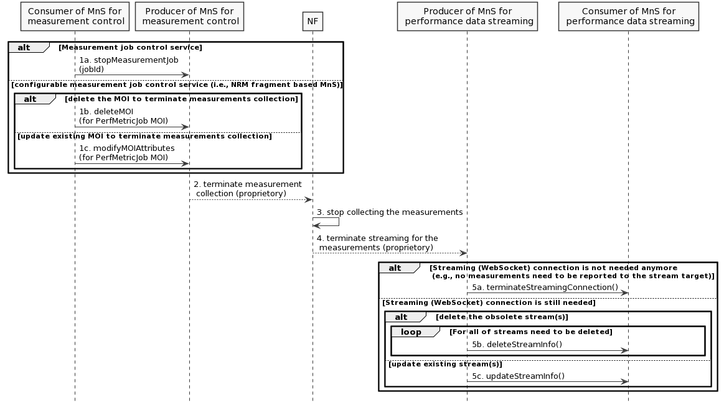
Figure D.2.1-1
1. The consumer of MnS for measurement control requests the MnS producer to stop the measurement collection by the following two alternatives:
1) by the measurement job control service
1a. The MnS consumer invokes the stopMeasurementJob operation towards the MnS producer;
2) by the configurable measurement control service (a.k.a, NRM fragment-based measurement control service)
1b. The MnS consumer deletes the PerfMetricJob MOI , by invoking the deleteMOI operation towards the MnS producer;
1c. The MnS consumer modifies the PerfMetricJob MOI with deletion of the measurements that do not need to be collected anymore, by invoking the modifyMOIAttributes operation towards the MnS producer.
2. The producer of MnS for measurement control requests the NF to stop collecting the measurements. The mechanism of this step is vendor specific. If producer of MnS for measurement control is in the NF, this step can be skipped.
3. The NF stops collecting the measurements. This step is the internal behaviour of the NF.
4. The NF triggers the producer of MnS for performance data streaming to terminate streaming for the measurements. The mechanism of this step is vendor specific. If producer of MnS for performance data streaming is in the NF, this step can be skipped.
5. The producer of MnS for performance data streaming communicates with the consumer to:
5a. terminate the streaming (WebSocket) connection if no measurements need to be reported to the consumer anymore, by invoking the terminateStreamingConnection operation;
5b. delete the information for the stream(s) obsoleted due to the termination of the measruements collection if the streaming connection still needs to be retained, by invoking the deleteStreamInfo operation;
5c. update the information for the stream(s) partially affected by the termination of the measurements collection, by invoking the updateStreamInfo operation.

D.2.2 PlantUML codes
@startuml
skinparam shadowing false
skinparam monochrome true
hide footbox

participant "Consumer of MnS for\n measurement control" as MC
participant "Producer of MnS for\n measurement control" as MP
participant "NF" as NF
participant "Producer of MnS for\n performance data streaming" as SP
participant "Consumer of MnS for\n performance data streaming" as SC

alt Measurement job control service
MC -> MP : 1a. stopMeasurementJob\n(jobId)
else configurable measurement job control service (i.e., NRM fragment based MnS)
alt delete the MOI to terminate measurements collection
MC -> MP : 1b. deleteMOI\n(for PerfMetricJob MOI)
Else update existing MOI to terminate measurements collection
MC -> MP : 1c. modifyMOIAttributes\n(for PerfMetricJob MOI) end
end

MP --> NF: 2. terminate measurement\n collection (proprietory)

NF -> NF: 3. stop collecting the measurements
NF --> SP: 4. terminate streaming for the\n measurements (proprietory)
alt Streaming (WebSocket) connection is not needed anymore\n (e.g., no measurements need to be reported to the stream target)
SP->SC: 5a. terminateStreamingConnection()

else Streaming (WebSocket) connection is still needed
alt delete the obsolete stream(s)
loop For all of streams need to be deleted
SP->SC: 5b. deleteStreamInfo()
end
else update existing stream(s)
SP->SC: 5c. updateStreamInfo()
end
end

@enduml

Annex E (normative):
OpenAPI specification

E.1 Introduction
This clause describes the capabilities of the Management Services in the structure of the OpenAPI Specification Version 3.0.1. The OpenAPI document is represented in the YAML format option.

E.2 OpenAPI document " TS28550_PerMeasJobCtlMnS.yaml"
openapi: 3.0.1
info:
title: TS 28.550 Performance Measurement Job Control Service
version: 16.8.0
description: >-
OAS 3.0.1 specification of the Performance Measurement Job Control Service
@ 2020, 3GPP Organizational Partners (ARIB, ATIS, CCSA, ETSI, TSDSI, TTA, TTC).
All rights reserved.
externalDocs:
description: 3GPP TS 28.550 V16.8.0; Performance assurance
url: http://www.3gpp.org/ftp/Specs/archive/28_series/28.550/
servers:
- url: '{MnSRoot}/PerfMeasJobCtrlMnS/{MnSVersion}'
variables:
MnSRoot:
description: See clause 4.4.2 of TS 32.158
default: http://example.com/3GPPManagement
MnSVersion:
description: Version number of the OpenAPI definition
default: XXX
paths:
/measJobs:
post:
summary: Create a measurement job
description: To create a measurement job the representation of the measurement job is POSTed on the /measJobs collection resource.
requestBody:
required: true
content:
application/json:
schema:
$ref: '#/components/schemas/measJobCreation-RequestType'
responses:
'201':
description: Success case ("201 Created"). The representation of the newly created measurement job resource shall be returned.
content:
application/json:
schema:
$ref: '#/components/schemas/measJobCreation-ResponseType'
'202':
description: Partial success case ("202 Partically created"). The representation of the newly created measurement job resource with unsupported list shall be returned.
content:
application/json:
schema:
$ref: '#/components/schemas/measJobCreation-ResponseType'
default:
description: Error case.
content:
application/json:
schema:
$ref: '#/components/schemas/error-ResponseType'
get:
summary: Read resources of measurement jobs
description: 'With HTTP GET, resources of measurement jobs are read. The resources to be read are identified with the path component (base resource) and the query component (jobIdList) of the URI. The fields query component allows to select the resource properties to be returned.'
parameters:
- name: jobIdList
in: query
description: This parameter identifies the list of jobId to select the resources from the collection resources identified with the path component of the URI.
required: true
schema:
type: array
items:
type: string
responses:
'200':
description: 'Success case ("200 OK"). The resources identified in the request for retrieval are returned in the response message body. In case the fields query parameter is used, the selected resources are returned.'
content:
application/json:
schema:
$ref: '#/components/schemas/measJobsRetrieval-ResponseType'
default:
description: Error case.
content:
application/json:
schema:
$ref: '#/components/schemas/error-ResponseType'
'/measJobs/{jobId}':
get:
summary: Read resource of a single measurement job
description: 'With HTTP GET, resource of a measurement job is read. The resource to be read is identified with the path component of the URI.'
parameters:
- name: jobId
in: path
description: Identifies the measurement job to be read.
required: true
schema:
$ref: '#/components/schemas/uri-Type'
responses:
'200':
description: 'Success case ("200 OK"). The resource identified in the path for retrieval is returned in the response message body. '
content:
application/json:
schema:
$ref: '#/components/schemas/measJobsRetrieval-ResponseType'
default:
description: Error case.
content:
application/json:
schema:
$ref: '#/components/schemas/error-ResponseType'
delete:
summary: Delete a single measurement job
description: The measurement job is deleted by deleting the corresponding measurement job resource. The resource to be deleted is identified with the path component of the URI.
parameters:
- name: jobId
in: path
description: Identifies the measurement job to be deleted.
required: true
schema:
$ref: '#/components/schemas/uri-Type'
responses:
'204':
description: Success case ("204 No Content"). The measurement job resource has been deleted. The response message body is absent.
default:
description: Error case.
content:
application/json:
schema:
$ref: '#/components/schemas/error-ResponseType'
components:
schemas:
dateTime-Type:
type: string
format: date-Time
uri-Type:
type: string
measJobCreation-RequestType:
type: object
properties:
iOCName:
type: string
iOCInstanceList:
type: array
items:
$ref: '#/components/schemas/uri-Type'
measurementCategoryList:
type: array
items:
type: string
reportingMethod:
$ref: '#/components/schemas/reportingMethod-Type'
granularityPeriod:
type: integer
reportingPeriod:
type: integer
startTime:
$ref: '#/components/schemas/dateTime-Type'
stopTime:
$ref: '#/components/schemas/dateTime-Type'
schedule:
$ref: '#/components/schemas/schedule-Type'
streamTarget:
type: string
priority:
$ref: '#/components/schemas/priority-Type'
reliability:
type: string
measJobCreation-ResponseType:
type: object
properties:
unsupportedList:
type: array
items:
$ref: '#/components/schemas/unsupportedMeas-Type'
measJobsRetrieval-ResponseType:
type: object
properties:
jobInfoList:
type: array
items:
$ref: '#/components/schemas/measJobInfo-ResourceType'
error-ResponseType:
type: object
properties:
error:
type: object
properties:
errorInfo:
type: string
measJobInfo-ResourceType:
type: object
properties:
href:
$ref: '#/components/schemas/uri-Type'
iOCName:
type: string
iOCInstanceList:
type: array
items:
$ref: '#/components/schemas/uri-Type'
measurementCategoryList:
type: array
items:
type: string
reportingMethod:
$ref: '#/components/schemas/reportingMethod-Type'
granularityPeriod:
type: integer
reportingPeriod:
type: integer
startTime:
$ref: '#/components/schemas/dateTime-Type'
stopTime:
$ref: '#/components/schemas/dateTime-Type'
schedule:
$ref: '#/components/schemas/schedule-Type'
streamTarget:
type: string
priority:
$ref: '#/components/schemas/priority-Type'
reliability:
type: string
schedule-Type:
type: object
properties:
scheduleOption:
$ref: '#/components/schemas/scheduleOption-Type'
dailySchedule:
type: array
items:
$ref: '#/components/schemas/timeInterval-Type'
weeklySchedule:
type: array
items:
$ref: '#/components/schemas/scheduleOfDay-Type'
timeInterval-Type:
type: object
properties:
intervalStart:
type: string
format: Time
intervalEnd:
type: string
format: Time
scheduleOfDay-Type:
type: object
properties:
dayOfWeek:
$ref: '#/components/schemas/dayOfWeek-Type'
intervalsOfDay:
type: array
items:
$ref: '#/components/schemas/timeInterval-Type'
unsupportedMeas-Type:
type: object
properties:
iOCInstance:
$ref: '#/components/schemas/uri-Type'
measurementTypeName:
type: string
reason:
type: string
reportingMethod-Type:
type: string
enum:
- file
- streaming
priority-Type:
type: string
enum:
- low
- medium
- high
scheduleOption-Type:
type: string
enum:
- daily
- weekly
dayOfWeek-Type:
type: string
enum:
- Monday
- Tuesday
- Wednesday
- Thursday
- Friday
- Saturday
- Sunday

E.3 Void

Annex F (normative):
Threshold crossing notifications triggering

F.1 Threshold crossing notifications triggering for cumulative counters
For the threshold monitoring of performance measurements that are cumulative counters, the notification notifyThresholdCrossing is emitted immediately when the cumulative counter of measured events reached the threshold, without waiting to the end of the monitoring granularity period (GP).
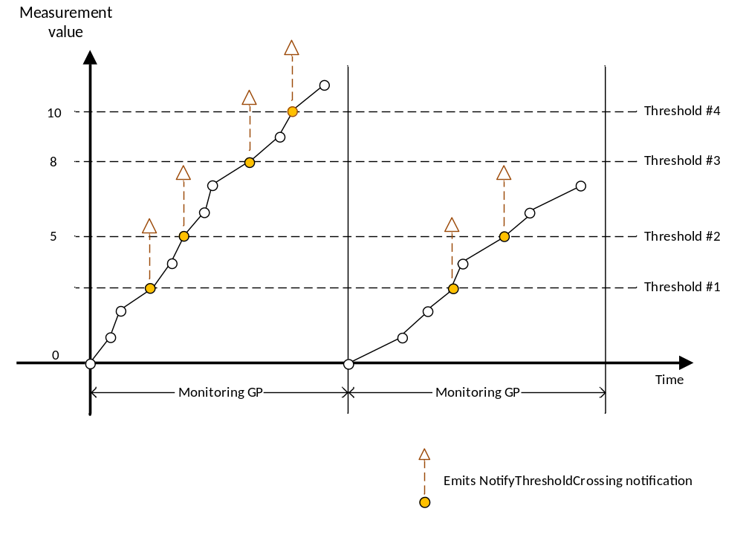
Figure F.1-1: Threshold crossing notifications triggering for cumulative counters

F.2 Threshold crossing notifications triggering for measurements that are not cumulative counters
For the threshold monitoring of performance measurements that are not cumulative counters, the notification notifyThresholdCrossing is emitted at the end of the monitoring granularity period (GP) if the measurement value reached or crossed the threshold.
The threshold crossing notification event time field indicates the time during the Monitoring GP that the threshold was crossed.
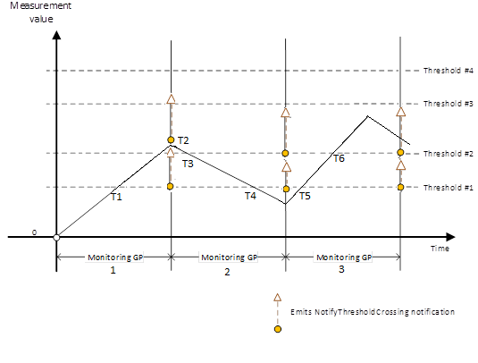
Figure F.2-1: Threshold crossing notifications triggering for measurements that are not cumulative counters
Thresholds configured in both directions would emit the following notifications:
Notifications are emitted for Threshold #1 (T1) and Threshold #2 (T2) at end of Monitoring GP 1.
Notifications are emitted for Threshold #2 (T3) and Threshold #1 (T4) at end of Monitoring GP 2.
Notifications are emitted for Threshold #1 (T5) and Threshold #2 (T6) at end of Monitoring GP 3.

Annex G (normative):
ASN.1 definition for performance data stream units

G.1 ASN.1 definition rule
For performance data streaming, the type of WebSocket Data frame shall be binary (with opcode of 0x2).
This clause specifies the abstract syntax notation one (ASN.1) definition for the Performance Data Stream Units (see Annex C) as Payload data of WebSocket Data frame.
The Performance Data Stream Units are described using ASN.1 as specified in ITU-T Rec. X.680 [15] and X.681 [16]. Transfer syntax for Performance Data Stream Units is derived from their ASN.1 definitions by use of Packed Encoding Rules (PER), aligned as specified in ITU-T Rec. X.691 [17].
The following encoding rules apply in addition to what has been specified in ITU-T Rec. X.691 [17]:
- When a bit string value is placed in a bit-field as specified in clause 15.6 to 15.11 in ITU-T Rec X.691 [c], the leading bit of the bit string value shall be placed in the leading bit of the bit-field, and the trailing bit of the bit string value shall be placed in the trailing bit of the bit-field;
- When decoding a BIT STRING or OCTET STRING constrained with a Contents Constraint, PER decoders are required to never report an error if there are extraneous zero or non-zero bits at the end of the BIT STRING or OCTET STRING.
NOTE: The terms 'leading bit' and 'trailing bit' are defined in ITU-T Rec. X.680 [15]. When using the 'bstring' notation, the leading bit of the bit string value is on the left, and the trailing bit of the bit string value is on the right.

G.2 ASN.1 definition
-- ASN1START
PerformanceDataStreamUnits-Schema DEFINITIONS AUTOMATIC TAGS ::=
BEGIN
-- PDSUs-START

PDSUs ::= SEQUENCE OF PDSU

PDSU ::= SEQUENCE {
streamId INTEGER,
granularityPeriodEndTime DATE-TIME,
standardizedMeasResults SEQUENCE OF MeasValue,
vendorSpecificMeasResults SEQUENCE OF MeasValue OPTIONAL -- may be omitted
}

MeasValue ::= CHOICE {
integerValue INTEGER,
realValue REAL,
stringValue VisibleString,
subCounters SubCounterListType,
... -- allow extension in futher version
}

-- uses recursion for the value to support multi-dimensional measurements
SubCounterListType ::= SEQUENCE {
subCounterIndex SubCounterIndexType,
subCounterValue MeasValue OPTIONAL -- "empty" bins are allowed
}

SubCounterIndexType ::= CHOICE {
sum VisibleString ("SUM"),
binIndex INTEGER,
qOS-5QI INTEGER,
qOS-QCI INTEGER,
cause INTEGER,
stringIndex VisibleString,
plMN OCTET STRING (SIZE(3)), -- definition from TS 38.413
sNSSAI SEQUENCE { -- definition from TS 38.413
sst OCTET STRING (SIZE(1)),
sd OCTET STRING (SIZE(3))
},
... -- allow extension in futher version
}

-- PDSUs-STOP
END
-- ASN1STOP

Annex H (normative):
NSI and NSSI performance assurance

H.1 General
After network slice instance is created, 3GPP management system creates all resources to the NSI and configurations satisfy the network slice requirements, including the performance of NSI requested according to network slice SLS (as part of SLA). In order to guarantee the performance of network slice, NSI modification can be triggered by NSI provisioning service. During the NSI performance supervision, the end to end KPIs defined in TS 28.554 [21], performance measurements defined in TS 28.552[2] and optionally slice QoE provided by NWDAF in 3GPP TS 23.288 [22] should be used for SLA fulfilment evaluation. According to the evaluation result, NSI modification defined in TS 28.531[24] can be triggered for network slice performance assurance.

H.2 Procedure of NSI and NSSI performance assurance
This Figure H.2-1 illustrates the procedure of performance assurance for NSI(s) or NSSI(s).
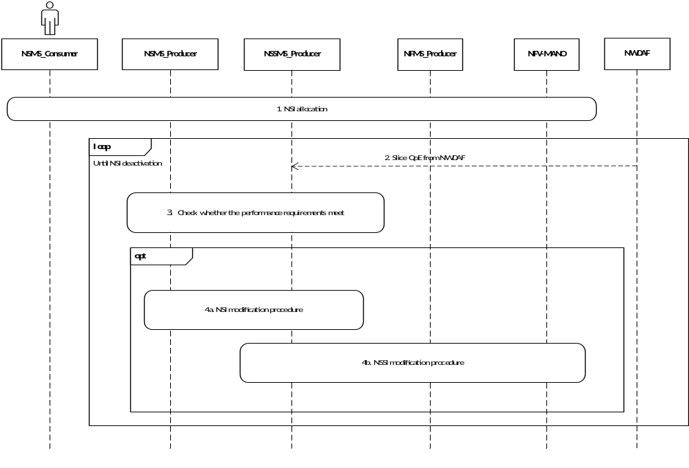
Figure H.2-1: Example of procedure for NSI and NSSI performance assurance
1. The authorized consumer requests NSMS_Producer to allocate a new NSI. NSMS_Producer consumes provisioning services provided by NSSMS_Producer to create the NSI. After NSI allocation, the NSMS_Producer and NSSMS_Producer perform NSI and NSSI performance supervision.
2. The NSMS_Producer or NSSMS_Producer may get slice QoE analytics provided by NWDAF.
3. The NSMS_Producer or NSSMS_Producer checks whether the performance requirements can be met by NSI or NSSI by utilizing the end to end KPIs defined in TS 28.554 [21], performance measurements defined in TS 28.552[2] and slice QoE analytics provided by NWDAF in 3GPP TS 23.288 [22].
4a. If the performance requirements of NSI cannot be met, the NSMS_Producer triggers the NSI modification procedure. NSMS_Producer modifies the capacity of the network slice, or modifies the network slice configuration to guarantee the performance requirements.
4b. If the performance requirements of NSSI cannot be met, the NSSMS_Producer of CN modifies virtualized resources and the configuration of 5GC NFs to guarantee the performance requirements. NSSMS_Producer of AN reconfigures RRMPolicy to optimize performance.

Annex I (normative):
GPB schema for performance data stream units

I.1 Performance Data Stream Units (GPB) schema
Normative GPB schema for Performance Data Stream Units (see Annex C).
syntax = "proto3";

import "google/protobuf/timestamp.proto";

message PDSUs {
message PDSUType {
message SubCounterIndexType {
oneof type {
string sum = 1;
int32 bin_index = 2;
int32 qOS_5QI = 3;
int32 qOS_QCI = 4;
int32 cause = 5;
string string_index = 6;
bytes plmn = 7;
SNSSAI snssai = 8;
}

message SNSSAI {
bytes sst = 1;
bytes sd = 2;
}
}

message MeasValue {
oneof meas_value_type {
int64 integer_value = 1;
double real_value = 2;
string string_value = 3;
SubCounterListType sub_counters = 4;
}
}

// uses recursion for the value to support multi-dimensional measurements
message SubCounterListType {
SubCounterIndexType sub_counter_index = 1;
optional MeasValue sub_counter_value = 2;
}

int64 stream_id = 1;
google.protobuf.Timestamp granularity_period_end_time = 2;
repeated MeasValue standardized_meas_results = 3;
repeated MeasValue vendor_specific_meas_results = 4; // may be omitted
}

repeated PDSUType pdsu = 1;
}

Annex J (Informative):
Example of ASN.1 Streaming of PMs
This annex provides an example for ASN.1 schema for Performance Data Stream Units.
PDSUs ::= {
PDSU {
{
streamId ::= 123123,
granularityPeriodEndTime ::= 20230301141430,
standardizedMeasResults {
{
integerValue ::= 2322
},
{
realValue ::= 3.1416
},
{
stringValue ::= "This is example String"
},
{
subCounters {
{
subCounterIndex {
{
binIndex ::= 1
}
},
subCounterValue {
{
integerValue ::= 5441
}
}
}
}
}
}
},
{
streamId ::= 122323,
granularityPeriodEndTime ::= 20230301181130,
standardizedMeasResults {
{
integerValue ::= 1122
},
{
realValue ::= 55.336
},
{
stringValue ::= "This is example String"
},
{
subCounters {
{
subCounterIndex {
{
qOS-5QI ::= 3
}
}
}
}
}
}
}
}
}

Annex K (informative):
Change history
Change history
Date | Meeting | TDoc | CR | Rev | Cat | Subject/Comment | New version
2019-03 | SA#83 | SP-190122 | 0003 | 1 | F | Add the missing RESTFul API definitions | 15.1.0
2019-03 | SA#83 | SP-190122 | 0007 | 1 | F | Correction on MDAS | 15.1.0
2019-03 | SA#83 | SP-190111 | 0004 | 1 | B | Add operations for performance data streaming | 16.0.0
2019-06 | SA#84 | SP-190371 | 0008 | 1 | B | Add performance threshold monitoring service | 16.1.0
2019-09 | SA#85 | SP-190748 | 0009 | 3 | A | Add the missing stage 3 solutions for performance data streaming | 16.2.0
2019-09 | SA#85 | SP-190746 | 0010 | - | F | Correction on StreamInfoList | 16.2.0
2019-09 | SA#85 | SP-190748 | 0012 | - | A | Correction on performance data file reporting service components | 16.2.0
2019-09 | SA#85 | SP-190746 | 0013 | - | F | Correction on performance data streaming service components | 16.2.0
2019-09 | SA#85 | SP-190748 | 0016 | 1 | A | Remove the PM file format | 16.2.0
2019-09 | SA#85 | SP-190746 | 0027 | 1 | B | NSI and NSSI performance assurance | 16.2.0
2019-09 | SA#85 | SP-190746 | 0028 | 1 | B | Add use case for NSI performance threshold monitoring | 16.2.0
2019-09 | SA#85 | SP-190746 | 0029 | 1 | B | Add use case for NSSI performance threshold monitoring | 16.2.0
2019-12 | SA#86 | SP-191171 | 0030 | 1 | B | Add performance management service enhancement for tenant support | 16.3.0
2019-12 | SA#86 | SP-191174 | 0033 | 2 | A | Add stream information management related operations | 16.3.0
2019-12 | SA#86 | SP-191150 | 0034 | 4 | B | Add UC and requirements for KPI job control | 16.3.0
2019-12 | SA#86 | SP-191150 | 0038 | 1 | B | Add management service responsible for KPI job control | 16.3.0
2019-12 | SA#86 | SP-191150 | 0039 | - | F | Update the description of scope | 16.3.0
2019-12 | SA#86 | SP-191150 | 0042 | 1 | B | Enhace performance data report related operations to support KPI reporting | 16.3.0
2020-03 | SA#87E | SP-200181 | 0044 | 1 | A | Update the peformance data streaming procedure | 16.4.0
2020-03 | SA#87E | SP-200181 | 0046 | 1 | A | Add streaming procedure for measurement collection termination | 16.4.0
2020-07 | SA#88-E | SP-200497 | 0052 | 4 | B | Clarify performance measurement for a tenant | 16.5.0
2020-07 | SA#88-E | SP-200484 | 0054 | - | F | Correct Typos of Reference | 16.5.0
2020-07 | SA#88-E | SP-200492 | 0056 | 1 | A | Add description for MnS components used for configurable performance measurement control | 16.5.0
2020-07 | SA#88-E | SP-200497 | 0057 | 1 | B | Add use case for performance management supporting multiple tenant | 16.5.0
2020-07 | SA#88-E | SP-200485 | 0058 | - | C | Convert performance measurement job control API to YAML | 16.5.0
2020-09 | SA#89E | SP-200738 | 0059 | - | F | Update description of MnS components used for configurable PM control | 16.6.0
2020-09 | SA#89E | SP-200724 | 0061 | - | F | Correction of performance data streaming sequence flow | 16.6.0
2020-09 | SA#89E | SP-200731 | 0063 | - | A | Remove the streaming solution from 28.550 | 16.6.0
2020-12 | SA#90e | SP-201057 | 0064 | - | F | Clarification on emission of threshold crossing notifications for non-cumulative counters | 16.7.0
2020-12 | SA#90e | SP-201088 | 0065 | - | F | Update attribute measType used in Annex C | 16.7.0
2021-09 | SA#93e | SP-210880 | 0068 | 1 | A | Correction of OpenAPI | 16.8.0
2022-03 | - | - | - | - | - | Update to Rel-17 version (MCC) | 17.0.0
2022-06 | SA#96 | SP-220498 | 0070 | - | A | OpenAPI file name and dependence change | 17.1.0
2022-09 | SA#97e | SP-220862 | 0074 | 1 | B | GPB schema introduction for PM streaming | 18.0.0
2023-03 | SA#99 | SP-230209 | 0077 | 1 | B | Example of ASN.1 schema for Streaming of PMs | 18.1.0

