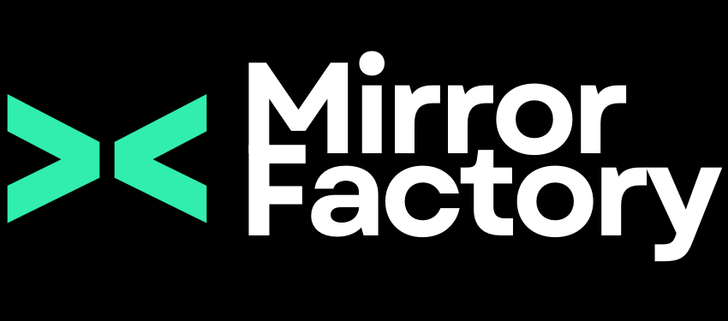

BlueWave Resource Partners x Mirror Factory
Swell — Product Engagement Proposal

Prepared by: Mirror Factory
Prepared for: BlueWave Resource Partners
Date: April 7, 2026
Revision: 0

1. Swell (The BlueWave AI Platform)
Mirror Factory proposes a phased product development engagement to design, build, and pilot Swell: a proprietary AI-powered call triage and candidate intelligence system for BlueWave Resource Partners.
Swell answers a simple question: what if every call to BlueWave’s main number was answered instantly, routed intelligently, and produced a contextual record that made the next human interaction better?
The system has two core components.
Inbound call triage: an AI receptionist answers calls, determines intent through natural conversation, and routes callers to the right department. When a candidate calls, the system transitions to a recruiter agent that leads a pre-screening conversation, evaluates the candidate, and writes structured data directly to Bullhorn. Every call generates a progressive ticket that fills with context as the conversation unfolds.
Outbound candidate screening: when BlueWave receives a new job requisition, Swell screens hundreds of candidates simultaneously against the real qualifying criteria and delivers a qualified shortlist within one hour.
Swell integrates directly with BlueWave’s existing systems: Bullhorn, RingCentral, and Slack. No data leaves your ecosystem. BlueWave owns all custom-built Swell IP outright, including full source code and documentation, with no vendor lock-in.
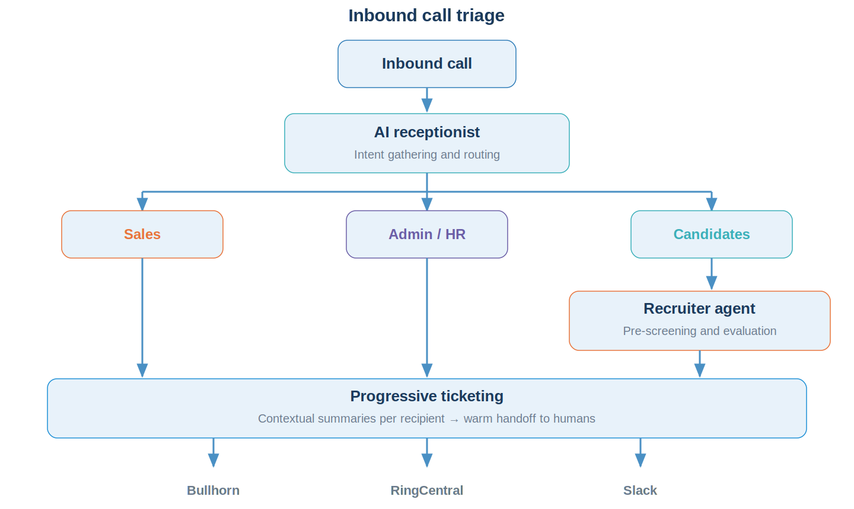
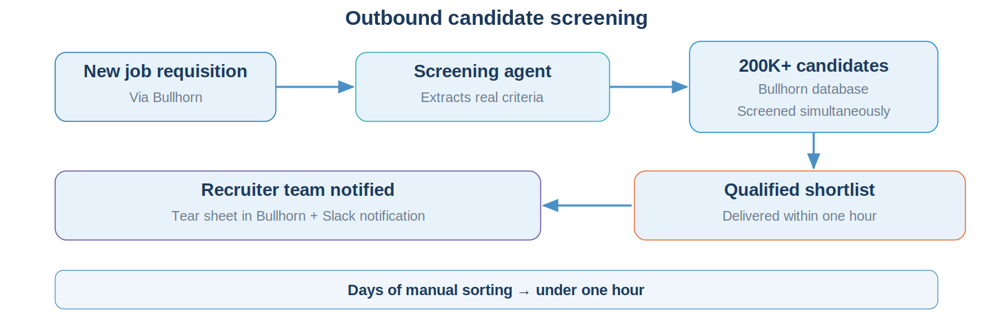

2. Goals and Success Criteria
- Eliminate low-value inbound call handling. Calls are triaged by an AI receptionist and routed to the right person or resolved without human intervention.
- Pre-screen candidates before human follow-up. A recruiter agent captures structured evaluation data and writes it to Bullhorn, so recruiters start with context.
- Create a native ticketing system. Every call generates a progressive ticket with contextual summaries tailored to the recipient.
- Establish BlueWave-owned software IP. Swell is a separable asset owned entirely by BlueWave.
- Validate through a controlled pilot. A 90-day internal pilot with progressive delegation, expanding as confidence builds.

3. Engagement Plan

Phase 1: Design, Discovery, and Prototyping (4 to 6 weeks)
Mirror Factory embeds into BlueWave’s operational environment. We observe real workflows, work with real Bullhorn data, and iterate rapidly through design and prototyping cycles: direct observation, iterative design sessions with key stakeholders, working prototypes against real call scenarios, and hands-on validation.
- Immersive discovery. Map call routing logic across Sales, Admin/HR, and Candidate paths. Document messaging SOPs. Confirm Bullhorn and RingCentral API capabilities.
- Agent architecture and prototyping. Build the AI receptionist and recruiter agent. Establish context profiles, guardrails, and escalation rules.
- Integration development. Connect to Bullhorn (read/write candidate records, tear sheets) and RingCentral (inbound call routing). Set up Slack notifications.
- Ticketing system. Progressive ticket creation, repeat caller merging, and contextual handoff summaries.
- Pilot preparation. Define the testing strategy, success metrics, and Phase 2 milestones.

Phase 2: Development, Pilot, and Consulting (~90 days)
Continued development of both inbound and outbound systems alongside a live internal pilot. Weekly consulting with your team throughout.
- Internal pilot. Launch inbound triage for live calls with progressive delegation, starting with low-stakes call types.
- Continued development and QA. Refine agent behavior based on real-world performance. Execute QA with human callers and scripted simulations.
- Outbound screening development. Requisition ingestion, candidate matching, and shortlist generation designed in parallel with inbound pilot.
- Consulting and support. Weekly reviews, agent performance reporting, error flagging, and team training on the audit interface.

Phase 3: Expansion and Productization (future, not priced)
Full activation of outbound screening, where the system contacts hundreds of candidates simultaneously and delivers a qualified shortlist within one hour. Evaluation of packaging Swell 1.0 for licensing to other staffing firms. Design of additional AI tools for sales, compliance, and business development. Implementation of system learning so agents improve from placement outcomes and recruiter feedback. Phase 3 is where the initial investment compounds: the system built for BlueWave becomes a product that generates value independently.

4. Budget and Schedule
Phase | Timeline | Investment
Phase 1: Design, Discovery, and Prototyping | 4 to 6 weeks | $20,000
Phase 2: Development, Pilot, and Consulting | ~90 days | $120,000 to $180,000
Phase 3: Expansion and Productization | Q4 2026 (tentative) | Scoped separately
Phase 1 is a fixed-price engagement. Phase 2 is a directional estimate that will be refined into a detailed scope before work begins. The range reflects variability in development scope, QA approach, integration complexity, and the pace of progressive delegation.

Milestones
Phase | Target Dates | Key Milestones
Phase 1 | Mid-April to late May 2026 | Kickoff design session (Wk 1). Integration confirmed (Wk 2–3). Prototype demo (Wk 4–5). Phase 2 plan (Wk 5–6).
Phase 2 | June to August 2026 | Low-stakes launch (Mo 1). Candidate screening expansion (Mo 2). Pilot review and go/no-go (Mo 3).
Phase 3 | Q4 2026 (tentative) | Outbound screening. Productization evaluation. Additional AI tools.
Timeline, budget, and milestones are subject to change based on the final agreed-upon timeline and scope of work.

