

BlueWave Resource Partners x Mirror Factory
Swell — Engagement Proposal

Prepared by: Mirror Factory
Prepared for: BlueWave Leadership Team
Date: April 7, 2026
Revision: 0

1. Swell
Mirror Factory proposes a phased engagement to design, build, and pilot Swell: a proprietary AI-powered call triage and candidate intelligence system for BlueWave Resource Partners. Swell answers a simple question: what if every call to BlueWave’s main number was answered instantly, routed intelligently, and produced a contextual record that made the next human interaction better?

Inbound call triage
An AI receptionist answers every call, determines the caller’s intent through natural conversation, and routes them to the right department or agent. No phone trees, no hold music, no wasted time. When a candidate calls, the system transitions seamlessly to a recruiter agent that leads a pre-screening conversation, evaluates the candidate against qualifying criteria, and writes structured data directly to Bullhorn. Every call generates a progressive ticket that fills with context as the conversation unfolds. When a human picks up, they already know what’s going on.
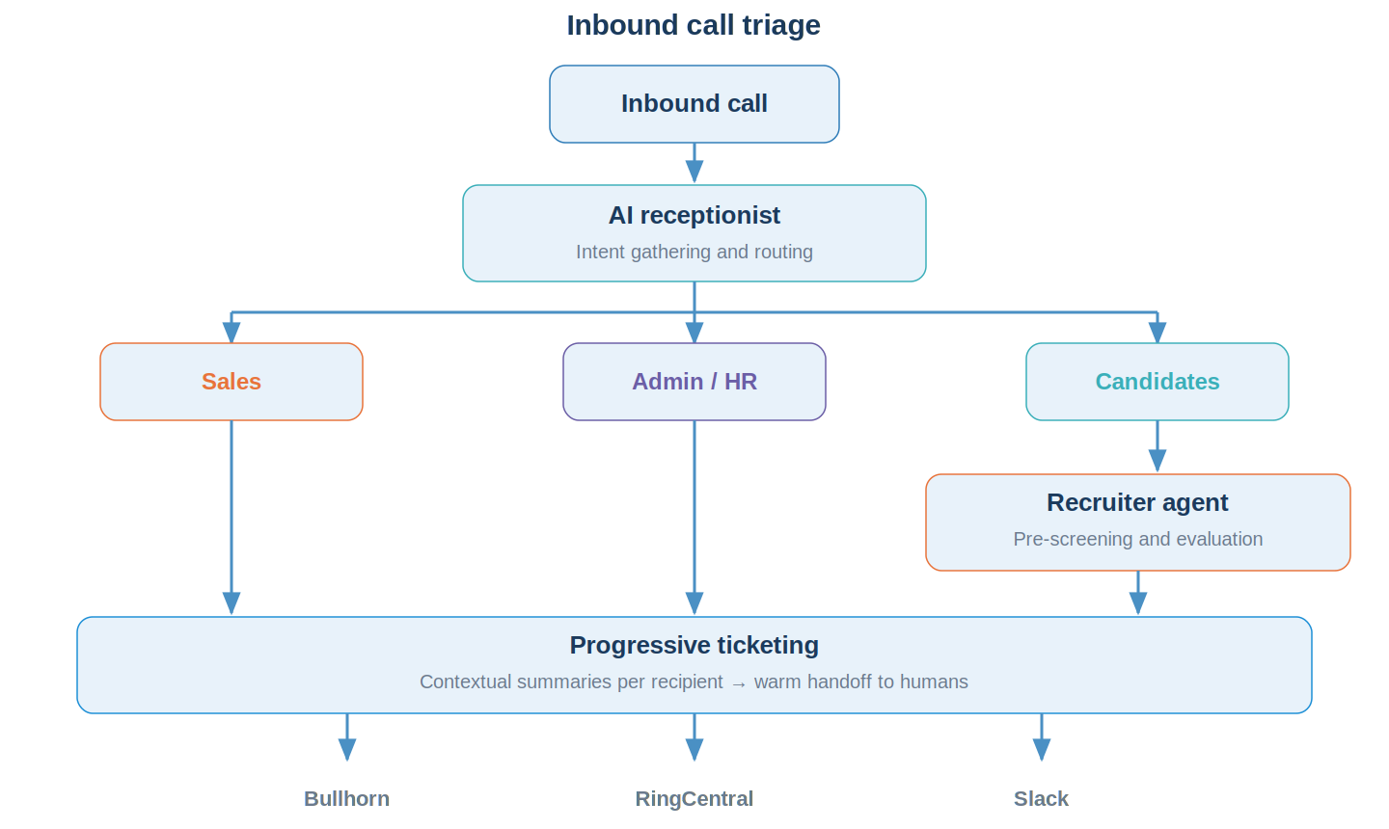

Outbound candidate screening
When BlueWave receives a new job requisition, Swell screens hundreds of candidates simultaneously against the real qualifying criteria and delivers a qualified shortlist within one hour. This compresses what currently takes days of manual sorting through databases, resumes, and LinkedIn profiles into minutes of intelligent, automated screening. The recruiting team gets a Slack notification and a Bullhorn tear sheet, ready to start calling qualified, interested people.
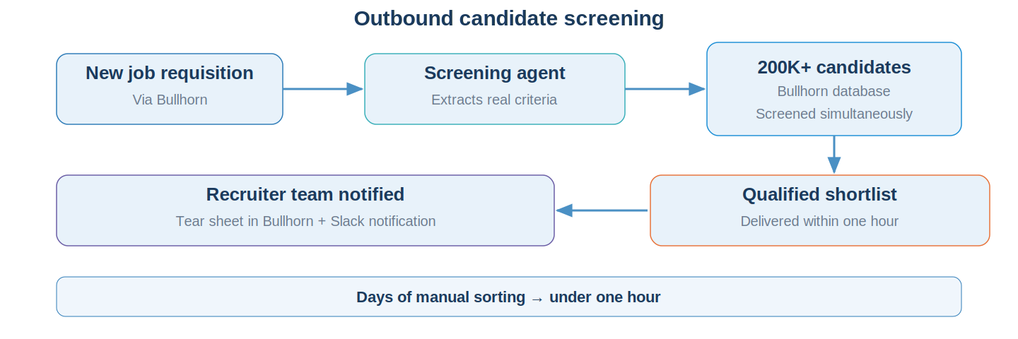

Integration and ownership
Swell integrates directly with BlueWave’s existing systems: Bullhorn for candidate data (200,000+ records), RingCentral for telephony, and Slack for internal notifications. No data leaves your ecosystem. The system is designed for a private, closed-loop deployment. BlueWave owns all custom-built Swell IP outright, including full source code and documentation, with no vendor lock-in. Mirror Factory’s platform tools are licensed to BlueWave with a perpetual, irrevocable license.

2. Goals and Success Criteria
These are the measurable outcomes that define success for this engagement.
- Eliminate low-value inbound call handling. Calls to BlueWave’s main number are triaged by an AI receptionist and routed to the right person or resolved without human intervention. Self-service tasks like ADP password resets and status checks are handled by the agent directly.
- Pre-screen candidates before human follow-up. A recruiter agent captures structured evaluation data (3 to 5 qualifying criteria, availability, compensation expectations) and writes it to Bullhorn, so human recruiters start every conversation with context instead of a cold call.
- Compress time-to-qualified-shortlist. Reduce the cycle from receiving a new job requisition to having a contacted, qualified candidate shortlist from days of manual sorting to under one hour through automated outbound screening.
- Build a native ticketing and context system. Every call generates a progressive ticket with contextual summaries tailored to the recipient. Repeat callers are automatically merged. Warm handoffs happen with full context, not a transcript dump.
- Establish BlueWave-owned software IP. Swell is architected as a separable asset owned entirely by BlueWave, with no vendor lock-in, increasing company value as a standalone technology asset.
- Validate through a controlled pilot. A 90-day internal pilot with progressive delegation: start with low-stakes call types, expand as confidence builds, and end with a clear go/no-go decision for broader deployment.

3. The Business Case
Three value dimensions justify this investment: operational efficiency, revenue capacity, and competitive positioning.

Recruiter productivity
BlueWave’s 18 to 20 recruiters currently spend 75 to 80% of their time on unqualified candidates. At a conservative fully-loaded cost of $50,000 per recruiter, that represents $675,000 to $750,000 per year in labor allocated to low-yield screening. Industry benchmarks confirm this pattern: staffing agencies using AI report 23% higher placement rates alongside lower costs, and AI screening cuts time-to-shortlist by 75%. Swell is designed to invert this ratio so recruiters spend the majority of their time on qualified, interested candidates rather than sorting through databases.

Revenue capacity without headcount growth
BlueWave’s team is at capacity. Growing placement volume today requires hiring more recruiters. Swell changes that equation. If each recruiter can intelligently manage 5,000 to 10,000 candidates instead of approximately 1,000, the team’s capacity to handle requisitions grows without proportional headcount. Staffing firms using AI voice screening report 10x candidate reach and 60% reduction in recruiter phone time without adding headcount. Industry data shows that automation saving each recruiter four hours per week recovers over $5,000 in productive capacity every month for a team of eight recruiters. BlueWave has more than twice that many. Even a conservative 2x increase in placement capacity at BlueWave’s revenue scale represents significant incremental revenue without additional salary expense.

Competitive positioning
BlueWave evaluated RingCentral AIR, Bullhorn Amplify, Tenzo AI, and several third-party staffing tools. None solve the full problem: multi-caller-type inbound triage with deep Bullhorn integration, combined with outbound screening at scale. The market gap validates the custom-build approach. The staffing agencies that thrive in 2026 will not be the ones with the most recruiters, but the ones whose recruiters are augmented by AI that handles screening, scheduling, and outreach, freeing humans to focus on relationships and closing.
Building Swell as proprietary software rather than subscribing to a third-party platform means BlueWave owns the asset. It appears on the balance sheet, it can be demonstrated to potential acquirers, and it can be evaluated for licensing to other staffing firms. No existing product handles this full problem, which means Swell has no direct off-the-shelf equivalent.

What comparable tools cost
For context, comparable SaaS solutions in the staffing vertical command significant annual investment. Medium-tier recruiting platforms cost $100 to $200 per user per month, and enterprise-grade AI platforms with custom integrations range from $25,000 to $150,000 in implementation costs alone in year one, plus ongoing subscription fees. BlueWave’s investment in Swell produces a system it owns outright: no recurring subscription that appreciates for someone else, no data locked in a vendor’s ecosystem, and no dependency on a third party’s product roadmap.

4. How Swell Works
This section describes the system’s inner workings: the AI agents that power it, the voice experience callers interact with, the ticketing system that captures context, and the tools your team uses to audit and improve it over time.

4.1 AI agent architecture
Swell is powered by three AI agents, each with a single, clear responsibility.
Receptionist agent. Answers every inbound call with a branded introduction, gathers intent through open-ended conversation, and routes the caller to the correct path: Sales, Admin/HR, or Candidates. The Receptionist can also resolve simple requests directly, like providing ADP password reset instructions or answering benefits questions from a knowledge base. When the Receptionist encounters uncertainty, the default is to escalate to a human with full context, not to guess.
Recruiter agent. Activates when the Receptionist identifies a candidate. The Recruiter leads a structured pre-screening conversation: it drives the discussion, evaluates the candidate against 3 to 5 qualifying criteria defined per job type, captures structured output (candidate profile, evaluation scores, call summary), and writes everything to Bullhorn. The candidate experiences a seamless conversation, not a transfer. Context gathered by the Receptionist is passed forward so screening starts with information, not from scratch.
Screening agent (outbound). Triggered when a new job requisition enters Bullhorn. The Screening Agent ingests the job description, extracts the real qualifying criteria (stripping out boilerplate), searches BlueWave’s 200,000+ candidate database, and initiates simultaneous outreach via phone, text, and email. Candidate responses are evaluated against the screening rubric, scored, and compiled into a qualified shortlist pushed to a Bullhorn tear sheet.

4.2 Voice experience
The external voice experience is the primary interface for all inbound callers. It must feel natural, professional, and human-like. Callers should not feel like they are navigating a phone tree or talking to a robot. Conversations are open-ended and adaptive: the agent handles natural patterns like interruptions, corrections, pauses, and topic changes.
The voice pipeline targets under 800 milliseconds of total latency (speech-to-text, LLM inference, and text-to-speech combined) to maintain a natural conversational feel. Voice model selection (cloud services like ElevenLabs, AWS Bedrock, or local models like Gemma 26B+) will be resolved during Phase 1 based on security requirements, latency testing, and cost analysis.

4.3 Progressive ticketing system
Every inbound call instantly creates a blank ticket that fills progressively as the conversation unfolds. This is not a raw transcript. It is a structured, contextual record that includes caller ID, intent classification, routing decision, conversation summary, evaluation data (if applicable), resolution status, and a full action trace of every agent decision.
When the same person calls again, tickets are automatically merged by phone number, name match, or Bullhorn candidate ID. Prior context surfaces immediately: the agent knows this is Fraser’s sixth call about the Disney electrical engineer position. When a call routes to a human, the ticket provides a summary tailored to the recipient: recruiters get candidate-fit summaries, admin gets resolution context, and leadership gets escalation context.

4.4 Internal messaging bus
A central routing layer delivers agent notifications, ticket summaries, and escalation alerts to the right person in the right channel. The system routes across text (SMS), Slack, and email based on BlueWave’s internal SOPs: who gets what message type, department-specific rules, and urgency tiers. Routing rules are configurable without code changes. Each message includes contextual information from the relevant ticket, and recipients can act directly from the notification (for example, clicking through to the relevant Bullhorn record).

4.5 Audit and feedback interface
Every agent action is logged and traceable. The BlueWave team can review agent behavior through a CMS-level simple interface: review the past week’s interactions, see the full decision path for any call, flag incorrect actions, and provide corrections that are incorporated into the agent’s context. The system tracks correction history to identify recurring error patterns. Think of it like managing a team of interns: clear instructions, controlled environment, regular audits, and continuous improvement through feedback loops.

5. Engagement Plan
The engagement is structured in three phases. The first two are priced in this proposal. The third is outlined for planning purposes and will be scoped based on Phase 2 outcomes.

Phase 1: Design, discovery, and prototyping (4 to 6 weeks)
Mirror Factory embeds into BlueWave’s operational environment. We observe real workflows, work with real Bullhorn data, and iterate rapidly through design and prototyping cycles. This follows a human-centered design process: understand your team’s daily reality through direct observation and collaboration, define routing and screening logic through iterative design sessions with key stakeholders, prototype working agent systems against real call scenarios, and validate through hands-on testing.
- Immersive discovery and requirements gathering. Embed with BlueWave’s team to observe and map call routing logic across Sales, Admin/HR, and Candidate paths. Document messaging SOPs and escalation rules through direct collaboration. Confirm Bullhorn and RingCentral API capabilities (read/write on candidate records, tear sheets, job requisitions).
- Agent architecture and prototyping. Design and build the AI receptionist agent (intent gathering, routing, self-service resolution) and recruiter agent (pre-screening conversation, rubric evaluation, structured output). Establish agent context profiles, guardrails (what agents should never do), and escalation rules.
- Integration development. Connect to Bullhorn for reading and writing candidate records, tear sheets, and job requisitions. Connect to RingCentral for inbound call routing to the AI receptionist. Set up Slack notifications for the internal messaging bus.
- Ticketing system design and build. Build the native ticketing system: progressive ticket creation on call connect, automatic repeat caller merging, and contextual handoff summaries tailored per recipient role.
- QA plan and pilot preparation. Define the testing strategy (human callers, TTS simulation, or hybrid), establish success metrics and KPIs, and define Phase 2 milestones. Prepare the system for internal pilot deployment. Resolve deployment model (cloud, local, or hybrid) based on security and cost evaluation.

Phase 2: Development, pilot, and consulting (approximately 90 days)
Continued development of both inbound and outbound systems alongside a live internal pilot. Mirror Factory provides weekly consulting throughout, with monthly formal reviews on agent performance, error rates, and system improvements.
- Internal pilot deployment. Launch inbound triage for live calls with progressive delegation. Start with low-stakes call types (Admin/HR routing, self-service requests) before expanding to candidate pre-screening. Monthly goals and expansion gates.
- Continued inbound development and QA. Refine agent behavior based on real-world performance data. Execute the QA plan using the hybrid approach defined in Phase 1. Test edge cases: unclear intent, caller frustration, immediate human requests, repeat callers, background noise, speakerphone. Validate voice quality across real-world conditions.
- Outbound screening development. Architecture and development of the outbound candidate screening system: requisition ingestion, criteria extraction, Bullhorn database matching, simultaneous candidate outreach, and shortlist compilation. Designed in parallel with the inbound pilot.
- Consulting, support, and team training. Weekly reviews with the BlueWave team. Agent performance reporting and error flagging. Training your team on the audit interface and feedback workflow. Ongoing iteration on agent context, routing rules, and screening rubrics based on team input.
- 90-day pilot review. Formal review at the conclusion of the pilot covering agent performance against baseline metrics, corrections log analysis, system reliability, and recommendations for Phase 3. This review is the go/no-go gate for expansion.

Phase 3: Expansion and productization (future, not priced)
This is where Swell evolves from an internal tool into a scalable product and BlueWave’s competitive advantage compounds.
- Activate outbound candidate screening. Full deployment of the screening system. The system contacts hundreds of candidates simultaneously against a new job requisition and delivers a qualified, interested shortlist within one hour. Cost controls established for per-click sourcing tools (Indeed, Dice, ZipRecruiter) before enabling agent access.
- Evaluate productization. Assess packaging Swell 1.0 for licensing to other staffing firms. Architecture decisions around multi-tenancy, documentation standards, and portability made based on Phase 2 learnings.
- Design additional AI tools. Sales workflow automation, compliance tools, outbound business development, and shared inbox management. These are designed based on what your team surfaces during the Phase 2 pilot.
- Implement system learning. Agents improve automatically over time by learning from placement outcomes, response rates, screening question effectiveness, and recruiter feedback. Learning insights are surfaced in the audit interface for review.
- Expand channel coverage. Website chatbot integration, additional communication channels, and deeper workflow automation across BlueWave’s operations.

6. Testing and Quality Assurance
Voice-based AI systems present unique QA challenges. Unlike text-based software where automated testing can cover thousands of scenarios, voice requires either real human interaction or high-quality speech simulation. The external voice experience is the highest-risk surface: caller trust depends entirely on voice quality and conversational naturalness.

QA approach
We recommend a hybrid approach combining two methods. The exact mix depends on budget, which is a design input resolved during Phase 1.
- Hired human callers. External callers run scripted and adversarial scenarios against the system. Highest fidelity testing. Covers real-world variability: accents, background noise, interruptions, edge cases.
- TTS scripted simulation. Write call scripts and use text-to-speech to simulate callers at scale. Higher coverage than internal testing, lower fidelity than real humans. Effective for regression testing and known-scenario validation.
Both approaches are viable. A higher QA budget enables a robust human caller program plus TTS automation for regression, targeting 100+ scripted test calls before live deployment. A leaner budget leans TTS-heavy with targeted human testing for critical paths.

Pre-launch testing requirements
Before any live deployment, the following must be validated:
- All three routing paths (Sales, Admin/HR, Candidates) tested end-to-end.
- Recruiter agent screening validated against at least 3 job types.
- Edge cases tested: unclear intent, caller frustration, immediate human request, repeat callers, wrong numbers.
- Ticketing validated: creation, progressive fill, merging, and contextual summaries.
- Messaging bus validated: correct channel, correct person, correct urgency tier.
- Voice quality validated across environments: mobile, landline, speakerphone, background noise.

Success metrics
Formal success metrics will be defined during Phase 1 and serve as the evaluation criteria for the Phase 2 go/no-go gate. Candidate metrics include:
- Call resolution rate: percentage of calls resolved without human escalation.
- Time-to-qualified-shortlist: hours from requisition receipt to shortlist delivery (outbound screening).
- Recruiter hours saved per week.
- Ticket accuracy: percentage rated useful by the receiving team member.
- Error rate: percentage of calls requiring post-hoc correction.
- Candidate satisfaction signal: qualitative feedback from the recruiting team.

7. Budget and Schedule
Phase | Timeline | Investment
Phase 1: Design, Discovery, and Prototyping | 4 to 6 weeks | $20,000
Phase 2: Development, Pilot, and Consulting | ~90 days | $120,000 to $180,000
Phase 3: Expansion and Productization | Q4 2026 (tentative) | Scoped separately
Phase 1 is a fixed-price engagement covering immersive discovery, architecture, integration research, agent prototyping, and pilot planning. This phase produces a working prototype and a detailed plan for Phase 2. Payment: 50% at project kickoff ($10,000), 50% at Phase 1 completion ($10,000).
Phase 2 is a directional estimate that will be refined into a detailed scope before work begins. The range reflects variability in QA approach (human callers vs. automated simulation), integration complexity discovered during Phase 1, the pace of progressive delegation during the pilot, and the depth of outbound screening development. Phase 2 payment terms will be defined when Phase 2 is formally scoped; we anticipate monthly billing aligned to the 90-day pilot cadence.
Phase 3 will be scoped and priced separately based on Phase 2 outcomes and the productization decision.

Milestones
Phase | Target Dates | Key Milestones
Phase 1 | Mid-April to late May 2026 | Kickoff design session (Wk 1). Bullhorn/RingCentral integration confirmed (Wk 2 to 3). Working prototype demo (Wk 4 to 5). Phase 2 scope and QA plan delivered (Wk 5 to 6).
Phase 2 | June to August 2026 | Internal launch with low-stakes call types (Month 1). Progressive expansion to candidate screening (Month 2). Full pilot review, 90-day report, and go/no-go decision (Month 3).
Phase 3 | Q4 2026 (tentative) | Outbound screening activation. Productization evaluation. Additional AI tools. Scoped separately.
Timeline, budget, and milestones are subject to change based on the final agreed-upon timeline and scope of work.

8. IP and Licensing
Component | Owner
Swell: all custom-built software including routing logic, decision engine, ticketing system, screening rubrics, staffing integrations, messaging bus, and audit interface | BlueWave Resource Partners
Mirror Factory platform tools: context management infrastructure, agent framework, integration connectors, and authoring tools | Mirror Factory (perpetual, irrevocable license to BlueWave)
BlueWave owns all custom-built Swell IP outright, including full source code and documentation. Swell functions independently of Mirror Factory’s platform. BlueWave is not locked in and can substitute generic alternatives at any time. The license is perpetual and irrevocable.

9. About Mirror Factory
Mirror Factory is an AI-native design and development studio based in Orlando, specializing in building proprietary AI systems for organizations that want to own their technology, not subscribe to someone else’s. We focus on context management: helping teams design, build, and maintain the information infrastructure that makes AI agents effective, trustworthy, and improvable over time.
Our team brings over a decade of experience in software development, spanning virtual reality simulation, real-time systems, creative technology, and AI product design. We operate as a hybrid of consulting and platform: we design and build custom solutions while contributing reusable patterns and tools to our own platform, which benefits every client engagement.
For BlueWave, this means you get a team that understands both the technology and the operational context. We are not deploying a generic SaaS tool. We are embedding with your team, learning your workflows, and building a system that is yours.

Bobby Torres, Kyle Morrand, and Alfonso Morales
Founders, Mirror Factory

