5 GHz Bin 5 Test Signal Waveform
Figure 1: Graphical Representation of Bin 5 Test Signal Waveform
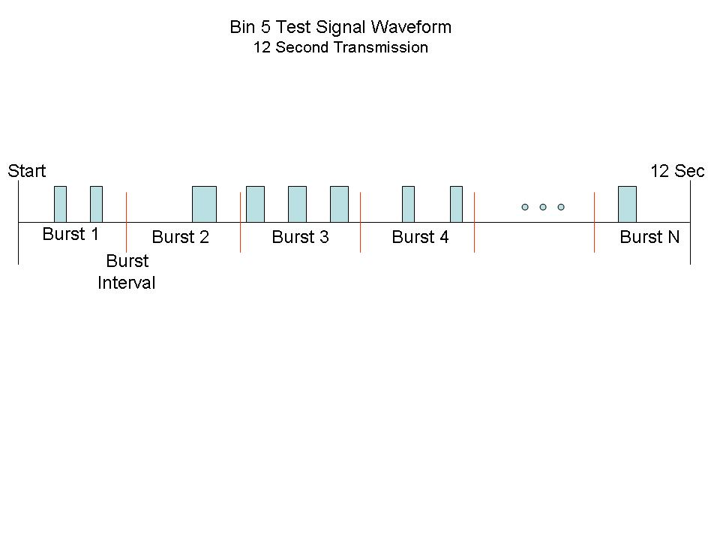

Generation of Bin 5 Test Signal Waveform:

- The Transmission period for the Bin 5 test signal will be 12 seconds.
- There will be a total of 8 to 20 pulse bursts in the 12 second period, with the number of bursts being randomly chosen.
- Each burst will consist of 1 to 3 pulses, with the number of pulses being randomly chosen. .
- Each pulse within a burst will have a linear FM of 5-20 MHz (each pulse within the burst will have the same amount of chirp). Each pulse burst within the 12 second sequence may have different chirp widths.
- Each pulse in a burst will be of the same randomly chosen length between 50 to 100 microseconds, with a minimum resolution of 5 microseconds.
- If more than one pulse is present in a burst, each space between the pulses will be a randomly chosen time of 1000 to 2000 microseconds, with a 1 microsecond minimum resolution.
- Each burst will then be placed at a random starting location within even intervals determined by:
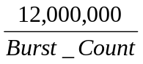

Pass/Fail
The test signal is transmitted once and must be successfully detected (1 out of 1).

A typical example of a bin 5 test waveform:
- The total test signal length is 12 seconds.
- 8 bursts are randomly generated for the burst_count.
- Burst 1 has 2 randomly generated pulses.
- The pulse length (for both pulses) is randomly selected to be 75 microseconds).
- The pulse spacing is randomly selected to be at 1213 microseconds.
Burst 2 through 8 would also be generated using step 2 – 4).
- Each burst will be contained in even intervals of 1,500,000 microseconds. The starting location for Pulse 1, Burst 1 is randomly generated (1 to 1,500,000 minus the lotal Burst 1 length) at the 325,001 microsecond step.
Burst 2 through 8 would randomly fall in successive 1,500,000 microsecond intervals (i.e. Burst 2 falls in the 1,500,001 – 3,000,000 microsecond range).

This waveform would be generated by the test lab and then transmitted at the device under test. Furthermore, each manufacturer will be tested with a unique waveform sequence and if a retest of the device is required a new waveform is generated for that test and all conformance tests must be re-done (bin 1-5 and frequency hopping test). In a compliance report all waveforms that were used in the tests will be reported regardless if the device passed or failed the test. The device under test must detect the test signal within the 12 seconds and move off of the channel under transmission within the time identified in the R&O to successfully pass the test.

