Description of DFS Test Systems and Procedures

Note: [Known open issues are indicated by brackets and red font.]

1. Introduction

This document describes acceptable instrument system configurations for performing Dynamic Frequency Selection (DFS) tests under FCC Part 15 Subpart E Rules. A complete test system consists of three subsystems: (1) the radar signal generating subsystem, (2) the DFS monitoring subsystem and (3) the traffic monitoring subsystem.

Preferred and alternate subsystems are described for the radar signal generating subsystem and the DFS monitoring subsystems. These two subsystems are independent such that the preferred subsystem for one function can be used with the alternate subsystem for the other function.

The traffic monitoring subsystem is specific to the type of equipment under test. Traffic monitoring systems are described for IP-based systems [and Frame-based systems].

The preferred subsystems were developed by the NTIA / ITS Laboratory located in Boulder, Colorado. ITS can provide schematics and a parts list to those who are interested in replicating the custom hardware devices. The custom software and data files that control this subsystem, that was developed by ITS, will be made available by NTIA to those who are interested in using it.

The alternate subsystems were developed by independent compliance testing laboratories Compliance Certification Services and Elliott Laboratories, in collaboration with WLAN manufacturers Atheros Communications, Broadcom Corporation and Cisco Systems.

The custom software used to generate simulated frequency hopping signals will be made available by CCS and Elliott to those who are interested in using it. [These software offers by CCS and Elliott are made with the provision that the NTIA accepts the alternate radar signal generating subsystems and the alternate DFS monitoring subsystem.]

Other instrument configurations may also meet the frequency hopping radar signal generator requirements and the DFS monitoring requirements, however any deviations from the subsystems described here must be submitted to the FCC OET for evaluation.

2. Radar Signal Generating Subsystems

Computer control is not necessary to generate the fixed frequency radar signals, however the frequency hopping signals by their nature require computer control. Both of the frequency hopping radar signal generating subsystems can also generate the required fixed frequency radar signals.

A manually operated fixed frequency radar signal generating sub system is described first, followed by descriptions of the computer controlled frequency hopping radar signal generating subsystems.

2.1 Fixed Frequency Radar Signal Generating Subsystem

The pulse generator is adjusted to the shortest rise and fall times. The pulse width, PRF, and number of pulses per burst are set according to the radar signal parameters. The pulse generator is triggered manually. The trigger output from the pulse generator can also be connected to the DFS monitoring subsystem as required to synchronize the two subsystems.

The Signal Generator is set to the channel center frequency and pulse modulation mode. The amplitude is adjusted to achieve the specified Interference Detection Threshold.

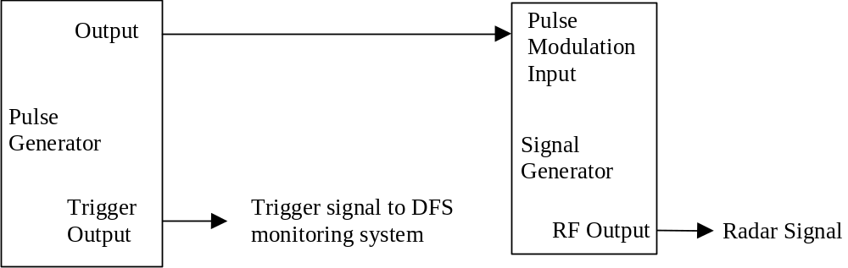

Figure 1. Fixed Frequency Radar Signal Generating Subsystem

2.2 Preferred Frequency Hopping Radar Signal Generating Subsystem

With the exception of the Frequency Doubler and the DFS Box, the test and measurement system uses off-the-shelf components with vendor-supplied software and customized software that was developed by ITS engineers.

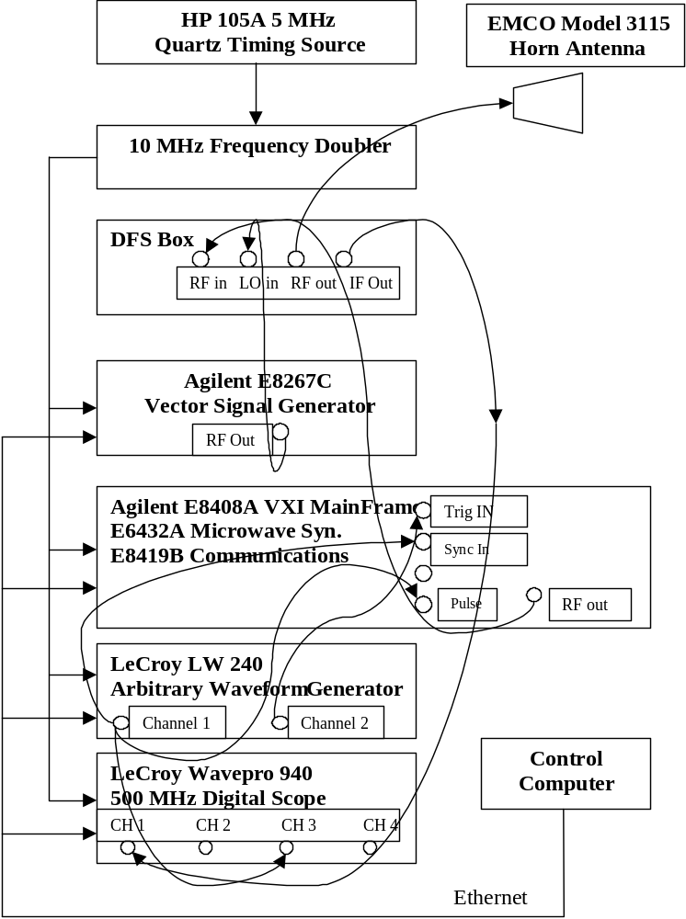
Figure 2. Preferred Frequency Hopping Radar Signal Generating Subsystem

HP 105A 5 MHz Quartz Timing Source

The HP105A is an accurate 5 MHz timing generator that is used as a timing reference source for input to the Frequency Doubler. This device does not require any programming.

10 MHz Frequency Doubler

The Frequency Doubler takes the 5 MHz source and doubles the clock frequency to 10 MHz. The 10 MHz timing source is then routed to all the test equipment to assure that all of the measuring devices and signal generators are synchronized from a common source. This device was constructed by engineers at ITS. However it was made from off-the-shelf components and is not difficult to manufacture. The Frequency Doubler box does not require any programming. ITS can provide schematics and a parts list to those who are interested in replicating this device.

DFS Box

The DFS Box was constructed by ITS engineers using off-the-shelf components. This device was made so that the RF output of the VXI mainframe could be mixed down so that the radar signal structures could be observed in a full 500 MHz bandwidth to verify that they have the correct timing and structure. This was especially important for observing the Frequency Hopping signal that hops across 475 MHz. The DFS box does not require any programming. ITS can provide schematics and a parts list to those who are interested in replicating this device.

[NTIA to add block diagram]

Agilent E8267C Vector Signal Generator (VSG)

The VSG is used as a signal source for the local oscillator (LO) input to the DFS box. The frequency of the VSG was set to 5225 MHz. The VSG does not require any special programming.

[NTIA to add information regarding special firmware/hardware for chirping]

Agilent E8408A VXI MainFrame
E6432A Microwave Synthesizer
E8419B Communications

The Agilent E8408A VXI mainframe with the Microwave Synthesizer and communications modules installed is the device that provides the RF pulses for the fixed frequency and frequency hopping signals. This device is a flexible tool that takes the outputs of the AWG into its Trigger and Synch inputs; is controlled with custom software; and generates the RF pulses at the correct frequency with the correct prf, pulse width, and number of pulses. The custom software that controls this device, that was developed by ITS, will be made available by NTIA to those who are interested in using it.

LeCroy LW 240 Arbitrary Waveform Generator (AWG)

The LeCroy LW240 is a dual channel AWG that provides the timing for the radar signals in baseband form. Both channels of the AWG are used to provide timing inputs to the VXI for RF pulse generation. The custom data files that are loaded into the AWG that generate the pulse timing characteristics were developed by ITS, and will be made available by NTIA to those who are interested in using it.

The AWG is used to start the DFS tests by the operator pressing a key that triggers all of the events. For the Fixed Frequency Tests, a trigger signal is sent to the DFS monitoring subsystem to begin data acquisition when the AWG burst Trigger is pressed. For the Frequency hopping tests, the trigger is sent to the DFS monitoring subsystem when a frequency that falls within the bandwidth of the EUT receiver detection bandwidth and within the DFS band is generated.

[How is such a frequency determined to be within the EUT receiver bandwidth?]

LeCroy Wavepro 940 500 MHz Digital Scope

The Lecroy digital Scope is used to examine the timing of the pulses and their structures in a full 500 MHz bandwidth. This is used to verify that they comply with the parameters as specified by the regulations. This device does not require any specialized software.

EMCO Model 3115 Horn Antenna

The EMCO horn is a calibrated 1-18 GHz antenna that is used to transmit the radar pulses to the DFS device for radiated tests. It is linearly polarized, and for radiated tests will be oriented to emit signals in the polarization that matches the polarization of the antennas associated with the EUT. For conducted tests, it is not used.

Notes on the test procedure when using the preferred frequency hopping subsystem:

[The detection bandwidth of the EUT and the number of hops that lie within the EUT detection bandwidth are required to determine the validity of the selected sequence.]

2.3 Alternate Simulated Frequency Hopping Radar Signal Generating Subsystem

The simulated frequency hopping signal generator system uses the same hardware that is used to manually generate fixed frequency radar signals, with the addition of a control computer and a burst generator to create the hopping trigger pulse pattern. The simulated signal generation approach produces both time-domain and frequency-domain simulations of an actual frequency hopping signal.

Conceptual Description of Simulated Frequency Hopping Generator

Time-domain simulation: The simulated hopping system generates the same number of hops, using identical pulse parameters, at the identical timing compared to the actual hopping signal, using a fixed frequency within the EUT detection bandwidth. Thus the detectable RF energy received by the EUT is identical in both instances.

Frequency-domain simulation: Multiple trials are made, each at a different fixed frequency. The frequencies selected for each trial lie within the EUT detection bandwidth. Thus the EUT receives RF energy throughout the detection bandwidth.

Figures 3 and 4 below show the comparison between an example frequency hopping signal (consisting of 3 pulses per hop) and the corresponding simulated hopping signal. The horizontal axis is time and the vertical axis is frequency.

Referring to the actual hopping signal, the hops that are outside the detection bandwidth are shown as three dots and the hops that are within the detection bandwidth are shown as three lines. The center of the lines indicate the frequency of the hop. Note that three hops fall within the EUT detection bandwidth.

Referring to the simulated hopping signal, the hops that are generated are shown as three lines. Note that three hops are generated, and each hop is at the same frequency.

Figure 3. Actual Frequency Hopping Radar
Total Hopping Span
Hopping Sequence Length
EUT Detection Bandwidth

Total Hopping Span
EUT Detection Bandwidth
Hopping Sequence Length

Figure 4. Simulated Frequency Hopping Radar

The simulated signal generator system is configured as follows:
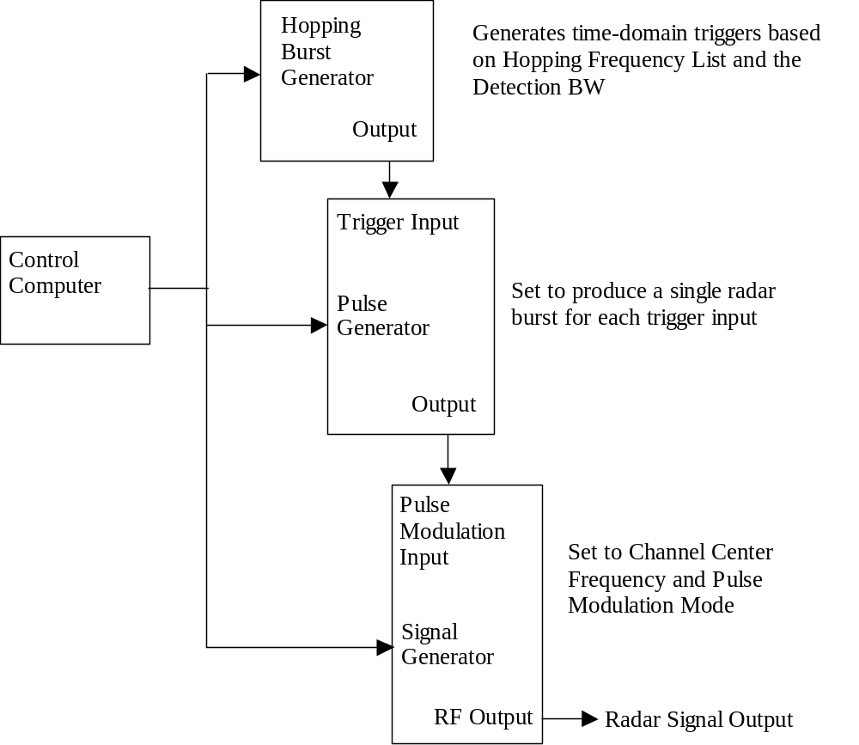

Figure 5. Simulated Frequency Hopping Radar Generator System

Compliance Certification Services Alternate Hopping Burst Generator

The hopping burst generator is a National Instruments PCI-6534, installed in the control computer. This is a digital I/O card with integral crystal-controlled timing that functions as a programmable pulse generator.

Two output ports from this card are used. The primary output, consisting of the burst pattern trigger pulses, is connected to the trigger input of the pulse generator as shown in Figure 3. The secondary output is connected to the monitoring system and provides a trigger signal approximately 1 second prior to the start of the hopping burst pattern.

The software used to generate the hopping trigger pulses in accordance with the alternate test procedure, and program the resulting burst pattern into the PCI-6534 will be made available by CCS to those who are interested in using it.

Elliott Laboratories Alternate Hopping Burst Generator

The hopping burst generator is an Agilent 33120A, connected to the control computer via GPIB. The output, consisting of the burst pattern trigger pulses, is connected to the trigger input of the pulse generator as shown in Figure 3.

The software used to generate the hopping trigger pulses in accordance with the alternate test procedure, and program the resulting burst pattern into the 33120A, will be made available by Elliott to those who are interested in using it.

Pulse Generator and Signal Generator

The pulse generator is an Agilent 33250A, Agilent 81101A, or equivalent pulse generator. It is adjusted as described in the alternate test procedure.

The signal generator is an HP 83732B, HP 8340A, or equivalent microwave signal generator. It is adjusted as described in the alternate test procedure.

The pulse generator is triggered from either Hopping Burst Generator. The output from the pulse generator is fed to the pulse modulation input of the signal generator as shown in Figure 5.

3 DFS Monitoring Subsystems

The DFS monitoring subsystem is used to verify that the EUT has vacated the channel in the appropriate amount of time (Closing Time and Move Time) and does not transmit on a channel for 30 minutes after the detection and channel move (Non-Occupancy Time). It can also be used to monitor EUT transmissions upon start-up (Channel Availability Check Time).

3.1 Preferred DFS Monitoring Subsystem

The test set-up of the preferred DFS monitoring subsystem is shown in Figure 6. This subsystem consists of two major functional blocks. One measures RF transmissions for a short amount of time (12 seconds) and the other measures RF transmissions for a long amount of time (30 minutes).

The 12-second measurement is made with an Agilent VXI E8408A Vector Signal Analyzer (VSA) controlled by a computer. A Watkins Glen log-periodic antenna connected to the VSA is used to receive the EUT transmissions. Upon receiving a trigger signal from the signal generator system (Arbitrary Waveform Generator from the preferred system and Pulse Generator from the alternate system), the VSA will digitize the EUT transmissions for 12 seconds and store that data to a storage device. The stored data are time tagged and the EUT transmissions can be reviewed in voltage vs. time format using the software in the computer controlling the VSA or in a Matlab program to verify that the EUT complies with the limits. The VSA comes with software from Agilent. The Matlab program is very simple and will be made available by NTIA to those who are interested in using it.

The 30 minute measuring time is made with a spectrum analyzer connected to an omni antenna. Since the power of the EUT transmissions are well above the noise floor of the analyzer, a preamplifier and tracking pre-selector are not required for this measurement. The analyzer is set to zero span mode on the frequency of the EUT operating channel with a peak detector and a 30 minute sweep time. If any EUT transmissions occur within that time, they will be detected and recorded to a resolution of two seconds.

[The positions of the various antennas need to be documented. The procedure for connecting the horn antenna and the omni antenna to the spectrum analyzer needs to be documented (is there a power splitter to connect both simultaneously or are they never connected at the same time?). The radiated / conducted setups are independent of the preferred / alternate monitoring systems and probably ought to be documented as separate elements.]

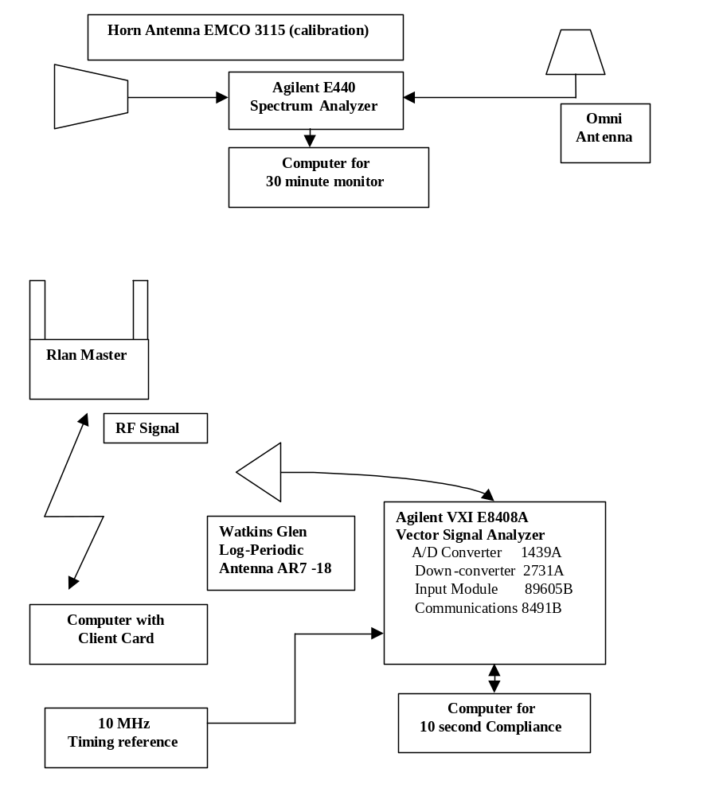
Figure 6. DFS Timing Monitoring Diagram

3.2 Alternate Monitoring Subsystem

This option is an alternative to monitor the EUT and radar test signals during DFS compliance testing. This method provides coarser timing measurements than the preferred method and will overestimate the Aggregate Time. It provides an upper bound measurement of the signal duration.

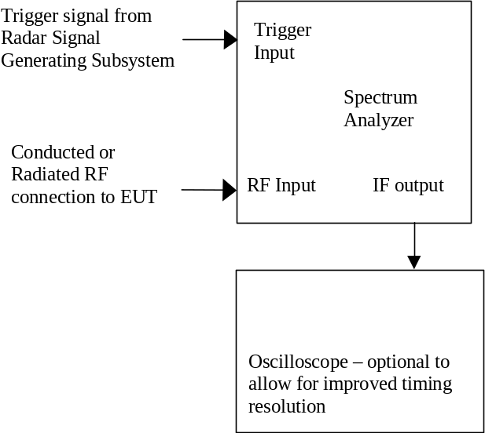

Figure 7. Alternate DFS Timing Monitoring Diagram

With the spectrum analyzer set to zero span at the radar simulated frequency, peak detection, and max hold, the dwell time per bin is given by

D = S / B

where D is the dwell time per bin, S is the sweep time and B is the number of bins.

An upper bound of the Aggregate Closing Time can be calculated by

C = N * D

where C is the Closing Time, N is the number of spectrum analyzer bins showing a WLAN transmission and D is the dwell time per bin.

4 Traffic Generation and Monitoring of Traffic Loading

Properly loading the network is very important for these tests. As the network is loaded with more data transmissions, the EUT device has less time is available to listen for radar pulses

4.1 Traffic and Loading for IP-based systems

The EUT will be loaded using the equipment shown in Figure 8.

[Does this equipment actually load the traffic, i.e., does it replace the MPEG file, or does it only monitor the traffic? Per the phone discussion on 5/18 the network loading likely needs to be verified at the RF level rather than a network level. One thing that was not discussed due to the evacuation was how to ensure that traffic is uniform rather than cached and sent in bursts] It consists of a program called a Network Sniffer developed by Network Associates being run on a computer working in conjunction with a HP 5304 XL 100 Mbs switch. The Sniffer program will allow an operator to control how much data is being broadcasted by the RLANS device. It has a pop-up display with dials that indicate what the current data rate is and the length of the data packets. The Network Sniffer program was bought off-the-shelf.

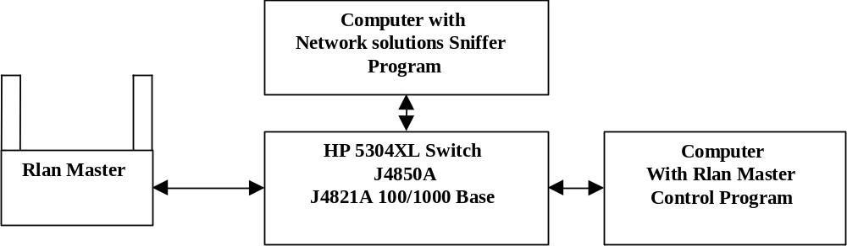

Figure 8. Traffic Monitoring Setup for IP-based Systems

4.2 - Traffic and Loading for Frame-based systems

[This needs to be documented]

Figure 9. Traffic Monitoring Setup for Frame-based Systems

5 Test Procedures

Preferred Frequency Hopping Procedure

[Test procedure for the preferred system.]

Alternate Simulated Frequency Hopping Procedure

Step 1: Determine the Radar Detection Bandwidth of the device under test

Set up the generating equipment as shown in Figure 1, or equivalent. Set up the DFS monitoring equipment as shown in Figure 6 or 7. Set up the overall system for either radiated or conducted coupling to the EUT.

Adjust the equipment to produce a single burst of a radar signal that has the same parameters as the frequency hopping radar signal (1 us pulse width, 3 kHz pulse repetition rate, 9 pulses / burst) at the channel frequency. Calibrate the amplitude to the applicable threshold level.

Set the EUT up as a standalone device (no associated Slave or Master, as appropriate) and no traffic.

Generate a single radar burst, and note the response of the EUT. Repeat for a minimum of 10 trials. The EUT must detect radar 90% or more of the time.

Increase the radar frequency in 1 MHz steps, repeating the above test sequence, until the detection rate falls below 90%. Record the highest frequency (denote as F_{H}) at which detection is greater than or equal to 90%. The detection rate at frequencies above F_{H} is irrelevant.

Decrease the radar frequency in 1 MHz steps, repeating the above test sequence, until the detection rate falls below 90%. Record the lowest frequency (denote as F_{L}) at which detection is greater than or equal to 90%. The detection rate at frequencies below F_{L} is irrelevant.

The detection bandwidth is calculated as follows:

Detection Bandwidth = F_{H} – F_{L}

The detection bandwidth must be at least 80% of the EUT transmitter 99% power Bandwidth (the 99% bandwidth is the bandwidth of the signal that contains 99% of the total signal power), otherwise, the EUT does not comply with DFS requirements. This is essential to ensure that the EUT is capable of detecting radar signals across the same frequency spectrum that contains the significant energy from the system.

[An alternative is that the detection bandwidth must be at least 100% of the EUT transmitter 6 dB Bandwidth.]

[Explanatory note, certainly relevant for discussion but probably not appropriate for inclusion in final procedure:

DEFINITION:

The frequency response of the receiver is assumed to be the same as the spectrum envelope of the transmitter. The center frequency of the Rx frequency response is assumed to be equal to the center frequency of the Tx envelope. If the receiver has a 3 dB margin to the Interference Detection Threshold, then the frequency range over which the receiver will reliably detect a radar will be equal to the 3 dB BW of the transmitter envelope. If the receiver has a 20 dB margin to the Interference Detection Threshold, then the frequency range over which the receiver will reliably detect a radar will be equal to the 20 dB BW of the transmitter envelope, etc.

RATIONALE FOR REQUIREMENT:

When the NTIA hopping radar is used, any sequence in which there are no hops within the detection bandwidth must be discarded. When the simulated hopping radar is used, the detection bandwidth must be measured in order to create the burst pattern. Thus a minimum detection bandwidth measurement is needed, independent of the test method used (NTIA hopper or simulated hopper).

In order to protect the spectrum in which the transmitter is operating, the receiver must detect radars in that same spectrum. Thus a minimum detection bandwidth specification is needed.

DISCUSSION REGARDING SELECTION OF LIMIT:

FCC Part 15 Subpart E Rules require a measurement of the 26 dB bandwidth. Thus as a starting point for consideration, the receiver detection bandwidth minimum requirement could be specified as being greater than or equal to the 26 dB transmitter bandwidth. This would require that the receiver have 26 dB margin to the interference detection threshold. Such a requirement is not feasible. Such a requirement is not necessary either, since very little of the transmitted energy is in the sideband skirts.

Consider the envelope of an OFDM signal: it is similar to a wideband FM signal in that it has a flat top and sloping skirts, plus there are individual sub-carrier spectral peaks that ride on the flat top portion of the envelope. The bandwidth of the flat top of the envelope contains most of the transmitted energy, and it contains all of the information content of the signal. (see diagram on following page that shows the 20 MHz 802.11a channel and the OFDM signal within that channel).

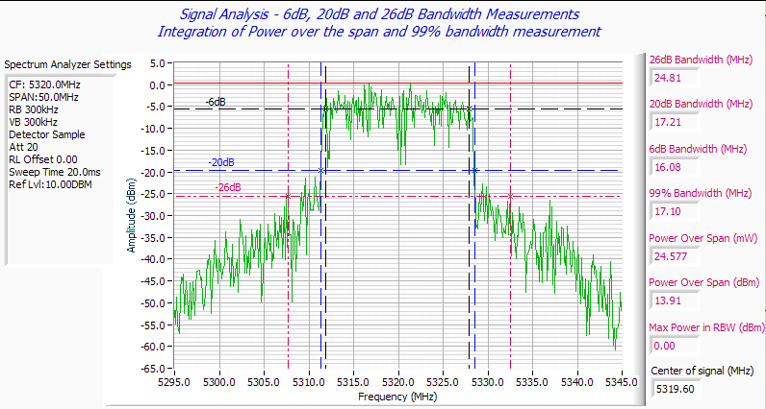
“Nominal Max BW” based on Channel Spacing
99% Power BW
Proposed minimum radar detection bandwidth (80% of the 99% Power Bandwidth)
26 dB BW
20 dB BW
6 dB BW

The associated receiver must receive all of this information content in order to produce a viable system, thus the receiver detection bandwidth will inherently tend to be equal to the spectrum over which most of the energy is transmitted. The actual frequency response of the receiver will not have peaks at each of the transmitter sub-carrier frequencies, rather it will simply be a flat top with sloping skirts.

One possible measurement upon which to base the receiver detection bandwidth specification would be the transmitter 6 dB bandwidth. Such a measurement is required under 15.247 Rules. However, this measurement is not required under 15.407. Additionally, for signals that do not use OFDM modulation, the 6 dB bandwidth will not generally represent the portion of the envelope that contains most of the transmitted power.

The 26 dB bandwidth can yield rather large deviations, depending on the measurement parameters set in the spectrum analyzer. The 99% power bandwidth is far more consistent, is generally close to the 20 dB bandwidth, and is required for Canadian certification.

Thus, it is recommended that the receiver detection bandwidth requirement be based on a percentage of the 99% bandwidth. This will provide the most consistency. Tests show that for a typical receiver system that has a margin of 2 to 3 dB to the Interference Detection Threshold, the receiver detection bandwidth, measured as described, will be between 80% and 90% of the 99% power bandwidth.

Error: Reference source not found
Step 2: Configure the Simulated Hopping Radar Signal Generator

Set up the equipment as shown in Figure 5.

Step 3: Determine Time Slots at which to Generate Radar Bursts

The hopping burst generator produces a patterned burst of trigger pulses. The pattern corresponds to the time-domain simulation of the NTIA frequency hopping radar. The timing of these trigger pulses is calculated via software in the control computer.

The NTIA hopping frequency list containing randomized sequential hop frequencies is read into the control computer. A segment of this hopping frequency list is defined by a start element and a length:

Start element for each trial = [TBD by NTIA and DoD]
Length = Burst Duration (seconds) * Hopping Rate (1/seconds)

The hopping frequencies within this segment are reviewed to determine each element that falls within the frequency range (F_{L} to F_{H} determined during step 1), which is the detection bandwidth. If no frequencies within the selected hopping segment fall within the detection bandwidth then a new segment shall be selected.

The trigger pattern is created by one trigger signal for each element in the segment that falls within the detection bandwidth. For example, if the k^{th} frequency falls within the detection bandwidth then a trigger is sent [(k-1) / hopping rate] seconds into the test. No trigger is created for each element in the segment that falls outside the detection bandwidth.

The hopping burst generator is programmed with this trigger pattern and outputs one trigger signal at each k^{th} time slot specified above.

While software will generally be used to define and create the hopping pattern, the actual burst generator must be implemented in hardware to achieve the proper timing. Software implementation of the trigger pulses is theoretically possible, however no commercial systems are known to be able to maintain synchronization at a particular hopping rate.

Step 4: Setup the Pulse Generator

The output from the hopping burst generator is fed to the external trigger input of the pulse generator.

The pulse generator produces a single burst of pulses each time it is triggered by the hopping burst generator.

Pulse width = as specified, 1 us
Rise and Fall Times = as short as possible
Pulse Repetition Rate = as specified, 3 KHz (= 333 us PRI)
Number of pulses per burst = as specified, 9
Hopping Rate = nominal 333 Hz [is the actual rate defined as = 1 / (3 ms)?]

Burst Frequency:

Pulse generators with burst capability generally require that the burst clock fully complete all of the specified cycles and turn off before it can be triggered again. If the exact ratio of PRF, Number of Pulses, and Burst Frequency / Hopping Rate is used, such systems will not have the ability to trigger the second burst in cases where two sequential hops lie within the detection bandwidth. Therefore the pulse generator is set as follows:

If the Specified Number of Pulses < (Specified PRF / Specified Hopping Rate)
then set the Burst Frequency exactly equal to the specified PRF.

If the Specified Number of Pulses = (Specified PRF / Specified Hopping Rate)
then set the Burst Frequency to (Specified PRF + Delta), where Delta is the smallest increment that can be entered on the instrument. Delta may be zero for pulse generators that have the capability to be retriggered synchronously with the exact end of a cycle. In any case, the Burst Frequency must be within 1% of the PRF, otherwise a different model pulse generator shall be used.

Step 5: Setup the Signal Generator

The output of the pulse generator is fed to the pulse modulation input of the microwave signal generator. The microwave signal generator produces the actual RF radar pulses.

Modulation mode = Pulse modulation
Frequency = The frequency range is equal to the detection bandwidth [Alternative under consideration: The frequency range is equal to the 6 dB BW of the EUT’s associated transmitter]. For each trial the frequency shall be set in 1 MHz increments over the frequency range. For all trials the selected frequencies shall be uniformly distributed over the frequency range.
Amplitude = Adjust using the same procedure as for fixed frequency radar testing

Preferred Monitoring Procedure

[Test procedure for the preferred system.]

Alternate Monitoring Procedure

Step 6: Configure the Monitoring System

Set up the equipment as shown in Figure 7.

Generally it is useful to trigger the monitoring system approximately one second prior to the radar signal in order to monitor the EUT traffic prior to radar detection.

For fixed frequency tests the timing of the signal that triggers the monitoring system is related to the output of the pulse generator, while for hopping frequency tests it is related to the start of the simulated radar sequence.

Step 7: Set the analyzer to the following settings.

Frequency: EUT Channel Frequency
Span: Zero
RBW: > 3 MHz, Use the highest available setting
VBW: VBW > RBW, Use the highest available setting
Detector function: Peak
Number of Bins: If this is adjustable, set to the highest number available.
Trace function: Max Hold

Sweep Time: 16 seconds for closing and move time
Greater than or equal to 30 minutes for non-occupancy
Fast sweep time for detailed observations of closing time

Trigger the analyzer to take a sweep, then trigger the radar signal approximately one second after the start of the analyzer sweep. This will allow the display of some WLAN traffic prior to the radar burst.

Move Time measurement:

Use the 16 second sweep time. This will leave sufficient sweep time after the radar burst to examine the 10 second maximum move time window plus an additional 5 second time period (thus the observation period will encompass 150% of the maximum limit).

Use the analyzer marker delta function to measure the time between the end of the last radar burst and the end of the last EUT transmission.

Confirm that no WLAN transmissions occur after 10 seconds following the radar.

Non Occupancy Time measurement:

Use the 30 minute sweep time.

Examine the trace and confirm that no EUT transmissions occur after 10 seconds following the radar.

Display of Closing Time:

Use the analyzer marker delta function to show the 200 ms period following the end of the last radar burst. Any EUT transmissions are allowed during this period.

Examine the EUT transmissions that occur after this 200 ms period and ensure that they are intermittent [we need a definition of “intermittent”, for both the primary and alternate procedures]. If the EUT transmissions are not intermittent, the EUT fails the test. If the EUT transmissions are intermittent, proceed with the calculation of the Aggregate Closing Time.

Calculation of Aggregate Closing Time:

The dwell time per bin is given by (1) where D is the dwell time per bin, S is the sweep time and B is the number of bins.

D = S / B (1)

Count the number of bins that show an EUT transmission, starting from 200 ms after the end of the last radar pulse. The aggregate Closing Time is given by (2) where C is the Closing Time, N is the number of spectrum analyzer bins showing an EUT transmission and D is the dwell time per bin:

C = N * D (2)

If the analyzer display cannot be observed by eye with sufficient clarity to count each bin, the trace will need to be downloaded into a computer and inserted into a spreadsheet or similar file. Examine the amplitude values in the spreadsheet cells and count the number of cells that show that show an EUT transmission, starting from 200 ms after the end of the last radar pulse.

Calculate the aggregate closing time using equations (1) and (2) above.

If the total aggregate closing time following the initial 200 ms period is less than 60 ms the EUT complies with the Closing Time requirement.

If the total aggregate closing time following the initial 200 ms period is greater than approximately 60 ms, it is recommended that the primary procedure be employed to determine if the EUT complies with the requirement

[For additional measurement resolution using the alternate monitoring subsystem the test may be repeated using a faster sweep time (or an additional spectrum analyzer can be used, with all settings as specified above except for a faster sweep time). The faster sweep time will yield a smaller dwell time per bin thus the upper bound calculation will generally be closer to the actual aggregate time. Since the faster sweep time will not encompass the entire 10 second close time window, the original plot must be presented to demonstrate that no EUT transmissions occur during the period following the end of the fast sweep.]

[Another alternative for improving timing accuracy is to connect the if output of the spectrum analyzer to an oscilloscope. Because of the linear amplitude display used on the oscilloscope it is difficult to show the high level channel traffic and lower level radar signal on the same trace. It is therefore recommended that the oscilloscope be set-up with two channels, one to display the if output (display channel traffic) and the second channel connected directly to the pulse modulation source to display the radar signals.]

Step 8: Perform the Test

The EUT is set up in an associated Master-Slave configuration. [Traffic is generated using the applicable streaming file or traffic generator TBD and monitored by TBD].

An applicable hopping radar signal sequence is generated, and the response of the EUT is noted. This test is repeated [TBD] times using [selected hopping segments TBD] and the percentage of successful detections is calculated. [Group – we still need to document the procedure for bins 2 through 4; this will be very similar to the hopping signal; it is more important to circulate this document for comments regarding the clarity of defining the alternate hopping signal.]

The above test is repeated for each required set of hopping radar parameters. [TBD: Only one set of timing measurements is required for bins 1 – 4 and for the hopping radar simulations provided that the EUT has a mode to indicate radar has been detected to determine the success rate over a number of trials.]
A set of hopping radar parameters is selected at random from a predetermined list [requirements for randomization and the enforcement of the randomization TBD], the test system is adjusted to produce the selected parameters, and the above test is repeated.
The above sequence of tests is repeated for each modulation and other channel frequencies as applicable. One frequency within each operational band shall be measured for compliance with DFS requirements [Needs to be confirmed by FCC and written into the procedure – a slave device without radar detection need not be tested in both bands since it follows the commands of the master device.].
[The random test procedure is also applied to a fixed frequency radar TBD]

