Predicting hand trajectory during rehabilitation process in augmented reality using Arduino

|  |  |  |
| --- | --- | --- |
| 1st member  Mir Habib Ul Latif  Id:1510175  dept.Computer Science  Independent University, Bangladesh  mirsahib24@gmail.com | 2nd member  Tanvir Ahmed  Id:1530207  dept.Computer Science  Independent University, Bangladesh  tan_840@yahoo.com | 3rd member  Md Rumman Hossain  Id:1531032  dept.Computer Science  Independent University, Bangladesh  Rummanhossain95@yahoo.com |

***Abstract*—In this project proposed a system that will predict hand trajectory during rehabilitation process in augmented reality using low cost device such as arduino, accelerometer and gyroscope.**

***Keywords—Augmented Reality, kinematic tracking , arduino***

# INTRODUCTION

In past few years, augmented and virtual reality become very popular as practical techniques for use in rehabilitation process. Studies has been conduct to see the application of this technology on post-stroke rehabilitation, myoelectric prosthesis control and brain computer interface. In those studies the sensor are used to capture physical motion of the subject and translate it into virtual motion which include optical kinematic tracker, depth motion cameras and electrogonimeter. These sensors are more than capable to handle these task but they are both expensive and highly sensitive to movement that result in partial obstruction of the target

# EXISTING SYSTEM

In the existing system experiment is done using a nrf51822 micro-controller with a MPU9250 9 axis motion sensor. These two device are then fitted into a 3D printed case and attached to the torso,upper arm and forearm of the subject using Velcro fasteners Fig:1.

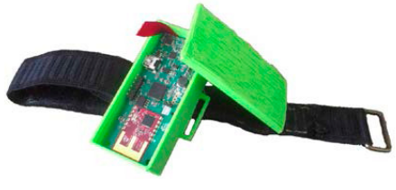

**Fig1: nrf51822 micro-controller with a MPU9250 9 axis motion sensor in a 3d printed** case.

The subject were asked to perform certain task which generate data from the motion sensor Fig 2:

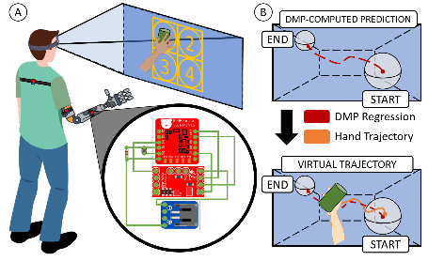

**Fig 2: Subject performing task**

This data is transmitted back to the central hub for further processing. The processed data are then transferred to the Microsoft Hololens to give the subject a visual feedback.  
Before the experimentation the accuracy and the precision of the sensor were validate using a digital goniometer and a stepper motor.

*Hardware description:*

* nRF51822 micro-controller(RedBearLab)[2]: It is a general purpose, ultra-low power SoC ideally suited for Bluetooth® Low Energy and 2.4 GHz proprietary wireless applications. It is built around the 32-bit ARM® Cortex™-M0 CPU with 256/128 KB flash and 32/16 KB RAM. The flexible 2.4 GHz radio supports Bluetooth Low Energy.
* MPU9250 9 axis motion sensor(InvenSense)[1]:It is a second generation 9 axis motion processing unit for smartphone,tablet and other wearable device. It is consist of accelerometer,gyroscope and magnetometer.
* Microsoft Hololens[3]:It is a pair of mixed reality smartglasses developed and manufactured by Microsoft.
* Central hub: Intel Core i5 2.5 GHz processor with 8 GB RAM on a 64-bit Windows 8 operating system.

# PROPOSED SYSTEM

In this project we propose a low cost and less sensitive devices to predict the trajectory of the subject hand. We will use an Arduino (due or zero) board with MPU9250 9 axis motion sensor.These two device will be fitted into a 3D printed case and attached to the torso, upper arm and forearm of the subject using Velcro fasteners. The data generated by the sensor will then be send to raspberry pi 3 b+(proposed central hub) through usb for further processing. The central hub can be fix on the chest(or on the back) of the subject body using a Velcro fasteners. The processed data will be then transfer to a smartphone(xaomi)which is fitted with a mi vr box.The smartphone and the mi vr box will serve as the virtual reality headset in our proposed system.The smartphone will contain a virtual reality app which will give the visual feedback to the subject.The app will be develop using the unity game engine software.

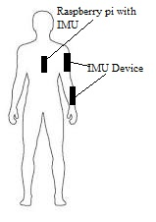

**Fig 3: Device position on human body**

*Hardware Description:*

* Arduino mega [5]: It is a an arduino board based on the ATmega2560 chip which is a 8 bit microcontroller.256KB flash memory,8KB SRAM and 16MHz clock speed.
* Rasberry pi 3 b+(proposed central hub)[6] :It is a single-board computer based on Broadcom BCM2837B0, Cortex-A53 (ARMv8),1.4GHz 64-bit quad-core processor,1GB LPDDR2 SDRAM,2.4GHz and 5GHz IEEE 802.11.b/g/n/ac wireless LAN, Bluetooth 4.2, BLE.
* MPU9250 9 axis motion sensor(InvenSense): It is a second generation 9 axis motion processing unit for smartphone,tablet and other wearable device. It is consist of accelerometer,gyroscope and magnetometer.
* Mi vr box[4]:Mi VR Play is a virtual reality headset similar to Google Cardboard developed and manufactured by Xiaomi.It supports smartphones that have a display screen size between 4.7-5.7 inches.

# RISK

* 1. *Potential cause of failure*:
* Performance and accuracy: atmega2560 is 8Mhz clock speed microcontroller which may have slow data transmission.
* The performance and the prediction accuracy of our proposed central hub will be negligible compared with the existing system central hub which is a standalone computer.
  1. *Potential adverse effect to the society:*

Low accuracy of the prediction system may injured the subject hand.

# REFERENCE

1. https://store.invensense.com/Products/Detail/MPU9250-TDK-InvenSense/487537/
2. https://www.nordicsemi.com/Products/Low-power-short-range-wireless/nRF51822
3. https://en.wikipedia.org/wiki/Microsoft_HoloLens
4. https://xinreality.com/wiki/Mi_VR_Play
5. https://www.arduino.cc/en/Guide/ArduinoDue
6. https://www.raspberrypi.org/products/raspberry-pi-3-model-b-plus/