Assignment#1 – AWS Storage, AWS RDS and AWS DynamoDB

**Student:** Aslan Mirsakiyev

**ID:** 300850326

**Purpose:** The purpose of this assignment is to help you:

1. Understand AWS S3, AWS RDS and AWS DynamoDB
2. Become familiar with IAM
3. Able to set up development environment

**Instructions**: Be sure to read the following general instructions carefully:

This assignment should be completed individually by all students. You need to demonstrate your solution during lab session, and submit your solution **through the dropbox**. Your submission must be a word document or a pdf document which contains necessary screenshot, and be named following the pattern of **studentID(yourlastname)_ASSnumber.pdf**. e.g., 300123456(**smith)_ASS#1**.pdf

**Question 1 [10 marks]**

* 1. [6 marks] Use example to explain elements of IAM, such as user, group, role, access key, secret key and policy

First of all, IAM stands for Identity and Access Management, which contains the such sensitive elements as user, group, role, access key, secret key, etc.

**User –** in other words, user is a person who is assigned to certain groups and has some permission(roles). For example, I am a user of centennial college and I am assigned to group COMP-306 and I have the following role: student. Or it could be Michael Dawn is a user of George Brown College and he is assigned to group MAPT-2122 and has the following roles: professor, advisor.

**Group –** basically it’s a stack of people(users) who have something in common. For example, COMP-306 is a group of people(users) who decided to attend this course. We have the same classes scheduled every week, same assignments, etc. However, myself and the rest of the class were assigned the following role: student. Meanwhile, out professor belongs to the same group but has different role. So, people in groups could have different roles and people could be assigned to one or multiple groups.

**Role –** perfect example could be a student. Student is a role that’s given to a person who attends school/college/university. Student is allowed to attend scheduled classes, allowed to use library and has access to lab’s computers. However, there is also such role as professor, but this role has more power. For instance, professors can open locked classroom with their access card, or reschedule a class, etc.

**Access Key and Secret Key -** I think the best analogy is that the access key is your username and the secret key is your password. For example, my centennial ID is the access key and my centennial password is the secret key. However, it is better to keep both of them secret.

**Policy –** for instance, every college/university have their own policies, so people who study/work there have to follow it. Some policies could be unique.

**1.2** [4 marks] Finish the example ***upload2S3***, make sure it can upload object(s) to your S3.

**Demonstrated in lab class on Sep 21st**

**Question2 [10 marks]**

**2.1** Create a MySQL database instance, create a table called **Student** to hold all information about student such as ID, first name, last name, email address, contact number; insert your own information into table Student [4 marks]

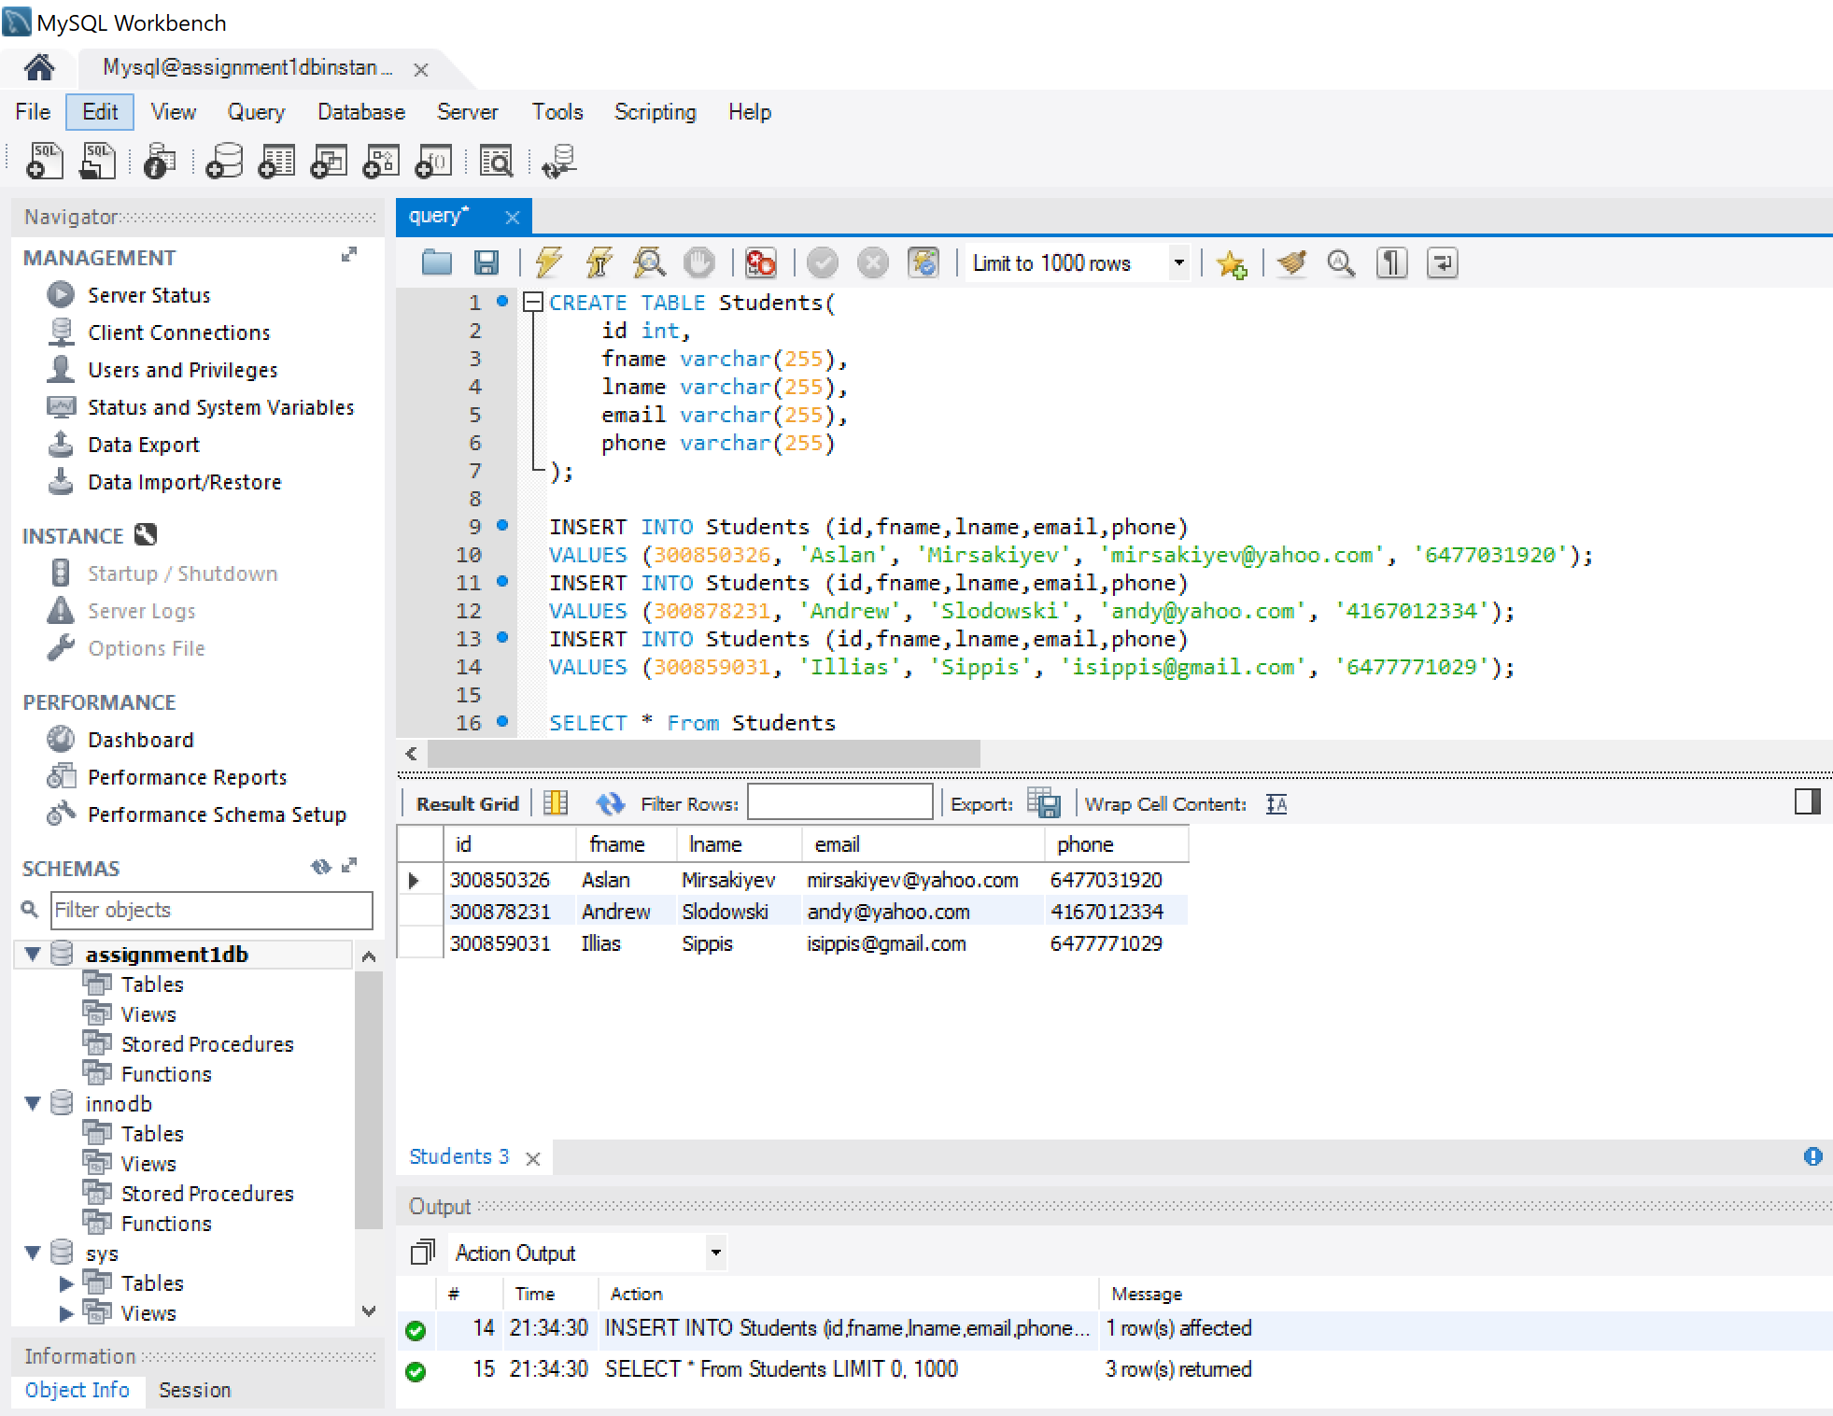

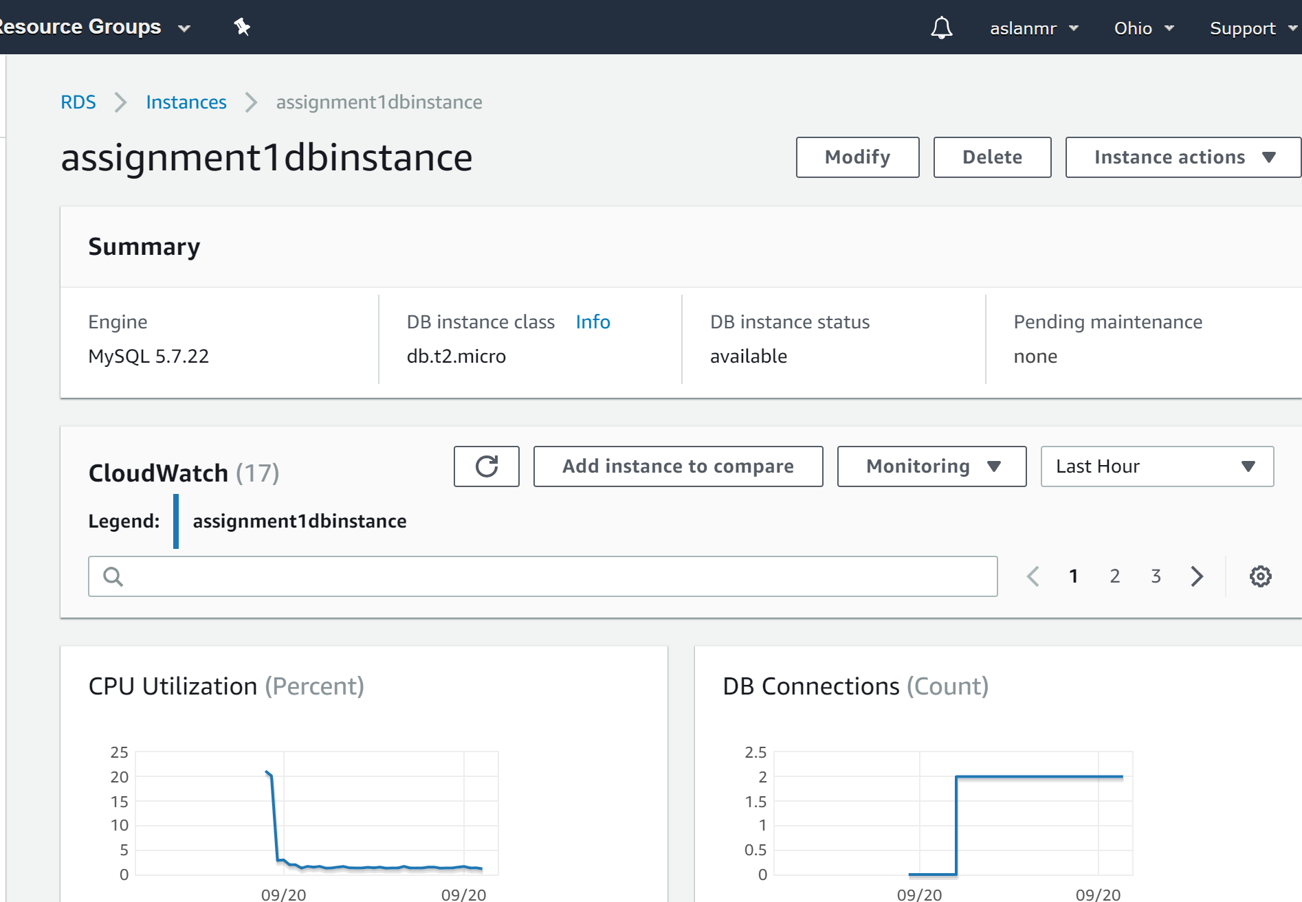

**2.2** Explain the partition key and sort key of AWS DynamoDB [2 marks]

Partition key is a unique key, which is very similar to primary key.

Sort key makes our life easier, because it allows us to sort data in more efficient way.

I would say that: Partition key + Sort key = Primary key

**Example:**

|  |  |  |  |  |
| --- | --- | --- | --- | --- |
| **Partition Key** | **Sort Key** | **Attributes** | | |
| **Student ID** | **Student’s Program Code** | **Name** | **Age** | **Residence** |
| 300850326 | 3419 (Software Engineering) | Aslan Mirsakiyev | 21 | Canada |
| 300850327 | 2400 (Business and Finance) | John Cena | 41 | USA |
| 300850333 | 3419(Software Engineering) | Jamal L. Jackson | 20 | USA |

In above table we can see that every student has a unique ID, which is a partition key. Also, we could sort this table by program code, which is a sort key (two students enrolled in 3419 and only one enrolled in 2400)

**2.3** Create a DynamoDB table to record emails for a mail server, the table should include sending date, sender, recipient, subject, message, etc. Explain the rationale of your design (**not sure how should I explain this part, however if anything I can try to explain it in the next class**) [4 marks]

