**Lab-Assignment 2**

Aslan Mirsakiyev #300850326

**Part 1 – Testing Network Connectivity Using Ping**

Step 1

1. www.cisco.com

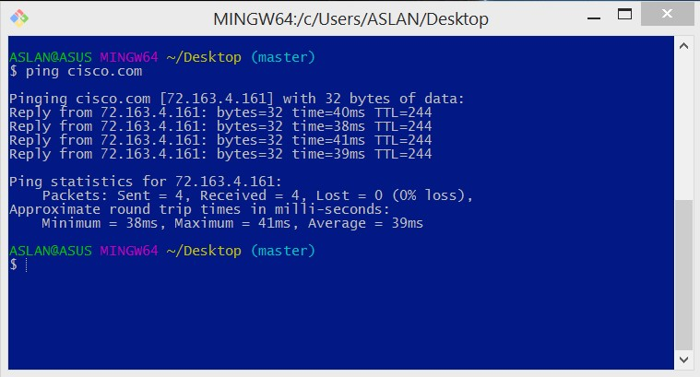

1. www.afrinic .net

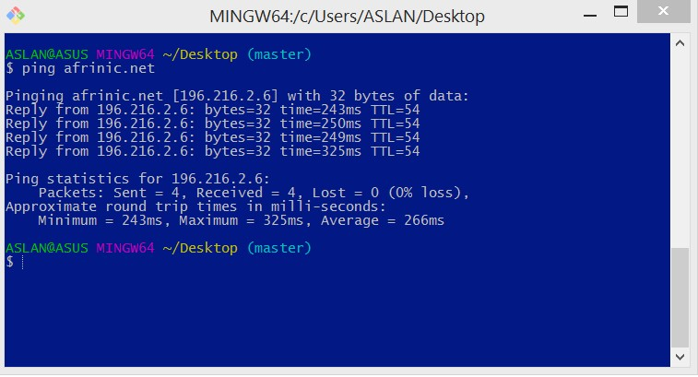

1. www.apnic.net

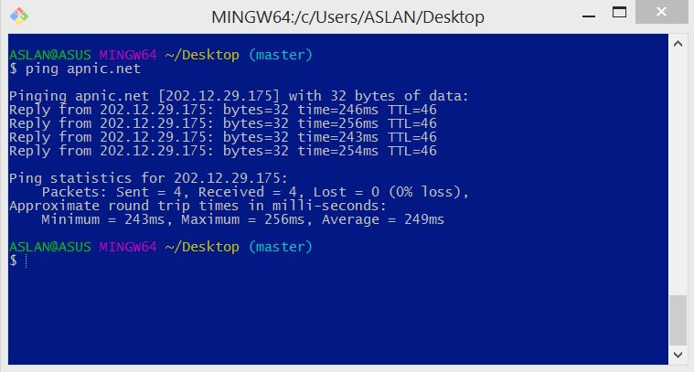

1. www.ripe.net

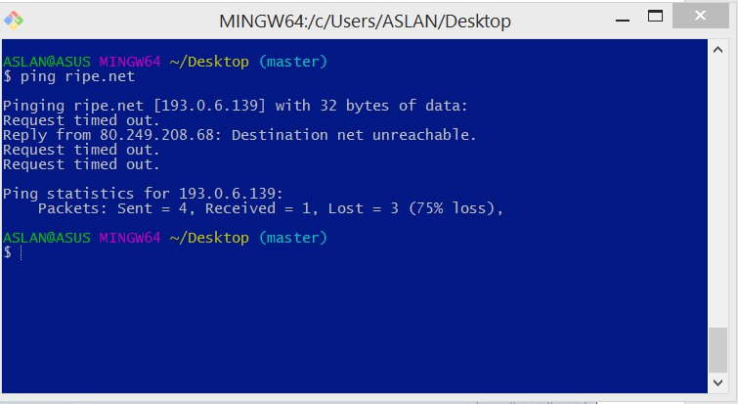

1. lacnic.net

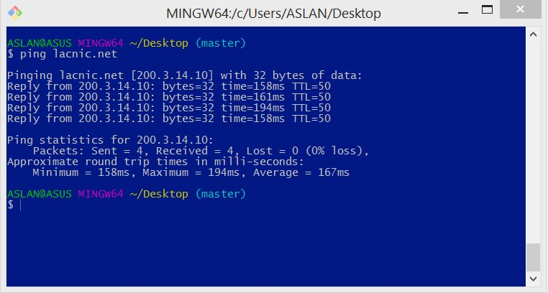

• An average ping time in milliseconds is increasing within the distance.

• Request to European server(www.ripe.net) failed for me.

**Part 2 – Tracing a Route to a Remote Server Using Tracert**

Step 1

1. www.cisco.com

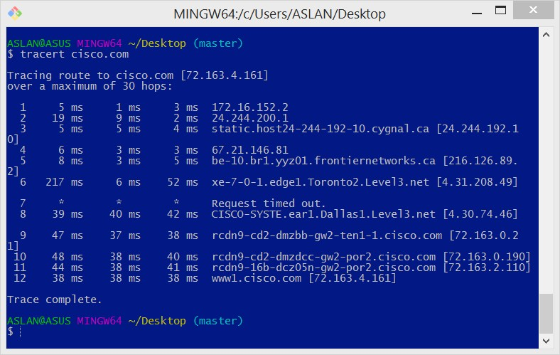

ASLAN@ASUS MINGW64 ~/Desktop (master)

$ tracert cisco.com

Tracing route to cisco.com [72.163.4.161]

over a maximum of 30 hops:

1 5 ms 1 ms 3 ms 172.16.152.2

2 19 ms 9 ms 2 ms 24.244.200.1

3 5 ms 5 ms 4 ms static.host24-244-192-10.cygnal.ca [24.244.192.1 0]

4 6 ms 3 ms 3 ms 67.21.146.81

5 8 ms 3 ms 5 ms be-10.br1.yyz01.frontiernetworks.ca [216.126.89. 2]

6 217 ms 6 ms 52 ms xe-7-0-1.edge1.Toronto2.Level3.net [4.31.208.49]

7 * * * Request timed out.

8 39 ms 40 ms 42 ms CISCO-SYSTE.ear1.Dallas1.Level3.net [4.30.74.46]

9 47 ms 37 ms 38 ms rcdn9-cd2-dmzbb-gw2-ten1-1.cisco.com [72.163.0.2 1]

10 48 ms 38 ms 40 ms rcdn9-cd2-dmzdcc-gw2-por2.cisco.com [72.163.0.190]

11 44 ms 38 ms 41 ms rcdn9-16b-dcz05n-gw2-por2.cisco.com [72.163.2.110]

12 38 ms 38 ms 38 ms www1.cisco.com [72.163.4.161]

Trace complete.

1. www.afrinic.com

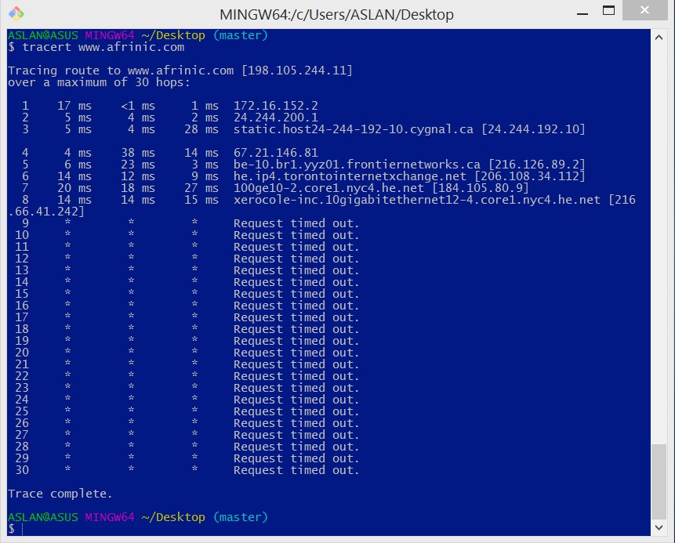

Hop 7 :

OrgName:        Hurricane Electric, Inc.  
OrgId:          HURC  
Address:        760 Mission Court  
City:           Fremont  
StateProv:      CA  
PostalCode:     94539  
Country:        US  
RegDate:          
Updated:        2015-05-26  
Ref:            https://whois.arin.net/rest/org/HURC

1. www.lacnic.com

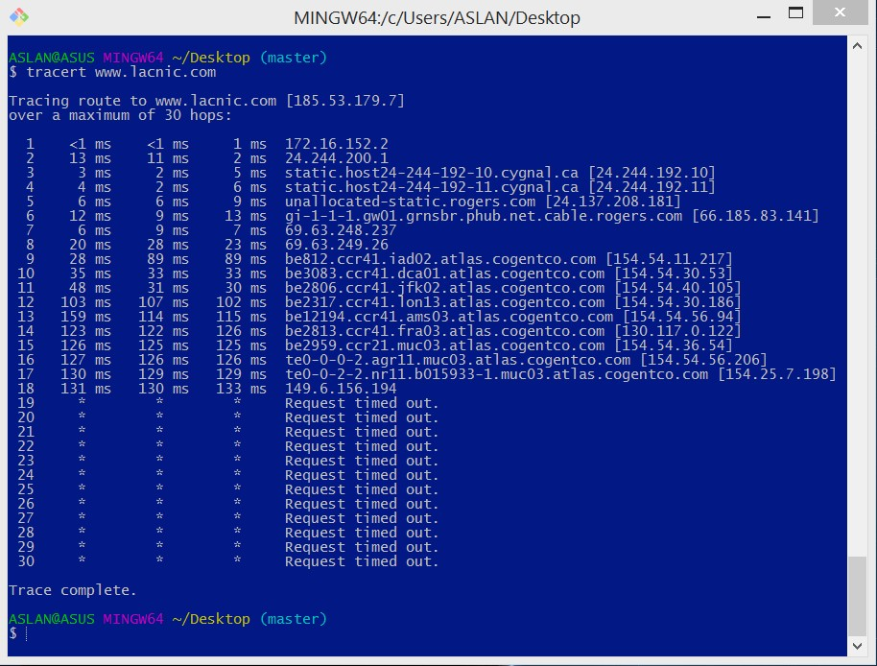

Hop 7:

OrgName:        Rogers Communications Canada Inc.  
OrgId:          RCC-184  
Address:        333 Bloor Street East 9th Floor  
City:           Toronto  
StateProv:      ON  
PostalCode:     M4W 1G9  
Country:        CA  
RegDate:        2016-10-26  
Updated:        2017-01-10  
Ref:            https://whois.arin.net/rest/org/RCC-184

**Part 3 – Tracing a Route to a Remote Server Using Web-Based and Software Tools**

**Step 1**

**www.cisco.com**

TracePath Output:

1: pera.subnetonline.com (141.138.203.105) 0.141ms pmtu 1500

1: gw-v130.xl-is.net (141.138.203.1) 0.603ms

2: te0-22.cr1.nkf.as49685.net (80.246.207.190) asymm 4 2.403ms

3: amsix-ams8.netarch.akamai.com (80.249.209.208) asymm 5 1.547ms

4: a23-62-103-197.deploy.static.akamaitechnologies.com (23.62.103.197) asymm 6 1.290ms reached

Resume: pmtu 1500 hops 4 back 6

---- Finished ------

**www.afrinic.net**

TracePath Output:

1: pera.subnetonline.com (141.138.203.105) 0.131ms pmtu 1500

1: gw-v130.xl-is.net (141.138.203.1) 9.078ms

2: te0-22.cr1.nkf.as49685.net (80.246.207.190) asymm 4 1.040ms

3: 8-2-5.ear2.Amsterdam1.Level3.net (213.19.196.201) asymm 5 1.134ms

4: ae-225-3601.edge3.London1.Level3.net (4.69.166.146) asymm 7 7.262ms

5: INTERNET-SO.edge3.London1.Level3.net (195.50.124.34) asymm 7 8.606ms

6: core2b-pkl-pos-0-0-5-0.ip.isnet.net (168.209.201.66) asymm 9 188.598ms

7: 168.209.1.169 (168.209.1.169) asymm 9 184.604ms

8: 196.37.155.180 (196.37.155.180) asymm 9 170.755ms

9: 196.216.3.164 (196.216.3.164) asymm 11 173.864ms

10: www.afrinic.net (196.216.2.6) asymm 12 182.849ms reached

Resume: pmtu 1500 hops 10 back 12

---- Finished ------

**Step 2**

**Using Visual Route 2010**

**www.cisco.com**

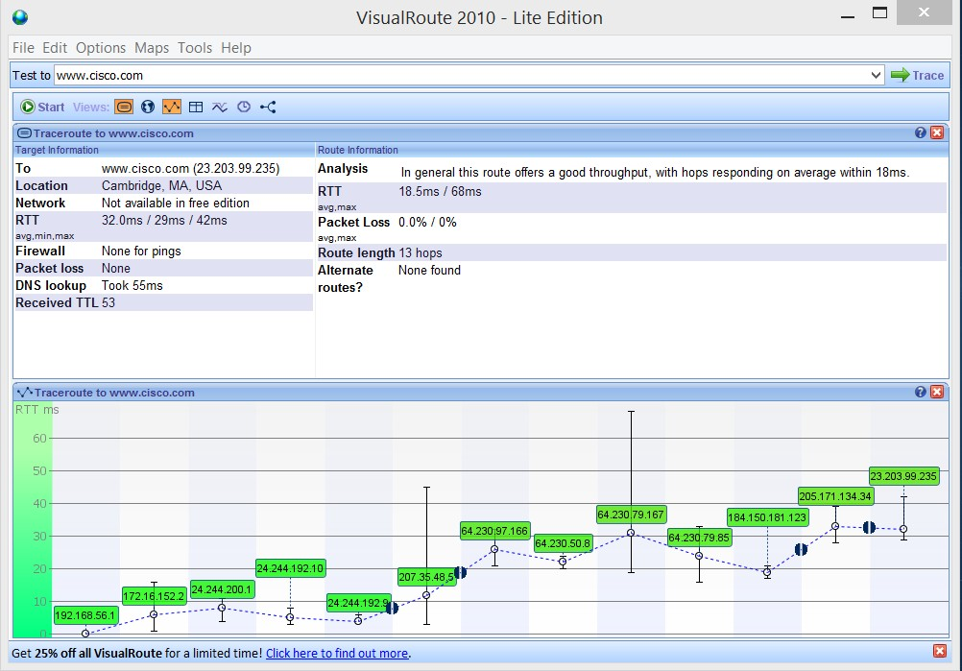

**Part 4 – Compare Traceroute Results**

**Step 1**

ASLAN@ASUS MINGW64 ~/Desktop (master)

$ tracert cisco.com

Tracing route to cisco.com [72.163.4.161]

over a maximum of 30 hops:

1 5 ms 1 ms 3 ms 172.16.152.2

2 19 ms 9 ms 2 ms 24.244.200.1

3 5 ms 5 ms 4 ms static.host24-244-192-10.cygnal.ca [24.244.192.1 0]

4 6 ms 3 ms 3 ms 67.21.146.81

5 8 ms 3 ms 5 ms be-10.br1.yyz01.frontiernetworks.ca [216.126.89. 2]

6 217 ms 6 ms 52 ms xe-7-0-1.edge1.Toronto2.Level3.net [4.31.208.49]

7 * * * Request timed out.

8 39 ms 40 ms 42 ms CISCO-SYSTE.ear1.Dallas1.Level3.net [4.30.74.46]

9 47 ms 37 ms 38 ms rcdn9-cd2-dmzbb-gw2-ten1-1.cisco.com [72.163.0.2 1]

10 48 ms 38 ms 40 ms rcdn9-cd2-dmzdcc-gw2-por2.cisco.com [72.163.0.190]

11 44 ms 38 ms 41 ms rcdn9-16b-dcz05n-gw2-por2.cisco.com [72.163.2.110]

12 38 ms 38 ms 38 ms www1.cisco.com [72.163.4.161]

Trace complete.

**Step 2**

TracePath Output:

1: pera.subnetonline.com (141.138.203.105) 0.141ms pmtu 1500

1: gw-v130.xl-is.net (141.138.203.1) 0.603ms

2: te0-22.cr1.nkf.as49685.net (80.246.207.190) asymm 4 2.403ms

3: amsix-ams8.netarch.akamai.com (80.249.209.208) asymm 5 1.547ms

4: a23-62-103-197.deploy.static.akamaitechnologies.com (23.62.103.197) asymm 6 1.290ms reached

Resume: pmtu 1500 hops 4 back 6

---- Finished ------

**Step 3**



**Reflection:**

Visual Route 2010- Lite Edition provides the location of the server, DNS lookup and it does its own analysis about the router.