**Lab-Assignment 3**

Aslan Mirsakiyev #300850326

Andre Oliveira #300909648

Hyemin Jeong #300884872

Antonio Magalhaes #300883536

**Part 2: Display and Configure Basic Device Settings**

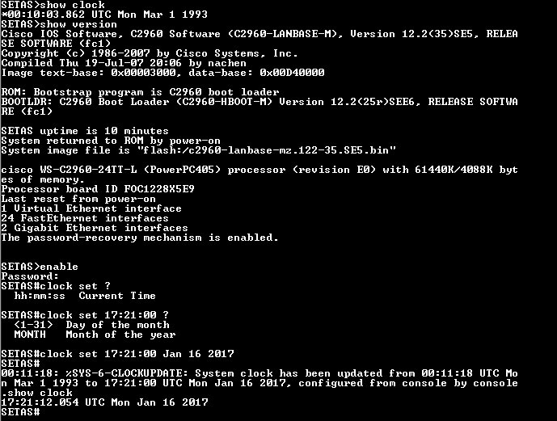

**Reflection**

1. You configure a password to prevent unauthorized users.
2. It is a matter of port availability whether the computer has a serial port or if the switch has a mini-USB console port. Nowadays, the most PCs have USB ports.