**Lab-Assignment 4**

Aslan Mirsakiyev #300850326

Andre Oliveira #300909648

Hyemin Jeong #300884872

Antonio Magalhaes #300883536

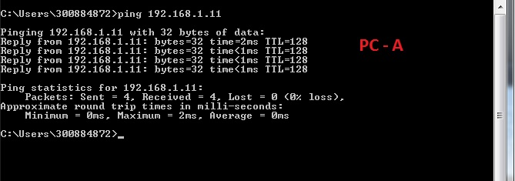

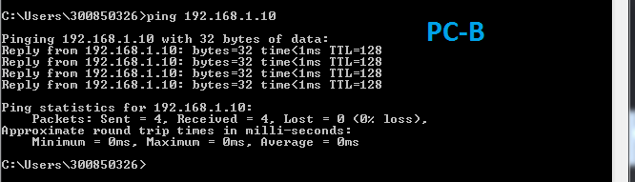

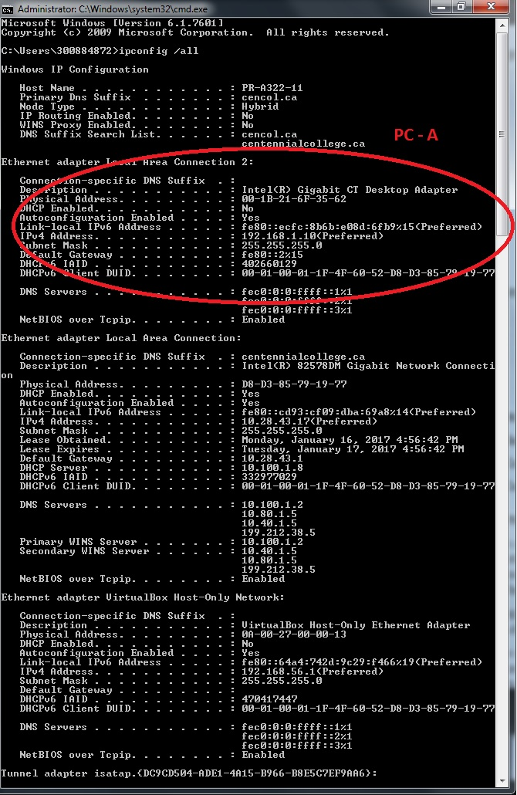

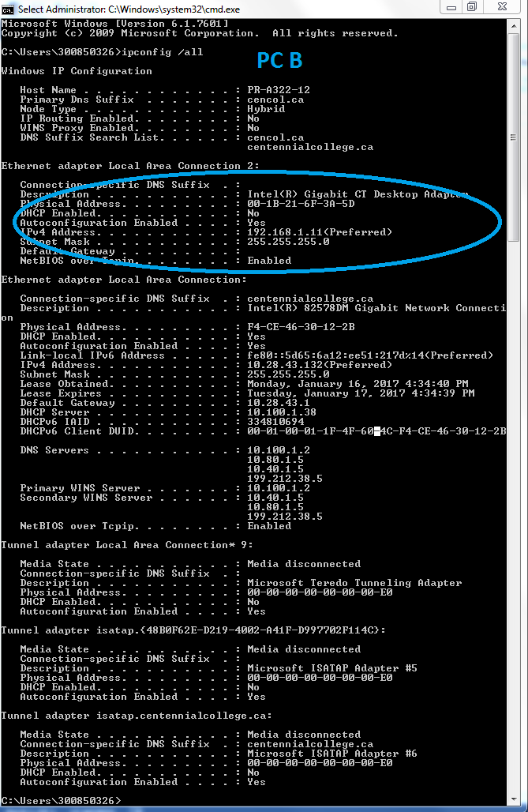

**S1**

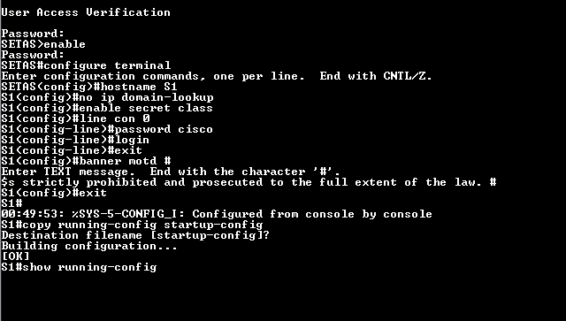

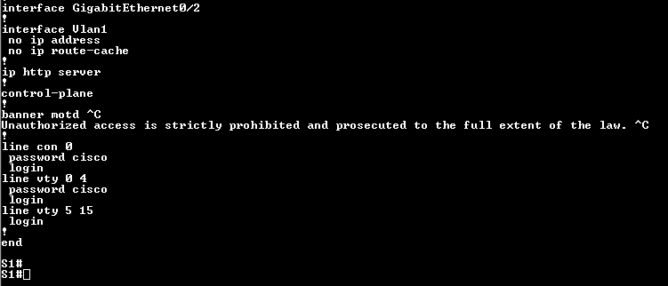

|  |  |  |  |  |
| --- | --- | --- | --- | --- |
| **Interface** | **S1** | | **S2** | |
| **Status** | **Protocol** | **Status** | **Protocol** |
| **F0/1** | Up | Up | Up | Up |
| **F0/6** | Up | Up | Down | Down |
| **F0/18** | Down | Down | Up | Up |
| **VLAN 1** | Up | Up | Up | Up |

Why are some FastEthernet ports on the switches up and others are down?

*Because some of the port are already connected to other ports using Ethernet cables.*

**Reflection**

What could prevent a ping from being sent between PCs?

*If the two switches weren’t to each other, because the two PCs are connected to different switches. One is connected to S1 and the other is connected to S2.*