**Lab 2**

**Author**: Aslan Mirsakiyev #300850326

**Part 1**

Step 1

1. www.cisco.com

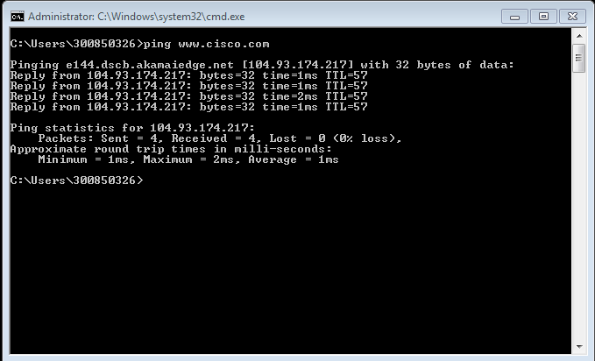

1. www.afrinic .net

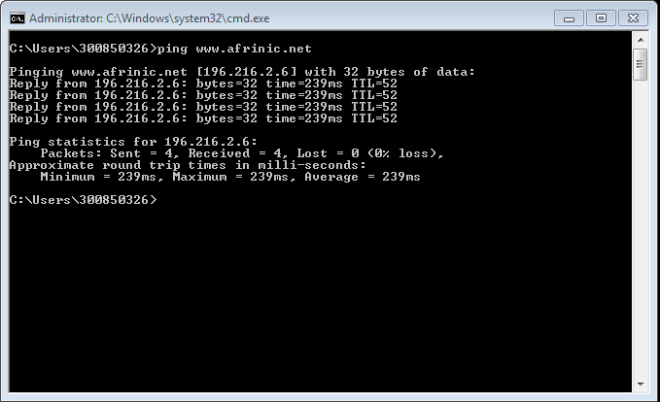

1. [www.apnic.net](http://www.apnic.net)

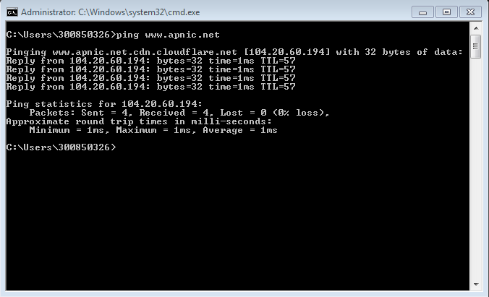

1. [www.ripe.net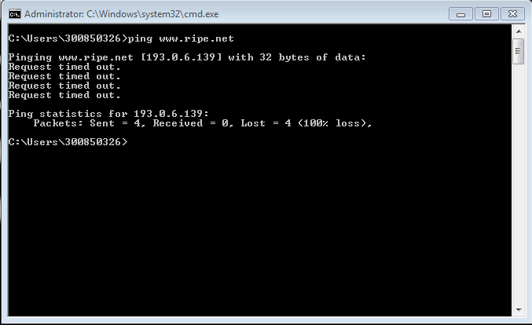](http://www.ripe.net#)
2. Lacnic.net

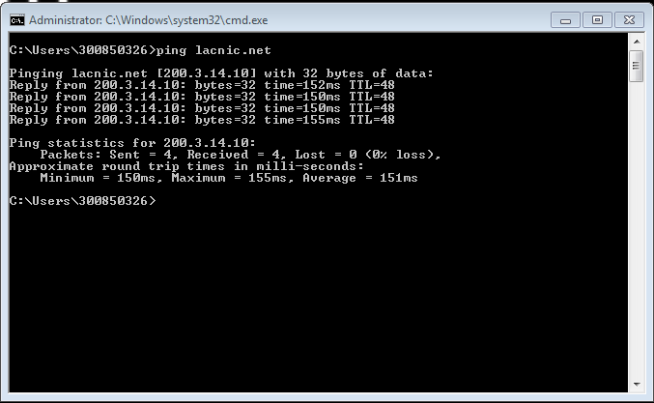

An average ping time in milliseconds is increasing within the distance.

Request to European server failed for me.

**Part 2**

Step 1

1. www.cisco.com

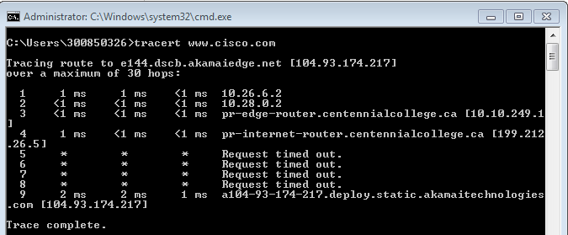

C:\Users\300850326>tracert www.cisco.com

Tracing route to e144.dscb.akamaiedge.net [104.93.174.217]

over a maximum of 30 hops:

1 1 ms 1 ms <1 ms 10.26.6.2

2 <1 ms <1 ms <1 ms 10.28.0.2

3 <1 ms <1 ms <1 ms pr-edge-router.centennialcollege.ca [10.10.249.1

]

4 1 ms <1 ms <1 ms pr-internet-router.centennialcollege.ca [199.212

.26.5]

5 * * * Request timed out.

6 * * * Request timed out.

7 * * * Request timed out.

8 * * * Request timed out.

9 2 ms 2 ms 1 ms a104-93-174-217.deploy.static.akamaitechnologies

.com [104.93.174.217]

Trace complete.

C:\Users\300850326>

1. [www.afrinic.com](http://www.afrinic.com)

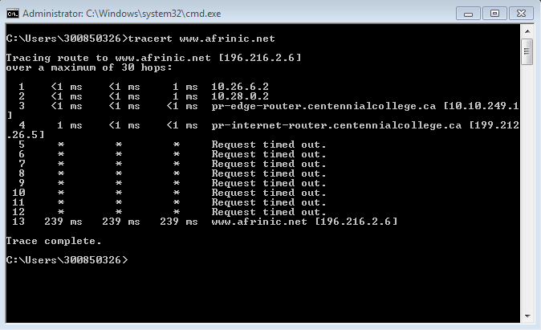

1. [www.lacnic.com](http://www.lacnic.com)

