**Comp-311 Lab-Assignment 2**

Aslan Mirsakiyev #300850326

Create a Java project and import the .jar file

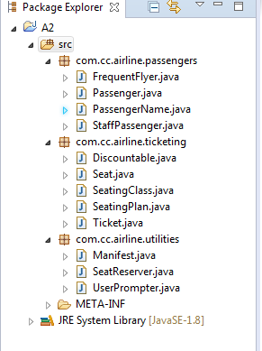

Debugging

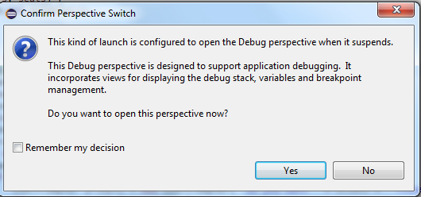

Debug Perspective

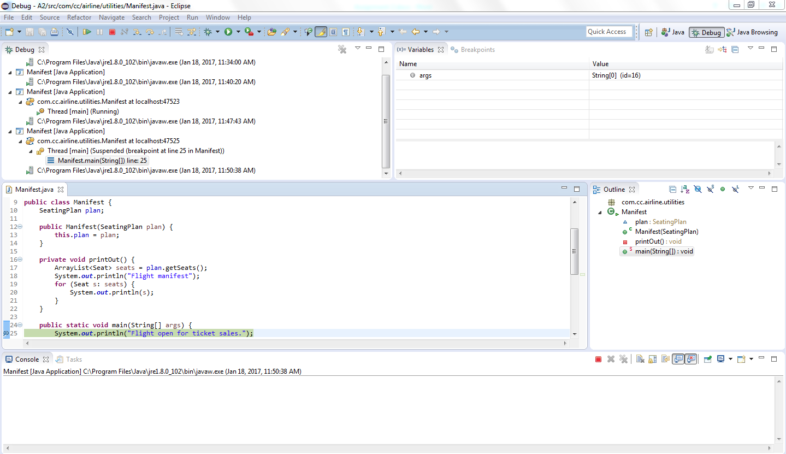

Find and fix the error

