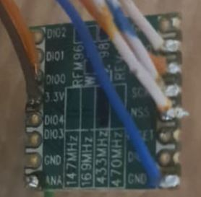

TTGO TDISPLAY PINOUT
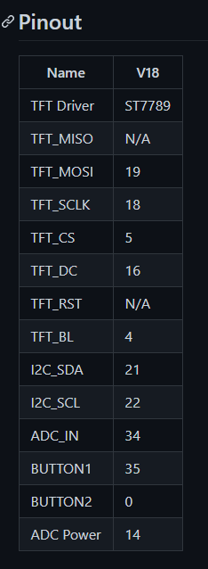
LORANOW connecions
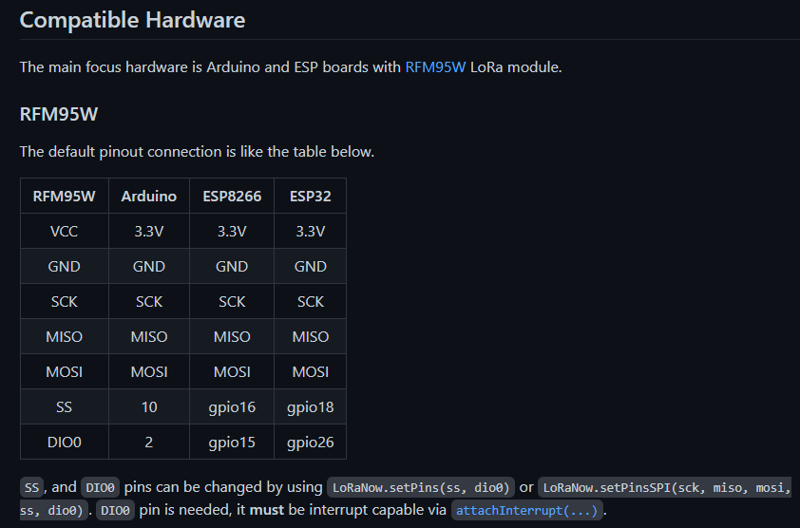

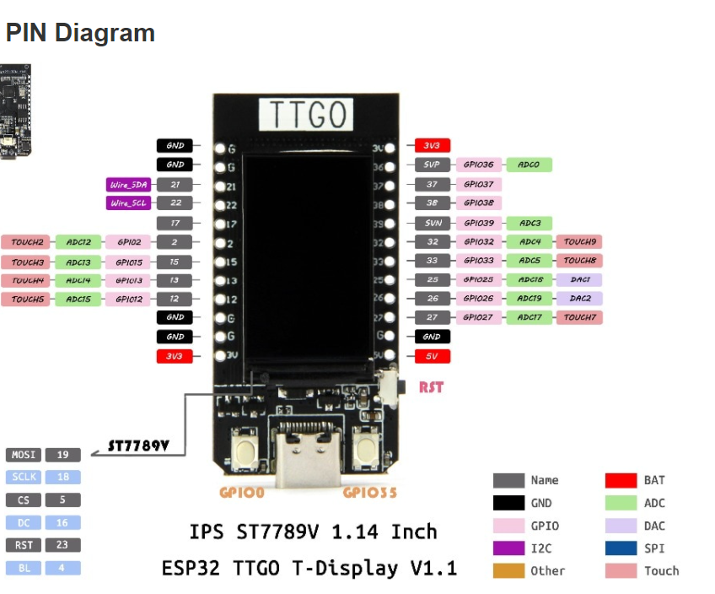

Połączenie Koncentartor V3

LORA RFM 98

RFM97 - ESP32
MISO - 15
MOSI - 13
SCK - 12
SS - 17
DIO0 - 2

DS18B20
DQ - 32

MCP23017

SDA - 21
SCL - 22

Zmiany bibliotek:
1.Zmieniono domyślne ustawienia biblioteki spi dla esp32 – tworzony domyślnie obiekt SPI jest podłączony do HSPI a nie VSPI
2. Zmieniono domyślny adres urządzeń MCP23XXX – plik C:\Users\mirsmok\Documents\Arduino\libraries\Adafruit_MCP23017_Arduino_Library\src\Adafruit_MCP23XXX.h linia 27 :
#define MCP23XXX_ADDR 0x20 //!< Default I2C Address
na
#define MCP23XXX_ADDR 0x27 //!< Default I2C Address

Zmiana w blibliotece PubSubClient
funkcja connect dodany zmieniony timeout
_client->setTimeout(500);

ESP32 GPIO CONFIG

GPIO | Input | Output | Notes
0 | pulled up | OK | outputs PWM signal at boot
1 | TX pin | OK | debug output at boot
2 | OK | OK | connected to on-board LED
3 | OK | RX pin | HIGH at boot
4 | OK | OK
5 | OK | OK | outputs PWM signal at boot
6 | x | x | connected to the integrated SPI flash
7 | x | x | connected to the integrated SPI flash
8 | x | x | connected to the integrated SPI flash
9 | x | x | connected to the integrated SPI flash
10 | x | x | connected to the integrated SPI flash
11 | x | x | connected to the integrated SPI flash
12 | OK | OK | boot fail if pulled high
13 | OK | OK
14 | OK | OK | outputs PWM signal at boot
15 | OK | OK | outputs PWM signal at boot
16 | OK | OK
17 | OK | OK
18 | OK | OK
19 | OK | OK
21 | OK | OK
22 | OK | OK
23 | OK | OK
25 | OK | OK
26 | OK | OK
27 | OK | OK
32 | OK | OK
33 | OK | OK
34 | OK |  | input only
35 | OK |  | input only
36 | OK |  | input only
39 | OK |  | input only
Continue reading for a more detail and in-depth analysis of the ESP32 GPIOs and its functions.

Input only pins
GPIOs 34 to 39 are GPIs – input only pins. These pins don’t have internal pull-up or pull-down resistors. They can’t be used as outputs, so use these pins only as inputs:

Those internal touch sensors are connected to these GPIOs:
- T0 (GPIO 4)
- T1 (GPIO 0)
- T2 (GPIO 2)
- T3 (GPIO 15)
- T4 (GPIO 13)
- T5 (GPIO 12)
- T6 (GPIO 14)
- T7 (GPIO 27)
- T8 (GPIO 33)
- T9 (GPIO 32)
Learn how to use the touch pins with Arduino IDE: ESP32 Touch Pins with Arduino IDE

Analog to Digital Converter (ADC)
The ESP32 has 18 x 12 bits ADC input channels (while the ESP8266 only has 1x 10 bits ADC). These are the GPIOs that can be used as ADC and respective channels:
- ADC1_CH0 (GPIO 36)
- ADC1_CH1 (GPIO 37)
- ADC1_CH2 (GPIO 38)
- ADC1_CH3 (GPIO 39)
- ADC1_CH4 (GPIO 32)
- ADC1_CH5 (GPIO 33)
- ADC1_CH6 (GPIO 34)
- ADC1_CH7 (GPIO 35)
- ADC2_CH0 (GPIO 4)
- ADC2_CH1 (GPIO 0)
- ADC2_CH2 (GPIO 2)
- ADC2_CH3 (GPIO 15)
- ADC2_CH4 (GPIO 13)
- ADC2_CH5 (GPIO 12)
- ADC2_CH6 (GPIO 14)
- ADC2_CH7 (GPIO 27)
- ADC2_CH8 (GPIO 25)
- ADC2_CH9 (GPIO 26)

