Bragg-peak validation of the DWA proton machine in matRad
DWA_proton_v2 vs TOPAS input vs RayStation 14 — pencil beam and Monte Carlo
Mirta Dumancic · UHN Medical Biophysics · 6 November 2026

1. Purpose
The aim was to check that matRad reproduces, in water, the single-spot integrated depth-dose curves (IDDs) from which the DWA machine was built. TOPAS simulations of the DWA beam (Bui et al. 2026, PMB 71 175030) are the ground truth. RayStation 14, commissioned on the same data, is a second reference. Pencil-beam engines are compared with pencil-beam engines, and Monte Carlo with Monte Carlo.
Two different questions are answered:
- Pencil beam: was the machine data entered and applied correctly? matRad’s pencil beam (HongPB) reads the TOPAS IDD tables directly, so agreement is expected by construction. A deviation would point to a data-entry or geometry error.
- Monte Carlo: does an independent transport code (MCsquare), given the same beam source, reproduce TOPAS? This is the independent test of the beam model.

2. Data and engines
Source | Algorithm | Role | Depth grid
TOPAS (Alaina Giang Bui) | Geant4-based MC | Ground truth; input to the machine | 1 mm bins
matRad, DWA_proton_v2 | HongPB, double Gaussian | Pencil beam under test | 1 mm voxels
matRad, DWA_proton_v2 | MCsquare, 10⁶ protons per energy | Monte Carlo under test | 1 mm voxels
RayStation 14.0.100 | SpotWeightPencilBeam 6.5 | Clinical pencil-beam reference | 1 mm
RayStation 14.0.100 | IonMonteCarlo 5.5 | Clinical MC reference | 1 mm
Table 1. Data sources. All curves cover the same 58 energies, 20.01–228.84 MeV.

3. Geometry and calculation
The matRad set-up reproduces the commissioning geometry of the TOPAS and RayStation curves:
- Single spot, gantry 0°, water surface at the isocentre, isocentre-to-snout distance 400 mm.
- Water box 160 × 160 mm laterally and 430 mm deep, preceded by 20 mm of air in the CT. Voxels are 2 mm laterally and 1 mm in depth, so depth samples sit at the same positions as the TOPAS bins (0.5, 1.5, … mm).
- The IDD is the dose summed over a circular detector of 120 mm diameter (r ≤ 60 mm), as in TOPAS and RayStation.
- Pencil beam: HongPB with the double-Gaussian lateral model, geometric lateral cut-off 100 mm, no dosimetric cut-off.
- Monte Carlo: MCsquare with 10⁶ primary protons per energy, run on the Windows PC (the macOS binary does not run on Apple Silicon) from a path without spaces.
- Script: DWA_final_machine/matRad_BraggPeaks_vsTOPAS_RayStation.m. Analysis: BraggPeaks_vsTOPAS_RS/analysis/compare_bragg_peaks.py.

3.1 Air-offset correction
With matRad’s default settings the pencil-beam peaks were 0.41 mm shallower than TOPAS on average. The cause is the air-offset correction in matRad’s particle pencil-beam engine, which adds a water-equivalent depth of 0.0011 × (nozzle-to-skin distance − meta.fitAirOffset) mm for the air between nozzle and skin. DWA_proton_v2 has fitAirOffset = 0, although the TOPAS curves already include the 400 mm of air between nozzle and water surface. The air was therefore counted twice: 0.0011 × 400 = 0.44 mm.
Two other explanations were tested and ruled out: half-voxel sampling (a 0.5 mm grid gave the same offset) and the air density in the CT (changing it gave the same offset). For this validation the correction was switched off (airOffsetCorrection = false), which is exact when the surface is at the isocentre. The permanent fix, fitAirOffset = 400, is part of DWA_proton_v3 (Section 8). MCsquare is not affected.

4. Analysis
Baseline. Every difference (Δ) in this report is relative to TOPAS: Δ = engine − TOPAS at the same energy. matRad and RayStation are never compared directly with each other; both are compared with the same reference.
Normalisation. The TOPAS and RayStation curves are relative, so each curve is normalised to 100 % at its own maximum and interpolated onto a common 0.05 mm depth grid. The comparison is therefore of curve shape, not of absolute dose.
Metrics, per energy:
- R80: depth beyond the peak where the dose falls to 80 % of the maximum (range). ΔR80 in mm.
- Distal fall-off: R20 − R80, in mm.
- Entrance dose: dose at 2 mm depth, in % of the maximum.
- Plateau difference: mean |engine − TOPAS| from 2 mm to the TOPAS R90, in % of the maximum.
Results are summarised in three energy bands (below 60 MeV, 60–120 MeV, ≥ 120 MeV) as the mean and the range across energies. The bands are reported separately because the TOPAS 1 mm bins resolve the peak poorly at low energies, where the peak is about one bin wide.

5. Figures
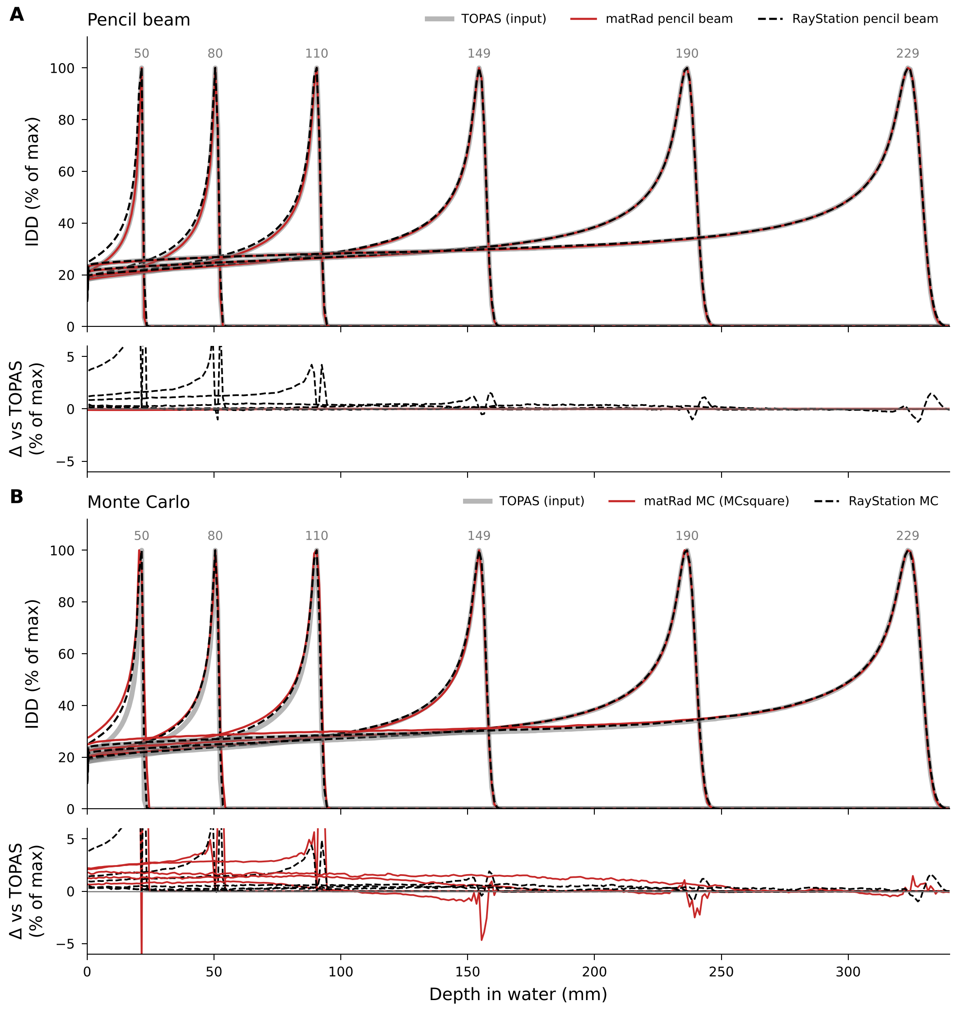
Figure 1. Integrated depth-dose curves in water for six of the 58 energies (labels in MeV above the peaks). (A) Pencil beam: TOPAS input (thick grey), matRad HongPB (red) and RayStation pencil beam (black dashed). (B) Monte Carlo: TOPAS (grey), matRad MCsquare (red) and RayStation MC (black dashed). The narrow panel below each shows the difference from TOPAS in % of the maximum. All curves are normalised to their own maximum. Large spikes at the distal edge come from subtracting very steep curves that are offset by a fraction of a millimetre, and are not dose errors.
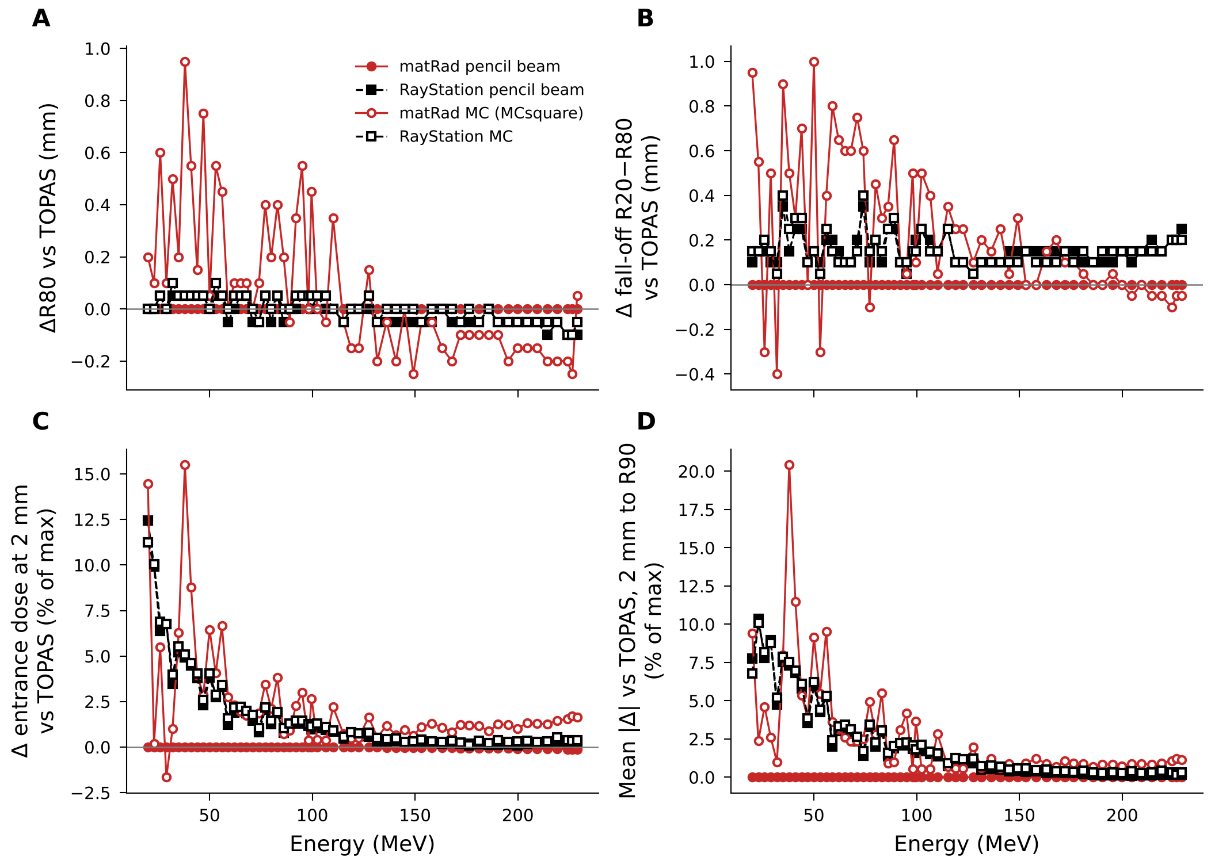
Figure 2. Differences from TOPAS against beam energy for all 58 energies. (A) ΔR80. (B) Δ distal fall-off R20−R80. (C) Δ entrance dose at 2 mm. (D) Mean |Δ| from 2 mm to R90. Filled symbols: pencil beam (red circles matRad, black squares RayStation); open symbols: Monte Carlo (red circles matRad MCsquare, black squares RayStation MC). matRad pencil beam lies on zero in every panel.

6. Results
Engine | Band (MeV) | n | ΔR80 (mm) | Δ fall-off (mm) | Δ entrance (%) | Plateau |Δ| (%)
matRad PB | all | 58 | 0.00 [0.00, 0.00] | 0.00 | −0.03 | 0.01 (max 0.02)
RayStation PB | < 60 | 14 | +0.03 [−0.05, +0.05] | +0.17 | +5.1 | 6.3 (max 10.4)
 | 60–120 | 19 | +0.01 [−0.05, +0.05] | +0.17 | +1.3 | 2.0 (max 3.3)
 | ≥ 120 | 25 | −0.05 [−0.10, 0.00] | +0.14 | +0.3 | 0.3 (max 1.0)
matRad MCsquare | < 60 | 14 | +0.37 [0.00, +0.95] | +0.40 | +5.5 | 6.9 (max 20.4)
 | 60–120 | 19 | +0.16 [−0.15, +0.55] | +0.38 | +1.7 | 2.4 (max 5.5)
 | ≥ 120 | 25 | −0.12 [−0.25, +0.15] | +0.06 | +1.2 | 0.9 (max 2.0)
RayStation MC | < 60 | 14 | +0.04 [0.00, +0.10] | +0.19 | +5.2 | 6.4 (max 10.1)
 | 60–120 | 19 | +0.02 [−0.05, +0.05] | +0.17 | +1.4 | 2.2 (max 3.5)
 | ≥ 120 | 25 | −0.03 [−0.10, +0.05] | +0.13 | +0.4 | 0.5 (max 1.2)
Table 2. Differences from TOPAS by energy band: mean, with the range across energies in brackets. matRad pencil beam with airOffsetCorrection = false.

6.1 Pencil beam
matRad reproduces the TOPAS input exactly at all 58 energies (ΔR80 = 0.00 mm, plateau difference 0.01 %). This confirms that the depth-dose tables, energies and depth axis were entered correctly and that the geometry matches. It is not an independent test of the physics, because HongPB reads these tables directly.
RayStation’s pencil beam, fitted to the same TOPAS data during commissioning, agrees within 0.10 mm in R80 at every energy. Its fall-off is about 0.15 mm wider, and its entrance dose is a few percent higher below 60 MeV, where its model has to fit peaks that TOPAS resolves with only one or two bins.

6.2 Monte Carlo
Above 120 MeV, MCsquare is within 0.25 mm of TOPAS in R80 (mean −0.12 mm), with a plateau difference of 0.9 %. Its entrance dose is systematically about 1.2 % higher (up to 1.7 % at the highest energies), compared with 0.4 % for RayStation MC. A smooth, energy-dependent excess of this kind is consistent with differences between the codes in nuclear interactions and secondary particles.
Below about 120 MeV the MCsquare metrics scatter from one energy to the next (ΔR80 0 to +0.95 mm, entrance up to +15 % of the maximum). A real physics difference would vary smoothly with energy. Two observations show that this scatter comes from sampling a very small range difference on 1 mm bins:
- The shift of the dose-weighted mean depth (centroid), which does not depend on how the peak falls within the bins, changes smoothly with energy (Table 3). It shows MCsquare depositing its energy about 0.1–0.4 mm deeper than TOPAS at low energies.
- At low energy the peak is narrower than a bin. When MCsquare’s peak sits near a bin edge its dose is split between two bins (at 38 MeV: 100 % and 89 %; TOPAS: 100 % and 7.5 %). The normalised maximum then drops, which raises the normalised entrance dose and moves the interpolated R80.
Energy (MeV) | 20.0 | 38.0 | 50.0 | 71.0 | 98.1 | 149.2 | 190.3 | 228.8
matRad MCsquare | +0.38 | +0.33 | +0.19 | +0.10 | −0.18 | −1.13 | −1.86 | −2.52
RayStation MC | +0.04 | 0.00 | −0.01 | −0.06 | −0.07 | −0.18 | −0.33 | −0.19
Table 3. Shift of the dose-weighted mean depth (centroid) relative to TOPAS, in mm. Positive: deeper. At high energies the negative shift reflects the higher plateau, not a shorter range (ΔR80 there is only −0.1 to −0.25 mm).
Earlier, the low-energy scatter was attributed to a missing energy spectrum in the machine file. That was wrong: DWA_proton_v2 already contains Alaina’s source energy spread (dE/E at the nozzle, exact) and energies within 0.005 MeV of the achieved TOPAS energies, and MCsquare uses them. The difference therefore comes from the transport codes and the binning, not from the beam input.

6.3 Bottom line
- The DWA machine is applied correctly in matRad’s pencil beam, which is the engine used for all plan optimisation.
- Without the fix, the default air-offset correction made every DWA range 0.44 mm short. Plans calculated so far carry this offset; it is small relative to the 3 mm + 3.5 % range margins.
- MCsquare, given the same source, agrees with TOPAS to within 0.25 mm in range above 120 MeV and to within about 0.4 mm (centroid) at lower energies, with a 1–2 % higher plateau. RayStation MC agrees more closely because it was tuned to these curves during commissioning.

7. Limitations
- Below 60 MeV the 1 mm TOPAS bins under-resolve the Bragg peak, so R80, fall-off and normalised entrance dose there are dominated by binning. Finer scoring (0.1–0.2 mm) would be needed for a stronger low-energy test.
- Curves are normalised to their maximum; absolute dose per proton was not tested because the v2 depth-dose tables are relative.
- Only integrated depth dose in water was compared. Lateral spot profiles (also available from RayStation) and heterogeneous media were not tested.
- Statistical uncertainty of the MCsquare IDDs (10⁶ protons) was not quantified separately; the smooth centroid trend suggests it is small compared with the effects discussed.
- The LET tables are a stopgap borrowed from Generic and are not part of this validation.

8. Next version: DWA_proton_v3
DWA_proton_v3 is built by DWA_final_machine/matRad_makeMachines_v3.m (which also builds IBA_cyclotron_v2). The parent machines are not changed. Two changes:
- meta.fitAirOffset = 400 mm. Removes the 0.44 mm double count. This is the only change that alters pencil-beam dose distributions.
- Absolute calibration of Z. Each layer is scaled to MeV cm²/g per proton so that the energy it deposits equals f(E) × E, where f(E) is the deposited-energy fraction of matRad’s Generic proton machine at the same energy (0.99 at 50 MeV, 0.91 at 236 MeV). As an independent check, the calibrated entrance dose at 2 mm matches Generic at the same energy to within ±1 % above 50 MeV (median ratio 1.000 for DWA, 0.994 for IBA). Pencil-beam plans keep the same dose distributions; only dose per unit spot weight changes. MCsquare dose is absolute, so pencil beam and MC can now be compared in Gy.
Re-validation after building v3:
- Rerun the Bragg-peak script with machineName = ’DWA_proton_v3’ and airOffsetCorr = true (matRad’s default). Expected: ΔR80 = 0.00 mm, as in Table 2.
- Compare absolute IDDs of HongPB and MCsquare for the same spot weight (expected ratio ≈ 1).
- Repeat the benchmark for IBA_cyclotron_v2 against the RayStation and measured GTR102 curves (detector diameter 81.6 mm).

