AIR QUALITY ASSESSMENT IN TN

1. Project Objective:

The project aims to analyse and visualize air quality data from monitoring stations in Tamil Nadu. The objective is to gain insights into air pollution trends, identify areas with high pollution levels, and develop a predictive model to estimate RSPM/PM10 levels based on SO2 and NO2 levels. This project involves defining objectives, designing the analysis approach, selecting visualization techniques, and creating a predictive model using Python and relevant libraries.

2. Understanding the project:

To extract valuable insights regarding air pollution trends in the region, pinpoint areas with consistently high pollution levels, and ultimately construct a predictive model capable of estimating Respirable Suspended Particulate Matter (RSPM) and Particulate Matter (PM10) levels based on the concentrations of Sulphur dioxide (SO2) and nitrogen dioxide (NO2). To achieve these goals, the project will employ Python programming and relevant libraries for data analysis, visualization, and machine learning. The workflow will encompass several key steps, including data preprocessing, exploratory data analysis, spatial and temporal analysis, predictive model development, and the creation of informative visualizations. Ultimately, the project aims to provide actionable insights to local authorities, aiding in more effective air quality management and fostering a healthier environment in Tamil Nadu.

3. Analysis Objectives and Methodology:

Data Collection Process: Dataset for Air quality in Tamil Nadu was gathered. These datasets were cleaned, integrated, and made ready for analysis. Data Visualization using Google Colab notebook was employed to create visualizations, such as line graphs, heat maps, and dashboards, to represent the data comprehensively. Insights Generated: The analysis focused on understanding the trajectory of the high pollution in different regions, identifying the correlation between amount RSPM, PM10, SO2 and NO2.

4. Visualization using Google Colab:

**Mean of NO2, SO2, PM10/RSPM of each city:**

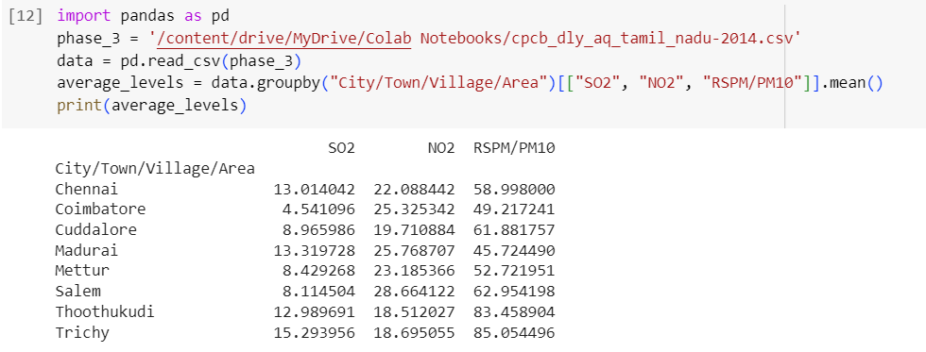

**Graph plotted:**

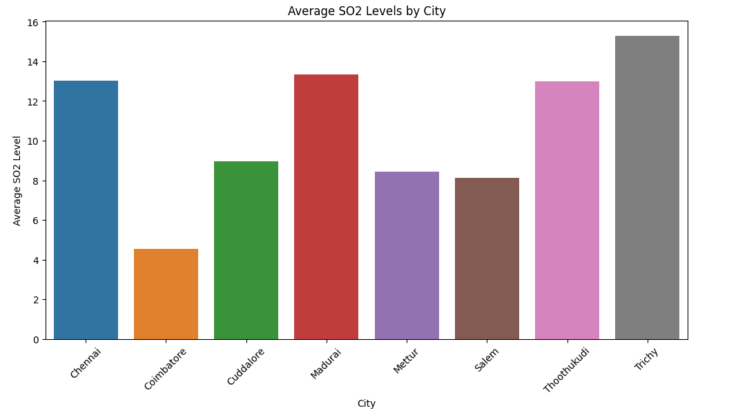

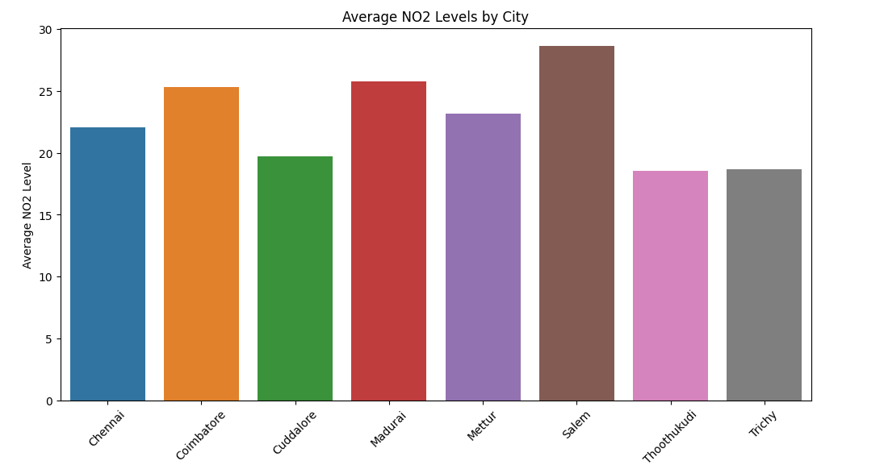

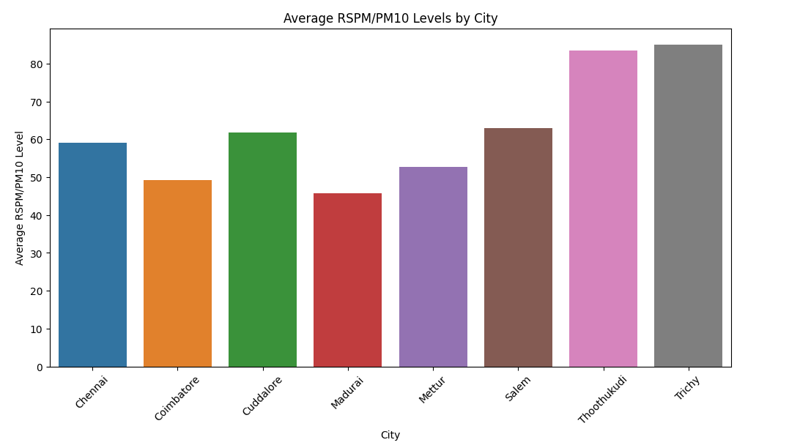

5. Finding and plotting high polluted areas:

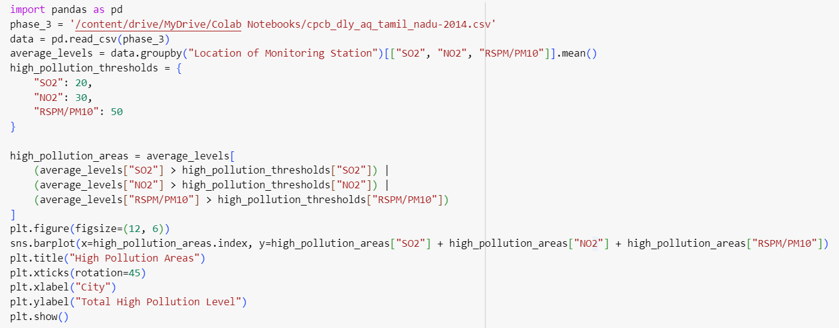

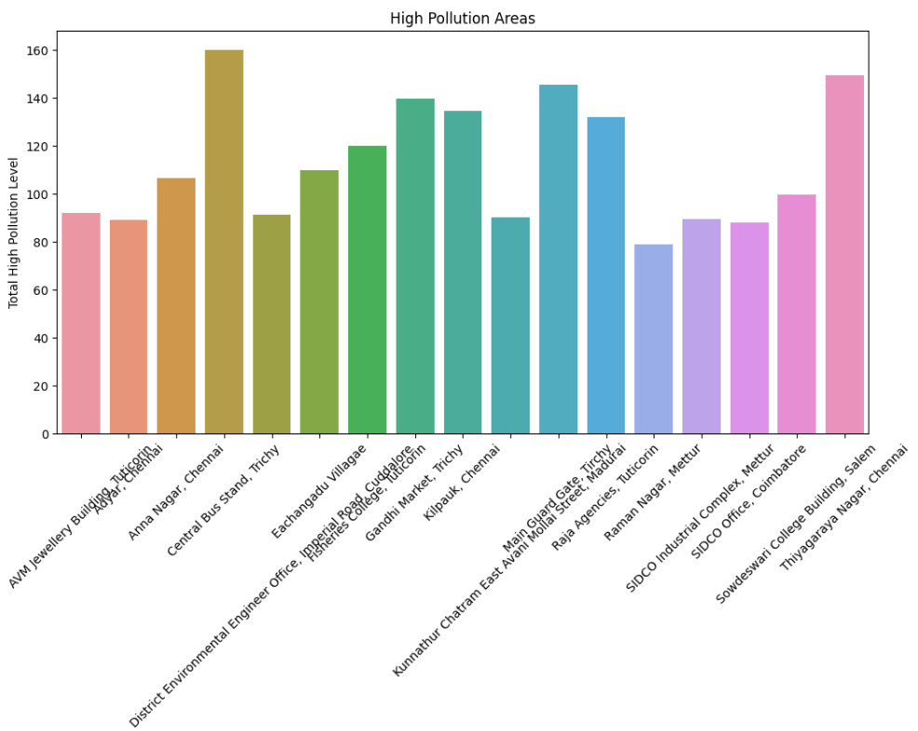

6. Conclusion:

The project successfully analyzed the amount of NO2, SO2 and RSPM/PM10 present in the air of important cities in Tamil Nadu and found out the highly polluted regions of each and every important cities of Tamil Nadu. Now the government can use our project or the analysis made to regulate the regions that are polluting and control the air pollution.