**== How it works ==**

1. Create a folder in Google Drive and share it.

2. Upload a file in Google Drive folder.

3. Set up Google Drive folder in Wordpress Admin >> Media >> Google Drive Media Library >> Mapping Folder.

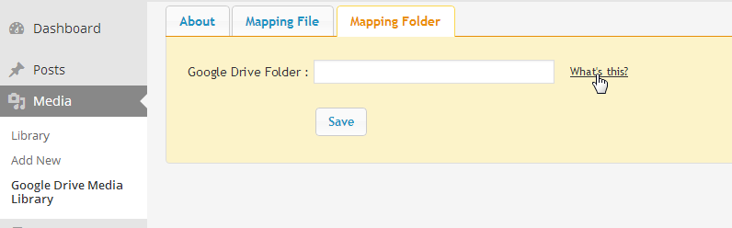

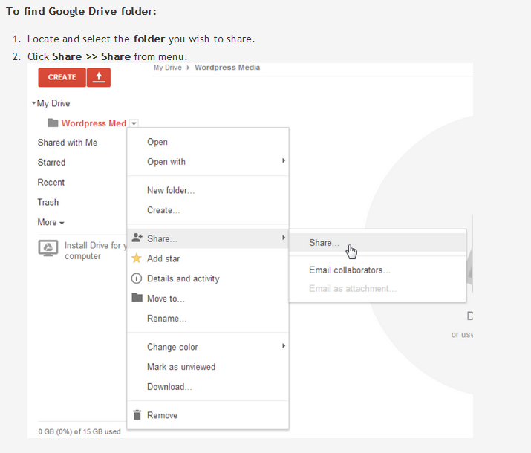

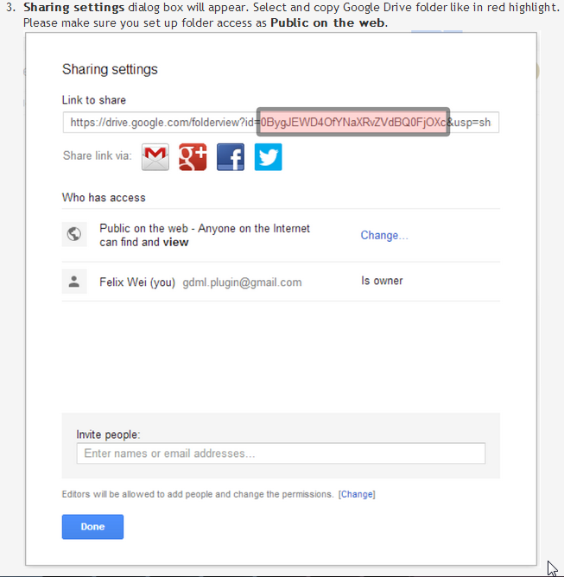

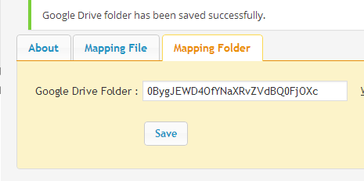

4. Add file name in Wordpress Admin >> Media >> Google Drive Media Library >> Mapping File.

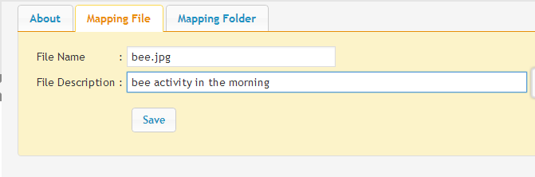

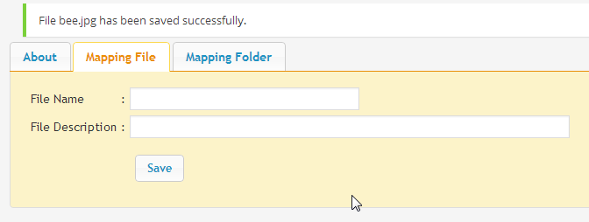

5. Go to menu Google Drive folder in Wordpress Admin >> Media >> Library. Now you can see your Google Drive file in preview.

