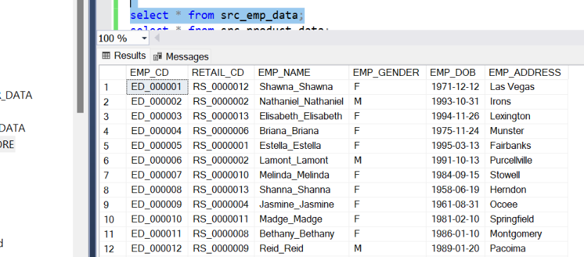 **STEP1: Src_emp_data, src_product_data, src_customer_data, src_sales, src_retail_store are all loaded from the respective csv files.**

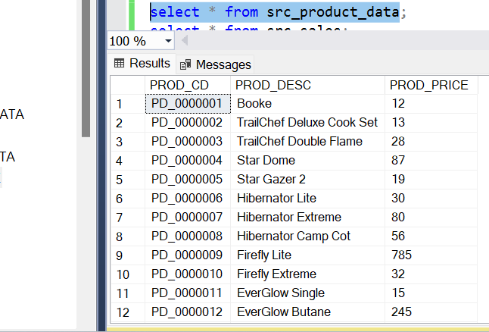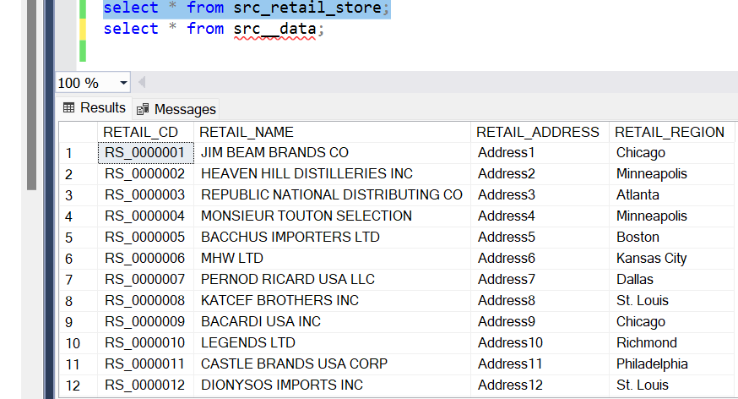

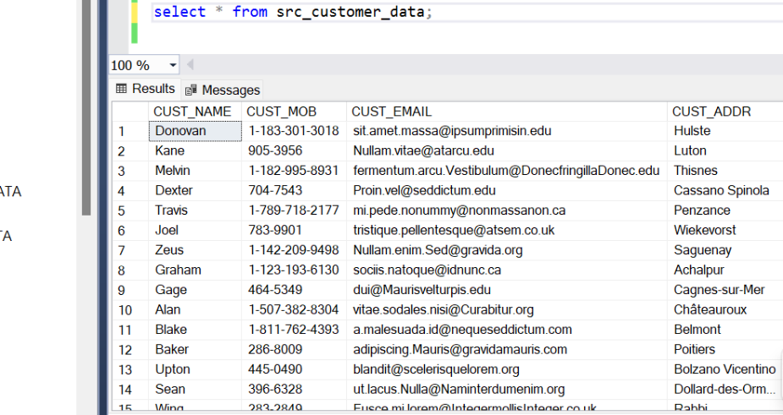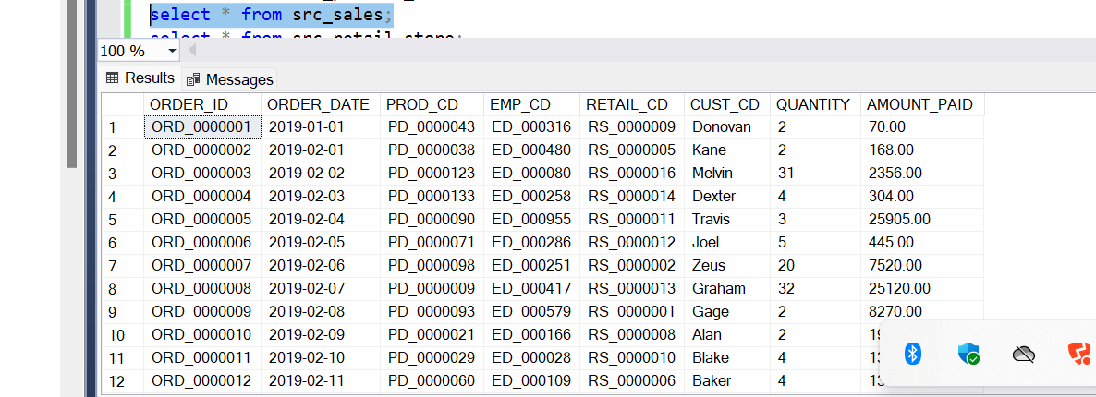

**STEP2 : Load these into the staging tables.**

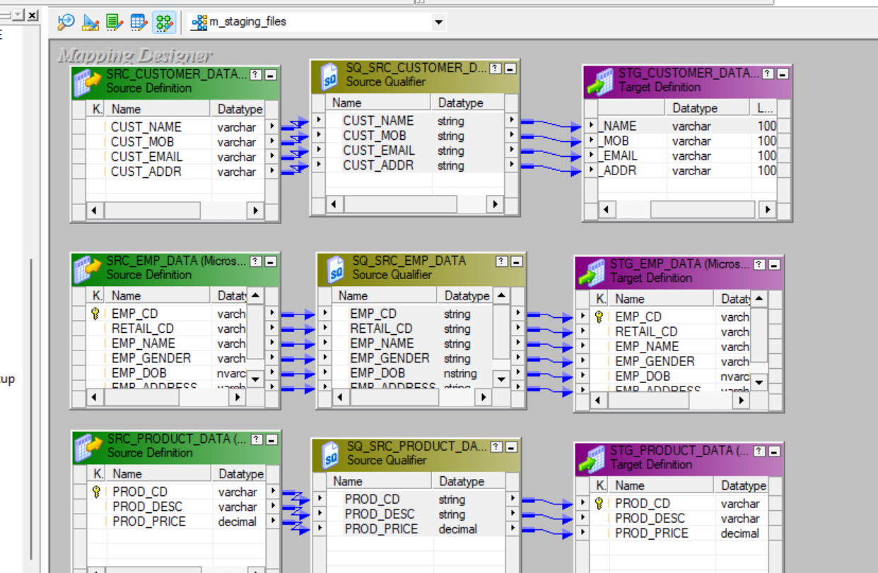

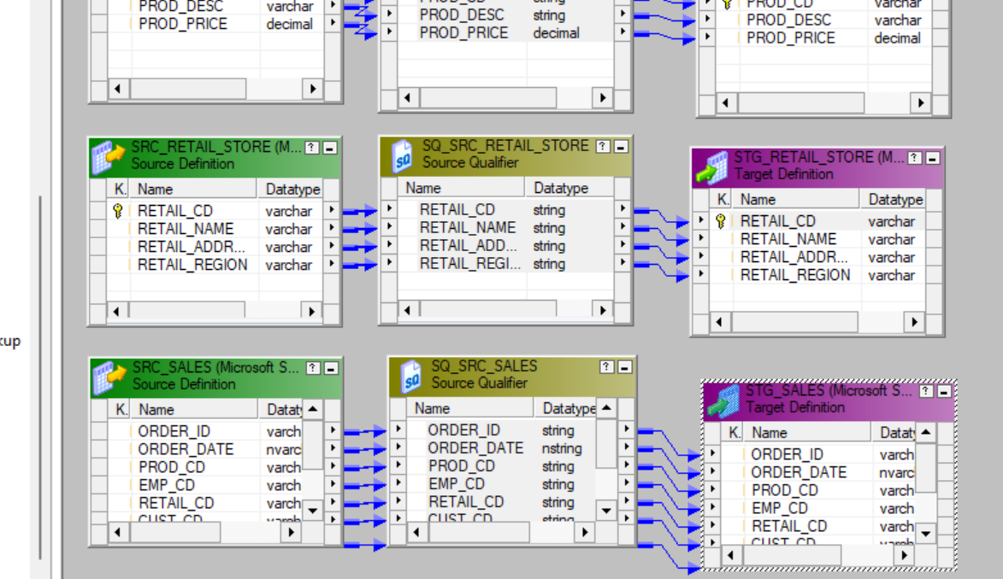

**All the source data were properly put into staging tables**

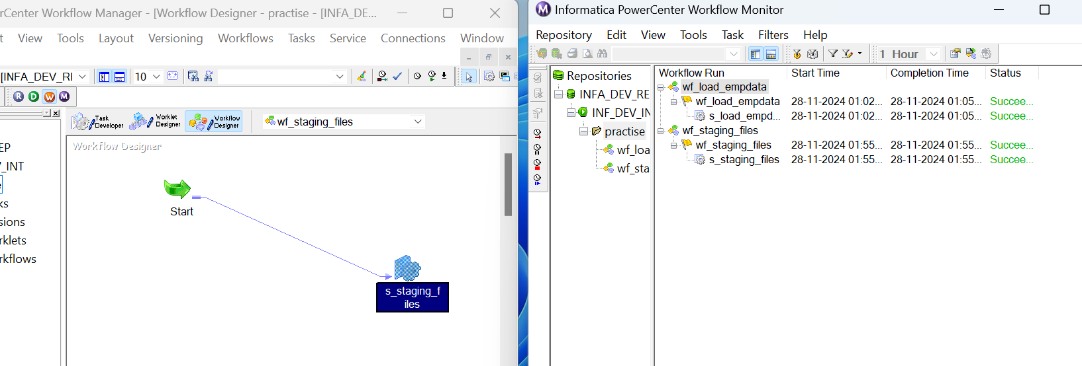

**STEP 3: Now we perform SCD1 operation for all the dimension tables using condition - iif**(**isnull**(lkp_cust),dd_insert,dd_update)

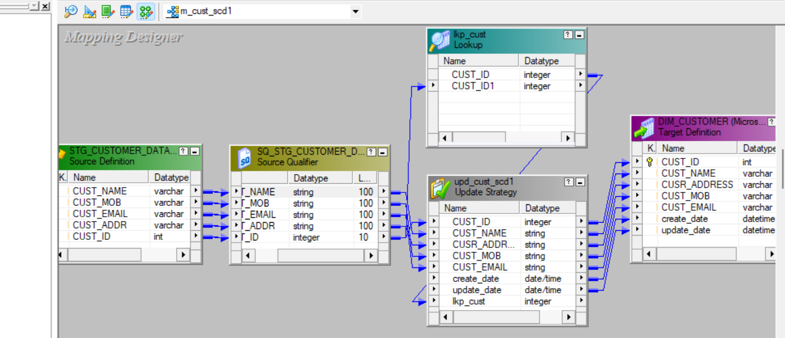

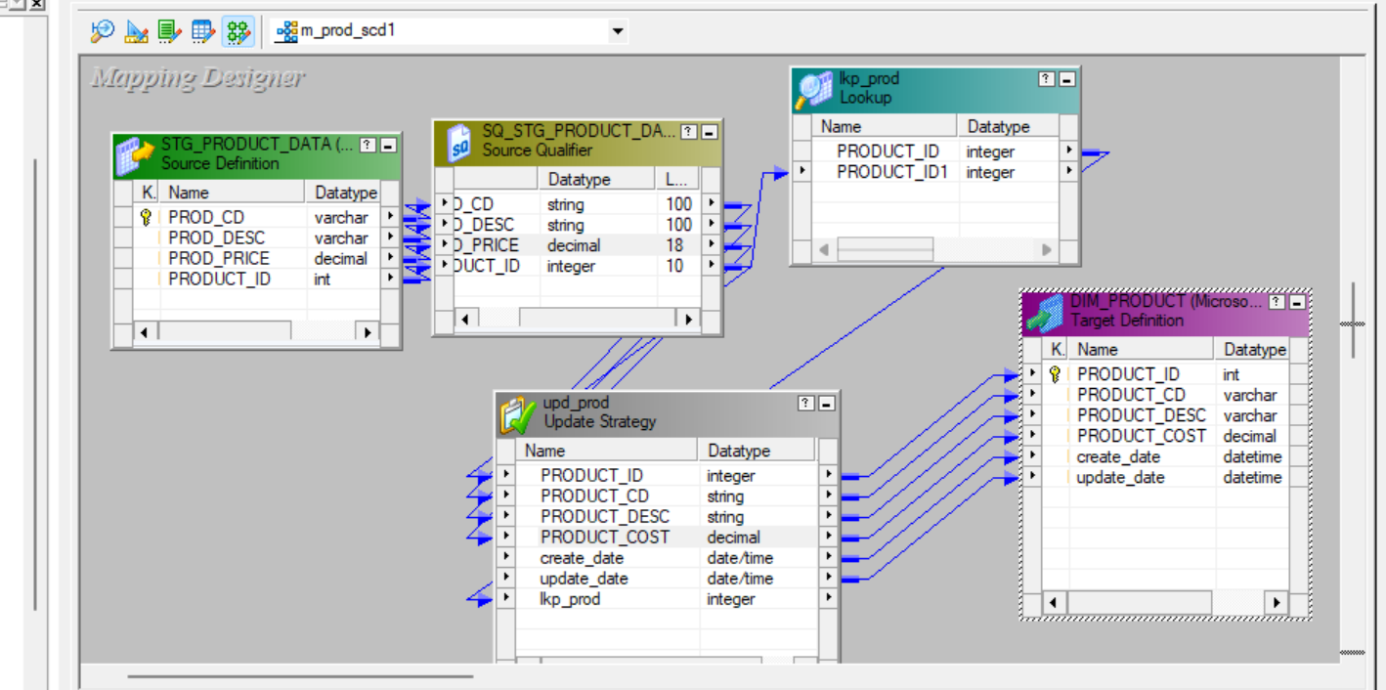

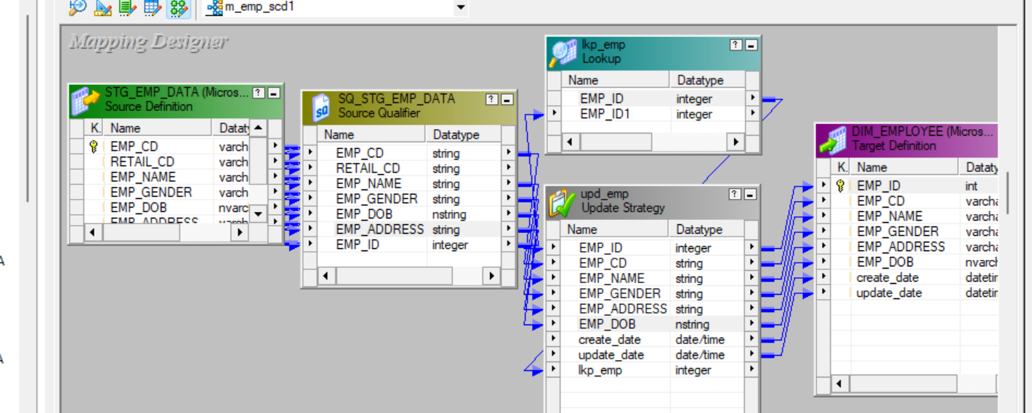

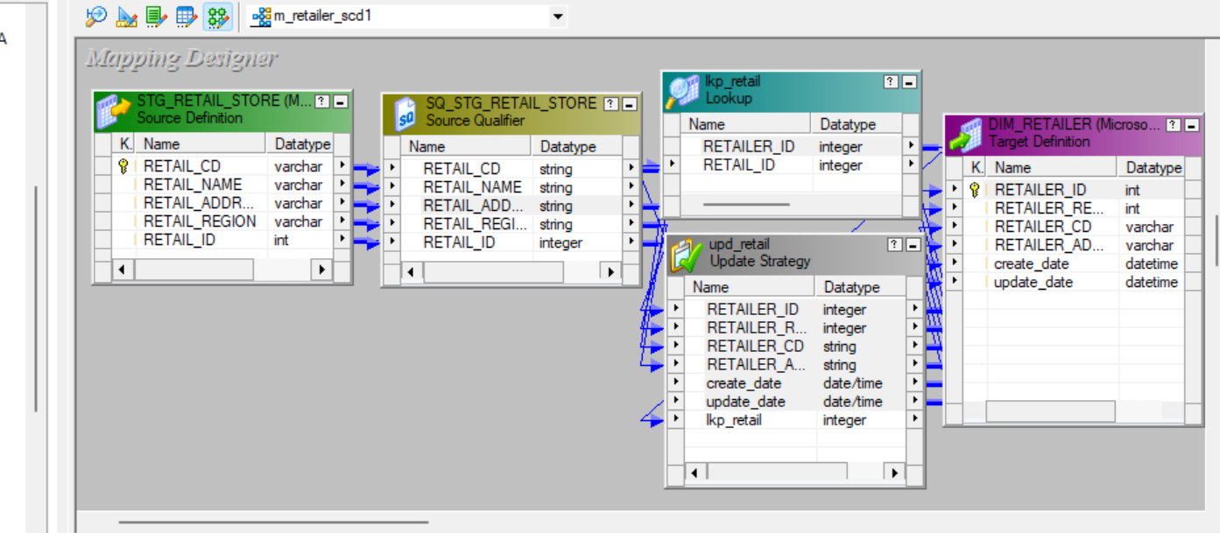

**STEP4: Now we use lookup and router to join the fact table with the dimension tables. Then we obtain our fact table in the form of an excel sheet.**

