PROJECT REPORT – IMAGE GALLERY
Introduction
Vintage Echoes is a responsive vintage-themed gallery website developed to showcase different categories of vintage collections such as cars, hats, bags, shoes, coins, arts, and jewellery. The website was designed with a calm and elegant visual style inspired by nostalgic vintage aesthetics. The main aim of the project was to create an interactive and user-friendly image gallery that works smoothly on different devices.

HTML
HTML was used to create the structure of the website. Different pages were created for the homepage, category galleries, and saved images section. HTML helped in organizing navigation bars, image cards, carousel sections, headers, footers, and the lightbox modal. Semantic tags were also used to improve readability and accessibility.

CSS
CSS was used to design the visual appearance of the website and create the vintage theme. Soft background colors, elegant typography, shadows, spacing, and hover effects were added using CSS. Responsive layouts were created using CSS Grid, Flexbox, and media queries so that the website adjusts properly on mobile phones, tablets, and desktops. Smooth transitions and hover animations were also included to improve user experience.

JavaScript
JavaScript was used to add interactivity to the website. It was mainly used for opening images in a lightbox view, saving favorite images, and handling user interactions. The save feature was implemented using localStorage so that saved images remain available even after refreshing the page. JavaScript was also used for keyboard support, modal closing actions, and updating button states dynamically.
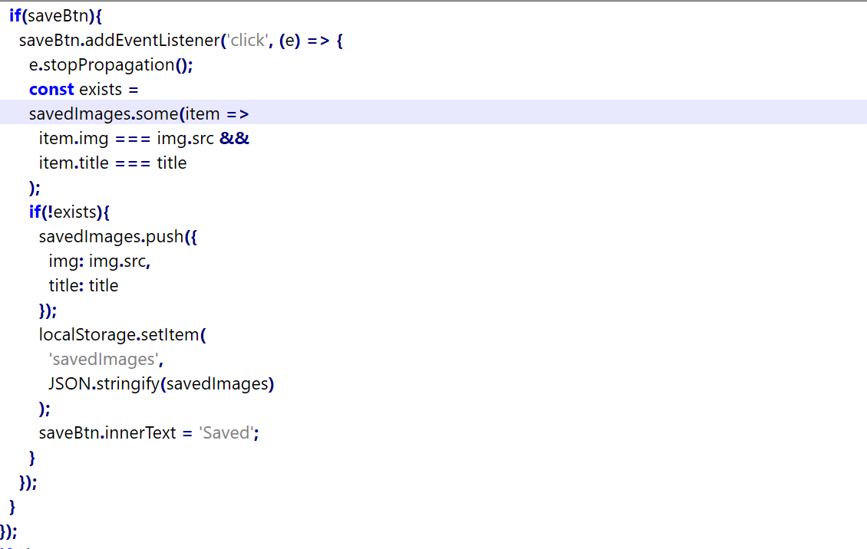

Bootstrap
Bootstrap was used to make the website more responsive and mobile friendly. It helped in building the carousel section on the homepage and provided responsive containers and layout utilities. Bootstrap also reduced development time by offering ready-made responsive components.
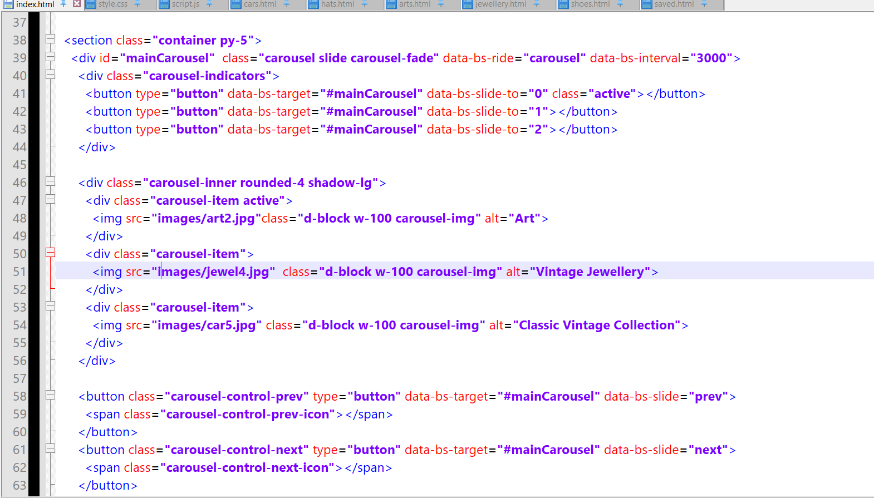

Homepage Design
The homepage contains a responsive carousel that automatically displays vintage images from different categories. Navigation controls and indicators were added to improve interaction. A brief introduction section was also included to describe the concept of the gallery and provide a welcoming experience for users.
Gallery Pages
Separate category pages were created for each vintage collection. Each page contains a responsive grid layout displaying multiple image cards with titles. Hover effects were added to create a modern Pinterest-style gallery appearance. Clicking on an image opens a larger preview using the lightbox feature.
Save Feature
A save feature was implemented to allow users to store their favorite images. When users click the save button, the image information is stored using localStorage and displayed in the saved collection page. Additional options were added to remove saved images and clear the entire collection.
Responsiveness
The website was designed to work properly on different screen sizes. Responsive layouts, flexible images, and media queries ensure that the gallery adapts smoothly to mobile phones, tablets, and desktop computers without breaking the layout.
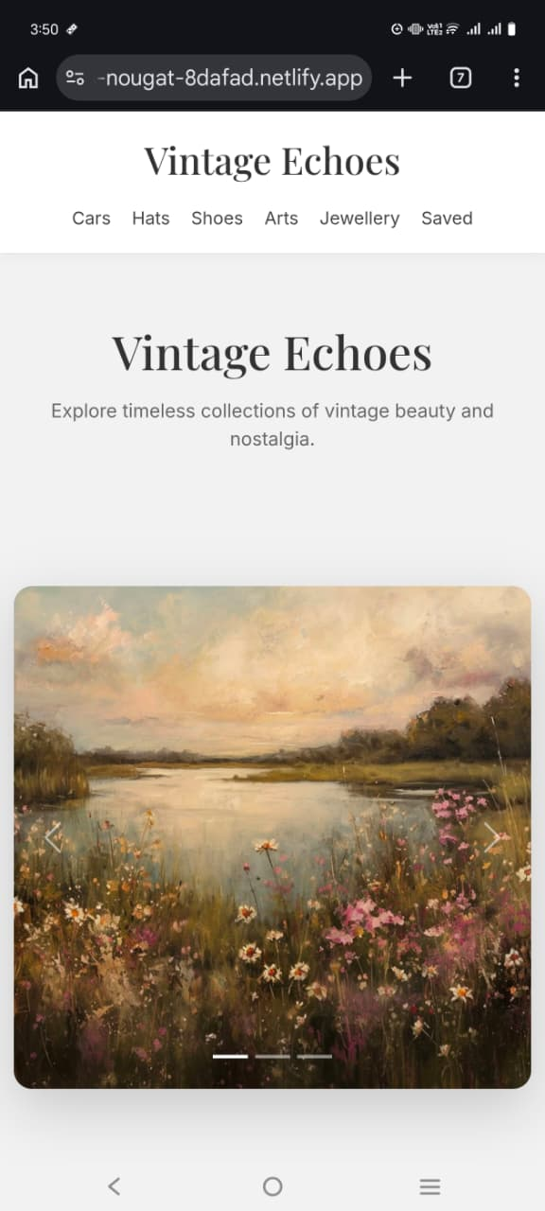

Deployment
The project was deployed online using platforms such as GitHub Pages and Netlify. Deployment made the website accessible from any device with an internet connection. Image folders and file paths were properly organized to ensure that all gallery images load correctly after deployment.
Link: https://6a0bf235566d09f0c227d470--famous-nougat-8dafad.netlify.app/

Conclusion
The Vintage Echoes project successfully combines design and functionality to create an interactive vintage gallery website. Through this project, knowledge of HTML, CSS, JavaScript, Bootstrap, responsive design, localStorage, and website deployment was improved. The final website provides a clean, responsive, and visually appealing user experience for exploring vintage collections.

