SOFTWARE PROJECT REPORT

NEUROSCAN AI
BRAIN TUMOR SEGMENTATION
DESIGN IMPLEMENTATION AND EVALUATION

Prepared by
Hamza Mustafa
GitHub
github.com/mirxa-hamza
Project Repository
github.com/mirxa-hamza/
Brain-Tumor-Segmentation-Classification

National University of Modern Languages
Department of Computer Sciences

14 SEPTEMBER 2026
Prepared for academic project submission
Educational application for multi-modal brain MRI segmentation

Acknowledgments
I acknowledge the open-source contributors and tools, including PyTorch, NumPy, NiBabel, FastAPI, Next.js, React, and NiiVue, that supported the development of NeuroScan AI. I also thank the BraTS dataset contributors and Kaggle for providing resources that enabled this academic project.

Project context
This project was prepared by Hamza Mustafa, Department of Computer Sciences, National University of Modern Languages. It demonstrates software engineering and deep learning integration for brain MRI studies. Its intended use is education and research; results require expert review before any medical interpretation.

Executive Summary
NeuroScan AI integrates a PyTorch 3D U-Net with FastAPI and Next.js to segment four MRI modalities (T1, T1-CE, T2, and FLAIR), providing visualization, volume metrics, mask export, and PDF reports. The model achieved a recorded mean validation Dice of 87.08% across NCR/NET, ED, and ET regions. Future work includes improving inference completeness, reproducibility, and systematic application testing.

Table Of Contents
Acknowledgments 2
Project context 2
Executive Summary 3
Introduction 5
Background and problem statement 5
Objectives 5
Scope and terminology 5
Methodology 6
System architecture 6
Architecture and Tech Stack 7
Storage and interfaces 7
Dataset Organization 8
MRI Inputs and Preprocessing 9
Model Design and Training 10
Prediction and Evaluation Rules 11
From network output to labels 11
Measurements 11
Analysis 12
Application workflow 12
Browser data delivery 12
API and Case Persistence 13
Key Findings 14
Training and validation loss 14
Validation Dice Results 15
Saved MRI Segmentation Example 16
Region Volumes and Result Interpretation 17
What was verified for this report 17
Limits of the evidence 17
Recommendations 18
Model evaluation and input coverage 18
Reproducibility and case provenance 18
Application reliability 18
Deployment and user experience 18
References 19

Introduction

Background and problem statement
A segmentation checkpoint is only one part of a usable MRI application. A complete workflow must identify the four input modalities, validate uploads, prepare volume arrays, run the model, restore output dimensions, display the segmentation, and communicate measurements and errors. NeuroScan AI addresses these integration tasks in a local web application.
Multi-modal MRI supplies complementary information. T1 provides anatomical contrast, T1-CE highlights contrast-associated signal, and T2 and FLAIR contribute fluid-sensitive information. The model uses all four arrays as input channels. The project assumes a compatible study organization; importing files is not equivalent to performing registration or establishing clinical image quality.

Objectives
- Implement a compact 3D U-Net for the three BraTS tumor sub-regions.
- Require a case name and a complete four-modality study before analysis.
- Provide interactive MRI viewing, segmentation overlays and volume summaries.
- Support segmentation download, PDF export and a combined local startup command.
- Document recorded results and the limitations of the current research workflow.

Scope and terminology
The output is a voxel-wise label map with values 0, 1, 2 and 4. The application does not implement a separate disease classification model, histological grading, treatment recommendation or hospital-record integration. The software should be evaluated as an educational segmentation and visualization system. [3–7]

Methodology

System architecture
The project separates offline training from local serving. The training script produces model.pt and metrics.json. During serving, a model holder loads compatible weights, uses CUDA when available or CPU otherwise, and runs evaluation without gradients. Case artifacts remain in the backend workspace. [1, 4]
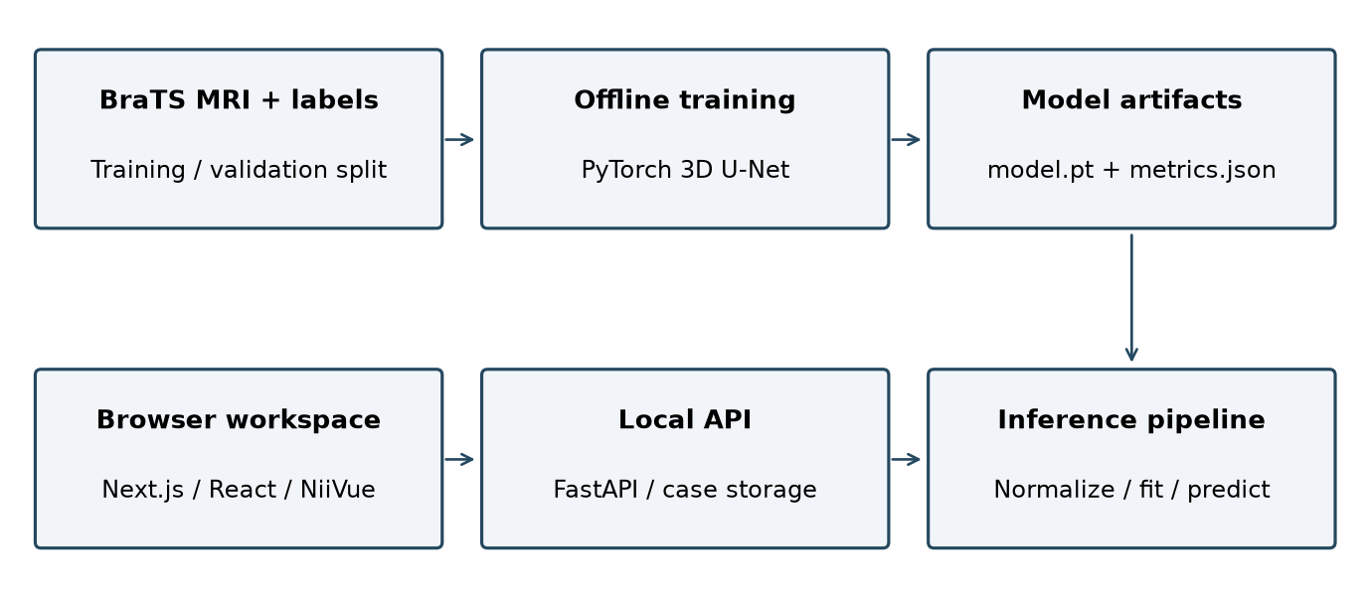
Figure 1. Application components and the offline training artifact path. Browser requests reach the local FastAPI service through the Next.js proxy.
The browser first uploads a named study to POST /api/cases. Segmentation is a separate POST /api/cases/{id}/predict action. Original volumes and the saved label map are then fetched by the viewer, while a report route reads the saved data to generate a PDF. [6, 7]
If a checkpoint or PyTorch is unavailable, the inference service can generate a synthetic demonstration label map. This must remain distinguishable from trained-model output. The saved example used later in this report does not preserve enough model provenance to establish which path created it. [4]

Architecture and Tech Stack
Python implements import, preprocessing, model execution, measurement and PDF generation. TypeScript and React implement the browser workflow. The current ML path uses PyTorch; TensorFlow, Keras and OpenCV are not part of the declared backend implementation. [3, 10]
Table 1. Implemented technology stack
Layer | Technology | Responsibility
Frontend | Next.js, React, TypeScript | Routing, case state and user actions
Presentation | Tailwind CSS, Lucide | Responsive layout and icons
MRI viewer | NiiVue | Volume slices and label overlays
Metrics | Recharts | Loss curves and Dice display
API | FastAPI, Uvicorn, Pydantic | Requests, schemas and responses
Model | PyTorch | 3D convolutions and inference
Image data | NiBabel, NumPy, SciPy, pydicom | NIfTI arrays and DICOM import
PDF report | ReportLab, Pillow | Formatted case report and images
Persistence | Local NIfTI and JSON files | Case images, masks and metadata
Startup | npm, PowerShell | Combined local process launch

Storage and interfaces
The project stores case folders beneath backend/data/cases and model artifacts beneath backend/models_store. A relational database is not implemented. The browser uses NEXT_PUBLIC_API_BASE_URL when explicitly configured; otherwise it addresses the /backend proxy. This environment variable name is taken from the current client API module. [7, 9]

Dataset Organization
The metrics notes record 1,128 training cases and 125 validation cases, a total of 1,253 studies. The current script shuffles complete case groups with seed 42 and allocates 10% to validation. Counts below reproduce the saved experiment notes; no full dataset recount was performed for this report. [1, 2]
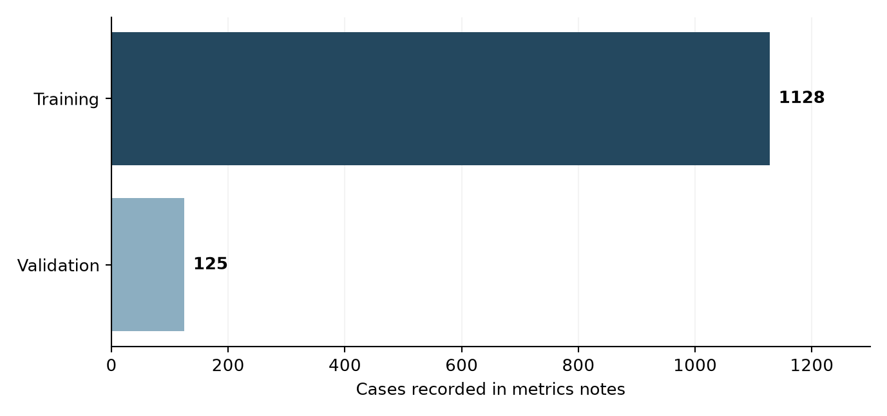
Figure 2. Recorded training and validation case counts. Source: backend/models_store/metrics.json.
Table 2. Required study files
Input | Naming example | Role
T1 | case_t1.nii.gz | First input channel
T1-CE | case_t1ce.nii.gz | Second input channel
T2 | case_t2.nii.gz | Third input channel
FLAIR | case_flair.nii.gz | Fourth input channel
Reference label | case_seg.nii.gz | Training target; not an input modality

Training discovery requires the four modalities plus a segmentation target in a common case group. The uploader requires the four image modalities for serving. A dataset reference segmentation must not be confused with a new model prediction.

MRI Inputs and Preprocessing
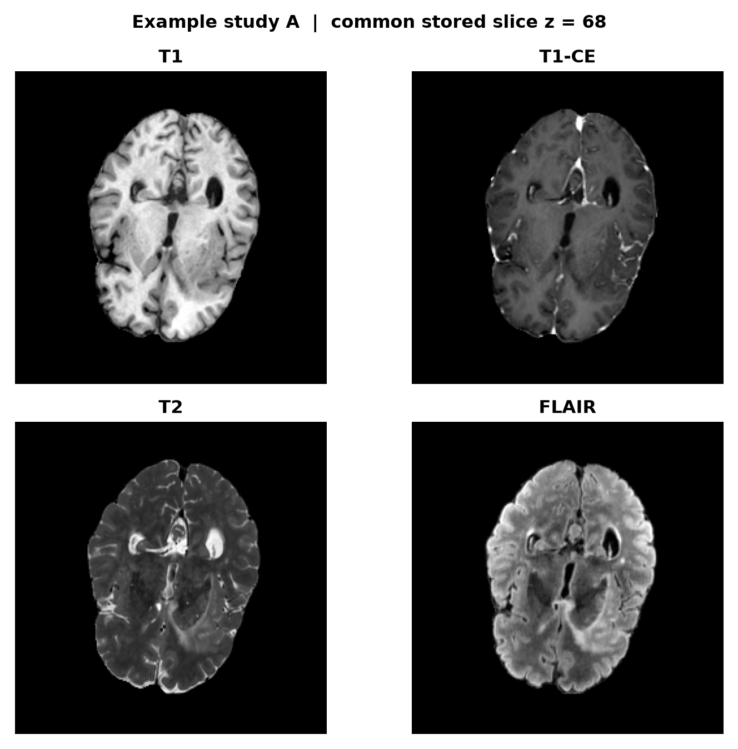
Figure 3. Four MRI modalities from Example study A at stored slice z = 68. Images are rendered from the project NIfTI files; no clinical orientation labels are inferred.
Normalization is applied to voxels with intensity greater than zero. Their mean and standard deviation define the z-score transform; other voxels remain zero. A very small standard deviation is replaced by 1.0. Each array is centre-cropped or zero-padded to 128 × 128 × 128; it is not spatially resampled. [1, 4]
For a 240 × 240 × 155 volume, centre fitting retains indices 56–183 on the first two axes and 13–140 on the third. Restoring the output shape fills excluded areas with zeros, so cropped peripheral tissue cannot receive model predictions. This is a material limitation when interpreting full-volume overlays.

Model Design and Training
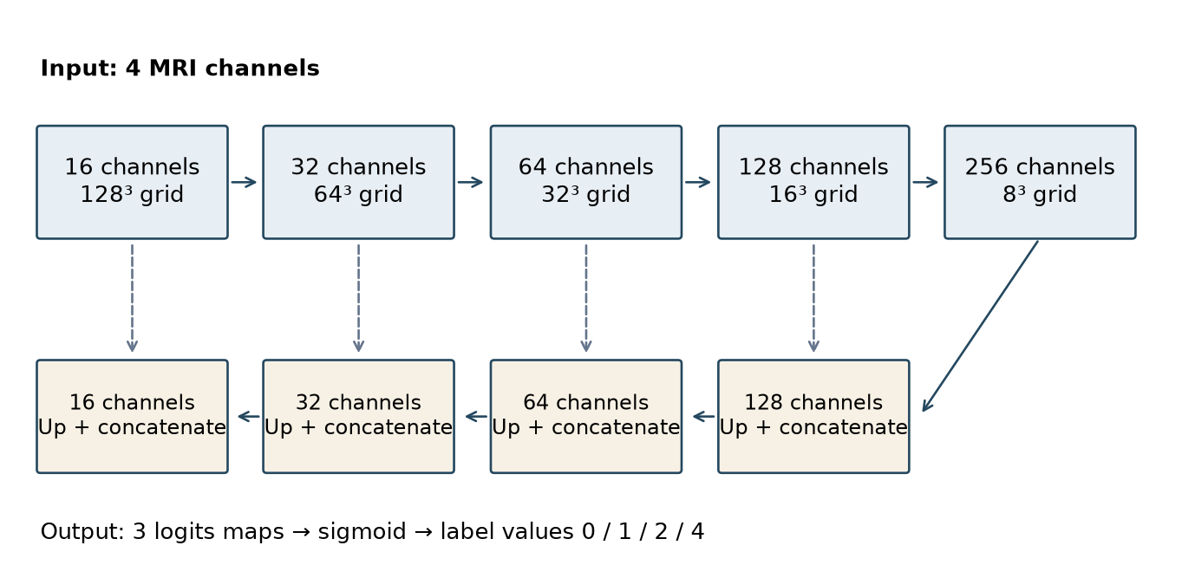
Figure 4. Compact 3D U-Net stages. Dashed arrows are encoder-to-decoder skip connections. Spatial dimensions refer to the fitted model grid.
Each convolution block applies two 3 × 3 × 3 convolutions with affine InstanceNorm3d and LeakyReLU. Strided convolutions downsample the grid; transposed convolutions upsample it. Decoder blocks concatenate the matching encoder feature maps. The final 1 × 1 × 1 convolution returns three logits maps. [3]
Table 3. Current training configuration
Setting | Value
Input / base channels | 4 modalities / 16 base channels
Grid / batch size | 128 × 128 × 128 / 1
Epochs / optimizer | 40 / Adam
Initial learning rate | 0.0001
Scheduler | CosineAnnealingLR, T_max = 40
Loss | Binary cross entropy with logits + soft Dice loss
Validation / seed | Every 2 epochs / 42
Checkpoint policy | Final model saved after training

Prediction and Evaluation Rules

From network output to labels
Training targets use three binary channels corresponding to label values 1, 2 and 4. Soft Dice loss is added to binary cross entropy with logits. The validation metric thresholds sigmoid outputs at greater than 0.5 independently for each channel and averages batch-level Dice values. With batch size one, this acts as a mean of case-level scores. [1]
Serving applies sigmoid, restores each probability array to the source dimensions and assigns the highest-probability class when its score is at least 0.5. If no class passes, the voxel is background. This single-label resolution differs from independent channel thresholding in validation, so a reported training Dice does not directly establish the score of the exported label map. [4, 5]
Table 4. Segmentation labels and derived regions
Region | Definition | Output type
Background | 0 | Label value
NCR/NET | 1 | Label value
Edema | 2 | Label value
Enhancing tumor | 4 | Label value
Whole tumor | 1 or 2 or 4 | Derived union
Tumor core | 1 or 4 | Derived union

Measurements
Dice = (2 × intersection + ε) / (predicted voxels + reference voxels + ε), with ε = 0.00001 in the training script. Volume in cm³ = labelled voxel count × voxel volume in mm³ / 1000. Whole-tumor and tumor-core volumes overlap the component categories and must not be added again to obtain a total. [1, 5]

Analysis

Application workflow
The interface provides a dashboard, upload page, case detail, metrics and about page. Upload state identifies all four modalities and requires a nonblank case name. Following case creation, the user starts segmentation from the case detail page. Successful prediction updates the saved mask and region statistics. [6, 7]
Table 5. User interactions and states
State or action | Implemented behavior
Incomplete study or empty name | Upload is unavailable; required input must be supplied
Named complete study | Multipart case upload is available
Segmentation request | Processing state while the API runs prediction
Viewer controls | Choose modality, layout, overlay opacity and label visibility
Download mask | Save the generated NIfTI segmentation
Export PDF | Same-page download link to the report attachment route
Viewer or API failure | Error state is displayed for the failed action

Browser data delivery
Current viewer URLs are extensionless. The NiiVue component supplies an explicit NIfTI filename for format detection. This reduces interception by download-manager extensions that target .nii.gz links. The PDF export uses a same-page anchor to the attachment endpoint without a client-side PDF-signature check. The interface timer does not prove that the download completed. [7]
The frontend and backend are separate processes coordinated by npm run dev through scripts/dev.ps1. Dependencies must be installed before this launcher is used. [9]

API and Case Persistence
Table 6. Principal backend routes
Method and path | Purpose
GET /api/health | Model, device and service state
GET /api/metrics | Recorded training and validation metrics
GET /api/cases | List stored cases
POST /api/cases | Validate and store a named study
GET /api/cases/{id} | Read case metadata
POST /api/cases/{id}/predict | Run segmentation and update saved state
GET /api/cases/{id}/volume/{modality} | Read an MRI volume
GET /api/cases/{id}/segmentation | Read the saved label map
GET /api/cases/{id}/report.pdf | Generate a case-report attachment
DELETE /api/cases/{id} | Delete the selected case

Case storage normalizes imported NIfTI output to float32 with a clean header and spatial affine. Generated segmentation uses a fresh uint8 header. This is intended to improve compatibility with browser NIfTI parsers; it does not establish that every input series is registered or clinically suitable. [4, 6]
The backend streams uploaded files and applies an aggregate upload limit. ZIP handling checks member count, expanded size, path safety and compression ratio. The configured backend upload limit is 2 GiB, whereas the local Next.js proxy is set to 128 MB. End-to-end acceptance is therefore constrained by the smaller applicable limit. [6, 9]
The report endpoint requires a saved segmentation, reads the current volume and label map, recomputes statistics and creates slice images. Recomputing values from the stored mask helps avoid displaying stale metadata in the exported report. [8]

Key Findings

Training and validation loss
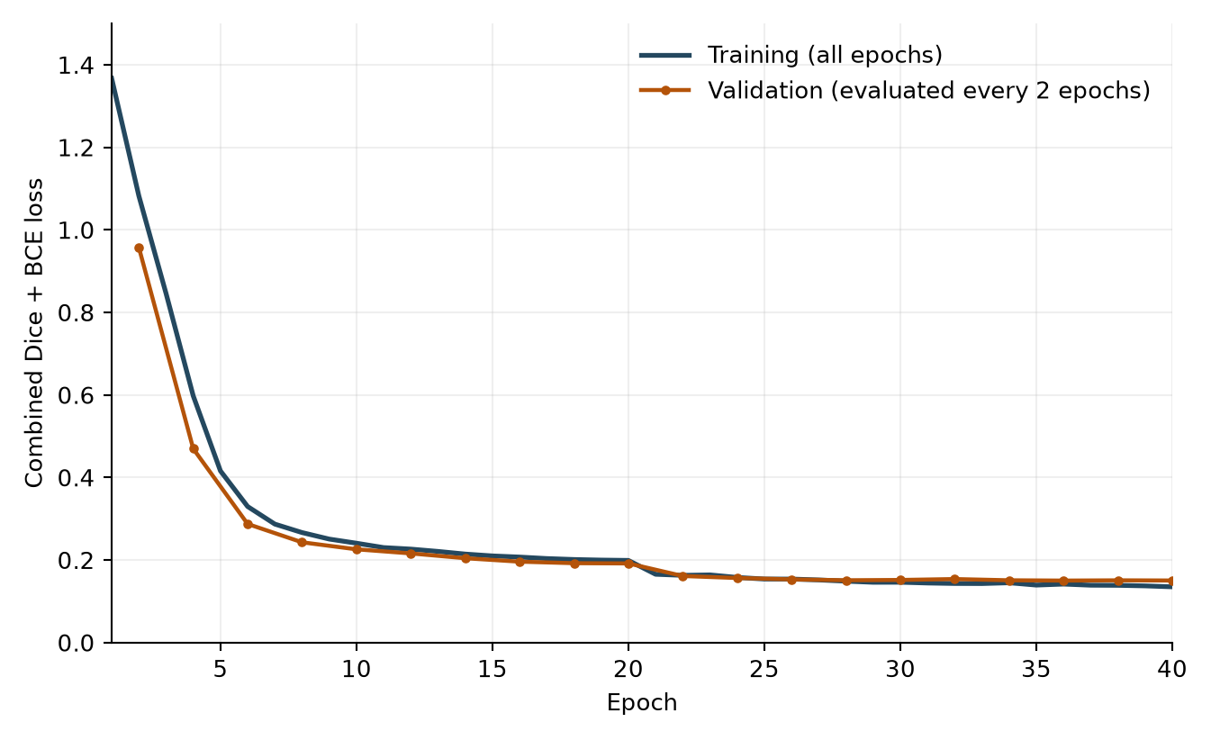
Figure 5. Recorded 40-epoch training curve and evaluated validation points. Odd-epoch validation placeholders are deliberately omitted. Source: metrics.json and validation cadence in train_brats.py.
Table 7. Recorded loss summary
Quantity | Value
Initial training loss, epoch 1 | 1.3669
Final training loss, epoch 40 | 0.1347
First evaluated validation loss, epoch 2 | 0.9571
Lowest evaluated validation loss, epoch 36 | 0.1498
Final validation loss, epoch 40 | 0.1500

Both evaluated curves decrease substantially during the run and flatten later. Final validation loss is slightly above its minimum at epoch 36. The current script saves the final checkpoint, rather than selecting the epoch with minimum validation loss. The recorded curves cannot establish external generalization. [1, 2]

Validation Dice Results
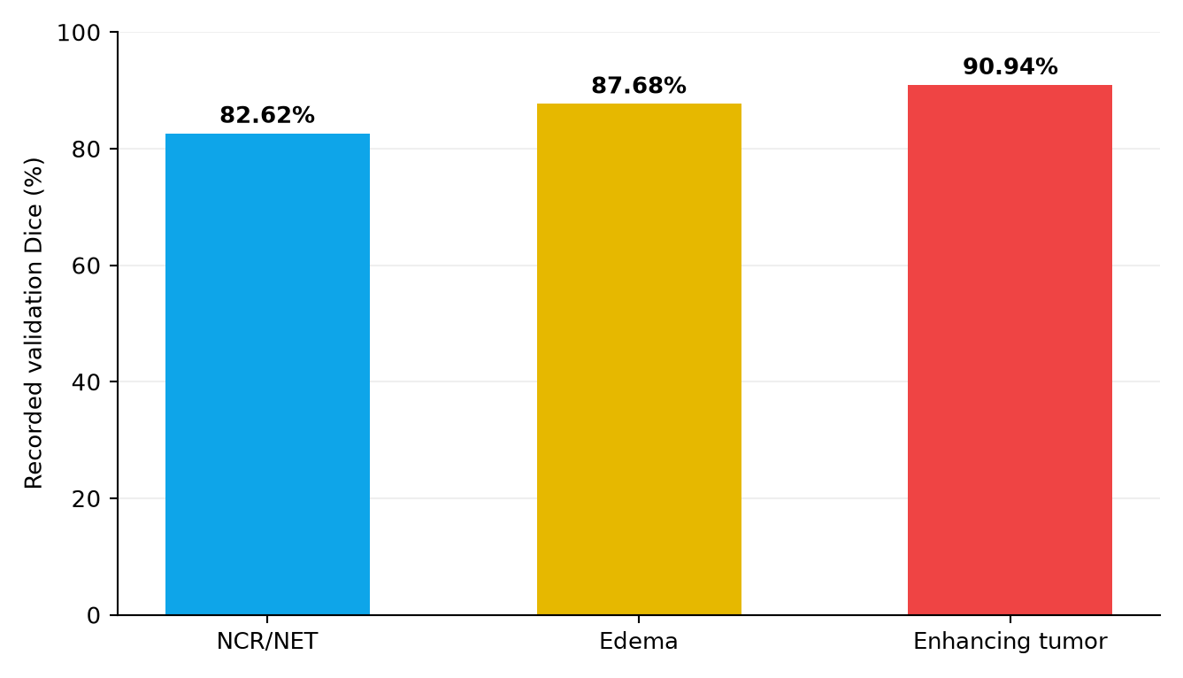
Figure 6. Recorded per-region validation Dice on a zero-to-100% scale. These are overlap scores, not classification accuracy or clinical confidence.
Table 8. Recorded validation overlap
Region | Dice | Percentage
NCR/NET | 0.8262 | 82.62%
Edema | 0.8768 | 87.68%
Enhancing tumor | 0.9094 | 90.94%
Arithmetic mean | 0.8708 | 87.08%

Enhancing tumor has the highest recorded score; NCR/NET has the lowest, separated by 8.32 percentage points. The mean above is calculated from the three saved class scores and is not an additional independently measured metric. The artifact does not include per-case predictions or confidence intervals. [2]
The saved notes mention dual GPUs, but the inspected training script places a model on one selected device and does not implement distributed or DataParallel training. The notes alone do not establish the exact historical execution configuration. A frozen notebook and environment record would resolve this provenance gap. [1, 2]

Saved MRI Segmentation Example
Example study A has stored dimensions 240 × 240 × 155 and voxel spacing 1 × 1 × 1 mm. Figures 3 and 7 use the same saved project study. The label map is read directly from disk and contains only the expected labels 0, 1, 2 and 4.
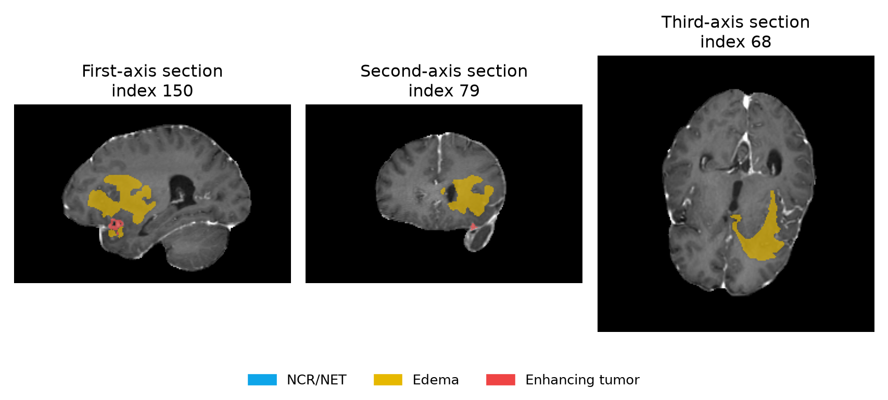
Figure 7. Saved segmentation over T1-CE slices, chosen independently along each stored array axis for maximum labelled area. Colours follow the project legend. These are illustrative stored outputs, not reference annotations.
Table 9. Recomputed measurements for Example study A
Region | Voxel count | Volume cm³
NCR/NET | 10 | 0.010
Edema | 26,875 | 26.875
Enhancing tumor | 3,310 | 3.310
Whole tumor | 30,195 | 30.195
Tumor core | 3,320 | 3.320

The example metadata does not retain a checkpoint hash or demo-mode flag. Consequently, the stored mask is suitable for demonstrating the software output format, but it cannot be used here as evidence of a newly verified model prediction. No paired ground-truth mask was used to calculate case-specific Dice.

Region Volumes and Result Interpretation
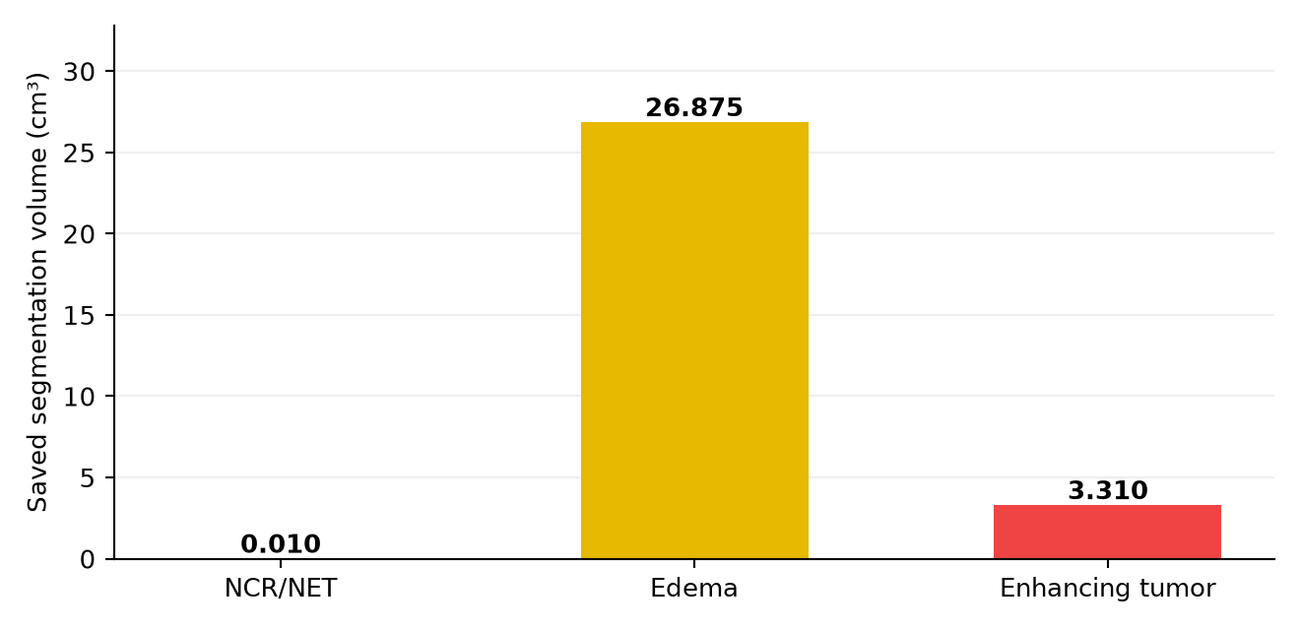
Figure 8. Non-overlapping component volumes recomputed from the saved mask for Example study A. Composite whole-tumor and tumor-core values are excluded from this chart to avoid double counting.
Edema accounts for 89.00% of labelled voxels in this saved example. Whole tumor is 30.195 cm³ and tumor core is 3.320 cm³. These are geometric measurements from a label map; they do not determine malignancy, grade or clinical severity.

What was verified for this report
The report-generation checks read the compressed NIfTI header and voxel payload, verify array dimensions and allowed labels, recompute voxel counts and compare them with the saved case statistics. Graph values are taken directly from metrics.json. This checks the consistency of the illustrated artifacts; it is not a new model-training or accuracy experiment.

Limits of the evidence
There is no independent test-set score, whole-volume exported-mask Dice, Hausdorff distance, per-case distribution or confidence interval in the supplied metrics artifact. A confusion matrix or ROC curve would require additional prediction and reference data; inventing such figures would misrepresent the available results.

Recommendations
The following priorities arise from the current source code and the saved evidence. They are proposed improvements to the software and experimental workflow.

Model evaluation and input coverage
Evaluate the exact exported label-map algorithm, including class conflict resolution and the 0.5 boundary. Separate true validation observations from unmeasured epochs in future metrics files. Save the best checkpoint using an explicit selection rule, and report held-out per-case metrics with uncertainty estimates.
Replace or complement centre cropping with sliding-window inference or another method that covers the full image. Verify modality shapes, spatial alignment and orientation before stacking arrays. A restored array size alone does not recover tissue removed by cropping.

Reproducibility and case provenance
Persist model version, checkpoint hash, preprocessing configuration and demo-mode status with each result. Store dataset split manifests and exact execution configuration with training artifacts. Make synthetic demonstration results unmistakable in the viewer and exported report.

Application reliability
Add integration checks covering a complete upload-to-viewer-to-PDF flow, malformed NIfTI payloads, incomplete modalities, empty names, rejected archives and backend failures. Align proxy and backend upload limits. A report download should expose server errors clearly and avoid navigation side effects.

Deployment and user experience
Treat deployment as a separate validation task. The present system uses a local proxy, filesystem persistence and a development launcher. A hosted version needs suitable model-serving compute, durable storage and controlled access. Test keyboard navigation, focus feedback, contrast and comprehensible error states throughout the study workflow.

References
Primary project evidence is listed below. Numerical results and illustrations in this report are traceable to these local source files and saved artifacts. Package manifests declare compatible dependencies; they do not prove the versions used in the historical training environment.
[1] Hamza Mustafa. training/train_brats.py. Dataset discovery, centre fitting, 3D U-Net training, Dice calculation, validation cadence and checkpoint export.
[2] Hamza Mustafa. backend/models_store/metrics.json. Forty recorded epochs, loss arrays, per-region validation Dice and experiment notes.
[3] Hamza Mustafa. backend/app/models/unet3d.py and backend/app/core/config.py. Network blocks, channels, modality order, model grid and label definitions.
[4] Hamza Mustafa. backend/app/services/preprocessing.py and inference.py. Intensity normalization, crop/pad transforms, model loading, demo fallback and segmentation writing.
[5] Hamza Mustafa. backend/app/services/postprocessing.py. Probability-to-label conversion and region volume calculations.
[6] Hamza Mustafa. backend/app/services/case_store.py, dicom_import.py and api/routes/cases.py. Case creation, file safeguards, DICOM import and API behavior.
[7] Hamza Mustafa. frontend/lib/api.ts, components/cases/CaseDetailClient.tsx, components/viewer/NiivueViewer.tsx and upload components. Browser requests, viewing and download actions.
[8] Hamza Mustafa. backend/app/services/report.py. PDF construction, image preparation and case measurement presentation.
[9] Hamza Mustafa. README.md, package.json, scripts/dev.ps1 and frontend/next.config.js. Startup requirements, proxy and development configuration.
[10] Hamza Mustafa. backend/requirements.txt and frontend/package.json. Backend and frontend dependency declarations.
[11] Saved local project case 6502ce1b58cd. raw/t1.nii.gz, raw/t1ce.nii.gz, raw/t2.nii.gz, raw/flair.nii.gz, segmentation.nii.gz and meta.json. Displayed as Example study A.

