SOFTWARE PROJECT REPORT
PNEUMOSCAN AI
CHEST X-RAY CLASSIFICATION
DESIGN, IMPLEMENTATION AND EVALUATION
Prepared by
Hamza Mustafa
GitHub
github.com/mirxa-hamza
Project Repository
github.com/mirxa-hamza/Pneumonia-Detection
National University of Modern Languages
Department of Computer Sciences

14 SEPTEMBER 2026
Prepared for academic project submission.
An educational application for chest X-ray classification.

Acknowledgments
I acknowledge the open-source communities and contributors of PyTorch, torchvision, timm, FastAPI, Next.js, React, and other tools that supported the development of PneumoScan AI. I also appreciate the contributions of Kaggle and the supporting libraries that enabled model training, evaluation, and full-stack application development.

Executive Summary
PneumoScan AI classifies uploaded chest X-rays as normal or pneumonia positive using EfficientNet-B0, PyTorch and a FastAPI backend. Its Next.js interface provides image previews, color-coded predictions and one-command local startup. The saved experiment reports 92.31% accuracy, 90.52% pneumonia precision and 97.95% pneumonia recall on 624 test images. However, the final threshold was selected after examining test results, so these figures are exploratory. The project demonstrates an integrated educational application; independent evaluation, dataset auditing and deployment testing remain the main next steps.

Table of Contents
Acknowledgments 1
Executive Summary 3
Table of Contents 4
Introduction 5
Methodology 6
Analysis 11
Key Findings 15
Recommendations 19
References 20

Introduction

Background and Problem Statement
A trained machine learning model alone does not provide a complete software application. A usable system must also prepare inputs consistently, expose a reliable prediction interface and communicate results in a form that users can understand. PneumoScan AI addresses this engineering problem by connecting a chest X-ray classification model to a browser-based upload workflow.
The project focuses on binary classification using images organized into NORMAL and PNEUMONIA classes. The frontend allows a user to select an image, inspect a preview and request a prediction without writing Python commands. The backend applies the model's preprocessing steps, performs inference and returns structured results.

Core Objectives
- Develop a transfer-learning classifier using the available chest X-ray dataset.
- Separate training, validation and evaluation responsibilities in the software.
- Report accuracy, precision, recall, F1-score and ROC-AUC.
- Provide an understandable interface with green normal and red pneumonia-positive results.
- Support local startup of the frontend and backend through one command.
- Preserve trained weights, preprocessing metadata and the decision threshold for inference.
The original project plan targets at least 90% accuracy and 90% pneumonia precision. These are project objectives, not guaranteed outcomes for new datasets or real-world use.

Scope of the Application
The application accepts JPEG and PNG images. It implements two-class inference and displays model scores. It does not implement DICOM processing, disease localization, severity grading, patient registration, medical records or multiclass diagnosis. An image passing file validation is not necessarily a chest X-ray; there is no separate model that confirms the anatomical content of an upload.
This report describes the current source files and saved artifacts. Historical notes and plans are treated as supporting context; where they differ from executable code, the current implementation takes precedence.

Methodology

System Architecture
The implementation combines an offline training workflow with an online inference workflow. Training is executed through Python scripts, with notebooks supporting Kaggle operation. The resulting checkpoint is copied into the application's artifacts directory. During local operation, the API loads that checkpoint and serves predictions to the browser.
The main request sequence is:
1. The user selects or drops an image into the Next.js interface.
2. The browser checks its declared format and size and creates an image preview.
3. The frontend sends a multipart request to POST /predict.
4. The API verifies the image and applies the evaluation transform.
5. EfficientNet-B0 produces two output scores, converted to probabilities through softmax.
6. The pneumonia probability is compared with the stored threshold.
7. The API returns JSON, which the frontend renders as a result card.
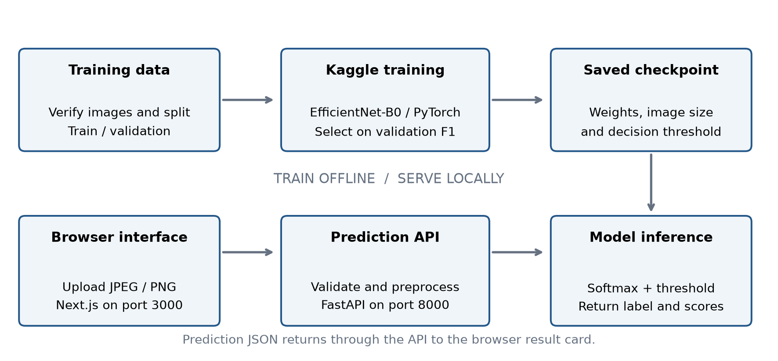
Figure 1. Training and local inference architecture, derived from src/train.py, src/api.py and the frontend request flow.

Architecture and Tech Stack
Python implements data handling, training, evaluation and model serving. JavaScript and JSX implement the Next.js/React frontend. CSS and Tailwind utility classes provide styling and animation. PowerShell coordinates local processes, and npm exposes the startup command.
The ML framework is PyTorch, with torchvision transforms and a timm model factory. The API uses FastAPI and Uvicorn. The alternative interface uses Gradio. TensorFlow and Keras are not part of the inspected implementation. OpenCV is declared as a dependency, but the core data and prediction code uses Pillow and torchvision rather than OpenCV operations.
No database is implemented. Model parameters are stored in a .pt checkpoint, evaluation outputs in JSON and PNG files, and frontend state in React component state. The FastAPI prediction handler does not explicitly persist uploaded images. This is distinct from a general claim that every component, including temporary upload handling in Gradio or the web framework, is free of temporary storage.
Table 1. Implemented technology stack
Layer | Technology | Responsibility
Interface | Next.js / React | Image upload, preview, request state and result display
Styling | Tailwind CSS / Lucide | Responsive layout, styling and interface icons
API | FastAPI / Uvicorn | Readiness route and multipart prediction endpoint
Model | PyTorch / timm | EfficientNet-B0 training and inference
Image processing | Pillow / torchvision | Decode, verify, resize and normalize images
Evaluation | scikit-learn / NumPy | Metrics and stratified splitting
Storage | Local PT / JSON / PNG files | Checkpoint, experiment history and figures; no database
Local startup | npm / PowerShell | Start the frontend and API together

Dataset Organization
The supplied folders contain 5,856 images across train, val and test. Training uses a separate 18% validation split drawn from the 5,216-image training folder; the supplied 16-image val folder is not used by that path.
Table 2. Supplied dataset counts and actual use
Supplied folder | Normal | Pneumonia | Total | Use
train | 1,341 | 3,875 | 5,216 | Split into 4,277 training and 939 validation images
val | 8 | 8 | 16 | Unused by src/train.py
test | 234 | 390 | 624 | Recorded evaluation partition

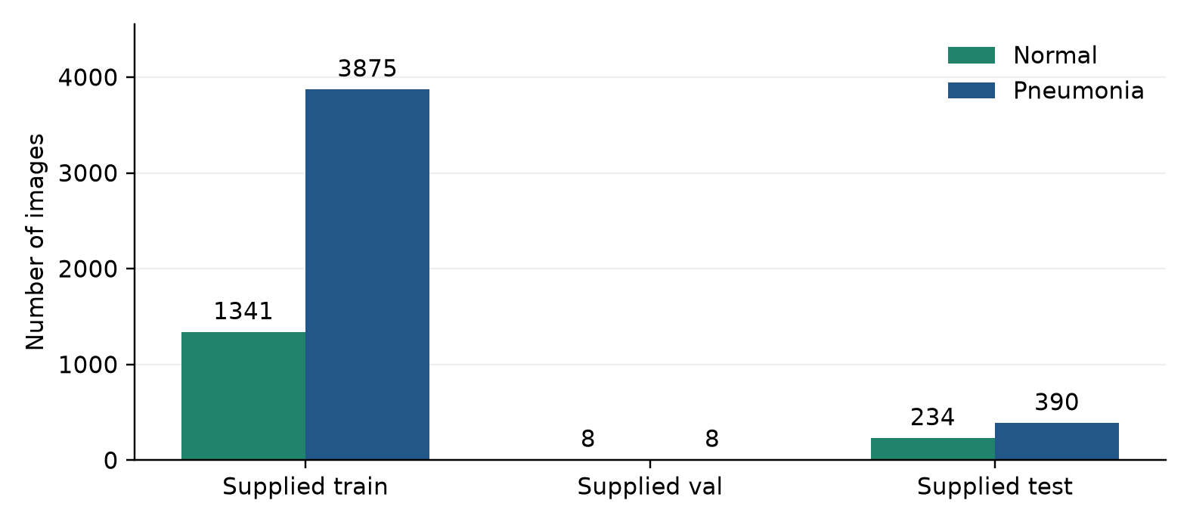
Figure 2. Class distribution in the top-level dataset folders. Counts are image files, not unique patients.
The supplied training folder is imbalanced: approximately 74.29% of images have the pneumonia label. Training addresses this through class-weighted cross-entropy. File verification detects unreadable images, but does not establish label accuracy, patient independence or absence of duplicates.

Example Images and Preprocessing
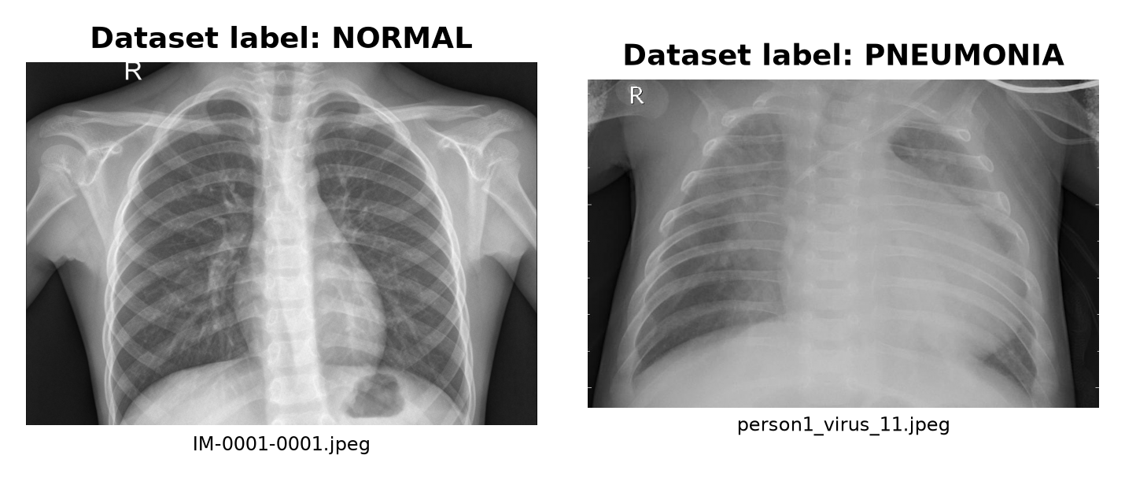
Figure 3. Real examples from the supplied test folders. Labels come from dataset membership; these are illustrative inputs, not newly verified model predictions.
All model inputs are converted to RGB and resized to 224 by 224 pixels. Training augmentation applies random affine transformations with rotation up to 7 degrees, translation fractions of 0.04 and scaling between 0.95 and 1.05. Brightness and contrast jitter use values of 0.08 and 0.12 respectively.
Images are converted to tensors and normalized using channel means [0.485, 0.456, 0.406] and standard deviations [0.229, 0.224, 0.225]. Evaluation and serving reuse eval_transform, which excludes random augmentation. This shared transform helps keep serving inputs consistent with evaluation inputs.
Source files: chest_xray/test/NORMAL/IM-0001-0001.jpeg and chest_xray/test/PNEUMONIA/person1_virus_11.jpeg. The application does not generate anatomical annotations or disease-localization heatmaps.

Training and Evaluation Procedure
Table 3. Current default training configuration
Setting | Value
Architecture / output | EfficientNet-B0 / two classes
Input size | 224 × 224 RGB
Maximum epochs / batch size | 12 / 32
Optimizer / learning rate | AdamW / 0.0003
Weight decay | 0.0001
Validation fraction / random seed | 18% / 42
Loss | Class-weighted cross-entropy
Checkpoint selection | Highest validation pneumonia F1
Scheduler | ReduceLROnPlateau; factor 0.3, patience 2
Early stopping | 4 epochs without validation F1 improvement
Current threshold search | 0.01–0.99 on validation predictions

Training starts from pretrained weights through timm. CUDA execution enables mixed precision and gradient scaling. The threshold selector prioritizes recall among validation thresholds with precision of at least 90%; it falls back to the best F1-score if none qualify. Current checkpoints record the threshold origin.
src/evaluate.py loads the checkpoint, predicts the test images and applies the threshold already stored in the checkpoint. It writes aggregate metrics, a per-class classification report, invalid-file information and a confusion-matrix image. It does not search for thresholds itself. Although intended as a final evaluation step, the script does not technically prevent repeated execution or subsequent manual threshold adjustment.

Analysis

Project File Structure
The following is a selected structure of the implementation and its supporting artifacts. Generated dependency folders and caches are omitted for clarity.
Pnenia Model/
|-- package.json
|-- run_project.ps1
|-- run_project.cmd
|-- app.py
|-- requirements.txt
|-- requirements-api.txt
|-- README.md
|-- DEPLOY.md
|-- Dockerfile
|-- plan.md
|-- src/
| |-- __init__.py
| |-- data.py
| |-- model.py
| |-- train.py
| |-- evaluate.py
| `-- api.py
|-- frontend/
| |-- package.json
| |-- package-lock.json
| |-- postcss.config.js
| |-- vercel.json
| |-- .env.example
| `-- app/
| |-- page.js
| |-- layout.js
| |-- globals.css
| `-- icon.svg
|-- notebooks/
| |-- train_on_kaggle.ipynb
| `-- notebook88d896ab16 (1).ipynb
|-- artifacts/
| |-- best_model.pt
| |-- training_report.json
| |-- test_report.json
| `-- test_confusion_matrix.png
`-- chest_xray/
|-- train/
|-- val/
`-- test/

Frontend Interface
frontend/app/page.js contains the main client component, PneumoniaScanner. It manages the selected file, preview URL, drag state, scanning state, result and error. The interface includes navigation, a hero section, an upload workspace, a result panel, an explanation of the workflow and a footer identifying Hamza Mustafa.
Users can select a file through the browser or drag and drop it. JPEG/PNG type and the 10 MiB byte limit are checked before analysis. A preview is created with URL.createObjectURL, and reset clears the selected image and result. The analyze button is disabled when no file is selected or while processing is active.
The frontend submits a FormData object and interprets prediction === 'pneumonia_positive' as the positive class. Successful results show a red or green card, a score bar, both class probabilities and the threshold. Failed requests display an error rather than generating a substitute prediction. Error and processing containers include live-region semantics.
globals.css defines entrance, floating, scanning and result animations. Reduced-motion settings disable the listed custom entrance and floating classes, though this does not establish that every animation has been disabled. layout.js defines document metadata and a body-level hydration-warning suppression. This suppression is a presentation workaround; it does not prevent browser extensions from modifying HTML.
Table 4. User interaction states
State | Visible behavior
No image selected | Upload prompt; analysis is disabled
Valid image selected | Preview and file size; analysis becomes available
Analysis running | Processing indicator; analysis button disabled
Normal result | Green result card, label and model scores
Pneumonia result | Red result card, label and model scores
Request failed | Visible error message; no substitute prediction

Backend Routes and Output
Table 5. Application API routes
Method and route | Input | Response / behavior
GET /health | None | JSON readiness flag and device
POST /predict | Multipart field file | Prediction, label, confidence, probabilities and threshold
POST /predict errors | Invalid file / missing model | HTTP 400 for rejected uploads; HTTP 503 for missing checkpoint

src/api.py exposes two application routes:
- GET `/health`: Returns whether a model is loaded and the selected device. The current implementation returns a JSON readiness flag rather than changing the HTTP status when the model is absent.
- POST `/predict`: Accepts a multipart field named file, validates the image, performs inference and returns the prediction. A missing checkpoint results in HTTP 503; rejected formats, invalid images and invalid sizes result in HTTP 400.
The prediction response contains prediction, label, confidence, normal_probability, pneumonia_probability and threshold. Probability and confidence fields are scaled to percentages, unlike the fractional values used internally. The threshold is also returned as a percentage.
The displayed confidence is the softmax score of the selected output label. It is not a measured reliability guarantee or a calibrated clinical probability. Because the decision threshold can differ from 0.50, a normal classification does not necessarily mean that the normal class has the larger softmax score.
The API selects CUDA when available and otherwise uses CPU. It loads the model at startup, switches it into evaluation mode and disables gradient recording during inference. Browser cross-origin access defaults to the local frontend origins and can be configured using ALLOWED_ORIGINS.

Local Execution and Deployment
From the project root, the documented command is:
npm run dev
The root npm script calls run_project.ps1. The launcher checks for the model checkpoint, creates a virtual environment and installs API dependencies if the environment does not exist, installs frontend packages if node_modules is missing, starts Uvicorn on port 8000 and Next.js development mode on port 3000, then opens the browser. Process output is redirected into .runtime logs.
The launcher checks whether ports become reachable; this is not a full model-readiness or prediction test. The root npm start currently invokes the same development launcher. It should not be described as a production serving command. In contrast, the frontend's own start script runs next start after a build.
MODEL_CHECKPOINT configures the API checkpoint path. NEXT_PUBLIC_API_URL sets the frontend API address, defaulting to http://127.0.0.1:8000. ALLOWED_ORIGINS configures browser origins. The standalone Gradio application accepts a PORT override and defaults to local port 7860.

Alternative Interface and Deployment Files
app.py loads the model directly and presents a Gradio upload interface with a result heading, JSON details and educational notices. It duplicates part of the API's inference logic, which creates a maintenance requirement when preprocessing or output behavior changes.
The repository contains a Docker recipe for the Python API and a Vercel configuration for frontend security headers. DEPLOY.md describes a split deployment. These files demonstrate deployment preparation, but do not establish that a live service has been published. The inspected configuration does not implement a complete Vercel-only model deployment.

Key Findings

Training Results
artifacts/training_report.json records a CUDA training run dated 23 August 2026 with seed 42. Twelve epochs are present. Training loss decreased from approximately 0.42321 in epoch 1 to 0.00827 in epoch 12.
Epoch 10 has the highest recorded validation pneumonia F1-score, approximately 0.99355. At that epoch, validation accuracy is 99.04%, pneumonia precision is 99.43%, recall is 99.28% and ROC-AUC is approximately 0.99908. Its recorded threshold is 0.13. Later epochs did not improve the selected F1-score.
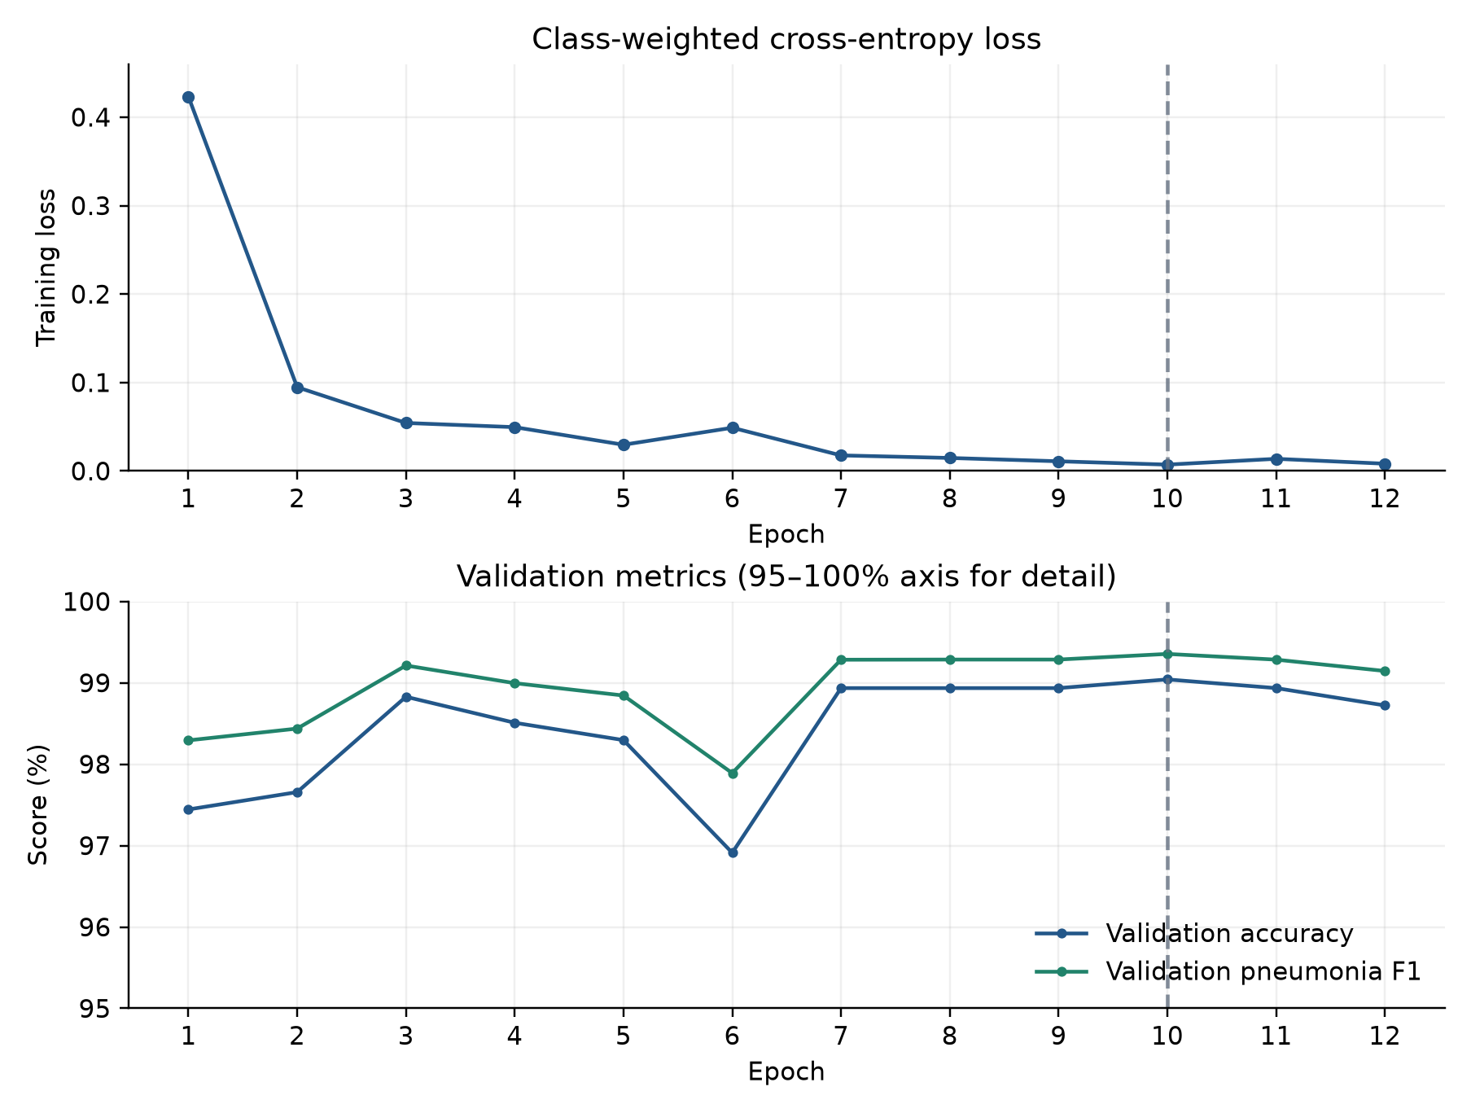
Figure 4. Saved 12-epoch training history. The dashed line marks epoch 10, selected by validation F1. Validation scores use a 95–100% axis for detail; validation loss was not recorded.

Test Results
The saved test report was generated at a decision threshold of 0.95 on 624 images. The threshold was adjusted after inspecting test predictions, so the following results are exploratory rather than an independent final evaluation.
Table 6. Aggregate results at threshold 0.95
Measure | Recorded value | Meaning
Accuracy | 92.31% | 576 correct predictions out of 624
Pneumonia precision | 90.52% | 382 true positives among 422 positive predictions
Pneumonia recall | 97.95% | 382 detected among 390 pneumonia images
Pneumonia F1 | 0.94089 | Harmonic mean of precision and recall
ROC-AUC | 0.97212 | Reported discrimination across score thresholds

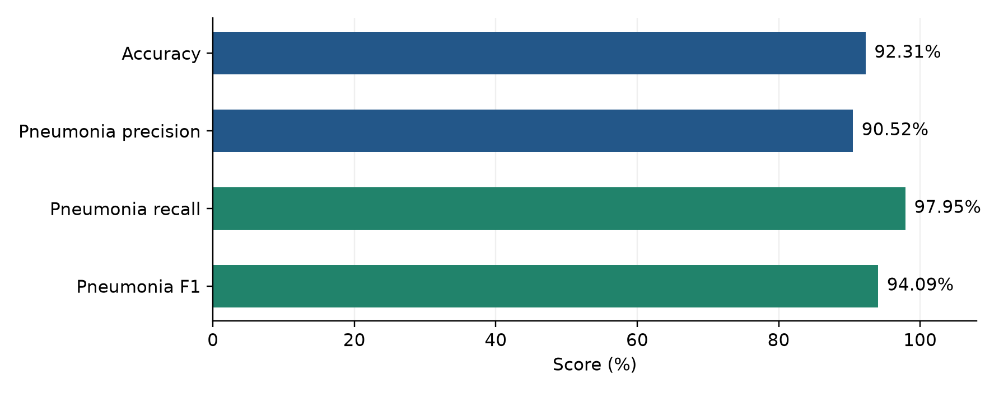
Figure 5. Recorded classification metrics, shown on a 0–100% scale. The F1-score is expressed as a percentage for this chart.
ROC-AUC is reported as a scalar because per-image prediction scores are not saved in the JSON artifact. A ROC curve cannot be reconstructed faithfully from a single AUC value.

Confusion Matrix
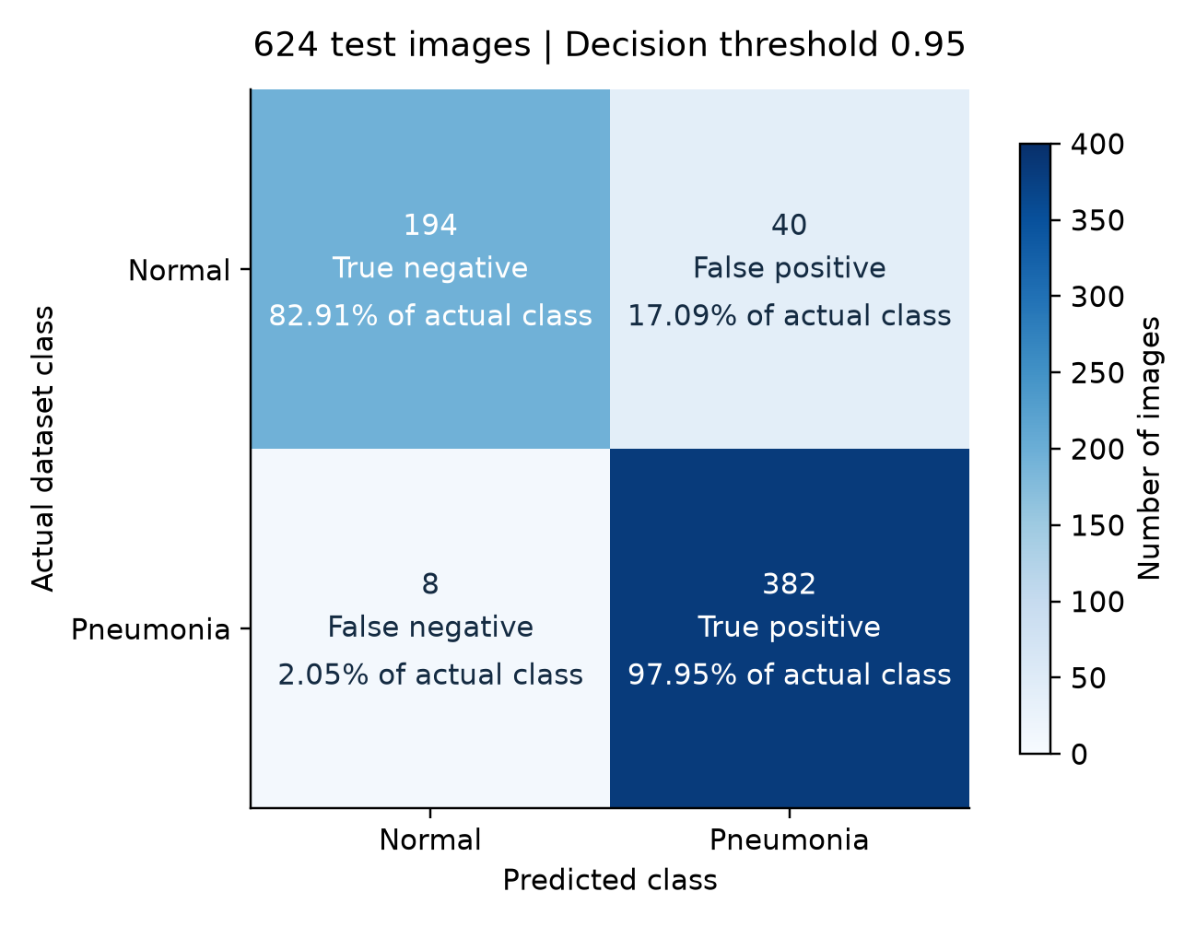
Figure 6. Confusion matrix at threshold 0.95. Counts match artifacts/test_confusion_matrix.png and the saved classification report. Percentages inside cells are normalized within each actual class.
Table 7. Interpreting the prediction counts
Outcome | Count | Interpretation
True negative | 194 | Normal image classified as normal
False positive | 40 | Normal image classified as pneumonia
False negative | 8 | Pneumonia image classified as normal
True positive | 382 | Pneumonia image classified as pneumonia

The model missed 8 of 390 pneumonia images (2.05%) and flagged 40 of 234 normal images (17.09%). Overall, 48 of 624 predictions were incorrect. High pneumonia recall therefore coexists with a larger false-positive rate in the normal class.

Class Performance and Evaluation Limits
Table 8. Per-class metrics from test_report.json
Class | Precision | Recall | F1 | Images
NORMAL | 96.04% | 82.91% | 0.8899 | 234
PNEUMONIA | 90.52% | 97.95% | 0.9409 | 390

The exploratory notebook evaluates several thresholds against test predictions, then explicitly writes checkpoint['threshold'] = 0.95. Therefore, the reported accuracy and precision exceed the numerical targets on that dataset, but cannot establish that the targets were met on an untouched final evaluation set.
The current training code selects thresholds from validation data and records their origin. This improves future experiment traceability but does not retroactively validate the historical experiment. Since the existing test results have already informed development, stronger confirmation requires new independent data or a clearly defined evaluation partition that has not influenced model decisions.

Completed Integrations and Remaining Evidence Gaps
The source provides a complete route from image upload to model output, shared evaluation preprocessing, checkpoint loading, formatted frontend results and a combined local startup command. Saved artifacts demonstrate that training and evaluation were performed.
The inspected files do not establish measured request latency, concurrent-user capacity, external clinical validation or a live deployment URL. Automated patient-overlap checks, duplicate detection, probability calibration and Grad-CAM explanations are not implemented in the inspected core modules. No new training run, deployment or performance benchmark was performed for this report.

Recommendations
The following recommendations address the implementation and evidence gaps identified in the source and saved experiment.
- Establish an independent final evaluation. Select the operating threshold using validation data, freeze it with the checkpoint and evaluate on previously untouched data. Clearly label the existing test results as exploratory.
- Audit the dataset before further training. Record file hashes, detect duplicate images, investigate patient identifiers and use patient-aware splitting where identifiers are available. Keep duplicate archive extractions out of experiment inputs.
- Strengthen experiment records. Save exact library versions, training arguments, dataset identifiers, split manifests and checkpoint hashes. The current reports provide useful history but do not capture every detail required to reproduce the original environment.
- Improve result interpretation. Assess calibration on appropriate validation data and distinguish a model score from calibrated confidence. Explain how the decision threshold changes the selected label, especially when it differs substantially from 0.50.
- Expand evaluation coverage. Report uncertainty intervals, precision-recall analysis and subgroup outcomes where suitable metadata exists. Validate robustness to image quality and acquisition differences before making broader performance claims.
- Centralize inference logic. Extract the shared preprocessing, checkpoint loading and prediction steps used by FastAPI and Gradio into one maintained module. Verify output consistency across both interfaces.
- Add meaningful automated checks. Cover class ordering, threshold boundaries, corrupt images, missing checkpoints, oversized uploads and API response fields. Add an integration check that confirms the frontend displays the prediction returned by the API.
- Harden the upload and request lifecycle. Bound reads before accepting the full upload, enforce decoded image limits and handle concurrent inference without blocking unrelated requests. Address stale responses when a user resets or replaces an image during analysis.
- Improve the launcher and documentation. Check dependency-install exit codes, verify model readiness rather than only port availability and reliably stop child process trees. Update older instructions that still describe separate startup commands or previous threshold ranges.
- Validate deployment as a separate engineering task. Choose the target runtime, test actual dependency and model packaging, configure the production API address and origins, and measure cold-start and request behavior. The current development launcher should not be used as a production server.
- Refine accessibility and terminology. Complete keyboard and reduced-motion checks, review focus states, and use consistent prediction wording throughout the interface. If image explanations are added later, distinguish model attribution from verified anatomical findings.

References
The references below identify primary project evidence and dependency declarations. Version ranges are copied from manifests and describe allowed installations, not a verified inventory of the original Kaggle environment.

Project Evidence
1. src/data.py: Dataset discovery, class mapping, image verification and transforms.
2. src/model.py: EfficientNet-B0 model factory with two output classes.
3. src/train.py: Split creation, optimization, threshold selection and checkpoint generation.
4. src/evaluate.py: Stored-threshold test evaluation and confusion-matrix output.
5. src/api.py: Readiness and prediction routes, response fields and CORS configuration.
6. frontend/app/page.js, layout.js and globals.css: Browser workflow, metadata, styles and animations.
7. app.py: Alternative Gradio interface and direct inference.
8. artifacts/training_report.json and artifacts/test_report.json: Recorded experiment results.
9. notebooks/notebook88d896ab16 (1).ipynb: Executed workflow and test-based threshold override.
10. notebooks/train_on_kaggle.ipynb: Reusable training and evaluation notebook template.
11. Root package.json, run_project.ps1 and run_project.cmd: Local process coordination.
12. requirements.txt, requirements-api.txt, frontend/package.json and frontend/package-lock.json: Dependency declarations and frontend lockfile.
13. DEPLOY.md, Dockerfile and frontend/vercel.json: Deployment instructions and configuration.
14. Git remote origin: https://github.com/mirxa-hamza/Pneumonia-Detection.
15. Civics Project Report.pdf, supplied by the project owner: structural and stylistic reference only. Its institution, course details and education statistics are not used as facts about this software project.

Python Dependencies
- PyTorch: torch>=2.9,<2.14 - training and inference.
- torchvision: >=0.24,<0.29 - image transforms.
- timm: >=1.0,<2.0 - model architecture and pretrained model support.
- scikit-learn: >=1.5,<2.0 - splitting and evaluation metrics.
- NumPy: >=1.26,<3.0 - arrays and numerical processing.
- Pillow: >=10.4,<12.0 - image decoding and verification.
- Matplotlib: >=3.9,<4.0 - evaluation figure generation.
- Seaborn: >=0.13,<0.14 - confusion-matrix heatmap.
- Gradio: >=5.0,<6.0 - standalone interface.
- FastAPI: >=0.115,<1.0 - HTTP API.
- Uvicorn: uvicorn[standard]>=0.32,<1.0 - ASGI server.
- python-multipart: >=0.0.18,<1.0 - multipart upload parsing.
- pandas: >=2.2,<3.0 - declared dependency; not directly used by the inspected core ML/API modules.
- opencv-python-headless: >=4.10,<5.0 - declared dependency; no OpenCV preprocessing is implemented in the inspected core path.
requirements-api.txt retains the serving subset: torch, torchvision, timm, Pillow, FastAPI, Uvicorn and python-multipart.

Frontend Dependencies
- Next.js: ^16.1.0 - application framework and development/build scripts.
- React: ^19.2.0 - component rendering and state.
- React DOM: ^19.2.0 - browser rendering.
- Lucide React: ^1.34.0 - interface icons.
- Tailwind CSS: ^4.3.3 - utility styling.
- @tailwindcss/postcss: ^4.3.3 - Tailwind PostCSS integration.
- PostCSS: ^8.5.26 - CSS processing.
- Autoprefixer: ^10.5.4 - declared CSS tooling dependency.

