Date: 20/04/2026 | Shift: Day: 0700hrs to 1500hrs | Agent: Mirriam

Incidences on critical systems/service
Description | Date/Time | End Date/  Time | Incident  No | Duration | Action to | Status | Incident activities and handover notes | Incident Report  provided
Nairobi From gpo to e-hse | 20/04/2026@1630hrs |  | 1-75NET | 6 days |  | Assigned | 20/04/2026@1633hrs: customer complain
Rongai outage | 20/04/2026@1630hrs | 24/04/2026@1659hrs | 1-75NETfk | 6 days |  | Resolved | 20/04/2026@1634hrs: Been resolved
Nairobi From gpo to e-hse | 20/04/2026@1630hrs |  | 1-75NET | 6 days |  | Assigned | 20/04/2026@1633hrs: customer complain  20/04/2026@1635hrs: resolved

FIBER INCIDENCES
Incidences | Ref. No | Date & Time  Reported | Duration | Person Assigned | Report Status | Handover Notes
CENTRAL REGION
fibre breakage | YH56efh | 20/04/2026@1844hrs |  | eng. ng'eno | Assigned

SYSTEM UPTIME (DAYS)
SYSTEM | UPTIME (DAYS) | LAST DATE OF OUTAGE
AMI | 202 days | 30th September 2025
INCMS | 202 days | 30th September 2025
INSMM | 202 days | 30th September 2025
USSD | 567 days | 30th September 2024
CONTACT CENTRE | 202 days | 30th September 2025
PREPAID | 202 days | 30th September 2025
POSTPAID | 202 days | 30th September 2025
TOKEN TRACKER | 202 days | 30th September 2025
IPMP | 202 days | 30th September 2025
SAP | 202 days | 30th September 2025

SYSTEM SCREENSHOTS
AMI
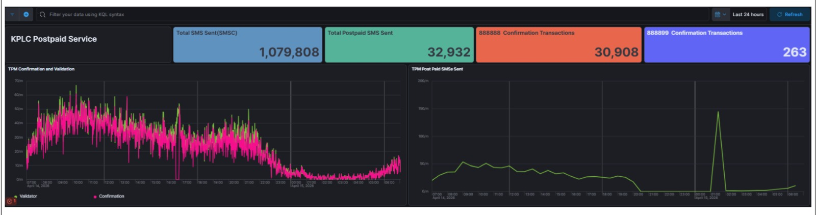

INCMS
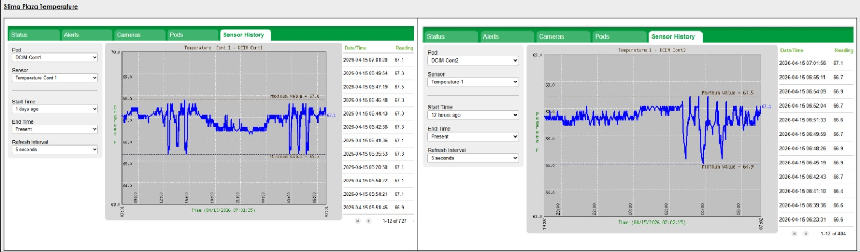

INSMM
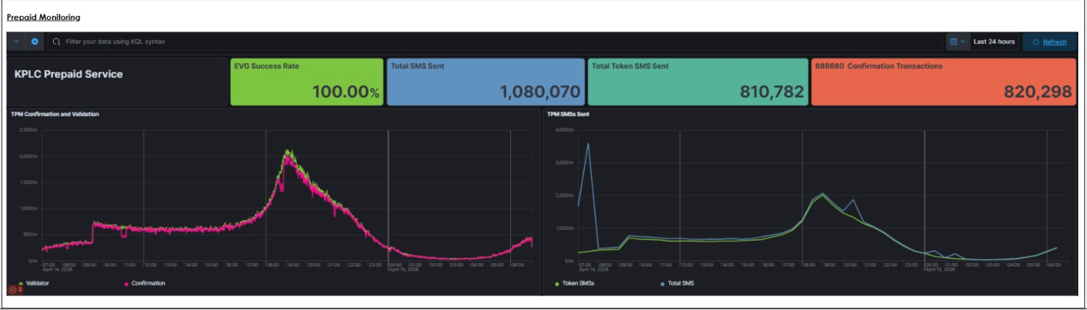

PREPAID
