NAME: MIRZA ZAIN ALI BAIG
ROLL NO.: 2025(S)-SE-20

Submitted to

Muhammad Khadim Hussain

- Inheritance
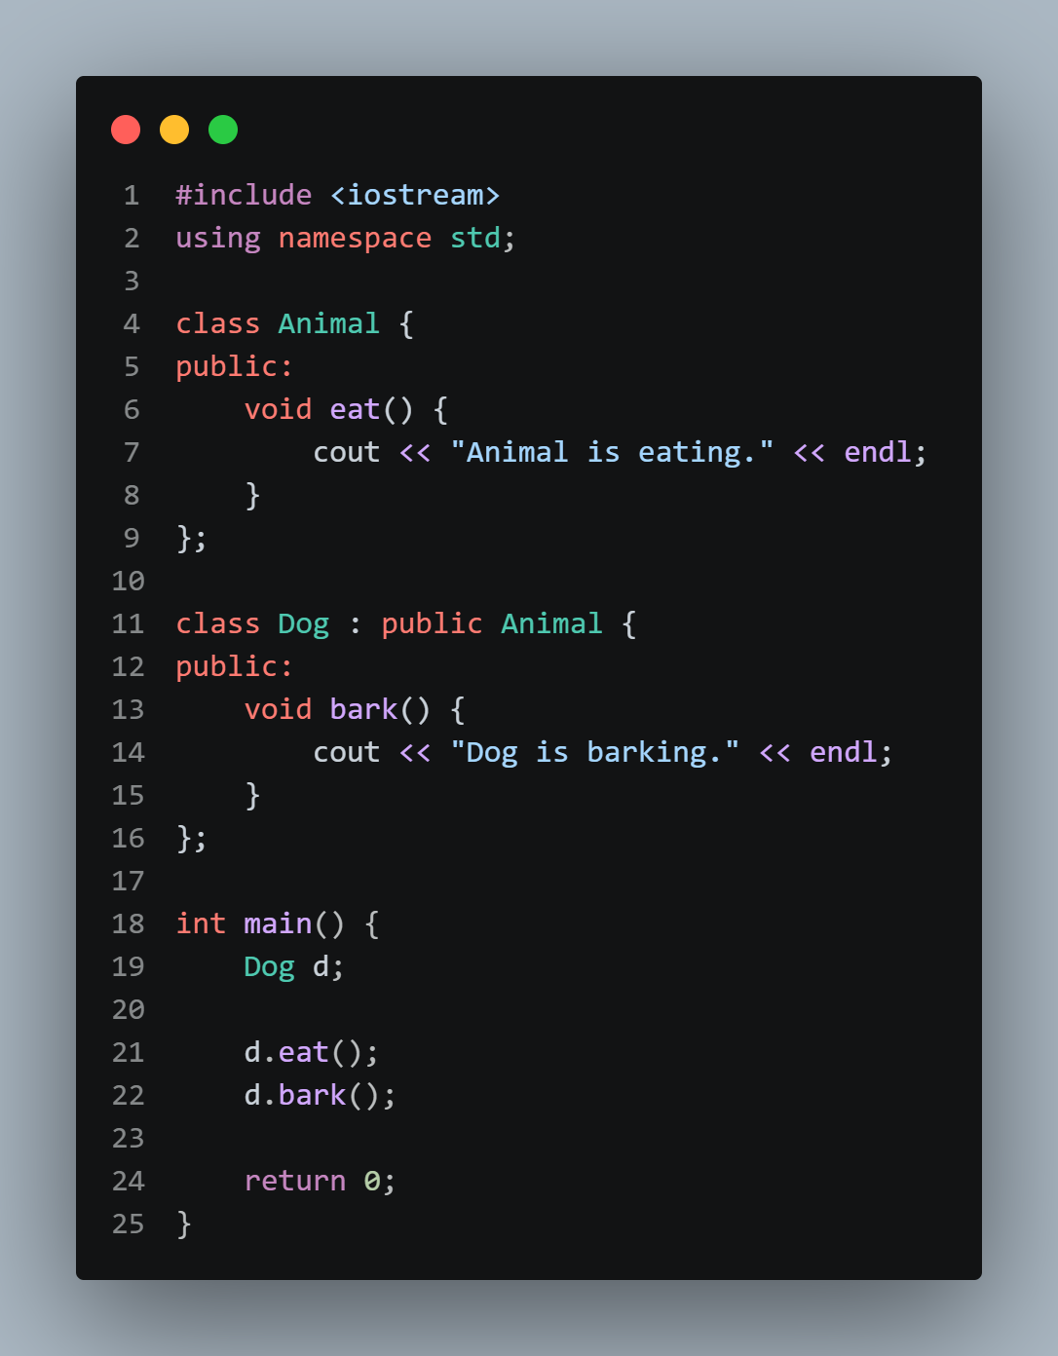

Output:
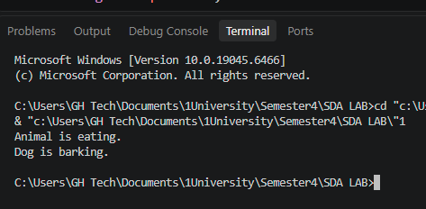

- Polymorphism

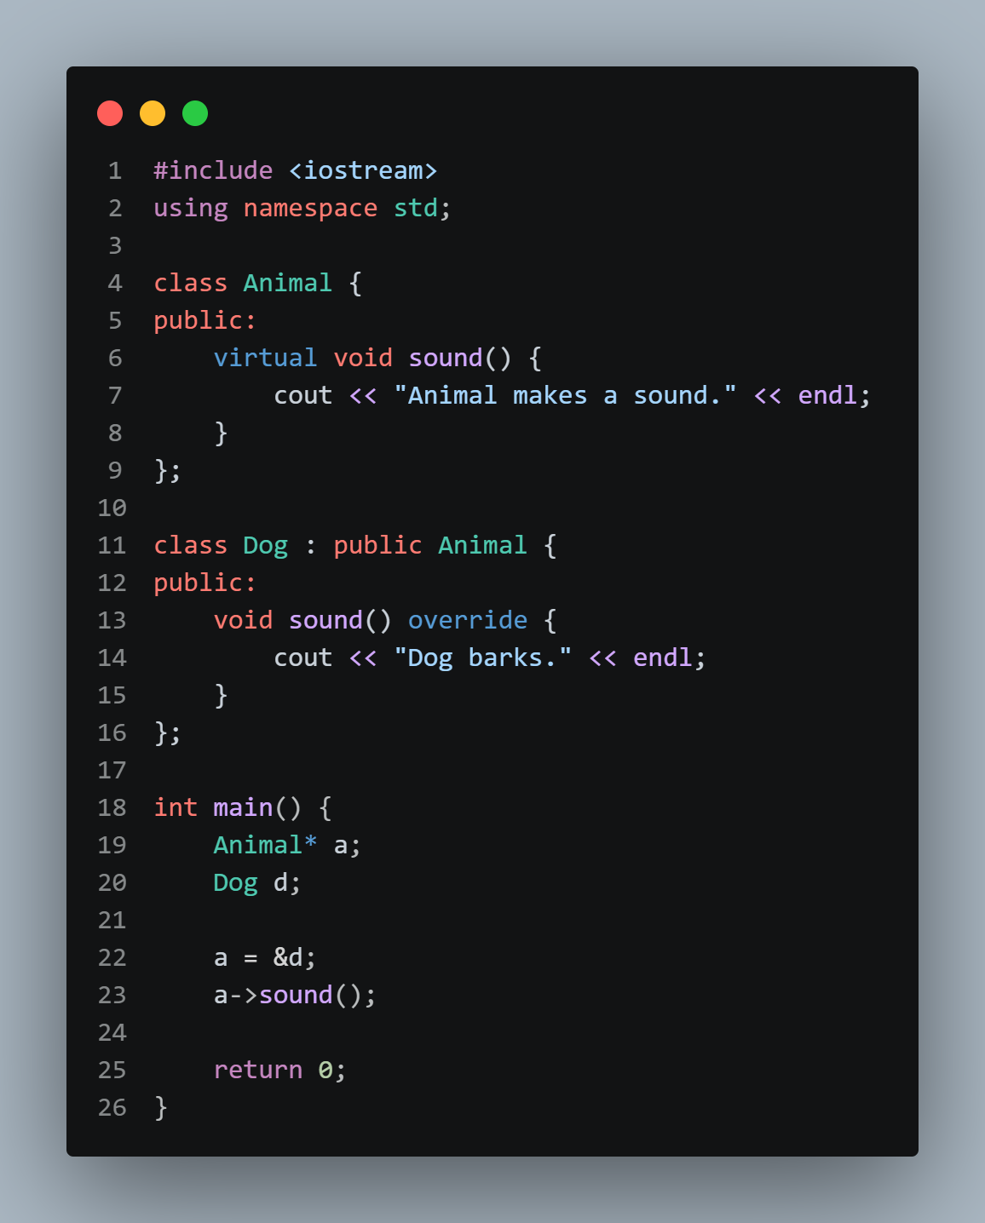

Output:
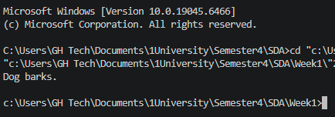

- Encapsulation
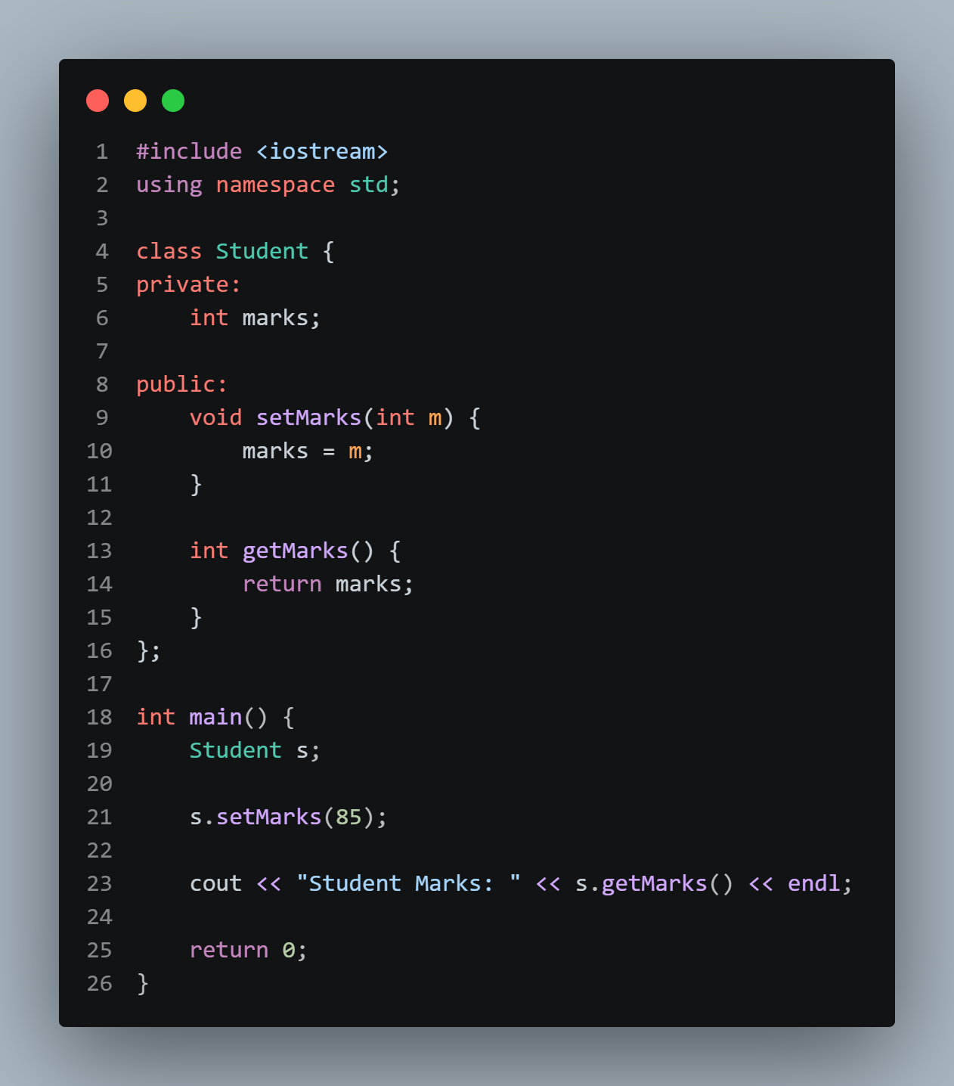
Output:
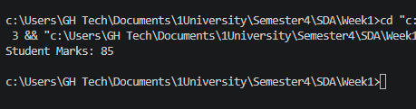

- Abstraction
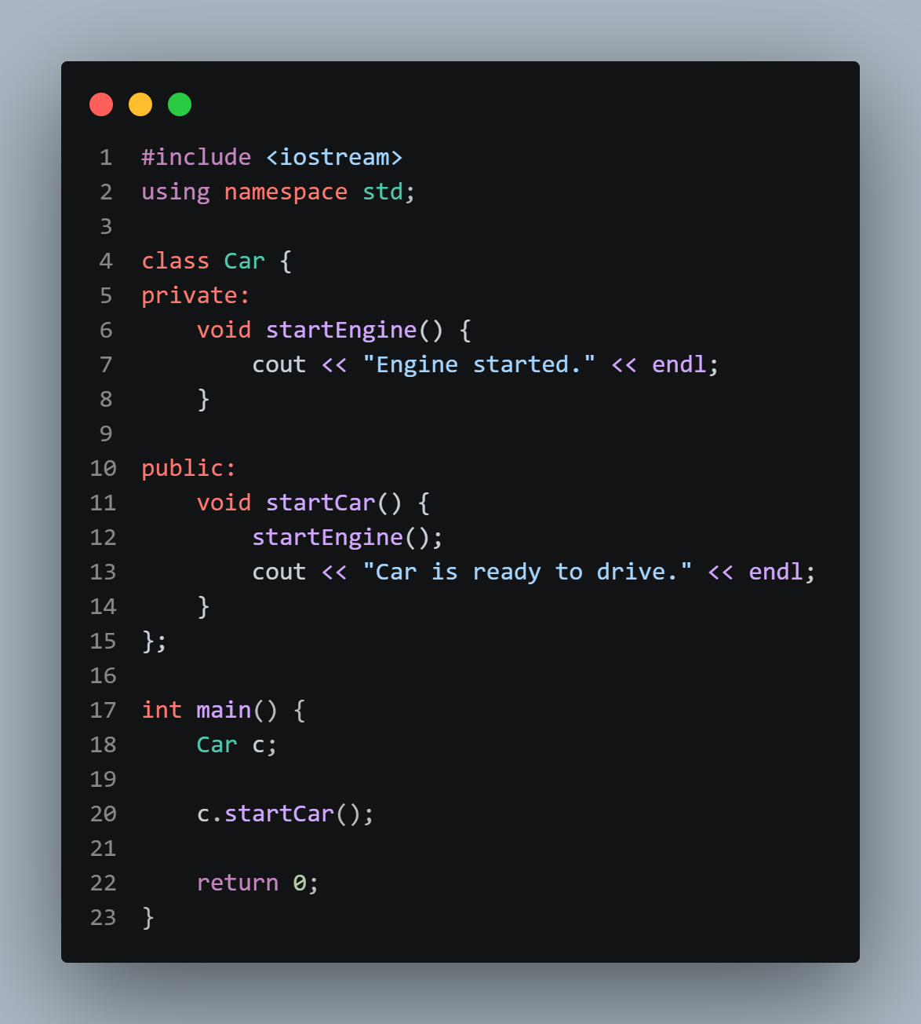
Output:
