Twitter Analyzer - Sample Project

1. Download binary zip file “dist.zip” from GitHub: <https://github.com/mirzafasi/Samples> --> dist.zip
2. Unpack dist.zip to “dist” folder on your machine.
3. Make sure Java (JDK or JRE) is installed on the system and “JAVA_HOME” environment variable has been set.
4. The project uses JRE 7 but the “Compiler Compliance Level” has been set to 1.6. Hence it’s possible to execute the program with Java 6.
5. The project has been tested on Java 1.7.0_25.
6. Update “db.properties” file under “dist/resources”. Set hostname and port of the MongoDB server on your machine.
7. Start MongoDB server.
8. Open command prompt and navigate to “dist” folder.
9. Execute“run.bat”.
10. The program will execute and the console will print the following statistics:
    1. Top 5 followed users 🡪 “userId” and “count”
    2. Top 5 retweeted tweets. 🡪 “retweet_count” and “text”
    3. Top 5 mentioned users. 🡪 “_id” and “value”

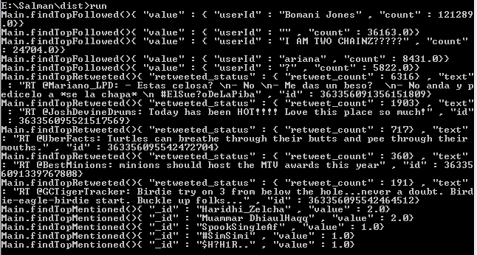

1. Twitter’s Streaming API has been used to get Sample Stream from Twitter.
2. 200 twitter records are loaded into “sample.txt”
3. This “sample.txt” file is used to load data into MongoDB and analyze.
4. dist/resources contains the “sample.txt” file.
5. MongoDB version 2.4.5 on Win32 has been used for development and testing.

# Eclipse Java Project:

1. The project which contains sources has been uploaded to GitHub: <https://github.com/mirzafasi/Samples> --> TwitterAnalyzer
2. In order to execute the project, modify db.properties under “src” folder and enter the values for “host” and “port”.
3. Make sure MongoDB server is started.
4. Open “sample.main.Main.java” and “Run as Java Application.”

# Use Cases:

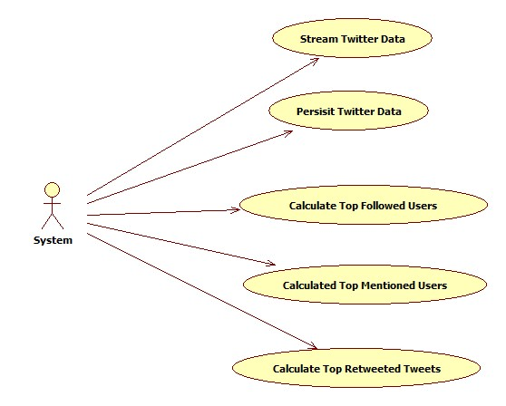

### Figure: Use case diagram

# Sequence Diagrams:

1. Use Case: Stream Twitter Data.

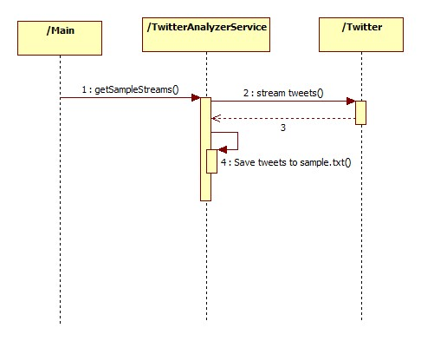

### Figure: Sequence of steps to persist Twitter data to sample.txt

1. Use Case: Persist Twitter Data

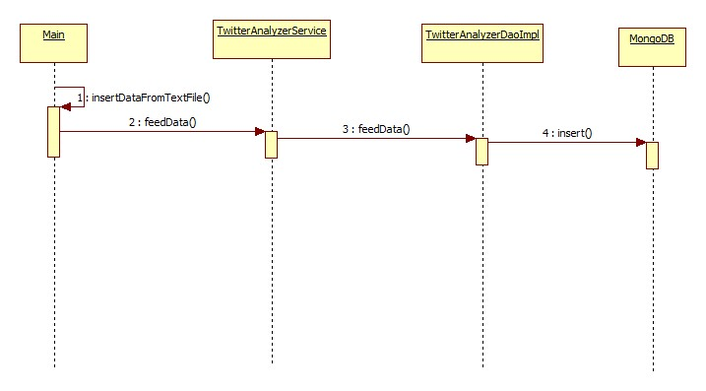

### Figure: Sequence of steps to persist Twitter data from sample.txt to MongoDB

1. Use Case: Calculate Top Followed Users

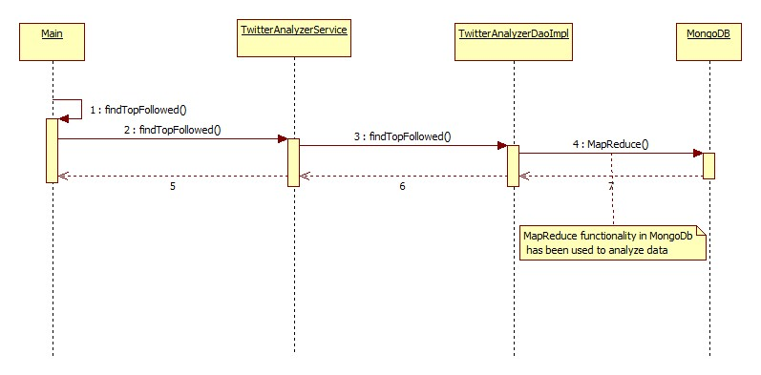

### Figure: Sequence of steps to calculate Top Followed Users

1. Use Case: Calculate Top Mentioned Users

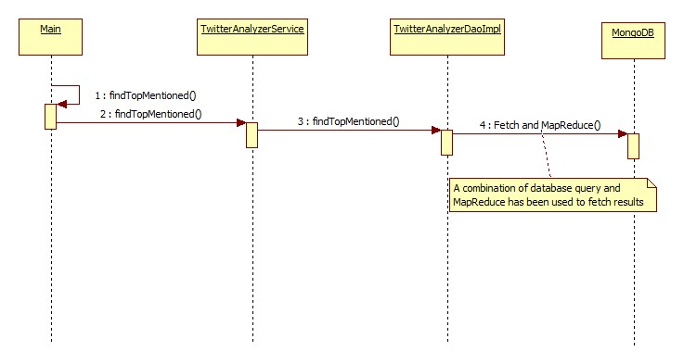

### Figure: Sequence of steps to calculate Top Menioned Users

1. Use Case: Calculate Top Retweeted Tweets

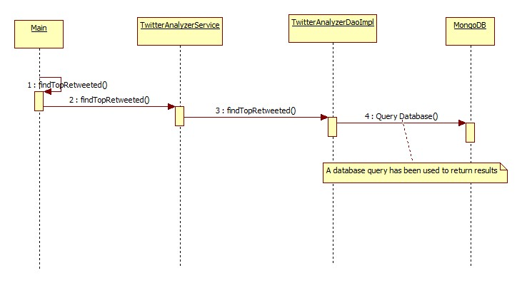

### Figure: Sequence of steps to calculate Top Retweeted Tweets