Dokumentation
Gruppe 9 (sdi09)

Software defined Infrastructure
Herr Prof. Dr. Martin Goik
WS20/21

Autoren: Fabian Ikizoglu (fi006)
Aydin Mirzaghayev (am180)

Datum: 07.11.26

Inhaltsverzeichnis

​ 1. UNIX / LINUX Basics 3
​ 2. Ubuntu / Debian Package management 4
​ 3. UNIX / LINUX Basics 5
​ 4. DNS 6
​ 4.1 Querying DNS data. 6
​ 4.2 Installing Bind 6
​ 4.3 Reverse lookups 6
​ 4.4 Forwarders 6
​ 4.5 Mail exchange record 6
​ 5. LDAP 7
​ 5.1 Browse an existing LDAP Server 7
​ 5.2 Set up an OpenLdap server 7
​ 5.3 Populating your DIT. 7
​ 5.4 Testing a bind operation as non - admin user 7
​ 5.5 Filter based search 7
​ 5.6 Extending an existing entry 7
​ 5.7 Accessing LDAP data by a mail client 7
​ 5.8 LDAP configuration 7
​ 5.9 LDAP based user login 8
​ 5.10 Backup and recovery / restore 8
​ 5.11 Accessing LDAP by a Java™ application. 8
​ 6. Apache web server 9
​ 6.1 First Steps 9
​ 6.2 Virtual hosts 9
​ 6.3 SSL / TLS Support 9
​ 6.4 LDAP authentication 12
​ 6.5 Mysql™ database administration 12
​ 6.6 Providing WEB based user management to your LDAP Server 12
​ 6.7 Publish your documentation 12
​ 7. File cloud 13
​ 8. Mail 14
​ 8.1 Install and send to local Users 14
​ 8.2 Authentication Setup and Virtual Users 14
​ 8.3 TLS 14
​ 8.4 Spam and Virus defense 14
​ 9. Docker 15
​ 9.1 The simple way: Using SQLite 15
​ 9.2 The real McCoy: Using Mariadb 15

1. UNIX / LINUX Basics

This lecture requires practical exercises. Each group will have access to two virtual machines for mimicking client-provider and replication scenarios.

2. Ubuntu / Debian Package management

This lecture requires practical exercises. Each group will have access to two virtual machines for mimicking client-provider and replication scenarios.

3. UNIX / LINUX Basics

This lecture requires practical exercises. Each group will have access to two virtual machines for mimicking client-provider and replication scenarios.

4. DNS

4.1 Querying DNS data.
This lecture requires practical exercises. Each group will have access to two virtual machines for mimicking client-provider and replication scenarios.

4.2 Installing Bind
This lecture requires practical exercises. Each group will have access to two virtual machines for mimicking client-provider and replication scenarios.

4.3 Reverse lookups
This lecture requires practical exercises. Each group will have access to two virtual machines for mimicking client-provider and replication scenarios.

4.4 Forwarders
This lecture requires practical exercises. Each group will have access to two virtual machines for mimicking client-provider and replication scenarios.

4.5 Mail exchange record
This lecture requires practical exercises. Each group will have access to two virtual machines for mimicking client-provider and replication scenarios.

5. LDAP

5.1 Browse an existing LDAP Server
This lecture requires practical exercises. Each group will have access to two virtual machines for mimicking client-provider and replication scenarios.

5.2 Set up an OpenLdap server
This lecture requires practical exercises. Each group will have access to two virtual machines for mimicking client-provider and replication scenarios.

5.3 Populating your DIT.
This lecture requires practical exercises. Each group will have access to two virtual machines for mimicking client-provider and replication scenarios.

5.4 Testing a bind operation as non - admin user
This lecture requires practical exercises. Each group will have access to two virtual machines for mimicking client-provider and replication scenarios.

5.5 Filter based search
This lecture requires practical exercises. Each group will have access to two virtual machines for mimicking client-provider and replication scenarios.

5.6 Extending an existing entry
This lecture requires practical exercises. Each group will have access to two virtual machines for mimicking client-provider and replication scenarios.

5.7 Accessing LDAP data by a mail client
This lecture requires practical exercises. Each group will have access to two virtual machines for mimicking client-provider and replication scenarios.

5.8 LDAP configuration
This lecture requires practical exercises. Each group will have access to two virtual machines for mimicking client-provider and replication scenarios.

5.9 LDAP based user login
This lecture requires practical exercises. Each group will have access to two virtual machines for mimicking client-provider and replication scenarios.

5.10 Backup and recovery / restore
This lecture requires practical exercises. Each group will have access to two virtual machines for mimicking client-provider and replication scenarios.

5.11 Accessing LDAP by a Java™ application.
This lecture requires practical exercises. Each group will have access to two virtual machines for mimicking client-provider and replication scenarios.

6. Apache web server

6.1 First Steps
This lecture requires practical exercises. Each group will have access to two virtual machines for mimicking client-provider and replication scenarios.

6.2 Virtual hosts
This lecture requires practical exercises. Each group will have access to two virtual machines for mimicking client-provider and replication scenarios.

6.3 SSL / TLS Support
This lecture requires practical exercises. Each group will have access to two virtual machines for mimicking client-provider and replication scenarios.

SSL

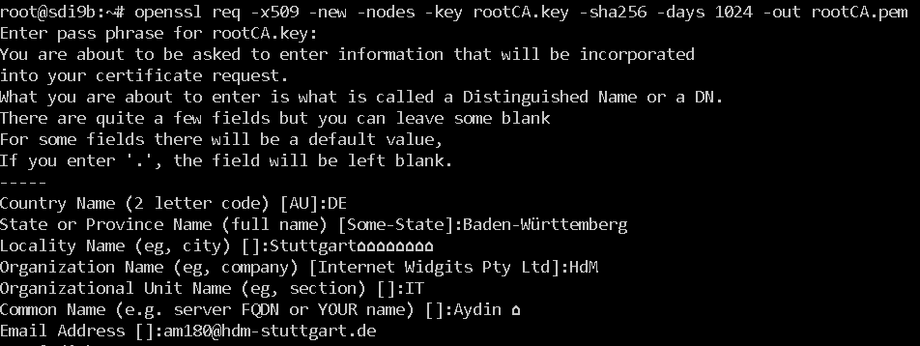
sd

Configure Apache:
old:

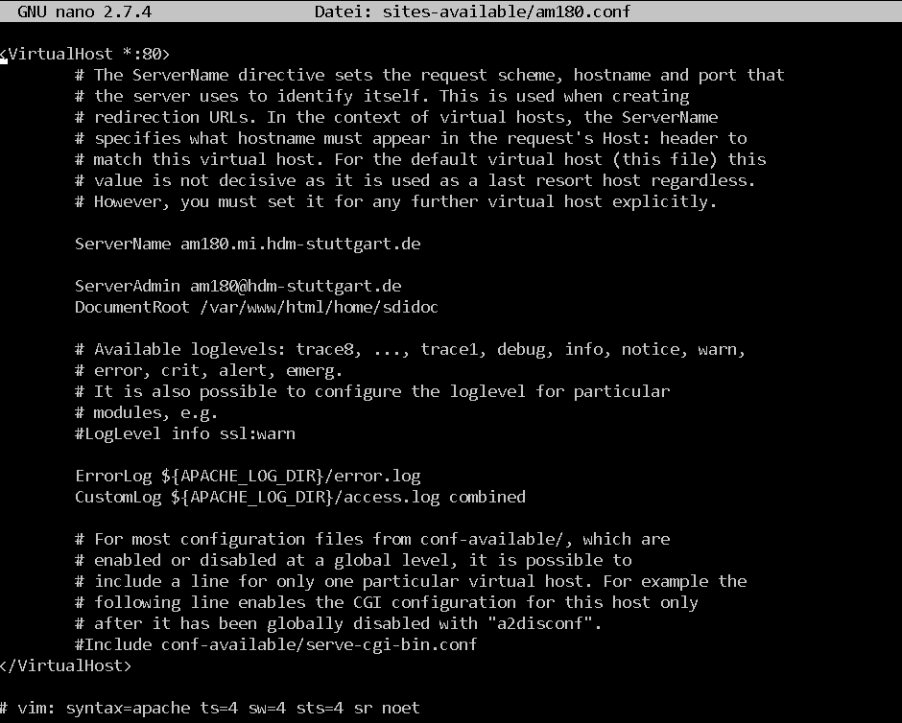
new:

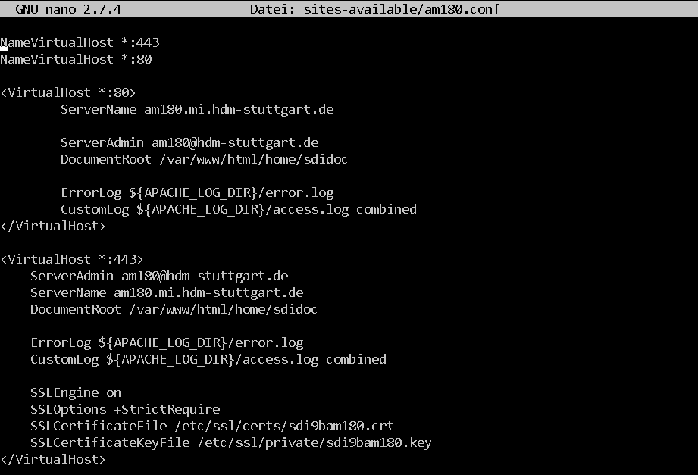
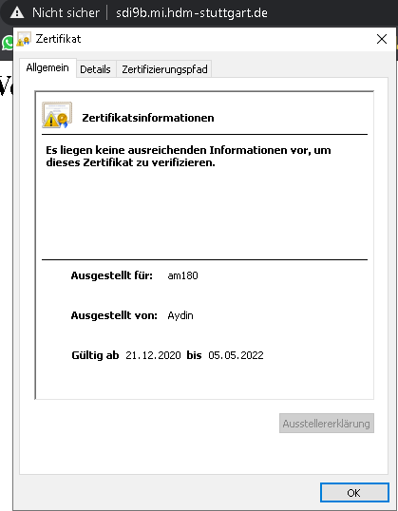
fds

6.4 LDAP authentication
This lecture requires practical exercises. Each group will have access to two virtual machines for mimicking client-provider and replication scenarios.

6.5 Mysql™ database administration
This lecture requires practical exercises. Each group will have access to two virtual machines for mimicking client-provider and replication scenarios.

6.6 Providing WEB based user management to your LDAP Server
This lecture requires practical exercises. Each group will have access to two virtual machines for mimicking client-provider and replication scenarios.

6.7 Publish your documentation
This lecture requires practical exercises. Each group will have access to two virtual machines for mimicking client-provider and replication scenarios.

7. File cloud

This lecture requires practical exercises. Each group will have access to two virtual machines for mimicking client-provider and replication scenarios.

8. Mail

8.1 Install and send to local Users
This lecture requires practical exercises. Each group will have access to two virtual machines for mimicking client-provider and replication scenarios.

8.2 Authentication Setup and Virtual Users
This lecture requires practical exercises. Each group will have access to two virtual machines for mimicking client-provider and replication scenarios.

8.3 TLS
This lecture requires practical exercises. Each group will have access to two virtual machines for mimicking client-provider and replication scenarios.

8.4 Spam and Virus defense
This lecture requires practical exercises. Each group will have access to two virtual machines for mimicking client-provider and replication scenarios.

9. Docker

9.1 The simple way: Using SQLite
This lecture requires practical exercises. Each group will have access to two virtual machines for mimicking client-provider and replication scenarios.

9.2 The real McCoy: Using Mariadb
This lecture requires practical exercises. Each group will have access to two virtual machines for mimicking client-provider and replication scenarios.

