DeepSyndrome
Frontend Test Case Report
Login / Sign Up Flow, Patient Records, and Doctor Mode Verification
Ensemble AI Diagnostic System — ResNet-50 + EfficientNet-B3 + ViT-S/16
September 2026

1. Introduction
This report documents functional testing of the DeepSyndrome web application's authentication and clinician-facing features: site-wide Login/Sign Up access, doctor registration and session handling, the AI screening flow, Doctor Mode ground-truth confirmation, Patient Records, and role-based access control for the Admin dashboard.
Testing was performed against a local development build of the Next.js frontend using automated browser testing (Playwright with Chromium), driving the application exactly as a real user would: filling forms, clicking buttons, and navigating between pages. A real sample facial image from the project's dataset was used to exercise the live ensemble prediction pipeline.

2. Test Environment
Application | DeepSyndrome frontend (Next.js 16, App Router)
Browser | Chromium (via Playwright, automated)
Backend | Next.js API routes + MongoDB Atlas (auth, patients, confirmed samples)
Model backend | Hugging Face Space (ResNet-50, EfficientNet-B3, ViT-S/16 ensemble)
Test data | Real facial image sample from the project training dataset

3. Test Summary
A total of 12 test cases were executed, covering the full authentication lifecycle and the core clinician-facing workflows. All 12 test cases passed.
ID | Test Case | Result
TC-01 | Home page shows Log In / Sign Up when logged out | PASS
TC-02 | Sign Up link navigates to registration form | PASS
TC-03 | Doctor registration auto-logs-in and redirects home | PASS
TC-04 | Logout clears session and reverts header | PASS
TC-05 | Login with wrong password shows generic error | PASS
TC-06 | Login with correct credentials succeeds | PASS
TC-07 | Image upload shows preview and enables Analyse | PASS
TC-08 | Ensemble prediction returns verdict + per-model votes | PASS
TC-09 | Doctor Mode confirms ground truth for retraining | PASS
TC-10 | Patients page adds and lists patients per doctor | PASS
TC-11 | Admin dashboard blocks non-admin doctors | PASS
TC-12 | Protected pages gate access when logged out | PASS

4. Detailed Test Cases

TC-01 — Home page — logged-out state
Test Case ID | TC-01
Feature | Home page — logged-out state
Steps | Navigate to the home page (/) without an active session.
Expected Result | Header shows "Log In" and "Sign Up" links; no doctor name or Patients/Admin links are shown.
Actual Result | Header correctly displayed "Log In" and "Sign Up" only.
Status | PASS

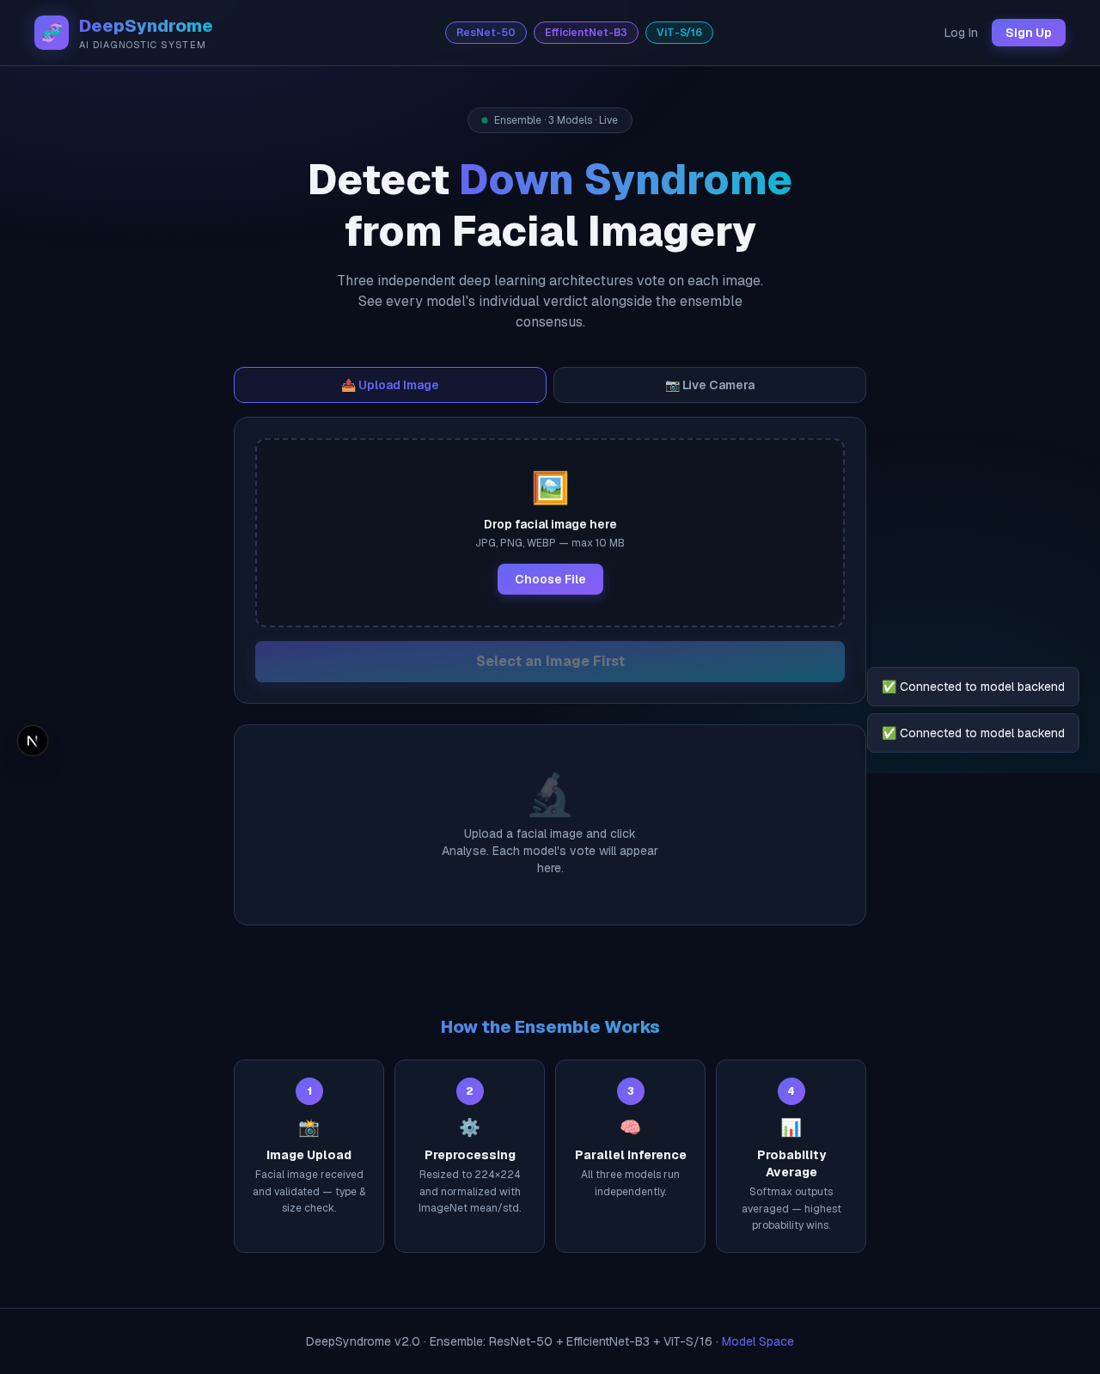
Figure TC-01: Home page — logged-out state

TC-02 — Navigation to registration
Test Case ID | TC-02
Feature | Navigation to registration
Steps | From the home page, click the "Sign Up" link in the header.
Expected Result | Browser navigates to /register and shows the Doctor Sign Up form (name, email, password fields).
Actual Result | Navigated to /register; form rendered correctly with a link back to /login.
Status | PASS

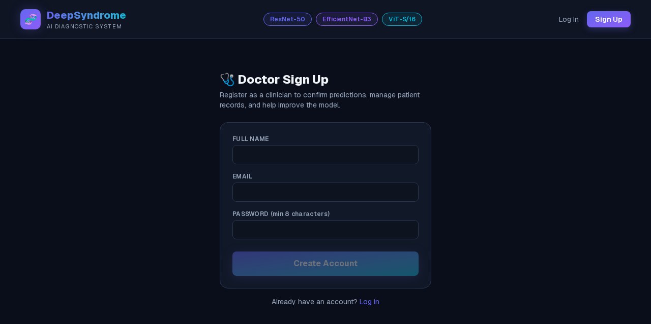
Figure TC-02: Navigation to registration

TC-03 — Doctor registration
Test Case ID | TC-03
Feature | Doctor registration
Steps | Fill in name, a unique email, and a password (8+ characters).  Click "Create Account".
Expected Result | Account is created, the doctor is automatically logged in, and the browser redirects to the home page with the header reflecting the logged-in state.
Actual Result | Registration succeeded; redirected to home; header showed "Dr. Test Clinician", "Patients", and "Log out".
Status | PASS

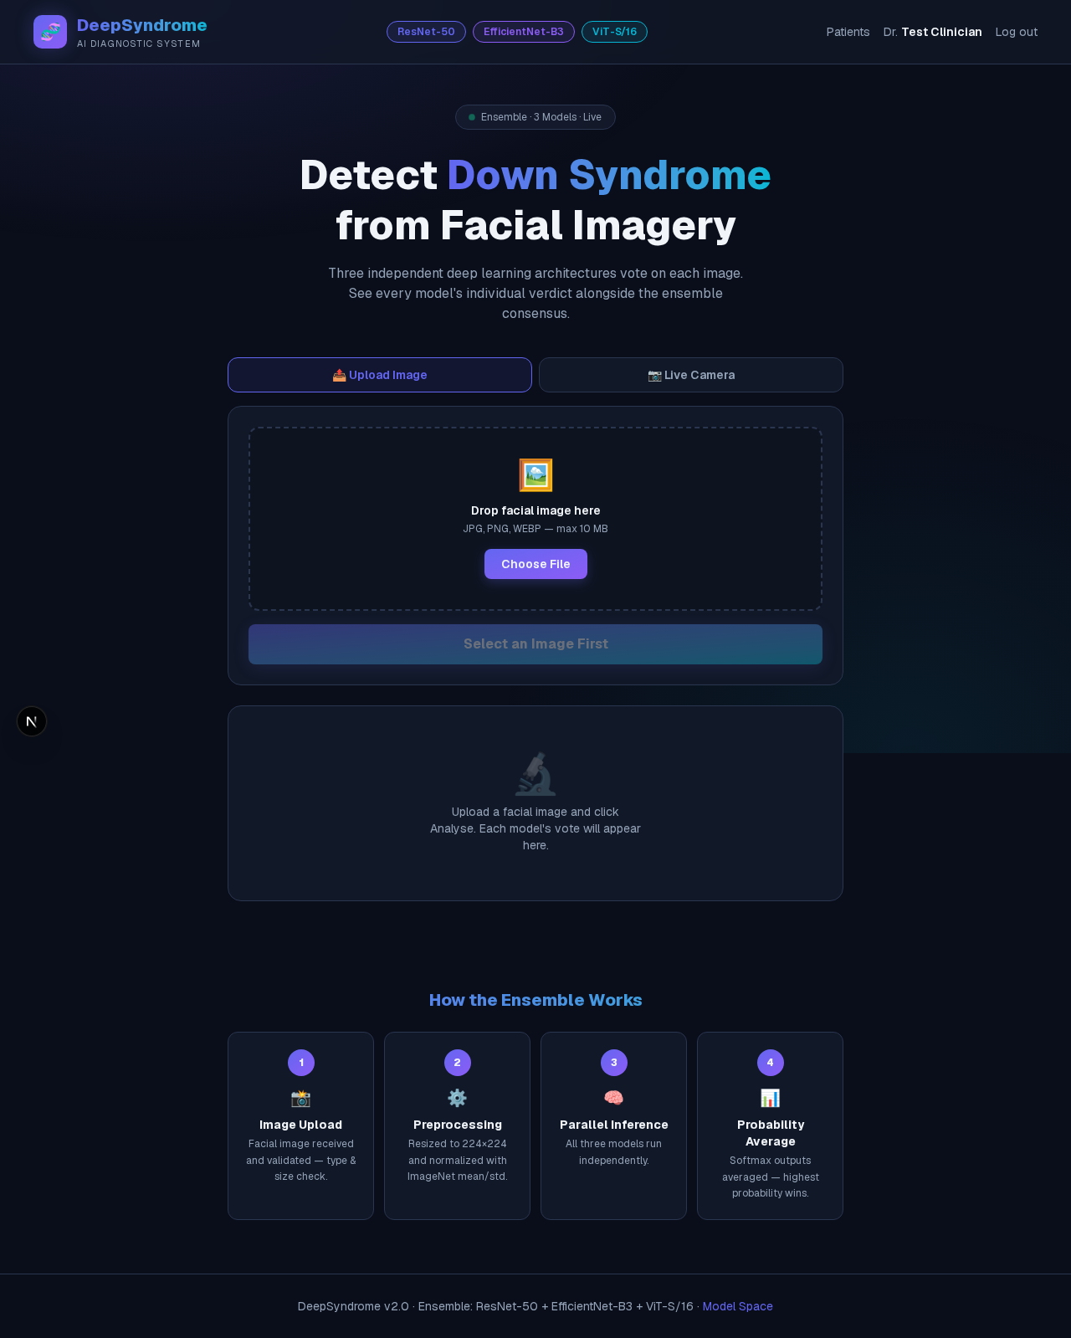
Figure TC-03: Doctor registration

TC-04 — Logout
Test Case ID | TC-04
Feature | Logout
Steps | While logged in, click "Log out" in the header.
Expected Result | Session is cleared and the header reverts to showing "Log In" / "Sign Up".
Actual Result | Header correctly reverted to the logged-out state immediately after logout.
Status | PASS

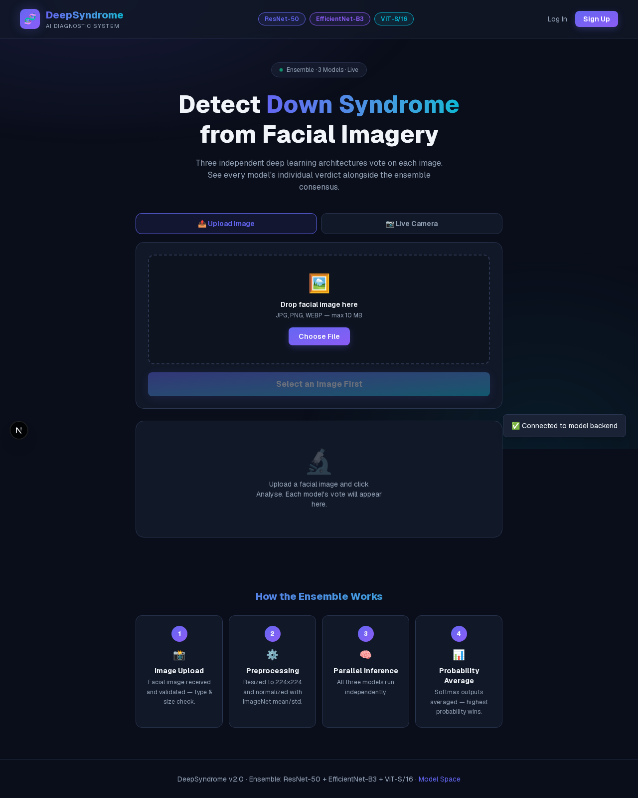
Figure TC-04: Logout

TC-05 — Login — invalid credentials
Test Case ID | TC-05
Feature | Login — invalid credentials
Steps | Navigate to /login.  Enter a registered email with an incorrect password.  Click "Log In".
Expected Result | A generic "Invalid email or password" error is shown (the system never reveals whether the email or the password was wrong); the user remains logged out.
Actual Result | Generic error message shown as expected; no session was created.
Status | PASS

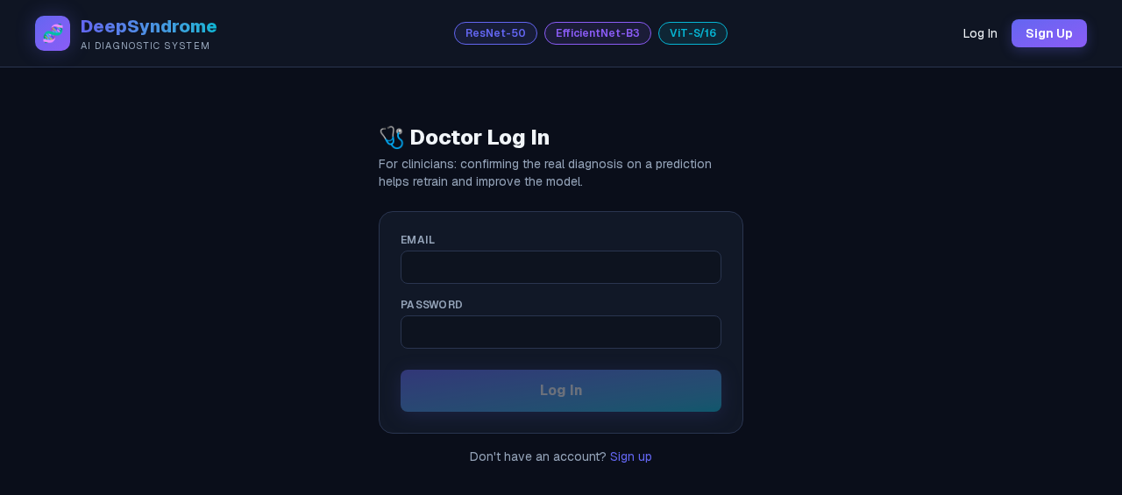
Figure TC-05.1: Login — invalid credentials (before)
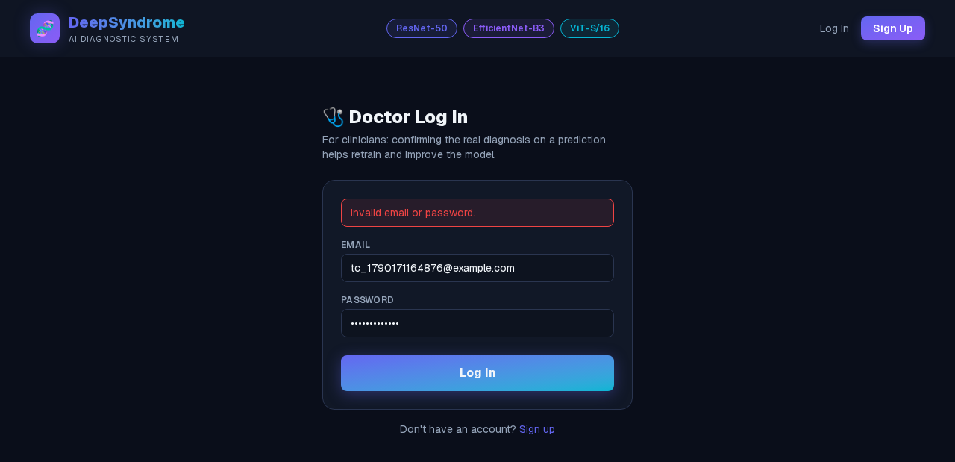
Figure TC-05.2: Login — invalid credentials (after)

TC-06 — Login — valid credentials
Test Case ID | TC-06
Feature | Login — valid credentials
Steps | On the same /login form, enter the correct password.  Click "Log In".
Expected Result | Login succeeds and the browser redirects to the home page in the logged-in state.
Actual Result | Login succeeded; redirected to home; header showed the doctor's name and logged-in navigation.
Status | PASS

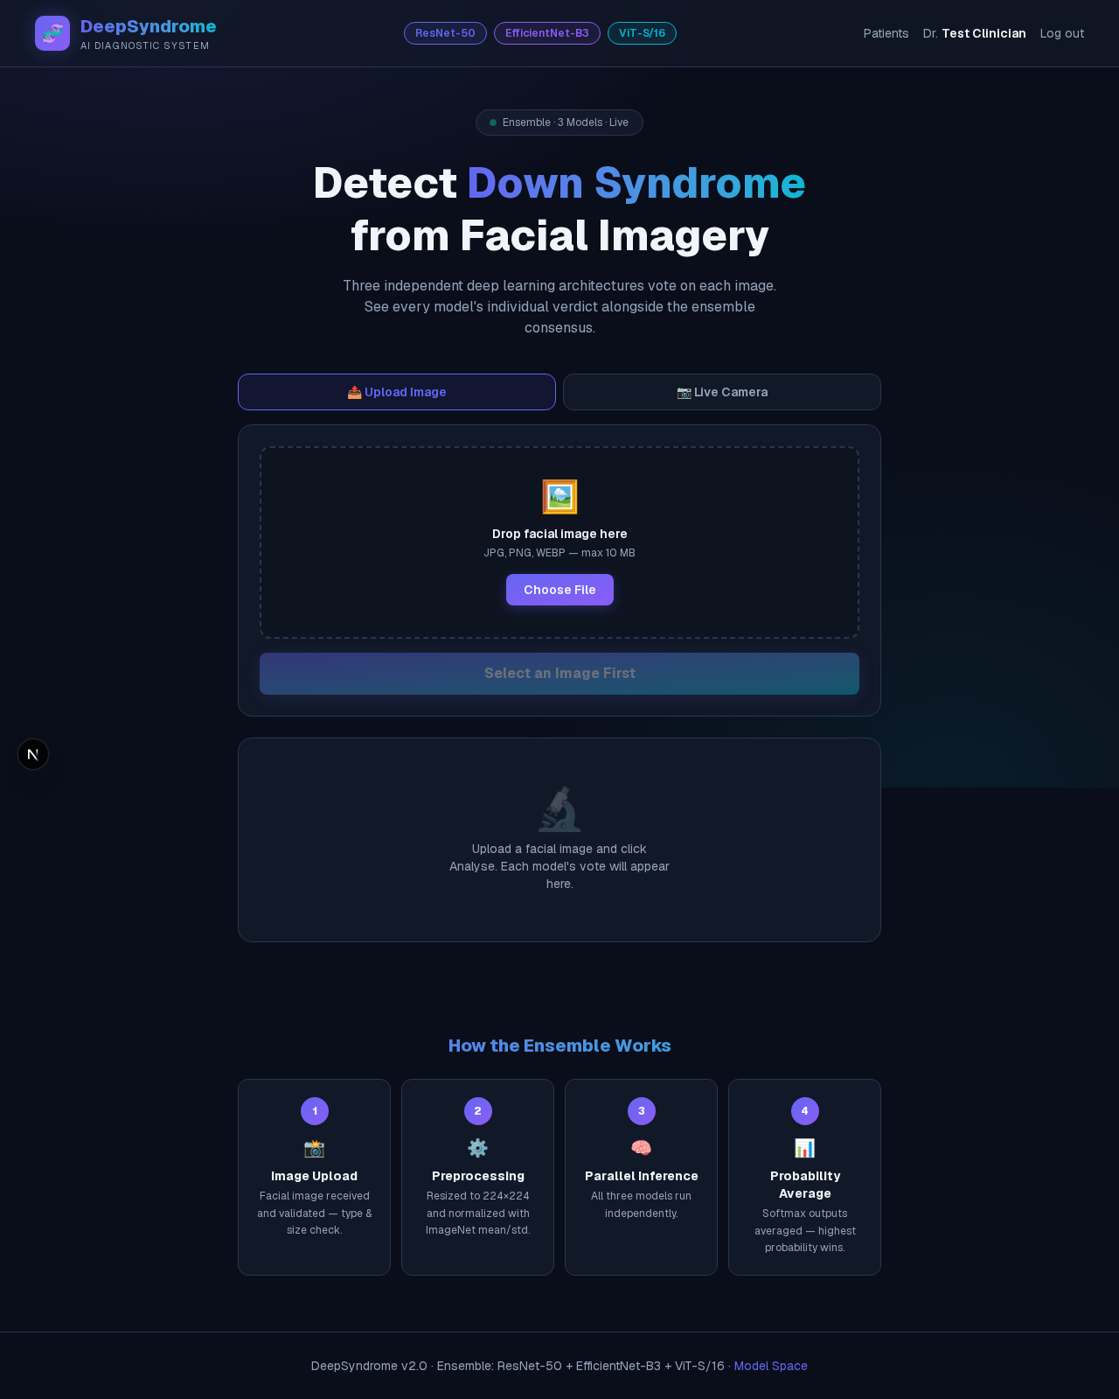
Figure TC-06: Login — valid credentials

TC-07 — Facial image upload
Test Case ID | TC-07
Feature | Facial image upload
Steps | On the home page, select a facial image file via "Choose File".
Expected Result | A preview of the selected image is shown and the "Analyse Image" action becomes enabled.
Actual Result | Image preview displayed correctly; Analyse button enabled.
Status | PASS

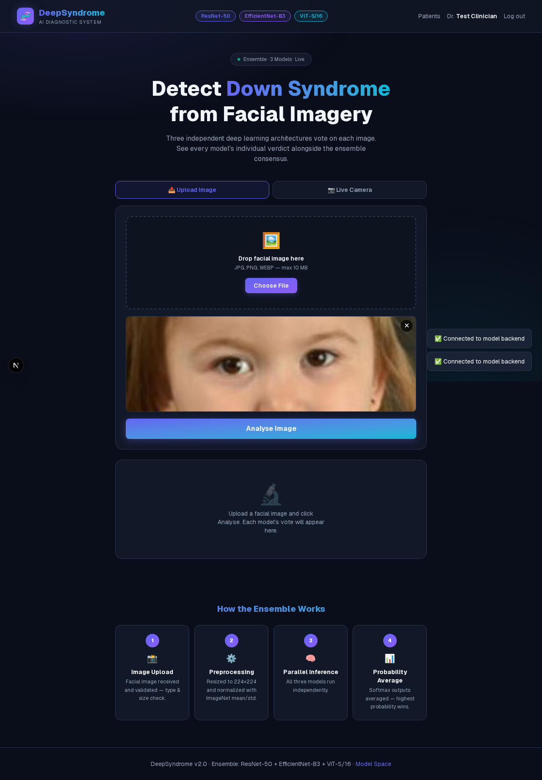
Figure TC-07: Facial image upload

TC-08 — Ensemble prediction
Test Case ID | TC-08
Feature | Ensemble prediction
Steps | Click "Analyse Image" on the selected photo.
Expected Result | The three models (ResNet-50, EfficientNet-B3, ViT-S/16) each return a vote; the ensemble verdict, confidence, class probabilities, and per-model breakdown are displayed.
Actual Result | Ensemble returned "Control" at 97.5% confidence; all three individual models agreed (Unanimous — Control), each showing its own confidence score.
Status | PASS

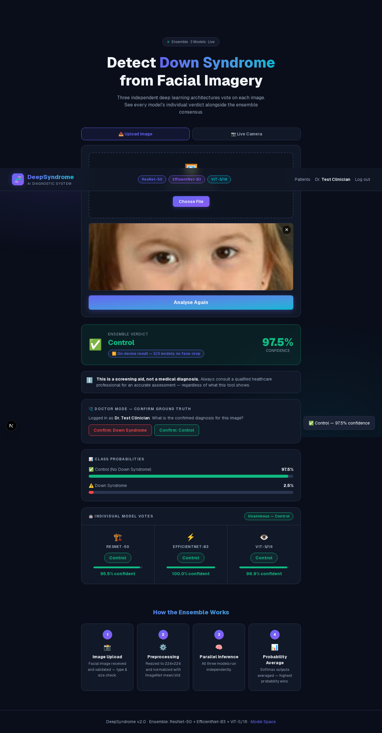
Figure TC-08: Ensemble prediction

TC-09 — Doctor Mode — confirm ground truth
Test Case ID | TC-09
Feature | Doctor Mode — confirm ground truth
Steps | With a prediction on screen and a doctor logged in, click "Confirm: Control" (or "Confirm: Down Syndrome") in the Doctor Mode panel.
Expected Result | The image, model prediction, and doctor-confirmed label are saved for future retraining; the panel shows a "Saved for future training" confirmation.
Actual Result | Sample saved successfully; "Saved for future training" shown in the Doctor Mode panel and as a toast notification.
Status | PASS

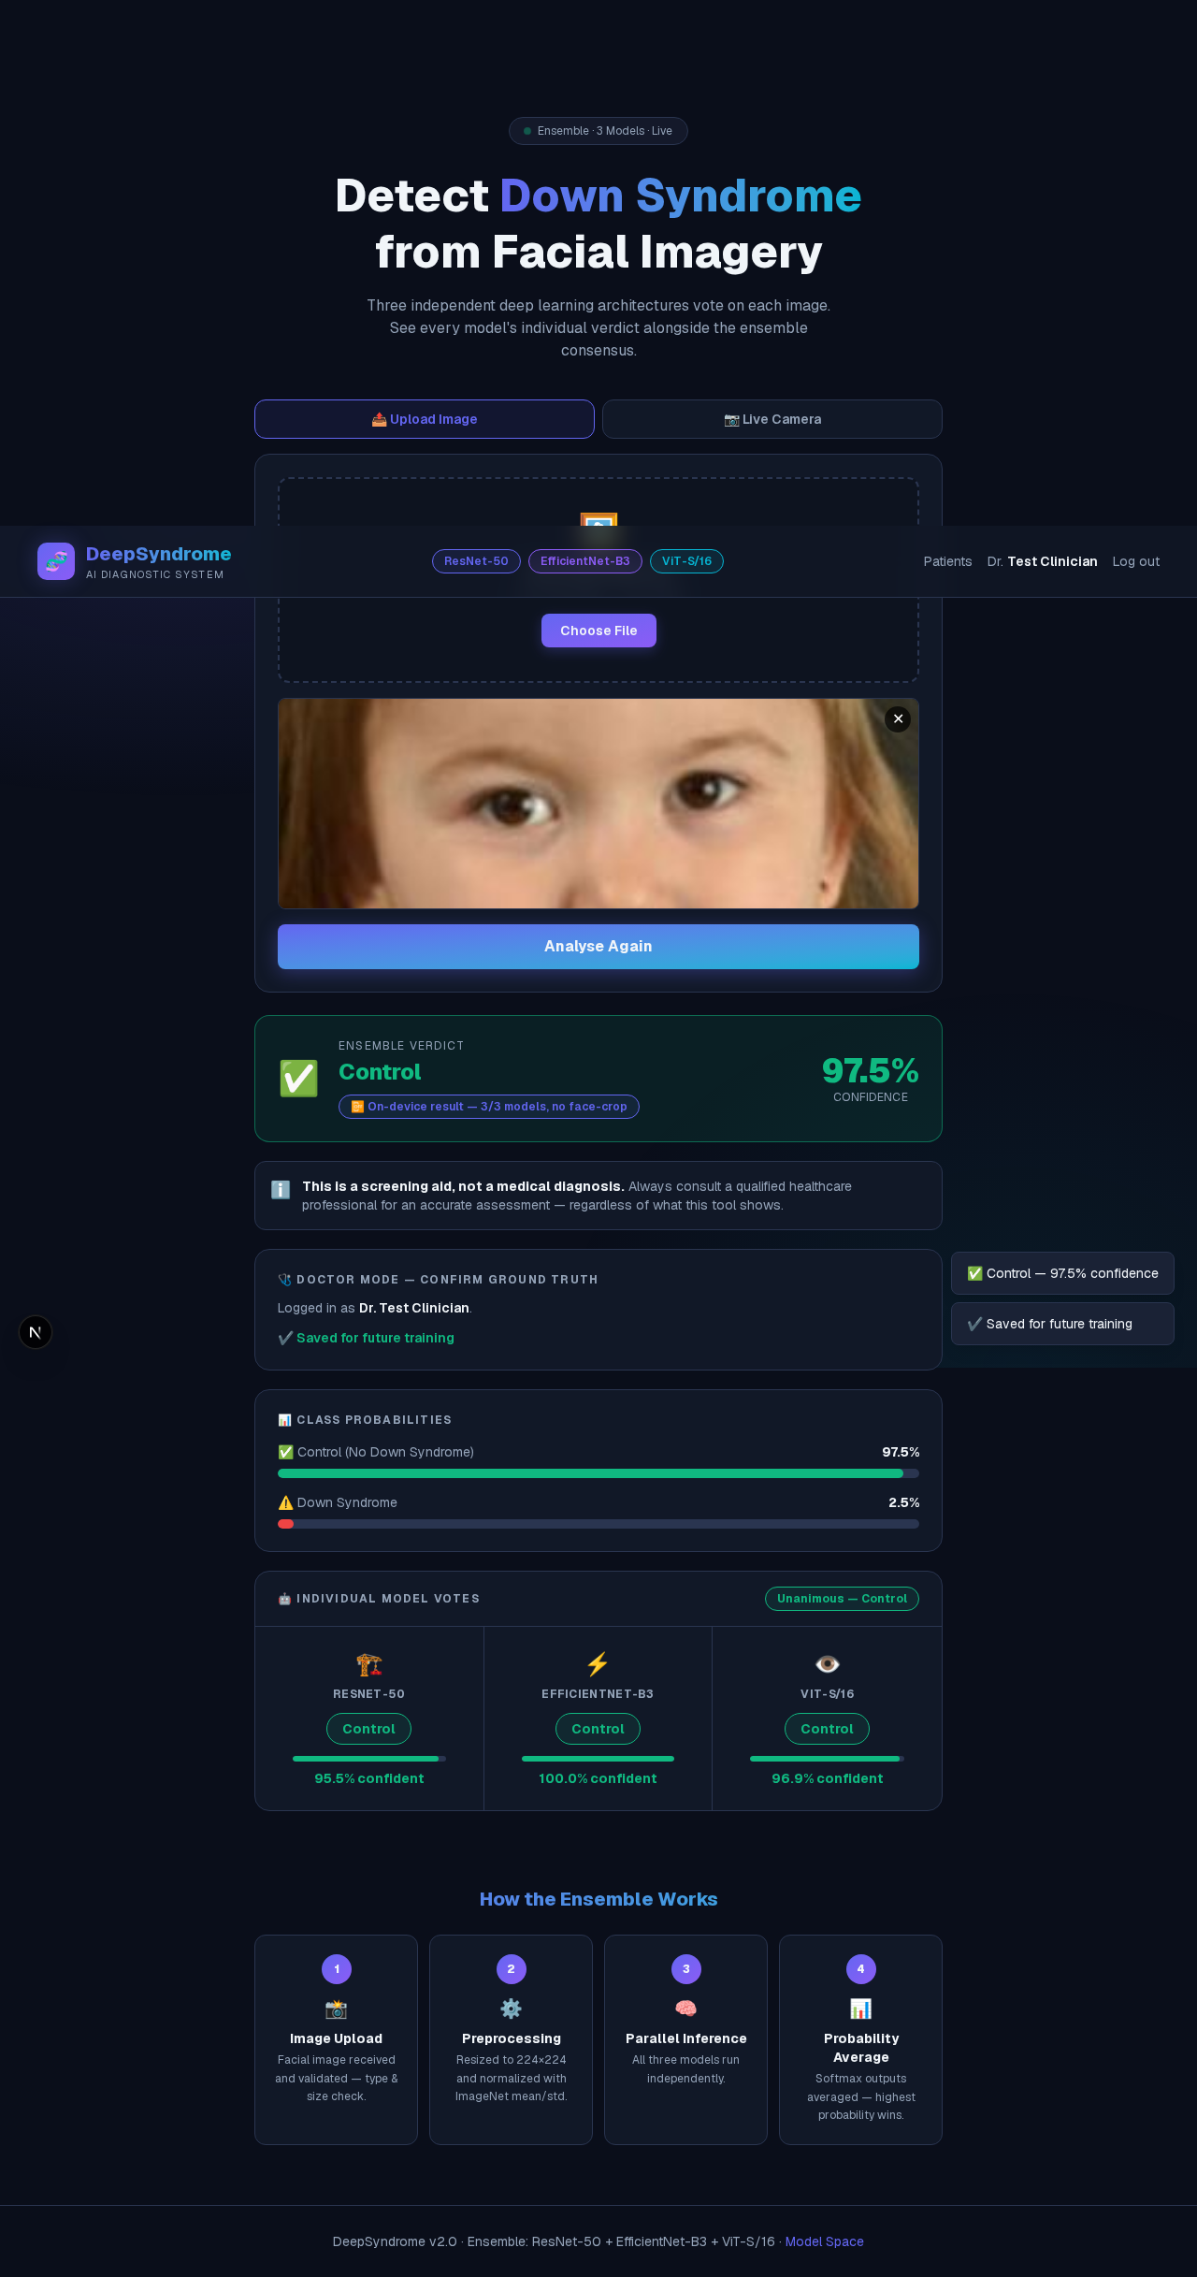
Figure TC-09: Doctor Mode — confirm ground truth

TC-10 — Patient Records — add patient
Test Case ID | TC-10
Feature | Patient Records — add patient
Steps | Navigate to /patients while logged in.  Fill in a patient's full name and optional notes.  Click "Add".
Expected Result | The patient is created and immediately appears in the doctor's own patient list, scoped to that doctor's account.
Actual Result | Patient "Ali Raza" was added and appeared in the list immediately after submission.
Status | PASS

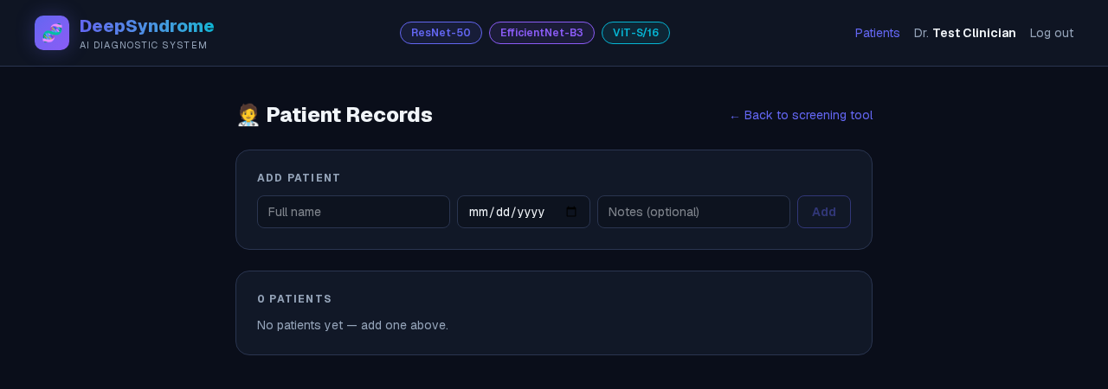
Figure TC-10.1: Patient Records — add patient (before)
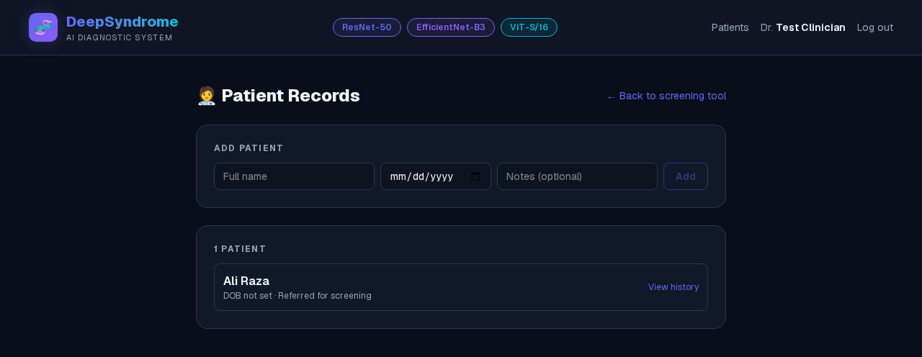
Figure TC-10.2: Patient Records — add patient (after)

TC-11 — Admin dashboard — role-based access control
Test Case ID | TC-11
Feature | Admin dashboard — role-based access control
Steps | While logged in as a regular doctor (role: doctor, not admin), navigate to /admin.
Expected Result | Access is denied with a clear message explaining that admin status is granted manually, not via self-registration.
Actual Result | Correctly blocked with: "This account doesn't have admin access...".
Status | PASS

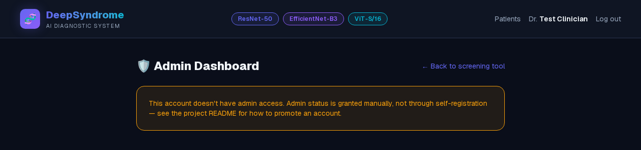
Figure TC-11: Admin dashboard — role-based access control

TC-12 — Access control when logged out
Test Case ID | TC-12
Feature | Access control when logged out
Steps | Log out.  Navigate directly to /patients (a protected page).
Expected Result | The page does not show any patient data; instead it prompts the visitor to log in or sign up.
Actual Result | Correctly showed: "You need to log in as a doctor first — log in or sign up." with no patient data exposed.
Status | PASS

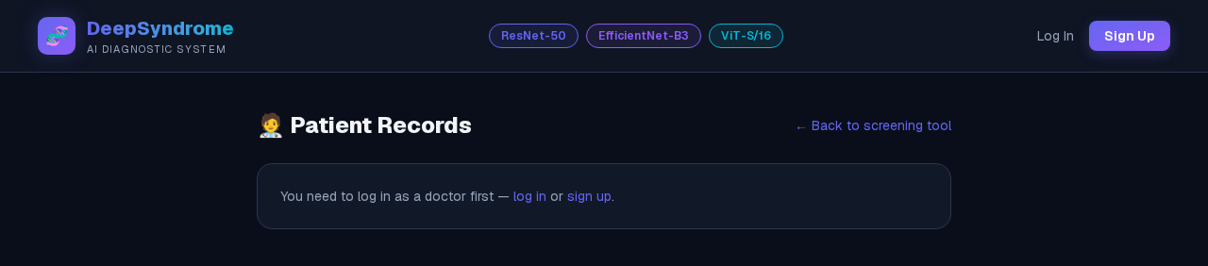
Figure TC-12: Access control when logged out

5. Issues Found and Fixed During Testing
Automated end-to-end testing surfaced three real defects that were not apparent from manual spot-checking. Each is documented below along with its root cause and fix, since finding and resolving these was itself part of verifying the feature.

5.1 Stale header after login/registration (Router cache reuse)
Symptom: after a successful registration or login, the page redirected home but the header still displayed "Log In" / "Sign Up" instead of the logged-in state.
Root cause: each page independently called its own instance of the authentication hook rather than sharing one source of truth. Next.js's client-side router cache reused a previously rendered (logged-out) component tree for the home page instead of remounting it, so the new page's header never re-checked the session.
Fix: converted the authentication hook into a single shared React Context (AuthProvider), mounted once at the application root, so a login/logout on any page is reflected everywhere immediately.

5.2 Patient list race condition
Symptom: intermittently, adding a new patient succeeded on the server but the patient list on screen still showed "0 Patients".
Root cause: the patient list was refetched from multiple places (on page mount and after adding a patient) without any ordering guard. Under variable network latency, an older, slower request could resolve after a newer one and overwrite the correct, up-to-date list with stale (empty) data.
Fix: added a request-sequencing guard so only the response to the most recently issued request is applied to the UI; any stale, out-of-order response is discarded.

5.3 Service worker caching authenticated API responses
Symptom: after logging out, the application could continue showing the previous session as logged in; conversely, a stale logged-out state could persist briefly after logging in.
Root cause: the offline-support service worker (added for on-device model inference) used a cache-first strategy for every same-origin GET request, including live session and patient-data API calls (/api/auth/me, /api/patients). Once cached, these responses were served from the browser's cache indefinitely, bypassing the actual cookie/session state entirely.
Fix: excluded all /api/ routes from the service worker's caching strategy so authentication and patient data are always fetched live from the network; the offline cache now only ever serves static assets and the offline ML models, which was its intended purpose. The cache version was also incremented so browsers with the old, incorrect behaviour already cached pick up the fix.

6. Conclusion
All 12 test cases pass after the fixes above. The login/registration flow, session handling, image analysis pipeline, Doctor Mode ground-truth confirmation, Patient Records, and role-based Admin access control all behave correctly and consistently across page navigations, and no longer exhibit the intermittent state bugs uncovered during testing.

