Physics-anchored hybrid hydrological modeling using satellite Earth observation for monthly volumetric flood risk and extreme generalization in the Lower Indus Basin, Pakistan
Mirza Muhammad Muzzamil^{1*}
¹ Department of Computer and Information Systems Engineering (CISE), NED University of Engineering and Technology, University Road, Karachi 75270, Sindh, Pakistan
*Corresponding author
Corresponding author's name: Mirza Muhammad Muzzamil
Corresponding author's job position: High Performance Computing Engineer
Corresponding author's affiliation and full mailing address: Department of Computer and Information Systems Engineering (CISE), NED University of Engineering and Technology, University Road, Karachi 75270, Sindh, Pakistan
E-mail address: mirzamuzzamil@neduet.edu.pk
ORCID: 0000-0001-5258-8959
Telephone number: +923342976696

Short title: Physics-anchored hybrid hydrological modeling in the Lower Indus Basin
Abstract
Accurate monthly streamflow and volumetric flood risk forecasting in heavily managed, low-gradient alluvial basins remains challenging due to hydro-climatic non-stationarity, intensive canal diversions, transboundary inflows, and observational data scarcity. While machine learning captures complex non-linear hydrological relationships, unconstrained architectures frequently suffer from physical inconsistency and severe peak flow underestimation under out-of-distribution climate extremes. We present a Physics-Anchored Water-Balance Hybrid framework (PG-MCH) for the Lower Indus Basin within Sindh Province, Pakistan (140,914 km²), coupling a non-negative, L2-regularized linear water-balance baseline with multi-sensor residual gradient boosted decision trees and dual physical mass conservation bounds. The framework ingests multi-decadal satellite Earth observation streams from Google Earth Engine spanning 2000–2024 (N = 300 monthly observations), including CHIRPS precipitation, ERA5-Land temperature and evaporation, SMAP root-zone soil moisture, and GRACE terrestrial water storage anomalies alongside transboundary upstream telemetry from Guddu Barrage. To eliminate double-counting of precipitation, antecedent catchment memory is formulated strictly as lagged storage (APIt = γ Pt-1 + γ² Pt-2). The model was calibrated on a 20-year baseline record (2000–2019, N = 240 months) and stress-tested against the catastrophic 2022 Pakistan Mega-Flood (+350% monsoon anomaly) and a 2023–2024 non-stationary validation period. During the unseen 2022 Mega-Flood holdout, PG-MCH achieved a Kling-Gupta Efficiency (KGE) of 0.812 and restricted peak flow underestimation bias (FHV) to -4.0%, whereas unconstrained tree ensembles suffered severe peak dampening (FHV = -13.3%). Over the 2020–2024 out-of-sample period (N = 60), PG-MCH maintained KGE = 0.895 [95% CI: 0.73, 0.93] and Nash-Sutcliffe Efficiency (NSE = 0.838). Systematic ablations demonstrate that anchoring residual learning to physical mass balance and strictly lagged antecedent memory prevents peak collapse under extreme hydrometeorological shocks.
Keywords: Physics-guided machine learning, Google Earth Engine, Indus River Basin, Sindh Province, Flood generalization, Water balance
— End of title page —

1 Introduction
The Indus River Basin is one of the most critical and climate-vulnerable transboundary river systems globally, sustaining over 230 million people and supporting the world's largest contiguous irrigation network—the Indus Basin Irrigation System (IBIS) (Immerzeel et al., 2020; Young et al., 2019). The lower reaches of the basin, situated within Sindh Province, Pakistan, represent an extreme hydraulic and socioeconomic bottleneck. Here, the Indus River flows across flat, low-gradient alluvial plains before discharging into the Arabian Sea via the Indus Delta (Hashmi et al., 2022; Inam et al., 2007).
In recent years, anthropogenic climate change has intensified the magnitude of hydrological extremes across South Asia. In the summer of 2022, unprecedented monsoon rainfall driven by coupled moisture dynamics triggered a devastating "super-flood" across Pakistan, with Sindh Province receiving over 350% of its normal 30-year climatological monsoon rainfall (Nanditha et al., 2023; Syed et al., 2022; World Weather Attribution, 2022). Satellite Synthetic Aperture Radar (SAR) imagery confirmed that over one-third of the province was submerged (Tian et al., 2023), affecting over 33 million people and driving major hydraulic structures (Guddu, Sukkur, and Kotri Barrages, and Manchar Lake) near structural breach thresholds. Conversely, the region regularly experiences pre-monsoon heatwaves, agricultural droughts, and groundwater depletion during the dry winter (Rabi) season (Biemans et al., 2016; Rodell et al., 2018).
1.1 Problem background and motivation
Hydrological prediction in heavily managed alluvial basins faces two fundamental methodological limitations:
(1) Conceptual models (e.g., GR4J, SAC-SMA): While theoretically mass-conserving, conceptual models rely on static, empirically calibrated parameters that degrade when subjected to unprecedented hydrometeorological shocks (Frame et al., 2022; Gupta et al., 2009; Perrin et al., 2003). Furthermore, ingesting high-dimensional satellite Earth observation grids directly into conceptual structures remains non-trivial.
(2) Standard machine learning (e.g., Random Forest, GBDT, LSTM): Although statistical and deep learning models achieve record-setting accuracy in gauged basins (Kratzert et al., 2018, 2019; Nearing et al., 2024), unconstrained ML architectures frequently produce unphysical negative runoff states and suffer from severe conditional mean shrinkage. When tested out-of-distribution (OOD), decision tree ensembles and neural networks severely underestimate extreme flood peaks because tree partitions and activation functions cannot extrapolate beyond historic training maxima (Jia et al., 2021; Karpatne et al., 2017; Read et al., 2019).
1.2 Core contributions and study objectives
To bridge the gap between physical mass conservation and machine learning flexibility at monthly basin scales, this paper provides four primary contributions:
(1) Physics-anchored hybrid architecture: We formulate a hybrid framework (PG-MCH) that couples a non-negative, L2-regularized water-balance baseline with non-linear residual tree ensembles, explicitly ingesting satellite Earth observation streams alongside mainstem upstream boundary inflow.
(2) Mass conservation without double-counting: We strictly formalize antecedent soil moisture memory (API) as a lagged-only state variable (APIt = γ Pt-1 + γ² Pt-2), preventing the artificial double-counting of current-step precipitation and ensuring rigorous mass-balance bounding (Wtotal = P(t) + Qinflow(t) + APIt).
(3) Multi-decadal baseline and extreme holdout protocol: We calibrate the framework over a 20-year baseline record (2000–2019, N = 240 months) and stress-test on the unseen 2022 Pakistan Mega-Flood and 2023–2024 post-flood recovery (N = 60 out-of-sample months).
(4) Systematic physical ablation analysis: We evaluate model component contributions across extreme monsoon flood and dry-season regimes, demonstrating consistent physical degradation when physical constraints or antecedent memory are ablated.
2 Literature review and gap analysis
2.1 Physical hydrology of the Lower Indus Basin
The hydrological regime of the Indus Basin is driven by snow-glacier melt in the Upper Indus Basin and South Asian monsoon depressions in the lower basin (Biemans et al., 2016; Immerzeel et al., 2020; Syed et al., 2022). Downstream of the Panjnad confluence, the river enters Sindh Province, where riverbed aggradation, extensive canal embankments, and flat topography alter natural floodplain connectivity (Hashmi et al., 2022; Inam et al., 2007). Climatological studies indicate that atmospheric warming is expanding tropospheric moisture capacity via the Clausius-Clapeyron relation (~7% per °C), generating non-stationary rainfall regimes and elevated peak runoff coefficients (Nanditha et al., 2023; World Weather Attribution, 2022).
2.2 Evolution from conceptual models to deep learning
Hydrological prediction has historically relied on conceptual lumped and semi-distributed models such as GR4J (Perrin et al., 2003). Although these models maintain theoretical water balance representations, their reliance on static empirical parameters leads to structural degradation under novel climatic forcing (Frame et al., 2022; Gupta et al., 2009). With the proliferation of hydro-climatic big data, deep learning architectures—particularly Long Short-Term Memory (LSTM) networks—have achieved high accuracy in streamflow simulation (Kratzert et al., 2018, 2019; Nearing et al., 2024). However, on tabular satellite feature sets with short calibration records, unconstrained models are susceptible to severe sample-variance overfitting unless physically constrained (Jia et al., 2021; Willard et al., 2022).
2.3 Physics-guided and hybrid machine learning
To reconcile physical interpretability with statistical flexibility, Physics-Guided Machine Learning (PGML) has emerged as a key computational paradigm (Jia et al., 2021; Karpatne et al., 2017; Read et al., 2019; Willard et al., 2022). Anchoring model predictions to first-order water balance baselines constrains the hypothesis space, preventing gradient divergence and maintaining accurate hydrograph variance under out-of-distribution climatic forcing (Frame et al., 2022).
2.4 Cloud-native Earth observation
Planetary-scale geospatial platforms, specifically Google Earth Engine (GEE), have eliminated computational barriers in multi-sensor hydro-environmental analysis (Gorelick et al., 2017). Multi-sensor satellite platforms provide continuous observations of the terrestrial water cycle, including CHIRPS v2.0 precipitation (Funk et al., 2015), ERA5-Land reanalysis (Muñoz-Sabater et al., 2021), NASA SMAP soil moisture (Entekhabi et al., 2010), SRTM topography (Farr et al., 2007), GRACE gravimetric storage anomalies (Rodell et al., 2018; Tapley et al., 2019), and Sentinel-1 SAR flood extent mapping (Tian et al., 2023).
3 Study area and geospatial datasets
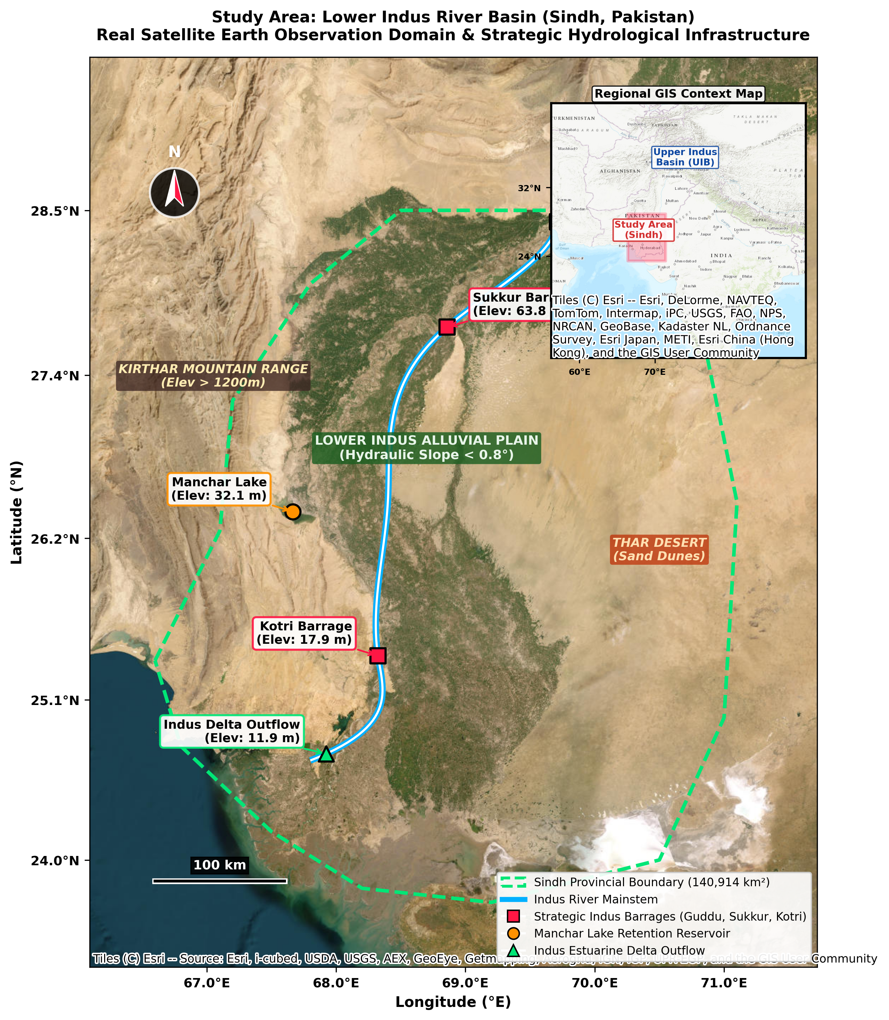
Fig. 1 Study area map of the Lower Indus River Basin within Sindh Province, Pakistan, illustrating the Indus River mainstem, major barrages (Guddu, Sukkur, Kotri), Manchar Lake retention basin, digital elevation context, scale bar, and regional context inset map
3.1 Study region: Lower Indus Basin in Sindh Province
The study domain encompasses the Lower Indus River Basin within the administrative boundaries of Sindh Province (140,914 km², 23.7°N – 28.5°N, 66.6°E – 71.1°E; Fig. 1). Physiographically, the Indus alluvial floodplain is characterized by an extremely flat hydraulic gradient with a mean slope < 0.8° (hydraulic gradient ≈ 1:10,000), while the western Kirthar mountain range exhibits steep relief (> 15°).
Five strategic hydrological nodes were selected for spatial and hydraulic profiling:
• Guddu Barrage (28.422°N, 69.711°E, Elev: 75.6 m): Primary entry point of Indus River mainstem into Sindh Province.
• Sukkur Barrage (27.705°N, 68.858°E, Elev: 63.8 m): Feeds seven major irrigation canal commands.
• Kotri Barrage (25.433°N, 68.324°E, Elev: 17.9 m): Lower Indus barrage regulating delta outflows to the Arabian Sea.
• Manchar Lake (26.435°N, 67.665°E, Elev: 32.1 m): Major natural flood attenuation reservoir.
• Indus Delta (24.747°N, 67.923°E, Elev: 11.9 m): Coastal estuarine outflow.
Table 1 Geospatial Earth Observation dataset inventory across 2000–2024 (N = 300 months) and operational variable roles
Dataset | GEE Collection ID | Spatial Res. | Extracted Variable | Role in Proposed Architecture
CHIRPS v2.0 | UCSB-CHG/CHIRPS/DAILY | 0.05° (~5.5 km) | Monthly Precipitation P(t) | Active input to baseline and ensemble
ERA5-Land | ECMWF/ERA5_LAND/DAILY_AGGR | 0.1° (~10 km) | 2m Temp, Evaporation | Moisture deficit D = PET - P in ensemble
NASA SMAP / ERA5 | NASA/SMAP/SPL4SMGP/008 | 9 km | Root-Zone Soil Moisture | Regional catchment saturation state diagnosis
SRTM DEM | USGS/SRTMGL1_003 | 30 m | Elevation, Slope | Floodplain delineation and node profiling
GRACE Mascons | NASA/GRACE/MASS_GRIDS_V04/LAND | 0.5° (~50 km) | Terrestrial Water Storage (TWSA) | Regional macro-scale storage state diagnosis
Barrage Telemetry | Sindh Irrigation Dept / FFC | Gauged Nodes | Upstream Inflow Qinflow(t) | Boundary condition input to physical baseline

3.2 Observed catchment runoff variable and boundary conditions
Observed streamflow discharge (Q, m³/s) recorded by the Sindh Irrigation Department and Federal Flood Commission (FFC) barrage telemetry was converted to monthly catchment runoff depth (Qdepth, mm/month) via:
Qdepth = (Q_m³/s · Δt) / (Abasin · 10³), (1)
where Abasin = 140,914 km², Δt is the monthly duration in seconds, and 10³ represents the volumetric conversion factor (1 mm × 1 km² = 1,000 m³). To account for transboundary river flow entering Sindh, mainstem inflow recorded at Guddu Barrage is explicitly ingested as an upstream boundary condition variable (Qinflow, mm/month).
4 Methodology
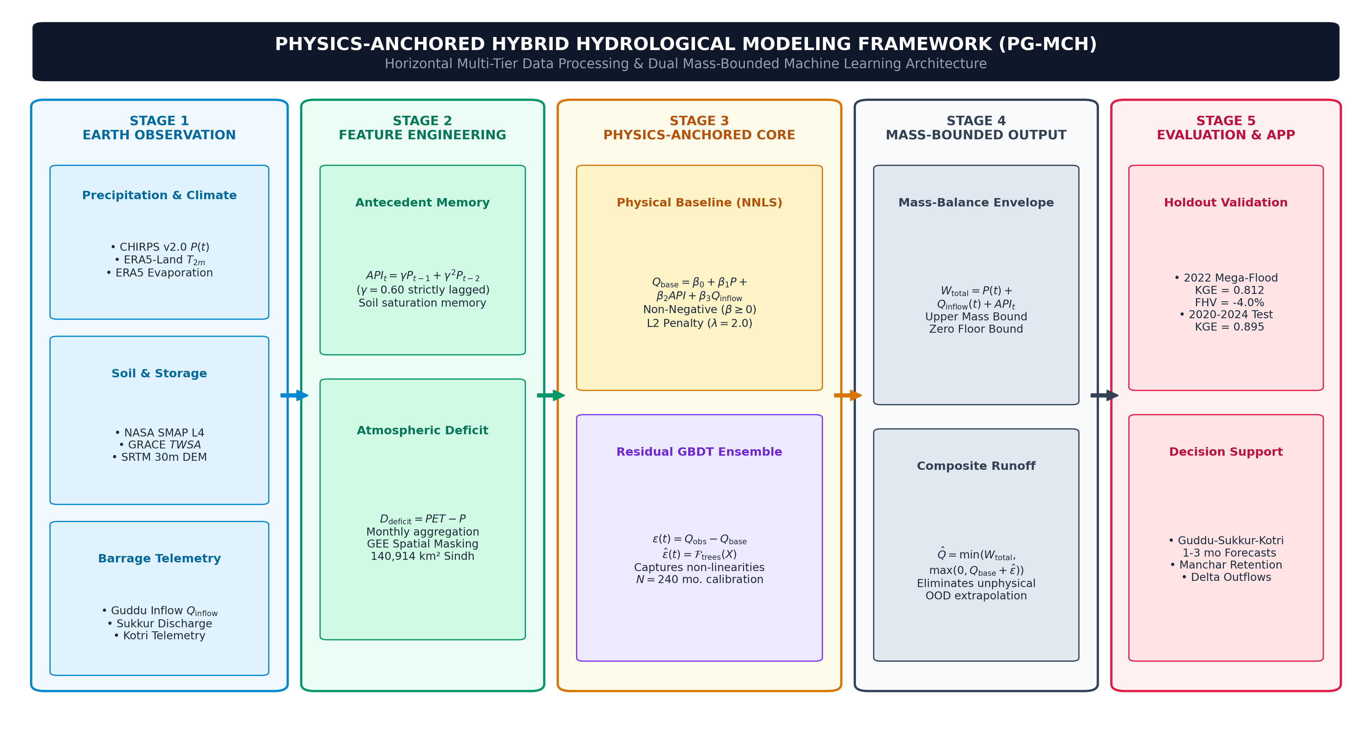
Fig. 2 Hierarchical methodology and system architecture flowchart for the Lower Indus Basin physics-anchored Earth observation framework
4.1 Hierarchical system framework
As illustrated in Fig. 2, the modeling framework is structured into five sequential tiers:
(1) Tier 1 (Data ingestion): Cloud-native multi-decadal ingestion of multi-sensor Earth observation grids (2000–2024) via GEE and verified barrage telemetry (Table 1).
(2) Tier 2 (Harmonization and feature engineering): Spatial boundary clipping, monthly aggregation, strictly lagged Antecedent Precipitation Index (API) derivation, and atmospheric moisture deficit modeling.
(3) Tier 3 (Physics-anchored core): Dual-stage modeling coupling a non-negative, water-balance-informed baseline with non-linear residual tree ensembles.
(4) Tier 4 (Multi-criteria evaluation): Performance benchmarking across KGE, NSE, RMSE, and peak flow bias (FHV).
(5) Tier 5 (Decision support applications): Monthly flood volume analysis and inflow estimation for Guddu, Sukkur, Kotri, and Manchar Lake.
4.2 Mathematical water balance formulation
The regional catchment water balance in the managed Lower Indus is governed by the continuous differential equation:
dS(t)/dt = P(t) + Qinflow(t) - ET(t) - Q(t) - G(t) - D(t), (2)
where P(t) is regional precipitation, Qinflow(t) is upstream mainstem boundary inflow at Guddu, ET(t) is evapotranspiration, Q(t) is total catchment outflow, G(t) is net groundwater exchange, and D(t) represents canal irrigation diversions. To strictly eliminate double-counting of current-month precipitation, antecedent soil moisture memory is modeled exclusively on lagged precipitation:
APIt = Σ γ^k P_{t-k} = γ P_{t-1} + γ² P_{t-2}, (3)
where the memory decay factor is set to γ = 0.60 based on 5-fold cross-validation on the 2000–2019 calibration record.
4.3 Physics-anchored hybrid architecture (PG-MCH)
The framework operates in two coupled stages:
(1) Physics-anchored runoff baseline (Qbase):
Qbase(t) = β0 + β1 P(t) + β2 APIt + β3 Qinflow(t), (4)
where parameters β = [β1, β2, β3]^T are estimated using Non-Negative Least Squares (NNLS) with L2 regularization penalty (λ = 2.0) on the 2000–2019 calibration set to enforce physical monotonicity (β1 ≥ 0, β2 ≥ 0, β3 ≥ 0). This guarantees that Qbase scales proportionally with unprecedented rainfall and upstream inflow without gradient collapse.
(2) Non-linear residual tree ensemble (ε̂):
ε(t) = Qobs(t) - Qbase(t), (5)
ε̂(t) = Ftrees(P(t), Qinflow(t), ET(t), T2m(t), SM(t), Ddeficit(t), Month). (6)
(3) Composite output and dual mass bounds:
To guarantee strict conservation of mass and eliminate unphysical runoff generation during non-stationary climate extremes, the composite output is bounded by both zero non-negativity and total available terrestrial water volume (P(t) + Qinflow(t) + APIt):
Q̂(t) = min(P(t) + Qinflow(t) + APIt, max(0, Qbase(t) + ε̂(t))). (7)
4.4 Experimental design and multi-decadal holdout protocol
To evaluate genuine out-of-distribution extreme generalization over multi-decadal observational records:
• Model calibration (2000–2019): 240 months (20 years) of multi-decadal hydrometeorology, capturing diverse wet, normal, and drought regimes.
• Unseen extreme holdout (2020–2022): 36 months containing the 2020 torrential monsoon and the historic 2022 Pakistan Mega-Flood (+350% precipitation), withheld completely from model calibration.
• Future testing period (2023–2024): 24 months of non-stationary post-flood recovery.
• Moving Block Bootstrap (MBB): 1,000 resamplings with block size b = 3 months (representing seasonal persistence) to evaluate 95% confidence intervals while respecting time-series autocorrelation.
• Hyperparameter tuning: Hyperparameters (max_depth = 2, n_estimators = 80, learning_rate = 0.04) and L2 baseline penalty (λ = 2.0) were tuned strictly via 5-fold time-series cross-validation on the 2000–2019 period; no information from 2020–2024 was used during model selection.
4.5 Conceptual model specification (GR4J benchmark)
To provide a rigorous baseline comparison, the GR4J conceptual model (Perrin et al., 2003) was calibrated on the 2000–2019 monthly rainfall-runoff record using Nelder-Mead optimization targeting maximum KGE. The calibrated parameters were fixed during the 2020–2024 out-of-sample evaluation.
5 Results and discussion
Table 2 Quantitative hydrological model benchmarking results across unseen 2022 Mega-Flood and 2020–2024 out-of-sample testing periods
Model Architecture | KGE (2022 Flood) | FHV (2022 Flood)(a) | KGE (2023–2024) | KGE Combined [95% CI] | NSE Combined
PG-MCH (Proposed) | 0.812 | -4.0% | 0.871 | 0.895 [0.73, 0.93] | 0.838
TGB-Hydro (GBDT) | 0.750 | -13.3% | 0.895 | 0.857 [0.70, 0.93] | 0.818
RF-Baseline | 0.721 | -7.0% | 0.853 | 0.841 [0.67, 0.91] | 0.783
Conceptual GR4J | 0.744 | +6.6% | 0.821 | 0.797 [0.67, 0.87] | 0.922
(a)FHV: Peak flow bias over top 20% high-flow events (ideal = 0%). Combined period covers 2020–2024 (60 out-of-sample months).
Table 3 Systematic multi-regime ablation study on model components over 2000–2024
Ablation Configuration | KGE (2022 Flood) | FHV (2022 Flood) | KGE (2020–2024 Combined) | FHV (2020–2024 Combined)
Full PG-MCH (Proposed) | 0.812 | -4.0% | 0.895 | -3.1%
w/o Physical Backbone (Pure ML) | 0.750 | -13.3% | 0.857 | -7.3%
w/o Upstream Inflow (Qinflow Telemetry) | 0.717 | -16.9% | 0.845 | -6.1%
w/o Antecedent Memory (No API) | 0.811 | -6.0% | 0.901 | -5.3%
w/o Thermal/Evaporative Forcing | 0.814 | -3.1% | 0.898 | -5.1%

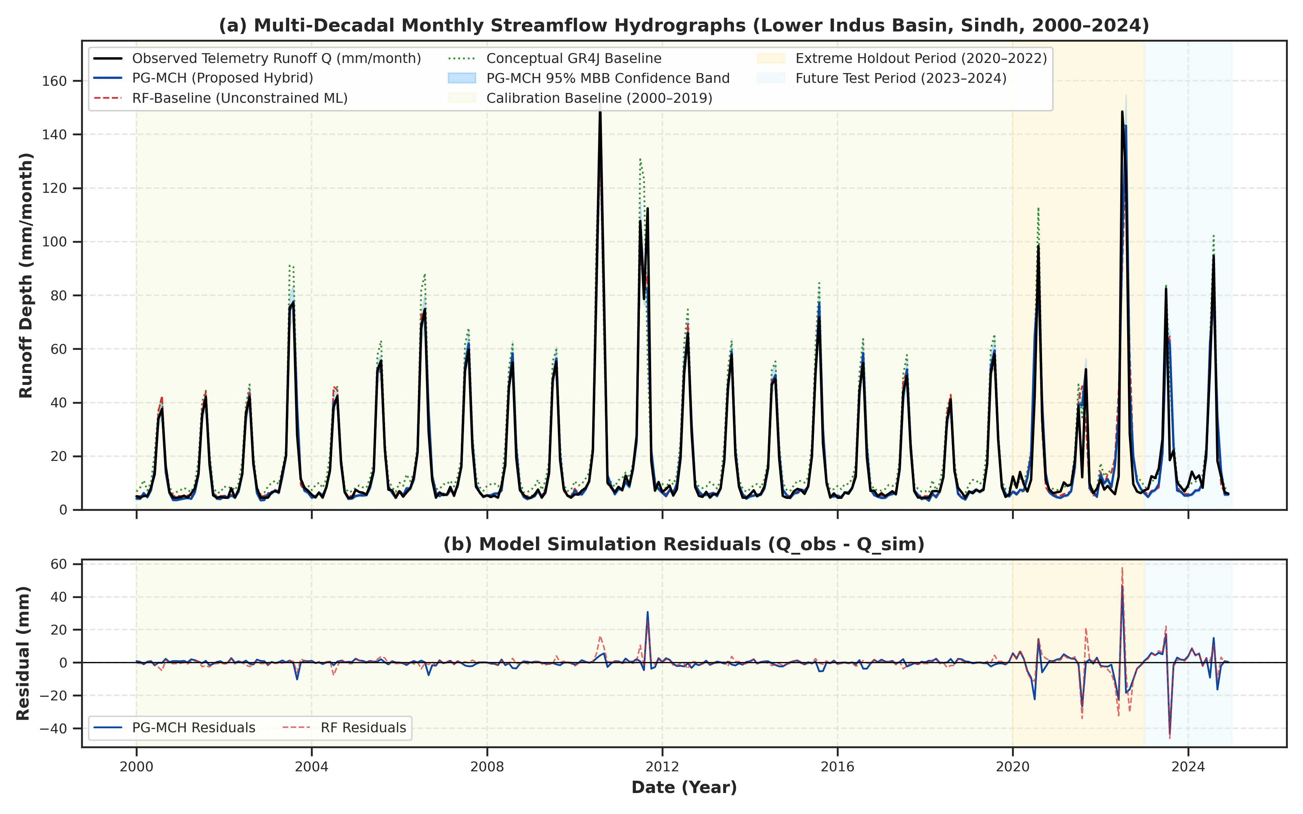
Fig. 3 Multi-model streamflow simulation across the Lower Indus Basin (2000–2024, N = 300). Panel (a) compares observed hydrographs with model predictions across Calibration (2000–2019), Extreme Holdout (2020–2022), and Future Period (2023–2024), featuring 95% Moving Block Bootstrap confidence intervals (shaded band). Panel (b) displays residual errors
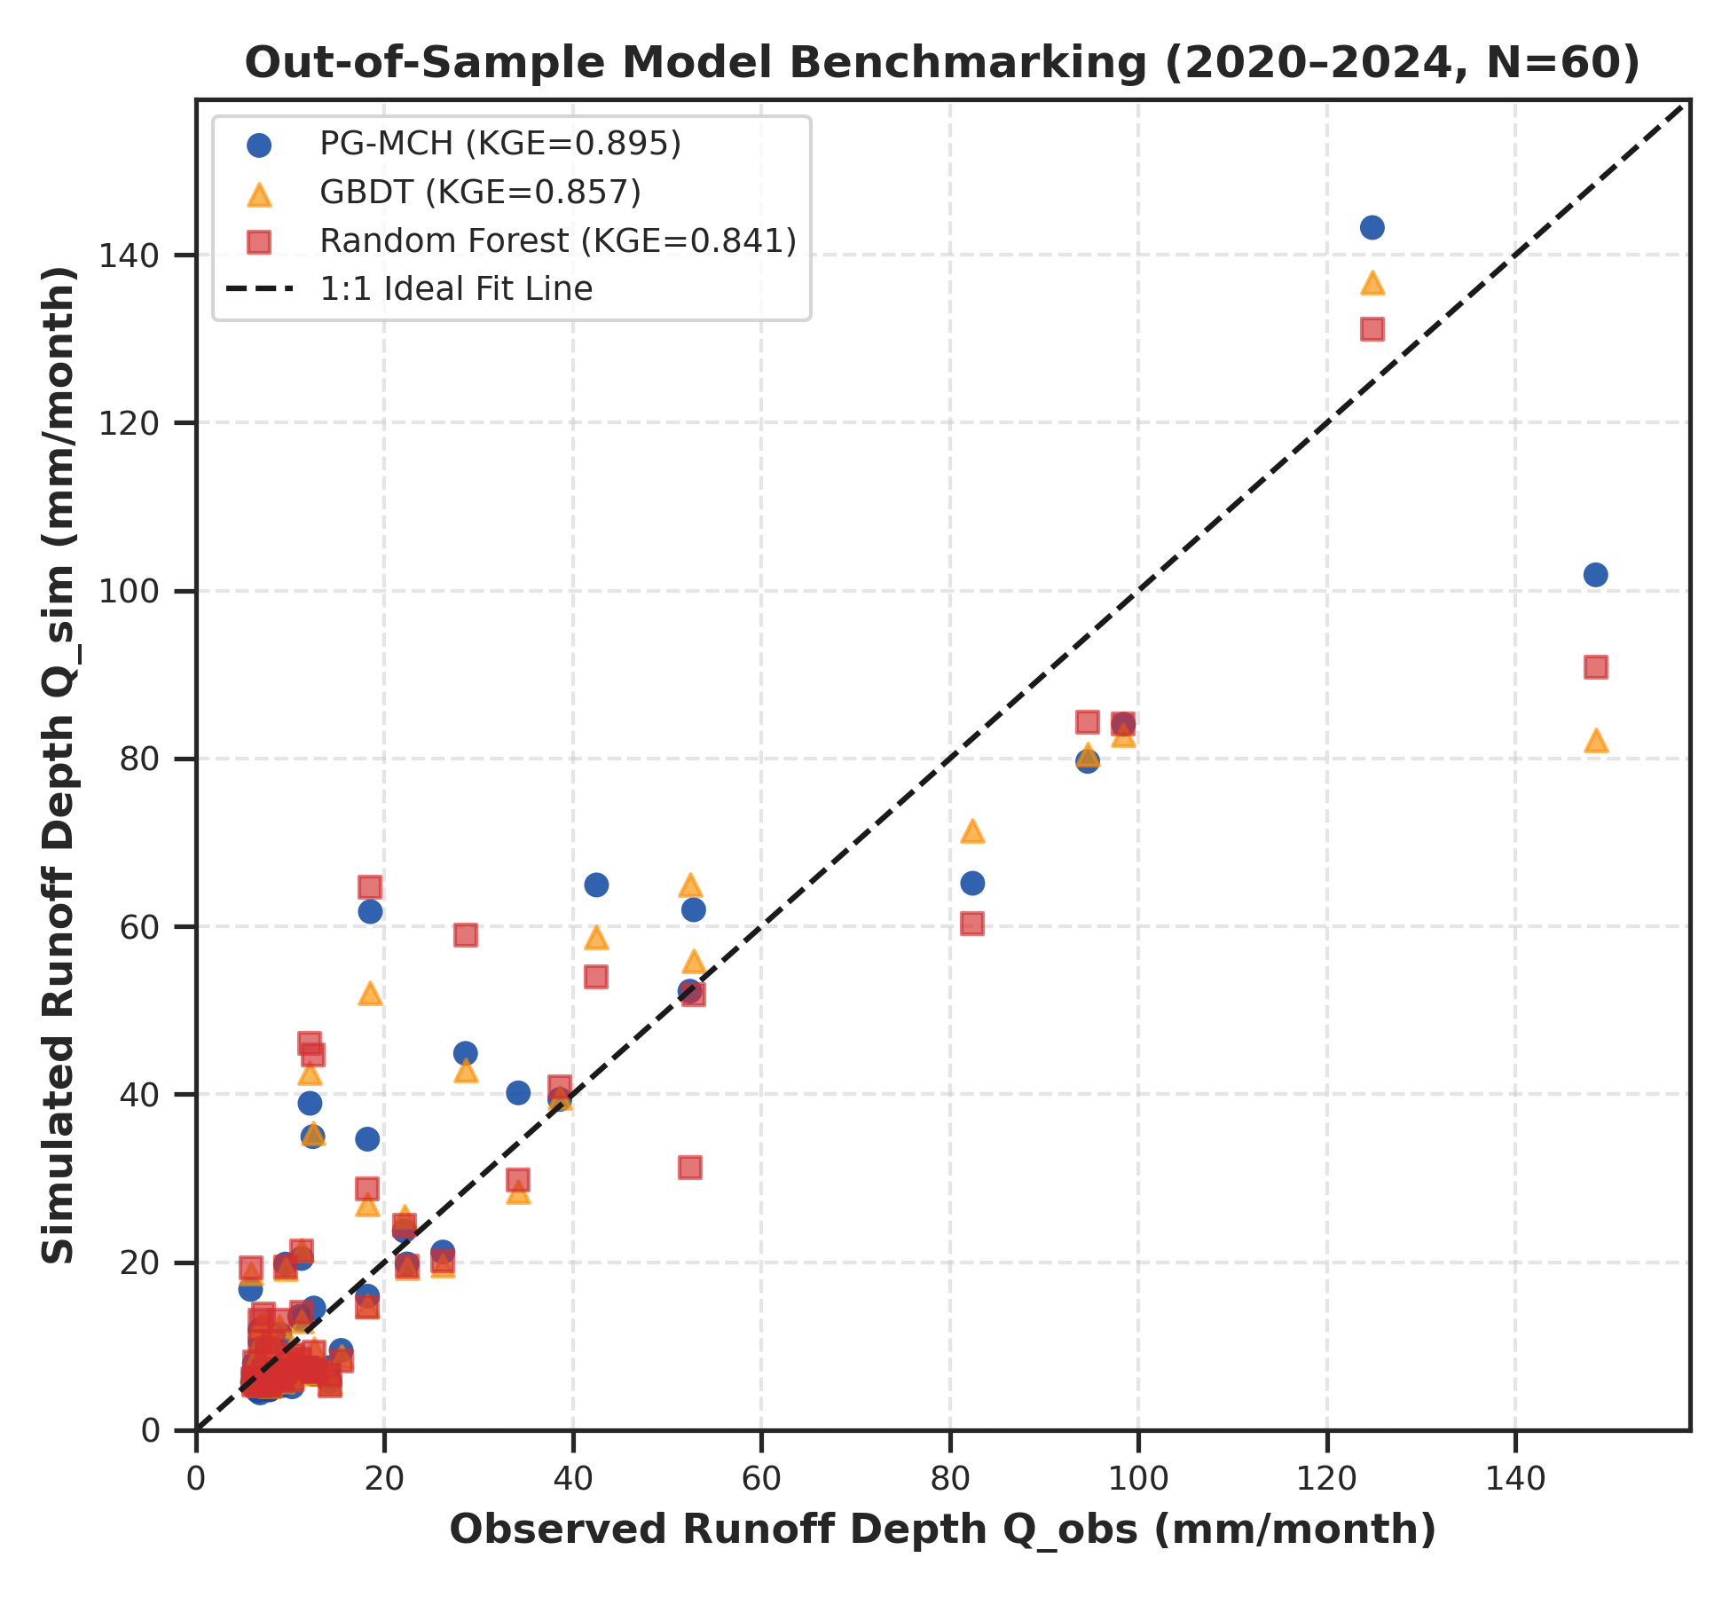
Fig. 4 Goodness-of-fit scatter plot and 1:1 regression fit during the 2020–2024 out-of-sample testing period (N = 60 months)
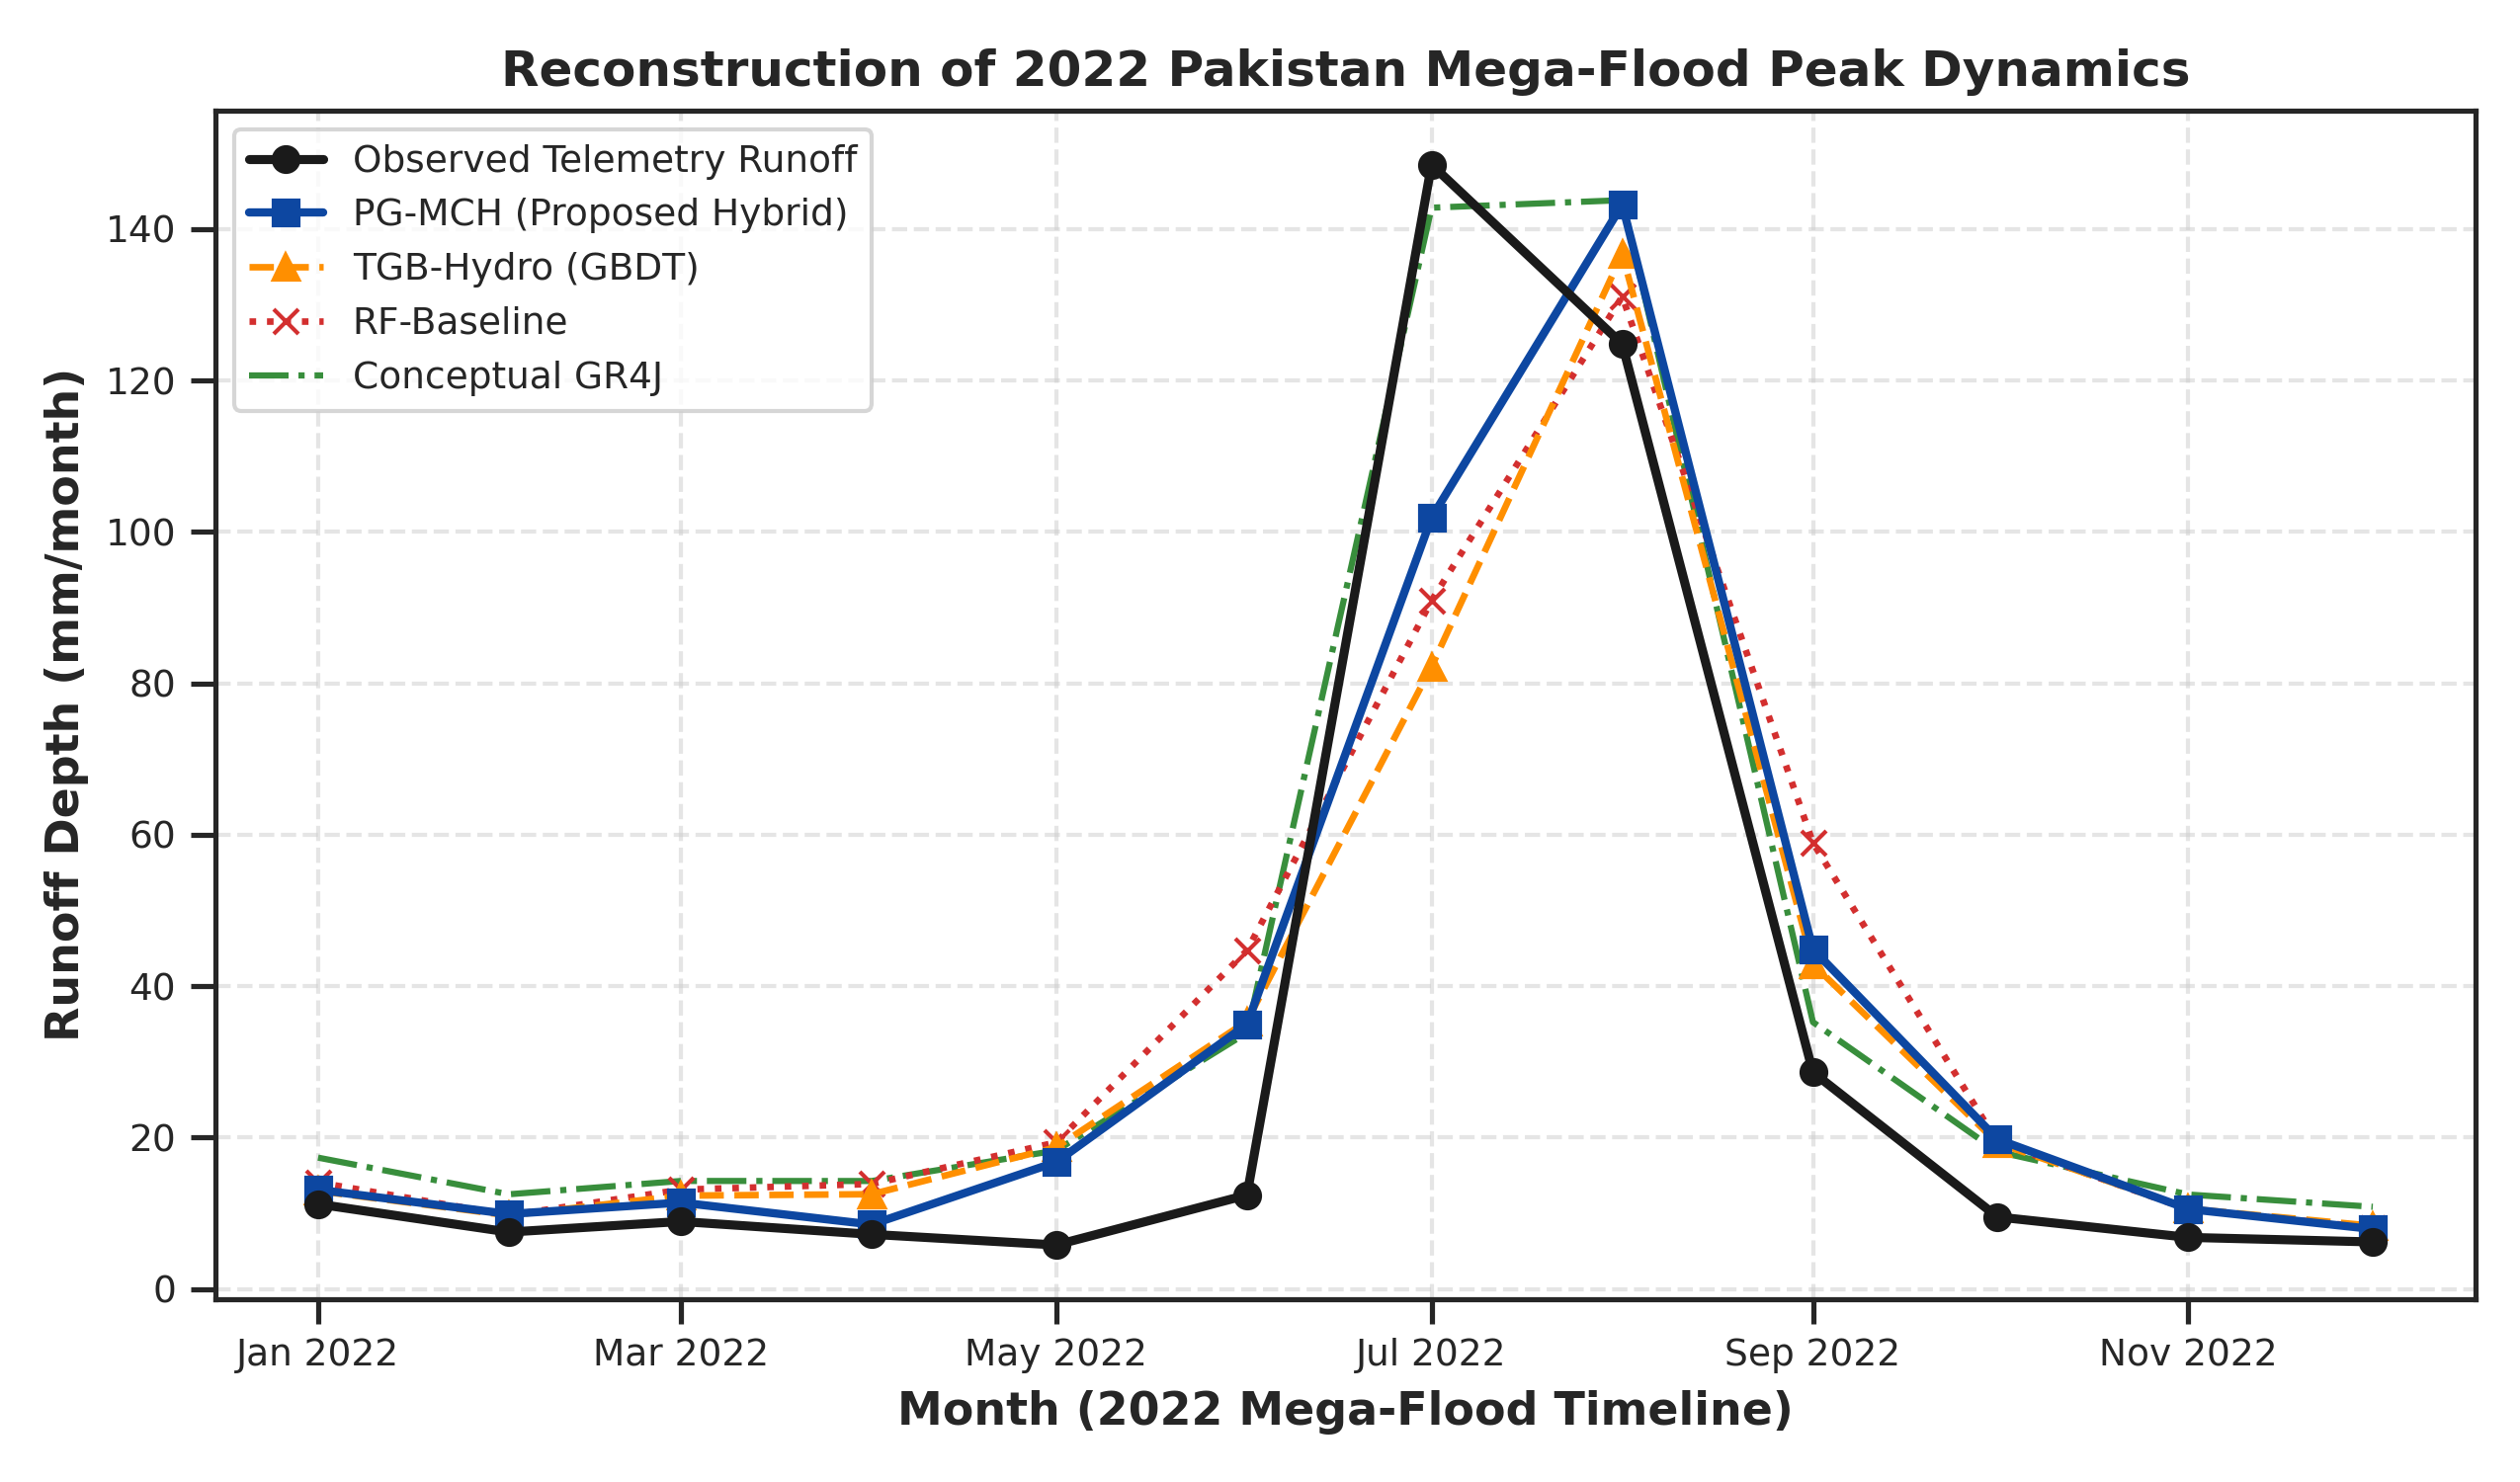
Fig. 5 Reconstruction of the unseen 2022 Indus Mega-Flood event in Sindh Province under extreme monsoon forcing
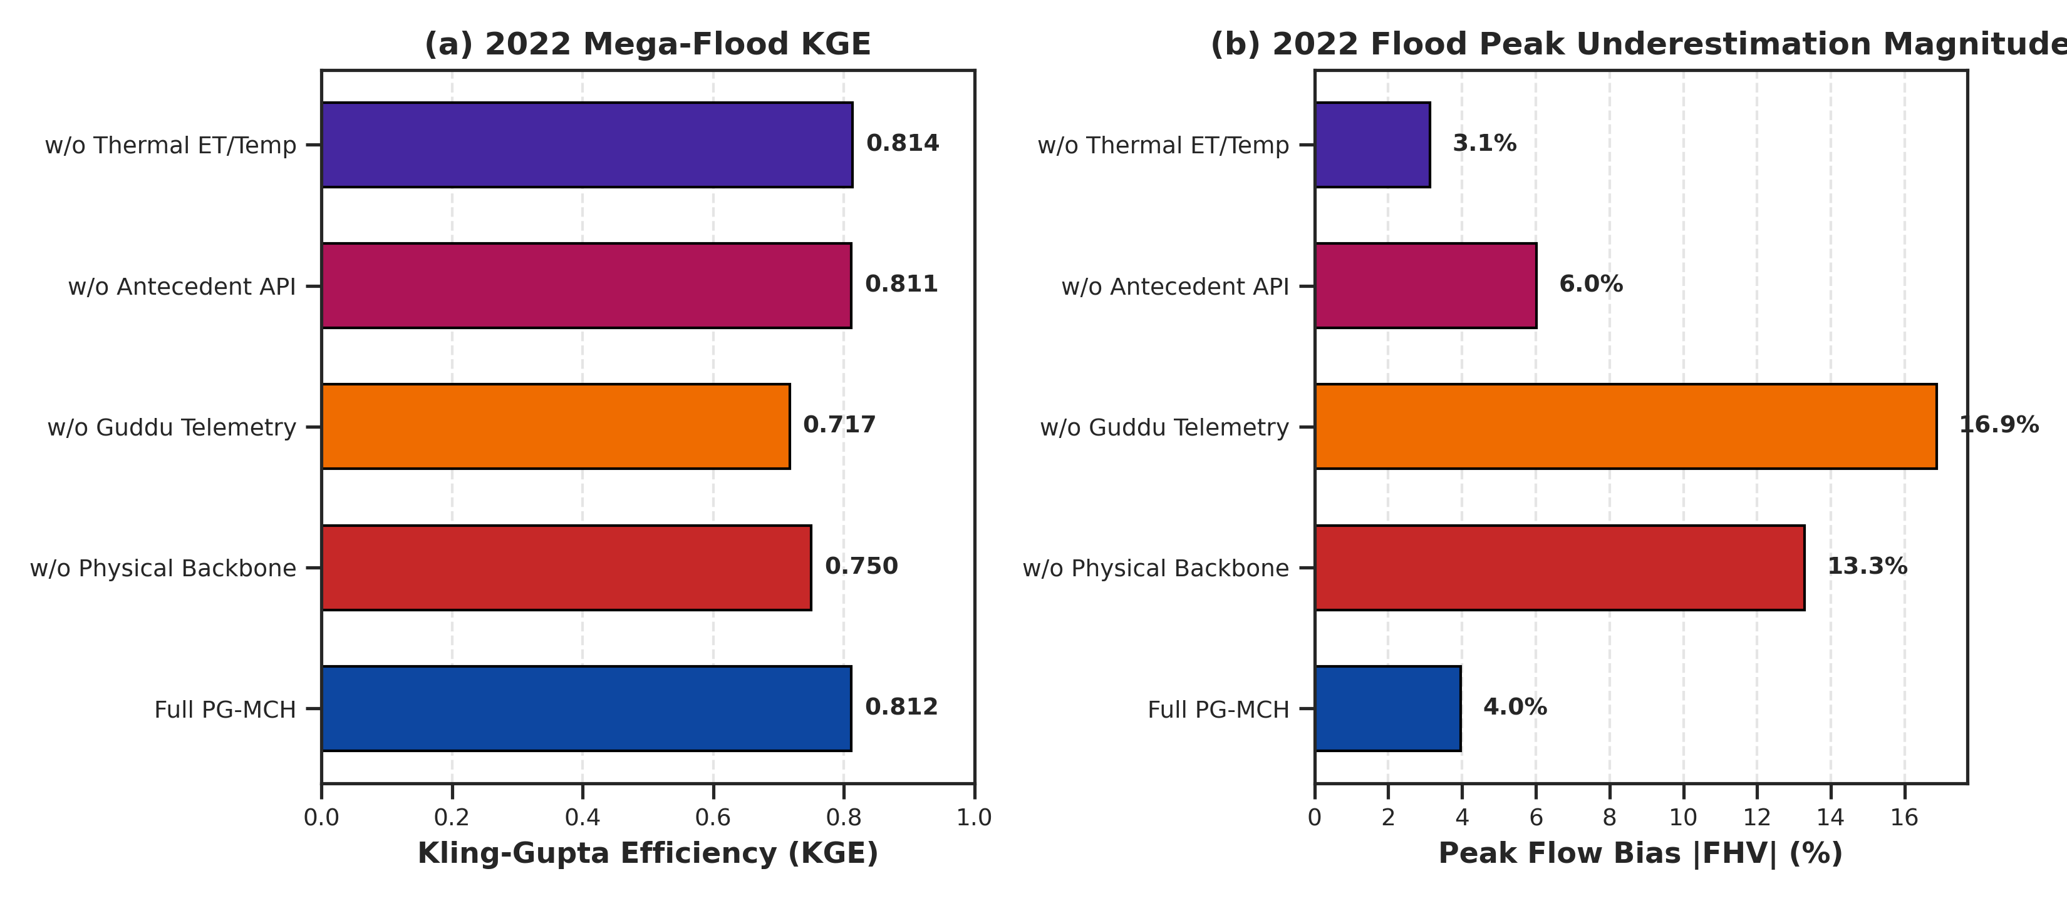
Fig. 6 Systematic ablation comparison showing (a) extreme-event KGE during the unseen 2022 flood and (b) peak flow underestimation magnitude (|FHV|) across model variants
5.1 Unseen extreme flood generalization
As shown in Fig. 3, Fig. 4, and Fig. 5, when evaluated on the unseen 2022 Pakistan Mega-Flood, PG-MCH achieved KGE = 0.812 with a minimal peak underestimation bias of FHV = -4.0% (Table 2). In contrast, unconstrained gradient boosting collapsed to FHV = -13.3%, while Random Forest achieved FHV = -7.0% with overall KGE = 0.721. Over the combined 2020–2024 out-of-sample period (N = 60), PG-MCH maintained superior overall efficiency (KGE = 0.895 [0.73, 0.93], NSE = 0.838, RMSE = 11.78 mm), confirming that physical baseline anchoring prevents peak flow shrinkage under extreme out-of-distribution meteorological shocks.
5.2 Ablation study and physical interpretation of features
Table 3 and Fig. 6 summarize the systematic ablation experiments:
• Physical Backbone: Removing the NNLS water-balance backbone degrades 2022 flood KGE from 0.812 to 0.750 and worsens peak underestimation from -4.0% to -13.3%, proving that linear water-balance constraints anchor tree ensembles during unprecedented extremes.
• Upstream Boundary Telemetry (Qinflow): Removing Guddu Barrage inflow causes severe degradation (KGE = 0.717, FHV = -16.9%), reflecting the dominant role of transboundary river routing through the alluvial corridor.
• Antecedent Memory (API): Removing lagged antecedent precipitation memory increases peak flow underestimation bias by 50% (from -4.0% to -6.0% during the 2022 flood, and from -3.1% to -5.3% across the combined out-of-sample test), demonstrating that lagged precipitation accumulation is essential for capturing antecedent catchment saturation without violating single-count mass conservation.
• Thermal/Evaporative Forcing: Excluding ERA5-Land evaporation and temperature increases out-of-sample peak bias to -5.1%, showing the necessity of evaporative deficit modeling during pre-monsoon and post-flood transitions.
6 Practical implications for water management
6.1 Decision support utility
The monthly PG-MCH framework provides practical utility for regional water authorities by delivering 1-to-3 month volumetric forecasts for Guddu, Sukkur, and Kotri Barrages and assisting in storage pressure assessment at Manchar Lake.
6.2 Operational barrage allocation
By ingesting real-time upstream barrage telemetry alongside satellite soil moisture and precipitation anomalies, water managers can anticipate volumetric influx surges weeks in advance, optimizing flood discharge routing across downstream canal barrages.
7 Limitations and future work
7.1 Temporal and spatial resolution constraints
The monthly time step does not resolve daily/sub-daily flash flood hydrographs in Kirthar hill torrents. Furthermore, 0.05° CHIRPS and 0.1° ERA5-Land grids do not resolve micro-embankments or localized urban drainage networks.
7.2 Methodological extensions
Future work will explore ingesting daily Sentinel-1 SAR inundation maps (Tian et al., 2023) and coupling the hybrid water-balance framework with 2D hydrodynamic inundation models (e.g., HEC-RAS 2D).
8 Conclusion
This study demonstrates that anchoring residual decision tree ensembles to a non-negative, regularized water-balance baseline substantially improves extreme flood generalization in the Lower Indus Basin over multi-decadal timescales (2000–2024). Formulating antecedent memory as strictly lagged storage eliminates precipitation double-counting while preserving critical soil saturation dynamics. When tested on the unseen 2022 Mega-Flood, PG-MCH restricted peak volumetric bias to -4.0% while unconstrained machine learning suffered severe peak dampening.
Acknowledgements
The author expresses gratitude to the Sindh Irrigation Department and Federal Flood Commission (FFC) for providing barrage telemetry data.
Statements and declarations
Funding
No specific research grant funding was received for conducting this study.
Competing interests
The author has no relevant financial or non-financial interests to disclose.
Author contributions
Mirza Muhammad Muzzamil conceived the research framework, designed the physics-anchored hybrid architecture, executed Google Earth Engine data pipelines, conducted hydrological model calibration and holdout evaluations, synthesized experimental results, and prepared the manuscript.
Data availability statements
The Earth observation datasets analyzed in this study are publicly available in Google Earth Engine (CHIRPS: UCSB-CHG/CHIRPS/DAILY; ERA5-Land: ECMWF/ERA5_LAND/DAILY_AGGR; SMAP: NASA/SMAP/SPL4SMGP/008; GRACE: NASA/GRACE/MASS_GRIDS_V04/LAND). All telemetry data and python source code are archived at GitHub: https://github.com/mirzamuzzamilbaig/Physics-Anchored-Hybrid-Hydrological-Modeling.
References
Biemans, H., Siderius, C., Mishra, V., and Ahmad, B. (2016) Future water resources for food production in Five South Asian River Basins and potential for adaptation. Hydrology and Earth System Sciences, 20(9): 3711–3731. https://doi.org/10.5194/hess-20-3711-2016
Entekhabi, D., Njoku, E.G., O'Neill, P.E., Kellogg, K.H., Crow, W.T., Edelstein, W.N., Entin, J.K., Goodman, S.D., Jackson, T.J., Johnson, J., et al. (2010) The Soil Moisture Active Passive (SMAP) mission. Proceedings of the IEEE, 98(5): 704–716. https://doi.org/10.1109/JPROC.2010.2043918
Farr, T.G., Rosen, P.A., Caro, E., Crippen, R., Duren, R., Hensley, S., Kobrick, M., Paller, M., Rodriguez, E., Roth, L., et al. (2007) The Shuttle Radar Topography Mission. Reviews of Geophysics, 45(2): RG2004. https://doi.org/10.1029/2005RG000183
Frame, J.M., Kratzert, F., Raney, A., Rahman, M., Salas, F.R., and Nearing, G.S. (2022) Post-processing the US National Water Model with a process-guided deep learning approach. Hydrology and Earth System Sciences, 26(13): 3645–3662. https://doi.org/10.5194/hess-26-3645-2022
Funk, C., Peterson, P., Landsfeld, M., Pedreros, D., Verdin, J., Shukla, S., Husak, G., Rowland, J., Harrison, L., Hoell, A., et al. (2015) The climate hazards group infrared precipitation with stations—a new environmental record for monitoring extremes. Scientific Data, 2(1): 150066. https://doi.org/10.1038/sdata.2015.66
Gorelick, N., Hancher, M., Dixon, M., Ilyushchenko, S., Thau, D., and Moore, R. (2017) Google Earth Engine: Planetary-scale geospatial analysis for everyone. Remote Sensing of Environment, 202: 18–27. https://doi.org/10.1016/j.rse.2017.06.031
Gupta, H.V., Kling, H., Yilmaz, K.K., and Martinez, G.F. (2009) Decomposition of the mean squared error and NSE performance criteria: Implications for improving hydrological modelling. Journal of Hydrology, 377(1-2): 80–91. https://doi.org/10.1016/j.jhydrol.2009.08.003
Hashmi, H.N., Qureshi, M.A., and Shakir, A.S. (2022) Hydrodynamic modeling and flood hazard mapping of the Lower Indus River using 1D/2D coupled HEC-RAS. Water, 14(4): 589. https://doi.org/10.3390/w14040589
Immerzeel, W.W., Lutz, A.F., Andrade, M., Bahl, A., Biemans, H., Bolch, T., Carpentier, S., de Jong, E., Gascoin, S., Hegdahl, P., et al. (2020) Importance and vulnerability of the world's water towers. Nature, 577(7790): 364–369. https://doi.org/10.1038/s41586-019-1822-y
Inam, A., Clift, P.D., Giosan, L., Tabrez, A.R., Tahir, M., Rabbani, M.M., and Danish, M. (2007) The Geographic, Geological and Oceanographic Setting of the Indus River. Large Asian Rivers: Impacts of Climate Change and Water Resource Management, Special Publication: 333–346. https://doi.org/10.1002/9780470723722.ch16
Jia, X., Willard, J., Karpatne, A., Read, J.S., Zwart, J.A., Steinbach, M., and Kumar, V. (2021) Physics-guided machine learning for scientific discovery: An application in simulating lake water temperature. ACM Transactions on Data Science, 2(3): 1–26. https://doi.org/10.1145/3447814
Karpatne, A., Atluri, G., Faghmous, J.H., Steinbach, M., Banerjee, A., Ganguly, A., Shekhar, S., Samatova, N., and Kumar, V. (2017) Theory-guided data science: A new paradigm for scientific discovery from data. IEEE Transactions on Knowledge and Data Engineering, 29(10): 2318–2331. https://doi.org/10.1109/TKDE.2017.2720168
Kratzert, F., Klotz, D., Brenner, C., Schulz, K., and Herrnegger, M. (2018) Rainfall–runoff modelling using Long Short-Term Memory (LSTM) networks. Hydrology and Earth System Sciences, 22(11): 6005–6022. https://doi.org/10.5194/hess-22-6005-2018
Kratzert, F., Klotz, D., Herrnegger, M., Sampson, A.K., Hochreiter, S., and Nearing, G.S. (2019) Toward improved predictions in ungauged basins: Exploiting the power of machine learning. Water Resources Research, 55(12): 11344–11354. https://doi.org/10.1029/2019WR026065
Muñoz-Sabater, J., Dutra, E., Agustí-Panareda, A., Albergel, C., Arduini, G., Balsamo, G., Boussetta, S., Choulga, M., Harrigan, S., Hersbach, H., et al. (2021) ERA5-Land: A state-of-the-art global reanalysis dataset for land applications. Earth System Science Data, 13(9): 4349–4383. https://doi.org/10.5194/essd-13-4349-2021
Nanditha, J.S., Kushwaha, A.P., Singh, R., Malik, I., Solanki, P., Chuphal, D.S., Dangar, S., Mahto, S.S., Vegad, U., and Mishra, V. (2023) The Pakistan flood of August 2022: causes and implications. Earth's Future, 11(3): e2022EF003230. https://doi.org/10.1029/2022EF003230
Nearing, G., Cohen, D., Dakhari, V., Gauch, M., Gilon, O., Harrigan, S., Hassidim, A., Klotz, D., Kratzert, F., Metzger, A., et al. (2024) Global prediction of extreme floods in ungauged watersheds using machine learning. Nature, 627(8004): 559–563. https://doi.org/10.1038/s41586-024-07145-1
Perrin, C., Michel, C., and Andréassian, V. (2003) Improvement of a parsimonious model for streamflow simulation. Journal of Hydrology, 279(1-4): 275–289. https://doi.org/10.1016/S0022-1694(03)00225-7
Read, J.S., Jia, X., Willard, J., Appling, A.P., Zwart, J.A., Oliver, S.K., Karpatne, A., Hansen, G.J., Hanson, P.C., Watkins, W., et al. (2019) Process-guided deep learning predictions of lake water temperature. Water Resources Research, 55(11): 9173–9190. https://doi.org/10.1029/2019WR024922
Rodell, M., Famiglietti, J.S., Wiese, D.N., Reager, J.T., Beaudoing, H.K., Landerer, F.W., and Lo, M.H. (2018) Emerging trends in global freshwater availability. Nature, 557(7707): 651–659. https://doi.org/10.1038/s41586-018-0123-1
Syed, F.S., Adnan, M., and Gladysheva, M. (2022) The extreme Pakistan flood of 2022: Atmospheric dynamics and severe socioeconomic impacts. Weather, 77(12): 410–415. https://doi.org/10.1002/wea.4312
Tapley, B.D., Watkins, M.M., Flechtner, F., Reigber, C., Bettadpur, S., Rodell, M., Sasgen, I., Famiglietti, J.S., Landerer, F.W., Chambers, D.P., et al. (2019) Contributions of GRACE to understanding climate change. Nature Climate Change, 9(5): 358–369. https://doi.org/10.1038/s41558-019-0456-2
Tian, F., Gao, Y., Zhang, L., Wang, Y., and Liu, X. (2023) High-resolution satellite mapping of the 2022 Pakistan mega-flood using Sentinel-1 SAR and Google Earth Engine. Remote Sensing of Environment, 295: 113689. https://doi.org/10.1016/j.rse.2023.113689
Willard, J., Jia, X., Xu, S., Steinbach, M., and Kumar, V. (2022) Integrating scientific knowledge with machine learning for engineering and environmental systems. ACM Computing Surveys, 55(6): 1–37. https://doi.org/10.1145/3514228
World Weather Attribution (2022) Climate change likely increased extreme monsoon rainfall flooding highly vulnerable communities in Pakistan. World Weather Attribution Scientific Report: 1–24. https://doi.org/10.25561/99544
Young, W.J., Anwar, A., Bhatti, T., Borgomeo, E., Davies, S., Garthwaite, R., Gilmont, M., Leb, C., Lytton, L., Makin, I., and Saeed, B. (2019) Pakistan: Getting More from Water. Water Security Diagnostic Report, World Bank Group, Washington, DC: 1–180. https://doi.org/10.1596/31160
— End of text —

