|  |
| --- |
| Wi-Chat Project Report |
| Subject – Software Development Project Course Code - 2112 |
| **Instructor**  MD. Motiur Rahman  Assistant Professor  Dept. of Computer Science & Engineering |



Project Name : Wi-Chat

**Team Members**

1. Mirza Inkiad Ahmed Prangon (ID – CE 13015)
2. Mahfuzur Rahman (ID – CE 13013)
3. Shahriar Shabbir Tarafdar (ID – CE 13017)
4. MD. Muntasir Hossain (ID – CE 13014)
5. Mahmood Shahriar (ID – CE 13016)

Department of Computer Science & Engineering,

Mawlana Bhashani Science & Technology University

Santosh, Tangail.

**Instructor**

**MD. Motiur Rahman**

Assistant Professor

Department of CSE

MBSTU.

# INTRODUCTION:

Networking and telecommunication is the main source of information and communication for mankind now a day. We make business proposal while being abroad, we can communicate with a man who is continents away with a click of a button. Or talk with our near and dear ones from anywhere. Life has become indeed easier. We are living in a vast ocean of digital signals, trillions of trillions of bits floating around us, searching their destination.

This project is a simple project in the field of networking and telecommunication. With this application two users can communicate with each other by text message through LAN.

The goal of this project was not to build a robust application for communication. It is a simple text chat client which works on Local Area Network. But the goal of this project was to familiarize us, the students with the way networking works, infrastructure of the network itself, how to write an application to communicate through network, how to implement network programming procedure to achieve a working solution. Thus this is our small journey to finish a project, stumble two or three times in the way while learning many things in the process. We ought to tell, it was fun to do.

# Existing Software & Solution for Network Communication:

There are many software and service for communication via network today. Some of them are for social purposes, others are solely for communication.

## Google

The tech giant. Google is best known for its search engine and email client services. But Google also provides voice and video communication with other users, also text chatting service. Google provides meeting like group conversation. Most of Google’s services are web based so user need a web browser, and that’s all one needs.

Google Talk is an [instant messaging service](http://en.wikipedia.org/wiki/Instant_messaging) that provides both text and voice communication. The instant messaging service is colloquially known as "gtalk" or "gchat" to its users, although Google does not endorse those names. Google Talk is also the name of the client applications previously offered by [Google](http://en.wikipedia.org/wiki/Google) to use the service. Google Talk applications were available for [Microsoft Windows](http://en.wikipedia.org/wiki/Microsoft_Windows) ([XP](http://en.wikipedia.org/wiki/Windows_XP), [Server 2003](http://en.wikipedia.org/wiki/Windows_Server_2003), [Vista](http://en.wikipedia.org/wiki/Windows_Vista), and [Windows 7](http://en.wikipedia.org/wiki/Windows_7)), [Android](http://en.wikipedia.org/wiki/Android_%28operating_system%29), [BlackBerry](http://en.wikipedia.org/wiki/BlackBerry), and [Chrome OS](http://en.wikipedia.org/wiki/Chrome_OS) operating systems. A Google Talk web app had also been previously available for Android. In 2013, Google replaced Google Talk client software offerings with those of [Google Hangouts](http://en.wikipedia.org/wiki/Google_Hangouts). Dropped support for the [XMPP](http://en.wikipedia.org/wiki/XMPP) instant messaging protocol was announced May 2013 and took place a year later.

Because the Google Talk servers communicate with clients using an open protocol, Extensible Messaging and Presence Protocol [XMPP](http://en.wikipedia.org/wiki/XMPP), the service could, before May 2014, also be used with any other client that supports XMPP. Such clients are available for a number of operating systems not supported by the Google Talk client. Google Talk used extensions to XMPP for voice/video signaling and peer-to-peer communication. As of August 2012, Google Talk’s implementation differs slightly from the draft XMPP [Jingle](http://en.wikipedia.org/wiki/Jingle_%28protocol%29) specifications. In 2012, Google had stated that an update was under way.

## Yahoo!

Yahoo Messenger is an [advertisement](http://en.wikipedia.org/wiki/Advertisement)-supported [instant messaging](http://en.wikipedia.org/wiki/Instant_messaging) [client](http://en.wikipedia.org/wiki/Client_%28computing%29) and [associated protocol](http://en.wikipedia.org/wiki/Yahoo_Messenger_Protocol) provided by [Yahoo](http://en.wikipedia.org/wiki/Yahoo). Yahoo Messenger is provided free of charge and can be downloaded and used with a generic "Yahoo ID" which also allows access to other Yahoo services, such as [Yahoo Mail](http://en.wikipedia.org/wiki/Yahoo_Mail), where users can be automatically notified when they receive new email. Yahoo also offers PC-PC, PC-Phone and Phone-to-PC service, file transfers, webcam hosting, text messaging service, and chat rooms in various categories.Yahoo Messenger was originally launched under the name Yahoo Pager on March 9, 1998.

In addition to instant messaging features similar to those offered by [ICQ](http://en.wikipedia.org/wiki/ICQ), it also offers (on [Microsoft Windows](http://en.wikipedia.org/wiki/Microsoft_Windows)) features such as: IMVironments (customizing the look of Instant Message windows, some of which include authorized themes of famous cartoons such as [Garfield](http://en.wikipedia.org/wiki/Garfield) or [Dilbert](http://en.wikipedia.org/wiki/Dilbert)), address-book integration and Custom Status Messages. It was also the first major IM client to feature BUZZing and music-status. Another recently added feature is customized [avatars](http://en.wikipedia.org/wiki/Avatar_%28virtual_reality%29).

Yahoo Messenger's installation process automatically installs an extra [URI scheme](http://en.wikipedia.org/wiki/URI_scheme) ("[protocol](http://en.wikipedia.org/wiki/Yahoo_Messenger_Protocol)") handler into some web browsers, so that URIs beginning "ymsgr:" can open a new Yahoo Messenger window with specified parameters. This is similar in function to the mailto: URI scheme, which creates a new e-mail message using the system's default mail program.

## Facebook

Facebook is an online [social networking service](http://en.wikipedia.org/wiki/Social_networking_service) headquartered in [Menlo Park, California](http://en.wikipedia.org/wiki/Menlo_Park,_California). Its name comes from a [colloquialism for the directory](http://en.wikipedia.org/wiki/Facebook_%28directory%29) given to students at some American universities.[[7]](http://en.wikipedia.org/wiki/Facebook#cite_note-Growth-7) Facebook was founded on February 4, 2004, by [Mark Zuckerberg](http://en.wikipedia.org/wiki/Mark_Zuckerberg) with his college roommates and fellow [Harvard University](http://en.wikipedia.org/wiki/Harvard_University) students [Eduardo Saverin](http://en.wikipedia.org/wiki/Eduardo_Saverin), [Andrew McCollum](http://en.wikipedia.org/wiki/Andrew_McCollum), [Dustin Moskovitz](http://en.wikipedia.org/wiki/Dustin_Moskovitz) and [Chris Hughes](http://en.wikipedia.org/wiki/Chris_Hughes).[[8]](http://en.wikipedia.org/wiki/Facebook#cite_note-8) The founders had initially limited the website's membership to Harvard students, but later expanded it to colleges in the Boston area, the [Ivy League](http://en.wikipedia.org/wiki/Ivy_League), and [Stanford University](http://en.wikipedia.org/wiki/Stanford_University). It gradually added support for students at various other universities and later to their high-school students.

Facebook is the giant of social networking. It is fully network based. Facebook works via the World Wide Web or internet. User use facebook via his/her web browser. So, facebook uses TCP/IP protocol and port 80 to work. Facebook provides robust chat service both texts based and video/voice based. One user can communicate with any other user. Facebook supports group chatting and meeting like service.

## Skype

Skype is a [free](http://en.wikipedia.org/wiki/Freemium) [voice over IP](http://en.wikipedia.org/wiki/Voice_over_IP) service and [instant messaging client](http://en.wikipedia.org/wiki/Instant_messaging_client), currently developed by [Microsoft](http://en.wikipedia.org/wiki/Microsoft)-owned [Skype Technologies](http://en.wikipedia.org/wiki/Skype_Technologies). The name was derived from "sky" and "peer". Skype was first released in August 2003. It was created by [Janus Friis](http://en.wikipedia.org/wiki/Janus_Friis) ([Denmark](http://en.wikipedia.org/wiki/Denmark)) and [Niklas Zennström](http://en.wikipedia.org/wiki/Niklas_Zennstr%C3%B6m) ([Sweden](http://en.wikipedia.org/wiki/Sweden)) in cooperation with [Ahti Heinla](http://en.wikipedia.org/wiki/Ahti_Heinla) ([Estonia](http://en.wikipedia.org/wiki/Estonia)), [Priit Kasesalu](http://en.wikipedia.org/wiki/Priit_Kasesalu) ([Estonia](http://en.wikipedia.org/wiki/Estonia)), and [Jaan Tallinn](http://en.wikipedia.org/wiki/Jaan_Tallinn) ([Estonia](http://en.wikipedia.org/wiki/Estonia)), who supplied the backend which was also used in [Kazaa](http://en.wikipedia.org/wiki/Kazaa). Skype had 663 million registered users at the end of 2010. Skype is not new to communication. Skype is solely for communication service. Skype provides video call, voice call and text based chat with other users. It supports conversation with multiple people simultaneously. Skype is the most widely used for video and voice chat. It is a standard application in the business sector also. Skype is widespread to business purposes and personals alike.

Skype uses a [proprietary](http://en.wikipedia.org/wiki/Proprietary_protocol) Internet telephony ([VoIP](http://en.wikipedia.org/wiki/VoIP)) network called the [Skype protocol](http://en.wikipedia.org/wiki/Skype_protocol). The protocol has not been made publicly available by Skype and official applications using the protocol are [closed-source](http://en.wikipedia.org/wiki/Proprietary_software). Part of the Skype technology relies on the [Global Index P2P](http://en.wikipedia.org/w/index.php?title=Global_Index_P2P&action=edit&redlink=1) protocol belonging to the [Joltid Ltd.](http://en.wikipedia.org/w/index.php?title=Joltid_Ltd.&action=edit&redlink=1) corporation. The main difference between Skype and standard VoIP clients is that Skype operates on a [peer-to-peer](http://en.wikipedia.org/wiki/Peer-to-peer) model (originally based on the [Kazaa](http://en.wikipedia.org/wiki/Kazaa) software), rather than the more usual [client–server model](http://en.wikipedia.org/wiki/Client%E2%80%93server_model) (note that the very popular [SIP](http://en.wikipedia.org/wiki/Session_Initiation_Protocol) model of VoIP is also peer-to-peer, but implementation generally requires registration with a server, as does Skype).

As far as networking stack support is concerned, Skype only supports the [IPv4](http://en.wikipedia.org/wiki/IPv4) protocol. It lacks support for the next generation Internet protocol, [IPv6](http://en.wikipedia.org/wiki/IPv6).

## Twitter

Twitter is a social type media where user “Tweets” what’s on his mind. Tweet is a simple text message with no more than 160 characters. Although bound by only 160 characters, Tweeter is overwhelmingly popular. The world of tweeter is populated by famous actors, writers, artists and big companies alike. Though it is so simple, Twitter is a major platform for sharing your thoughts, without any hassle.

Twitter is an online [social networking](http://en.wikipedia.org/wiki/Social_networking_service) service that enables users to send and read short 140-[character](http://en.wikipedia.org/wiki/Character_%28computing%29) messages called "tweets". Registered users can read and post tweets, but unregistered users can only read them. Users access Twitter through the website interface, [SMS](http://en.wikipedia.org/wiki/Short_Message_Service), or mobile device [app](http://en.wikipedia.org/wiki/Application_software). Twitter Inc. is based in [San Francisco](http://en.wikipedia.org/wiki/San_Francisco) and has more than 25 offices around the world.

Twitter was created in March 2006 by [Jack Dorsey](http://en.wikipedia.org/wiki/Jack_Dorsey), [Evan Williams](http://en.wikipedia.org/wiki/Evan_Williams_%28entrepreneur%29), [Biz Stone](http://en.wikipedia.org/wiki/Biz_Stone) and [Noah Glass](http://en.wikipedia.org/wiki/Noah_Glass) and by July 2006 the site was launched. The service rapidly gained worldwide popularity, with more than 100 million users who in 2012 posted 340 million tweets per day. The service also handled 1.6 billion [search queries](http://en.wikipedia.org/wiki/Web_search_query) per day. In 2013 Twitter was one of the ten [most-visited websites](http://en.wikipedia.org/wiki/List_of_most_popular_websites), and has been described as "the SMS of the Internet." Twitter places great reliance on [open-source software](http://en.wikipedia.org/wiki/Open-source_software). The Twitter Web interface uses the [Ruby on Rails](http://en.wikipedia.org/wiki/Ruby_on_Rails) framework, deployed on a performance enhanced [Ruby Enterprise Edition](http://en.wikipedia.org/w/index.php?title=Ruby_Enterprise_Edition&action=edit&redlink=1) implementation of [Ruby](http://en.wikipedia.org/wiki/Ruby_%28programming_language%29).

## WhatsApp

WhatsApp Messenger is a cross-platform mobile messaging app which allows one to exchange messages without having to pay for SMS. WhatsApp Messenger is available for iPhone, BlackBerry, Android, Windows Phone and Nokia and yes, those phones can all message each other via WhatsApp. Because WhatsApp Messenger uses the same internet data plan that one use for email and web browsing, there is no cost to message and stay in touch with ones friends. In addition to basic messaging WhatsApp users can create groups, send each other unlimited images, video and audio media messages.

WhatsApp Messenger is a [proprietary](http://en.wikipedia.org/wiki/Proprietary_software), [cross-platform](http://en.wikipedia.org/wiki/Cross-platform) [instant messaging](http://en.wikipedia.org/wiki/Instant_messaging) [subscription service](http://en.wikipedia.org/wiki/Subscription_business_model) for [smartphones](http://en.wikipedia.org/wiki/Smartphones) and selected [feature phones](http://en.wikipedia.org/wiki/Feature_phone) that uses the [internet](http://en.wikipedia.org/wiki/Internet) for communication. In addition to text messaging, users can send each other images, video and audio media messages as well as their location using integrated mapping features. WhatsApp Inc. was founded in 2009 by US citizens [Brian Acton](http://en.wikipedia.org/wiki/Brian_Acton) and [Jan Koum](http://en.wikipedia.org/wiki/Jan_Koum) (also the CEO), both former employees of [Yahoo!](http://en.wikipedia.org/wiki/Yahoo%21), and is based in [Mountain View](http://en.wikipedia.org/wiki/Mountain_View,_California), California. The company employs 55 people.[[3]](http://en.wikipedia.org/wiki/WhatsApp#cite_note-wsj20140220-3) The company is currently in the process of takeover after [Facebook Inc.](http://en.wikipedia.org/wiki/Facebook_Inc.) announced its acquisition of WhatsApp Inc. on February 19, 2014, for US$19 billion. As of August, 2014, WhatsApp has over 600 million active users

## Viber

Viber is a mobile application that allows one to make phone calls and send text messages to all other Viber users for free. Viber is available over WiFi or 3G. It’s sound quality is much better than a regular call. Once one and his friends install Viber, they can use it to talk and message as much as they want for free. One can also call any number that doesn't have Viber at low rates using ViberOut.

Viber is a [proprietary](http://en.wikipedia.org/wiki/Proprietary_software) [cross-platform](http://en.wikipedia.org/wiki/Cross-platform) [instant messaging](http://en.wikipedia.org/wiki/Instant_messaging) [voice-over-Internet Protocol](http://en.wikipedia.org/wiki/Voice_over_IP) software for [smartphones](http://en.wikipedia.org/wiki/Smartphone) developed by Viber Media. In addition to text messaging, users can exchange images, video and audio media messages. The client software is available for [Mac OS](http://en.wikipedia.org/wiki/Mac_OS), [Android](http://en.wikipedia.org/wiki/Android_%28operating_system%29), [BlackBerry OS](http://en.wikipedia.org/wiki/BlackBerry_OS), [iOS](http://en.wikipedia.org/wiki/IOS), [Series 40](http://en.wikipedia.org/wiki/Series_40), [Symbian](http://en.wikipedia.org/wiki/Symbian), [Bada](http://en.wikipedia.org/wiki/Bada), [Windows Phone](http://en.wikipedia.org/wiki/Windows_Phone), and [Microsoft Windows](http://en.wikipedia.org/wiki/Microsoft_Windows). A [Linux](http://en.wikipedia.org/wiki/Linux) version is available for [Ubuntu](http://en.wikipedia.org/wiki/Ubuntu_%28operating_system%29) 64-bit. Viber works on both [3G](http://en.wikipedia.org/wiki/3G)/[4G](http://en.wikipedia.org/wiki/LTE_%28telecommunication%29) and [Wi-Fi](http://en.wikipedia.org/wiki/Wi-Fi) networks. It first requires installation on a phone in order to work on a desktop operating system environment. Viber has over 100 million monthly active users from its 280 million global registered users.

## Nimbuzz

Nimbuzz is a [proprietary](http://en.wikipedia.org/wiki/Proprietary_software) [cross-platform](http://en.wikipedia.org/wiki/Cross-platform) [instant messaging](http://en.wikipedia.org/wiki/Instant_messaging) aggregator for [smartphones](http://en.wikipedia.org/wiki/Smartphone), [tablets](http://en.wikipedia.org/wiki/Tablet_computer) and [personal computers](http://en.wikipedia.org/wiki/Personal_computer) developed by Nimbuzz B.V. It has 150 million users in 200 countries. Under Vikas Saxena's leadership, Nimbuzz application enables users to enjoy [free calls](http://en.wikipedia.org/wiki/Free_calls), [instant messaging](http://en.wikipedia.org/wiki/Instant_messaging), [social games](http://en.wikipedia.org/wiki/Social_games), [file sharing](http://en.wikipedia.org/wiki/File_sharing), and [social networking](http://en.wikipedia.org/wiki/Social_networking) on their mobile device. In addition, Nimbuzz offers discounted calling rates to most countries in the world. Nimbuzz garners more than 210,000 new registrations per day.

Nimbuzz is available for [Android](http://en.wikipedia.org/wiki/Android_%28operating_system%29), [iOS](http://en.wikipedia.org/wiki/IOS), [BlackBerry OS](http://en.wikipedia.org/wiki/BlackBerry_OS), [Symbian](http://en.wikipedia.org/wiki/Symbian), [Windows Phone](http://en.wikipedia.org/wiki/Windows_Phone) and [Java ME](http://en.wikipedia.org/wiki/Java_Platform,_Micro_Edition) mobile operating systems. It is one of the few IM apps available for Java based phones, and they account for 25% of Nimbuzz users. For non-natively supported devices, a [WAP](http://en.wikipedia.org/wiki/Wireless_Application_Protocol) interface is available. For desktop computers, clients are available for both [Windows](http://en.wikipedia.org/wiki/Windows) and [Mac OS X](http://en.wikipedia.org/wiki/Mac_OS_X). It is available in Spanish, French, German, Italian, Dutch, Portuguese, Russian, Hindi and Arabic. Nimbuzz users can send [XMPP](http://en.wikipedia.org/wiki/XMPP) based instant messages, images, and share their location. Group chat is supported. [Voice-over-Internet Protocol](http://en.wikipedia.org/wiki/Voice_over_IP) calls between most Nimbuzz clients is supported, and there is a VoIP-to-[PSTN](http://en.wikipedia.org/wiki/PSTN) (landline/cellular) service branded as "NimbuzzOut". Nimbuzz can be set up with any valid SIP (VoIP) account.

# Inner Workings of Wi-Chat

An IP address is an identification number that is assigned to each computer on the network, and consists of four sets of digits separated by periods. You can view your IP address by running ipconfig.exe at the MSDOS prompt.

Intel computers and network protocols use reversed byte ordering from each other, and we have to covert each port and IP address to network byte order before we send it; else we'll have a big mix up. Port 25, when not reversed, will not end up being port 25 at all. So, we have to make sure we're speaking the same language as the server when we attempt to communicate with it.

The "host" computer is the computer that listens for and invites connections to it, and the "network" computer is the visitor that connects to the host. Following are the description of codes appear in the line number follows.

**30.** 

Initializes a new instance of the Socket class using the specified address family, socket type and protocol.

|  |  |
| --- | --- |
| [AddressFamily](http://msdn.microsoft.com/en-us/library/system.net.sockets.socket.addressfamily%28v=vs.110%29.aspx) | Gets the address family of the Socket |
| [SocketType](http://msdn.microsoft.com/en-us/library/system.net.sockets.socket.sockettype%28v=vs.110%29.aspx) | Gets the type of the Socket. |
| [ProtocolType](http://msdn.microsoft.com/en-us/library/system.net.sockets.socket.protocoltype%28v=vs.110%29.aspx) | Gets the protocol type of the Socket. |
|  |  |

The AddressFamily parameter specifies the addressing scheme that the Socket class uses, the SocketType parameter specifies the type of the Socket class, and the ProtocolType parameter specifies the protocol used by Socket. The three parameters are not independent. Some address families restrict which protocols can be used with them, and often the Socket type is implicit in the protocol. If the combination of address family, Socket type, and protocol type results in an invalid Socket, this constructor throws a SocketException.

**32.** sock.SetSocketOption(SocketOptionLevel.Socket, SocketOptionName.ReuseAddress, true)

Socket options determine the behavior of the current Socket. Set optionValue to true to enable the option, or to false to disable the option.

Socket options are grouped by level of protocol support.

**40.** IPHostEntry host - IPHostEntry Initializes a new instance of the IPHostEntry class.

The IPHostEntry class associates a Domain Name System (DNS) host name with an array of aliases and an array of matching IP addresses. The IPHostEntry class is used as a helper class with the Dns class.

**43.** public static IPHostEntry GetHostEntry( IPAddress address ):

Return Value: An IPHostEntry instance that contains address information about the host specified in address.

The GetHostEntry method queries a DNS server for the IP addresses and aliases associated with an IP address.

This member emits trace information when network tracing application is enabled

public static string GetHostName(): Returns a string that contains the DNS host name of the local computer.

**49.** We are using what is called the "loop-back address" to test our chat program without being connected to the Internet. This address is **127.0.0.1**. Whenever one tries to make a connection to this IP, the computer loops the request back to his computer and attempts to locate a server on the specified port. That way, one can have the server and client running on the same computer.

**63.** In this case it is checked whether the input fields in the host section are empty or not. If empty a warning message is shown to the user.

**72.** Then the button “Start Server” is enabled by clicking and the text is changed to “Started”.

**77.** IPEndPoint(IPAddress, Int32): Initializes a new instance of the IPEndPoint class with the specified address and port number.

**78.** Bind Associates a Socket with a local endpoint.

**88.** In this section it is checked if the input field in client’s name, client’s ip address or client’s pc’s port is empty or not.

**98.** Then by clicking the button connect the button is enabled and the text “CONNECTED ” is shown.

**108.** public IAsyncResult BeginReceiveFrom(

byte[] buffer,

int offset,

int size,

SocketFlags socketFlags,

ref EndPoint remoteEP,

AsyncCallback callback,

Object state )

**buffer:** An array of type Byte that is the storage location for the received data.

**offset:** The zero-based position in the buffer parameter at which to store the data.

**size:** The number of bytes to receive.

**socketFlags:** A bitwise combination of the SocketFlags values.

**remoteEP:** An EndPoint that represents the source of the data.

**callback:** The AsyncCallback delegate.

**state:** An object that contains state information for this request.

**Return Value:** An IAsyncResult that references the asynchronous read.

The BeginReceiveFrom method begins to asynchronously receive data from a specified network device.

**121.** This step assigns recieved data from Asynchronous operation, which is in AsyncState to receive Data variable. Asyncstate gets a user defined object that qualifies or contains information about an asynchronous operation.

**137.** private void buttonSendMessage_Click(object sender, EventArgs e)

The function for send message button. EventArgs is the base class for all event classes.

**150.** UnicodeEncoding Encoding = new UnicodeEncoding()

New UnicodeEncoding object to store message.

**152.** sendingData = Encoding.GetBytes(textboxMessageBox.Text)

Converts the input message string to byte.

**155.** sock.Send(sendingData)

Sends the converted message to the connected socket. The Send method sends the data passed as argument which has to be byte array to a socket connected.

**158.** ChatBox.Items.Add(HostName.Text + ": " + textboxMessageBox.Text)

Adds the message to the chatbox so that user can see what he/she has typed.

# How to use Wi-Chat:

On the welcome screen the user have to click on the “Let’s Go” button to initiate the main application.

## Welcome Screen:

Figure 1: Welcome Screen of Wi-Chat

## HOST’S INFO Tab

Then on the main application user will see his own IP address in the “HOST’S INFO” tab. Then user has to input his desired user name and any port which is a integer number. Then the user click the “Start Server” button.

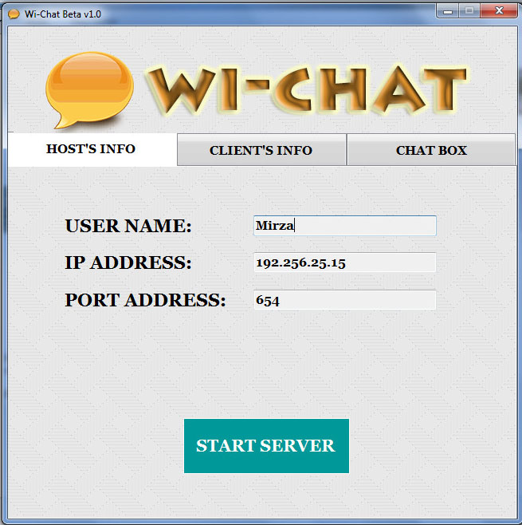

Figure 2: The Hosts Info tab of Wi-Chat

## CLIENT’S INFO Tab

Then user has to put the clients IP, Port and user name of the client in the “Client’s Info” tab with which he wish to chat. The other user have to go through similar steps. Then they both click “Connect” button.

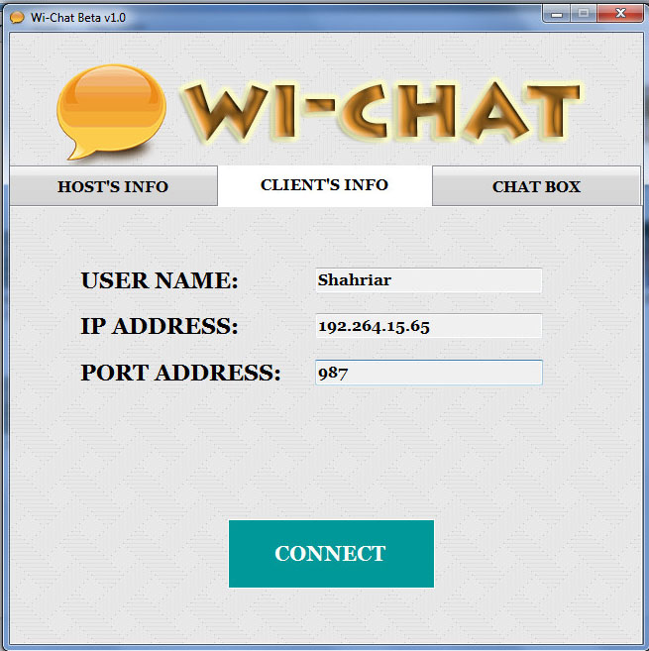

Figure 3: The Clients Info tab of Wi-Chat

## Now Chat Away!!!

Then both users can communicate through text with one another on the “CHAT BOX” tab. Users just type the message he wish to send in the text box below “Write Messages” and click the send button to send his message to the other user. Communications are shown in the above chat box.

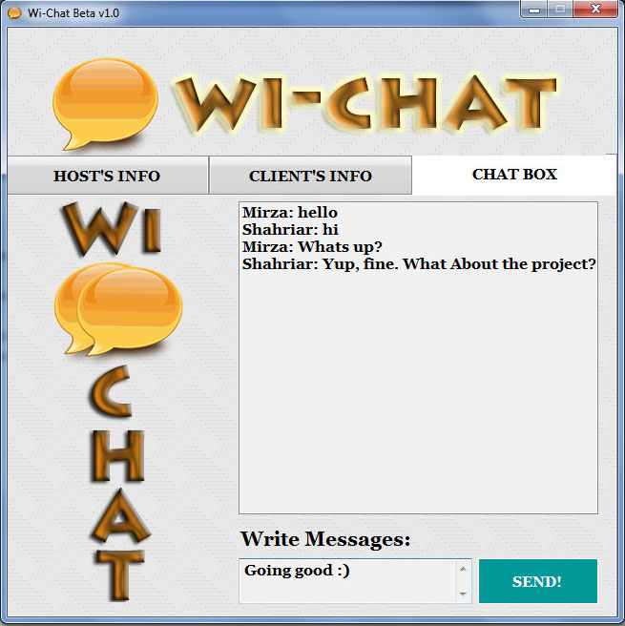

Figure 4: Chat box tab of Wi-Chat

# Conclusion:

It was fun to work in this project. We got to do a lot, stumble a lot and in the process learn a lot. Via this application two people can communicate with each other free and without any hassle. When we took this project we did not know if we could do this. But in the end we are very happy we could finish this project. Special thanks to Dr. MD. Motiur Rahman sir for supporting us.

This application is still in progress. We have more plan to improve the quality and features of this application in future.

# References

1. TCP/IP Illustrated, Volume 1: The Protocols by Kevin R. Fall, W. Richard Stevens
2. TCP/IP Illustrated, Volume 2 by Kevin R. Fall, W. Richard Stevens
3. Network Programming for Microsoft Windows by Anthony Jones, Jim Ohlund
4. UNIX® Network Programming Volume 1: The Sockets Networking API by [W. Richard Stevens](http://www.informit.com/safari/author_bio.asp@ISBN=0131411551), [Bill Fenner](http://www.informit.com/safari/author_bio.asp@ISBN=0131411551), [Andrew M. Rudoff](http://www.informit.com/safari/author_bio.asp@ISBN=0131411551)
5. C++ Network Programming Volume 1 by Douglus C. Schmidt, Stephen D. Huston
6. The World of Peer-to-Peer (P2P) by Dirk Huenniger
7. An Introduction to Network Programming with Java by Jan Graba
8. Java Network Programming by Elliotte Rusty Harold
9. Beej's Guide to Network Programming by Beej Jorgensen
10. C# Network Programming by Richard Blum
11. The C++ Programming Language By Bjarne Stroustrup
12. C++ Network Programming with ACE pattern by Douglus C. Schidt, Bjarne Stroustrup