Mirza Sneha
CSC 3750
Assignment 5

Chapter 16: 16-1, 16-2
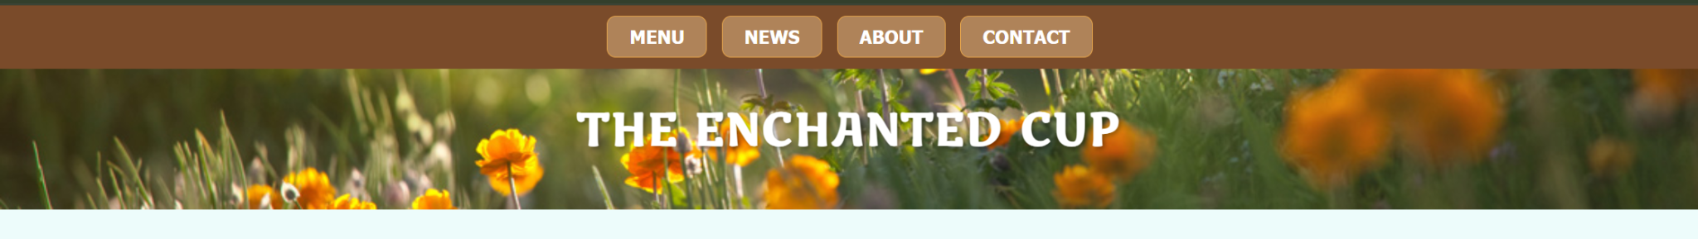
HTML:
<!DOCTYPE html>
<html lang="en">
<head>
<meta charset="UTF-8">
<title>The Enchanted Cup</title>
<link rel="stylesheet" href="indiSheet.css">
<link href="https://fonts.googleapis.com/css?family=Marko+One" rel="stylesheet">
</head>

<body>

<header class="hero">
<div class="nav-bar">
<nav>
<ul>
<li><a href="togo.html">MENU</a></li>
<li><a href="news.html">NEWS</a></li>
<li><a href="about.html">ABOUT</a></li>
<li><a href="contact.html">CONTACT</a></li>
</ul>
</nav>
</div>

<h1 class="site-title">THE ENCHANTED CUP</h1>
</header>

<main>
<h2>THE CAFÉ</h2>
<p>The Enchanted Cup offers a cozy, magical, and whimsical place to relax with your loved ones. We serve handmade drinks, delicious cakes, and savory snacks that are freshly made daily! </p>

<h2>CATERING</h2>
<p>You enjoy the party, we’ll handle the magic. The Enchanted Cup Catering provides sweet and savory options for birthday parties, study sessions, and even elegant evening events.</p>

<h2>LOCATION AND HOURS</h2>
<p>Detroit, Michigan<br>
Mon–Thu 10 AM–8 PM • Fri–Sat 10 AM–9 PM • Sun 11 AM–6 PM
</p>
</main>
</body>
</html>

CSS:
html { box-sizing: border-box; }
*, *::before, *::after { box-sizing: inherit; }

body {
margin: 0;
background-color: #EDFCFB;
font-family: "Book Antiqua", serif;
}
.hero {
background-image: url("nav.png");
background-size: cover;
background-position: center;
padding-bottom: 1em;
text-align: center;
position: relative;
}
.nav-bar {
background-color: #7A4B2A;
padding: 0.2em 0;
}
nav ul {
margin: 0;
padding: 0;
list-style: none;
display: flex;
justify-content: center;
}

nav ul li {
margin: 0.4em;
}

nav ul li a {
display: block;
border: 1px solid #E7A64B;
border-radius: 0.5em;
padding: 0.5em 1.2em;
background-color: rgba(255, 215, 160, 0.4);
color: #fff;
font-weight: bold;
text-decoration: none;
font-family: Tahoma, sans-serif;
}
nav ul li a:hover {
background-color: #E7A64B;
color: #3d260f;
}
.site-title {
margin-top: 0.7em;
font-family: "Marko One", Georgia, serif;
font-size: 2.5em;
color: white;
text-shadow: 2px 2px 4px rgba(0,0,0,0.4);
letter-spacing: 2px;
}
main {
padding: 2em 15%;
}
h2 {
font-family: Tahoma, sans-serif;
text-transform: uppercase;
color: #7A4B2A;
}
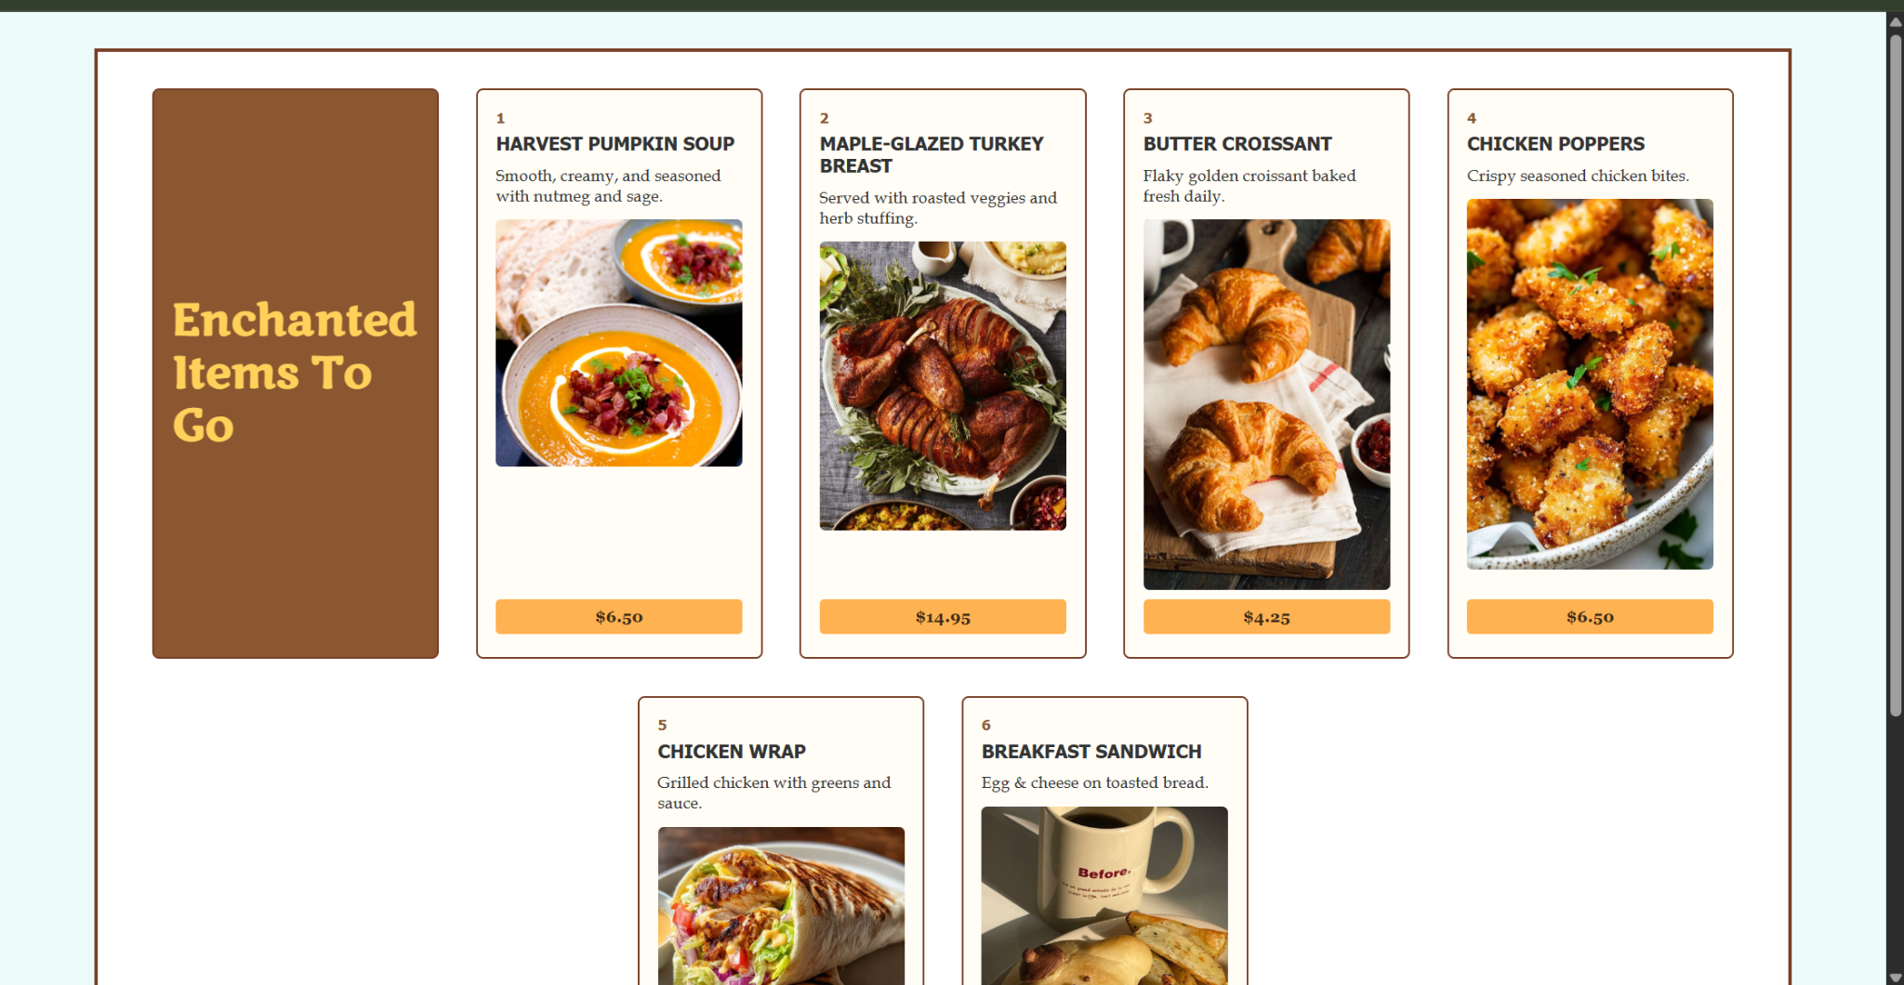
HTML:
<!DOCTYPE html>
<html lang="en">
<head>
<meta charset="utf-8">
<title>The Enchanted Cup • To-Go Menu</title>
<link href="http://fonts.googleapis.com/css?family=Marko+One" rel="stylesheet">
<link rel="stylesheet" href="enchanted-flex.css">
</head>
<body>

<div id="menu_wrapper">
<div id="menu">

<!-- BROWN LEFT PANEL (flex item #1) -->
<section class="intro">
<h1>Enchanted<br>Items To Go</h1>
</section>

<!-- 1 Pumpkin Soup -->
<section>
<h2>1</h2>
<h3>HARVEST PUMPKIN SOUP</h3>
<p>Smooth, creamy, and seasoned with nutmeg and sage.</p>
<img src="appetizer.png" alt="pumpkin soup">
<p class="price">$6.50</p>
</section>

<!-- 2 Turkey Breast -->
<section>
<h2>2</h2>
<h3>MAPLE-GLAZED TURKEY BREAST</h3>
<p>Served with roasted veggies and herb stuffing.</p>
<img src="turkey.png" alt="turkey breast">
<p class="price">$14.95</p>
</section>

<!-- 3 Croissant -->
<section>
<h2>3</h2>
<h3>BUTTER CROISSANT</h3>
<p>Flaky golden croissant baked fresh daily.</p>
<img src="moon.png" alt="croissant">
<p class="price">$4.25</p>
</section>

<!-- 4 Chicken Pop -->
<section>
<h2>4</h2>
<h3>CHICKEN POPPERS</h3>
<p>Crispy seasoned chicken bites.</p>
<img src="chickenpop.png" alt="chicken poppers">
<p class="price">$6.50</p>
</section>

<!-- 5 Chicken Wrap -->
<section>
<h2>5</h2>
<h3>CHICKEN WRAP</h3>
<p>Grilled chicken with greens and sauce.</p>
<img src="chickenwrap.png" alt="chicken wrap">
<p class="price">$8.50</p>
</section>

<!-- 6 Breakfast Sandwich -->
<section>
<h2>6</h2>
<h3>BREAKFAST SANDWICH</h3>
<p>Egg & cheese on toasted bread.</p>
<img src="breaksandwich.png" alt="breakfast sandwich">
<p class="price">$5.95</p>
</section>

</div>
</div>

</body>
</html>

CSS:
html { box-sizing: border-box; }
*, *::before, *::after { box-sizing: inherit; }
body {
background-color: #EDFCFB;
margin: 0;
font-family: "Book Antiqua", serif;
color: #333;
}
#menu_wrapper {
border: 3px solid #783F27;
margin: 2em auto;
width: 90%;
background: white;
padding: 1em;
}
#menu {
display: flex;
flex-flow: row wrap;
justify-content: center;
}
#menu section {
width: 250px;
border: 2px solid #783F27;
border-radius: 6px;
padding: 1em;
margin: 1em;
background-color: #fffdf6;

display: flex;
flex-direction: column;
}
#menu .intro {
background-color: #8A5731;
color: #FFD15A;
font-family: "Marko One", Georgia, serif;
display: flex;
justify-content: center;
align-items: flex-start;
}
#menu .intro h1 {
margin: 0;
line-height: 1.2em;
font-size: 2.4em;
}
#menu section h2 {
margin: 0;
font-family: Tahoma, sans-serif;
font-size: 0.8em;
color: #8A5731;
}
#menu section h3 {
margin: 0.3em 0;
font-family: Tahoma, sans-serif;
text-transform: uppercase;
font-size: 1em;
}

#menu section p {
font-size: 0.9em;
margin: 0.3em 0;
}

#menu section img {
width: 100%;
border-radius: 5px;
margin: 0.5em 0;
}
#menu section .price {
margin-top: auto;
background-color: #FFB252;
padding: 0.5em;
text-align: center;
font-weight: bold;
border-radius: 4px;
font-family: Georgia, serif;
color: #3a2a16;
}

Chapter 17: 17-1
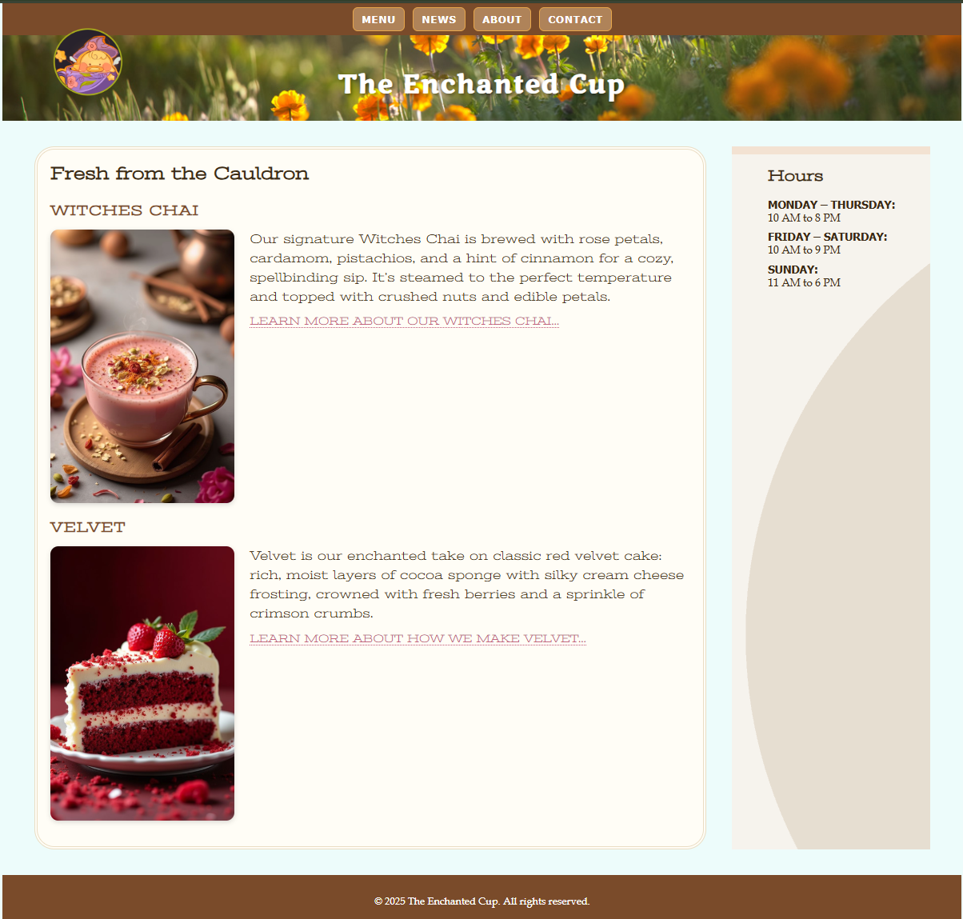
HTML:
<!DOCTYPE html>
<html lang="en">
<head>
<meta charset="UTF-8">
<title>The Enchanted Cup</title>
<link href="https://fonts.googleapis.com/css?family=Marko+One|Stint+Ultra+Expanded" rel="stylesheet">
<link rel="stylesheet" href="enchanted-rwd.css">
</head>
<body>

<div id="container">
<header>
<div id="award">
<img src="EnchantedLogo.png" alt="Enchanted Cup Award">
</div>
<nav>
<ul>
<li><a href="togo.html">MENU</a></li>
<li><a href="news.html">NEWS</a></li>
<li><a href="about.html">ABOUT</a></li>
<li><a href="contact.html">CONTACT</a></li>
</ul>
</nav>
<div id="banner">
<h1 class="site-title">The Enchanted Cup</h1>
</div>

</header>
<main>
<h2>Fresh from the Cauldron</h2>
<!-- WITCHES CHAI (replaces BREADS) -->
<section class="feature">
<h3>WITCHES CHAI</h3>
<img src="chai-400.png" alt="Witches Chai drink">
<p>
Our signature Witches Chai is brewed with rose petals, cardamom,
pistachios, and a hint of cinnamon for a cozy, spellbinding sip.
It’s steamed to the perfect temperature and topped with crushed
nuts and edible petals.
</p>

<p class="more">
<a href="#">LEARN MORE ABOUT OUR WITCHES CHAI…</a>
</p>
</section>
<!-- VELVET (replaces MUFFINS) -->
<section class="feature">
<h3>VELVET</h3>
<img src="velvet-400.png" alt="Slice of red velvet cake">
<p>
Velvet is our enchanted take on classic red velvet cake: rich,
moist layers of cocoa sponge with silky cream cheese frosting,
crowned with fresh berries and a sprinkle of crimson crumbs.
</p>

<p class="more">
<a href="#">LEARN MORE ABOUT HOW WE MAKE VELVET…</a>
</p>
</section>
</main>
<aside>
<h2>Hours</h2>
<dl>
<dt>MONDAY – THURSDAY:</dt>
<dd>10 AM to 8 PM</dd>

<dt>FRIDAY – SATURDAY:</dt>
<dd>10 AM to 9 PM</dd>

<dt>SUNDAY:</dt>
<dd>11 AM to 6 PM</dd>
</dl>
</aside>
<footer>
<p>&copy; 2025 The Enchanted Cup. All rights reserved.</p>
</footer>

</div><!-- /#container -->

</body>
</html>

CSS:
html {
box-sizing: border-box;
}
*, *::before, *::after {
box-sizing: inherit;
}

body {
margin: 0;
background-color: #EDFCFB;
font-family: "Book Antiqua", serif;
color: #3a2a16;
}
#container {
margin: 0 auto;
}
header {
background-color: #7A4B2A;
color: #fff;
position: relative;
}
#award {
text-align: center;
padding: 0.75em 0 0.25em;
}
#award img {
max-width: 120px;
height: auto;
}
#banner {
background-image: url("nav.png");
background-size: cover;
background-position: center;
text-align: center;
padding: 2.5em 1em 1.5em;
}

#banner h1 {
margin: 0;
font-family: "Marko One", Georgia, serif;
font-size: 2em;
letter-spacing: 2px;
color: #ffffff;
text-shadow: 2px 2px 4px rgba(0,0,0,0.45);
}
.tagline {
display: none;
margin-top: 0.4em;
font-style: italic;
}
nav {
background-color: #7A4B2A;
}
nav ul {
margin: 0;
padding: 0;
list-style: none;

display: flex;
flex-wrap: wrap;
}
nav ul li {
flex: 1 1 50%;
text-align: center;
}
nav ul li a {
display: block;
margin: 0.4em;
padding: 0.45em 0.8em;

border: 1px solid #E7A64B;
border-radius: 0.5em;
background-color: rgba(255, 215, 160, 0.4);

color: #fff;
font-family: Tahoma, sans-serif;
font-size: 0.8em;
font-weight: bold;
text-decoration: none;
letter-spacing: 1px;
}

nav ul li a:hover,
nav ul li a:focus {
background-color: #E7A64B;
color: #3d260f;
}
main {
padding: 1.5em 1em;
}
main h2 {
font-family: "Stint Ultra Expanded", Georgia, serif;
font-size: 1.4em;
margin-top: 0;
margin-bottom: 0.5em;
}
.feature {
clear: both;
}
.feature h3 {
font-family: "Stint Ultra Expanded", Georgia, serif;
font-size: 1.1em;
letter-spacing: 0.05em;
text-transform: uppercase;
color: #7A4B2A;
margin-bottom: 0.5em;
}
.feature img {
width: 70%;
max-width: 230px;
height: auto;
display: block;
margin: 0.5em auto;
border-radius: 8px;
box-shadow: 0 2px 6px rgba(0,0,0,0.15);
}
.feature p {
line-height: 1.5em;
margin: 0 0 0.6em;
}
.feature p.more {
font-size: 0.85em;
}
.feature p.more a {
text-decoration: none;
color: #c05575;
border-bottom: 1px dotted #c05575;
}
aside {
background-color: #F6F3ED;
margin: 0;
padding: 1em 1.5em 1.5em;
border-top: 10px solid #f3e2d2;
}
aside h2 {
font-family: "Stint Ultra Expanded", Georgia, serif;
font-size: 1.2em;
margin-top: 0;
}

aside dl {
margin: 0;
}

aside dt {
font-weight: bold;
font-family: Tahoma, sans-serif;
font-size: 0.85em;
margin-top: 0.5em;
}

aside dd {
margin: 0;
font-size: 0.85em;
}

footer {
background-color: #7A4B2A;
color: #fff;
text-align: center;
padding: 1em;
font-size: 0.8em;
}
@media screen and (min-width: 400px) {
nav ul li {
flex: none;
}
nav ul {
justify-content: center;
}
}
@media screen and (min-width: 480px) {
.feature img {
float: left;
width: 45%;
max-width: 230px;
height: auto;
margin: 0 1.2em 1em 0;
border-radius: 10px;
box-shadow: 0 2px 6px rgba(0,0,0,0.15);
}
}

@media screen and (min-width: 600px) {
header .tagline {
display: block;
margin-top: -1.3em;
font-family: Georgia, serif;
font-style: italic;
font-size: 1.1em;
}

main, h2, h3 {
font-family: 'Stint Ultra Expanded', Georgia, serif;
}

h2, h3 {
font-weight: bold;
}

main {
line-height: 1.8em;
padding: 1em;
border: double 4px #EADDC4;
border-radius: 25px;
margin: 2.5%;
background-color: #fffdf6;
}
}
@media screen and (min-width: 940px) {

#container {
display: grid;
grid-template-rows: auto minmax(0, 1fr) 5em;
grid-template-columns: minmax(25em, 1fr) 18em;
grid-template-areas:
"banner banner"
"main hours"
"footer footer";
max-width: 1200px;
margin: 0 auto;
position: relative;
background-color: #EDFCFB;
}

header {
grid-area: banner;
}

main {
grid-area: main;
margin: 2em 2em 2em 2.5em;
}

aside {
grid-area: hours;
background: url("scallop.png") repeat-y left top;
backgrounf-size: contain;
background-color: #F6F3ED;
padding: 1em;
padding-left: 45px;
margin: 2em 2.5em 2em 0;
}

footer {
grid-area: footer;
}
#award {
position: absolute;
top: 30px;
left: 50px;
padding: 0;
}
}

