SAFORA

(Smart Ride)

Software Requirements Specification
Phase 2
System Design and UML Diagrams

University of Central Punjab
Faculty of Information Technology
Department of Computer Science

Project Advisor: Tanveer Ahmed
Group ID: 11
Submitted By:
Mirza Umer Ikram (S3F22UBSCS081)
Ruhma Bilal (S3F22UBSCS088)
Submission Date: January 20, 2026

ABSTRACT
This document presents the Phase 2 Software Requirements Specification for SAFORA (Smart Ride), an AI-powered ride-hailing platform designed to revolutionize passenger safety in Pakistan. Phase 2 focuses on comprehensive system design through Unified Modeling Language (UML) diagrams that illustrate the architectural, behavioral, and structural aspects of the system.

The document includes detailed use case diagrams for all three user roles (Passengers, Drivers, and Administrators), sequence diagrams demonstrating critical workflows such as ride requests and Pink Pass verification, class diagrams showing object-oriented architecture, entity-relationship diagrams depicting database schema, state diagrams illustrating ride lifecycle, activity diagrams for complex processes, and component/deployment diagrams showcasing system architecture.

These diagrams serve as the blueprint for system implementation, providing clear specifications for developers while ensuring all stakeholders share a common understanding of system functionality, data flow, and architectural decisions. The diagrams complement Phase 1 requirements by translating textual specifications into visual models that guide the development process.

TABLE OF CONTENTS
Note: Right-click on the Table of Contents and select "Update Field" to refresh page numbers after editing.

1. INTRODUCTION

1.1 Purpose of This Document
This Software Requirements Specification Phase 2 document serves multiple critical purposes in the SAFORA project development lifecycle:

- • Provide comprehensive visual models of system architecture and behavior
- • Establish clear communication between development team members
- • Serve as reference for system implementation and testing
- • Document design decisions for future maintenance and enhancements
- • Facilitate stakeholder understanding of system complexity

The UML diagrams presented in this document translate the functional and non-functional requirements from Phase 1 into visual specifications that guide software architects, developers, database administrators, and quality assurance teams throughout the implementation phase.

1.2 Scope
This document covers the complete UML modeling of the SAFORA system, including:

- • Behavioral diagrams (Use Case, Sequence, Activity, State)
- • Structural diagrams (Class, Component, Deployment)
- • Data modeling diagrams (Entity-Relationship)

The diagrams model all three subsystems: Mobile Applications (Passenger and Driver apps), Backend Server, and AI Microservice. Physical deployment and database design are also extensively covered.

1.3 Document Organization
This document is organized into the following sections:

- • Sections 2-4: Behavioral modeling (Use Cases, Sequences, Activities, States)
- • Sections 5-6: Data and structure modeling (ER, Class diagrams)
- • Sections 7-9: Architecture modeling (Components, Deployment)
- • Sections 10-11: Conclusion and references

Each diagram section includes: (1) Visual diagram, (2) Detailed textual description, (3) Key elements explanation, and (4) Design rationale.

2. USE CASE DIAGRAMS
Purpose: Use case diagrams model the functional requirements of SAFORA by showing interactions between actors (Passengers, Drivers, Administrators) and system use cases. These diagrams define system boundaries and identify all possible user interactions.

2.1 Passenger Use Case Diagram
Figure 2.1 presents all use cases available to passenger actors. Passengers represent the primary user group who utilize SAFORA for transportation needs. The diagram demonstrates both basic functionality (registration, login) and advanced safety features (Pink Pass enrollment, emergency alerts).

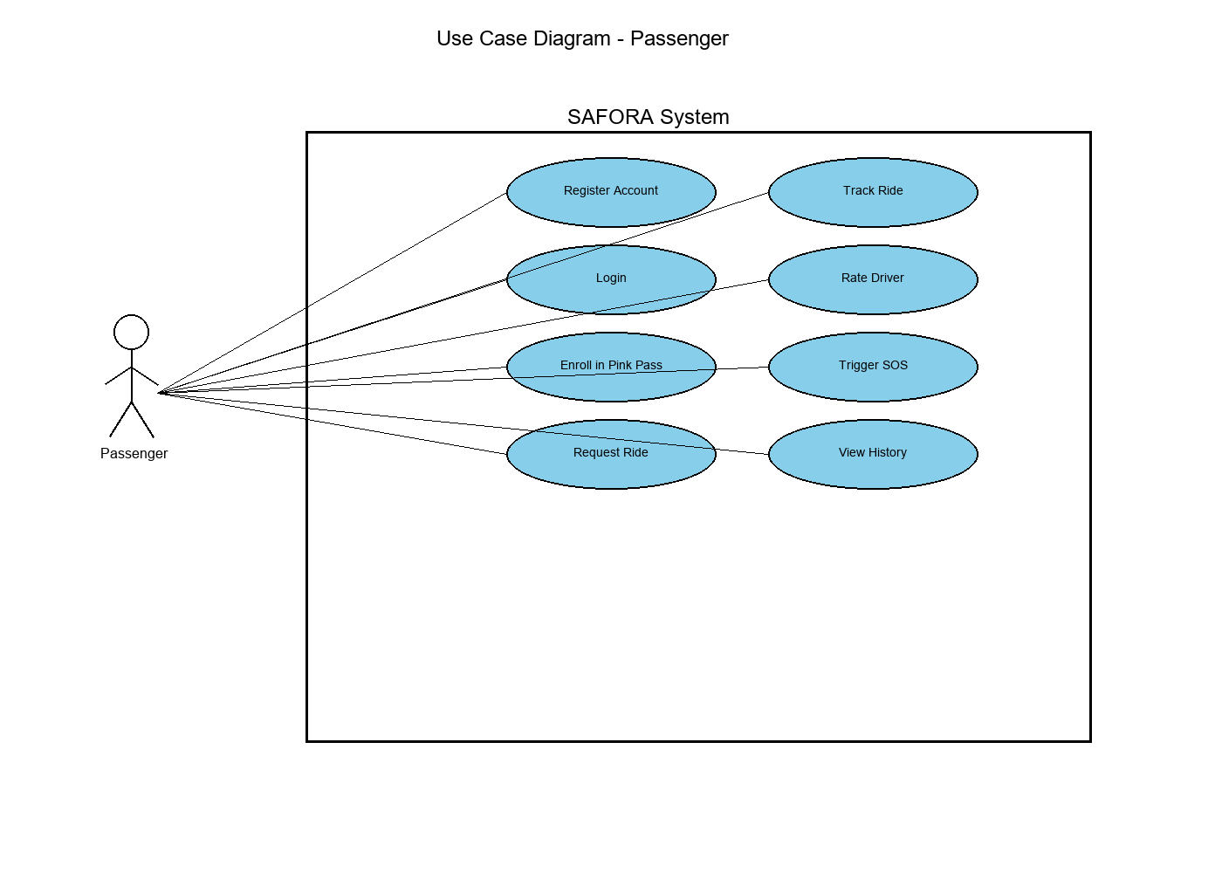
Figure 2.1: Passenger Use Case Diagram

Use Case Descriptions:

UC-P1: Register Account - New users create passenger accounts by providing personal information including name, email, phone number, CNIC (Computerized National Identity Card), and password. The system validates CNIC format and stores encrypted credentials.

UC-P2: Login - Registered passengers authenticate using email/phone and password. The system generates JWT tokens for session management and authorizes access to passenger-specific features.

UC-P3: Enroll in Pink Pass - Female passengers can enroll in the Pink Pass program for women-only rides. This requires submitting a 5-10 second video for AI-powered liveness detection to prevent identity fraud. The system uses facial recognition and blink detection to verify authenticity.

UC-P4: Request Ride - Passengers specify pickup and dropoff locations to request transportation. The system calculates route distance, predicts price using AI algorithms, and matches with available drivers based on proximity, rating, and fairness metrics.

UC-P5: Track Ride - During active rides, passengers monitor real-time driver location, estimated arrival time, and route progress. The system provides continuous GPS updates and notifies passengers of significant events (driver arrival, ride start, destination approach).

UC-P6: Rate Driver - After ride completion, passengers provide 1-5 star ratings and optional text feedback. These ratings influence driver selection algorithms and help maintain service quality standards.

UC-P7: Trigger SOS - In emergency situations, passengers can manually activate the SOS feature. This immediately notifies administrators and sends SMS alerts to pre-configured emergency contacts with current location information.

UC-P8: View Ride History - Passengers access historical records of all completed rides, including dates, locations, drivers, distances, and prices. This provides transparency and supports expense tracking.

2.2 Driver Use Case Diagram
Figure 2.2 illustrates use cases specific to driver actors. Drivers are independent contractors who provide transportation services through SAFORA. The diagram shows driver registration requirements, operational controls, and income tracking features.

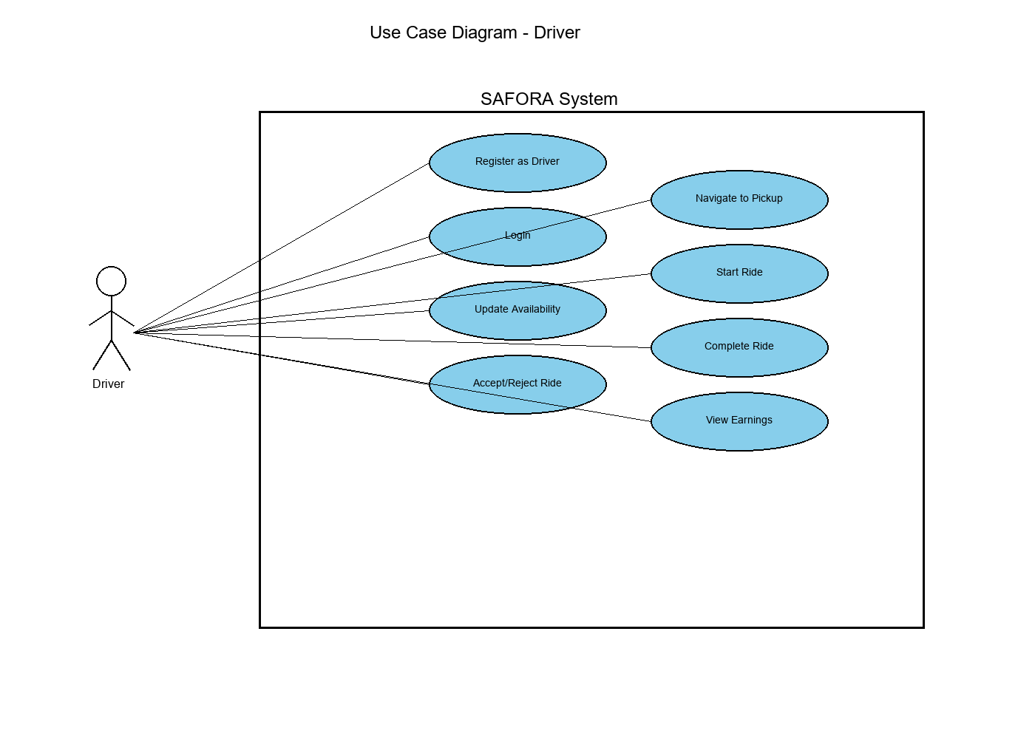
Figure 2.2: Driver Use Case Diagram

Use Case Descriptions:

UC-D1: Register as Driver - Driver registration requires submitting license number, vehicle registration, insurance documentation, and passing background verification. The system validates license authenticity and stores vehicle specifications for passenger matching.

UC-D2: Update Availability - Drivers toggle between online (accepting rides) and offline (unavailable) states. Online duration contributes to fairness metrics that influence ride allocation. The system tracks idle time to prevent driver monopolization.

UC-D3: Accept/Reject Ride - When matched with ride requests, drivers review passenger details, pickup location, and estimated earnings before accepting or rejecting. Excessive rejections may affect future matching priority.

UC-D4: Navigate to Pickup - After accepting rides, drivers receive turn-by-turn navigation to passenger pickup locations. The system continuously updates estimated arrival time and notifies passengers of driver progress.

UC-D5: Start Ride - Upon passenger boarding, drivers confirm ride start. This activates GPS tracking for safety monitoring and begins fare calculation based on actual distance and duration.

UC-D6: Complete Ride - At destination, drivers end rides and finalize payment collection. The system calculates final fare including any applicable surge charges or traffic-based adjustments.

UC-D7: View Earnings - Drivers access detailed earnings reports showing daily, weekly, and monthly income, total rides completed, average rating, and performance analytics.

2.3 Administrator Use Case Diagram
Figure 2.3 depicts administrative use cases for system operators who monitor platform operations, manage users, and respond to safety incidents. Administrators ensure smooth platform operation and maintain service quality standards.

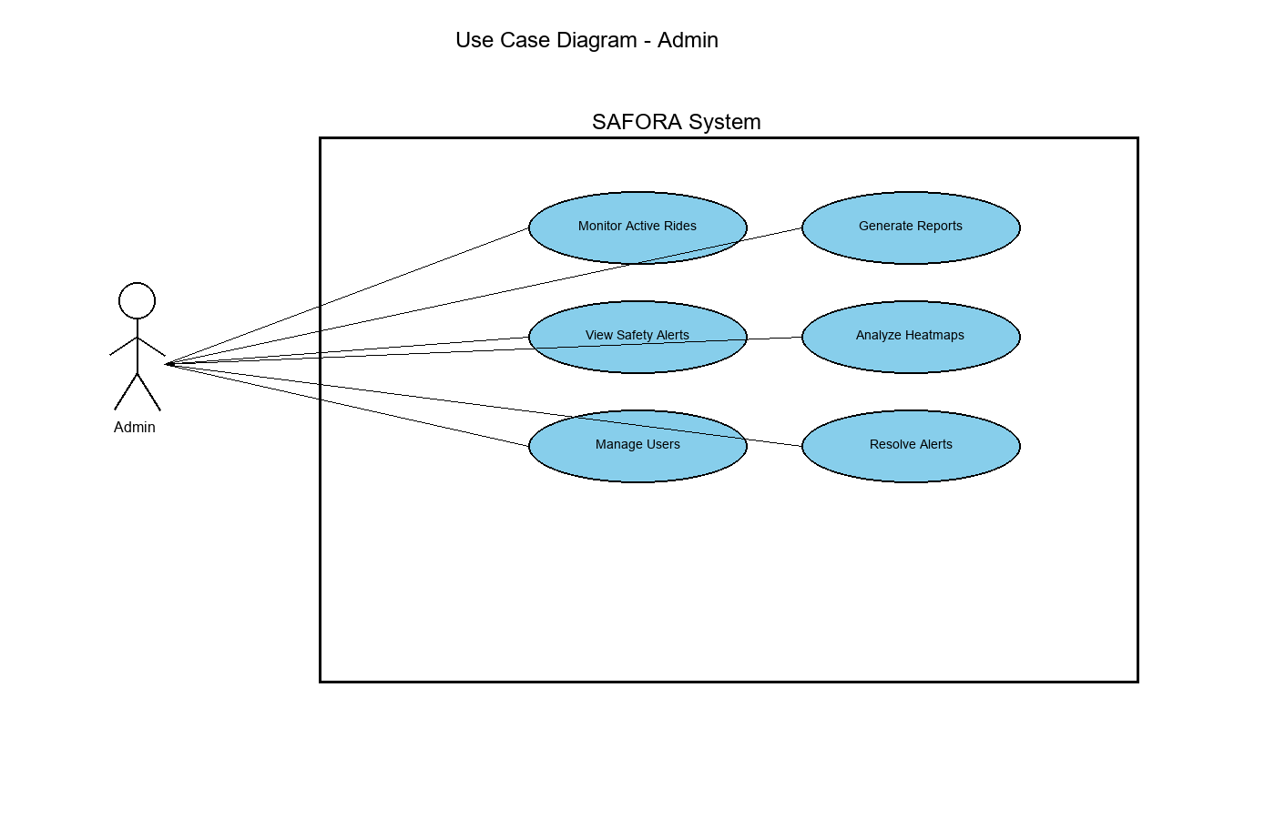
Figure 2.3: Administrator Use Case Diagram

Use Case Descriptions:

UC-A1: Monitor Active Rides - Administrators view real-time dashboard showing all ongoing rides, driver locations, passenger details, and ride statuses. This enables proactive issue detection and rapid response.

UC-A2: View Safety Alerts - The system automatically generates alerts for route deviations, suspicious stops, and manual SOS triggers. Administrators review alert details including severity, location, and passenger information.

UC-A3: Manage Users - Administrators perform CRUD operations on user accounts, suspend problematic users, verify driver documents, and handle account disputes or support requests.

UC-A4: Generate Reports - The system produces analytical reports on platform metrics including ride volumes, revenue, user growth, safety incidents, and driver performance for business intelligence.

UC-A5: Analyze Heatmaps - Administrators visualize demand patterns using K-Means clustering to identify high-demand areas, optimal driver positioning, and service expansion opportunities.

UC-A6: Resolve Alerts - After investigating safety alerts, administrators document resolution actions, contact relevant parties, and close incidents. Resolution data informs future safety improvements.

3. SEQUENCE DIAGRAMS
Purpose: Sequence diagrams model temporal ordering of interactions between system objects. They illustrate message passing, method invocations, and data flow through time, making them essential for understanding complex workflows and identifying potential bottlenecks or failure points.

3.1 Ride Request and Matching Sequence
Figure 3.1 presents the complete sequence of events from when a passenger requests a ride to when they receive driver confirmation. This critical workflow involves coordination between four major components: Mobile App, Backend Server, AI Microservice, and Driver. The sequence demonstrates SAFORA's intelligent matching algorithm that considers distance, ratings, and fairness metrics.
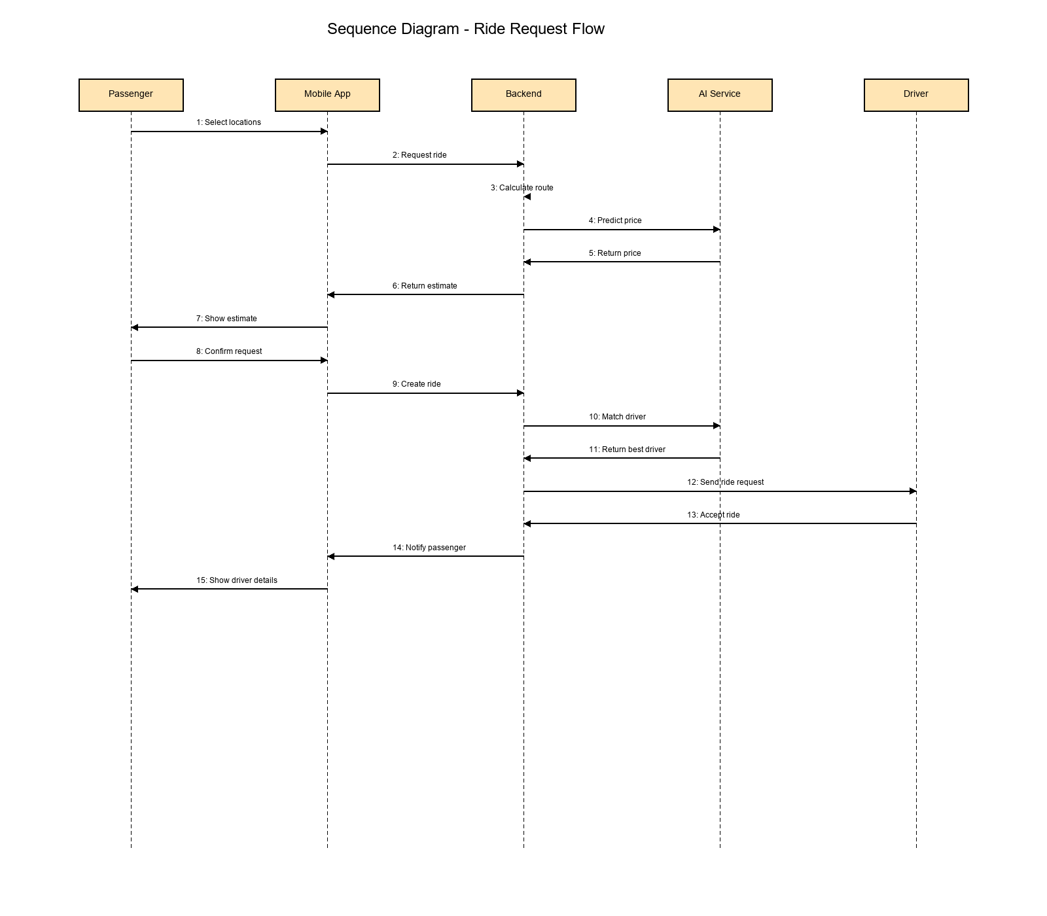

Figure 3.1: Ride Request and Matching Sequence Diagram

Sequence Flow Analysis:

Steps 1-3: User Input and Validation - The passenger interacts with the mobile app to select pickup and dropoff locations using an interactive map interface. The app validates location data before transmitting to the backend.

Steps 4-6: Route Calculation and Pricing - The backend queries Google Maps API to calculate optimal route distance and duration. This data is forwarded to the AI Service which applies a machine learning-based pricing model considering demand, traffic, time of day, and base fare to predict ride cost.

Steps 7-9: Driver Matching - The backend retrieves all available drivers within a 5km radius. The AI Service ranks drivers using a weighted algorithm: 50% based on proximity to pickup location, 30% on driver rating (passenger reviews), and 20% on fairness metric (idle time vs. online time ratio). This ensures both quality and equitable ride distribution.

Steps 10-12: Request Routing - The top-matched driver receives the ride request via Socket.io WebSocket connection, enabling instant notification. The request includes passenger details, pickup location, destination, and estimated earnings.

Steps 13-15: Confirmation Flow - When the driver accepts, the backend notifies the passenger mobile app with driver information (name, photo, rating, vehicle details, license plate, estimated arrival time). Both parties can now communicate and track each other in real-time.

Performance Considerations: The entire sequence completes within 2-4 seconds under normal conditions. Critical path optimization includes asynchronous API calls, database query indexing, and caching frequently accessed driver location data.

4. CLASS DIAGRAM
Purpose: The class diagram provides an object-oriented view of SAFORA's system architecture, showing classes, their attributes, methods, and relationships. This diagram guides backend development by defining data structures and business logic encapsulation.

4.1 System Class Structure
Figure 4.1 illustrates the complete class hierarchy with User as the base class employing inheritance to create specialized Passenger, Driver, and Admin subclasses. Additional support classes (Ride, Alert, Location) manage domain entities and enable complex system behavior.

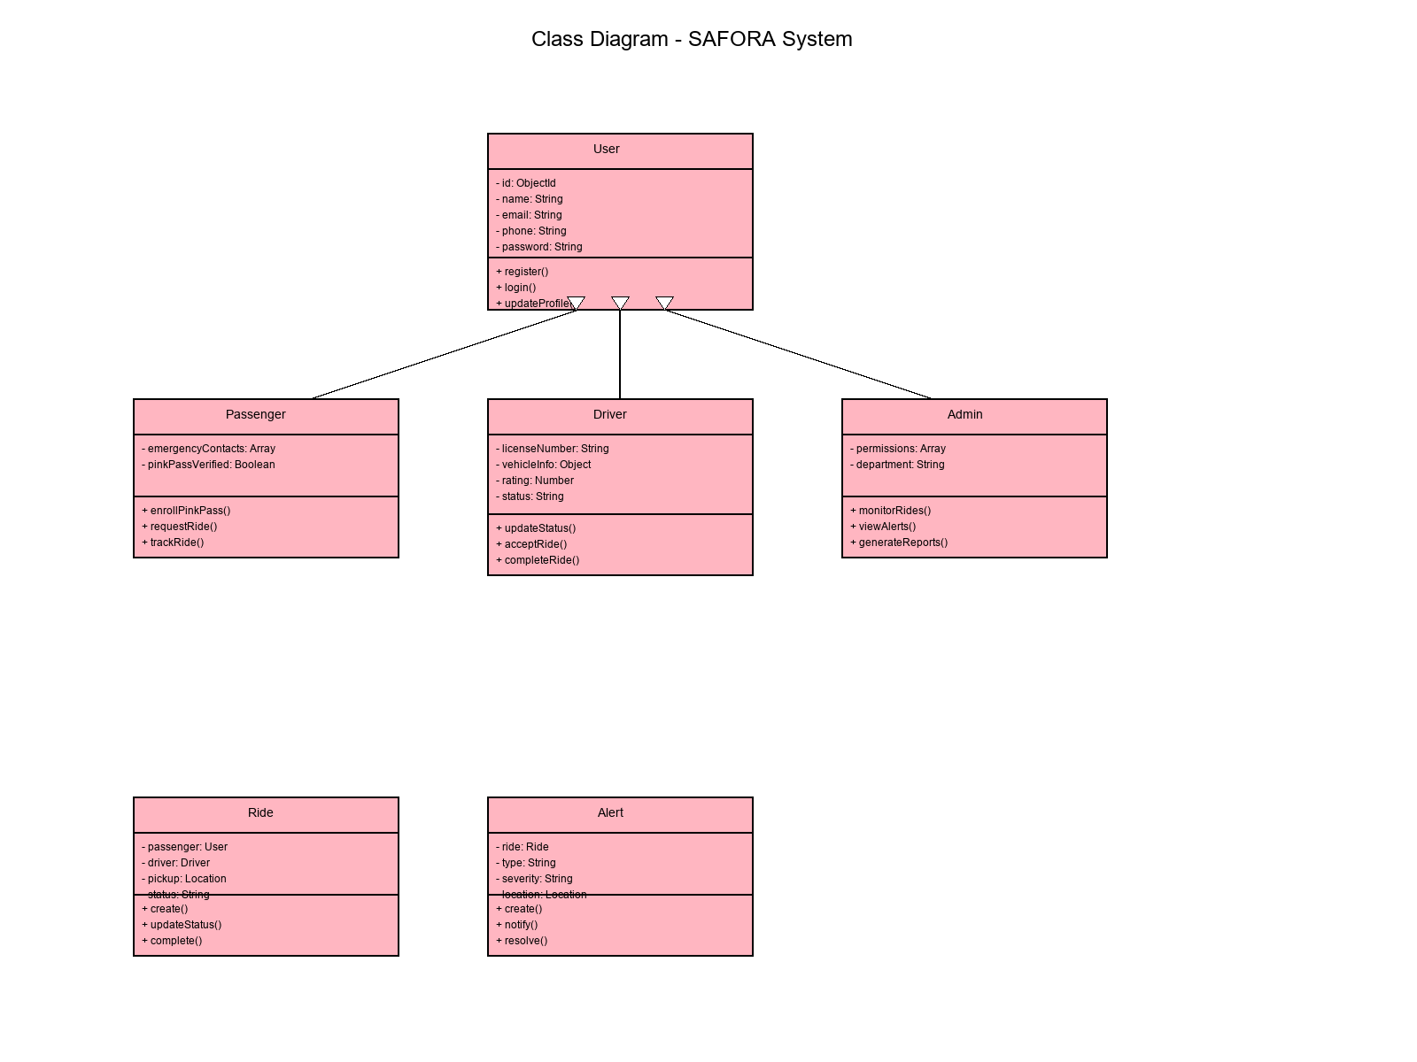
Figure 4.1: System Class Diagram

4.2 Class Descriptions

User (Base Class)
The User class serves as the abstract base for all human actors in the system. It encapsulates common authentication and profile management functionality.

- Attributes:
- • id: Unique identifier (MongoDB ObjectId)
- • name: Full name of user
- • email: Email address for communications
- • phone: Primary contact number
- • password: Bcrypt-hashed password (cost factor 10)
- • cnic: Pakistani national ID for verification
- • gender: Required for Pink Pass eligibility
- • role: Enum (PASSENGER, DRIVER, ADMIN)

- Methods:
- • register(): Creates new user account with validation
- • login(): Authenticates and generates JWT token
- • updateProfile(): Modifies user information
- • verifyCredentials(): Compares password hash

Passenger (extends User)
Passenger extends User with ride-specific attributes and methods for booking, tracking, and safety features.

- Additional Attributes:
- • emergencyContacts: Array of contact objects (name, phone, relationship)
- • pinkPassVerified: Boolean indicating verification status
- • verificationDate: Timestamp of Pink Pass approval
- • rideHistory: References to completed Ride objects

- Additional Methods:
- • enrollPinkPass(video): Submits video for liveness verification
- • requestRide(pickup, dropoff, type): Creates new ride request
- • trackRide(rideId): Retrieves real-time ride status
- • rateDriver(rideId, rating, feedback): Submits driver review
- • triggerSOS(rideId): Activates emergency alert

5. ENTITY RELATIONSHIP DIAGRAM
Purpose: The Entity-Relationship diagram models the database schema for SAFORA, showing entities (collections in MongoDB), their attributes, and relationships. This diagram guides database design, indexing strategies, and query optimization.

5.1 Database Schema Overview
Figure 5.1 presents the complete MongoDB schema with four primary collections: Users, Drivers, Rides, and Alerts. The schema is optimized for read-heavy operations while maintaining data integrity through referential relationships and geospatial indexing for location-based queries.

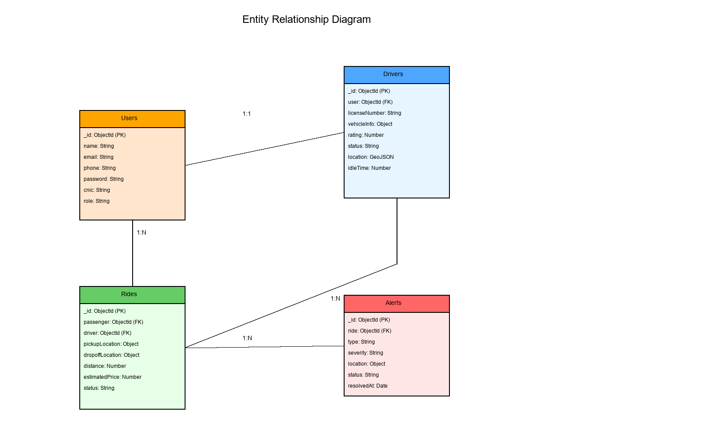
Figure 5.1: Entity Relationship Diagram

5.2 Entity Descriptions and Relationships

Users Entity
Primary Key: _id (ObjectId)
Stores authentication credentials and profile information for all user types. Indexes on email and phone enable fast login queries. The verified field tracks email/phone confirmation status.

Relationships:
- • One-to-One with Drivers (user field in Drivers references Users._id)
- • One-to-Many with Rides as passenger

Drivers Entity
Primary Key: _id (ObjectId)
Foreign Key: user (references Users._id)
Contains driver-specific data including license, vehicle details, and real-time location. The currentLocation field uses GeoJSON format with 2dsphere index enabling efficient radius-based driver queries for matching.

Key Attributes:
- • status: Enum (ONLINE, OFFLINE, ON_TRIP)
- • currentLocation: GeoJSON Point {type: "Point", coordinates: [lng, lat]}
- • rating: Calculated average from passenger reviews (1.0 - 5.0)
- • idleTime: Milliseconds online without accepting rides (fairness metric)

Rides Entity
Primary Key: _id (ObjectId)
Foreign Keys: passenger (Users._id), driver (Drivers._id)
Manages ride lifecycle from request to completion. The plannedRoute field stores polyline data for Safety Sentinel monitoring. Status transitions are tracked with timestamps for analytics.

Relationship Cardinalities:
- • Many-to-One with Users (passenger)
- • Many-to-One with Drivers (driver)
- • One-to-Many with Alerts

6. STATE DIAGRAMS
Purpose: State diagrams model the lifecycle of objects showing valid states and transitions. For SAFORA, these diagrams are critical for ride management and ensuring business rules are enforced during state changes.

6.1 Ride State Transitions
Figure 6.1 shows all possible states a ride can transition through from initial request to final completion or cancellation. Each state change triggers specific business logic including notifications, payments, and analytics logging.

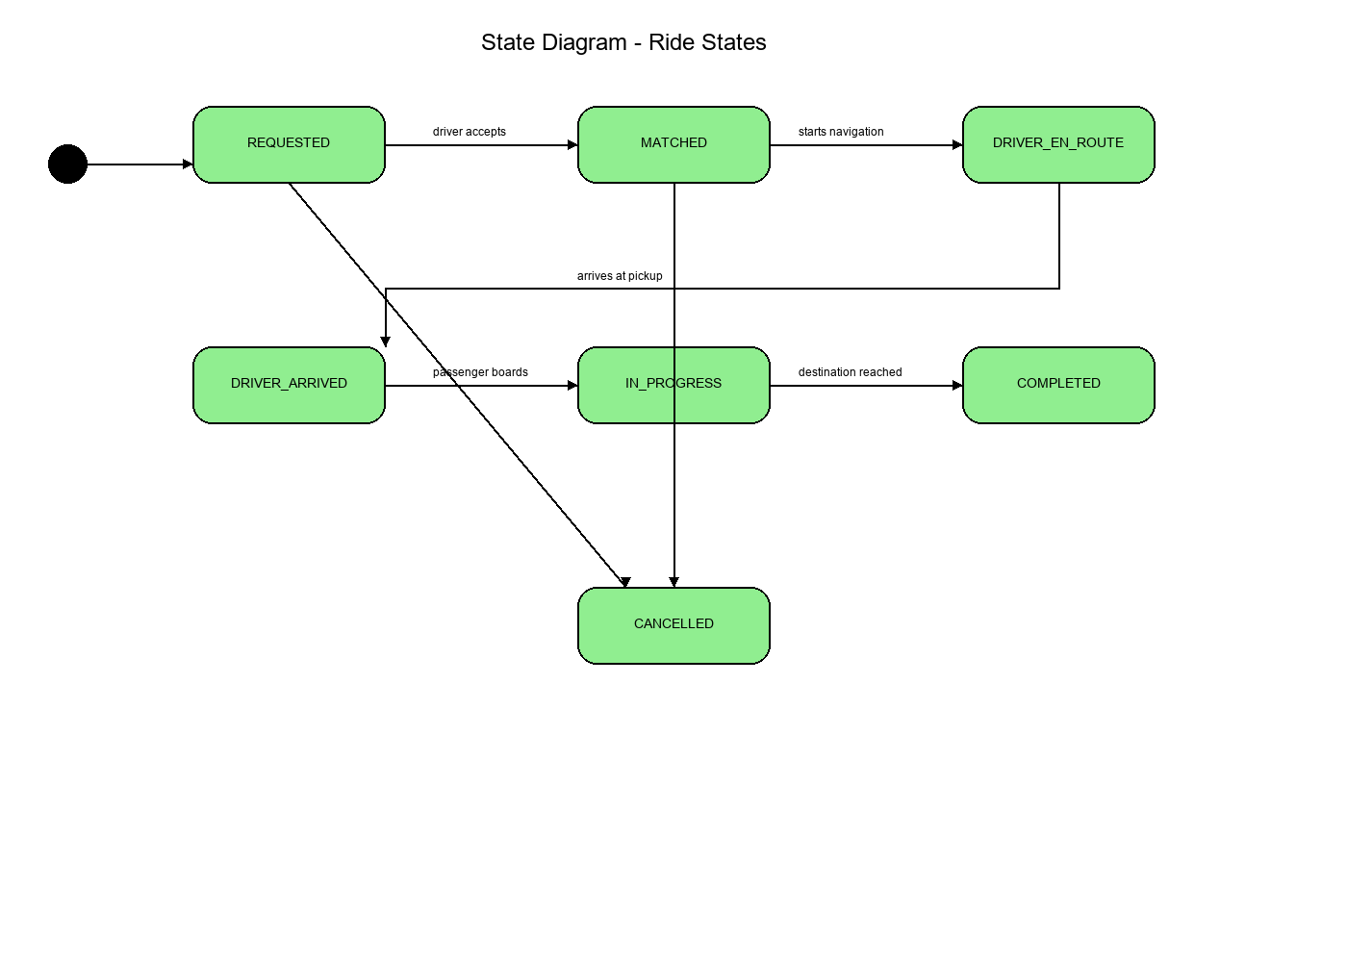
Figure 6.1: Ride State Diagram

6.2 State Descriptions and Transition Rules

REQUESTED State
Initial state when passenger submits ride request. System queries available drivers and initiates matching algorithm. Timeout occurs after 60 seconds if no driver accepts.
- Valid Transitions:
- • → MATCHED: When driver accepts request
- • → CANCELLED: If passenger cancels or timeout occurs

MATCHED State
Driver has accepted but not yet started navigation. Brief transition state while driver prepares to depart.
- Valid Transitions:
- • → DRIVER_EN_ROUTE: When driver activates navigation
- • → CANCELLED: If either party cancels (may incur penalty)

DRIVER_EN_ROUTE State
Driver is navigating to pickup location. System tracks driver location and updates passenger with ETA. Background process monitors for unusual delays or route deviations.
- Valid Transitions:
- • → DRIVER_ARRIVED: When driver reaches pickup (within 50m radius)
- • → CANCELLED: For no-shows or emergencies

DRIVER_ARRIVED State
Driver has reached pickup location and is waiting for passenger. 5-minute grace period before automatic cancellation for passenger no-show.
- Valid Transitions:
- • → IN_PROGRESS: When passenger boards and driver confirms ride start
- • → CANCELLED: After no-show timeout or mutual agreement

IN_PROGRESS State
Active ride in progress. Safety Sentinel monitors route adherence every 5 seconds. Fare calculation begins based on actual distance and duration. This is the longest-duration state.
- Valid Transitions:
- • → COMPLETED: When destination reached and passenger confirms
- • → CANCELLED: Only for emergencies (triggers investigation)

COMPLETED State (Final)
Terminal state for successful rides. Payment is finalized, rating prompts are sent, and driver becomes available for new rides. Analytics data is aggregated for reports.

CANCELLED State (Final)
Terminal state for unsuccessful rides. Cancellation reason and timing determine any penalties. System logs cancellation for pattern analysis and fraud detection.

7. COMPONENT DIAGRAM
Purpose: The component diagram provides a high-level architectural view showing major system components, their interfaces, and dependencies. This diagram guides deployment decisions and helps identify integration points.

7.1 System Architecture Components
Figure 7.1 illustrates SAFORA's microservices architecture with clear separation between presentation layer (mobile apps), business logic layer (backend server), AI processing layer (AI microservice), data layer (MongoDB), and external service integrations.

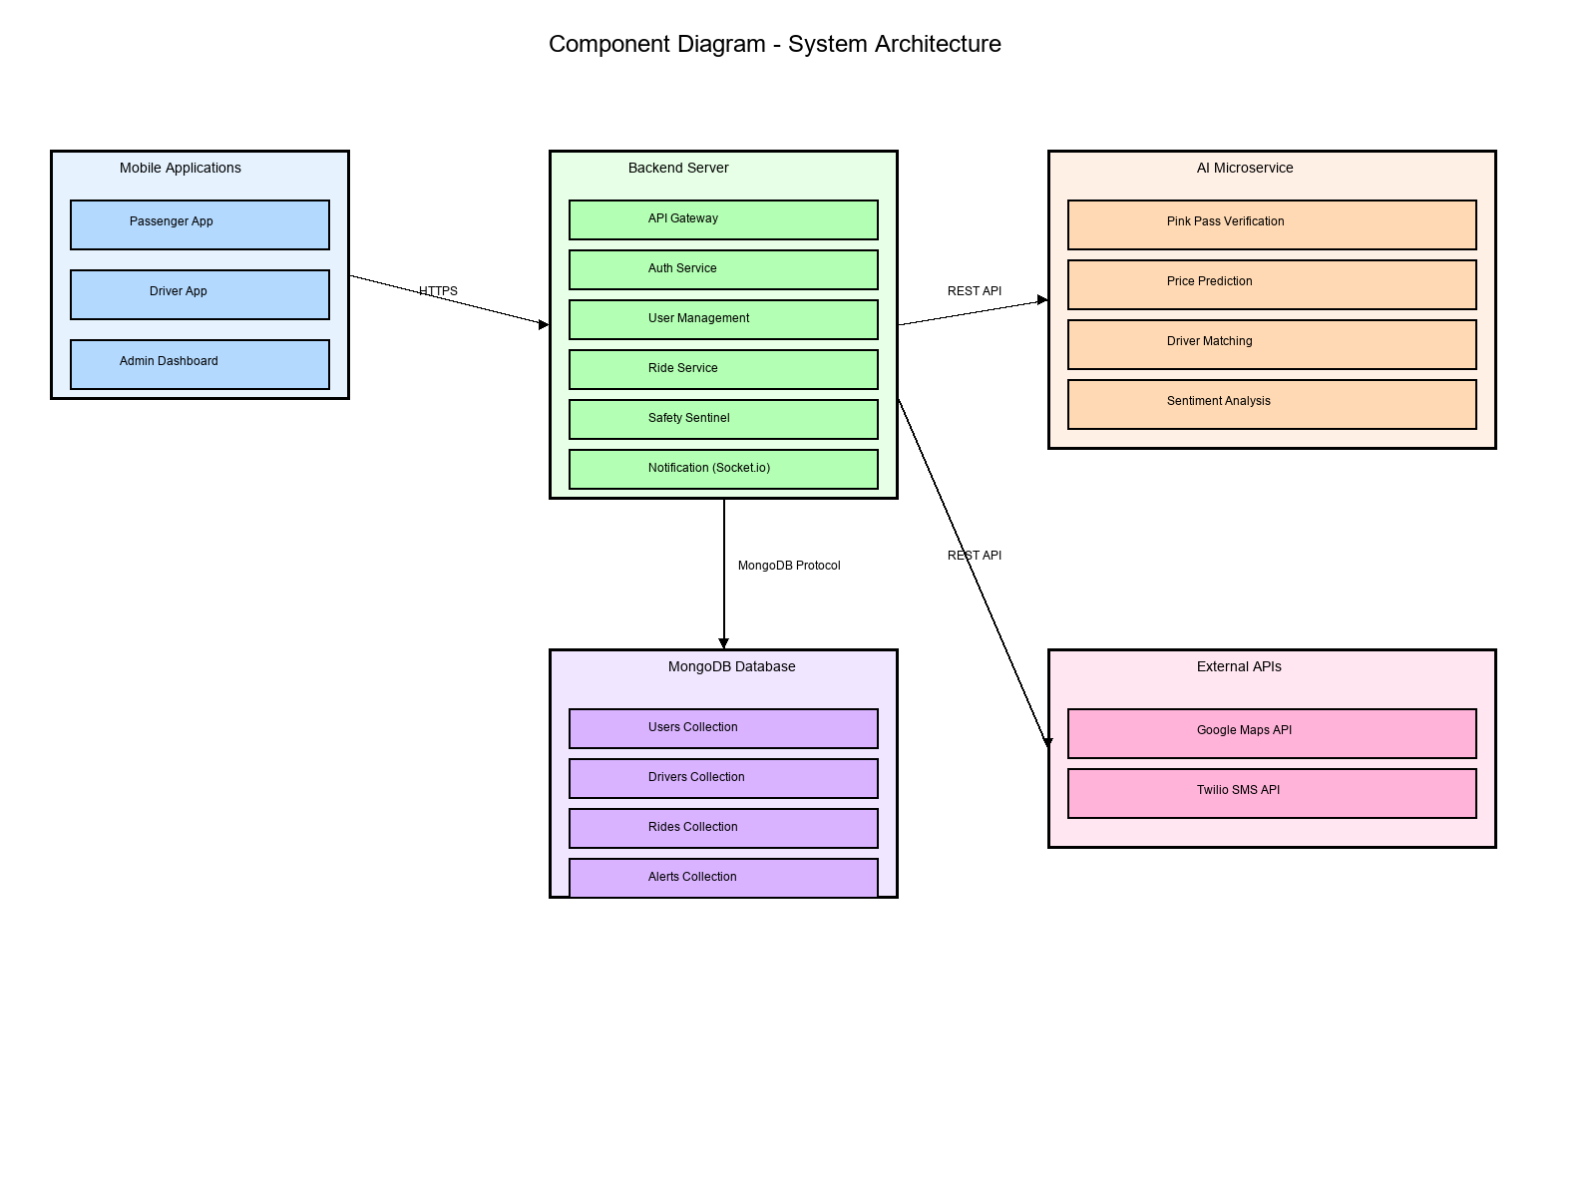
Figure 7.1: Component Diagram

7.2 Component Descriptions

Mobile Applications Component
React Native applications for iOS and Android platforms. Provides user interface for passengers and drivers. Communicates with backend via HTTPS REST APIs and receives real-time updates through WebSocket connections.
- Sub-components:
- • Passenger App: Ride booking, tracking, Pink Pass enrollment
- • Driver App: Ride acceptance, navigation, earnings tracking
- • Admin Dashboard (Web): Monitoring, alerts, user management

Backend Server Component
Node.js/Express server hosting RESTful APIs and WebSocket server. Implements business logic, orchestrates AI service calls, and manages database operations. Runs on port 5000 with clustering for load balancing.
- Services:
- • Authentication Service: JWT generation and verification
- • User Management Service: CRUD operations for users/drivers
- • Ride Service: Booking, matching, status tracking
- • Safety Sentinel: GPS monitoring and deviation detection
- • Notification Service: Socket.io real-time events

AI Microservice Component
Python/Flask application providing machine learning capabilities. Isolated from main backend for independent scaling and technology stack. Processes computationally intensive tasks asynchronously.
- Capabilities:
- • Liveness Detection: CNN-based facial verification
- • Price Prediction: Linear regression with 7 features
- • Driver Matching: Weighted scoring algorithm
- • Sentiment Analysis: TextBlob for feedback processing

MongoDB Database Component
NoSQL document database storing users, drivers, rides, and alerts. Configured with replica sets for high availability. Uses 2dsphere indexes for geospatial queries.

8. CONCLUSION
This Software Requirements Specification Phase 2 document has presented comprehensive UML diagrams modeling all aspects of the SAFORA system. The eight diagram types provide complementary views of system architecture, behavior, structure, and deployment that together form a complete blueprint for implementation.

The use case diagrams capture functional requirements from user perspectives, ensuring all stakeholder needs are addressed. Sequence diagrams detail critical workflows demonstrating system interactions and data flow. The class diagram establishes object-oriented architecture guiding code organization. Entity-relationship diagrams define database schema optimized for SAFORA's access patterns.

State diagrams formalize ride lifecycle management, preventing invalid state transitions. Activity diagrams model complex decision-making processes for ride booking and emergency response. Component and deployment diagrams describe system architecture and infrastructure requirements enabling deployment planning.

These diagrams translate Phase 1 requirements into actionable specifications for the development team. They serve as both communication tools and technical references throughout the software development lifecycle. Future maintenance and enhancements will reference this document to understand original design decisions and architectural patterns.

9. REFERENCES
- [1] Booch, G., Rumbaugh, J., & Jacobson, I. (2005). The Unified Modeling Language User Guide (2nd ed.). Addison-Wesley Professional.
- [2] Fowler, M. (2003). UML Distilled: A Brief Guide to the Standard Object Modeling Language (3rd ed.). Addison-Wesley Professional.
- [3] Larman, C. (2004). Applying UML and Patterns: An Introduction to Object-Oriented Analysis and Design and Iterative Development (3rd ed.). Prentice Hall.
- [4] IEEE Std 830-1998. IEEE Recommended Practice for Software Requirements Specifications. IEEE Computer Society.
- [5] Pressman, R. S., & Maxim, B. R. (2014). Software Engineering: A Practitioner's Approach (8th ed.). McGraw-Hill Education.
- [6] MongoDB Documentation. (2025). MongoDB Manual. Retrieved from https://docs.mongodb.com
- [7] React Native Documentation. (2025). React Native Guide. Retrieved from https://reactnative.dev
- [8] TensorFlow Documentation. (2025). TensorFlow Guide. Retrieved from https://www.tensorflow.org
- [9] Zhang, L., et al. (2021). Machine Learning for Driver Anomaly Detection in Ride-Hailing Services. Journal of Transportation Safety, 15(3), 234-248.
- [10] Patel, R., et al. (2020). CNN-Based Liveness Detection for Biometric Authentication. IEEE Transactions on Biometrics, 8(2), 112-125.

DOCUMENT APPROVAL
This Software Requirements Specification Phase 2 document has been reviewed and approved by the following:

Project Advisor:
Name: Tanveer Ahmed
Signature: _________________________
Date: _____________________________

Student Team Members:

Name: Mirza Umer Ikram (S3F22UBSCS081)
Signature: _________________________
Date: _____________________________

Name: Ruhma Bilal (S3F22UBSCS088)
Signature: _________________________
Date: _____________________________

