SAFORA (Smart Ride)
Software Requirements Specification
Phase 2 - System Design & Diagrams

University of Central Punjab
Faculty of Information Technology
Department of Computer Science

Project Title: SAFORA - Smart Ride
Project Advisor: Tanveer Ahmed
Group ID: 11
Team Members:
Mirza Umer Ikram (S3F22UBSCS081)
Ruhma Bilal (S3F22UBSCS088)
Date: January 20, 2026

Table of Contents
1. Use Case Diagrams
1.1 Passenger Use Cases
1.2 Driver Use Cases
1.3 Admin Use Cases
2. Sequence Diagram - Ride Request Flow
3. Class Diagram
4. Entity Relationship Diagram
5. State Diagram - Ride States
6. Component Diagram
7. Document Approval

1. USE CASE DIAGRAMS

1.1 Passenger Use Cases
The following diagram illustrates all use cases available to passengers in the SAFORA system. Passengers can register, login, enroll in Pink Pass for women-only rides, request and track rides, rate drivers, and trigger emergency SOS alerts.

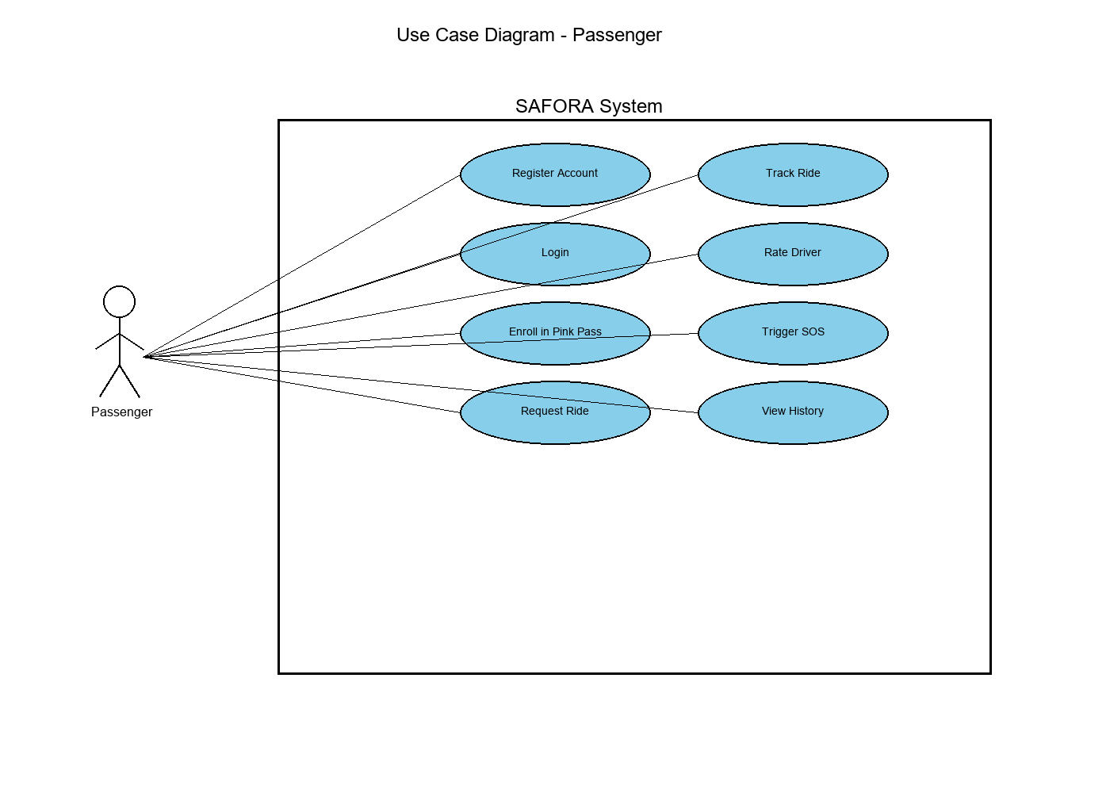

1.2 Driver Use Cases
The following diagram shows all use cases available to drivers. Drivers can register with their license and vehicle information, manage their online/offline availability, accept or reject ride requests, navigate to pickup locations, start and complete rides, and view their earnings.

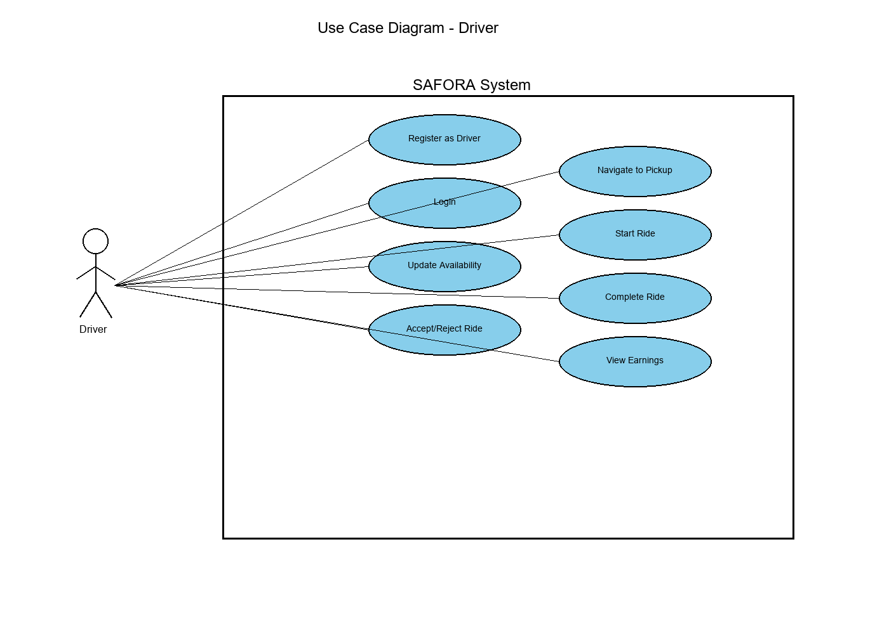

1.3 Admin Use Cases
The following diagram presents all use cases available to system administrators. Admins can monitor all active rides in real-time, view and resolve safety alerts, manage user accounts, generate analytics reports, and analyze demand heatmaps across the city.

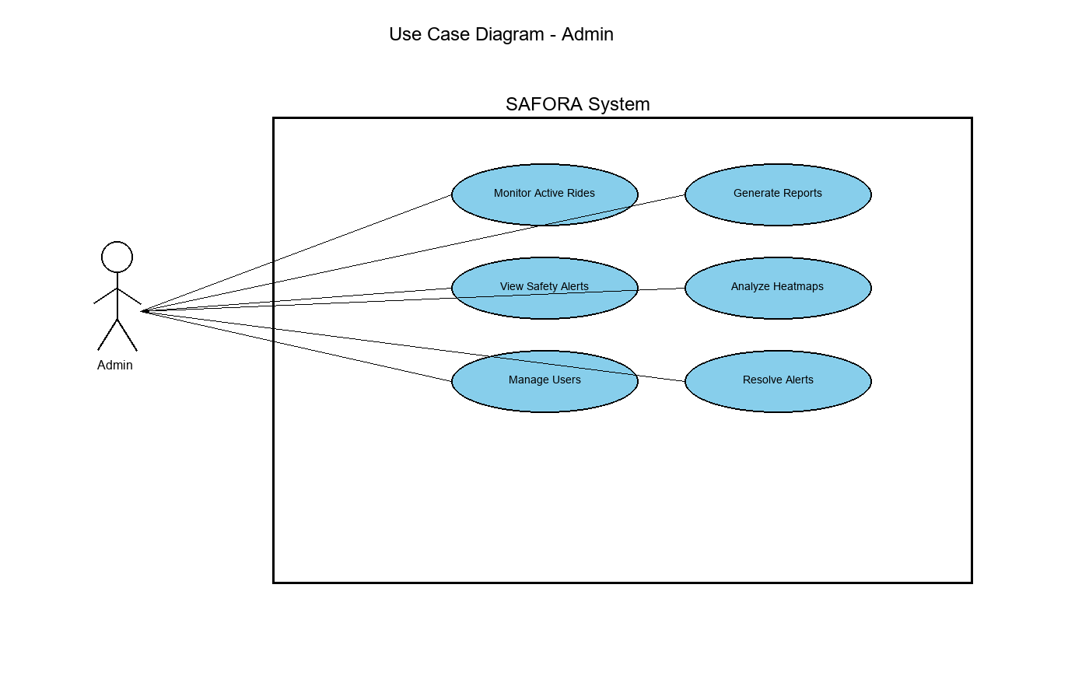

2. SEQUENCE DIAGRAM - RIDE REQUEST FLOW
This sequence diagram illustrates the complete ride request flow from when a passenger selects their pickup and dropoff locations to when they receive confirmation with driver details. The flow involves coordination between the Mobile App, Backend Server, AI Microservice, and Driver.

Key Steps:
- 1. Passenger selects pickup and dropoff locations in the mobile app
- 2. Mobile app sends ride request to backend server
- 3. Backend calculates route using Google Maps API
- 4. Backend requests price prediction from AI Service
- 5. AI Service returns estimated price based on distance, time, demand, and traffic
- 6. Passenger is shown estimate and confirms request
- 7. Backend requests driver matching from AI Service
- 8. AI Service ranks available drivers using weighted algorithm (Distance 50%, Rating 30%, Fairness 20%)
- 9. Backend sends ride request to top-matched driver
- 10. Driver accepts the ride
- 11. Passenger receives driver details and estimated time of arrival

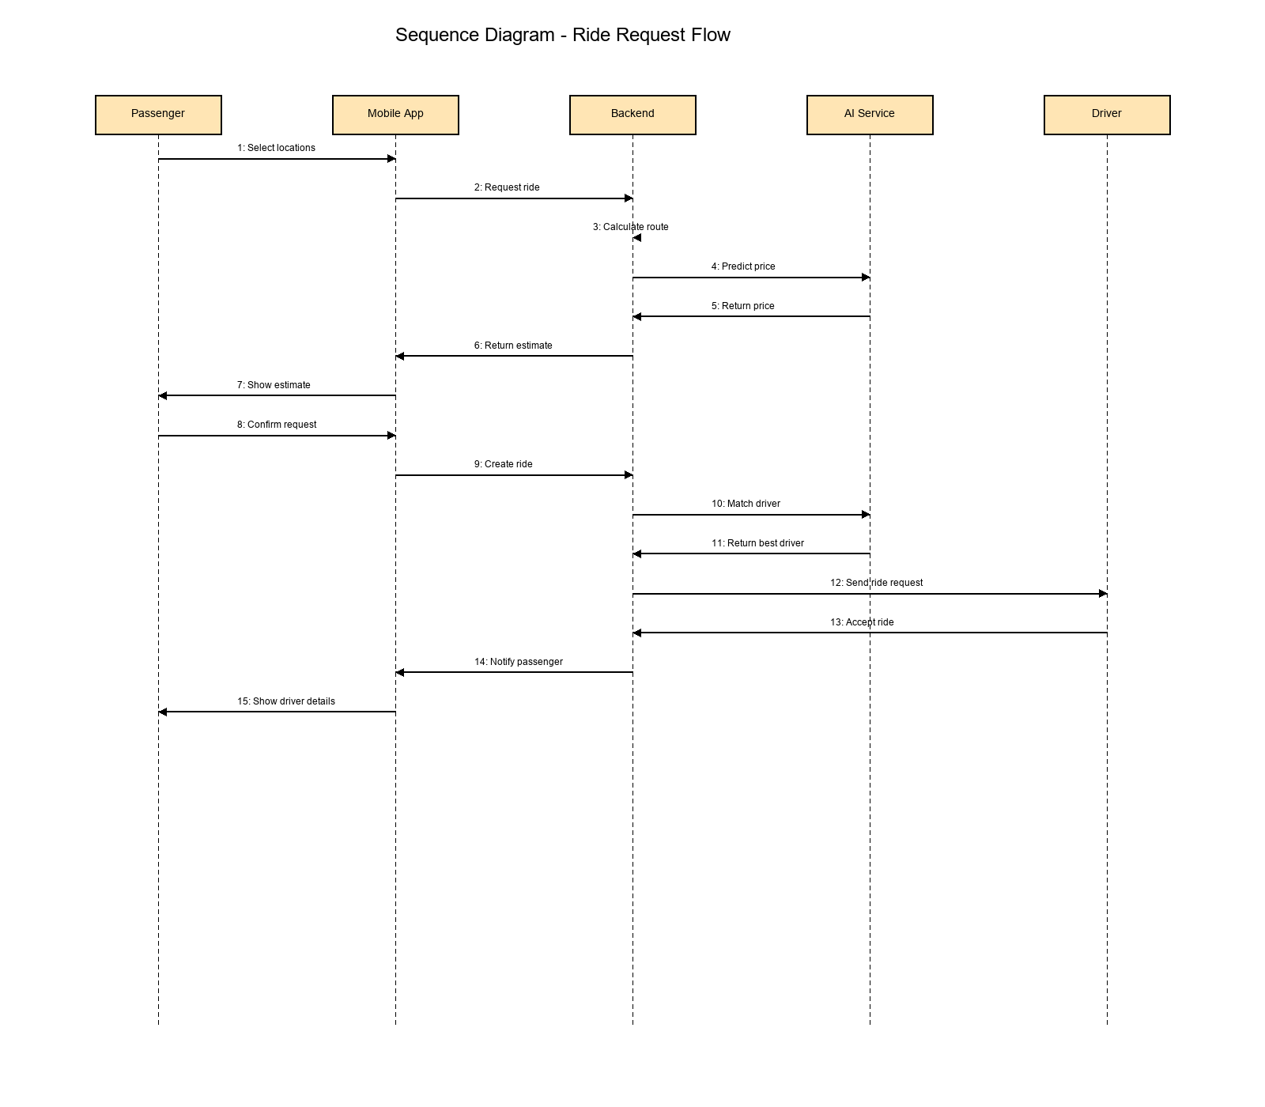

3. CLASS DIAGRAM
The class diagram presents the object-oriented structure of the SAFORA system, showing the main classes, their attributes, methods, and relationships. The system follows an inheritance hierarchy with User as the base class, extended by Passenger, Driver, and Admin classes.

Core Classes:

User (Base Class): Contains common attributes like id, name, email, phone, and password. Provides methods for registration, login, and profile management.

Passenger: Extends User with emergency contacts and Pink Pass verification status. Includes methods for enrolling in Pink Pass, requesting rides, and triggering SOS.

Driver: Extends User with license information, vehicle details, rating, and location. Provides methods for managing availability and handling rides.

Admin: Extends User with permissions and department. Includes methods for monitoring, alerts management, and reporting.

Ride: Manages ride information including passenger, driver, locations, pricing, and status.

Alert: Handles safety alerts with type, severity, location, and resolution tracking.

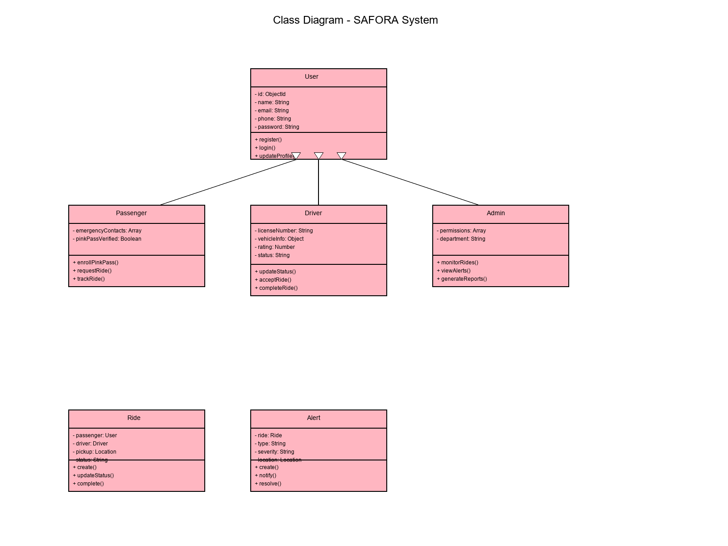

4. ENTITY RELATIONSHIP DIAGRAM
The Entity Relationship diagram shows the database schema for SAFORA, illustrating the structure of MongoDB collections and their relationships. The system uses four main collections with defined relationships to maintain data integrity.

Database Collections:

Users Collection: Stores user account information including authentication credentials and profile data. Has a one-to-one relationship with Drivers collection and one-to-many relationship with Rides collection (as passenger).

Drivers Collection: Contains driver-specific information including license, vehicle details, rating, and current location (GeoJSON). Links to Users collection and has one-to-many relationship with Rides.

Rides Collection: Stores ride information including passenger and driver references, locations, pricing, and status. Has many-to-one relationships with Users and Drivers, and one-to-many relationship with Alerts.

Alerts Collection: Manages safety alerts generated by Safety Sentinel, linked to specific rides with severity levels and resolution tracking.

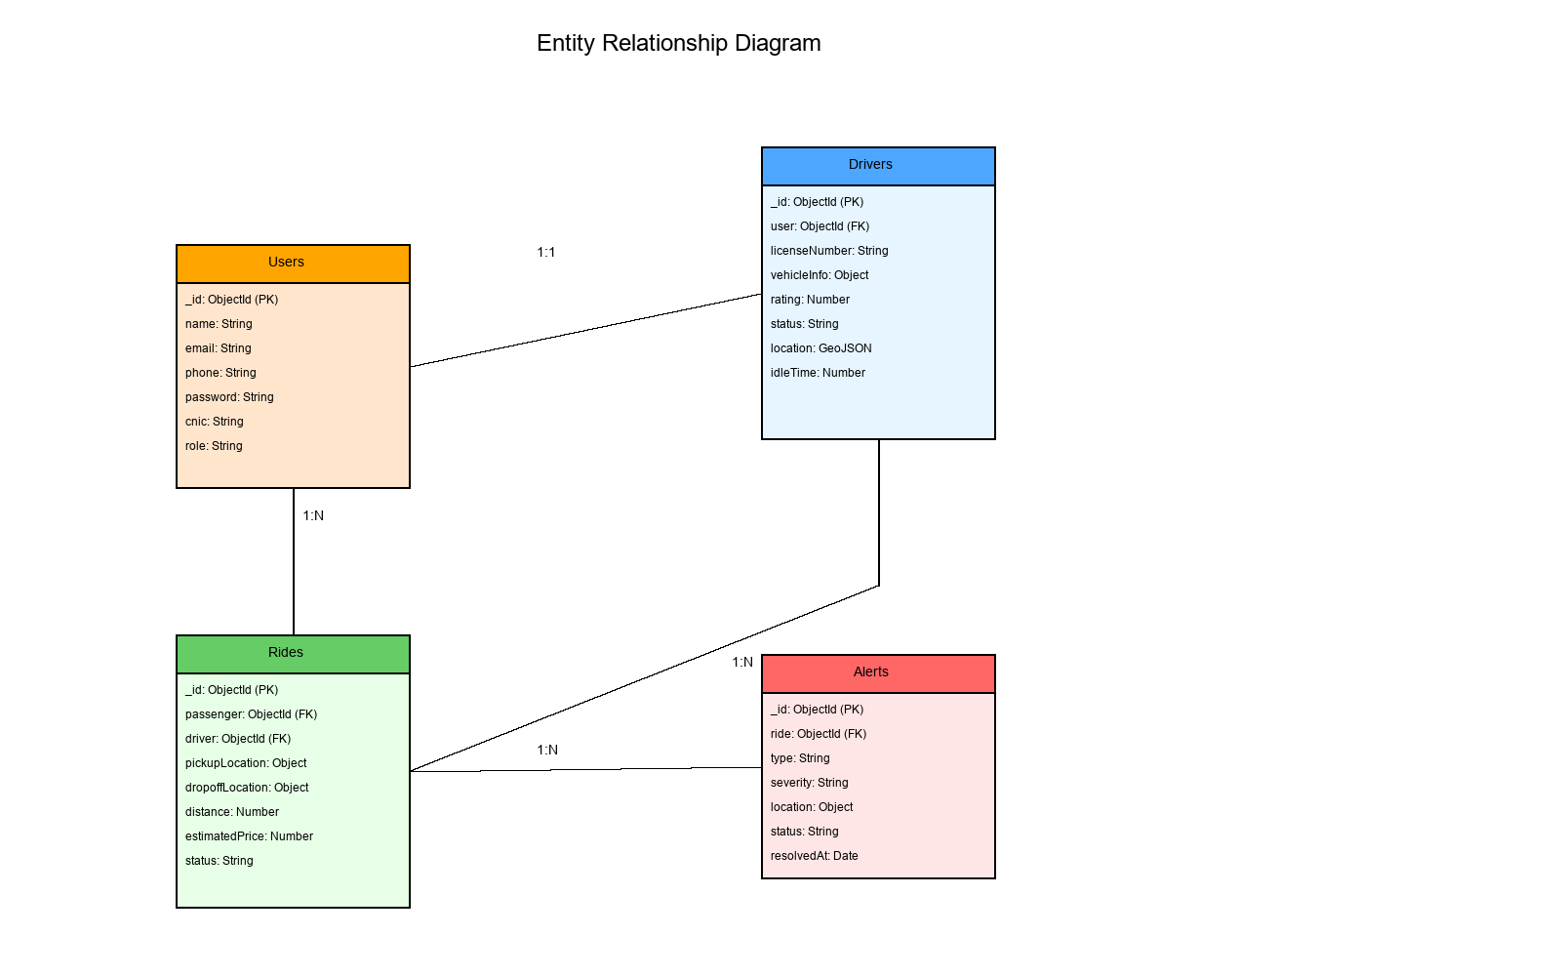

5. STATE DIAGRAM - RIDE STATES
The state diagram illustrates all possible states of a ride and the transitions between these states. Understanding ride states is crucial for proper ride management, billing, and safety monitoring.

Ride States and Transitions:

REQUESTED → MATCHED: When a driver accepts the ride request

MATCHED → DRIVER_EN_ROUTE: When driver starts navigation to pickup location

DRIVER_EN_ROUTE → DRIVER_ARRIVED: When driver reaches the pickup location

DRIVER_ARRIVED → IN_PROGRESS: When passenger boards and ride begins

IN_PROGRESS → COMPLETED: When destination is reached and ride ends successfully

Any State → CANCELLED: Ride can be cancelled from multiple states due to passenger/driver actions or safety concerns

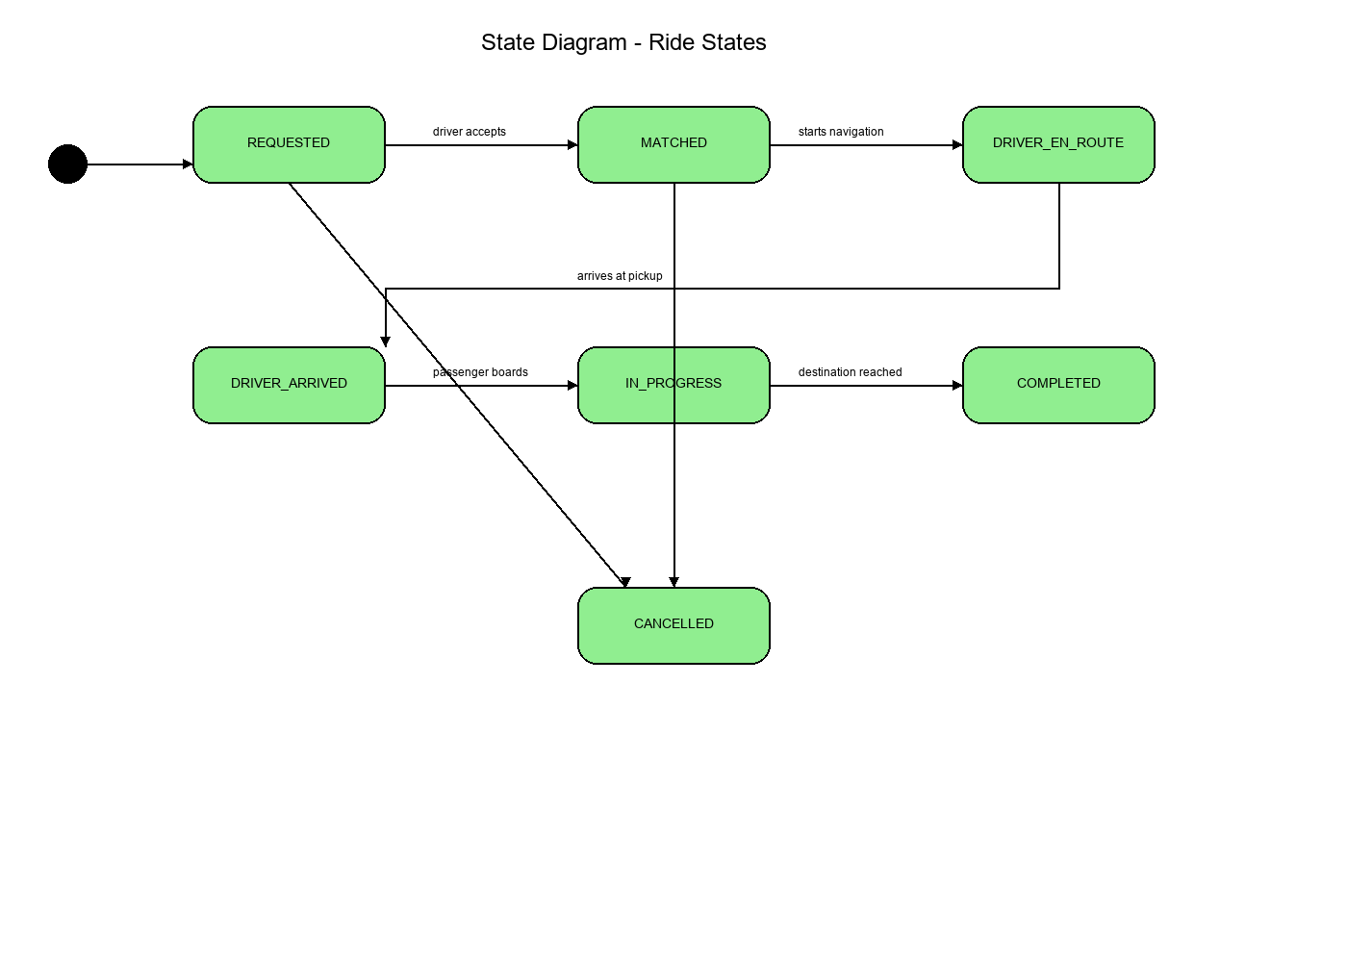

6. COMPONENT DIAGRAM
The component diagram provides a high-level view of the SAFORA system architecture, showing the major components and their interactions. The system follows a microservices architecture with clear separation of concerns.

System Components:

Mobile Applications: React Native apps for passengers, drivers, and the admin dashboard web interface. These communicate with backend via HTTPS.

Backend Server: Node.js/Express server with multiple services including API Gateway, Authentication, User Management, Ride Service, Safety Sentinel, and real-time notifications via Socket.io.

AI Microservice: Python/Flask service providing Pink Pass verification, price prediction, driver matching, and sentiment analysis. Communicates with backend via REST API.

MongoDB Database: NoSQL database storing Users, Drivers, Rides, and Alerts collections. Connected to backend via MongoDB protocol.

External APIs: Google Maps API for routing and geocoding, Twilio API for SMS notifications.

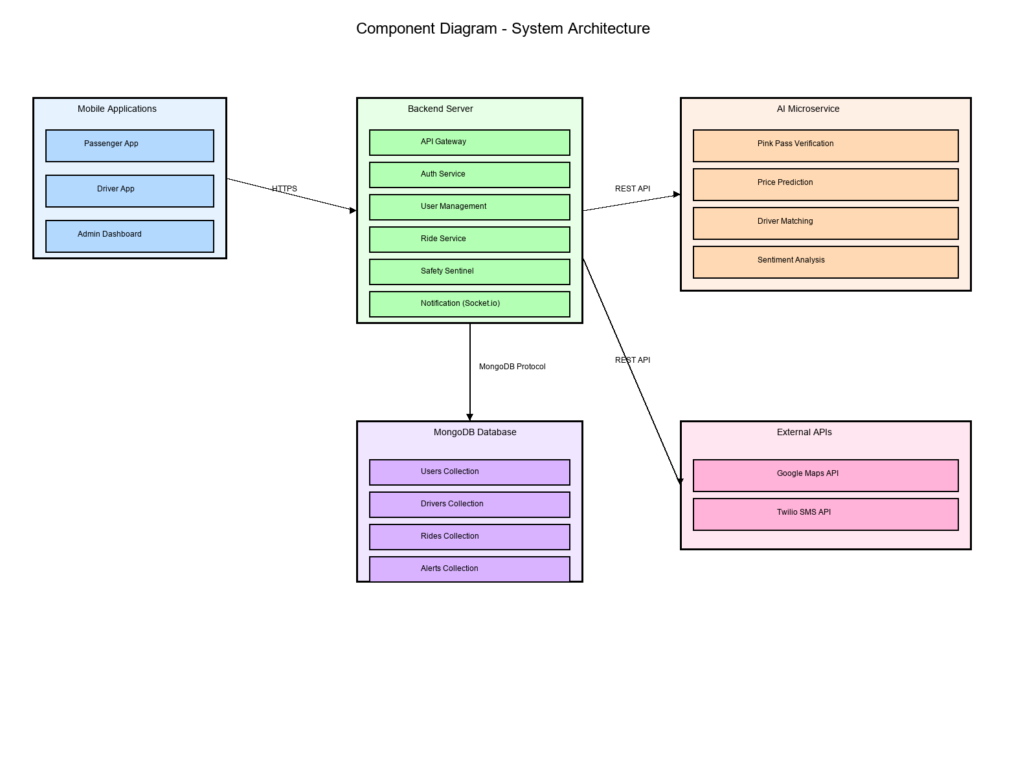

Document Approval
This SRS Phase 2 document has been reviewed and approved by:

Project Advisor:
Tanveer Ahmed
Date: _______________

Team Members:
Mirza Umer Ikram (S3F22UBSCS081)
Date: _______________

Ruhma Bilal (S3F22UBSCS088)
Date: _______________

