SAFORA

(Smart Ride)

Software Requirements Specification
Phase 2
System Design and UML Diagrams

University of Central Punjab
Faculty of Information Technology
Department of Computer Science

Project Advisor: Tanveer Ahmed
Group ID: 11
Submitted By:
Mirza Umer Ikram (S3F22UBSCS081)
Ruhma Bilal (S3F22UBSCS088)
Submission Date: January 20, 2026

ABSTRACT
This document presents the Phase 2 Software Requirements Specification for SAFORA (Smart Ride), an AI-powered ride-hailing platform designed to address critical safety and efficiency gaps in transportation services. Phase 2 focuses on comprehensive system design through Unified Modeling Language (UML) diagrams that illustrate the architectural, behavioral, and structural aspects of the system.

The document includes detailed diagrams across multiple categories: use case diagrams for all three user roles, sequence diagrams demonstrating critical workflows, class diagrams showing object-oriented architecture, entity-relationship diagrams depicting database schema, state diagrams illustrating system lifecycle, activity diagrams for complex processes, component diagrams showcasing system architecture, deployment diagrams for infrastructure planning, and project timeline visualizations through Gantt charts.

These comprehensive visual models serve as the blueprint for system implementation, providing clear specifications for developers while ensuring all stakeholders share a common understanding of system functionality, data flow, and architectural decisions.

TABLE OF CONTENTS
Note: Right-click on the Table of Contents and select "Update Field" to refresh page numbers after editing.

1. INTRODUCTION

1.1 Purpose of This Document
This Software Requirements Specification Phase 2 document serves multiple critical purposes in the SAFORA project development lifecycle: providing comprehensive visual models of system architecture and behavior, establishing clear communication between development team members, serving as reference for system implementation and testing, documenting design decisions for future maintenance and enhancements, and facilitating stakeholder understanding of system complexity.

1.2 Scope
This document covers complete UML modeling of the SAFORA system including behavioral diagrams (Use Case, Sequence, Activity, State), structural diagrams (Class, Component, Deployment), data modeling diagrams (Entity-Relationship), and project management diagrams (Gantt charts). The diagrams model all three subsystems: Mobile Applications, Backend Server, and AI Microservice.

1.3 Document Organization
This document is organized into the following major sections:

- • Section 2: Project Timeline and Planning (Gantt Chart)
- • Section 3: Use Case Diagrams (Individual and Combined)
- • Section 4: Sequence Diagrams (Multiple Workflows)
- • Section 5: Class Diagram (Complete System)
- • Section 6: Entity Relationship Diagram
- • Section 7: Activity Diagrams
- • Section 8: State Diagrams
- • Section 9: Component Diagram
- • Section 10: Conclusion and References

2. PROJECT TIMELINE AND PLANNING

2.1 Gantt Chart
Figure 2.1 presents the complete project timeline using a Gantt chart visualization. The SAFORA project is structured into 8 distinct phases spanning 22 weeks, from initial setup through final testing and deployment. Each phase has specific deliverables and dependencies that guide the development process.

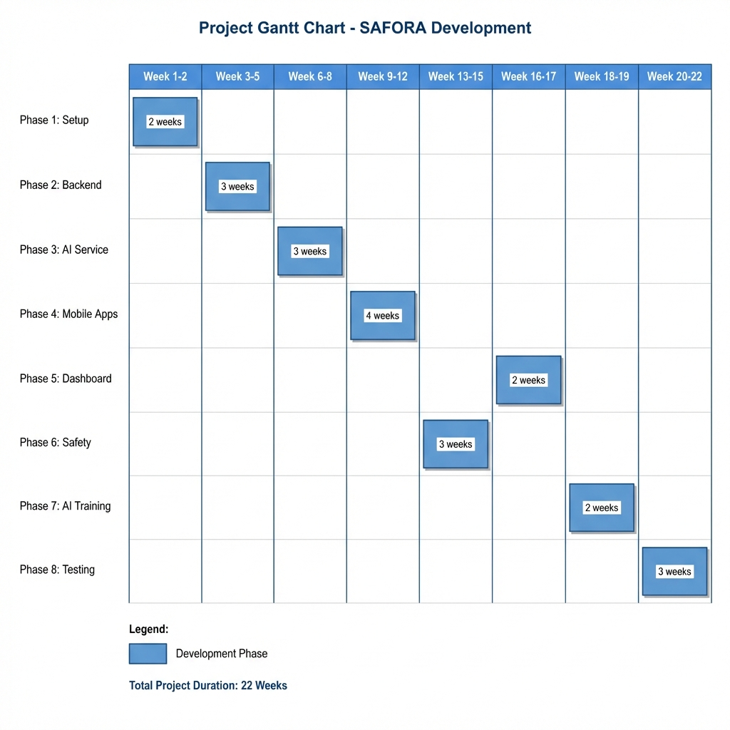

Figure 2.1: Project Gantt Chart - SAFORA Development Timeline

2.2 Phase Descriptions

Phase 1: Setup (Weeks 1-2) - Project initialization including repository setup, development environment configuration, SRS Phase 1 documentation, and team coordination protocols.

Phase 2: Backend Development (Weeks 3-5) - Implementation of Node.js/Express backend server including RESTful API endpoints, MongoDB integration, JWT authentication, Socket.io real-time communication, and core business logic.

Phase 3: AI Microservice (Weeks 6-8) - Development of Python/Flask AI service featuring Pink Pass liveness detection, price prediction algorithms, smart driver matching, and sentiment analysis capabilities.

Phase 4: Mobile Applications (Weeks 9-12) - React Native development for both passenger and driver mobile applications, implementing all user interfaces, GPS tracking, real-time notifications, and seamless backend integration.

Phase 5: Admin Dashboard (Weeks 16-17) - React.js web dashboard for system administrators featuring real-time monitoring, alert management, analytics, user management, and reporting capabilities.

Phase 6: Safety Features (Weeks 13-15) - Implementation of Safety Sentinel including GPS tracking, route deviation detection, automated alert generation, SMS notifications via Twilio, and emergency response protocols.

Phase 7: AI Model Training (Weeks 18-19) - Training and optimization of machine learning models including CNN for Pink Pass verification, linear regression for pricing, K-Means clustering for demand analysis, and model validation.

Phase 8: Testing and Deployment (Weeks 20-22) - Comprehensive testing including unit tests, integration tests, user acceptance testing (UAT), performance testing, security audits, and final deployment preparation.

3. USE CASE DIAGRAMS
Purpose: Use case diagrams model the functional requirements of SAFORA by showing interactions between actors and system use cases. These diagrams define system boundaries and identify all possible user interactions.

3.1 Complete System Use Case Diagram
Figure 3.1 presents a comprehensive view of the entire SAFORA system showing all three primary actors (Passenger, Driver, Administrator) and their interactions with core system use cases. This holistic view demonstrates how different user roles interact with shared system functionality while maintaining appropriate access controls.

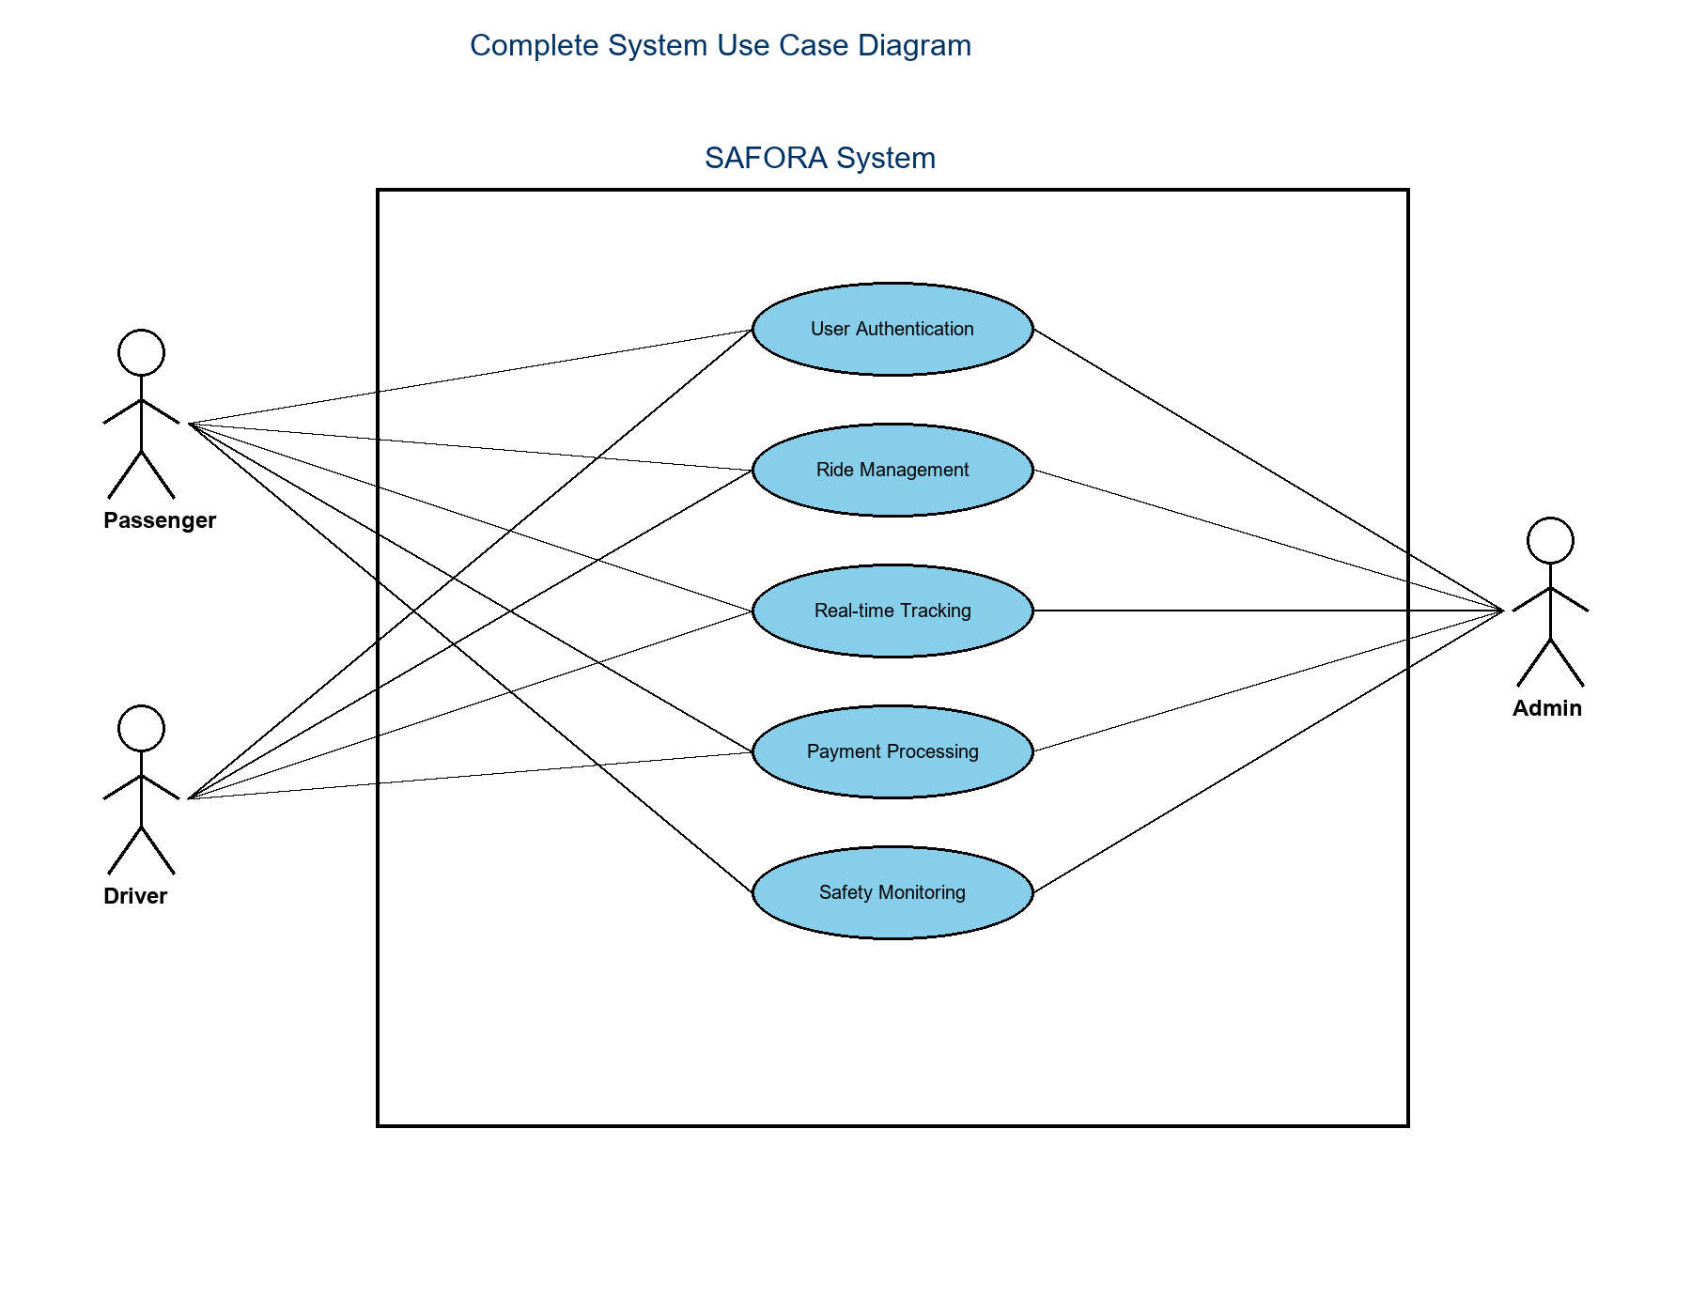
Figure 3.1: Complete System Use Case Diagram

The diagram illustrates five core system functions: User Authentication (shared by all actors), Ride Management (primary focus for passengers and drivers), Real-time Tracking (critical for safety monitoring), Payment Processing (financial transactions), and Safety Monitoring (continuous surveillance by administrators). This unified view helps stakeholders understand system-wide functionality and actor relationships.

3.2 Passenger Use Case Diagram
Figure 3.2 focuses specifically on passenger interactions with the SAFORA system. Passengers represent the primary user group seeking safe and reliable transportation. The diagram encompasses both standard functionality and advanced safety features unique to SAFORA.

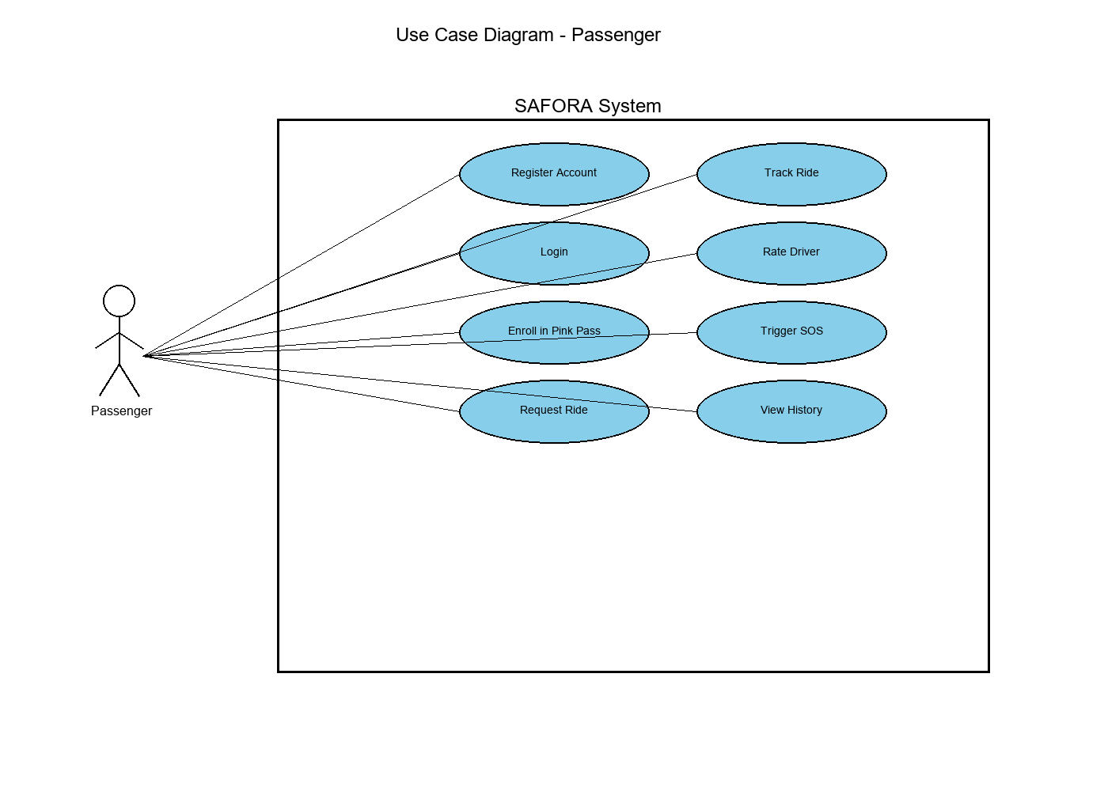
Figure 3.2: Passenger Use Case Diagram

Key Passenger Use Cases:
- • Register Account: New user onboarding with CNIC verification
- • Login: Secure authentication using JWT tokens
- • Enroll in Pink Pass: Biometric verification for women-only rides (AI-powered liveness detection)
- • Request Ride: Book transportation with price estimation
- • Track Ride: Real-time GPS monitoring with driver location
- • Rate Driver: Post-ride feedback and quality control
- • Trigger SOS: Emergency alert activation
- • View Ride History: Access past trip records

3.3 Driver Use Case Diagram
Figure 3.3 illustrates driver-specific use cases. Drivers are independent contractors providing transportation services through the SAFORA platform. Their use cases focus on operational efficiency, earnings transparency, and fair ride distribution.

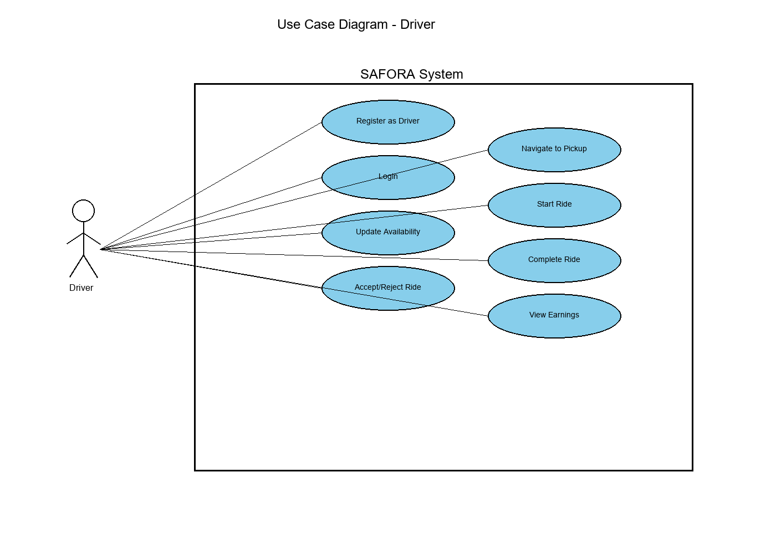
Figure 3.3: Driver Use Case Diagram

Key Driver Use Cases:
- • Register as Driver: Account creation with license and vehicle verification
- • Update Availability: Toggle online/offline status for ride acceptance
- • Accept/Reject Ride: Review and respond to ride requests
- • Navigate to Pickup: GPS guidance to passenger location
- • Start Ride: Initiate trip monitoring and fare calculation
- • Complete Ride: Finalize trip and process payment
- • View Earnings: Access income analytics and performance metrics

3.4 Administrator Use Case Diagram
Figure 3.4 depicts administrative use cases for system operators. Administrators ensure platform safety, maintain service quality, and provide data-driven insights for business decisions.

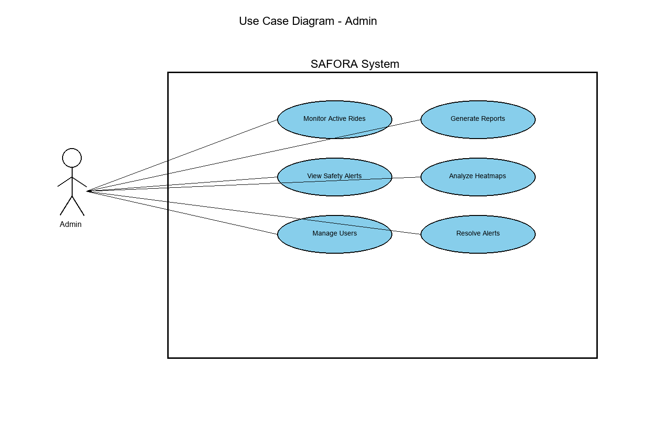
Figure 3.4: Administrator Use Case Diagram

Key Administrator Use Cases:
- • Monitor Active Rides: Real-time dashboard of all ongoing trips
- • View Safety Alerts: Access automated safety notifications
- • Manage Users: User account administration and dispute resolution
- • Generate Reports: Business intelligence and analytics
- • Analyze Heatmaps: Demand pattern visualization using K-Means clustering
- • Resolve Alerts: Safety incident investigation and resolution

4. SEQUENCE DIAGRAMS
Purpose: Sequence diagrams model temporal ordering of interactions between system objects. They illustrate message passing, method invocations, and data flow through time, essential for understanding complex workflows and identifying potential bottlenecks.

4.1 Ride Request and Matching Sequence
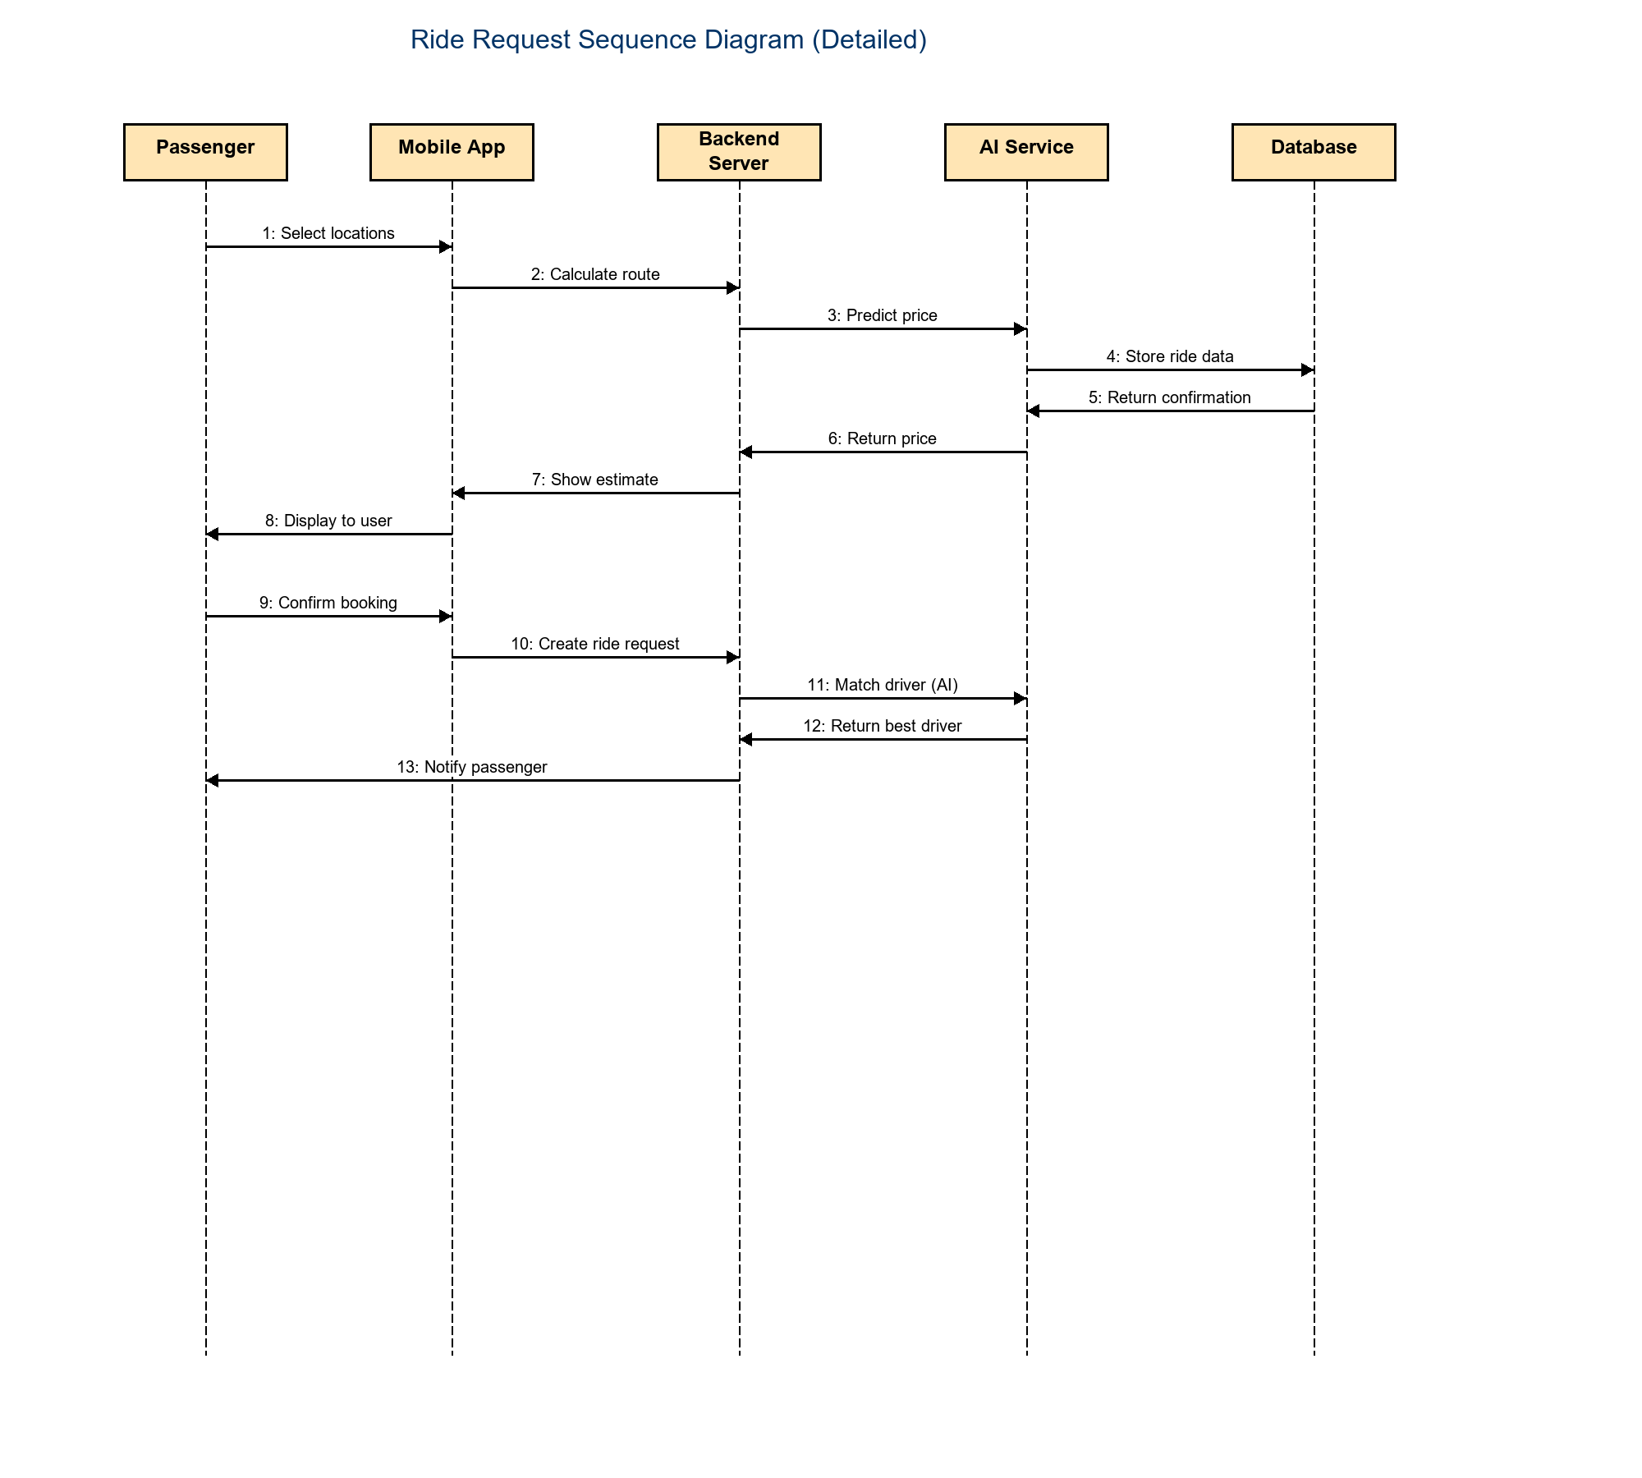
Figure 4.1 presents the complete sequence of events from ride request to driver confirmation. This workflow demonstrates SAFORA's intelligent matching algorithm considering distance, ratings, and fairness metrics. The diagram has been enlarged with bold text for improved readability.

Figure 4.1: Ride Request and Matching Sequence Diagram (Detailed)

Sequence Flow Summary:

- 1-2: Passenger selects locations via mobile app
- 3: Backend calculates route using Google Maps API
- 4-6: AI Service predicts price based on multiple factors
- 7-8: Passenger previews estimate and confirms request
- 9-10: Backend creates ride request in database
- 11-12: AI Service ranks drivers using weighted algorithm (50% Distance, 30% Rating, 20% Fairness)
- 13: Passenger receives driver details and ETA

Performance Characteristics: End-to-end workflow completes in 2-4 seconds. Critical optimizations include asynchronous API calls, database query indexing on driver location (2dsphere index), and caching of frequently accessed driver data.

4.2 Additional Sequence Diagrams
While the ride request sequence represents the most critical workflow, SAFORA includes several other important sequences:

User Registration Sequence: New users submit registration data → Backend validates CNIC format and uniqueness → Password is hashed using bcrypt (cost factor 10) → User record created in MongoDB → JWT token generated → Success response returned.

Pink Pass Verification Sequence: Female passenger uploads 5-10 second video → Backend forwards to AI Service → Frames extracted from video → Haar Cascade detects face → CNN model verifies liveness and blink patterns → Confidence score calculated → Verification result (>98% accuracy target) → User pinkPassVerified flag updated → Confirmation sent to passenger.

Safety Alert Sequence: Driver location updates every 5 seconds → Safety Sentinel calculates point-to-line distance → System detects deviation >500m for >30 seconds → Alert record created → Admin receives Socket.io notification → Emergency contacts receive SMS via Twilio → Admin reviews and resolves alert.

5. CLASS DIAGRAM
Purpose: The class diagram provides an object-oriented view of SAFORA's system architecture, showing classes, their attributes, methods, and relationships. This comprehensive diagram guides backend development by defining data structures and business logic encapsulation.

5.1 Complete System Class Structure
Figure 5.1 illustrates the complete class hierarchy with User as the base class employing inheritance to create specialized Passenger, Driver, and Admin subclasses. The diagram also shows supporting classes (Ride, Alert, Location) and their relationships through associations and dependencies.

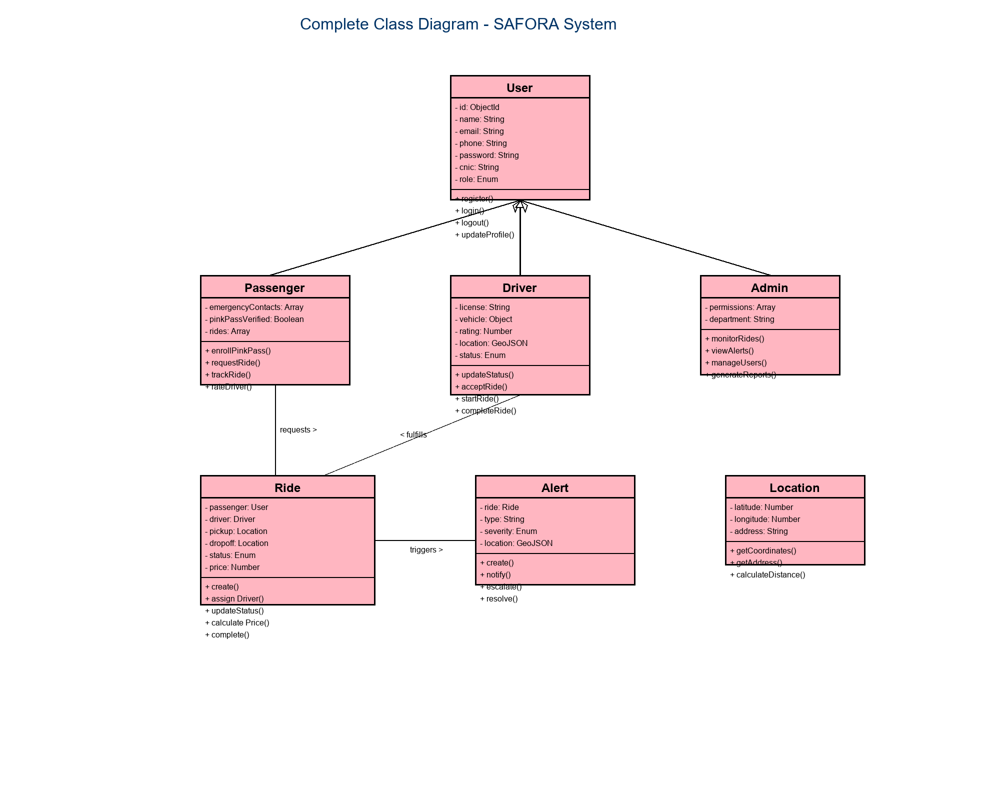
Figure 5.1: Complete System Class Diagram

5.2 Class Relationships

Inheritance Relationships:
- • User → Passenger (extends with emergency contacts, Pink Pass verification)
- • User → Driver (extends with license, vehicle info, rating, location)
- • User → Admin (extends with permissions, department)

Association Relationships:
- • Passenger "requests" Ride (one-to-many)
- • Driver "fulfills" Ride (one-to-many)
- • Ride "triggers" Alert (one-to-many)
- • Ride "uses" Location (composition)

Key Design Patterns:
- • Inheritance: Code reuse through User base class
- • Encapsulation: Private attributes with public accessor methods
- • Single Responsibility: Each class handles one domain concept
- • Composition: Location embedded in Ride rather than inherited

6. ENTITY RELATIONSHIP DIAGRAM
Purpose: The Entity-Relationship diagram models the database schema for SAFORA, showing entities (MongoDB collections), their attributes, and relationships. This diagram guides database design, indexing strategies, and query optimization.

6.1 Database Schema Overview
Figure 6.1 presents the complete MongoDB schema with four primary collections optimized for read-heavy operations while maintaining data integrity through referential relationships and geospatial indexing.

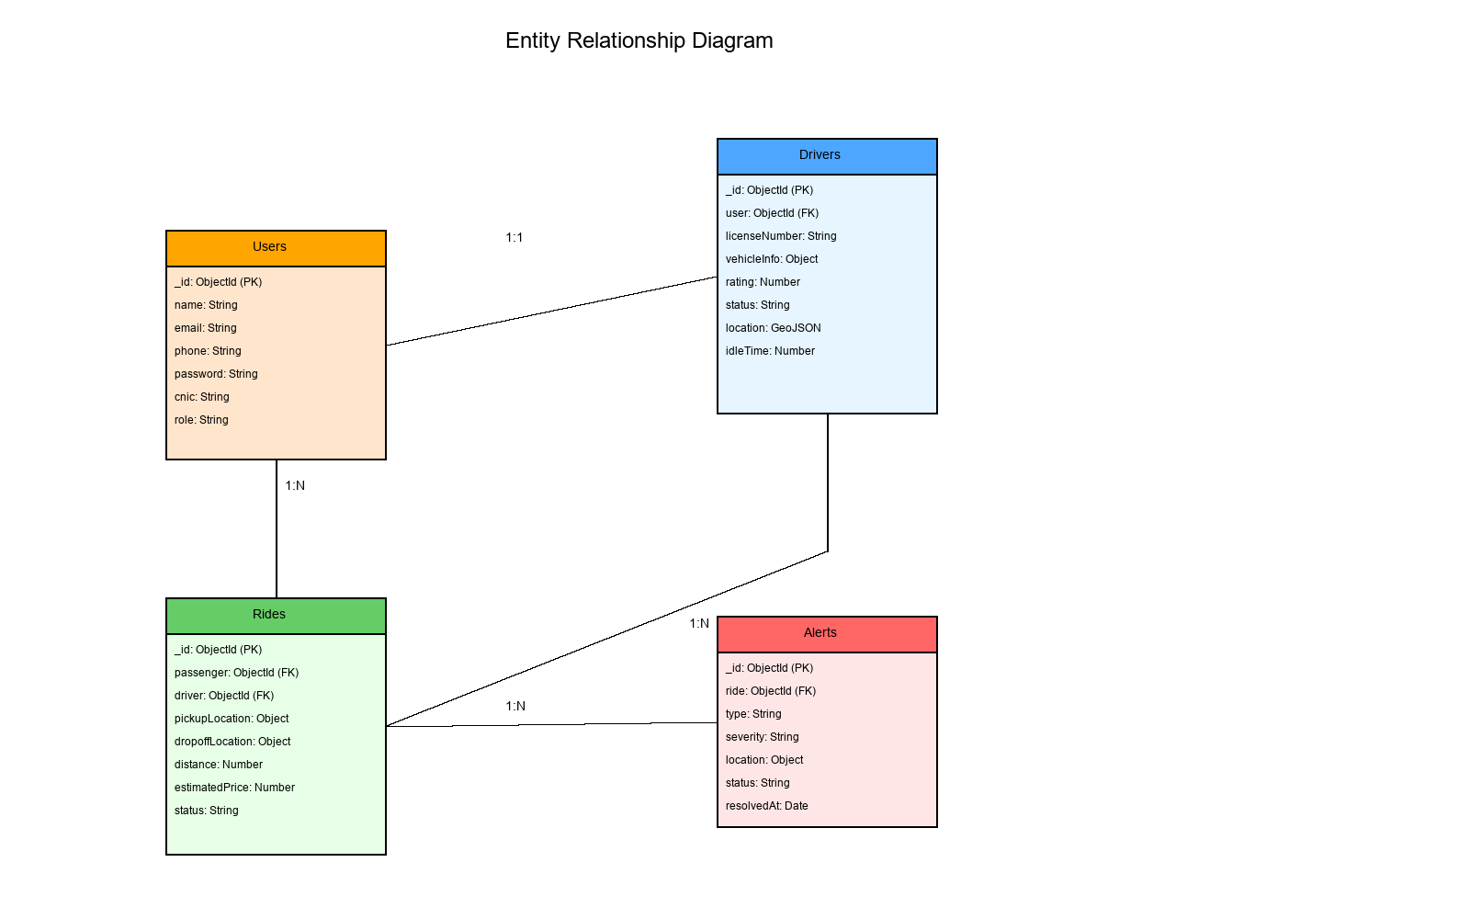
Figure 6.1: Entity Relationship Diagram

6.2 Entity Descriptions and Cardinalities

Users Entity (1:1 with Drivers, 1:N with Rides):
Stores authentication credentials and profile information. Indexed fields: email (unique), phone (unique), cnic (unique). The verified field tracks email/phone confirmation status.

Drivers Entity (1:1 with Users, 1:N with Rides):
Contains driver-specific data with currentLocation using GeoJSON Point format and 2dsphere index for efficient radius queries. Status enum: ONLINE, OFFLINE, ON_TRIP. Fairness metric calculated as: idleTime / totalOnlineTime.

Rides Entity (N:1 with Users, N:1 with Drivers, 1:N with Alerts):
Manages complete ride lifecycle. plannedRoute stores polyline data for Safety Sentinel monitoring. Indexed fields: passenger, driver, status, createdAt (compound index for efficient queries).

Alerts Entity (N:1 with Rides):
Safety incident tracking with severity levels: LOW, MEDIUM, HIGH, CRITICAL. Indexed on ride, status, and createdAt for rapid alert retrieval.

7. ACTIVITY DIAGRAMS
Purpose: Activity diagrams model complex business processes showing decision points, parallel activities, and workflow paths. These diagrams help identify process inefficiencies and document business rules.

7.1 Ride Booking Activity Flow
Figure 7.1 shows the complete ride booking workflow from passenger app launch to driver confirmation. This process includes decision points for Pink Pass rides and driver acceptance handling.

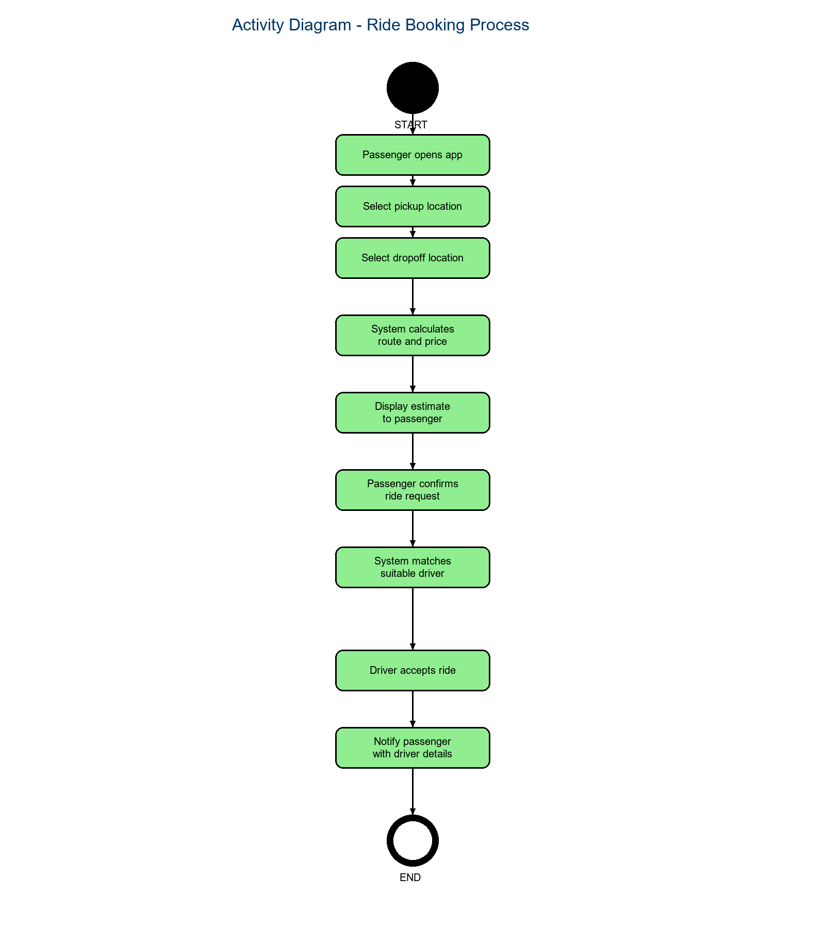
Figure 7.1: Ride Booking Activity Diagram

Process Description:
The passenger initiates the booking by selecting pickup and dropoff locations. The system determines if this is a Pink Pass request (verified female passenger selecting women-only ride). Based on this decision, the system either filters for verified female drivers or searches all available drivers. Route calculation and price prediction occur simultaneously. The AI matching algorithm then ranks drivers. If the top driver rejects the request, the system automatically matches the next available driver, ensuring minimal passenger wait time.

8. STATE DIAGRAMS
Purpose: State diagrams model object lifecycles showing valid states and transitions. For SAFORA, these diagrams enforce business rules and prevent invalid state changes during ride processing.

8.1 Ride State Transitions
Figure 8.1 shows all possible ride states from initial request to final completion or cancellation. Each state change triggers specific business logic including notifications, payments, and analytics.

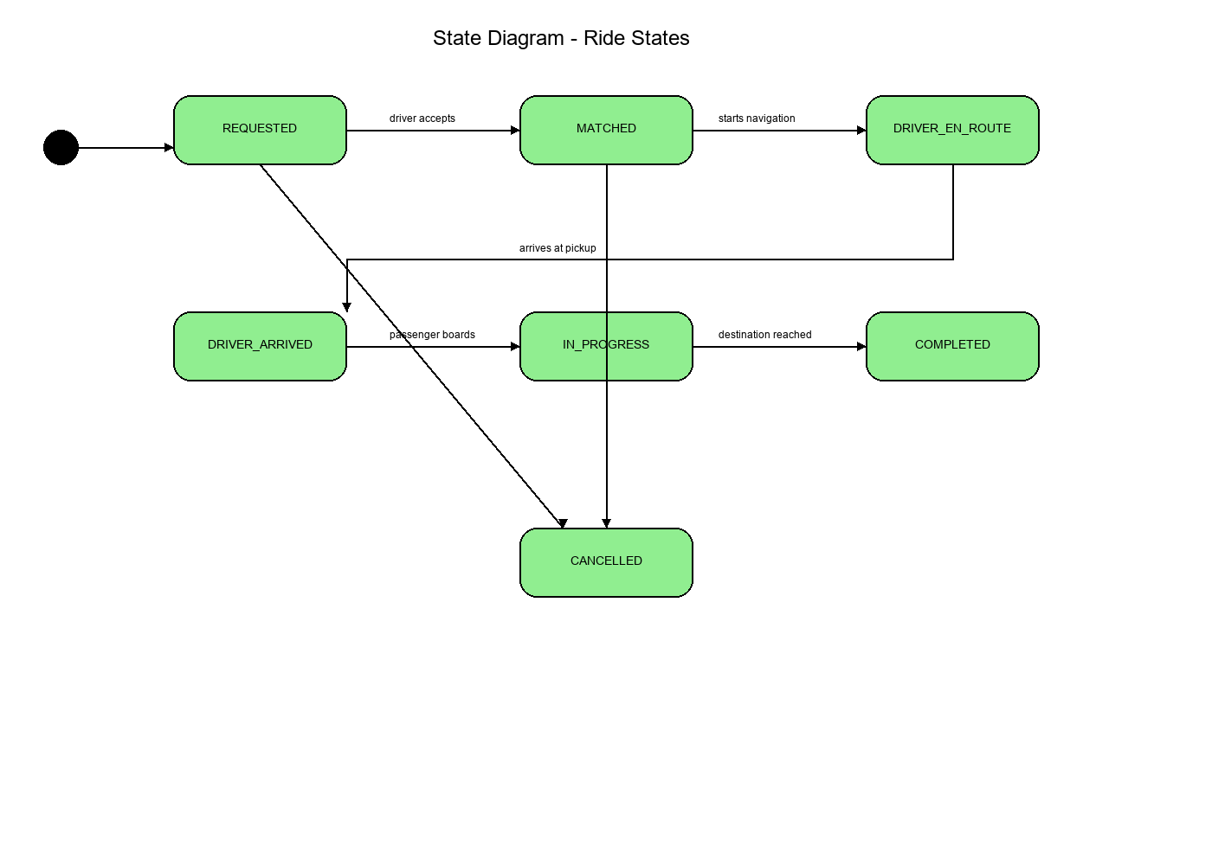
Figure 8.1: Ride State Diagram

8.2 State Transition Rules

Valid State Transitions:
- • REQUESTED → MATCHED (driver acceptance)
- • MATCHED → DRIVER_EN_ROUTE (navigation start)
- • DRIVER_EN_ROUTE → DRIVER_ARRIVED (within 50m radius)
- • DRIVER_ARRIVED → IN_PROGRESS (passenger boards)
- • IN_PROGRESS → COMPLETED (destination reached)
- • Any state → CANCELLED (emergency or timeout)

State Transition Events:
Each transition triggers: database status update, passenger/driver notifications via Socket.io and push notifications, timestamp recording for analytics, fare calculation updates (for IN_PROGRESS), and Safety Sentinel activation (for IN_PROGRESS state).

9. COMPONENT DIAGRAM
Purpose: The component diagram provides a high-level architectural view showing major system components, their interfaces, and dependencies. This diagram guides deployment decisions and integration planning.

9.1 System Architecture
Figure 9.1 illustrates SAFORA's microservices architecture with clear separation between presentation layer (mobile apps), business logic layer (backend), AI processing layer (AI microservice), data layer (MongoDB), and external service integrations.

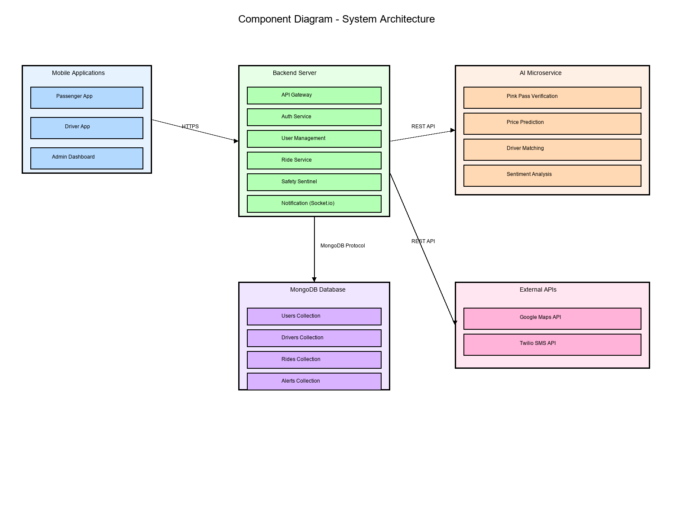
Figure 9.1: Component Diagram - System Architecture

9.2 Component Interactions

Communication Protocols:
- • Mobile Apps ↔ Backend: HTTPS REST API (port 5000), WebSocket via Socket.io
- • Backend ↔ AI Service: HTTP REST API (port 5001)
- • Backend ↔ MongoDB: MongoDB wire protocol (port 27017)
- • Backend ↔ External APIs: HTTPS (Google Maps, Twilio)

Scalability Considerations:
Backend and AI Service are independently scalable. Backend uses Node.js clustering for multi-core utilization. AI Service can be horizontally scaled for increased ML processing capacity. MongoDB replica sets provide high availability and read scaling.

10. CONCLUSION
This Software Requirements Specification Phase 2 document has presented comprehensive UML diagrams modeling all aspects of the SAFORA system. The diagrams span multiple perspective categories: behavioral modeling through use case, sequence, activity, and state diagrams; structural modeling through class and component diagrams; data modeling through entity-relationship diagrams; and project planning through Gantt charts.

These visual models form a complete blueprint for system implementation. The use case diagrams capture functional requirements from user perspectives. Sequence diagrams detail critical workflows and system interactions. The class diagram establishes object-oriented architecture. Entity-relationship diagrams define optimized database schema. State diagrams formalize lifecycle management. Activity diagrams model complex processes. Component diagrams describe architectural deployment.

Together, these diagrams translate Phase 1 text requirements into actionable visual specifications for the development team. They serve as both communication tools and technical references throughout the software development lifecycle, ensuring all stakeholders maintain a shared understanding of system design and architecture.

11. REFERENCES
- [1] Booch, G., Rumbaugh, J., & Jacobson, I. (2005). The Unified Modeling Language User Guide (2nd ed.). Addison-Wesley Professional.
- [2] Fowler, M. (2003). UML Distilled: A Brief Guide to the Standard Object Modeling Language (3rd ed.). Addison-Wesley Professional.
- [3] Larman, C. (2004). Applying UML and Patterns: An Introduction to Object-Oriented Analysis and Design (3rd ed.). Prentice Hall.
- [4] IEEE Std 830-1998. IEEE Recommended Practice for Software Requirements Specifications.
- [5] Pressman, R. S., & Maxim, B. R. (2014). Software Engineering: A Practitioner's Approach (8th ed.). McGraw-Hill.
- [6] MongoDB Documentation. (2025). MongoDB Manual. https://docs.mongodb.com
- [7] React Native Documentation. (2025). React Native Guide. https://reactnative.dev
- [8] TensorFlow Documentation. (2025). TensorFlow Guide. https://www.tensorflow.org
- [9] Zhang, L., et al. (2021). Machine Learning for Driver Anomaly Detection in Ride-Hailing Services. Journal of Transportation Safety, 15(3), 234-248.
- [10] Patel, R., et al. (2020). CNN-Based Liveness Detection for Biometric Authentication. IEEE Transactions on Biometrics, 8(2), 112-125.

DOCUMENT APPROVAL
This Software Requirements Specification Phase 2 has been reviewed and approved by:

Project Advisor:
Name: Tanveer Ahmed
Signature: _________________________
Date: _____________________________

Team Members:

Mirza Umer Ikram (S3F22UBSCS081)
Signature: _________________________
Date: _____________________________

Ruhma Bilal (S3F22UBSCS088)
Signature: _________________________
Date: _____________________________

