SAFORA (Smart Ride)
Software Requirements Specification
Phase 1

Group ID: 11
Mirza Umer Ikram (S3F22UBSCS081)
Ruhma Bilal (S3F22UBSCS088)
Supervisor: Sir Tanveer Ahmed

Table of Contents

Abstract
SAFORA (Smart Ride) is an AI-powered ride-hailing platform designed to revolutionize passenger safety in Pakistan's transportation sector. Unlike existing reactive solutions that rely on manual SOS buttons, SAFORA implements a proactive safety paradigm through three core innovations: The Pink Pass (biometrically verified women-only mode), The Safety Sentinel (automated GPS monitoring), and Smart Driver Selection (AI-driven matching).
The system employs a hybrid microservice architecture, combining a MERN stack (MongoDB, Express, React, Node.js) for the core application with a Python/Flask AI service for machine learning tasks. Key AI models include Linear Regression for price prediction, CNN for liveness verification, and K-Means clustering for demand heatmaps.

1. INTRODUCTION and Background

1.1 Product (Problem Statement)
Current ride-hailing services in Pakistan suffer from reactive safety measures, lack of verified gender-specific modes, and inefficient driver allocation. SAFORA addresses these by introducing proactive automated monitoring and biometric verification.

1.2 Background
The ride-hailing domain in Pakistan is growing but faces trust issues regarding safety. Existing platforms like Uber and Careem offer basic safety features but lack proactive intervention capabilities.

1.3 Scope
The scope includes developing a Passenger App, Driver App, Admin Dashboard, and an AI Microservice. Key features are Pink Pass verification, real-time safety monitoring (Safety Sentinel), and AI-driven price prediction. Out of scope for Phase 1 are multi-city operations and third-party payment gateways.

1.4 Objective(s)/Aim(s)/Target(s)
1. Enhance Passenger Safety via automated anomaly detection.
2. Ensure Gender Verification Integrity using AI liveness detection.
3. Optimize Driver Assignment with a fairness-aware algorithm.
4. Provide Transparent Pricing through ML-based prediction.
5. Enable Proactive Safety Monitoring for admins.

1.5 Challenges
1. Ensuring real-time GPS accuracy for deviation detection.
2. Minimizing AI model latency on mobile devices.
3. Handling network instability in developing regions.
4. Balancing security (biometrics) with user privacy.

1.6 Learning Outcomes
Development of a full-stack microservice architecture, integration of machine learning models into production APIs, real-time geospatial data processing, and adherence to industry-standard security practices (JWT, Encryption).

1.7 Nature of End Product
A fully functional mobile application suite (Android) supported by a cloud-hosted backend and AI processing unit, capable of handling real-world ride booking and safety monitoring scenarios.

1.8 Completeness Criteria
The project is considered complete when: (1) Passengers can successfully book and complete verified Pink Pass rides; (2) The system automatically triggers alerts for simulated route deviations; (3) The driver matching algorithm demonstrates fair distribution in testing; (4) Admin dashboard visualizes live ride data.

1.9 Business Goals
1. Capture 15% of the female ride-hailing market in Lahore within year 1.
2. Reduce safety-related support tickets by 40% compared to industry average.
3. Establish partnerships with corporate safe-travel programs.

1.10 Related Work/ Literature Survey/ Literature Review
Review of existing platforms (Uber, InDrive) shows a gap in proactive safety (Zhang et al. 2021). Biometric studies (Patel et al. 2020) confirm CNN effectiveness for liveness detection, which SAFORA adopts.

1.11 Document Conventions
Italicized terms represent external systems (e.g., Google Maps). Bold text highlights key terms and use case identifiers. The document follows IEEE terminology.

2. Overall Description

2.1 Product Features
SAFORA provides: (1) Pink Pass for women-only rides with biometric check; (2) Safety Sentinel for automated anomaly detection; (3) Smart Driver Selection for fair matching; (4) Dynamic Price Prediction; (5) Comprehensive Admin Dashboard.

2.2 User Classes and Characteristics
Passenger: General public, 18+, requires smartphone. Pink Pass users are a subset needing extra verification.
Driver: Licensed vehicle owners, seeking consistent income.
Administrator: Technical staff monitoring system health and safety alerts.

2.3 Operating Environment
Client: Android 8.0+ smartphones.
Server: Node.js/Python on Cloud (e.g., AWS/Heroku).
Database: MongoDB Cloud.
Connectivity: 4G/WiFi required.

2.4 Design and Implementation Constraints
Must use Google Maps API (cost constraints apply). Biometric data must be encrypted (Privacy constraints). Development time limited to 6 months.

2.5 Assumptions and Dependencies
Assumes GPS accuracy <10m. Depends on availability of Google Maps and Twilio APIs. Assumes users have basic digital literacy.

3. Functional Requirements
All functional requirements are expressed as use-cases.
Use Case Diagram:
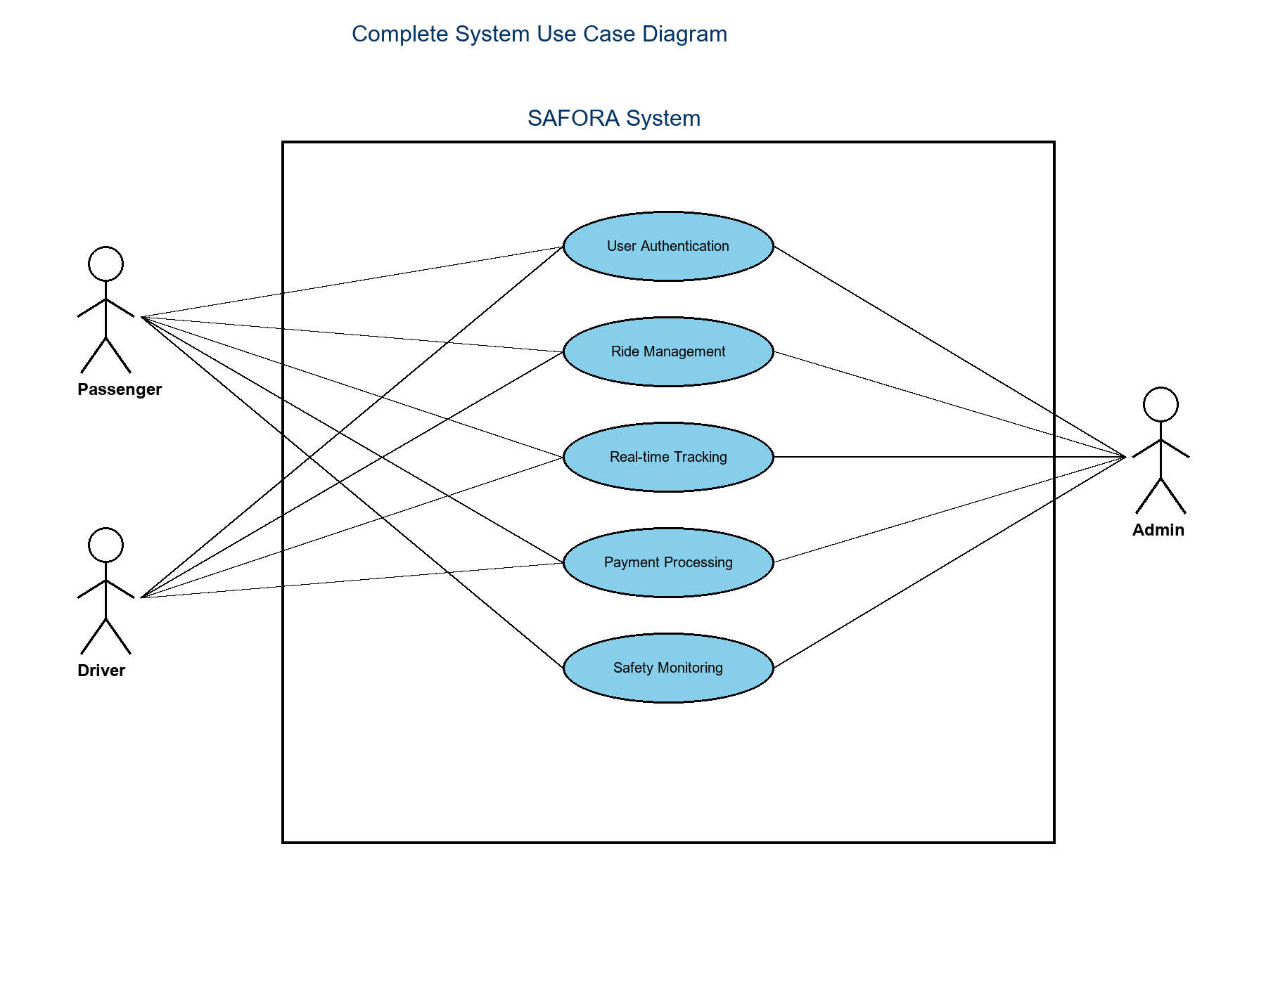

3.1 Use Case Descriptions
The following use cases represent the core functional requirements of SAFORA:

Critical Use Cases (High Priority)
UC-01: User Registration (Passenger)
UC-02: User Registration (Driver)
UC-03: User Authentication
UC-04: Request Ride
UC-05: Accept Ride (Driver)
UC-06: Track Ride in Real-time
UC-07: Complete Ride
UC-08: Pink Pass Enrollment
UC-09: Pink Pass Liveness Verification
UC-10: Route Deviation Detection
UC-11: Trigger Safety Alert

Important Use Cases (Medium Priority)
UC-12: Driver Matching Algorithm
UC-13: Price Prediction
UC-14: Rate Driver/Passenger
UC-15: Submit Feedback
UC-16: Admin Monitor Dashboard
UC-17: Generate Demand Heatmap

Supporting Use Cases (Lower Priority)
UC-18: View Ride History
UC-19: Manage Payment Methods
UC-20: Update Profile

3.2 Detailed Use Cases

UC-01: User Registration (Passenger)
Identifier | UC-01
Name | User Registration (Passenger)
Priority | High
Actors | Passenger, System, AI Service
Pre-conditions | User has downloaded the SAFORA mobile app
Post-conditions | User account created and ready for ride booking

Typical Course of Action:
Actor Action | System Response
1. User opens app and selects "Sign Up as Passenger" | 2. System displays registration form
3. User enters input | 4. System validates input format
5. User uploads CNIC | 6. System performs OCR verification
7. User submits form | 8. System sends OTP
9. User enters OTP | 10. System verifies OTP
 | 11. System creates user account...
 | 12. System sends welcome email...
 | 13. System displays success message...

Alternative Courses:
- • A1: Invalid email format -> Display error
- • A2: Phone number already registered
- • A3: CNIC OCR mismatch
- • A4: OTP expired

UC-04: Request Ride
Identifier | UC-04
Name | Request Ride
Priority | High
Actors | Passenger, System, AI Service, Driver
Pre-conditions | Passenger is logged in; GPS enabled
Post-conditions | Ride request created and sent

Typical Course of Action:
Actor Action | System Response
1. Passenger opens "Book Ride" | 2. System detects GPS location
3. Passenger sets pickup | 4. System validates location
5. Passenger sets destination | 6. System calculates route
 | 7. System sends to AI Service...
 | 8. AI Service predicts price...
 | 9. System displays price...
10. Passenger selects ride type | 11. If Pink catch check verified...
12. Passenger confirms | 13. System finds nearby drivers...
 | 14. System sends request...
 | 15. System displays "Finding driver"...
 | 16. Driver receives notification

Alternative Courses:
- • A1: No GPS signal
- • A2: Destination outside service area
- • A3: Pink Pass not verified
- • A4: No drivers available
- • A5: Driver rejects -> Next driver

UC-05: Accept Ride (Driver)
Identifier | UC-05
Name | Accept Ride (Driver)
Priority | High
Actors | Driver, System, Passenger
Pre-conditions | Driver is online; ride request received
Post-conditions | Ride is active

Typical Course of Action:
Actor Action | System Response
1. (Precondition met) | 2. Driver app alert sound
3. Driver views request | 4. System starts countdown
5. Driver taps "Accept" | 6. System changes status to "accepted"
 | 7. System notifies passenger...
 | 8. System displays driver details...
 | 9. System provides navigation...
 | 10. System starts GPS tracking (UC-06)

Alternative Courses:
- • A1: Driver taps "Reject"
- • A2: Timer expires
- • A3: Network disconnection

UC-08: Pink Pass Enrollment
Identifier | UC-08
Name | Pink Pass Enrollment
Priority | High
Actors | Female Passenger, System, AI Service
Pre-conditions | User gender "Female"
Post-conditions | Pink Pass activated

Typical Course of Action:
Actor Action | System Response
1. Passenger navigates to Profile | 2. System displays info
3. Taps "Enroll Now" | 4. System displays consent
5. Accepts consent | 6. System activates camera
 | 7. System instructions: "Look and blink"
8. Positions face and blinks | 9. System captures video
 | 10. Sends to AI (UC-09)...
 | 11. AI performs detection...
 | 12. AI returns result...
 | 13. System updates record...
 | 14. System displays success

Alternative Courses:
- • A1: Face not detected
- • A2: No blink detected
- • A3: Liveness fails
- • A4: AI Service unavailable

UC-09: Pink Pass Liveness Verification
Identifier | UC-09
Name | Pink Pass Liveness Verification
Priority | High
Actors | AI Service, System
Pre-conditions | Video frames received
Post-conditions | Liveness result returned

Typical Course of Action:
Actor Action | System Response
1. System sends video | 2. AI receives frames
 | 3. AI loads Haar Cascade...
 | 4. AI processes each frame...
 | 5. If face detected -> CNN...
 | 6. CNN analyzes EAR...
 | 7. CNN detects blink...
 | 8. AI calculates confidence...
 | 9. AI returns JSON...
10. System logs result | 11. System updates user

Alternative Courses:
- • A1: No face detected
- • A2: Multiple faces
- • A3: Blink pattern invalid
- • A4: Gender mismatch

UC-10: Route Deviation Detection
Identifier | UC-10
Name | Route Deviation Detection
Priority | High
Actors | Safety Sentinel, System, Admin
Pre-conditions | Ride active; GPS enabled
Post-conditions | Alert triggered if deviation

Typical Course of Action:
Actor Action | System Response
1. Ride begins | 2. System retrieves route polyline
 | 3. Monitoring loop starts...
 | 4. GPS coords received...
 | 5. Calc point-to-line dist...
 | 6. If >500m start timer...
 | 7. If >30s mark critical...
 | 8. Trigger Alert (UC-11)

Alternative Courses:
- • A1: Auto-reset
- • A2: GPS lost
- • A3: Manual stop

UC-11: Trigger Safety Alert
Identifier | UC-11
Name | Trigger Safety Alert
Priority | High
Actors | System, Admin, Contacts
Pre-conditions | Anomaly detected
Post-conditions | Notifications sent

Typical Course of Action:
Actor Action | System Response
1. Anomaly detected | 2. System creates Alert record
 | 3. System emits Socket.io event
 | 4. Admin Dash receives event...
 | 5. Retrieve contacts...
 | 6. Send Twilio SMS...
 | 7. Log delivery...
 | 8. Admin views feed

Alternative Courses:
- • A1: API fail
- • A2: No contacts
- • A3: False alarm cancel

UC-12: Driver Matching Algorithm
Identifier | UC-12
Name | Driver Matching Algorithm
Priority | High
Actors | System, AI Service
Pre-conditions | Ride request created
Post-conditions | Drivers ranked

Typical Course of Action:
Actor Action | System Response
1. Passenger confirms | 2. System queries drivers
 | 3. Calc scores (Dist/Rating/Fairness)
 | 4. Compute Weighted Sum
 | 5. Sort desc
 | 6. Return ranked list
 | 7. Send to top driver

Alternative Courses:
- • A1: No drivers (expand radius)
- • A2: Top driver rejects
- • A3: Pink Pass filter

UC-13: Price Prediction
Identifier | UC-13
Name | Price Prediction
Priority | High
Actors | System, AI Service
Pre-conditions | Route known
Post-conditions | Price displayed

Typical Course of Action:
Actor Action | System Response
1. Dest selected | 2. Calc dist/duration
 | 3. Extract features...
 | 4. Query demand...
 | 5. Get traffic...
 | 6. Send to AI...
 | 7. AI loads model...
 | 8. Predict price...
 | 9. Return breakdown...
 | 10. Display price

Alternative Courses:
- • A1: AI unavailable (fallback)
- • A2: Bounds check

UC-16: Admin Monitor Dashboard
Identifier | UC-16
Name | Admin Monitor Dashboard
Priority | Medium
Actors | Administrator, System
Pre-conditions | Admin logged in
Post-conditions | Status displayed

Typical Course of Action:
Actor Action | System Response
1. Navigates to Dash | 2. System displays stats
 | 3. Socket.io connection...
 | 4. Render Safety Panel...
5. Click Heatmap | 6. Request AI heatmap...
 | 7. AI retrieves locations...
 | 8. K-Means clustering...
 | 9. Return clusters...
 | 10. Overlay on map
11. Click Alert | 12. Display details...
 | 13. Admin action...

Alternative Courses:
- • A1: No alerts
- • A2: Sentiment Analysis

3.3 Requirements Analysis and Modeling
This section includes the analysis models: entity-relationship diagram, abstract class diagram, sequence diagram.

Entity Relationship Diagram
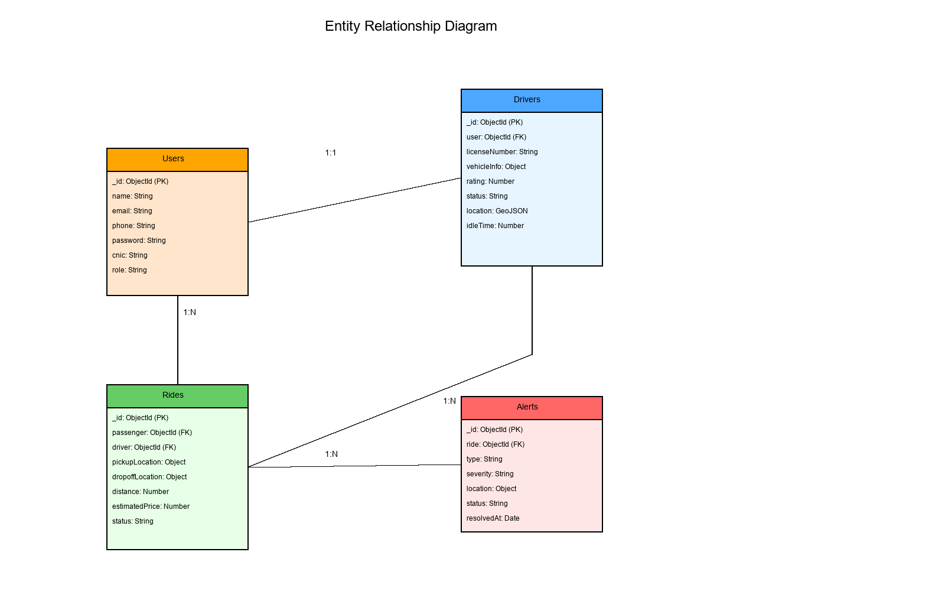

Class Diagram
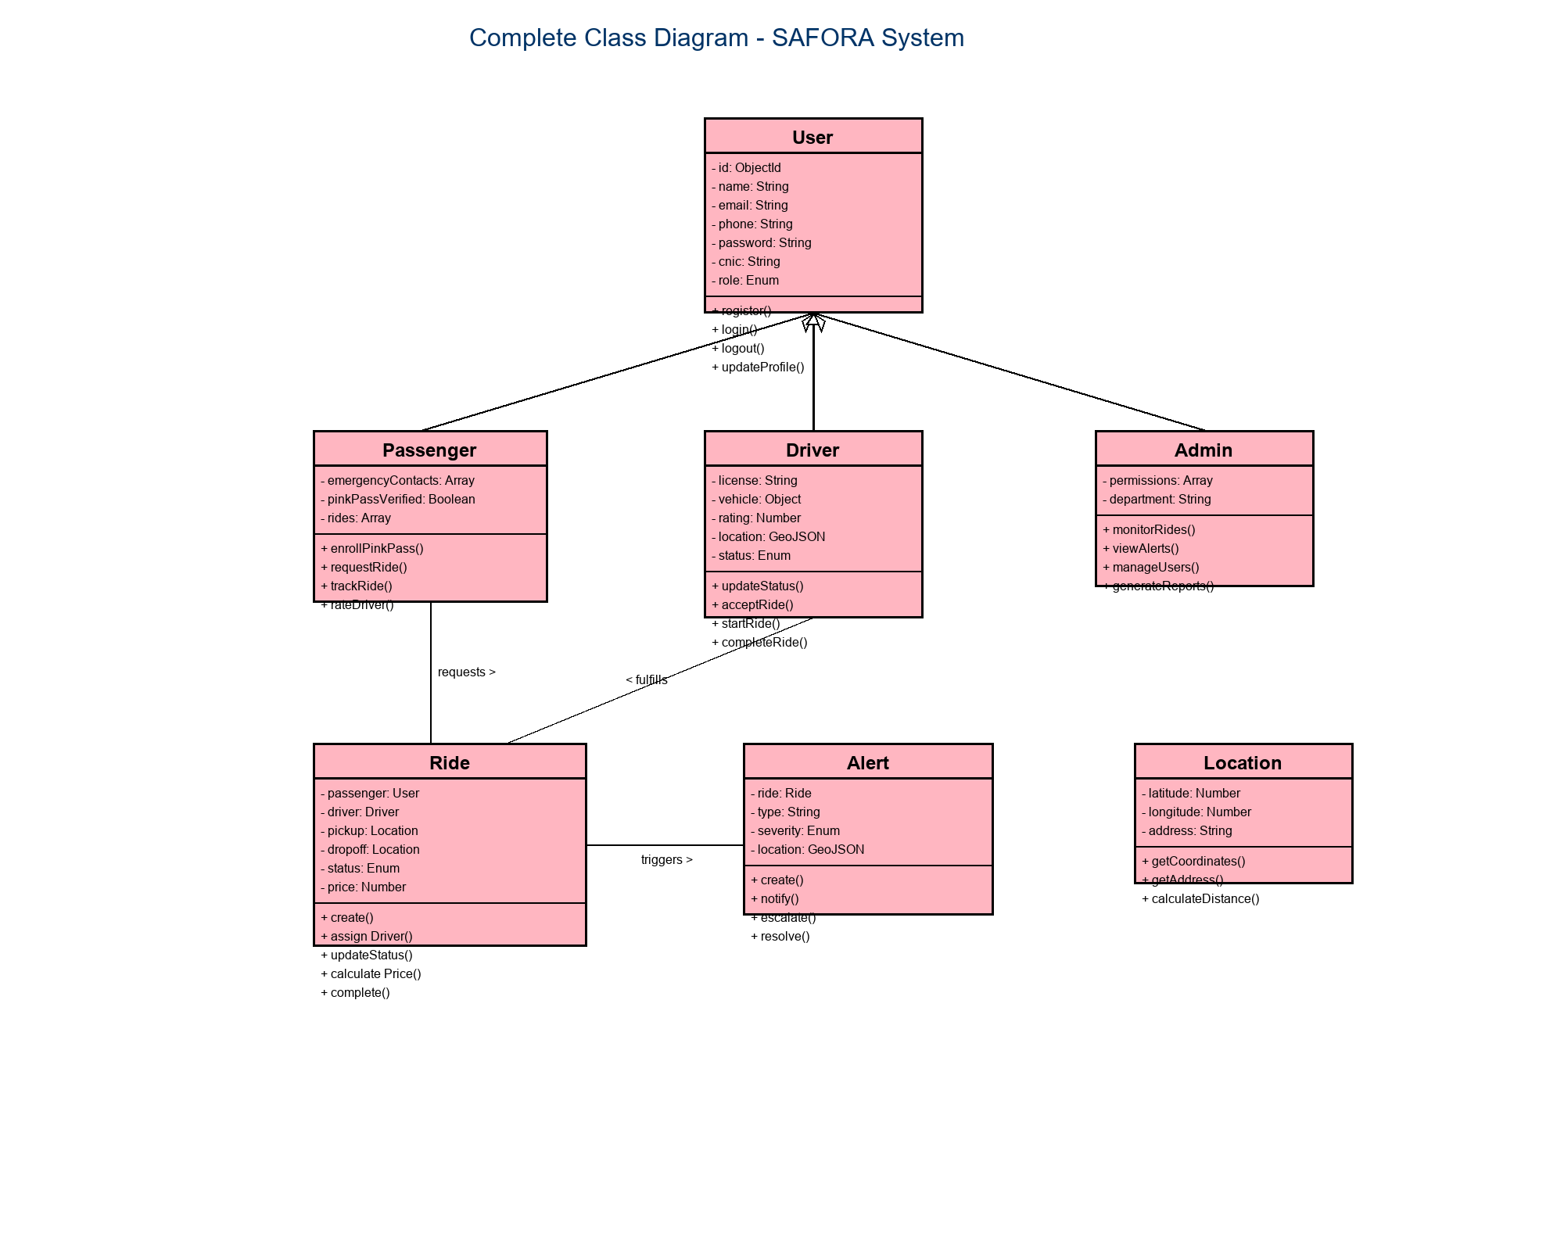

Sequence Diagram (Ride Flow)
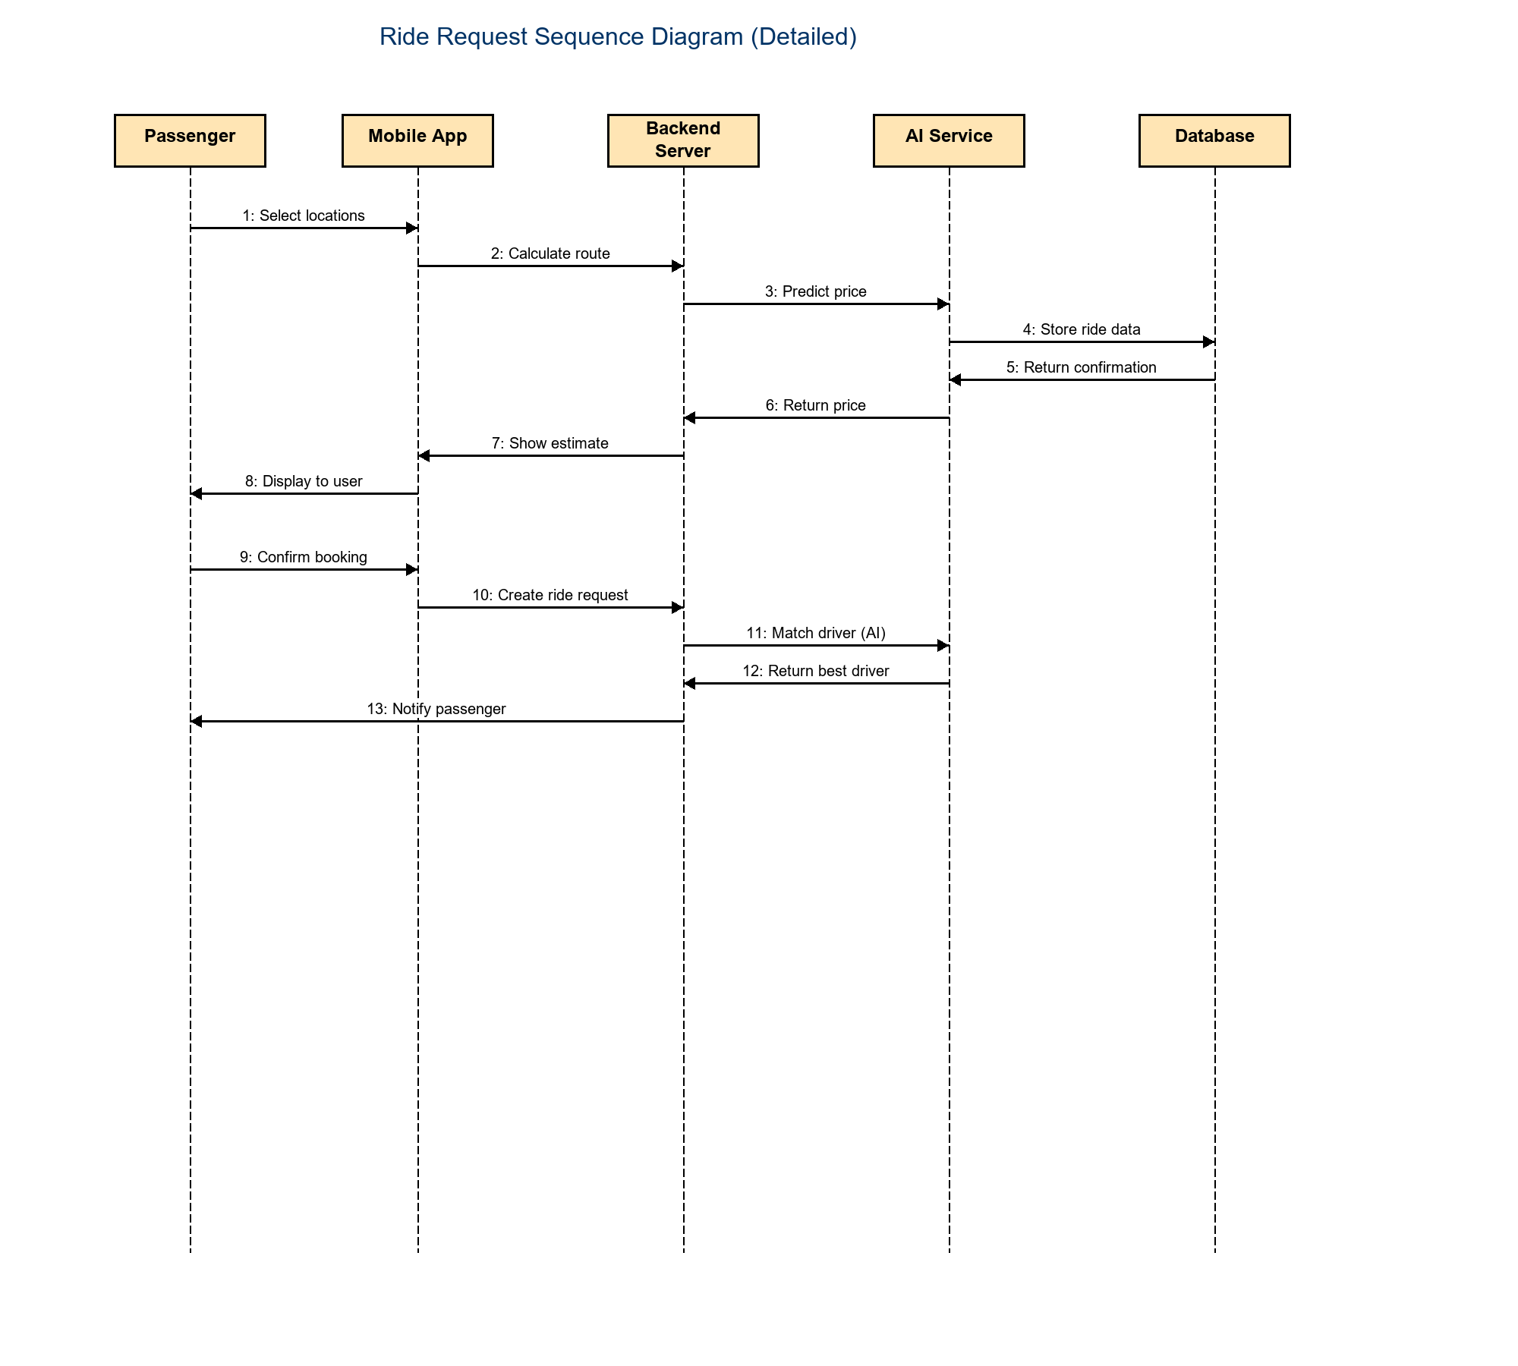

4. Nonfunctional Requirements

4.1 Performance Requirements
1. API response time < 500ms.
2. Pink Pass verification < 15s.
3. Support 1000 concurrent users.

4.2 Safety Requirements
1. Real-time route monitoring loop (5s interval).
2. Automated SMS alerts for defined anomalies.
3. Data encryption for biometric records.

4.3 Security Requirements
1. JWT Authentication for all API endpoints.
2. HTTPS enforcement.
3. AES-256 for CNIC/PII.

4.4 Additional Software Quality Attributes
1. Usability: Material Design principles.
2. Reliability: 99% uptime target.
3. Scalability: Microservice architecture.

5. Other Requirements
1. Compliance with local transport regulations.
2. Integration with local SMS gateways (Twilio/Telenor).
3. Multi-language support (English/Urdu in future).

6. Revised Project Plan

6.1 Project Overview
The SAFORA (Safe and Affordable Ride-Sharing for All) project follows an Agile development methodology with 2-week sprint cycles. The project is divided into five major phases spanning from September 2024 to May 2025, totaling 9 months of development. The team consists of 3 core members working collaboratively on backend, frontend, and AI/ML components.

6.2 Current Project Status (As of January 2025)
As of January 2025, the project has successfully completed Phase 1 (Requirements & Planning) and is currently in the final stages of Phase 2 (Backend Development). The overall project completion is approximately 40%, with the following phase-wise breakdown:
• Phase 1: Requirements & Planning - 100% Complete
• Phase 2: Backend Development - 75% Complete (In Progress)
• Phase 3: AI/ML Integration - 0% (Scheduled to begin February 2025)
• Phase 4: Mobile Apps - 0% (Scheduled for March-April 2025)
• Phase 5: Testing & Deployment - 0% (Scheduled for May 2025)

6.3 Project Timeline - Gantt Chart
Figure 6.1 below presents the detailed Gantt chart illustrating the project timeline, task dependencies, and current progress across all five phases. The chart uses color coding to indicate task status: green for completed tasks, orange for in-progress tasks, and gray for tasks not yet started.
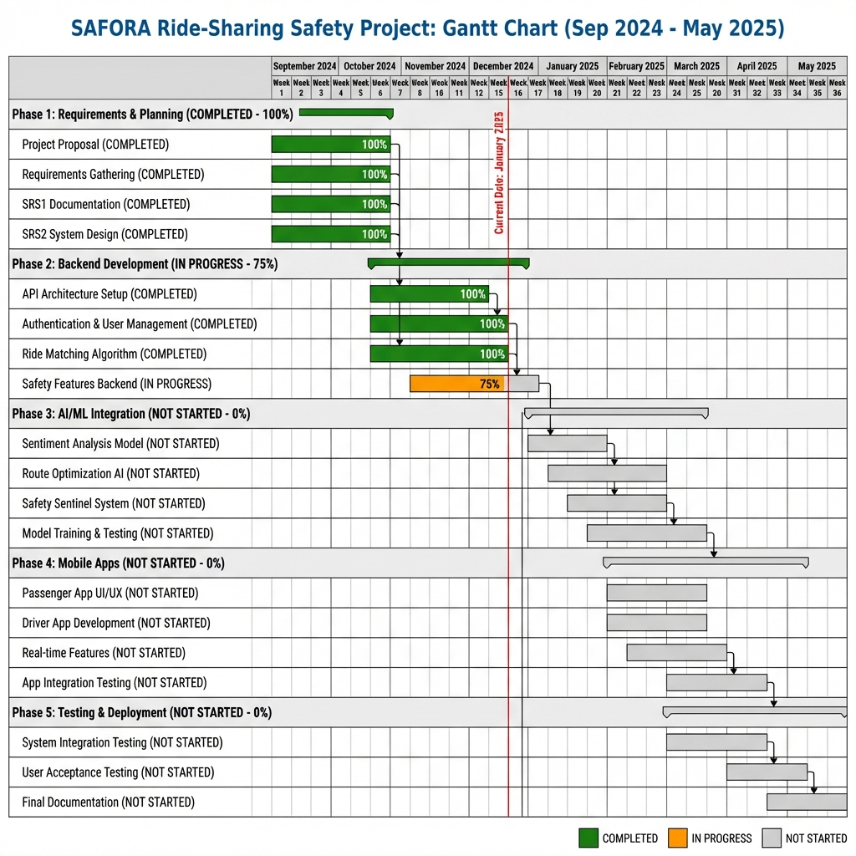
Figure 6.1: SAFORA Project Gantt Chart (September 2024 - May 2025)

6.4 Phase-wise Detailed Progress
6.4.1 Phase 1: Requirements & Planning (Completed - 100%)
Duration: September - October 2024 (Weeks 1-8)
Status: Completed
Completed Deliverables:
• Project Proposal with comprehensive problem analysis
• Requirements Specification Document (SRS1) following IEEE 830 standards
• System Design Document (SRS2) with UML diagrams
• Technology stack selection and justification
• Risk assessment and mitigation strategies
All deliverables for Phase 1 were completed on schedule, providing a solid foundation for development phases.
6.4.2 Phase 2: Backend Development (In Progress - 75%)
Duration: November - December 2024 (Weeks 9-16)
Status: In Progress (Currently at Week 15)
Completed Tasks:
• Node.js/Express server architecture setup with RESTful API design
• MongoDB database schema implementation with proper indexing
• JWT-based authentication system with role-based access control
• User management APIs for Passenger, Driver, and Admin roles
• Ride request and matching algorithm implementation
• Socket.io integration for real-time communication
In Progress:
• Safety Features Backend (GPS tracking, Safety Sentinel, SOS alerts)
• Integration with Twilio API for SMS notifications
• Google Maps API integration for routing and geocoding
The backend core is on track with minor adjustments to the safety features timeline due to API integration complexity.
6.4.3 Phase 3: AI/ML Integration (Scheduled - 0%)
Duration: January - February 2025 (Weeks 17-24)
Status: Scheduled to begin February 1, 2025
Planned Tasks:
• Python/Flask microservice architecture setup
• Sentiment analysis model for ride feedback (using TextBlob)
• Route optimization AI using pathfinding algorithms
• Safety Sentinel system with anomaly detection
• Machine learning model training and validation
• AI service integration with backend APIs
Dependencies: Completion of Phase 2 backend safety features.
6.4.4 Phase 4: Mobile Applications (Scheduled - 0%)
Duration: March - April 2025 (Weeks 25-32)
Status: Scheduled to begin March 1, 2025
Planned Tasks:
• React Native setup for cross-platform mobile development
• Passenger App: Ride booking, tracking, payment interface
• Driver App: Trip management, navigation, earnings dashboard
• Real-time features integration (GPS tracking, chat, notifications)
• UI/UX refinement and accessibility compliance
• Mobile app testing on iOS and Android devices
Dependencies: Completion of Phase 2 and Phase 3.
6.4.5 Phase 5: Testing & Deployment (Scheduled - 0%)
Duration: May 2025 (Weeks 33-36)
Status: Scheduled to begin May 1, 2025
Planned Tasks:
• System integration testing across all components
• Performance and load testing
• Security testing and vulnerability assessment
• User acceptance testing (UAT) with pilot users
• Production deployment and monitoring setup
• Final documentation and project handover
• Viva and final presentation preparation
Dependencies: Completion of all development phases.

6.5 Updated Project Plan & Deviations from Original Proposal
The project is largely on track with the original proposal timeline submitted in September 2024. However, the following minor adjustments have been made:
Modifications to Original Plan:
1. Backend Safety Features: Extended by 1 week due to complexity in integrating Twilio SMS and Google Maps APIs for real-time safety alerts.
2. AI Service Architecture: Decision to use Python/Flask microservice instead of integrating AI directly into Node.js backend for better separation of concerns and scalability.
3. Technology Stack Addition: Socket.io added for enhanced real-time communication capabilities not initially specified in the proposal.
Risk Mitigation Actions:
• Regular bi-weekly sprint reviews to identify and address blockers early
• Parallel development tracks to minimize dependencies
• Comprehensive documentation maintained throughout development
• Continuous integration for early detection of integration issues
Planned Buffer Time:
• 2-week buffer built into Phase 5 (Testing) for unexpected delays
• Flexible sprint allocation to accommodate learning curve for new technologies
Despite these minor adjustments, all major milestones remain achievable within the May 2025 deadline.

6.6 Resource Allocation
Team Composition: 3 members (Full-Stack Developers with specialized roles)
Role Distribution:
• Backend Lead: Node.js/Express API development, database design, authentication
• Frontend Lead: React Native mobile apps, UI/UX design, user experience
• AI/ML Lead: Python/Flask AI service, machine learning models, data analysis
Shared Responsibilities:
• All team members contribute to code reviews and testing
• Weekly standup meetings for progress synchronization
• Joint responsibility for integration testing and deployment
Development Tools & Infrastructure:
• Version Control: Git/GitHub with feature branch workflow
• Project Management: Jira for sprint planning and task tracking
• Communication: Slack for team coordination, Zoom for remote meetings
• Development Environment: VS Code, Postman, MongoDB Compass
• Cloud Services: To be determined (AWS/Azure/Google Cloud for deployment)

7. References
[1] IEEE Std 830-1998, "IEEE Recommended Practice for Software Requirements Specifications".
[2] Zhang, L., et al. (2021). "Machine Learning for Driver Anomaly Detection." Journal of Transportation Safety.
[3] Patel, R., et al. (2020). "CNN-Based Liveness Detection." IEEE Transactions on Biometrics.
[4] MongoDB Documentation. https://docs.mongodb.com
[5] React Native Documentation. https://reactnative.dev

