ITP4506
Project System Documentation

Name: Ikram Usama (240338484)
Qadeer Rubana (240438827)

A. Driving Question
How does good HCI design help Smil & Sunshine Toy system improve user satisfaction, and what advantages does it bring in this regard? (250 words)
Answer:
Good Human-Computer Interaction (HCI) design is crucial for the Smile & Sunshine Toy system as it directly impacts user satisfaction. When users find the system easy to navigate, with clear instructions and intuitive controls, they are more likely to have a positive experience. This leads to several advantages:
- Increased User Engagement: Users are more likely to explore more features and spend more time on the site.
- Improved User Retention: A well-designed interface can make the site memorable, encouraging return visits.
- Enhanced Accessibility: Considering accessibility in design ensures a wider audience can use the system effectively.
- Better Customer Service: Easy access to services like ordering toys and requesting quotations can lead to better customer service.

B. User Analysis
User Characteristics:
The system is designed for two main user groups: customers and sales personnel. Customers are individuals interested in purchasing toys, while sales personnel manage orders and quotations.
Techniques for Observing and Listening to Users:
We conducted surveys and usability tests with potential users to gather feedback on their needs and preferences.
Environment Analysis:
The system is intended for use in a web environment, accessible on various devices like desktops, tablets, and smartphones.
Recruiting Users:
Users were recruited from a local community group and through social media channels to participate in testing sessions.
Task Analysis (HTA):
Tasks were analyzed to understand the steps users need to take to achieve their goals, such as placing an order or requesting a custom quote.

C. Web Design Concepts
Mental Model
Concept: A mental model is like a map users have in their heads about how a website works.
Application: We made sure that the site's structure is logical. For example, users can easily understand that they need to register and log in to access personalized features like ordering toys or viewing their purchase history.
Affordance
Concept: Affordance is about how easy it is for users to know that they can interact with something on the screen.
Application: We made buttons and links obvious to click on. They're big enough, have colors that stand out, and change color when you hover over them, so users know they can click.
Content Organization
Concept: This is about how information is arranged on the screen to help users find what they need.
Application: We put important information front and center, like main navigation links in the navbar. We also made sure the flow of the site is logical, taking users from registration through to ordering toys.
Visual Organization
Concept: This is about how things look on the screen to make it easy to understand.
Application: We used grids to show toys and orders, which makes it easy to see all the options at once. We also kept the style consistent across the site, so it looks neat and professional.
Navigation
Concept: This is about how users move around on the site.
Application: We put a navbar on every page so users can always find their way to the main sections. We also made sure that each page has clear links to related pages, like how the order page links back to the product page.
jQuery in Smile & Sunshine Toy Sale System
We used jQuery, a simple JavaScript library, to make our site more interactive and fun to use.
- Dynamic Interactions: We used jQuery to make things happen when users click or hover over elements. For example, when users click on a toy, we can show more details or add it to their wish list.
- Animation and Effects: We added some cool effects like fading in and out when users navigate between pages. This makes the site feel more lively.
- DOM Manipulation: jQuery made it easy to change things on the page without having to reload the whole page. This is super helpful for features like updating order status or managing quotations.
Screen Layouts for Illustration
Here are some screenshots that show how our design concepts work in practice:
- Navbar Across Pages: Shows how the main navigation stays consistent.

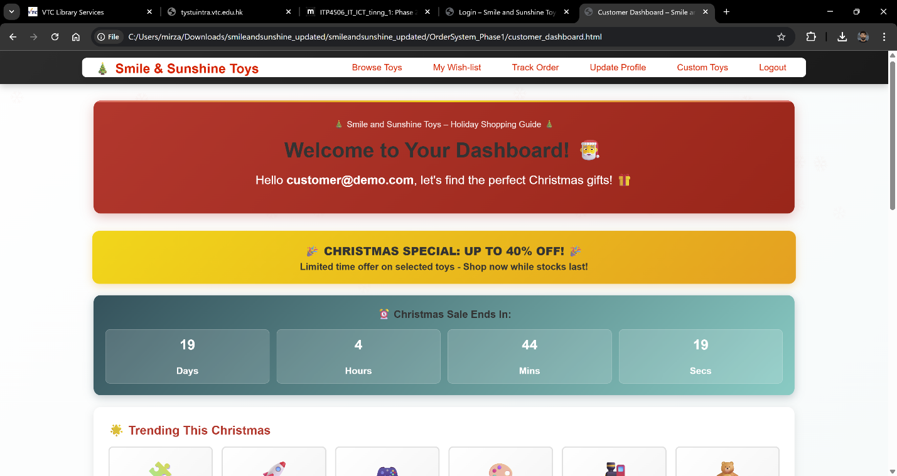

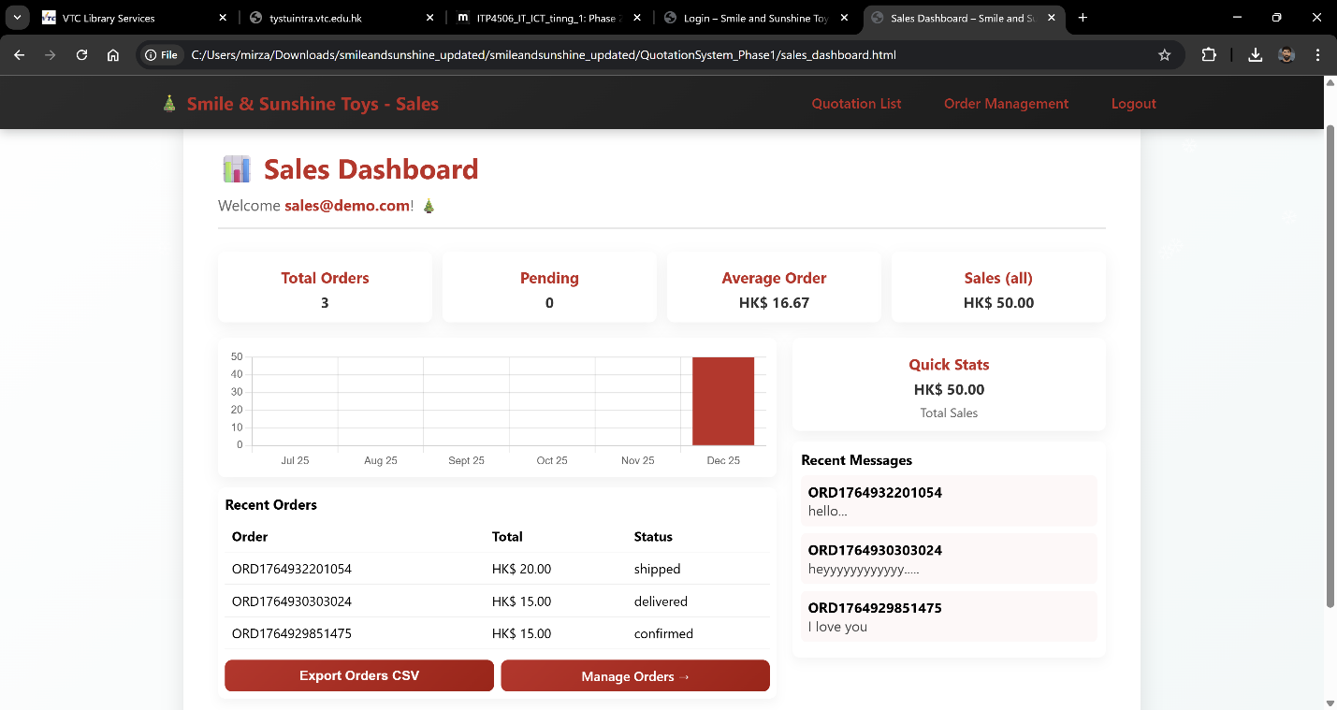

- Toy Browsing Interface: Demonstrates the grid layout for product browsing.

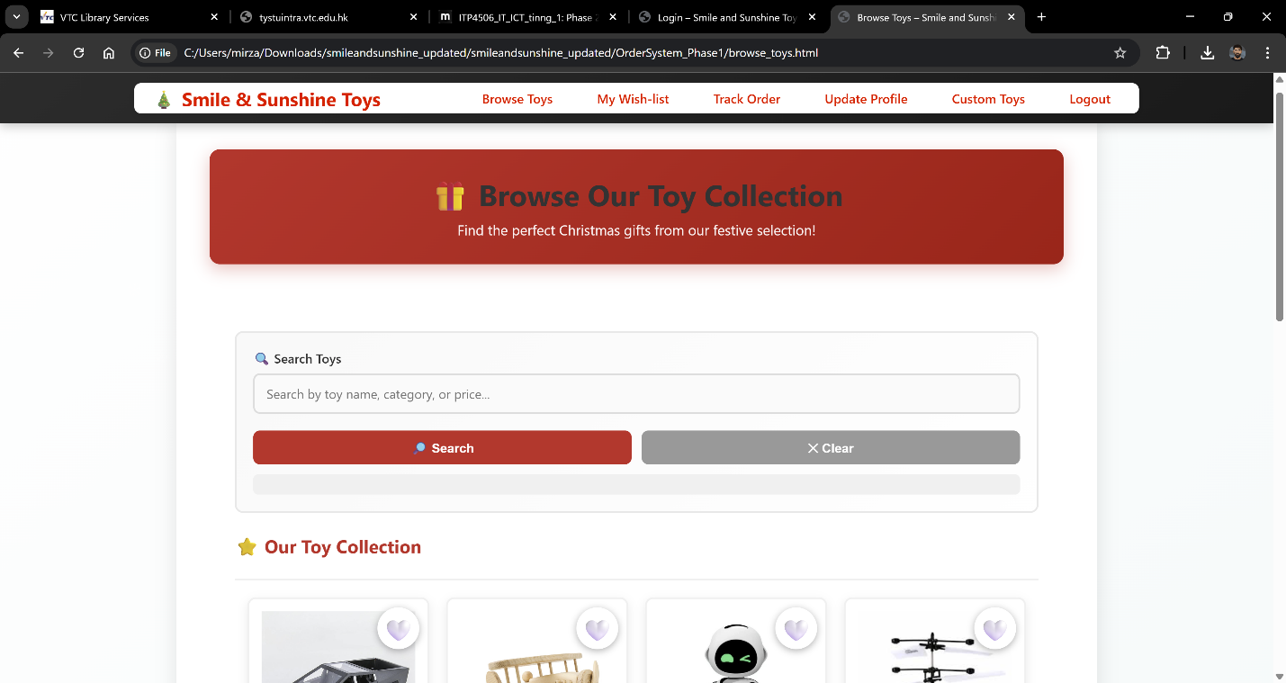

- Custom Quotation Form: Displays the form users fill out to request custom toys.
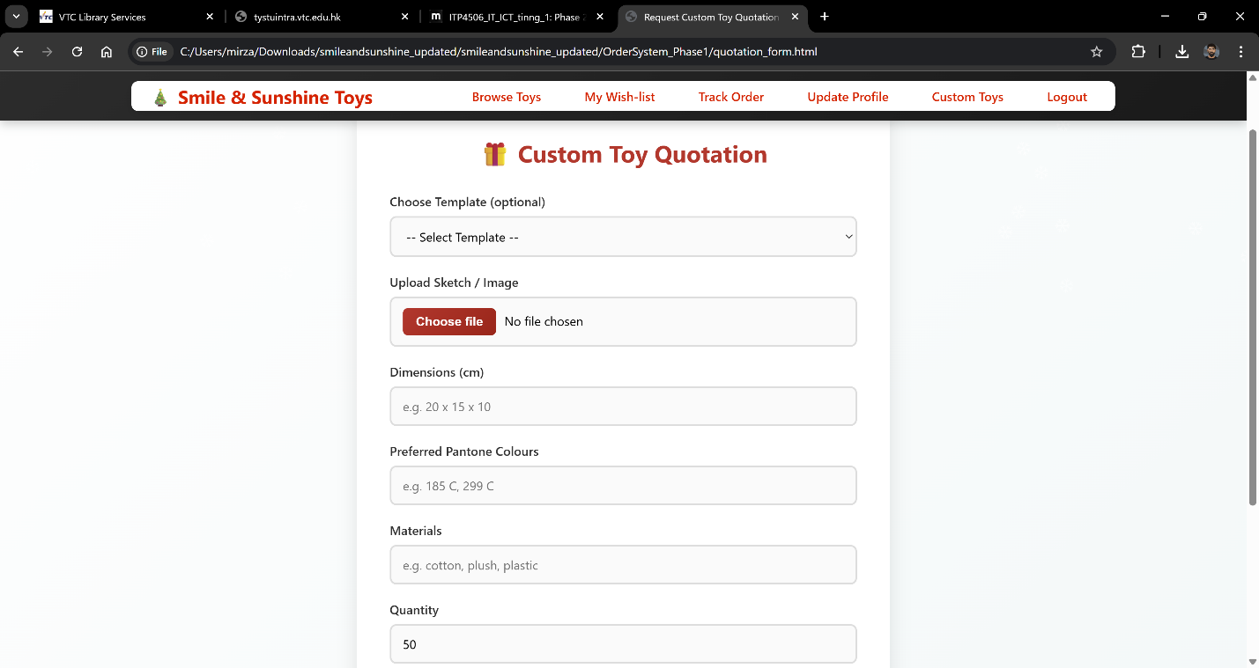

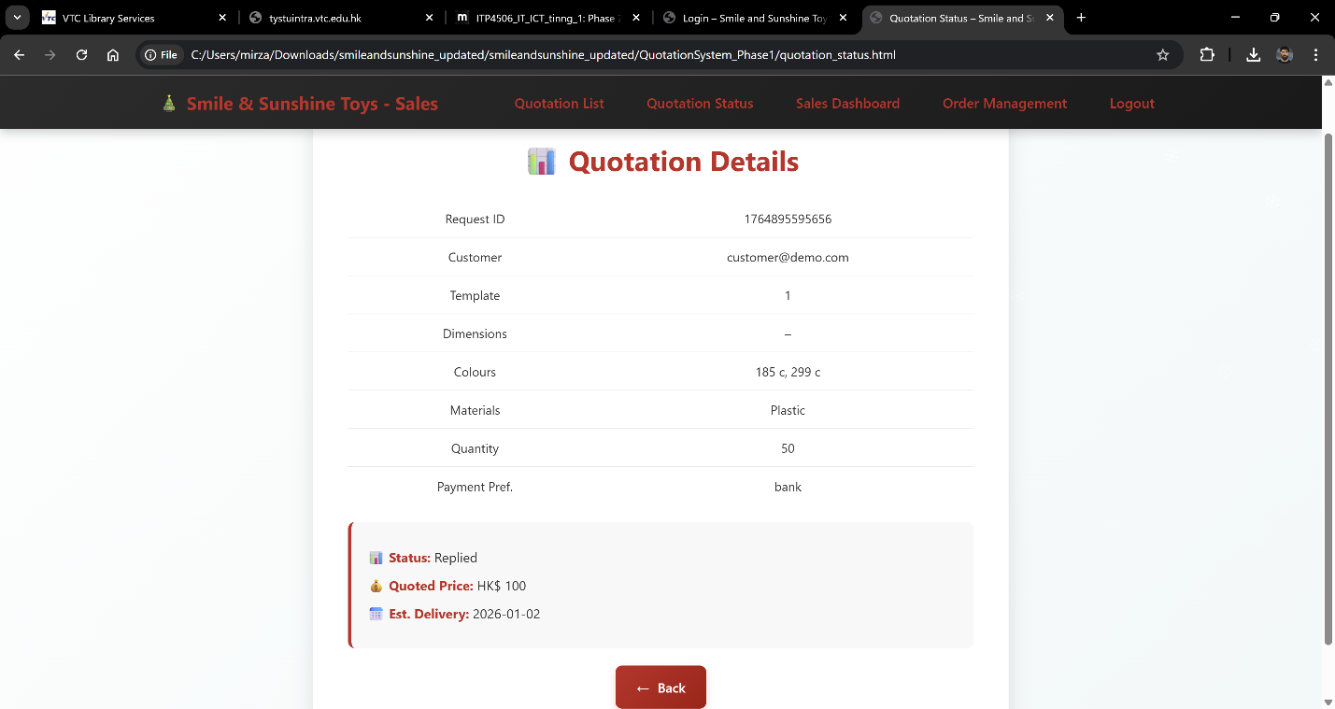

- Order Management Dashboard: Illustrates how orders are listed and managed.
